
LCBB4005 Environmental Analysis of a car manufacturing industry - Assessment 2
Module Lecturer: Dr. Rexon Nting

Student: Tonka nikolova, Group 1, Term 2, BABM, lcbb4005,uwtsd
Student id:1914038

Table of Contents
Introduction 2
Electric Vehicle Manufacturing 2
Analysis of Electric Cars in the Contemporary Business Environment 3
Evaluation of the Industry Development for Electric Vehicles 5
Conclusion 6
Reference List 7

Introduction
There has been an increase in electric vehicles in organizations arising from car advertising, which is lacking, considering the 1990s (Mwasilu et al. 507). This took over the main work in the technical and financial endeavours. This means that in the area of ​​the vehicle there are crossover electric vehicles that have a huge degree of development in the car areas. Following the introduction of electric vehicles in the vehicle division, the cost of securing them was high. Costs have now fallen, which is expanding interest in electric vehicles as buyers find ways to set aside money. Electric vehicles give many benefits to organizations and even people. However, there are different models that have survived. The document aims to examine the benefits provided by electric vehicles and the models through which electric vehicles have survived. In addition, there is further talk about the goals that must be achieved by electric vehicles and organizations after receiving these electric vehicles. Copies of these vehicles include the Nissan Leaf and Tesla Model, which are cost-saving and lead to a solid life. Below are a few models.

Electric Vehicle Manufacturing
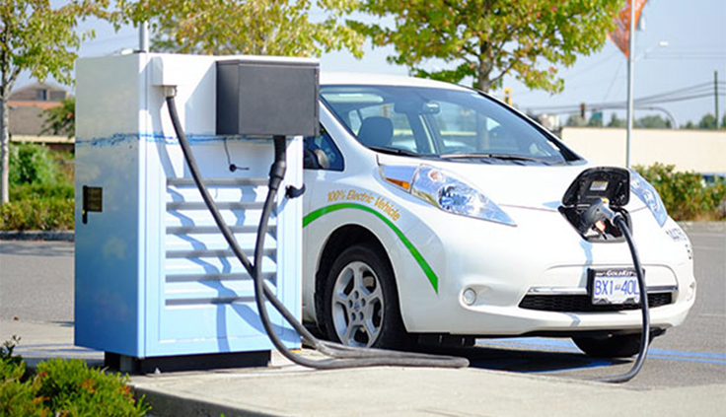
https://www.google.com/url?sa=i&source=images&cd=&cad=rja&uact=8&ved=2ahUKEwiCva7S-O3hAhUJEVAKHV_5DpEQjRx6BAgBEAU&url=https%3A%2F369S
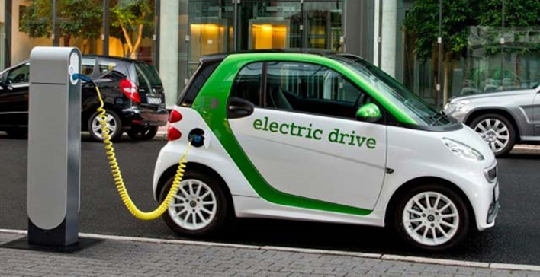
https://www.greentechlead.com/wp-content/transfers/2015/01/keen ed.jpg
As Hars (534) testifies, the battery of an electric vehicle is usually a battery-powered battery. They all contrast from the lighting, the start and the start. The improvement of the battery for electric vehicles has undergone several changes. An overflowing lead-corrosive battery was usually used, which was cheaper and more widely available. They then created nickel-iron and electric batteries from Detroit, which were extremely affordable in contrast to lead-corrosive batteries. In addition, they are low cost and naturally neighbourly. Continued progress in innovation ensures that the rechargeable battery used in electric vehicles has a huge limit, skill, safety and they are stable. These batteries emit oxygen, hydrogen and sulfur, which are harmless. Today, electric vehicles use batteries made of nickel metal, which have emerged due to the development of innovation. They are better than lead-corrosive batteries, which deliver 40 to 80 Wh / kg. if they are likely to be used well, they have a longer duration of the activity, and can subsequently give time to administrations. The following is an example of a battery used in electric vehicles.
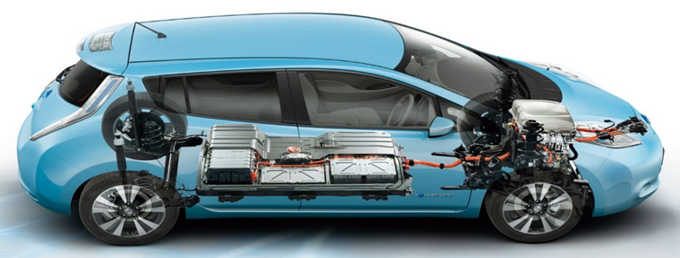
http://www.flanderstoday.eu/destinations/default/records/webimages/imec_3_0.jpg
As mentioned by Denton (123), When an organization adjusts the use of electric vehicles in its business, it evaluates a range of benefits. Immediately from the bat, filling it with power, it offers several advantages that cannot be accessed in ordinary vehicles with internal engine ignition. Because electric vehicles react faster, they are subsequently very responsive, they have great power. Electric vehicles are carefully connected during their assembly, contrasting with ordinary vehicles. A large number of charging stations for electric vehicles provide alternatives for managing their charging only by using mobile phone applications.
In addition, an electric vehicle can be charged in any case when on the premises of the organization without going to the gas stations and the vehicle is ready for use. Because power is available virtually anywhere, there are various alternatives that can be used to charge electric vehicles. This is done either when a person is busy at work, at home or outside and around. It is not necessary for the organization or the people in the organization to visit the gas stations, which is subsequently monotonous and annoying, reducing working hours. Electric vehicles have a fast activity afterwards, on which they rely a lot.

Analysis of Electric Cars in the Contemporary Business Environment
Through the operation of electric vehicles, the organization is likely to control environmental pollution. This is based on the fact that electric vehicles are described by reduced discharges that add to the exhaust cloud and changes in the environment. This improves overall well-being as a result of reduced natural damage. Nevertheless, the organization has a useful workplace. Electric vehicles are charged using sustainable sources of vitality. For example, the wind and the sun, which limit radiation. In contrast to ordinary vehicles, electric vehicles reduce environmental pollution and are therefore considered to be naturally well disposed of. Electric vehicles do not leak exhaust. At present, electric vehicles are estimated to emit about 15 per cent to 40 per cent less carbon monoxide than petroleum vehicles used by some organizations. An organization must show corporate social debt to the land.
In addition, electric vehicles offer more than individual benefits. They authorize an organization to present a different transportation solution. An organization that is more prone to energy for its vehicles is more vulnerable to graceful disturbances and jumps in value. There can be no possibility of flexible construction on a wide market (Denton 125). The use of electric vehicles in this way is considered less dangerous given the fact that there is currently power in every home. These include nuclear, petroleum gas, coal and other sustainable sources available to the organization.
In addition, electric vehicles or vehicles lead to a dramatic drop in the organization's transportation costs. This is observed mainly by those vehicles that have the usual trips such as a hundred miles in one day. Despite their significant costs associated with these vehicles, their operating costs are usually low, in contrast to reciprocal diesel and reciprocal. Finally, the use of electric vehicles provides an incredible opportunity for the organization to be associated with more creative progress in the vehicle division.
Due to the innovative turn of events, electric vehicles have survived different models (Jiuyu, Ouyang and Jingfu 597). Initially, electric vehicles had a huge measured battery. Nowadays, there are electric vehicles whose battery size has decreased. Although longer-range electric vehicles with huge batteries are hitting performance, there is a forecast for an expanded market for electric vehicles with fewer calculated batteries for the future. This shows that there are electric vehicles that rely on low batteries. This came as a result of the investigation, in which most of the vehicles cover huge miles. As the amount of charging tricks is relied upon to reduce, even BEVs will reduce its help for a full day trip by a factor of more than two. Innovation has even progressed and appropriations have been earmarked for the creation of an apparatus. Most administrations sponsor the cost of electric vehicles to reach more markets. Bytesnap envisages the appropriations given by the legislator as the reason for the growing interest in electric vehicles.
Similarly, due to the mechanical reversal of events, there are fast chargers to move forward. This is a place where drivers can relax or stare at the TV as they trust that their vehicles will be charged. This procedure has been improved to support dynamic drivers during the boot period. In addition, the fee encourages models of electric vehicles or electric forms, especially those organizations that are adapting to new innovations. In the previous days, there were many problems with the electric vehicle. This was essentially the limitation of the battery. The battery limit cannot meet the requirements for a vehicle. Due to improved innovation, organizations have been able to limit the length of charging and extend the life of the battery. Eventually, the cost of an electric vehicle was subsequently reduced and most people were available to them.

Evaluation of the Industry Development for Electric Vehicles
According to Mashinsky, organizations in many nations aim to achieve about 100% electric vehicles by 2030. On top of that, the goal is for every organization to switch to electric vehicles before 2030, as vehicles have numerous advantages. to the organization, This is in line with the objectives to be achieved by the transport unit to the administrations provided to customers. The main goal, which is planned to be achieved through the production of electric vehicles, is to reduce the carbon dioxide emission of the vehicle, which contributes to an anaesthetic, gloomy and unforced condition by creating more electric and self-driving vehicles. In addition, electric vehicles are designed to help organizations allocate money through fuel costs and the use of less expensive energy. This will enable the organization to assess tax relief through its activities. Third, vehicles are aimed at improving security of life by reducing the country's dependence on unknown oils that are above cost. In addition, due to high reliability, the nation cannot operate independently, which is why in some cases it is affected by the financial situation of different nations. Finally, electric vehicles are aimed at improving the serious status of the organization, which makes it more involved in development.
Although electric vehicles have numerous advantages for the organization and even the automotive business, they are also addressed by a number of difficulties (Situ 456). Initially, the foci of energy are not everywhere. Some of them are still in the process of formation, so a little from any strange point can proceed to charge the car. In addition, they have a longer resuscitation length, as it takes more hours to be fully charged with energy (4 to 6 hours). Third, some electric vehicle models are more expensive due to the new innovations used to create them. In addition, electric vehicles cannot be used in urban areas that face power shortages, as they exceptionally rely on power. Similarly, energy consumption is high and little of any odd individual can bear. Part of the batteries must be replaced within ten years, from now on it has a battery replacement test. In conclusion, vehicle models are smaller, usually, two-seater thus can not oblige countless people.
Given all this, this new idea for electric vehicles in the automotive business is exceptionally gaining recognition and there is a huge creation of vehicles of half breeds. Vehicles use rechargeable batteries that are inserted into the vehicle. However, batteries are used to drive the car, as well as for cleaning and lighting. Thus, organizations need to move to these new vehicle models, as they are environmentally friendly.
Norway is the nation with the most remarkable market entry per capita on the planet, with four modular electric vehicles per 1,000 inhabitants in 2013. In March 2014, Norway became the main country where more than 1 in every 100 passengers vehicles on the street is an electric module. In 2016, 29% of all new vehicle transactions in the country were with rechargeable batteries or modular crossbreeds. Norway also had the world's largest modular electrical fragment of the share of brand new vehicle transactions, 13.8% in 2014, compared to 5.6% in 2013. In June 2016, Andorra became the second country in this city, with 6% of the total consolidating electric vehicles and cross modules due to a solid open layout that gives a variety of favourable circumstances. Before the end of 2016, the 100,000th battery vehicle was sold in Norway.

Conclusion
Over the last few decades, the natural effect of the oil-based base, along with the horror of oil from the top, has sparked renewed enthusiasm for the electric transport frame. EMUs contrast with petroleum-controlled vehicles in that the power they consume can be produced from a wide range of sources, including non-renewable energy sources, nuclear power and inexhaustible sources, such as flowing power, solar-based power, hydropower, etc. wind energy or any combination thereof. Carbon impressions and the different emissions of electric vehicles change, relying on fuel and innovation used for the age of power. The power supply can then be closed using the vehicle using a battery, flywheel or supercapacitors. Vehicles using combustion-driven engines can usually simply derive their vitality from single or multiple sources, for the most part from unsustainable non-renewable energy sources. A key advantage of electric vehicles with crossover or modular models is the regenerative deceleration, which restores active vitality, regularly lost during contact, slowing down as heat, and power is restored to the on-board battery.

Reference List

Denton, T. (2018). Automobile electrical and electronic systems. Abingdon, Oxon ; New York, Ny: Routledge.

Du, J., Ouyang, M. and Chen, J. (2017, p. 584-596). Prospects for Chinese electric vehicle technologies in 2016–2020: Ambition and rationality.

Green European Journal. (2018). Car Wars: The Future of Europe’s Car Industry. [online] Available at: https://www.greeneuropeanjournal.eu/car-wars-the-future-of-europes-car-industry/[Accessed 07 Aug. 2020]. .

Hars, Alexander. "Self-driving cars: The digital transformation of mobility." Marktplätze im Umbruch. Springer Vieweg, Berlin, Heidelberg, 2015. 539-549.

Mai, Liqiang, Mengyu Yan, and Yunlong Zhao. "Track batteries degrading in real time." Nature News 546.7659 (2017): 469.

Mashinsky, Alex. "Self-charging electric vehicles and aircraft, and wireless energy distribution system." U.S. Patent No. 8,890,472. 18 Nov. 2014.

Mwasilu, Francis, et al. "Electric vehicles and smart grid interaction: A review on vehicle to grid and renewable energy sources integration." Renewable and sustainable energy reviews 34 (2014): 501-516.

Situ, L. (2009). Electric Vehicle development: The past, present future. [online] IEEE Xplore. Available at: https://ieeexplore.ieee.org/document/5228601 [Accessed 12 Aug. 2020].

