The University of Wales Trinity Saint David
Wales Institute of Science and Art


Passive RC Filter Networks

Electrical & Electronic Principles - ACDB4002

Dewi Miller
2112045
March 2023
Contents
1. Abstract 1
2. Introduction 2
3. Circuit Descriptions 3
4. Results 4
5. Discussion 5
6. Conclusion 6
7. References 7

Abstract
This report presents the results and analysis of laboratory work to measure the -3dB cut-off frequencies using low pass and high pass filter circuits. The equipment used included a signal generator, oscilloscope, probes, breadboard, crocodile clips, resistors and capacitors. The experiments involved measuring the peak and trough of the wavelength to calculate the V-out of the circuit and then using this to calculate the attenuation amplitude. The low pass filter experiment showed that the cut-off frequency is 25,000Hz at 3.5 V-out and -3.09dB, while the high pass filter experiment showed that at 3.5 V-out, the cut-off frequency at -3dB is 1,100Hz. The results were obtained by analysing graphical data from the experiments, which showed a dramatic decrease in amplitude beyond the cut-off frequency. The report concludes that 1,250Hz is the most reliable and stable Hz for the high pass filter circuit, while the low pass filter circuit shows a steady 25,000Hz- 30,000Hz to be the cut-off frequency of -3dB.

Introduction
In this assignment we were tasked with measuring the -3dB cut-off frequencies using the following equipment and equations:
- Signal generator outputting 5V pk-pk
- Oscilloscope to measure the peak and trough.
- Probes *
- 2x Breadboard
- 10kΩ resistor- Low pass
- 560pF capacitor- Low pass
- 15nF capacitor- High pass
- 10kΩ resistor- High pass
- The equation for the attenuation: $A=20×\log_{10}\frac{V_{out}}{V_{in}}$ .
I could find the -3dB cut-off frequencies using this equipment and equations.
I began the laboratory work by setting the signal generator output to 5V pk-pk, connecting the output to the breadboard’s input, as shown in figure 1. I proceeded to join the probes from the oscilloscope to the output of the breadboard. And I proceeded to measure the frequencies from 100Hz up to a maximum of 300kHz; I followed the previous steps but with the high pass filter stage shown in figure 3.

Circuit Descriptions

In this laboratory work, I experimented to find the -3dB cut-off frequency using the below circuits, which would produce different results, labels low pass and high. Using the oscilloscope, I measured the height of the peak and trough of the wavelength. I proceed to use that length to calculate the V- out of that circuit. With those numbers, I proceeded to calculate the amplitude and got the following results.
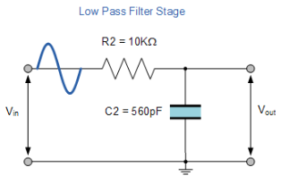
Figure 1- Low pass filter circuit diagram

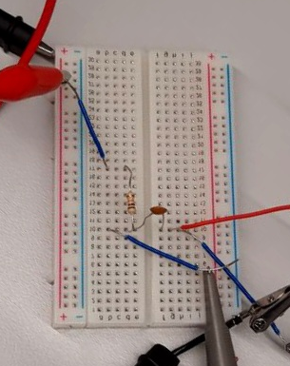
Figure 2- Low pass filter circuit
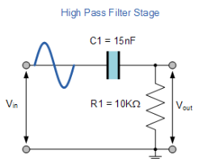
Figure 3- High pass filter circuit diagram
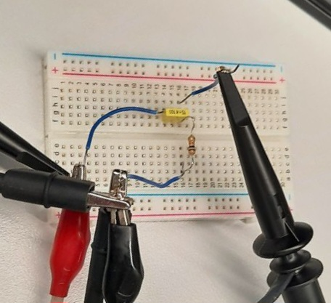
Figure 4- High pass filter circuit

Results
Graph 1- Low pass- V out against frequency
Graph 2- Low pass- A (dB) against frequency

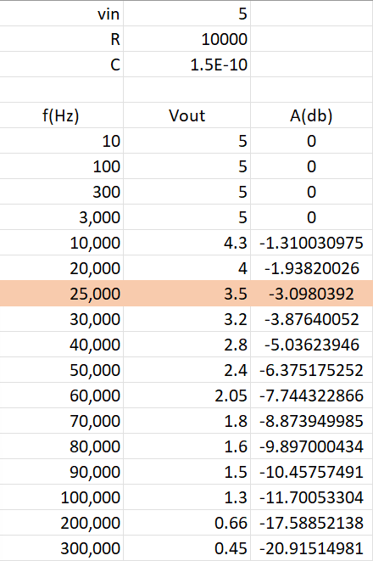
Graph 3 – Low pass- expanded view at the -3dB range.
Data table 1- Low pass filter results.
Graph 4- High pass- v- out against frequency
Graph 5- High pass- Amplitude against frequency
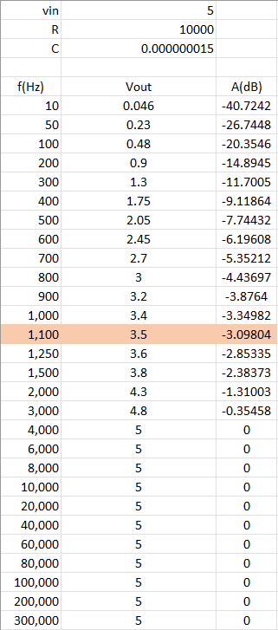
Graph 6- High pass- expanded view at the -3dB range.
Datasheet 2- High pass results.

Discussion
*It should be noted that the probe was on 1x to measure the low pass signal
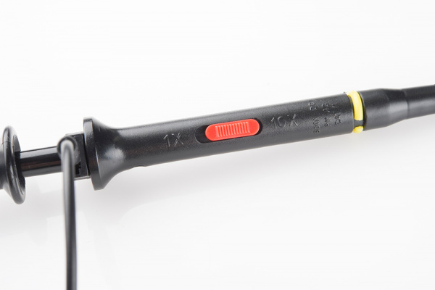

Figure 5- Probe
Low pass filter analysis
Looking at the results and graphical data from the low pass filter experiment I can deduce that the V-out begins to fall just under before 10,000Hz. The V-out decreased because when applied to a frequency, the reactance of C will be high compared to R, and C may be considered an open circuit. Hence, we have the name low-pass filter.
Analysing the data from graph 2, the low pass filter shows with a V-out of 3.5 the dB comes to 3.09 beyond this, they fall below -3dB. Once the v-out surpassed 3.5, it fell below -3dB, as shown when the v-out is 4, the decibels reached -1.93 dB. Looking at the graph, (graph 3) the amplitude falls dramatically from -1.31 to -20.91 dB. Which is a decrease of -19.60dB, over 290,000 Hz.
To conclude the results from the low-pass filter, the cut-off frequency is 25,000 Hz at 3.5 V-out and -3.09 dB.
High-pass filter analysis
Analysing the recorded data from the High pass filter experiment, I discovered that at 3.5 v-out the cut-off frequency at -3dB is 1,100 Hz. (Data sheet 2) Once it surpasses 1,250Hz the v-out is 3.6 which brings the amplitude to -2.85dB. It should be noted, however, at 900Hz it still achieves -3.87dB. which does not exceed the cut-off threshold. But is close to -4dB which is not a stable -3.00dB. The same applies to 1,000Hz it reached -3.34dB which is within the threshold. However, 1,250Hz is the most reliable and stable Hz for this circuit. (Graph 6)

Conclusion
- Results from the low-pass filter experiment showed V-out falling just under the 10,000Hz due to C having high reactance compared to R, making it an open circuit.
- Graph 2 showed V-out of 3.5 with dB at -3.09, falling below -3db once V-out exceed 3.5 at 30,000Hz.
- Graph 3 showed amplitude falling dramatically from -3.09 to -20.91 dB, a decrease of -17.82. The cut-off frequency is 25,000Hz at 3.5V out of a dB -3.09.
- Results from the high-pass filter experiment showed cut-off frequency at -3dB is 1,100Hz being the most reliable and stable Hz from the circuit.
- Equipment used in the laboratory work included a signal generator, oscilloscope, and probes.
- Frequency measurements were taken from 100Hz up to 300kHz for both the low-pass and high-pass filter stages.

References

Morgan Davis - photos of circuits

(ECStudio, N/A)

