Switch:

S1#show running-config
Building configuration...

Current configuration : 1639 bytes
!
! Last configuration change at 22:13:50 UTC Mon Mar 1 1993
! NVRAM config last updated at 12:22:17 UTC Tue Jan 14 2020
!
version 15.0
no service pad
service timestamps debug datetime msec
service timestamps log datetime msec
service password-encryption
!
hostname S1
!
boot-start-marker
boot-end-marker
!
enable secret 5 $1$Y.la$2NUVxwHL8lR1t8iIL8ZFf1
!
no aaa new-model
system mtu routing 1500
!
!
no ip domain-lookup
!
!
!
!
!
!
!
!
spanning-tree mode pvst
spanning-tree extend system-id
!
vlan internal allocation policy ascending
!
!
!
!
!
!
interface FastEthernet0/1
!
interface FastEthernet0/2
!
interface FastEthernet0/3
!
interface FastEthernet0/4
!
interface FastEthernet0/5
!
interface FastEthernet0/6
!
interface FastEthernet0/7
!
interface FastEthernet0/8
!
interface FastEthernet0/9
!
interface FastEthernet0/10
!
interface FastEthernet0/11
!
interface FastEthernet0/12
!
interface FastEthernet0/13
!
interface FastEthernet0/14
!
interface FastEthernet0/15
!
interface FastEthernet0/16
!
interface FastEthernet0/17
!
interface FastEthernet0/18
!
interface FastEthernet0/19
!
interface FastEthernet0/20
!
interface FastEthernet0/21
!
interface FastEthernet0/22
!
interface FastEthernet0/23
!
interface FastEthernet0/24
!
interface GigabitEthernet0/1
!
interface GigabitEthernet0/2
!
interface Vlan1
description remMngmnt
ip address 153.99.11.10 255.255.255.0
!
ip default-gateway 153.99.11.1
ip http server
ip http secure-server
!
banner motd ^CUnauthorized access is prohibited!^C
!
line con 0
password 7 121A0C041104
login
line vty 0 4
password 7 121A0C041104
login
line vty 5 15
password 7 121A0C041104
login
!
End

S1#show ip interface brief
Interface IP-Address OK? Method Status Protocol
Vlan1 153.99.11.10 YES manual up up
FastEthernet0/1 unassigned YES unset up up
FastEthernet0/2 unassigned YES unset up up
FastEthernet0/3 unassigned YES unset down down
FastEthernet0/4 unassigned YES unset down down
FastEthernet0/5 unassigned YES unset down down
FastEthernet0/6 unassigned YES unset down down
FastEthernet0/7 unassigned YES unset down down
FastEthernet0/8 unassigned YES unset down down
FastEthernet0/9 unassigned YES unset down down
FastEthernet0/10 unassigned YES unset down down
FastEthernet0/11 unassigned YES unset down down
FastEthernet0/12 unassigned YES unset down down
FastEthernet0/13 unassigned YES unset down down
FastEthernet0/14 unassigned YES unset down down
FastEthernet0/15 unassigned YES unset down down
FastEthernet0/16 unassigned YES unset down down
FastEthernet0/17 unassigned YES unset down down
FastEthernet0/18 unassigned YES unset down down
FastEthernet0/19 unassigned YES unset down down
FastEthernet0/20 unassigned YES unset down down
FastEthernet0/21 unassigned YES unset down down
FastEthernet0/22 unassigned YES unset down down
FastEthernet0/23 unassigned YES unset down down
FastEthernet0/24 unassigned YES unset down down
GigabitEthernet0/1 unassigned YES unset down down
GigabitEthernet0/2 unassigned YES unset down down

Router:

R1#show running-config
Building configuration...

Current configuration : 1506 bytes
!
! Last configuration change at 11:51:28 UTC Tue Jan 14 2020
! NVRAM config last updated at 11:51:49 UTC Tue Jan 14 2020
!
version 15.4
service timestamps debug datetime msec
service timestamps log datetime msec
service password-encryption
!
hostname R1
!
boot-start-marker
boot-end-marker
!
!
enable secret 5 $1$mhp8$1YgE4TbgAx5OKnE.znmAy1
!
no aaa new-model
!
!
!
!
!
!
!
!
!
!
!
!
!
!
no ip domain lookup
ip cef
no ipv6 cef
multilink bundle-name authenticated
!
!
cts logging verbose
!
!
license udi pid CISCO2901/K9 sn FCZ1930C0V4
!
!
!
redundancy
!
!
!
!
!
!
interface Embedded-Service-Engine0/0
no ip address
shutdown
!
interface GigabitEthernet0/0
description PCB
ip address 153.99.10.1 255.255.255.0
duplex auto
speed auto
!
interface GigabitEthernet0/1
description SW1
ip address 153.99.11.1 255.255.255.0
duplex auto
speed auto
!
interface Serial0/0/0
no ip address
shutdown
clock rate 2000000
!
interface Serial0/0/1
no ip address
shutdown
clock rate 2000000
!
ip forward-protocol nd
!
no ip http server
no ip http secure-server
!
!
!
!
!
control-plane
!
!
banner motd ^CUnauthorized access is prohibited!^C
!
line con 0
password 7 104D000A0618
login
line aux 0
line 2
no activation-character
no exec
transport preferred none
transport output pad telnet rlogin lapb-ta mop udptn v120 ssh
stopbits 1
line vty 0 4
password 7 0822455D0A16
login
transport input none
line vty 5 15
password 7 0822455D0A16
login
transport input none
!
scheduler allocate 20000 1000
!
End

R1#show ip interface brief
Interface IP-Address OK? Method Status Prot ocol
Embedded-Service-Engine0/0 unassigned YES unset administratively down down
GigabitEthernet0/0 153.99.10.1 YES manual up up
GigabitEthernet0/1 153.99.11.1 YES manual up up
Serial0/0/0 unassigned YES unset administratively down down
Serial0/0/1 unassigned YES unset administratively down down
R1#show ip interface brief
Interface IP-Address OK? Method Status Prot ocol
Embedded-Service-Engine0/0 unassigned YES unset administratively down down
GigabitEthernet0/0 153.99.10.1 YES manual up up
GigabitEthernet0/1 153.99.11.1 YES manual up up
Serial0/0/0 unassigned YES unset administratively down down
Serial0/0/1 unassigned YES unset administratively down down

PC-A IP config:
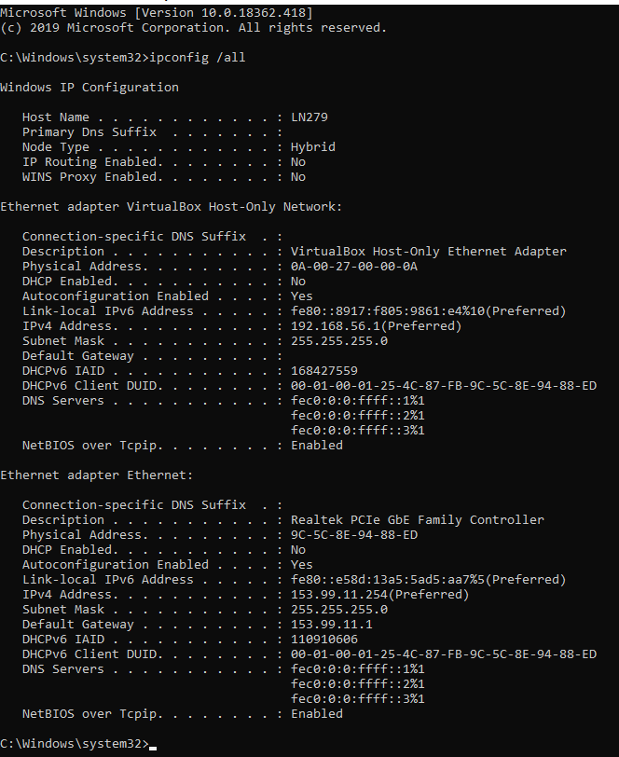

PC-B IP config:
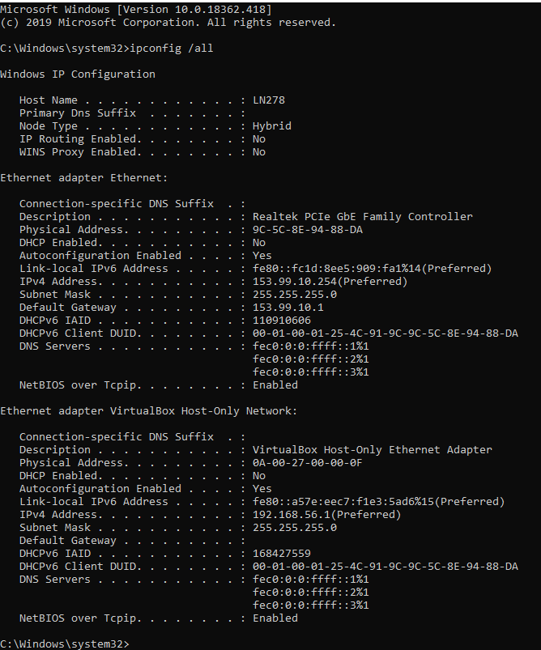

Ping PC-A -> PC-B:


