
Assessment Title: Research and case scenario in Data Security and Compliance

ACCA5034.

Dr. Dipo Dunsin (Lecturer)
University of Wales Trinity Saint David
(London Campus)

Student Name: PAUL CYRUS ABODERIN
Student Number: 2423978
Group: 01
Team: 01
Date: 11/08/26

SECURING THE HYBRID WORKFORCE
Protecting Data Beyond the Traditional Corporate Perimeter
A Condensed Analytical Brief on Zero Trust Network Access (ZTNA), Secure Access Service Edge (SASE), and Data Loss Prevention (DLP)
Prepared by Paul Cyrus Aboderin | Data Security and Compliance | July 2026

1. Executive Summary
Hybrid work has dissolved the corporate perimeter. Employees authenticate from home routers and personal devices; data lives in SaaS platforms and private clouds that were never designed to sit behind a firewall. Guarding an office network no longer protects an organization, because the organization no longer has one network to guard.
This brief argues that securing a hybrid workforce requires a shift from perimeter defence to a continuous, identity-centric, self-healing posture — one that anticipates risk, protects data at the point of use, detects anomalies in real time, and automatically contains threats. This is the Anticipate–Protect–Detect–Respond (APDR) loop, operationalized through three converging technologies — Zero Trust Network Access (ZTNA), Data Loss Prevention (DLP), and Secure Access Service Edge (SASE) — tied together by automation (SOAR/XDR). No single technology completes the loop alone: ZTNA secures the door, DLP secures what is inside the room, and SASE is the cloud platform that carries both to every edge of the organization. The brief closes with a comparative look at Nigerian, UK, and EU regulatory expectations and a phased implementation roadmap.

2. The Collapse of the Corporate Perimeter
For three decades, enterprise security assumed a single geographic centre: the office. Firewalls sat at the network edge and VPNs extended trust inward; once inside, a device was generally granted broad access. This worked while applications lived in on-premises data centres and staff worked from company-owned buildings.
Three shifts have broken that model. First, the workforce is now distributed, connecting from networks and devices IT never provisioned and cannot fully see. Second, applications and data have migrated to the cloud, so the resources an employee needs are reachable over the open internet rather than inside any corporate network. Third, attackers have adapted faster than defenders: identity-based attacks such as phishing and credential theft succeed precisely because a legitimate-looking login, once inside the old perimeter, was trusted by default.
The question organizations must answer has changed — not “how do we build a stronger wall?” but “how do we protect every user, device, application, and piece of data individually, wherever it is?”

3. The Anticipate–Protect–Detect–Respond (APDR) Framework
A coherent strategy requires thinking in terms of a continuous operating loop rather than individual products — an increasingly “self-healing” security operations model that never fully closes because the threat landscape never stops evolving.
Stage | Objective | What “Good” Looks Like
A. Anticipate | Reduce attack surface before a threat arrives | Full inventory of users, devices, applications, data flows; assume breach is inevitable
B. Protect | Stop unauthorized entry and exfiltration | Least-privilege access enforced consistently, regardless of location
C. Detect | Identify anomalies as they happen | AI/ML behavioural analytics watching activity continuously
D. Auto-Respond | Contain and fix without waiting on a human | Automatic quarantine, access revocation, and patching via pre-built playbooks
No single vendor product performs all four stages end to end. Effective security is a stack, not a purchase — one where the output of Detect automatically feeds the input of Respond.
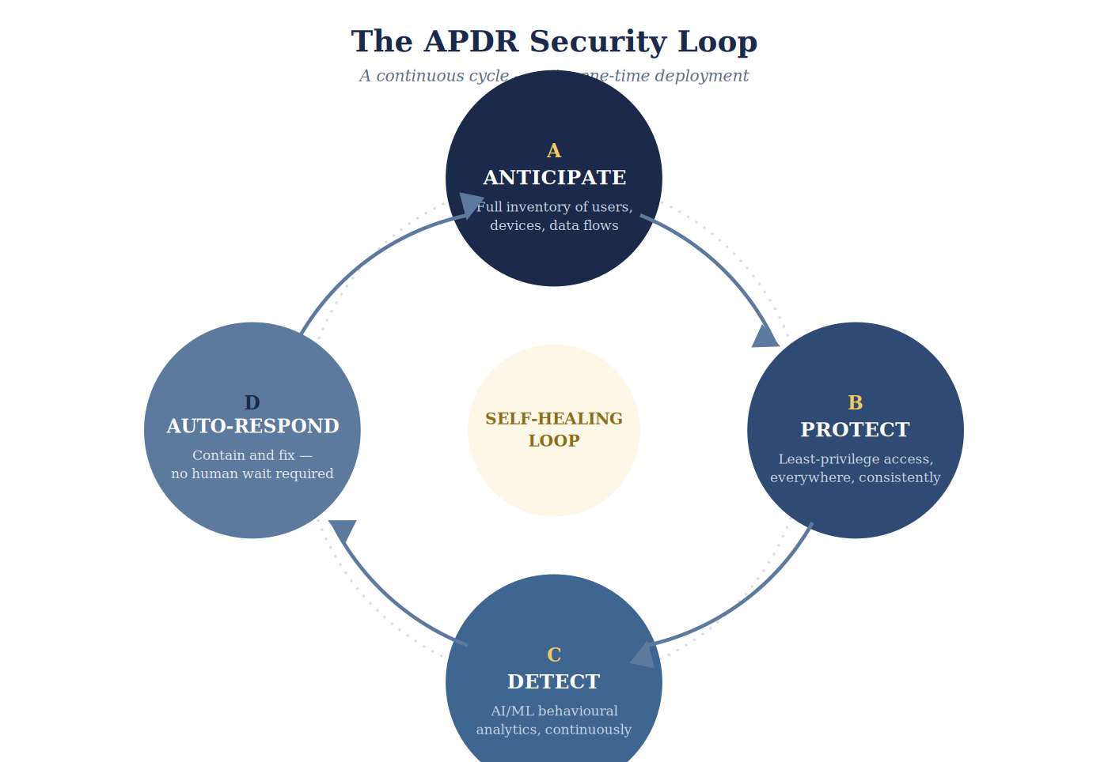
Figure 1 — The APDR loop: each stage feeds the next, with no terminal step.

4. Core Technology Pillars
Zero Trust Network Access (ZTNA) — Anticipate + Protect access. ZTNA replaces broad network-level trust with per-application, per-session access, scoring every login for risk and eliminating lateral movement inside a “trusted” segment. It is the practical implementation of the zero-trust philosophy formalized in NIST SP 800-207 (2020), which holds that no implicit trust should be granted simply because a device sits on a particular network or is company-owned. Limitation: ZTNA governs access to applications but has no visibility into data once a session is underway.
Data Loss Prevention (DLP) — Protect, Detect, and Respond for data itself. DLP continuously discovers and classifies sensitive data — PII, intellectual property, financial records — across endpoints, email, and cloud storage; blocks unauthorized uploads; and can automatically block a transfer, quarantine a file, or revoke a shared link the moment anomalous movement is flagged. Limitation: DLP has no control over the network path data travels on and depends on ZTNA or SASE to govern access in the first place.
Secure Access Service Edge (SASE) — The converged platform tying ZTNA, DLP, and network security together. Gartner defines SASE as the convergence of SD-WAN, secure web gateway, cloud access security broker, firewall-as-a-service, and ZTNA, delivered as a cloud service built around user identity rather than network location. It gives a single global policy engine, letting one action — “block this user everywhere” — take effect instantly. Limitation: full-platform SASE can be costly and complex, and depends on reliable connectivity at every edge.

5. A Layered Architecture for the Modern Workplace
Rather than choosing between the three, the defensible strategy is to sequence them into coordinated layers, each mapped to the APDR loop:
- Layer 1 — Identity and Access (ZTNA): treat identity as the new perimeter — SSO, MFA, and risk-based authentication for every login; grant access one application at a time; flag impossible-travel anomalies; trigger step-up MFA or automatic logout when risk persists.
- Layer 2 — Data Protection (DLP everywhere): run continuous discovery and classification of regulated data; block uploads to unmanaged destinations; identify bulk or unusual transfers; automatically block, encrypt, and open an incident ticket.
- Layer 3 — Network and Threat Protection (SASE): use threat intelligence to block newly registered phishing domains before employees reach them; restrict cloud storage to sanctioned platforms; correlate signals across the SASE cloud to spot lateral movement; execute a coordinated playbook — isolate, block, patch, notify.
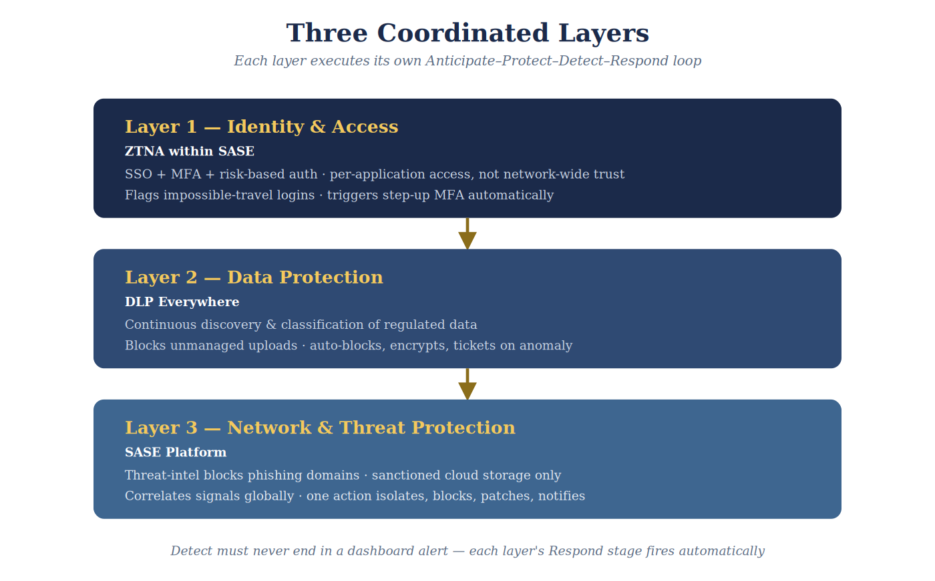
Figure 2 — The three layers operate independently but escalate to one another automatically.
The unifying idea: detection must never terminate in a dashboard alert a human may not see for hours. Each layer’s Detect stage needs a tested playbook that fires automatically in Auto-Respond — this is what elevates a security programme from reactive monitoring to genuinely autonomous defence.

6. Critical Evaluation: Strengths, Weaknesses, and the Residual Gap
Approach | Strength | Gap
ZTNA only | Strong app-level security; inexpensive to start | No visibility once access is granted
DLP only | Best-in-class leak prevention | Blind to who is accessing what first
SASE (converged) | Single management plane; scales globally | Vendor lock-in risk; needs reliable connectivity
Traditional VPN + firewall | Familiar, low complexity | Implicit trust inside the tunnel — the model zero trust replaces
Even combined, none of these technologies fix two foundational weaknesses: unpatched software and untrained users. IBM’s most recent global analysis attributes roughly a quarter of breaches to human error and a further quarter to IT failure. Technology closes the mechanical gaps; people and process must close the rest. Cost also compounds the case: breaches involving data spread across multiple environments — the hybrid-work norm — average roughly USD 5 million, against roughly USD 4 million for breaches confined to on-premises systems, making the layered architecture a pre-emptive investment rather than a reactive one.

7. Closing the Loop: Automation as the Fourth Stage
Auto-Respond is the stage most organizations implement least maturely, because it requires tools to trust one another enough to act without a human in the loop. SOAR platforms ingest alerts from disparate tools, apply a pre-built playbook, and either execute the response automatically or escalate only cases that genuinely need judgement — for example: if DLP flags exfiltration of identification data, automatically block the user in ZTNA, open a ticket, and notify the line manager. XDR takes a narrower, deeper approach, natively correlating telemetry from endpoints, networks, and cloud workloads within one ecosystem into a single incident view. The two are increasingly offered together. Whatever the label, organizations should insist a platform can ingest alerts across the stack and execute high-confidence remediation automatically — IBM’s 2025 research found organizations making extensive use of AI-assisted automation cut breach lifecycles by roughly 80 days and saved close to USD 1.9 million on average.

8. The Regulatory Dimension: Compliance as a Design Constraint
Security architecture cannot be designed in a regulatory vacuum. The comparison below shows convergence, not conflict: Nigeria, the UK, and the EU now expect substantially the same things from a hybrid organization — near real-time breach detection, a documented lawful basis for processing, proportionate technical safeguards, and rapid, structured notification once something goes wrong.
Jurisdiction | Governing Law | Regulator | Notification Window | Maximum Penalty
Nigeria | NDPA 2023 + GAID 2025 | NDPC | 72 hrs (high-risk) | 2% of gross revenue or ₦10m
United Kingdom | UK GDPR + DPA 2018 + DUA Act 2025 | ICO | 72 hrs where feasible | £17.5m or 4% turnover
European Union | GDPR + NIS2 Directive | National DPAs / CSIRTs | 24hr early warning + 72hr | €20m or 4% (GDPR)
Nigeria’s NDPA — enforced by the Nigeria Data Protection Commission and made operational through the March 2025 General Application and Implementation Directive — was deliberately modelled on the GDPR, requiring registration for major data controllers, technical safeguards proportionate to risk, and 72-hour breach notification. The NDPC has already fined MultiChoice Nigeria roughly ₦766.2 million and issued a far larger penalty against Meta Platforms, confirming enforcement is material, not theoretical. HR systems — holding national ID numbers, banking details, and medical records — should be a first-priority DLP classification target.
The EU’s GDPR Article 32 requires “appropriate technical and organisational measures,” and Article 35 requires a Data Protection Impact Assessment wherever processing carries high risk — a threshold hybrid-work monitoring tools frequently meet. Since 2023, the NIS2 Directive adds a 24-hour early-warning obligation that is very difficult to meet without SOAR-style automated detection, and makes senior management personally accountable for cybersecurity governance failures. The UK’s post-Brexit UK GDPR remains closely aligned with the EU regime; its Data (Use and Access) Act 2025, in force from June 2026, tightened complaints processes and international-transfer rules, while the ICO has cautioned that monitoring a remote employee engages a stronger privacy expectation than monitoring the same person in an office. Enforcement precedent illustrates the cost of the gaps this brief addresses: British Airways was fined £20 million after attackers exploited the absence of MFA — precisely the failure ZTNA is designed to close — and Meta was fined a record €1.2 billion over unlawful cross-border data transfer, underscoring that any hybrid workforce spanning borders must treat lawful transfer mechanisms as a first-class design requirement.

9. Recommended Implementation Roadmap
Adopting all three pillars simultaneously is neither realistic nor necessary. A phased sequence delivers the highest risk reduction per unit of cost:
- Phase 1 (0–3 months) — Foundation: Deploy ZTNA, a secure web gateway, and enforced MFA everywhere, removing most VPN-related risk. Satisfies “appropriate technical measures” under NDPA/UK GDPR/EU GDPR Art. 32 and NIS2’s MFA baseline.
- Phase 2 (3–6 months) — Data: Enable CASB-based DLP for productivity suites and endpoint DLP for laptops, prioritizing customer and employee PII. Operationalizes data-minimisation and DPIA duties.
- Phase 3 (6–12 months) — Automation: Connect ZTNA, DLP, and endpoint tooling to a SOAR/XDR platform with tested playbooks (e.g., PII-exfiltration alert → automatic ZTNA block → ticket → manager notification). Makes the 24–72-hour notification windows realistically achievable.

10. Conclusion
No organization can pick one technology and consider the hybrid-workforce problem solved. ZTNA secures the front door; DLP secures the valuables inside; SASE is the cloud platform enforcing one consistent policy everywhere the workforce is. None of the three alone closes the loop from detection to remediation — that requires deliberate investment in automation. Together, these capabilities anticipate risk, protect data at the point of use, detect anomalies as they happen, and automatically contain threats without waiting on a human who may be asleep, unavailable, or too slow. The Nigeria–UK–EU comparison shows this is a converging global expectation, not a local requirement: robust ZTNA, DLP, and SASE, tied together by automation, is now the baseline cost of doing business safely beyond the walls of a single office.

COMPLIANCE, INCIDENT RESPONSE,
AND PROTECTION CONTROLS
Regulatory Alignment, Response Planning, and Technical Safeguards,
Justified Against Dwell Time and Organisational Impact
A Companion Submission to the Cybersecurity Governance Programme
Prepared for: Data Security and Compliance Module
Prepared by
Paul Cyrus Aboderin
July 2026

Table of Contents
1. Purpose and Scope 3
2. Regulatory Alignment and Breach Notification Protocols 3
3. Incident Response and Disaster Recovery Planning 3
4. Continuous Monitoring and Automated Vulnerability Scanning 4
5. Endpoint Detection, Encryption, and Strong Authentication 4
6. Justification: Dwell Time and Organisational Impact 5
7. Conclusion 5
References 5

1. Purpose and Scope
This paper sets out the compliance, incident response, and technical protection controls that close the operational loop on the governance programme designed earlier. It covers regulatory alignment and breach notification, incident response and disaster recovery planning, continuous monitoring and automated vulnerability scanning, and endpoint detection, encryption, and strong authentication — and, for each, justifies precisely how the control reduces attacker dwell time and limits the organisational impact of a breach.

2. Regulatory Alignment and Breach Notification Protocols
Breach notification is treated as a pre-built, automated workflow rather than a decision made under crisis pressure, because notification deadlines are now measured in hours, not weeks. The applicable windows are mapped against the governance structure so the accountable owner and evidence trail are known in advance:
Regime | Notification Window | Trigger and Owner
Nigeria Data Protection Act (NDPA) 2023 | 72 hours | Confirmed high-risk breach; notified to the NDPC and affected individuals by the Data Protection Officer.
GDPR (EU/UK) | 72 hours | Breach likely to result in risk to rights and freedoms; supervisory authority notification by the DPO.
U.S. SEC Cybersecurity Disclosure Rule | 4 business days | Determination of materiality; disclosure authorised by the CISO and CEO.

This regulatory mapping is what the automated Tier 1 alerting design in the governance programme is built to feed: because confirmed-pattern incidents trigger automatic CISO and Board notification at the moment of detection, the notification clock starts immediately rather than after a delayed internal escalation, which is what typically consumes the majority of a statutory notification window.

3. Incident Response and Disaster Recovery Planning
Incident response follows NIST SP 800-61 Revision 3 (2025), which replaced the earlier six-stage lifecycle with structure mapped directly onto CSF 2.0's Govern, Identify, Protect, Detect, Respond, and Recover functions — explicitly treating preparation as continuous risk management rather than a one-time plan, and treating improvement as ongoing rather than confined to a post-incident review. This keeps incident response procedurally identical to the governance and monitoring design already established, rather than a separate parallel process.
Disaster recovery is integrated with the ISO 22301 business continuity design set out previously: every incident response playbook maps to a specific business-critical process and its Board-approved Recovery Time Objective, and playbooks are tested through tabletop exercises simulating the case-study breach pattern — unauthorised, prolonged access to Social Security numbers, dates of birth, and addresses — at least annually, so the first real test of the plan is not the incident itself.

4. Continuous Monitoring and Automated Vulnerability Scanning
These controls makes operational the automated detection stack and the Vulnerability Management Policy defined earlier. Continuous monitoring follows NIST SP 800-137's Information Security Continuous Monitoring (ISCM) model, with 100% log coverage for systems holding sensitive personal data streamed to the SIEM in real time. Automated vulnerability scanning runs authenticated internal scans weekly and continuous external attack-surface scanning, prioritised by CISA's Known Exploited Vulnerabilities catalogue rather than CVSS score alone, with KEV-listed findings on internet-facing systems remediated within a 72-hour SLA.
Both controls exist specifically to compress the gap between compromise and detection: current industry data shows only 26% of KEV-listed vulnerabilities are fully remediated on average, with median enterprise patching time at 43 days — the exact gap this scanning and remediation SLA is designed to close.

5. Endpoint Detection, Encryption, and Strong Authentication

5.1 Endpoint Detection and Response (EDR)
EDR provides continuous, behaviour-based visibility into every endpoint, catching malicious activity that has already bypassed preventive controls such as antivirus or the network perimeter. Because EDR platforms can act automatically — isolating a host or killing a process the moment malicious behaviour is confirmed — they close the specific gap that let the case-study attackers persist for over two months: without endpoint-level visibility, a compromised host can sit unnoticed on the network indefinitely.

5.2 Encryption
Consistent with the Data Protection Policy, all data classified Confidential or Restricted — including Social Security numbers, dates of birth, and addresses — is encrypted at rest and in transit without exception. Encryption does not prevent intrusion, but it determines whether a successful intrusion produces usable data: encrypted records exfiltrated without the corresponding keys are not the reportable, exploitable breach that unencrypted records would be.

5.3 Strong Authentication
Authentication is standardised on phishing-resistant, hardware-based multi-factor authentication (FIDO2 or PIV) rather than SMS or push-based codes, which CISA and NIST no longer classify as phishing-resistant because both can be intercepted or relayed by adversary-in-the-middle proxies. The case for this standard is not theoretical: Microsoft's analysis of Azure Active Directory accounts found MFA reduces the risk of account compromise by 99.22% across the population, and by 98.56% even when the password had already leaked — with the residual risk concentrated almost entirely in the weaker, phishable forms of MFA this policy excludes.

6. Justification: Dwell Time and Organisational Impact
Each control category acts on a different point in the attack lifecycle, and the combination is deliberate: detection controls shorten the time to discovery, and containment/protection controls shrink what an attacker can do with the time they have.
Control | How It Reduces Dwell Time | How It Limits Organisational Impact
Continuous monitoring (SIEM/UEBA) | Behavioural baselining flags anomalies within minutes rather than waiting for a scheduled review; documented deployments have cut dwell time from over 100 days to under a week. | Earlier detection caps the volume of records an attacker can extract before containment begins.
Automated vulnerability scanning and patching | Closes the specific entry point before it can be exploited; a 72-hour KEV SLA beats the 43-day industry median remediation time. | Fewer viable entry points means fewer opportunities for the initial compromise this whole lifecycle depends on.
Endpoint Detection and Response (EDR) | Provides real-time, host-level visibility and automated containment, removing the blind spot that let attackers persist for months in the case study. | Automated isolation of a compromised host stops lateral movement before it starts, limiting the blast radius.
Encryption at rest and in transit | Does not directly shorten dwell time but removes the reward for prolonged undetected access. | Converts a successful exfiltration into unusable ciphertext, materially reducing regulatory, financial, and reputational impact even if dwell time is not zero.
Phishing-resistant MFA | Prevents the credential-based initial access that most commonly starts the dwell-time clock in the first place. | A 99.22% reduction in account-compromise risk removes the most common single point of failure for both entry and lateral movement.

7. Conclusion
None of these controls works in isolation, and none is included for compliance appearance. Regulatory alignment ensures each organisation responds to a confirmed incident within a legally defensible window; incident response and disaster recovery planning ensure that response is rehearsed rather than improvised; continuous monitoring and vulnerability scanning close the gap between compromise and detection; and endpoint detection, encryption, and strong authentication each act on a distinct stage of the attack lifecycle — entry, persistence, and payoff. With the earlier governance, policy, strategic alignment, and risk assessment submissions, this is what converts the case-study failure pattern — months of undetected access to irreplaceable personal data — into a bounded, quickly contained, and low-impact event.

References

Textbooks
Fitzgerald, T. (2019). CISO compass: Navigating cybersecurity leadership challenges with insights from pioneers. CRC Press / Auerbach Publications.
Whitman, M. E., & Mattord, H. J. (2021). Management of information security (6th ed.). Cengage Learning.

Journal Articles
ISACA Journal. (2024). The Three Lines Model in cybersecurity governance and risk management. ISACA Journal, 2024(1).

News Articles
Security Boulevard. (2026, July). How effective is MFA, really? An evidence-based answer (2026) [citing Microsoft Azure Active Directory analysis].
Axis Intelligence. (2026, June 28). Cybersecurity statistics 2026: Breaches, costs & ransomware data [citing the 2026 Verizon Data Breach Investigations Report].

Websites and Technical Standards
National Institute of Standards and Technology. (2025). Incident response recommendations and considerations for cybersecurity risk management: A CSF 2.0 community profile (NIST SP 800-61, Rev. 3).
National Institute of Standards and Technology. (2011). Information security continuous monitoring (ISCM) for federal information systems and organizations (NIST SP 800-137).
National Institute of Standards and Technology. (2022). Guide to enterprise patch management planning (NIST SP 800-40, Rev. 4).
SentinelOne. (2026, March 2). What is phishing-resistant MFA?
Vectra AI. (2026, May 8). What is endpoint detection and response (EDR)?

Organisational Documents
Nigeria Data Protection Commission. (2023). Nigeria Data Protection Act, 2023.
International Organization for Standardization. (2019). Security and resilience — Business continuity management systems — Requirements (ISO 22301:2019).
Cybersecurity and Infrastructure Security Agency. (2026). Binding Operational Directive 26-04: Prioritizing security updates based on risk.
International Organization for Standardization. (2022). Information security, cybersecurity and privacy protection — ISMS requirements (ISO/IEC 27001:2022).

