

Assessment 1 – Reading Task
PART 1: Upload your photo of your A3 in-class notes here:
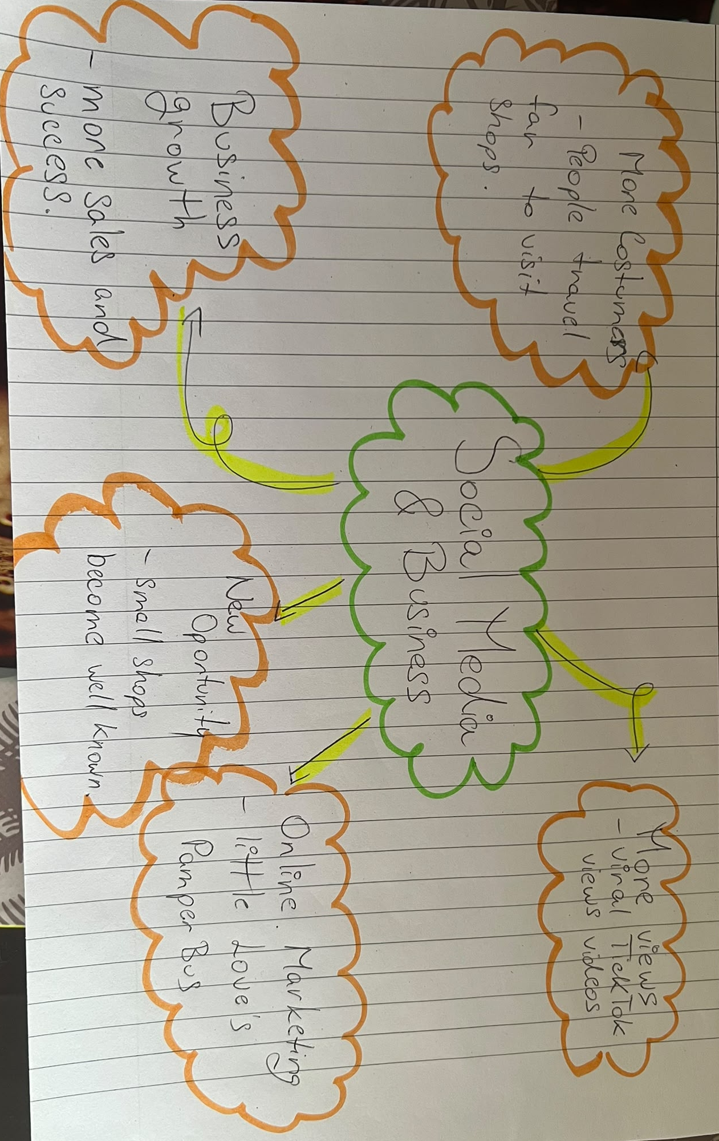

PART 2:
- Answer every question below in 1-3 full sentences.
- Use your own words. Do not use generative AI to answer these questions.
- Include a specific detail from the text when asked.
REMINDER
- The main idea is the overall message of the whole text.
- A key point helps to explain the main idea.
- A specific detail or example from the text shows that the key point is true.

- What is the main idea of the whole text?
Social media plays an important role in helping small businesses grow and become more successful. Through platforms such as TikTok, businesses can attract new customers, increase their popularity and discover new opportunities.

- What is one key point that supports the main idea, and which specific example from the text shows this?
Social media helps businesses attract more customers, including people who live far away. For example, some customers travelled three hours to visit Honywood Sandwich Shop after watching videos of its food on TikTok.

- What is a different key point that supports the main idea, and which specific example from the text shows this?

Online marketing can help small businesses gain millions of views and become more widely recognised. For example, Little Love's Pamper Bus received approximately 45 million views in less than a year through social media videos.

- Which part of the text do you think is most important, and why?

I think the most important part is how social media creates new opportunities for small businesses. This interested me because it shows how simple online videos can help a small company become successful without spending a lot of money on advertising.

Reflection:
- What did you find difficult in this task (including in-class components), and why was it difficult?

I found it challenging to understand some English words in the article and to choose the most important information for my mind map. This made the task more difficult because I needed to understand the text clearly before organising my ideas.

- What helped you with this difficulty, and how did it help you?

I used Google Translate to help me understand some unfamiliar English words by translating them into Romanian. This helped me understand the article better and organise my ideas more confidently in my mind map.

