

The Psychological and Physical affects Night Shifts have on Police Officers.

Student name: Mali John

Student number: 2222455

Acknowledgement:
Firstly, I would like to thank my colleagues at Gwent Police and my family for their continued support throughout whilst working a full-time job and studying towards my degree. It has been a tough three years, and I am looking forward to now progressing in my career. I would like to give a special thank you to my not only my colleague but best friend Aimee Hole for her encouragement and positivity throughout.

Declaration:
This work has not previously been accepted in substance for any degree and is not being concurrently submitted in candidature for any degree.
Signed: Mali John
Date: 30/06/2025

Statement 1:
This dissertation is being submitted in partial fulfilment of the requirements for the degree of BSc Policing and Criminology.
Signed: Mali john
Date: 30/06/2025

Statement 2:
This dissertation is the result of my own independent work/investigation, except where otherwise stated.
Other sources are acknowledged by footnotes giving explicit references. A bibliography is appended.
Signed: Mali John
Date: 30/06/2025

Statement 3:
I hereby give consent for my dissertation, if accepted, to be available for photocopying and for interlibrary loan, and for the title and summary to be made available to outside organisations.
Signed: Mali John
Date: 30/06/2025

Statement 4:
I hereby give consent for my dissertation, if accepted, to be available on the university’s IT system to those who have consent to use the system.
Signed: Mali John
Date: 30/06/2025

Abstract:

The title of research is: The psychological and physical affect night shifts have on police officers?
This study will gather evidence to support that night shifts have a negative affect on serving police officers and also influence their home like.
The study will gather perspective’s that have been obtained from current serving police officers of Gwent Constabulary. A questionnaire will gather information from officers and how night shifts impact them.

Table of contents:
Chapter one- introduction

Chapter two- Literature review:
2.1 -Physical Effects of Night Shifts on UK Police Officers
2.2- Psychological Effects of Night Shifts on UK Police Officers
2.3-Moderators & Mitigation Strategies

Chapter three- Methodology:
3.1 introduction
3.2 Aims and Objective of Project:
3.3 Research Strategy
3.4 Data from primary and secondary sources
3.5 Qualitative and quantitative data:
3.6 Method of collection of data
3.7 Ethics
3.8 Confidentiality
3.9 Risk assessment

Chapter four- Analysis of results:
4.1 introduction

Chapter five- Conclusion:
5.1 conclusion

Chapter six- recommendation
6.1 Implement Rotational Shift Scheduling with Recovery Time.
6.2 Introduce Sleep Hygiene and Fatigue Management Training
6.3. Provide Access to Mental Health Resources
6.4. Monitor and Limit Consecutive Night Shifts
6.5. Encourage Physical Activity and Healthy Lifestyle Choices
Chapter one- Introduction:
Being a police officer is hard work that often requires long, unpredictable hours, even at night. People generally know and respect the public service role of law enforcement, but not enough is said about how hard it is on the people who do it. throughout this dissertation will look at how working night shifts affects police officers' bodies and minds. This is a dissertation that touches on occupational health, organisational behaviour, and mental toughness.

There are a range of things that stress out police officers who work at night. Some of these are changes in the body's natural sleep-wake cycle, not getting enough sleep over time, not being as social, and being in more stressful situations during late-night calls. Police work is different from other night jobs because it requires being there in person, making quick decisions under pressure, controlling emotions, and sometimes being in situations that could kill you.

These things make the effects of sleep cycles that are messed up worse and can set off a chain reaction of mental and physical problems. Police departments all over the world have switched to shift work schedules so that public safety is always covered. A lot of places have both rotating and fixed night shifts. For instance, in the UK, a lot of police officers work a pattern that includes night shifts that repeat in a cycle, often with not much time to rest between shifts. This trend may also be seen in other Western police departments, and the nature of the job often makes it normal for people to deal with such tough schedules. But new research and public discussions have begun to cast doubt on how long these kinds of shift systems can last and how much they cost people. More and more scientific studies have shown that working night shifts in fields like healthcare, manufacturing, and transportation can be bad for your health.
But being a police officer is different because it's always unexpected and comes with a lot of mental stress. Studies have shown that police officers who work at night are more likely to develop mental health issues like anxiety, depression, and post-traumatic stress disorder (PTSD). At the same time, the effects on the body could include a higher risk of heart disease, metabolic disorders, digestive problems, and a weaker immune system. In short, working nights in policing is a sure way to get a lot of mental and physical stress. The body's internal biological clock, which controls sleep-wake cycles and other physical functions, is what causes most of the physiological effects of working the night shift. Through studying it is clear that Humans are diurnal by nature, which means that our bodies are naturally made to be active during the day and rest at night. When this rhythm is broken all the time, like it is for a lot of night shift workers, the body goes out of balance. This mismatch gets extremely worse for police officers because they have to be on high alert regularly, deal with conflicts, and act professionally even when they are upset. Working nights can be very hard on a person’s mind as well as their body.

Police officers describe themselves as often feeling cut off from their social support systems because their hours don't match up with those of their family and friends. Over time, this can make you feel lonely and tired. There are also usually fewer officers on duty at night, which can make things harder for each officer and make it harder for them to get help from their coworkers when things get tough. These things make it easy for chronic stress to build up, which can cause more serious mental health problems if not dealt with. You should also think about how working at night affects your ability to do your job and make decisions. A lot of research has shown that not getting enough sleep can make your brain work less well, especially when you need to be alert, think quickly, and do executive functions. When police officers make mistakes, it can have big effects on them and the communities they serve. People can make mistakes that lead to more fights, misunderstandings about how a suspect is acting, or accidents when they are tired and lose focus. This is because they don't use their tools or cars correctly.

The culture of the police department can also make the effects of working the night shift better or worse. Companies that put wellness programs first, encourage people to talk about their mental health, and give their workers enough time to heal tend to do better. On the other hand, departments that stress toughness, look down on mental health issues, or don't offer support services may be making their officers' health worse without even knowing it. To come up with good solutions, you need to know how an organization's dynamics work and how they affect shift work.
This dissertation also looks at how demographic and personality traits might change how people feel about working at night. Some things that can change how working evenings affects you are your age, gender, length of service, and any health problems you already have. humbly. Younger officers, for example, may be better able to deal with sleep patterns that change a lot, but they may not have the skills that come with experience. Women police officers may have more stress because of family responsibilities or bias at work, which makes it even harder to work shifts. We need to know a lot about how night shifts affect different groups of police officers so that we can make rules that include everyone and give them the help they need. With all of this in mind, this dissertation will look at the many ways that working the night shift affects police officers by looking at what has already been studied, looking at case studies, and, if possible, doing new research.

The main goals are to find out what the most common mental and physical health problems are that come with working night shifts, how these problems happen, and how well police agencies are currently dealing with these problems. The study also wants to suggest ways to make officers healthier and more productive at work based on what they found. This study is even more important now that there are still talks about police reform, workplace safety, and mental health awareness. As more people watch the police closely, it's also important to make sure that officers have the support they need to do their jobs well and treat others with respect. Not only is it hard to manage your own employees who work night shifts, but it's also a public health issue that affects everyone. In the end, this dissertation is about an important but often ignored part of police work. Working the night shift has a big effect on police officers' health, the efficiency of their department, and the trust of the community. By showing the problems that come with working as a police officer at night, this study hopes to help make policing more sustainable, compassionate, and effective.

Chapter Two- Literature review

2.1 Physical Effects of Night Shifts on UK Police Officers

UK police work is very demanding, with 24/7 coverage and high-intensity duties. This puts a lot of stress on officers' physical health, especially when they work night shifts.

1. Problems with sleep and circadian rhythms Night shifts make it hard for officers to sleep and wake up, which can lead to chronic sleep deprivation. According to research conducted by the UK Home Office, officers only get an average of 6 hours and 20 minutes of sleep before working a night shift, which is less than the recommended seven hours. Sixty-nine percent of them get less than seven hours, and forty-one percent get less than six hours. Many people who work night shifts have been identified as having Shift Work Sleep Disorder (SWSD), which is a recognised circadian rhythm disorder. This can make them very sleepy, makes it hard for them to concentrate, makes them irritable, and makes them depressed. A small number of officers change their melatonin and cortisol levels to fit night shifts, which makes them sleep less and perform worse.

2. Cognitive and performance decline due to fatigue Working rotating night shifts makes it harder for your brain to work. A study in North Yorkshire on forward-rotating patterns found that people who worked night shifts slept less and did worse on tasks that required vigilance and memory. Systematic reviews show that not getting enough sleep over a long period of time can make it harder to make decisions, drive safely, see clearly, and do important police work. Given the requirements of being a police officer this can put them in a dangerous position. These problems not only make it less safe for officers but also for the public.

3. Risk of injury and accidents There is a much higher risk of getting hurt at night. A long-term study of US police found that officers who worked the midnight shift were 72% more likely to get hurt than officers who worked the day shift (IRR 1.72). In the UK, 86% of officers rarely take breaks during their night shifts, which keeps them from recovering and makes their bodies work harder.

4. Health of the heart and metabolism Working at night messes up your body's metabolism. A study from Cambridge found that UK shift-working officers ate less healthy foods and ate later on all types of shifts. This was linked to a higher BMI and cardiometabolic risk. Up to 78% of UK male officers were overweight or obese, and 41% had three or more risk factors for heart disease and diabetes. Studies of the general population show that shift work is linked to a higher risk of high blood pressure, diabetes, and heart disease. This risk is made worse by eating and sleeping at the wrong times. There isn't much research in the UK on police officers and cardiovascular outcomes, but controlled trials with night workers show that eating at the wrong time raises blood pressure and clotting markers, which supports targeted interventions. The IARC says that chrono disruption from night shifts is a likely carcinogen and is linked to a higher risk of CVD.

5. Good ideas for action Pilot training for UK police forces on how to deal with fatigue increased the amount of sleep they got by 25 minutes on average and improved their sleep quality scores. Additional methods, such as scheduled naps, light therapy, and flagging breaks, show promise for resetting circadian rhythms and lowering the risk of injury. In short Night shifts put UK police officers at even more physical risk, such as lack of sleep, cognitive impairment, a higher risk of injury, and strain on their metabolism and heart, mostly because of circadian disruption and bad working habits. Early interventions do help, but more large-scale studies in the UK are needed to confirm and improve these strategies.

2.2 Psychological Effects of Night Shifts on UK Police Officers

The psychological effects of working the night shift in UK policing are very serious and should be taken serious by all independent forces. They include higher levels of stress, worse mental health, trauma responses, and cultural barriers that make these problems worse.
- Stress at work and common mental illnesses Longer hours and disrupted sleep patterns are two things that make UK police officers more stressed and mentally ill. A study in England found that officers who worked at least 49 hours a week were more than twice as likely (OR 2.05) to have mental health problems and almost twice as likely to say they were emotionally drained compared to officers who worked fewer hours (11h shifts included). According to a national survey data, 9.8% of UK police officers were likely depressed, Then 8.5% were likely anxious, and Then 3.9% were likely to have PTSD. This data shows that a lot of officers have common mental disorders that are linked to shift work, trauma, and drinking too much alcohol.

- PTSD, Complex PTSD, and Trauma Exposure Being a police officer in the UK means going through traumatic events over and over again and living in a stressful environment for a long time. The "Job, The Life" study found that almost 90% of the people who answered had been through something traumatic, and 20% showed signs of PTSD or complex PTSD. In another study in Cambridge with more than 12,000 officers, 12% met the criteria for complex PTSD. Officers who didn't get enough time off or support from their organisation were more than twice as likely to show symptoms compared to officers who did. Everyday stressors at work, such as not having enough freedom, having too much work to do, and not getting enough help, can be better indicators of post-traumatic stress disorder than one-time critical events.

3. Ways to deal with problems and stigma Police culture often stresses "getting on with the job," which makes it hard to talk about feelings or take care of oneself. Given the fast experience throughout organisations such as police can mean new officers will pick up on old behaviours. A lot of officers’ drink alcohol to deal with stress and trouble sleeping. A qualitative study that was completed showed that there was a lot of stigma: almost all of the participants said that their coworkers had negative attitudes towards mental illnesses, which made them less likely to seek help or talk about their problems. This stigma, along with the affects of shift work, makes it harder to get help early and makes mental health problems worse. This prevents intervention before matters worsen on that individual officer’s mental health

4. Burnout and a bad work-life balance Night shifts make it very hard to get enough sleep, spend time with family, and have time for yourself. An interview-based study found that officers were always "mentally exhausted, irritable, and impatient," had trouble sleeping, were depressed, and wanted to leave because their work shifts didn't fit with their family life. Also, UK data shows that 39% of all police sick days are due to mental health issues, and officers take about a week off each year for mental health reasons, usually PTSD or depression.

5. The role of organisational support in moderation Supportive work environments, such as those that have scheduled debriefs, peer support, flexibility in hours, and recognition of meaningful work, can cut the number of police officers with complex PTSD in half. Programs like psychological screening, support groups, and the Blue Light Wellbeing Framework seem to be helpful in lowering the mental health risks that come with working shifts. In short UK police officers who work the night shift have more psychological problems, which makes them more likely to get stressed, burned out, PTSD, and have a worse work-life balance. These effects get worse in a culture that doesn't accept vulnerabilities, even though there is evidence that better organisational structures and support can greatly reduce mental health problems.

2.3 Moderators & Mitigation Strategies

Targeted changes to the way the organisation such as police forces works, and targeted interventions can make the negative effects of night shifts on UK police officers much less severe.
These effects include fatigue, stress, trauma, and overall health issues.
- Learning how to deal with the risk of being tired UK Home Office forces have done pilot studies across forces that show that structured training on how to deal with fatigue can help people sleep longer and better to better their overall health. In one intervention, officers received training and support that included actigraphy monitoring and lessons.
On average, people slept 25 more minutes each night (up from 6.9 to 7.3 hours), and their scores on the Pittsburgh Sleep Quality and Perceived Stress scales went up a lot. This physical proof shows that teaching people about fatigue can help them deal with not getting enough sleep when they work the night shift.

2. Wearable tech and feedback just for you The Police Wellbeing Program from Liverpool John Moores University gives police officers wearables that keep track of their sleep, fatigue, and recovery. These wearables such as watches allows Participants look at data about their own lives and make changes to their routines and behaviour to see what stresses them out. More than 700 officers have already signed up to get the vaccine early, and more forces are joining in. This shows that if companies want to use objective self-monitoring to cut down on problems that happen on the job.

3. Systems that help peers and groups To help people get stronger mentally, the military has started using peer support programs like the Blue Light Wellbeing Network, trauma debriefs, and self-referral counselling. Psychologists lead group debriefs for the Lancashire Constabulary every three months, and officers can also get therapy on their own. This makes it easier for them to deal with trauma without feeling bad about it. TRiM is one of many national programs that build on these services to help people with PTSD and promote healthier ways to get help.

4. Help for high-impact roles and pause points Some police departments in the UK, like Cambridgeshire, have made "pause points" mandatory for officers who work in high-stress jobs. This formal break-in-role policy gives people time to think about their roles and make the switch, which helps them avoid burnout and move forward. His Majesty's Inspectorate agrees with this plan, which lets supervisors and employees handle work-related stress before it becomes a problem.

5. Better training for leaders and debriefings The College of Policing says that there should be daily informal debriefings in addition to formal supervision to look for signs of stress and keep people mentally safe. International workplace interventions also show that giving supervisors more information about mental health makes it easier for them to talk to each other and handle their work, which gets more support from line leadership. To sum up, education (to help you deal with fatigue), health technologies, peer and organisational support systems, required breaks, and leadership training are all good ways to avoid the bad effects of working the night shift. These all work together to protect people on many levels, such as their behaviour, how they interact with others, and the culture of the system. Researchers still need to do more work in this area to find out what long-term studies say about their long-term effects on large, diverse UK forces.
Most of the research that has been collated shows that working the night shift is very hard on the physical and mental health of UK police officers. Circadian misalignment and lifestyle changes cause officers to have chronic sleep problems, more fatigue, a higher risk of injury, and a higher risk of cardio metabolic disease.

Across the UK police forces, disturbed sleep, trauma exposure, limited recovery time, and a stigma around mental health all make occupational stress, burnout, and complex Post t more common.
It's important to note that psychological burden isn't just caused by the shift work itself; it's made worse by systemic and cultural factors like a lack of support from the organisation itself, rigid shift systems, and a culture of not talking about emotional problems in the police. Officers often get stuck in a cycle of disrupted sleep, poor recovery, and not asking for help, all of which make both short-term functional problems and long-term mental health risks worse. Officers do not identify burnout at the earlier stages. Even though there are clear risks, new evidence suggests that targeted interventions can lessen these effects.

Small-scale pilot studies show that fatigue-management training, wearable health technologies, better scheduling, structured debriefs, and more support from peers and also supervisors are all promising.

Organisational change, especially when it comes to mental health literacy and trauma-informed leadership, seems to be a key factor that can change the course of events. But there is still a big gap in long-term, large-cohort studies that look at these interventions across different UK forces. A lot of the current research is either cross-sectional or from other countries, which makes it less useful for our purposes. In addition, better evaluations of technology-based solutions and policies like required pause points are needed to come up with evidence-based best practices for UK policing. In short, working night shifts makes police officers in the UK much less physically and mentally strong. Recent efforts to help are promising, but more research and a long-term commitment from organisations are needed to reduce these harms and support the health of officers over the long term.

Chapter Three Methodology

3.1 Introduction
Police officers often work odd hours, like night shifts, which can be bad for their physical and mental health. Working night shifts can mess up your circadian rhythms, make it harder to sleep well, and make you tired all the time. These things can then lead on to bad things such as stress, less alertness, and physical problems.

This method used only describes the quantitative approach used to look into and measure these effects on police officers who work night shifts often compared to those who work day shifts. The study uses standardised tools and statistical methods to gather and analyse data. This then makes it easier to objectively look at possible links and differences between shift patterns and health outcomes.

3.2 Aims and Objective of Project:
The main goal of this study is to find out how night shifts affect police officers' mental and physical health in a measurable way. The study looks for differences in stress levels, fatigue, sleep quality, and reported physical symptoms between officers who mostly work night shifts and those who mostly workday shifts. Goals

1. To use standardised scales to find out how much stress police officers who work night and day shifts are under and compare the two groups.

2. To find out how common and serious physical health problems are that are linked to shift work.

3. To look into the link between how often people work night shifts and how tired and sleepy they say they are.

4. To find possible patterns in health outcomes that are linked to the length of shifts and how often they happen.

3.3 Research Strategy

Plan for Research This study uses a deductive, positivist research strategy with a quantitative, cross-sectional design. The study is based on theories that already exist that say shift work can cause circadian disruption and stress at work. Standardised surveys sent to a sample of police officers at a single point in time gather data. This method lets you use statistics to test hypotheses, find connections, and make generalisable conclusions.

3.4 Data from primary and secondary sources
Primary Data: The main data source is answers to a structured questionnaire sent to police officers. This includes information about how people sleep, how tired they are, how their bodies feel, and how stressed they are mentally. • Secondary Data: Academic articles, government health reports, and past quantitative studies on the effects of shift work on health are used to help choose the right instruments, come up with hypotheses, and set up the research framework as a whole. But this study is still based on primary data, so there is no direct analysis of any numerical secondary data.

3.5 Qualitative and quantitative data:
Data that is both qualitative and quantitative Only numbers are used in this project. There are no qualitative interviews, open-ended questions, or thematic analysis. All of the data we collect is numbers that can be statistically analysed. It comes from validated psychometric tools and closed-ended questions. This makes sure that the results are fair and makes it easier to test hypotheses.

3.6 Method of collection of data

How to Collect Data A structured online questionnaire will be used to gather data. It will be broken up into four main parts:
1. Demographics and Shift Work Patterns: This includes age, gender, rank, years of service, average weekly hours, and shift schedules.
2. Psychological Measures: The Perceived Stress Scale and the General Health Questionnaire (are used to find out how stressed out and mentally ill someone is.

3. Physical Health and Sleep Quality: The Pittsburgh Sleep Quality Index (PSQI) and the Fatigue Assessment Scale (FAS) are used to measure how well you sleep and how tired you are. Other questions ask about how often you have headaches, stomach problems, and pain in your muscles and bones.
4. Lifestyle Factors: exercising, and caffeine use to account for other factors that could affect the results. The survey will be done on a secure platform, like Qualtrics or Microsoft Forms, and responses will be collected anonymously over the course of four weeks.

3.7 Ethics
Moral values We will get ethical approval from the right institutional ethics board. Participants will get a digital Participant Information Sheet that explains what the study is about, how it works, and what the risks and benefits are. You must give informed digital consent before you can start the survey. People can choose to take part or not, and they can leave at any time without any problems. Because psychological questions can be very personal, we will give you the contact information for occupational health and mental health support services at the end of the survey.

3.8 Confidentiality
No identifying information, like names, badge numbers, or email addresses, will be collected to protect privacy and anonymity. Responses to the survey will be kept in encrypted files on computers that are password-protected. Only the researcher will be able to see the raw data. There will be no way to find out who participated in the study from the aggregated data, which will be shown in charts and tables. There will be a way to report results that keeps departments and individuals anonymous.

3.9 Risk assessment

Evaluating Risk This study is considered to be low risk. But the following risks and ways to reduce them are known: • Uncomfortable thoughts: Questions about mental health may make you feel bad. To make this less of a problem, participants can skip any question and get support contact information. • Risk to data security: Electronic data can be accessed by people who shouldn't be able to. All data will be encrypted and stored safely to avoid this. This is in line with GDPR and university data protection rules. • Response bias: People may not report as much stress as they actually feel because of the stigma at work. The survey is completely anonymous, and the information sheet makes sure of this.

Chapter 4- Analysis of results

4.1 Introduction: As part of this dissertation research a questionnaire was sent out to 24 police officers to collate realistic thoughts of frontline officers and how they manage with rotating shift patterns to facilitate the 24/7 service that policing is.

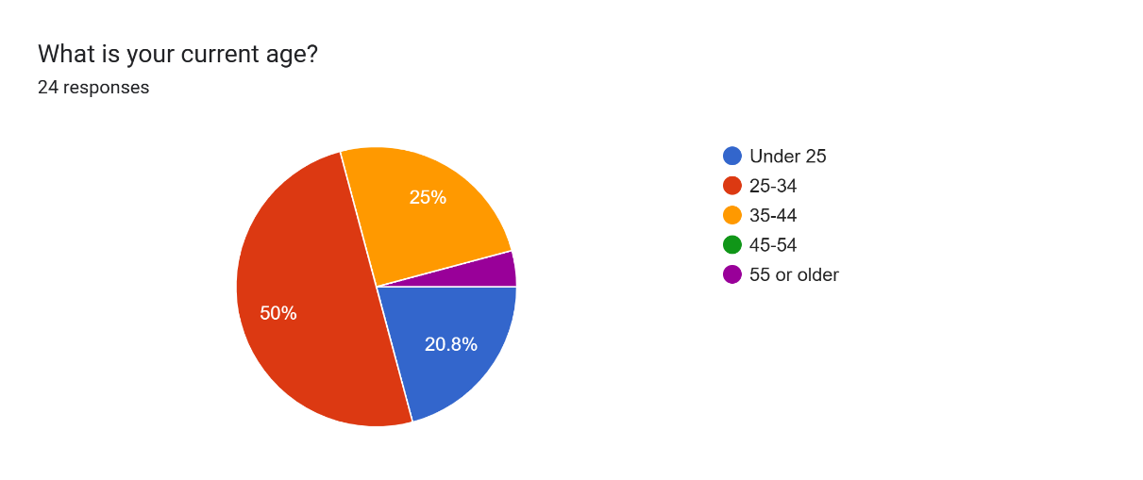

First question on the questionnaire was in regards to the range of ages of police officers. 50% of those asked were in 25 to 34 age category. 25% of those asked were in the age category 35-44. 20.8% fell into the under 25 category. That leaves only 4.2% of persons asked being 55 or older.

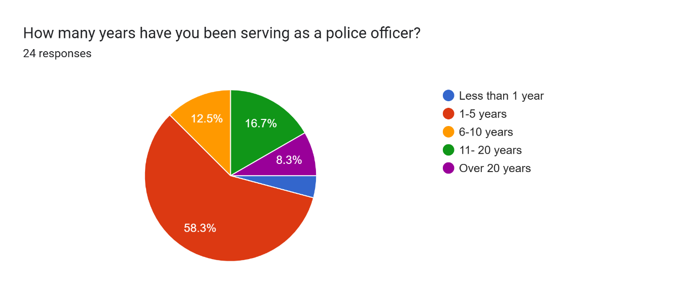
Secondly participants of the questionnaire were asked regarding the current length of service they hold as a police officer. In total there were 24 responses to this question. 58.3% of officers asked fall into the bracket of serving 1-5 years. 4.2% of officers asked had been serving for less than a year. 12.5% of officers asked having served between 6 and 10 years. 16.7% of officers participating in the questionnaire have current serving length of 11-20years. 8.3% of those asked had been a serving police officer for more than 20 years.

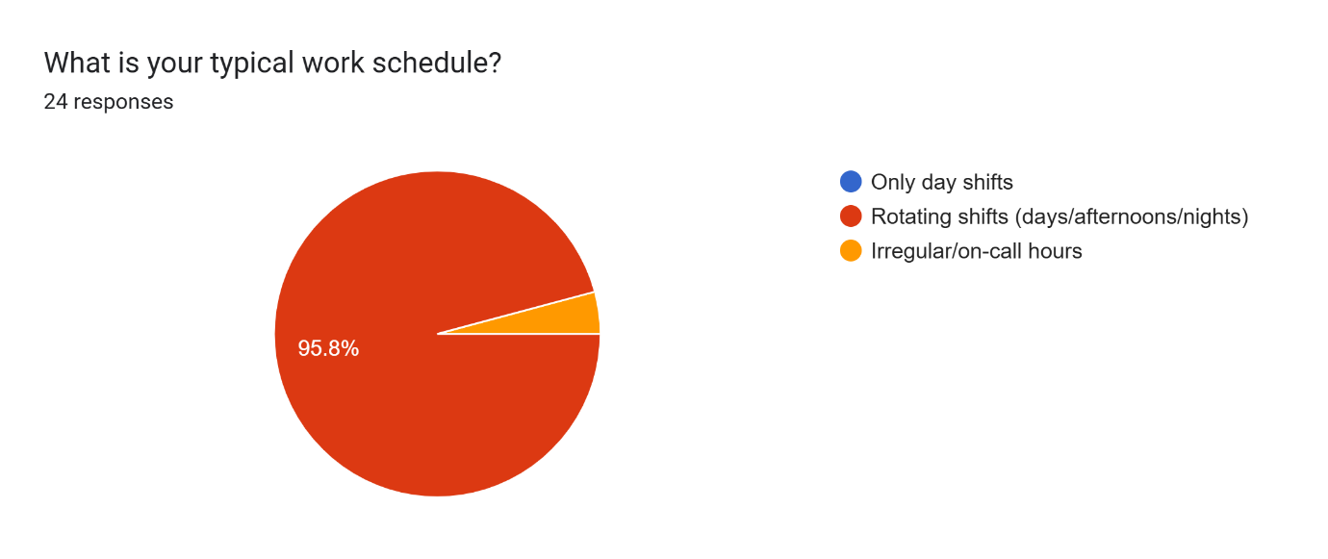
The next question asked was regarding typical work schedules of those participants. Not one person who participated worked regular day shifts. 4.2% of those officers asked worked irregular/ on call hours to facilitate their role within the force they are a serving member of.

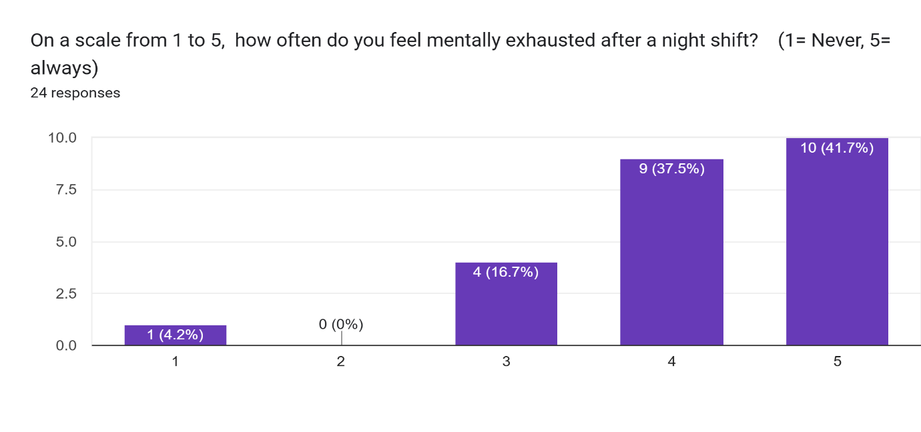This above table shows results after the participating police officers were asked how often they feel mentally unstable after a night shift. The question used a scale being 1 Never and 5 being always.
From the 24 participants 1 person answered that they never felt mentally exhausted. 4 persons answered giving a number 3 which is in the middle of the scale. 9 participants described as feeling mentally exhausted with a number 4. And lastly 10 participants answered number 5 and describe as feeling always mentally exhausted.

5.
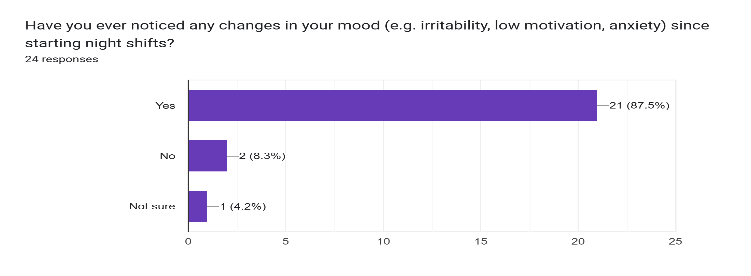

Participating officers were next asked regarding noticing any changes in moods such as low motivation, anxiety and irritability since starting night shifts. Out of the 24 responses from participating officers 87.5% answered Yes in regard to changes to moods. 8.3% of those asked stated NO and 4.2% of those asked were unsure.

6.
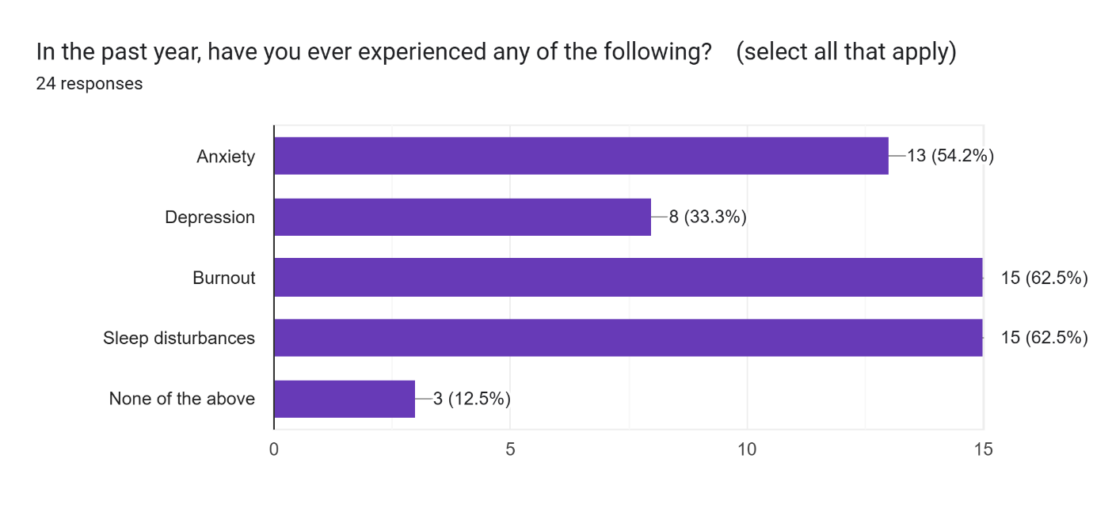
Participating officers were then asked if they had experienced symptoms such as anxiety, depression, burnout, sleep disturbances or none if any of the above didn’t apply.

13 Participants answered as having experienced anxiety. 8 participants answered as having experienced depression. 15 participants answered as having experienced burnout. 15 participants described as suffering with sleep disturbances. 3 persons answered as not experiencing any of the above.

7.
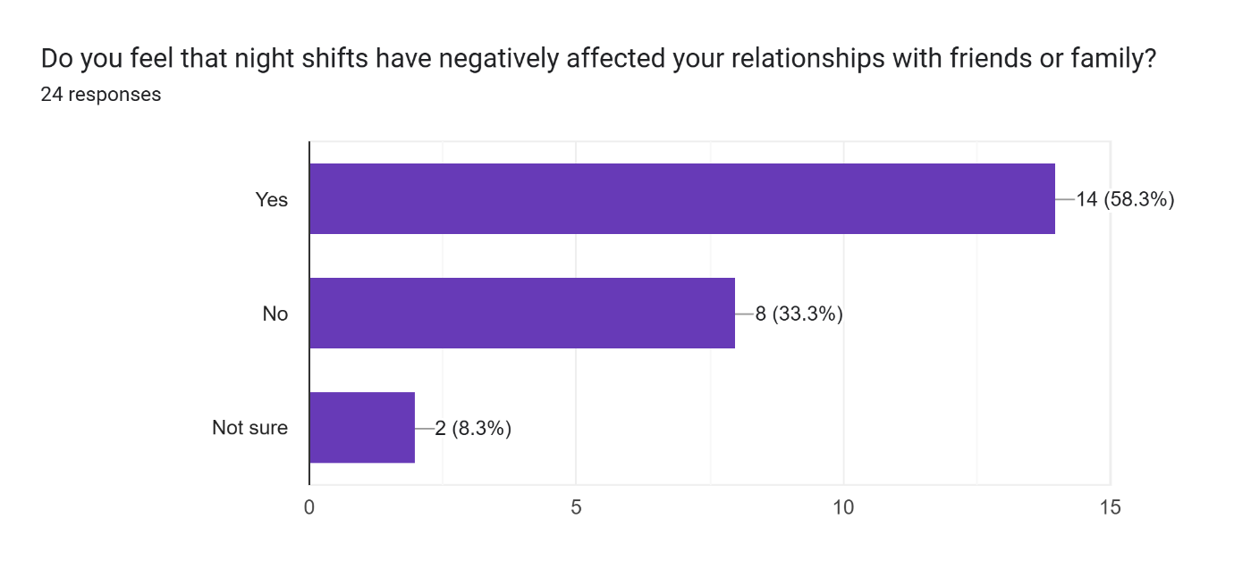
Officers were then asked regarding if they feel night shifts have negatively affected their relationship with friends or family. 14 participants answered yes, 8 participants answered no and then 2 participating officers stated they were unsure.

8.
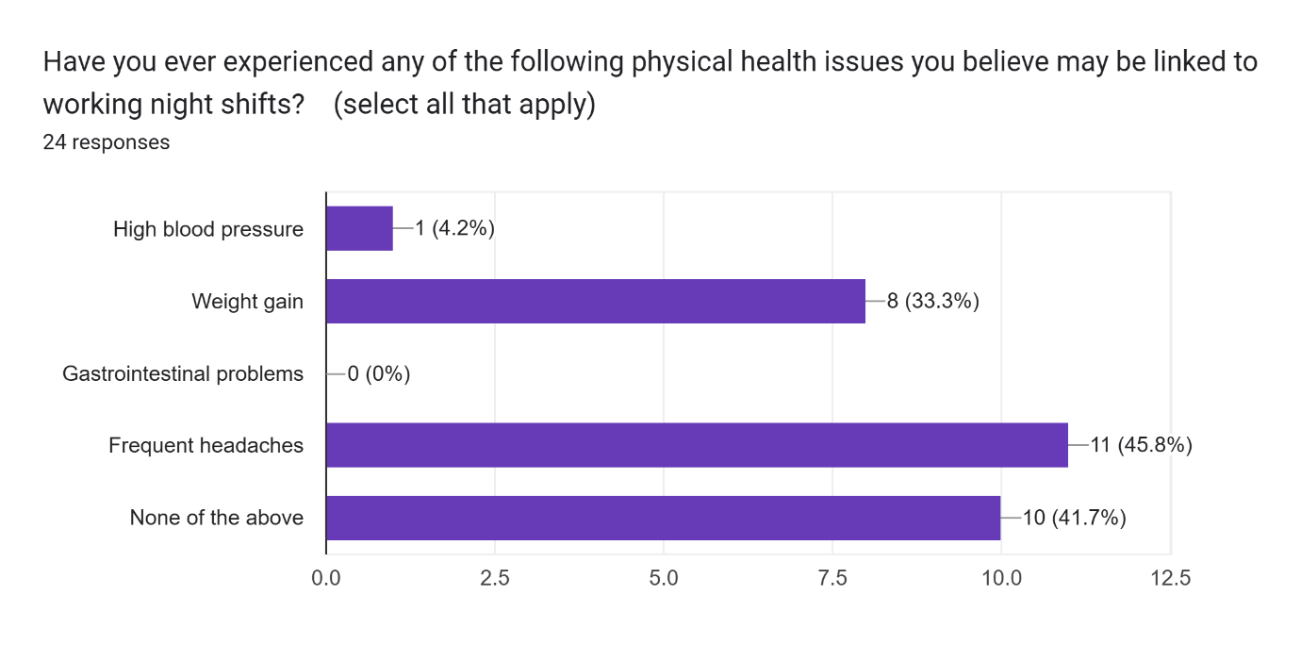
As part of the questionnaire officers were next asked if the had suffered physical health issues they believe maybe linked to working nights. 4.2% stated they had suffered with high blood pressure. 33.3% of participants stated they had suffered with weight gain. 45.8% stated they suffered with frequent headaches. 41.7% of person stated none had affected them.
9.
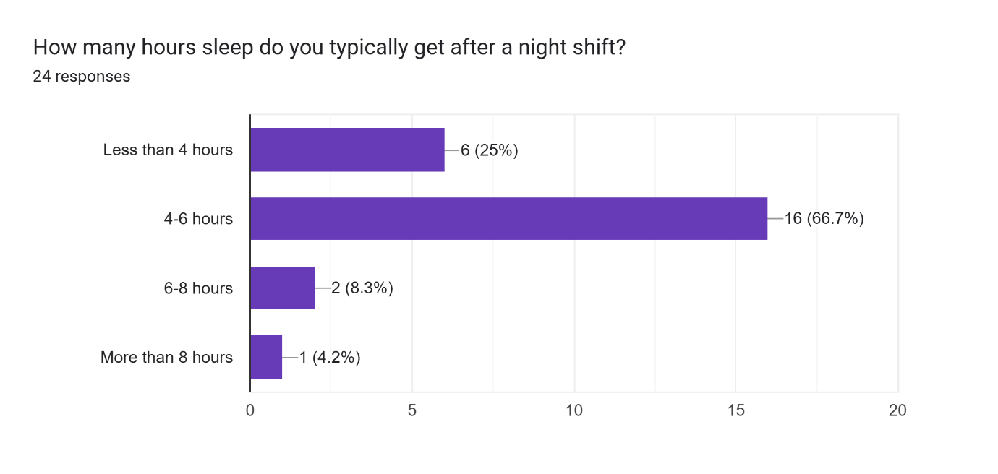
Participants were asked regarding the number of hours of sleep they typically get after a night shift. 25% of those who answered stated they typically get less than 4 hours. 66.7% of those asked stated they typically get between 4 and 6 hours a night. 8.3% of participants stated they get between 6 and 8 hours. With only 4.2% stating they get more than 8 hours sleep after a night shift.

10.

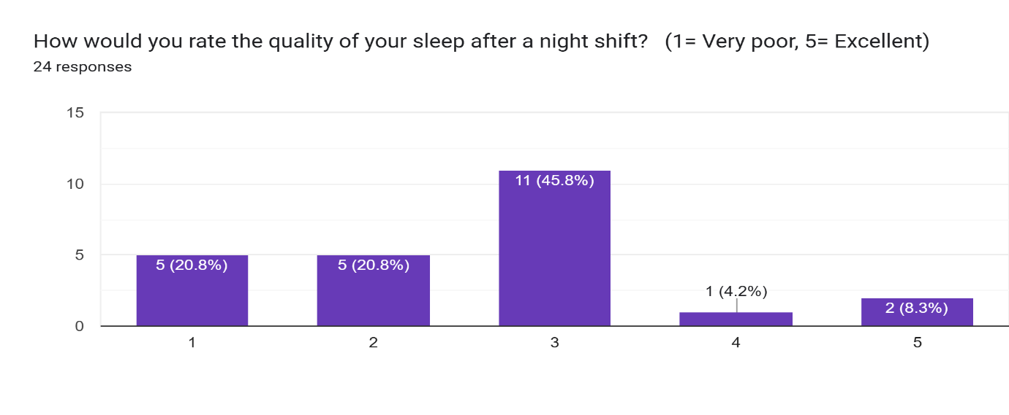

Participants were asked to rate the quality of sleep they have after completing a night shift. 1 being very poor and 5 being excellent. 20.8% described their sleep as a 1. 20.8% of participant’s described their sleep as a 2. 45.8% of participants described their sleep as a 3. 4.2% described their sleep as a 4 and lastly 8.3% of participants described their sleep as a 5.

11.
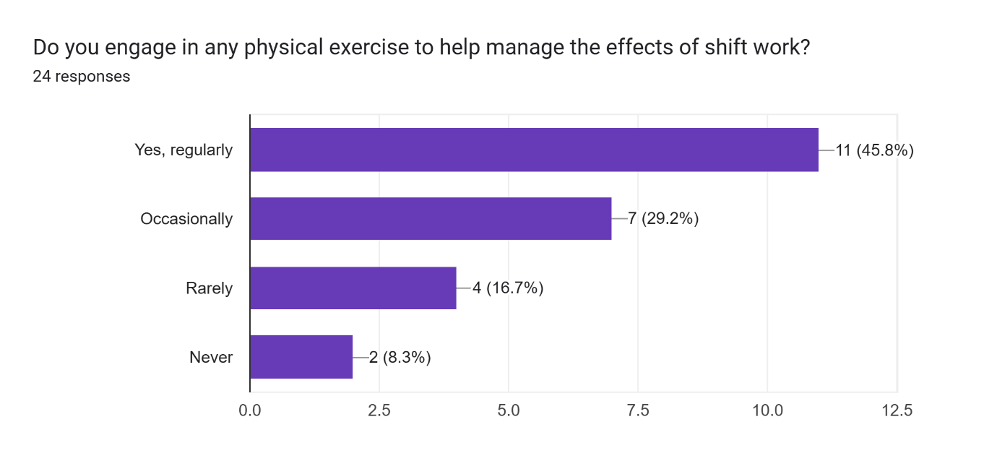
Participating officers were next asked if they engage in regular physical exercise to help manage the affects of shift work. 45.8% answered to yes. 29.2% answered to occasionally. 16.7% answered to rarely. With 8.3% of participants answering to never.

12.
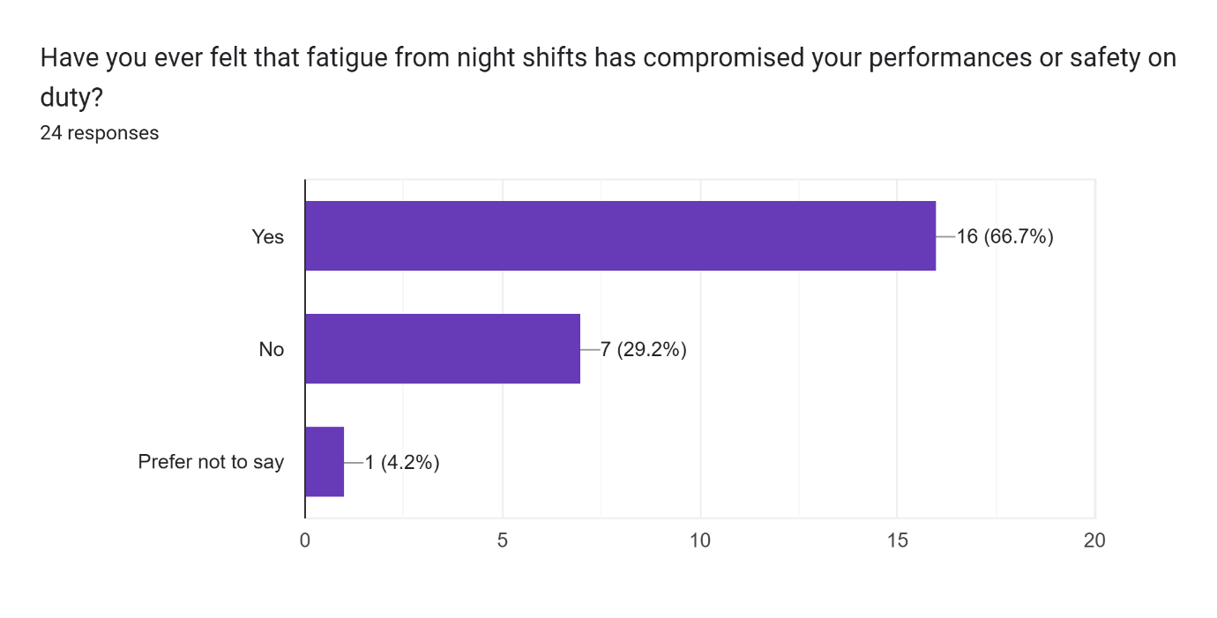
Police officers who were participating in the questionnaire were asked if they had ever felt fatigue from nights that had compromised their performance or safety on duty. 66.7% of participants answered to Yes. 29.2% answered to No and only 4.2% preferred not to say.

Chapter 5- Conclusion

Being a police officer is one of the hardest and most stressful jobs in today's world. Police officers are responsible for keeping the peace, protecting people, and responding to emergencies, often in very stressful and unpredictable situations.

Night shift work is one of the most stressful jobs because it affects both the mental and physical health of the people who do it. This dissertation looked at the many effects that night shifts have on police officers. It found that these work schedules throw off circadian rhythms, make officers more likely to have mental health problems, hurt their physical health, and hurt their job performance.

The first important finding from this study is that working night shifts messes up biological rhythms. We are naturally diurnal, which means that our bodies are biologically set up to be active during the day and rest at night. Night shift work forces this rhythm to change, which is like having jet lag all the time. Police officers who work at night need to stay alert and ready to act even though their bodies are telling them to rest.

This disruption causes a chain reaction of physiological effects over time, such as a weaker immune system, higher blood pressure, and hormonal imbalances. The study shows that this kind of biological misalignment is not just a temporary problem; it is a long-term condition that gets worse the longer you are exposed to it. Sleep deprivation is closely linked to circadian disruption and was one of the most common problems reported by people who worked night shifts. Officers often have trouble sleeping well, don't get enough sleep, and have trouble staying asleep. Sleeping during the day won't fix these sleep problems because daytime sleep is usually lighter, more likely to be interrupted, and less restorative.

Not getting enough sleep for a long time can lead to a number of bad things, such as memory problems, trouble concentrating, mood swings, and even a higher risk of diabetes and heart disease in the long term. Not getting enough sleep doesn't just hurt your health; it also makes it harder to make decisions and react quickly, both of which are very important for officers who work in dangerous situations. The mental effects of working night shifts are just as bad. Many of the studies mentioned in this dissertation show that police officers who work irregular hours are more likely to have anxiety, depression, burnout, and post-traumatic stress disorder (PTSD). Night shifts can make you feel emotionally drained and disconnected because you are often alone, see more violent events, and have less access to social and professional support. Also, officers who work at night often miss out on family events, social events, and regular interactions with other people, which adds to their mental stress and makes it harder to balance work and life. Another important finding has to do with how it affects physical health. Statistically, police officers who work night shifts are more likely to get chronic health problems like obesity, heart disease, and stomach problems. Some of the things that cause these health problems are a bad diet, periods of inactivity followed by periods of high-intensity activity, and metabolic rhythms that are out of sync. In some cases, officers use unhealthy ways to deal with stress, like drinking more caffeine, smoking, or eating fast food, which makes their health worse. Over time, these habits add up and make you more likely to get sick for a long time and age too quickly. This dissertation also showed how night shifts affect safety and operational performance. To do their jobs, police officers need to be able to think clearly, control their emotions, and react quickly. Working the night shift can make all of these things much worse. Officers who don't get enough sleep are more likely to make mistakes, get angry or irritable, and not act right when things get tough. This puts not only their own safety at risk, but also that of their coworkers and the public.

Chapter 6 Recommendation:

6.1 Implement Rotational Shift Scheduling with Recovery Time.
Set up a rotational shift schedule with time to recover Working night shifts for a long time and often without enough rest is one of the main causes of bad health effects. Police departments should use forward-rotating shift patterns (morning → afternoon → night) and make sure that officers have at least 48 hours to recover after a series of night shifts. This would help officers adjust better to changes in their shifts, which would let their circadian rhythms and sleep cycles partially reset. Shifts should change every two to four weeks instead of every week or staying on night duty all the time.

6.2 Introduce Sleep Hygiene and Fatigue Management Training

Departments should require training sessions on sleep hygiene, how to tell when you're tired, and also how to stay alert. Officers may not always know how to get the best sleep or make up for lost sleep. Training should cover things like how important it is to keep a regular sleep schedule, cut back on caffeine before bed, use blackout curtains, and stay away from screens before bed. This can help you sleep better and make your body stronger overall.

6.3. Provide Access to Mental Health Resources

The research indicated elevated stress and psychological distress levels among officers working night shifts. Departments should ensure that officers have easy, confidential access to psychological support services, including peer-support programs, counselling, and mental health screenings. Integrating mental health check-ins into routine occupational health assessments would help normalize mental wellness in a high-stress profession.

6.4. Monitor and Limit Consecutive Night Shifts
To lower the risk of cumulative fatigue and burnout, police management should set clear limits on the number of consecutive night shifts, with three being the maximum. Data showed that officers who worked four or more nights in a row had much worse physical and mental health problems.

6.5. Encourage Physical Activity and Healthy Lifestyle Choices
Departments should encourage good health by giving employees access to fitness facilities while they are on duty, nutritional advice, and wellness programs that are paid for by the department. Officers who work out regularly and eat well say they feel less stressed and tired. This is especially important for people who work the night shift, since their sleep patterns may not naturally include these activities.

Police forces can make big strides towards protecting the health and performance of their officers by following these evidence-based suggestions. This will help keep their operations running smoothly and their workforce healthy in the long term.

Bibliography
Åkerstedt, T. (2003) ‘Shift work and disturbed sleep/wakefulness’, Occupational Medicine, 53(2), pp. 89–94.
https://doi.org/10.1093/occmed/kqg046

Barger, L.K., Lockley, S.W., Rajaratnam, S.M.W. and Landrigan, C.P. (2009) ‘Neurobehavioral, health, and safety consequences associated with shift work in safety-sensitive professions’, Current Neurology and Neuroscience Reports, 9(2), pp. 155–164.

Brown, J.M., Fielding, J. and Grover, J. (1999) ‘Distinguishing traumatic, vicarious and routine operational stressor exposure and attendant adverse consequences in a sample of police officers’, Work & Stress, 13(4), pp. 312–325.
https://doi.org/10.1080/02678379950019798
Caruso, C.C. (2014) ‘Negative impacts of shiftwork and long work hours’, Rehabilitation Nursing, 39(1), pp. 16–25.
https://doi.org/10.1002/rnj.107
Finn, P. and Tomz, J.E. (1997) Developing a law enforcement stress program for officers and their families. Washington, DC: U.S. Department of Justice, Office of Justice Programs.

Fulton, J.E., Krock, L.P. and Dewald, J.P.A. (2021) ‘Effects of shift work on sleep and performance: Implications for policing’, Journal of Occupational and Environmental Medicine, 63(7), pp. e444–e451.
https://doi.org/10.1097/JOM.0000000000002198

Garbarino, S., De Carli, F., Nobili, L., Mascialino, B., Squarcia, S., Penco, M.A., Beelke, M. and Ferrillo, F. (2002) ‘Sleepiness and sleep disorders in shift workers: A study on a group of Italian police officers’, Sleep, 25(6), pp. 648–653.

Hartley, T.A., Burchfiel, C.M., Fekedulegn, D., Andrew, M.E. and Violanti, J.M. (2011) ‘Health disparities in police officers: Comparisons to the U.S. general population’, International Journal of Emergency Mental Health, 13(4), pp. 211–220.

James, S.M., Vila, B.J. and Daratha, K.B. (2013) ‘Impact of shift work and long work hours on police officers’ performance and safety: A review’, Policing: An International Journal, 36(4), pp. 780–796. https://doi.org/10.1108/PIJPSM-04-2013-0036

Maguire, E.R., Nix, J. and Campbell, B.A. (2016) ‘Attitudes toward police among youth of color: Findings from a Los Angeles survey’, Policing and Society, 27(4), pp. 463–479.

Rajaratnam, S.M.W., Barger, L.K., Lockley, S.W., Shea, S.A., Wang, W., Landrigan, C.P., O’Brien,C.S., Qadri, S., Sullivan, J.P., Cade, B.E., Epstein, L.J., White, D.P. and Czeisler, C.A. (2011) ‘Sleep disorders, health, and safety in police officers’, JAMA, 306(23), pp. 2567–2578.
https://doi.org/10.1001/jama.2011.1851

Violanti, J.M., Owens, S.L., McCanlies, E., Fekedulegn, D., Ma, C.C., Charles, L.E. and Burchfiel, C.M. (2018) ‘Law enforcement suicide: A review’, Policing: A Journal of Policy and Practice, 14(3), pp. 529–542.
https://doi.org/10.1093/police/paz018

Watson, N.F., Martin, J.L., Wise, M.S., Carden, K.A. and Curhan, G.C. (2015) ‘Short sleep duration and health risks among police officers: Results from the Buffalo Cardio-Metabolic Occupational Police Stress (BCOPS) Study’, Journal of Sleep Research, 24(3), pp. 301–308.
https://doi.org/10.1111/jsr.12272
West, C., Bernard, B. and Mueller, C. (1991) Health hazard evaluation report: Police department shift work. Cincinnati: National Institute for Occupational Safety and Health (NIOSH).

Banks, A. et al. (202?.) An exploration into the impact that shift work has on the nutritional behaviours of UK police officers. British Journal of Nutrition.

Cambridge, A. et al. (2024) ‘Circadian adaptation of melatonin… rotating shifts’, Journal of Circadian Rhythms, 2024.

James, L., James, S. and Hesketh, I. (2022) ‘Evaluating the effectiveness of the fatigue and shift working risk management strategy for UK home office police forces: a pilot study’, International Journal of Emergency Services, 11(2), pp. 292–299.

Kosmadopoulos, M., Kervezee, L. and Boudreau, L. (2024) ‘Circadian adaptation…’, Journal of Circadian Rhythms.

North Yorkshire Police study (2019). The Effects of Fatigue on Cognitive Performance in Police Officers and Staff During a Forward Rotating Shift Pattern.

PubMed (2012) ‘Shift work and the incidence of injury among police officers’, Journal of Occupational and Environmental Medicine.

POST (2021) ‘Shift Work, Sleep and Health’, Parliamentary Office of Science and Technology, No. 586.

ShpOnline (2020) ‘Is fatigue the greatest threat to UK policing?’, SHP Online.

Sun, F. et al. (202?). Weekend lie-ins are bad for your health, Wired UK.

The Sun (2025) ‘Night shift work decimates your heart health…’, The Sun.

Wikipedia entries: Chronodisruption (2025), Shift work sleep disorder (2025), Shift work (2025), Occupational cardiovascular disease (2025).

Bell, S. & Eski, Y. (2016) Coping strategies and alcohol use among police. International Journal of Mental Health and Addiction.

Burchell, B., et al. (2018) ‘UK policing: working conditions and Complex PTSD’, Policing: A Journal of Policy and Practice.

Foley, J., Hassett, A. & Williams, E. (2022) ‘Secondary trauma in UK policing’, Police Journal.

Gullon‑Scott, P. & Longstaff, L. (2024) ‘Depression, anxiety and length of service in UK police’, International Journal of Police Science & Management.

North Yorkshire Police (2019) The Effects of Shift Patterns on Officer Well‑being.

Stevelink, S. et al. (2020) ‘Mental health prevalence in UK police’, Journal of Affective Disorders.

Yorkshire Times Crime & Justice Commission (2024) ‘Police officer absence due to mental ill health’, The Times.

Police Federation of England & Wales (2020) Welfare Report.

Police Care UK & Cambridge University (2018) The Job, The Life Survey.

Anshel, M.H. (2000) Coping with occupational stress in policing. Journal of Police and Criminal Psychology.

Bell, S. & Eski, Y. (2016) Coping strategies and alcohol use among police. International Journal of Mental Health and Addiction.

Foley, J., Hassett, A. & Williams, E. (2022) ‘Secondary trauma in UK policing’, Police Journal, 95(3), pp. 312–328.

James, L., James, S. & Hesketh, I. (2022) ‘Evaluating the effectiveness of the fatigue and shift working risk management strategy for UK Home Office police forces: a pilot study’, International Journal of Emergency Services, 11(2), pp. 292–299.

Liverpool John Moores University (2024) Police Wellbeing Programme: personalised fatigue monitoring, press release.

Police Care UK (2020) Ill Health Retirement Peer Support.

Post, J. et al. (2023) ‘Pause points in policing: supporting individuals in high-impact roles’, HMICFRS Police Performance: Getting a Grip.

University of Cambridge (2024) ‘TRiM implementation in UK forces’, Current Psychology, online.

