

Module: Networks and Cyber Security Essentials
Module Code: ACCA4024
Programme: CertHE IT for the Workplace
Lecturer: Muhammad Azeem Abbas
Student Name: Dan Calin
Student ID: 2433738
Submission Date: 27th March 2026

Contents
Introduction 3
Identification of Threats 3
External Threads 3
Internal Threats 4
Hybrid Working Threats 4
Security Policies 5
Data Protection & Privacy Policy 5
NHS DSPT Policy 5
Access Control Policy 5
Mitigation Measures 6
Confidentiality 6
Integrity 6
Availability 7
Monitoring and Response 7
Monitoring 7
Incident Response Plan (IRP) 7
Training and Awareness 8
Core Message 8
Simulated Phishing 8
Executive Training 9
Conclusion 9
Appendix 10
References 15

Introduction

This report will discuss the cybersecurity challenges HealthPlus Analytics (HPA) currently has. HPA is a healthcare technology company which uses information to improve healthcare and handles and keeps safe a large amount of confidential details for hospitals and clinics throughout the UK. Cybersecurity is a very serious issue for healthcare at the moment, as patient records have highly desirable, private data, medical background, home addresses, and banking information - and this information fetches a good price if sold on the dark web. The shift to a blend of office and home work, or fully remote working, has effectively increased the difficulty of protecting data and making the network secure. Employees aren’t protected by a company’s secure firewall anymore; they are doing their jobs from home, or places like coffee shops. HealthPlus Analytics is in a bit of a crisis because they recently suffered unauthorized access to their cloud-stored patient data, along with a ransomware attack that targeted their analytics servers, the leadership is deeply concerned about data privacy breaches, the potential violation of UK data protection laws, and the reputational damage that could make hospitals stop trusting them. This report will outline a framework to fix these issues.

Identification of Threats

To secure HPA we first need to understand what could attack the network, threats can come from the outside or the inside.
External Threads
Hackers are always trying to break in and steal data or mess with system, especially into companies with a lot of personal data like HPA, and ransomware is a very big issue, ransomware is a type of virus that encrypts files, making them impossible to read / access, and the hackers demand a huge payment to provide the decryption key, Nowadays, they also use "double extortion," where they steal the data before encrypting it and threaten to leak it online if the company doesn't pay.
In 2025, ransomware attacks against businesses hit an estimated number of 19,000 attacks [1]. Healthcare providers specifically suffered 150 attacks [1]. A scary real-life example is the Synnovis ransomware attack in June 2024, which caused over 11,000 cancelled NHS operations and stolen data. Phishing is also huge, this is when attackers send fake emails pretending to be someone legitimate (like an IT admin or a boss) to trick staff into handing over their passwords. In 2025, phishing was labeled as the most common threat, as it affected 85% of all the affected businesses and charities in that year [1].

Internal Threats
It's not only employees deliberately being sneaky with data that cause problems inside a company, but mistakes people make are also a significant factor. Gartner's research says that in 99% of times cloud security fails, the company using the cloud is to blame, and this is largely because of incorrect settings. In fact, 26% of all data breaches happen because of human error. [2].

Cloud systems like AWS or Azure have lots of options and can be very complicated to set up. Even more scary, 9% of cloud storage which is available to the public contains confidential information just because of a missed privacy box being unchecked. And considering HPA has already had a situation of someone getting into the cloud they shouldn’t have, it’s likely someone in their IT department incorrectly configured an AWS or Azure storage ‘bucket’ using the standard security options and inadvertently allowed anyone on the internet to look at patient records.

Hybrid Working Threats
Employees are using their own phones, tablets and computers and getting work done from home. This creates a lot of danger, and these dangers are what we call BYOD (Bring Your Own Device) vulnerabilities. Because the IT team has no control over personal laptops or home WiFi, it’s very straightforward for viruses to get onto them. They can’t install company antivirus programs, implement firewall settings, or make sure security is updated on equipment that doesn’t belong to the company. Also, home routers are notorious for having weak default passwords. In fact, nearly a third of UK businesses have experienced a breach linked to a remote worker's home network [3]. If a remote worker's home laptop gets infected, that malware can travel through the VPN straight into HPA's central servers the next time they log in for work.

Security Policies

We can’t just make up rules out of nowhere, HPA’s policies need to align with the law and industry best practices.
Data Protection & Privacy Policy
This needs to align with the new Data (Use and Access) Act 2025 (DUAA). The policy must dictate exactly how patient data is processed and how to handle Data Subject Access Requests (DSARs) so we don't get fined by the Information Commissioner's Office (ICO) [4]

NHS DSPT Policy
Because HPA handles NHS data, they have to complete the NHS Data Security and Protection Toolkit (DSPT) Version 8. Under this, policies need to shift to an outcomes-driven approach aligned with the Cyber Assessment Framework (CAF) so we can pass mandatory independent audits [5].

Access Control Policy
Based on international standards like ISO 27001, HPA must enforce the Principle of Least Privilege, this means that staff members only get access to the data they strictly need to do their jobs, and all remote access requires Multi-Factor Authentication (MFA). [6]

Mitigation Measures

Writing policies is just the first step, to actually stop the hackers, we need technical measures. I am going to use the CIA Triad (Confidentiality, Integrity, Availability) to structure this

Confidentiality
Only those with permission should be able to see the data. To prevent people who shouldn’t be looking at things from getting in, HPA requires Cloud Security Posture Management (CSPM). This software links to HPA’s cloud accounts and goes over all the configurations automatically, every day. Should someone at HPA unintentionally leave a place to store things accessible to all or incorrectly set a firewall, the CSPM tool will immediately point it out or, in some cases, even correct the configuration before a hacker discovers it. Across the whole company, we also need to require Multi-Factor Authentication (MFA) to halt credential stuffing attacks [7]. And importantly, all information about patients needs to be coded with robust methods, such as AES-256, meaning that if someone manages to steal it, the hackers will only find something incomprehensible.

Integrity
Data integrity means the information is correct and hasn't been messed with by anyone with bad intentions. HPA needs to install Endpoint Detection and Response (EDR) software to prevent ransomware from changing data. Standard antivirus isn't doing a sufficient job now, as it only recognises threats it already knows about. EDR instead uses machine learning to identify unusual activity; for example, a program very quickly scrambling thousands of files, and will then stop that program and remove the contaminated computer from the network [7]. They should also segment the network. This means keeping the really important servers for analysis in a completely separate, secure digital area from what everyone else uses, to stop a virus from travelling across the system.

Availability
When we say “availability” we mean your systems will be working and you’ll get to them whenever your company requires. HPA’s servers recently went down because of a ransomware attack. To stop this happening again, HPA should use Immutable Backups. Essentially, these backups are kept safely in a separate cloud place where the information is entirely safe from alteration, being scrambled with encryption, or removal by anybody, and that includes the IT team, for a specified period. So if ransomware does attack and lock up the main servers, there’s no need for worry or to hand over money to the criminals; you can just erase the infected servers and get the good, untainted information back from the immutable backups [7].

Monitoring and Response

Even with the best mitigation measures, a hacker might still get lucky, HPA needs a way to watch the network and a good plan for when things go wrong.

Monitoring
It would be great if HPA used artificial intelligence and machine learning to find anomalies. One person in IT simply can’t go through all of those network logs by hand. AI can understand what a typical working day is for the business. So, if someone working from home suddenly begins downloading an enormous amount of patient information (many gigabytes) at 3am on a Sunday, the AI will instantly point this odd activity out as a possible problem,either someone from inside the organization being malicious, or an account being used by someone who shouldn’t have access. Also, as HPA has to deal with the NHS, linking their security monitoring to the NHS Cyber Security Operations Centre (CSOC) is a good idea. That way they will get the latest information about threats from the whole country and can stop traffic from IP addresses that are already known to be dangerous [8].

Incident Response Plan (IRP)
If a breach happens, under the UK GDPR, HPA must report it to the ICO within 72 Hours, I’ve made a flow chart that will represent the step-by-step procedure.

Training and Awareness

All the fancy AI monitoring won't work if the employees don't have any idea about what they are doing, HPA needs to describe a training program for the staff to ensure compliance and create good understanding of security awareness.

Core Message
It is crucial to create a "no blame" culture, employees need to feel comfortable to report near misses or if they accidentally clicked a bad link, rather than hiding it out of fear.

Simulated Phishing
Just plain PowerPoint presentation once or twice a year won’t really help, HPA will run unannounced simulated phishing emails every 2-3 months, if an employee falls for the fake email they won’t get in trouble, but they will have to take a quick 5 minute training video explaining what red flags they missed, this way it will feel more like a lecture than a punishment.

Executive Training
Teams with higher access need specialized training, HPA can use NCSC-Assured training for the board so they understand cyber risks and their legal accountability under the new laws [9]

Conclusion
In conclusion, completing this assessment has shown that cybersecurity in a real-world context like HealthPlus Analytics is incredibly complex but manageable, the shift to hybrid working has only made these problems worse by expanding the attack surface, however, by developing clear security policies that align with the latest UK laws, implementing CIA Triad mitigations like EDR and immutable backups, and training staff with a "no blame" approach, HPA can fix its current issues. This will protect sensitive patient data and restore trust with their NHS hospital clients.
Appendix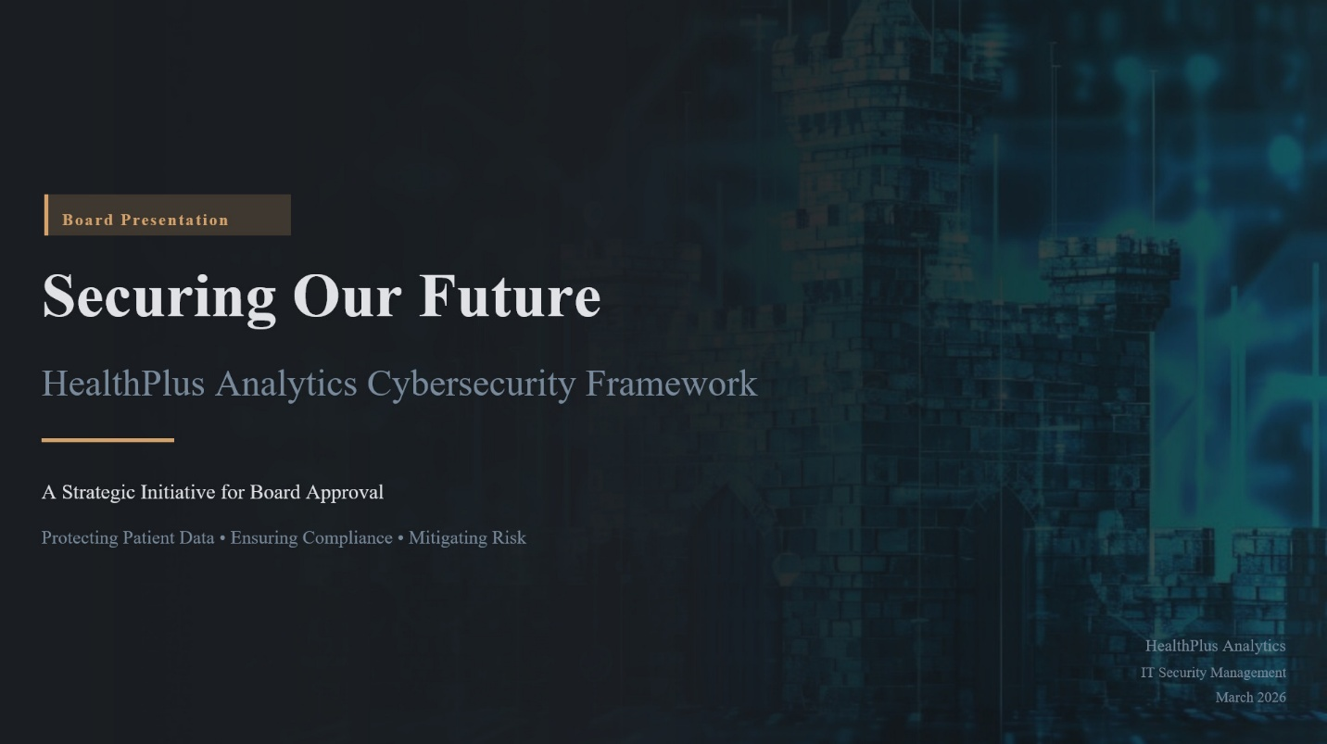
Figure 1 Title slide introducing the HealthPlus Analytics Cybersecurity Framework for board approval.
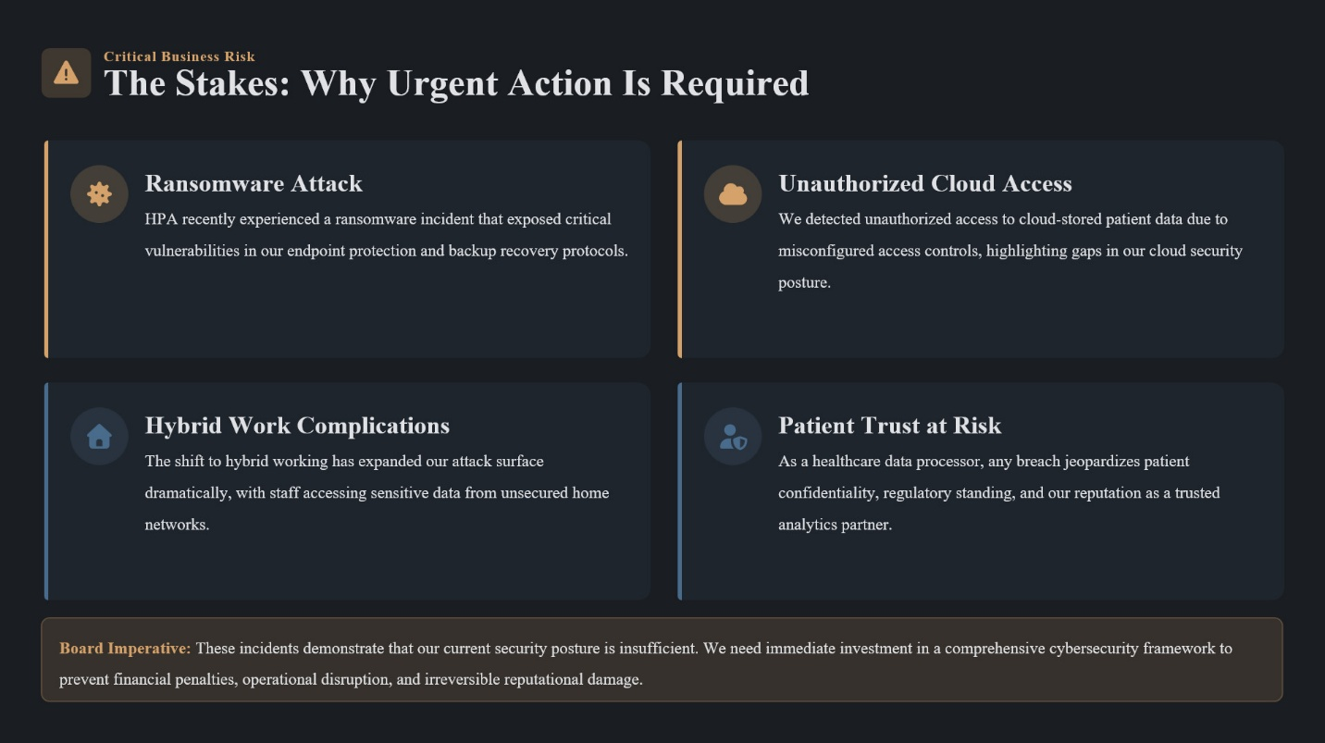
Figure 2 Slide detailing the critical business risks and the urgent need for action following recent incidents.
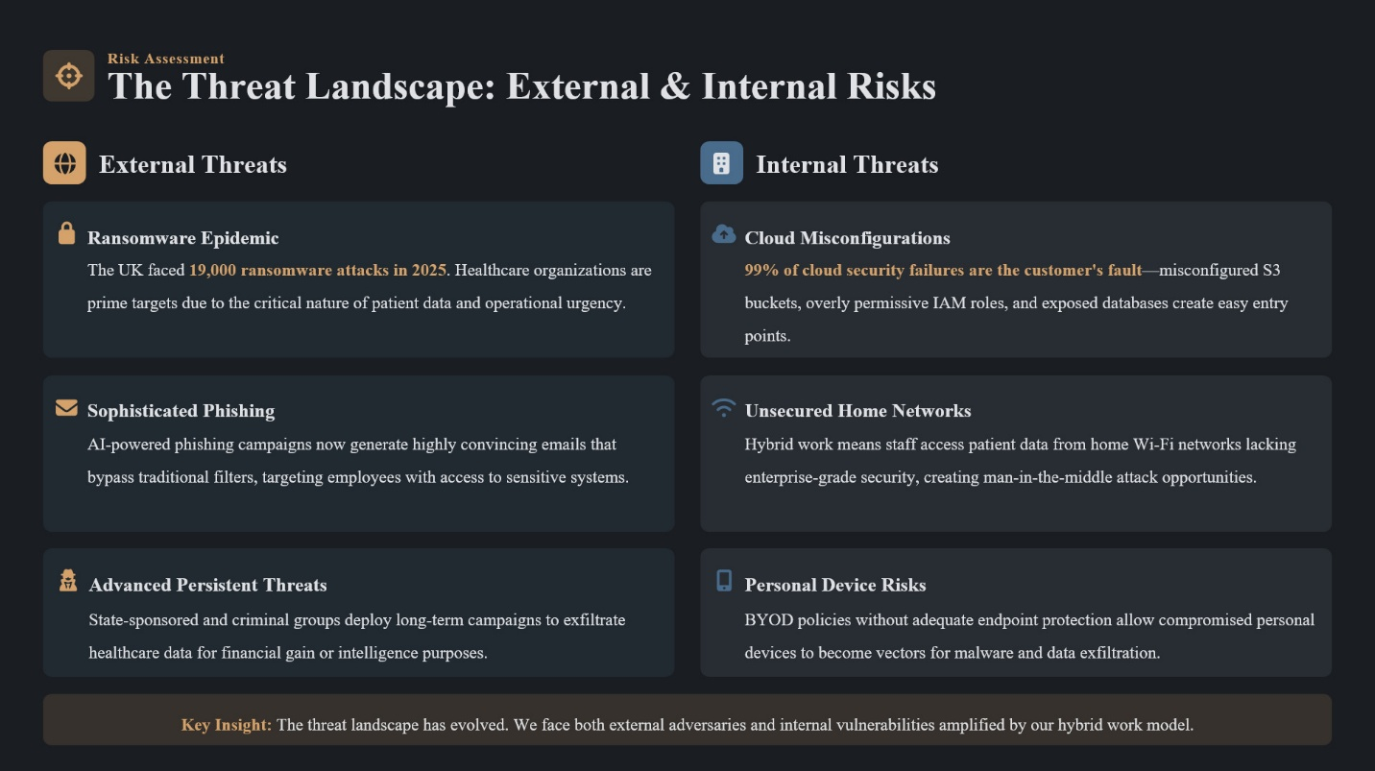
Figure 3 Slide outlining the external and internal threat landscape currently facing HealthPlus Analytics.

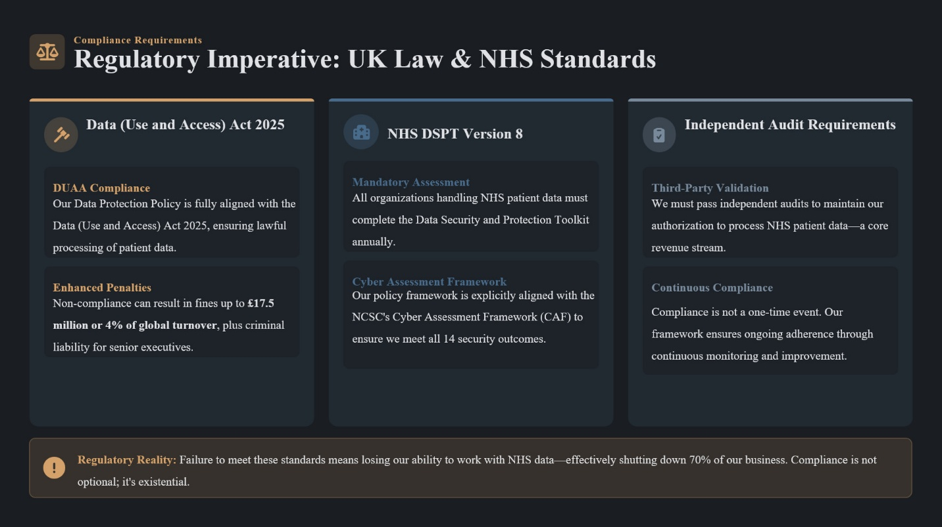
Figure 4 Slide explaining the regulatory imperatives, including the Data (Use and Access) Act 2025 and NHS DSPT standards.

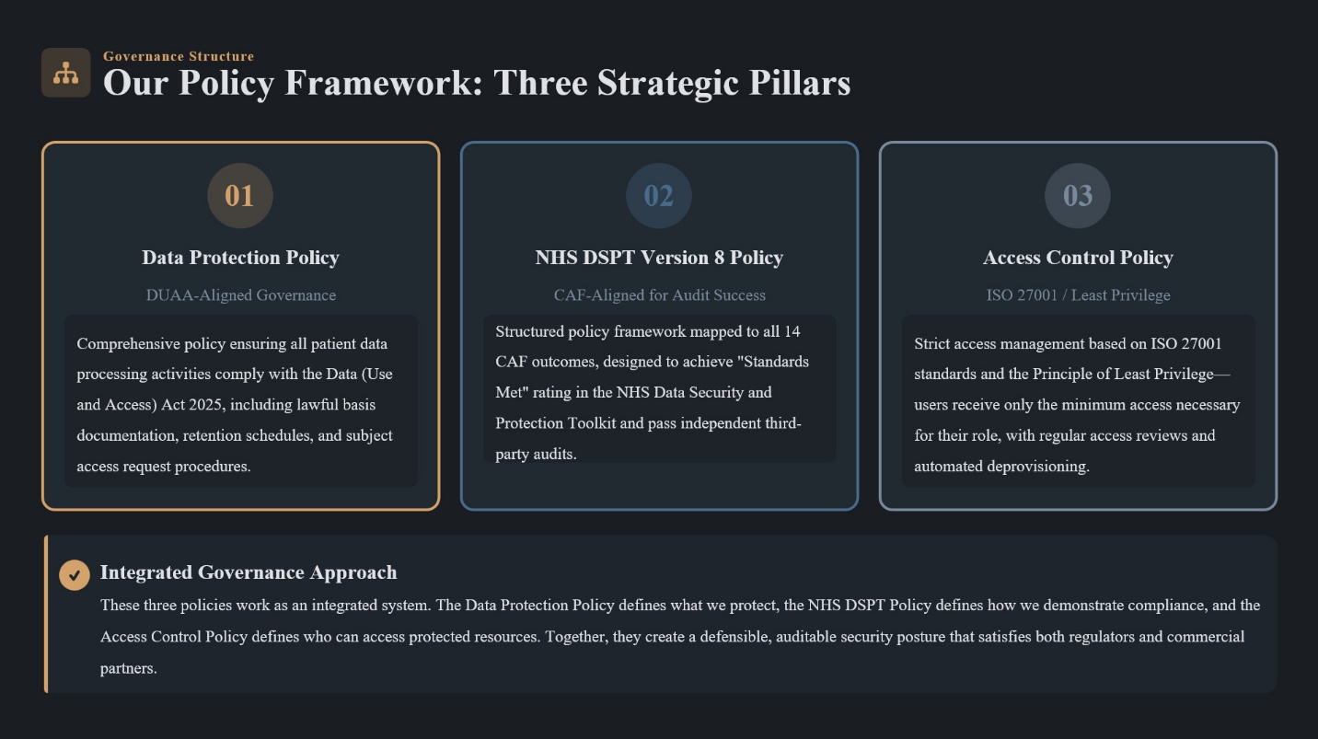
Figure 5 Slide presenting the three strategic pillars of the proposed security policy framework.

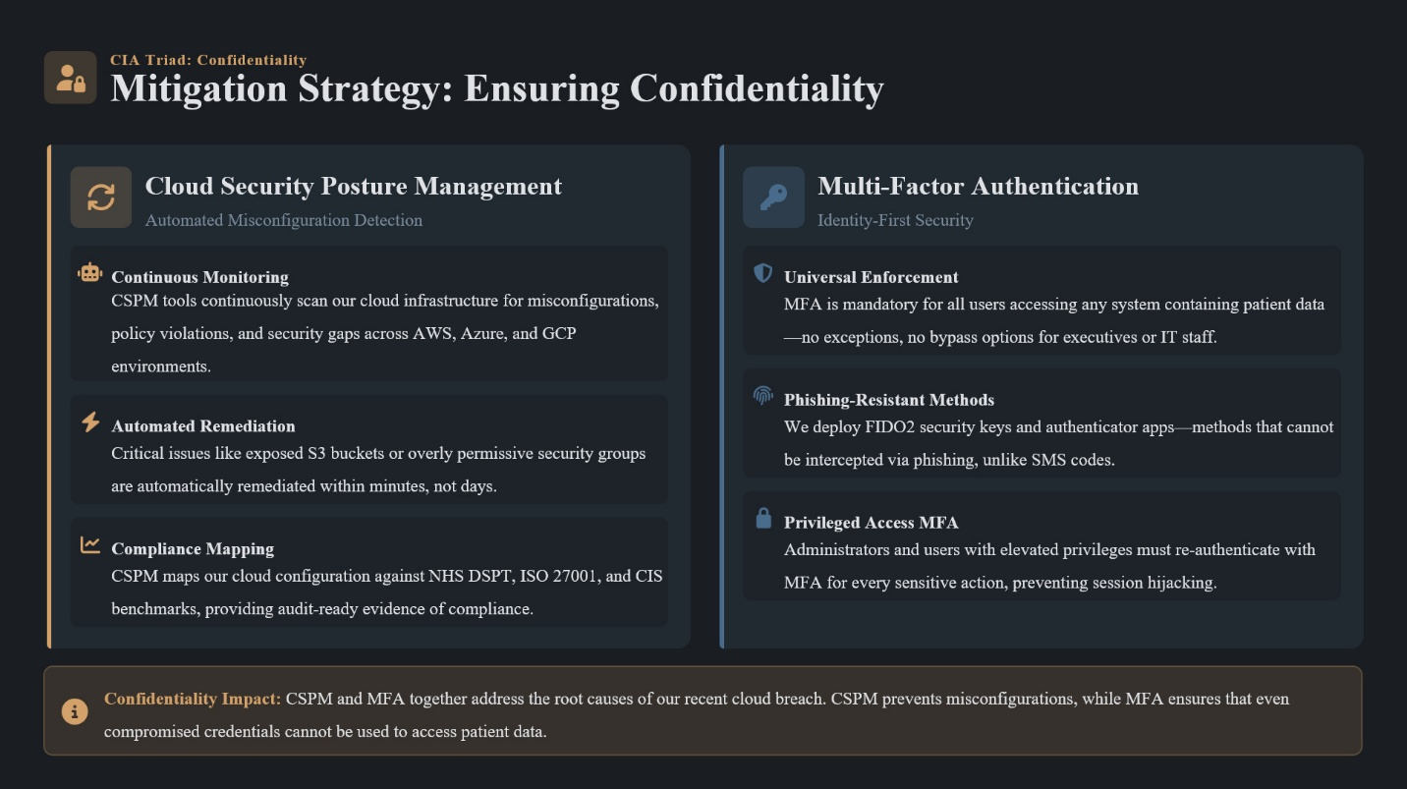
Figure 6 Slide detailing the mitigation strategies for ensuring data confidentiality, including CSPM and MFA.

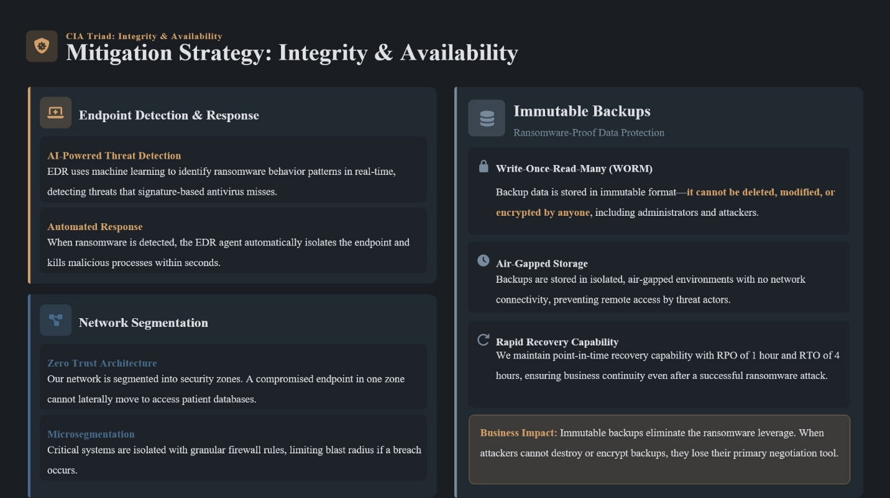
Figure 7 Slide detailing the mitigation strategies for ensuring data integrity and availability, including EDR and immutable backups.

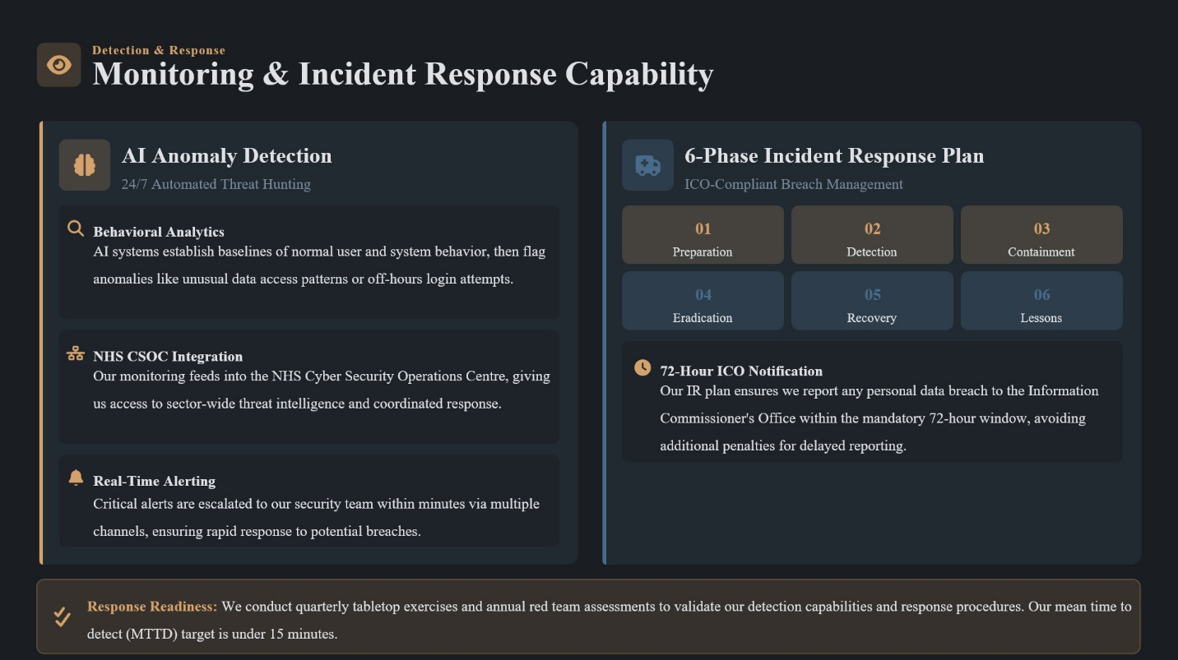
Figure 8 Slide outlining the AI-driven monitoring capabilities and the 6-phase incident response plan.
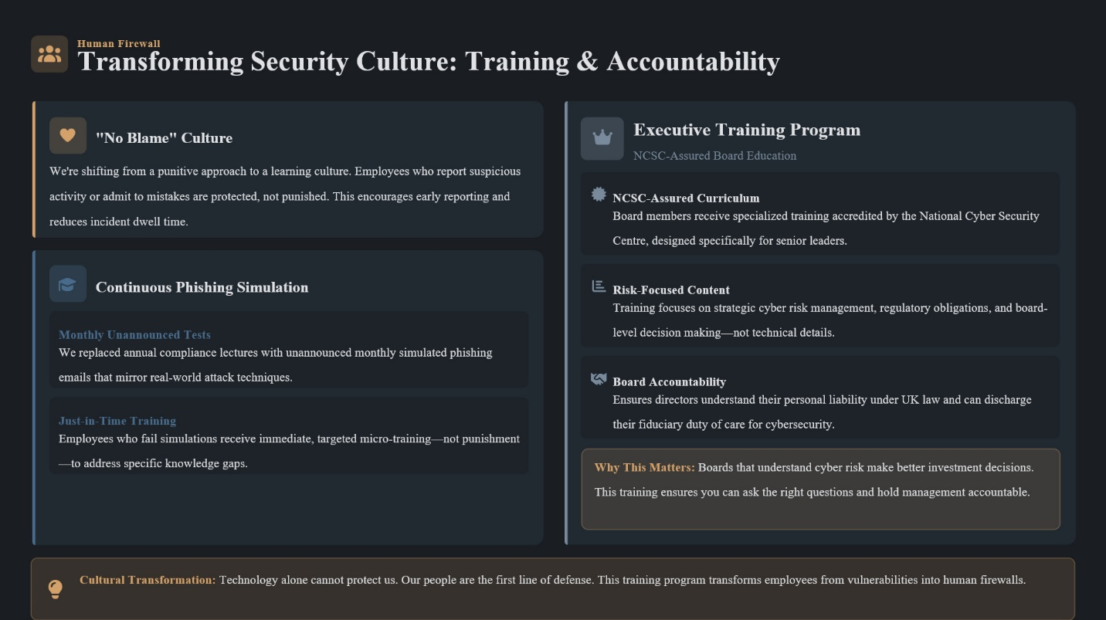
Figure 9 Slide explaining the transformation of the corporate security culture through "no blame" training and executive accountability.

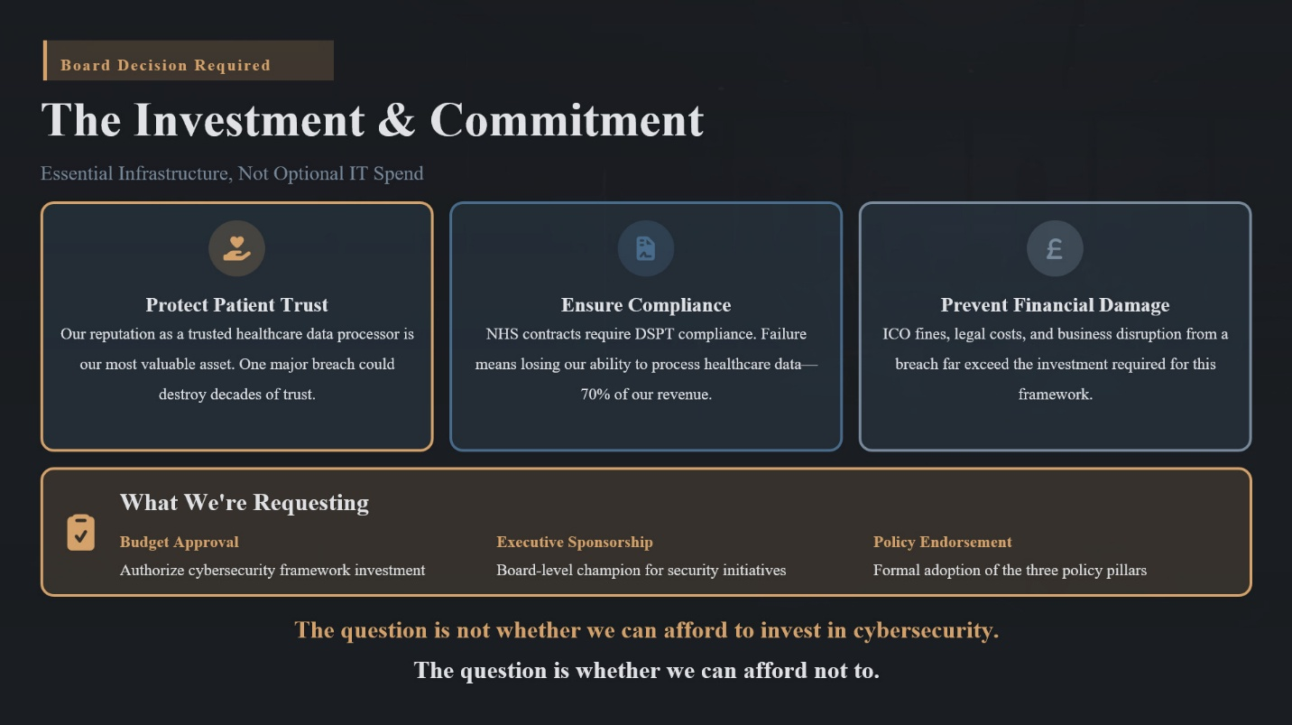
Figure 10 Concluding slide requesting board investment, executive sponsorship, and formal policy endorsement.

References
[1] Government of the UK, “Cyber security breaches survey 2025,” GOV.UK, Apr. 10, 2025. https://www.gov.uk/government/statistics/cyber-security-breaches-survey-2025/cyber-security-breaches-survey-2025
[2] S. Sharma, “Cloud Misconfiguration: The #1 Cause of Data Breaches 2025 | Fidelis Security,” Fidelis Security, Nov. 03, 2025. https://fidelissecurity.com/threatgeek/threat-detection-response/cloud-misconfigurations-causing-data-breaches/#elementor-toc__heading-anchor-0 (accessed Mar. 26, 2026).
[3] IT Desk UK, “Latest Remote & Hybrid Work Statistics 2025 | UK & Global Trends | IT Desk,” IT Desk, 2025. https://www.itdeskuk.com/latest-remote-hybrid-work-statistics
[4] ICO, “UK GDPR Guidance and Resources,” ico.org.uk, 2023. https://ico.org.uk/for-organisations/uk-gdpr-guidance-and-resources/
[5] S. Santos, “NHS DSPT Version 8: Key Updates & Compliance Guide 2025/26,” 8 Fold, Nov. 06, 2025. https://8foldgovernance.com/dspt-version-8/
[6] Wikipedia Contributors, “ISO/IEC 27001,” Wikipedia, Feb. 20, 2019. https://en.wikipedia.org/wiki/ISO/IEC_27001
[7] R. Anderson, Security Engineering: a Guide to Building Dependable Distributed systems. S.L.: John Wiley & Sons, 2020.
[8] “About us,” GOV.UK, Sep. 2025. https://www.gov.uk/government/organisations/cyber-and-specialist-operations-command/about
[9] “Board Toolkit,” www.ncsc.gov.uk. https://www.ncsc.gov.uk/collection/board-toolkit

