Student Name: Neve Morgan
P Number: 2004936
Programme of Study: Illustration (BA)
Module: ADAD4018 Ways of Thinking

Tasks in the order I received them:
Task One: Manifesto Writing = 514 words
Task Two: Observational Writing = 461 words
Task Three: Practice-based writing = 454 words
Tutor: Gwenllian Beynon

Manifesto
8 statements
- I believe that art is an important factor of everyday life
- I believe that illustration can be a useful tool to educate
- I believe that digital art is just as important and valid as traditional art
- I believe that art can be helpful for mental health and expressing oneself healthily
- I believe that you should share your art with others
- I believe that creative subjects should be funded better
- I believe that you should experiment with different aspects of art - style and medium
- I believe that everyone should be taught the fundamentals of art early on in life

Statement 1 –
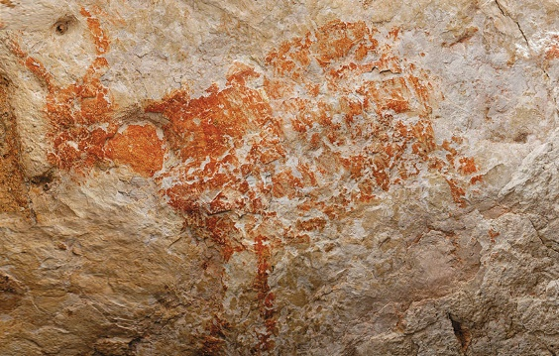
Fig, 1.
I believe that art is an important factor of everyday life. It is important to everyday life because it can make us feel something: joy, grief, anger, sadness, etc and makes us think about things in ways we might not have thought to do before. Art has been around us throughout all human history and It has been a great tool for us to understand life before our time and the time we live in now, as they all give an insight into what life was or is like, such as cave paintings. Art is so ingrained in our lives that we often overlook it, from logos to fonts. Similarly stated by Hyndman:
We are all type consumers: we all interact with and consume, a vast array of typefaces every day of our lives and most of the time we do this without being consciously aware of it.
(Hyndman, 2016 pg.16).
It is also important as it transcends spoken word and is a universal language. "Seeing comes before words. The child looks and recognizes before it can speak.” Berger, (1972 p.7) To use the above image as an example, we know it is an animal without it being stated anywhere in writing

Statement 2 –
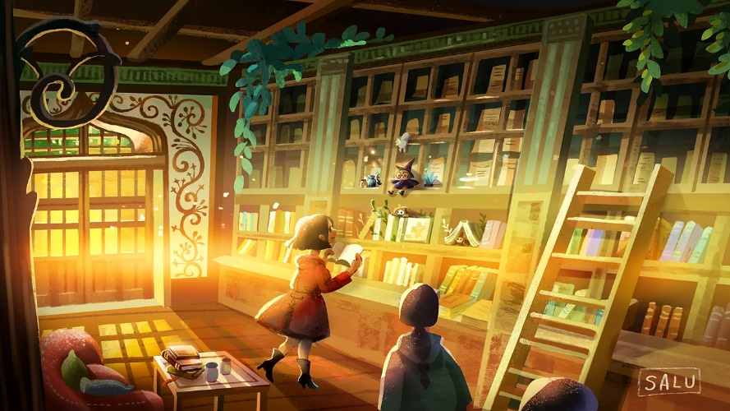
Fig, 2. Lulu Chen (2020) Library
Digital art is a medium that sparks many debates over its validity. Taylor (2014, p.6) stated that “The first critics described computer art as bleak and soulless” But I believe that digital art is just as valid and important as traditional. I think digital art is important especially in a growing technological era where many jobs are using digital programs more and more and as it is accessible to many. Experimenting with digital art I know that, while digital art does look easy from an outside perspective, there is still a lot of skill involved to make good looking art regardless of how you make it. As seen in fig. 2, you can see the use of perspective, character design and colour theory which makes the drawing pleasing to look at. People tend to forget that many shortcuts made with digital programs can easily be done traditionally, albeit it might be more time consuming, such as using a lightbox in place of digital layers.
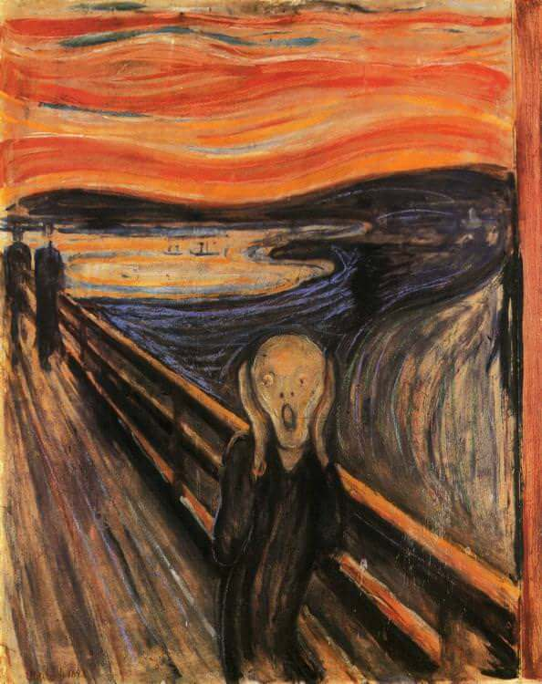
Fig. 3. Edvard Munch (1893) The Scream

Statement 3 -
I believe that art can be helpful for mental health and expressing oneself in a healthy way. As stated by Buchalter, (2014, p.15) art “helps reduce stress while increasing self-awareness and self-esteem.” Art is very personal, so you’ll see parts of an artist in every piece they make. Personally, I struggle to express myself with words, so art has become an alternative method for me. Art also brings me a lot of joy, creating and consuming it in my everyday life is something I look forward to. It is a powerful and healthy form of expression, no matter what your skill level is or the form it takes, and as art can take many forms, it is important for you to find one that makes you happiest. It can also help you gain connections and friendships as there are many art clubs as well as online art communities.

References:
Berger, J. (1972). Ways of seeing. London: British Broadcasting Corp. And Penguin Books.
Buchalter, S.I. (2014). Raising self-esteem in adults: an eclectic approach with art therapy, CBT and DBT based techniques. London: Jessica Kingsley Publishers.
Hyndman, S. (2016). Why fonts matter. London Virgin Books.
Taylor, G. (2014). When the Machine Made Art The Troubled History of Computer Art. New York: Bloomsbury Publishing
Figures:
Figure 1: One of the oldest known figurative paintings, a depiction of an unknown bovine. Available at: https://en.wikipedia.org/wiki/Cave_painting [Accessed 30 Oct. 2021].
Figure 2: Chen, L (2020) Library. Available at: https://www.salustudio.com/copy-of-gallery?lightbox=dataItem-knbjy8fy [Accessed 30 Oct. 2021].
Figure 3: Munch, E. (1893). The Scream. [Oil, tempera, pastel and crayon on cardboard] Available at: https://www.edvardmunch.org. [Accessed 1 Nov. 2021]
‌

Observational Writing
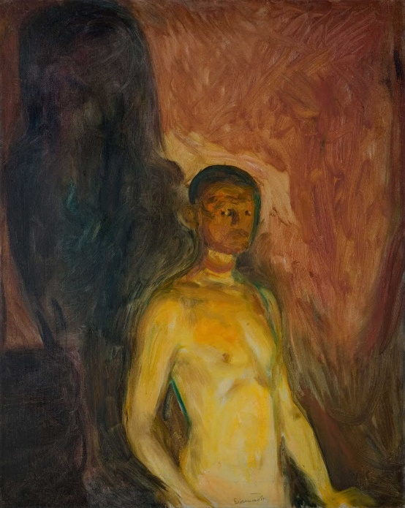
Fig, 1. Edvard Munch (1903) Self-Portrait in Hell
The purpose of this text is to explore the painting Self-Portrait in Hell by Edvard Munch (1903) through a semiotic analysis. “Semiotics is concerned with everything that can be taken as a sign.” (Eco 1976, p7) with signs in semiotics being “…an object, event, action, repeated process, state of affairs, an emotional situation and so on.” (Johansen and Larsen, 2002, p.26) Semiotics is important when it comes to art as it helps us understand the piece and derive meaning from it.
The piece I have chosen depicts the artist of the painting, Edvard Munch, in the foreground, with the background being an earthy red colour along with a black form of some sort in the background.
While researching this, I found that his self-portraits often have death iconography in them. The one I chose, as well as Self-portrait with Skeleton Arm by Edvard Munch (1895). So, to me, this painting symbolises an inner turmoil the artist was going through at the time. I believe this also shows in the way he paints. The signifier of his brush strokes in this painting are very erratic and chaotic showing his emotion through his painting style.
Looking at this piece, even without looking at the title I can see that the background is symbolising some sort of hellish atmosphere as the signifier of the colour red commonly symbolises danger and pain as well as red being associated with blood. “…the vibrant hue is connected intrinsically to the colour of fire and blood, both life sustaining and life threatening at the same time” (Eiseman and Pantone (Firm, 2017, p.28) The figure being naked not only shows a certain vulnerability but also adds to the danger in the way that there is nothing to protect you. The signifier of yellow lighting on the figure also makes me think he looks sickly, as well as it being red around his face and neck again signifies anger, signifying the term “seeing red”. The black form could symbolise multiple things, but my interpretation is that it is a form death takes and that its haunting the painter, going with the theme of being in hell.
My understanding of this piece has definitely changed since researching and analysing it. As mentioned by (Prideaux, 2005, p.170):
He felt doomed by the curse that was devouring his siblings and he felt guilty at being one of the survivors through no virtue of his own. His work became obsessed by death and family
This was in relation to his family members tragically passing away. Previous to this task I was not aware he went through this, and it explains a lot about the signs and themes like death within his work. It makes me see his art in a deeper, more meaningful way.

References:
Eiseman, L. and Pantone (Firm (2017). The complete color harmony: expert color information for professional results. Beverly, Ma: Rockport Publishers, An Imprint Of The Quarto Group.
Johansen, J.D. and Larsen, S.E. (2002). Signs in Use: An Introduction to Semiotics. United Kingdom: Routledge.
Munch, E. (1895). Self-portrait with Skeleton Arm. [Lithograph] Available at: https://commons.wikimedia.org/wiki/File:Edvard_Munch_-_Self-Portrait_with_Skeleton_Arm_-_Google_Art_Project.jpg [Accessed 21 Nov. 2021].
Prideaux, S. (2005). Edvard Munch : behind The scream. New Haven: Yale University Press.
Umberto Eco (1997). A theory of semiotics. Bloomington, Ind. Indiana University Press.

Figures:
Figure 1: Munch, E. (1903). Self-Portrait in Hell. [Oil on Canvas] Available at: https://commons.wikimedia.org/wiki/File:Edvard_Munch_-_Self-Portrait_in_Hell_-_Google_Art_Project.jpg [Accessed 20 Nov. 2021].

‌

Practice-based writing
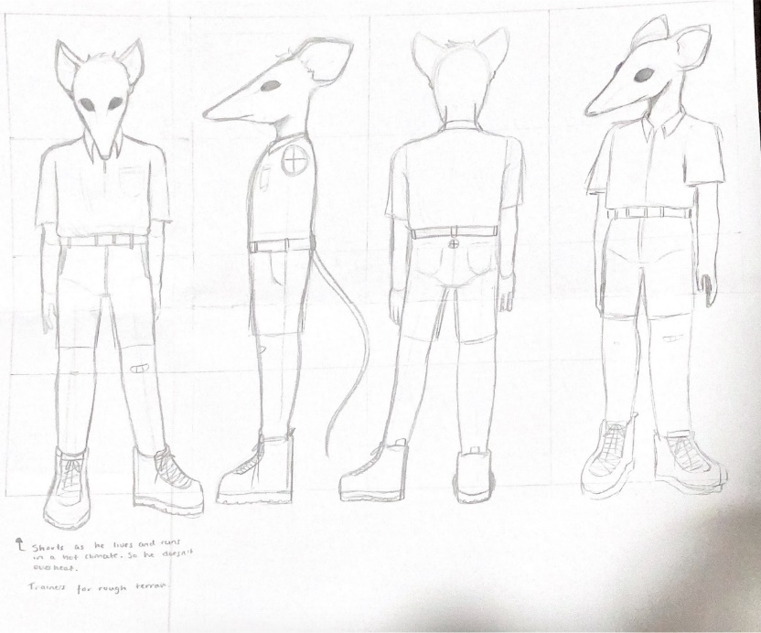
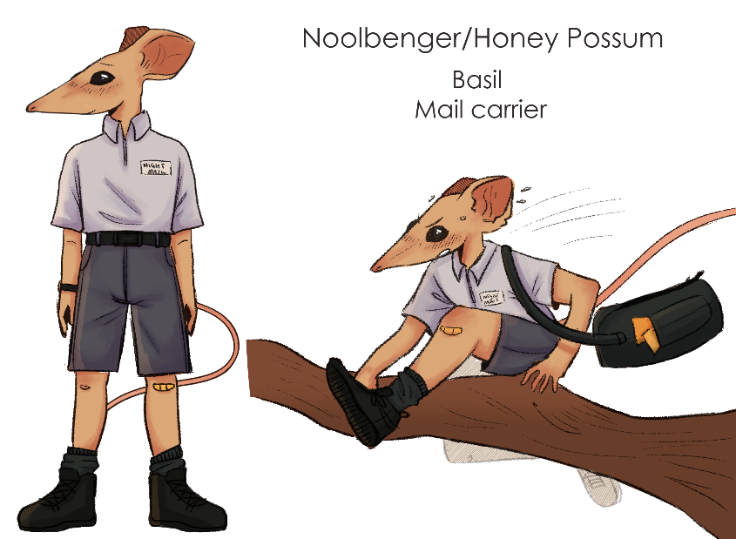
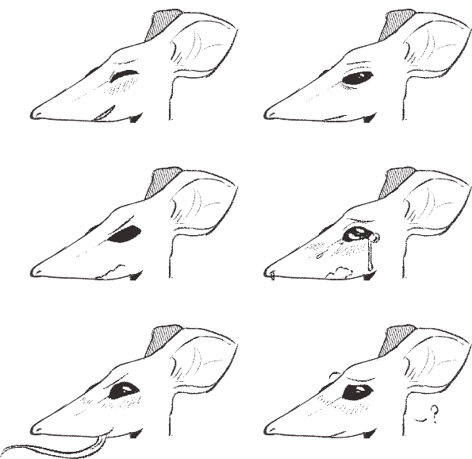
Fig. 1, Morgan. N, Character Design (2021)
For our illustration class, one of the tasks we were given was to create a character based on our initials.
The term “character design” is mainly used in the context of animated films, comics, and games in which there are one or more fictionalized characters with whom the audience is meant to identify.
(Erlhoff, M. and Marshall, T. 2007 p. 64)
As my initials are NM I decided to go with a Noolbenger/Honey Possum for the animal and a mail carrier for their occupation as I feel like that job would offer unique character interactions if I were to take this character design further to make it into a story. I then made a turnaround sheet and an expression sheet for them to make sure I always draw them consistently, no matter what angle/expression. I wanted to make the colours of this character softer and more muted to make this character appear more friendly and approachable. I decided on blue for the uniform as it is normally associated with mail carriers, but also blue is a soothing character and I wanted to get this character’s kind personality through the colour pallet. “When used in light, airy pastel tints, blue is associated with the sky, water, and feelings of serenity, relaxation, and calm.” (Mollica, 2018 p.37).

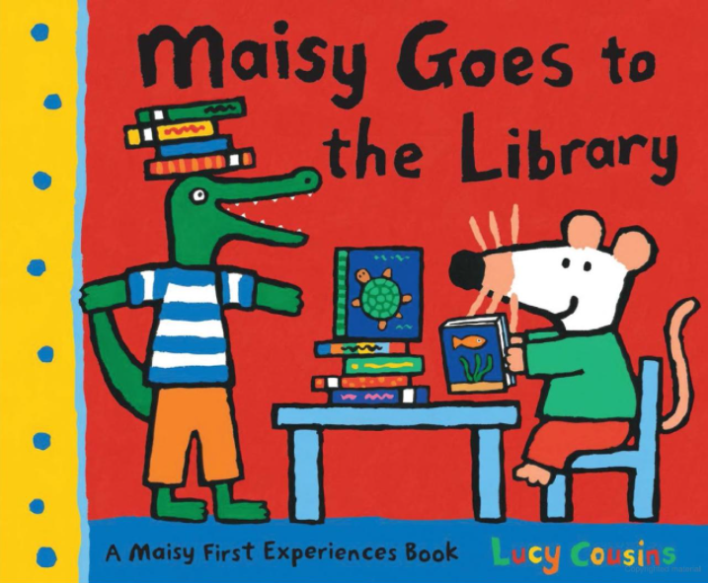
Fig. 2. Maisy Goes to the Library
As I wanted to focus on shape language for my character, I wanted to see how to make my character look more friendly. To do this I looked at story book illustrations. I was inspired by children’s book author and illustrator Lucy Cousins for my character design as honey possums and mice/rats have similar silhouettes. I found it interesting, as, in shape language, triangles are “Often used for villains because of its pointiness and dynamism” (Mattesi, 2008 p.62) but clearly Maisy is made to be a happy and fun character as she is depicted in her books. I believe that the colours being as vibrant as they are as well as the softness of Maisy’s character as a whole with the sharp edges rounded out balances the shape language out. Seeing this, I wanted to transfer that onto my own character, albeit with less vibrant colours.
This task was a bit difficult for me as I’m not used to drawing animal/animal-like characters, but after many concept sketches, I am very happy with the outcome I created. However, if I were to do this again, I think I would like to experiment with the costume design and try out different colour schemes as I mostly only went with my first choices. I would also like to create an environment for them to interact with, to base them more in reality and to get more of an idea for their personality.

References:
Erlhoff, M. and Marshall, T. (2007). Design Dictionary: Perspectives on Design Terminology. Berlin, Boston: Birkhäuser.
Mattesi, M.D. (2008). Force: character design from life drawing. Burlington, Ma; Oxford, Uk: Focal Press.
Mollica, P. (2018). Basic color theory special subjects: an introduction to color for beginner artists. Lake Forest, Ca: Walter Foster Publishing.
‌
Figures:
Figure 1: Morgan. N, Character Design (2021) UWTSD, Swansea
Figure 2: Cousins, L. (2007). Maisy goes to the library. London: Walker.

‌

