
UNIVERSITY OF WALES:  TRINITY SAINT DAVID |  | PRIFYSGOL CYMRU:  Y DRINDOD DEWI SANT

LOCATION: Coleg Sir Gar (Graig) | LLEOLIAD: Coleg Sir Gar (Graig)
LEVEL 6 | LEFEL 6
EXAMINATION PERIOD | CYFNOD ARHOLIADAU
may 2020 | mai 2020

MODULE CODE: SGdm6020
Engineering Management

Examination Solutions

Question 1
1.a. The student should describe the basic steps involved in a Taguchi DOE. Suitable comments should be made at each stage to demonstrate understanding, i.e.:
With Taguchi’s DOE, parameter or factor changes occur simultaneously in a product hence minimising the need to carry out large quantities of testing that would occur if one parameter at a time were changed. If we were to carry out a series of tests by changing one parameter at a time, then two at a time and so on, the number of different tests would be very high without considering the number of tests that would be need to be taken at each parameter setting in order to achieve accurate results.
Taguchi uses what is termed the L8 orthogonal array. These are the designs for experiments, which were previously identified by others but were codified in such a way that an engineer automatically has a route to the minimum number of prototypes necessary for experimentation. The numbers 1 to 8 are called experiment numbers. Each vertical column of the array contains four 1’s and four 2’s. For any experiment, in any two columns there are four possible combinations: (1,1), (1,2), (2,1) and (2,2). If each of these four combinations appears the same number of times in a pair of columns, the columns are said to be balanced, or orthogonal. Select any two of the seven columns in the L₈ array and count the (1,1), (1,2), (2,1) and (2,2) combinations; you will find that the columns are indeed orthogonal. Correct parameter analysis will then allow the engineer to achieve a new set of parameters that will best suit the system and hence reduce quality problems.
A graphical analysis for each effect in the design matrix can be obtained by plotting the average response at the 1 & 2 (or –1 & 1) levels for each column. After plotting the averages, the points are connected to form a line. The steepness of the slope reflects the importance of each effect. 10 Marks
1.b. The average value for the ‘deterioration data’ must be calculated:
$\overline{T}$ = (20+12+10+48+28+20+20+16+8) / 9 = 20.22
The mean values of the parameter levels can now be entered into the ‘Response table’:
Levels | A | B | C | D
1 | 14 | 29.33 | 18.67 | 18.67
2 | 32 | 18.67 | 22.67 | 17.33
3 | 14.67 | 12.67 | 19.33 | 24.67
Difference | 0.67 | 6 | 0.67 | 1.33
Rank | 3 | 1 | 3 | 2
The ‘difference’ value is obtained by discarding the highest, undesirable value for each parameter, and subtracting the two remaining lowest values. The ‘Rank’ or ‘Weight’ is then assigned to the highest parameter value in order of importance.
From the above table, the Optimum Parameter Setting would be those parameter giving the lowest values, therefore:
Optimum Process Parameter Setting = A₁B₃C₁D₂
Applying the formula to the average parameter values to predict the outcome for these settings:
$\hat{Y}$ = (A₁ + B₃ +C₁ +D₂) – 3T
$\hat{Y}=$(14 + 12.67 + 18.67 +17.33) – (3X 20.22)
$\hat{Y}$ = 62.66 – 60.66
$$\hat{Y}=2$$
A confirmation run is now required. 10 marks
1.c.
 | LEVEL | 1 | 2 | 3
A | Material cost (£/load) | 2,500 | 2,400 | 2,200
B | Process temperature (ºC) | 600 | 625 | 650
C | Process time (hours) | 2 | 1.75 | 1.5
D | Percentage additive | 2% | 4% | 6%

- Material cost (£/load)
The ‘mid price’ load (level 2) has a profound effect on deterioration and there is little difference (0.67) between Level 1 & level 3. Suggest the cheaper level 3 load be used, i.e. change from A₁ to A₃.
- Process temperature (ºC)
There is a 25ºC difference between level 2 and Level 3, but a profound (Rank 1) effect on the process. Recommend to retain the process temp at B₃.
- Process time (hours)
The optimum setting appears to be Level 1, but Level 3 gives a difference of 0.67, but a process reduction time of 25%. Recommend changing from C₁ to C₃.
- Percentage additive
No information on costs are available, and this is the second most important factor (Rank 2), it is suggested that Level 2 be retained i.e. D₂.
Recommended combination: A₃,B₃,C₃,D₂
New prediction for this combination:
$\hat{Y}$ = (A₃ + B₃ +C₃ +D₂) – 3T
$\hat{Y}=$(14.67 + 12.67 + 19.33 +17.33) – (3X 20.22)
$\hat{Y}$ = 64 – 60.66
$$\hat{Y}=3.34$$
This is an increase of deterioration of 67% from the optimum settings (Y=2)
Confirmation run required. 5 marks
Total marks for 1 = 25
Question 2
SWOT assists a company to define four major categories that require analysis. These are:
Strengths – internal strengths of the company, what it excels at and what can be done well and thus needs exploiting.
Weaknesses – internal weaknesses of the company – what it is poor at and thus needs to be strengthened.
Opportunities – external opportunities that the company can exploit (new markets etc.)
Threats – external threats that can create problems for the company (competition etc.)
1 mark awarded for the correct definition of each point and a further 2 marks for the discussion i.e. SW resources, internal capabilities and competencies, OT external environment. (6 Marks)

PESTLE
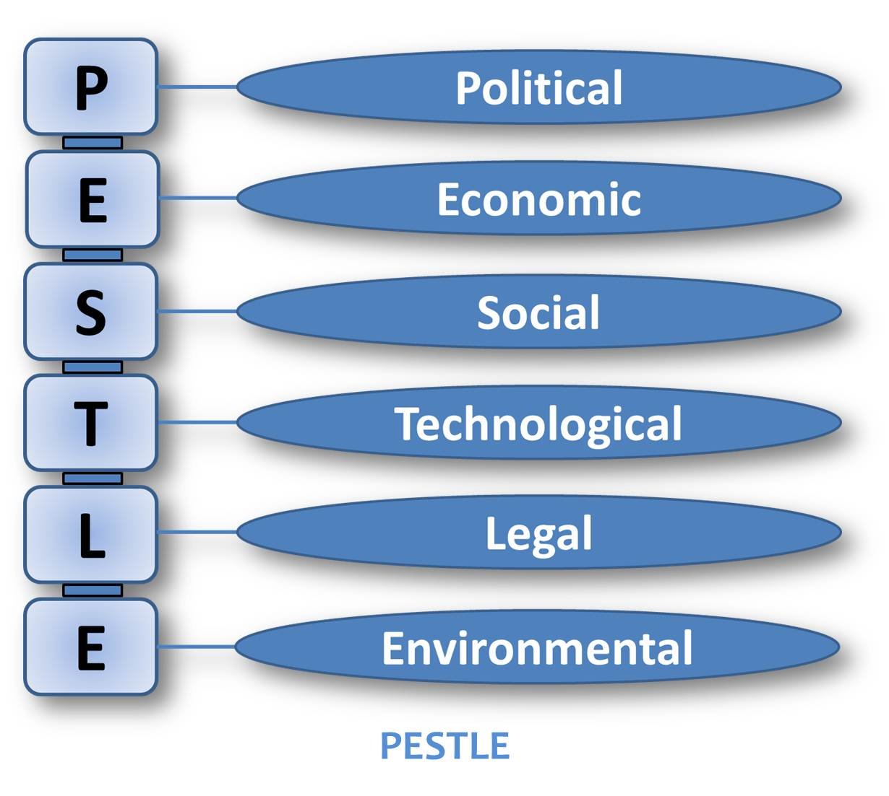
1 mark for the definition of each point and a further 2 marks for correct identification of examples of the external influences on a business. (8 Marks)
Total for Porter’s Forces 11 marks
Total for question 2, 25 marks

Question 3
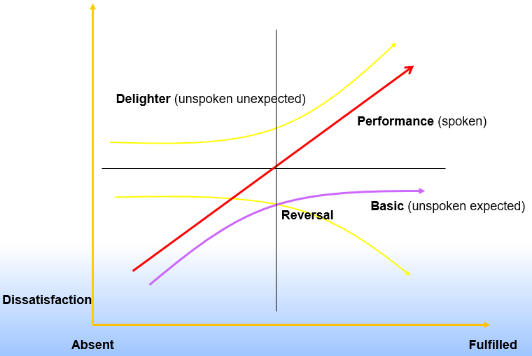
Basic – or ‘must be’ factors. Something the customer expects to be there, if not present they will feel dissatisfied or disgusted. However, if fully implemented, it will merely result in a feeling of neutrality (i.e. clean sheets in a hotel, windscreen washers on a car). Some of these factors may be particularly difficult to satisfy, and should not be taken for granted.
Performance – or ‘more/faster/easier is better’ factors. These can cause disgust at one extreme, or delight if implemented at the other. The challenge is to identify such factors, that may exist already but be neutral, so in need of improvement (i.e. speed of hotel check ins, ease of tuning a radio, fuel consumption etc.).
Delighter – or excitement factors, something that the customer did not expect, but if present may cause increasing delight (i.e. flowers or wine for arriving guests in a hotel). A true delighter is provided at minimum extra cost, and another risk is that customers may come to expect them, so raising their expectations and they then become ’basic’ factors, which is probably true of most delighters over time (i.e. CDs or power packs in cars, once optional extras but included as standard by some manufacturers, now they are the expected minimum norm..
The degree of customer satisfaction ranges from ‘disgust’ through ‘neutrality’, to ‘delight’. The Kano model works well with QFD and TRIZ.
3 marks for the diagram and 3 marks for each factor (12 marks)
(b) Helps to develop products faster, at lower cost and with better customer acceptance.
QFD provides a mechanism for determining customer requirements and translating them into relevant technical language that each function of the organisation can understand and act upon.
Greater attention is placed on defining a products required characteristics and to documenting the design process itself, which leads to less redesign and fewer engineering changes later.
In essence, the QFD team must answer three questions – WHO, WHAT and HOW.
- Who are the customers?
- What does the customer need?
- How will the customer’s needs be satisfied? 3 marks
House of Quality
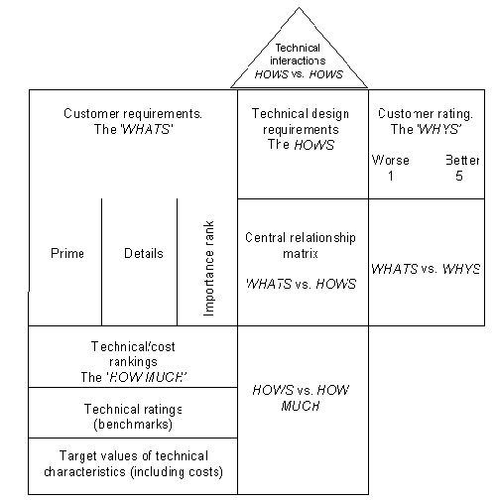
8 marks for correct sketch, 5 marks to describe the parts of the diagram; whats customer wants, hows the technical requirements, roof the technical interaction, the whys the competitor comparison.
Total for question 3, 25 marks

Question 4
- σ = $\overline{R}$ σ = 0.269 σ = 0.115
d₂ 2.33
$$\overset{̿}{x }$$
= 200.704 = 20.07
10

= 20.07 + 0.58 x 0.269 = 20.23

= 20.07 – 0.58 x 0.269 = 19.92

= 2.69 = 0.269
10

= 2.114 x 0.269 = 0.569

= 0 x 0.269 = 0
(10 Marks)

- ..6 marks
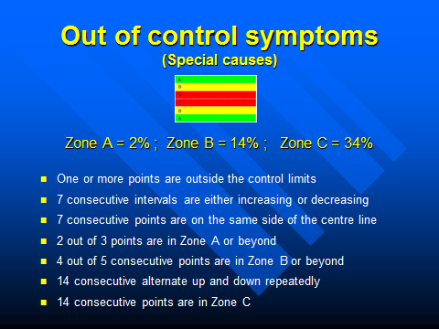

(c)
C_{p =} Total specified tolerance = ____0.5____ = 0.7218
6 σ 6 x 0.115

Therefore: Not good enough as basic is 1.33 and ideally more than 1.66
C_{pk =} Upper Specified Limit - $\overset{̿}{x }$ or $\overset{̿}{x }$ - Lower Specified Limit
3σ 3σ
C_{pk} = 20.25 – 20.07 / 3 x 0.115 or 20.07 – 19.75 / 3 x 0.115
C_{pk} = 0.504 or 0.9395
(9 Marks)
Total for question 4, 25 marks

