Task 1 – Photograph
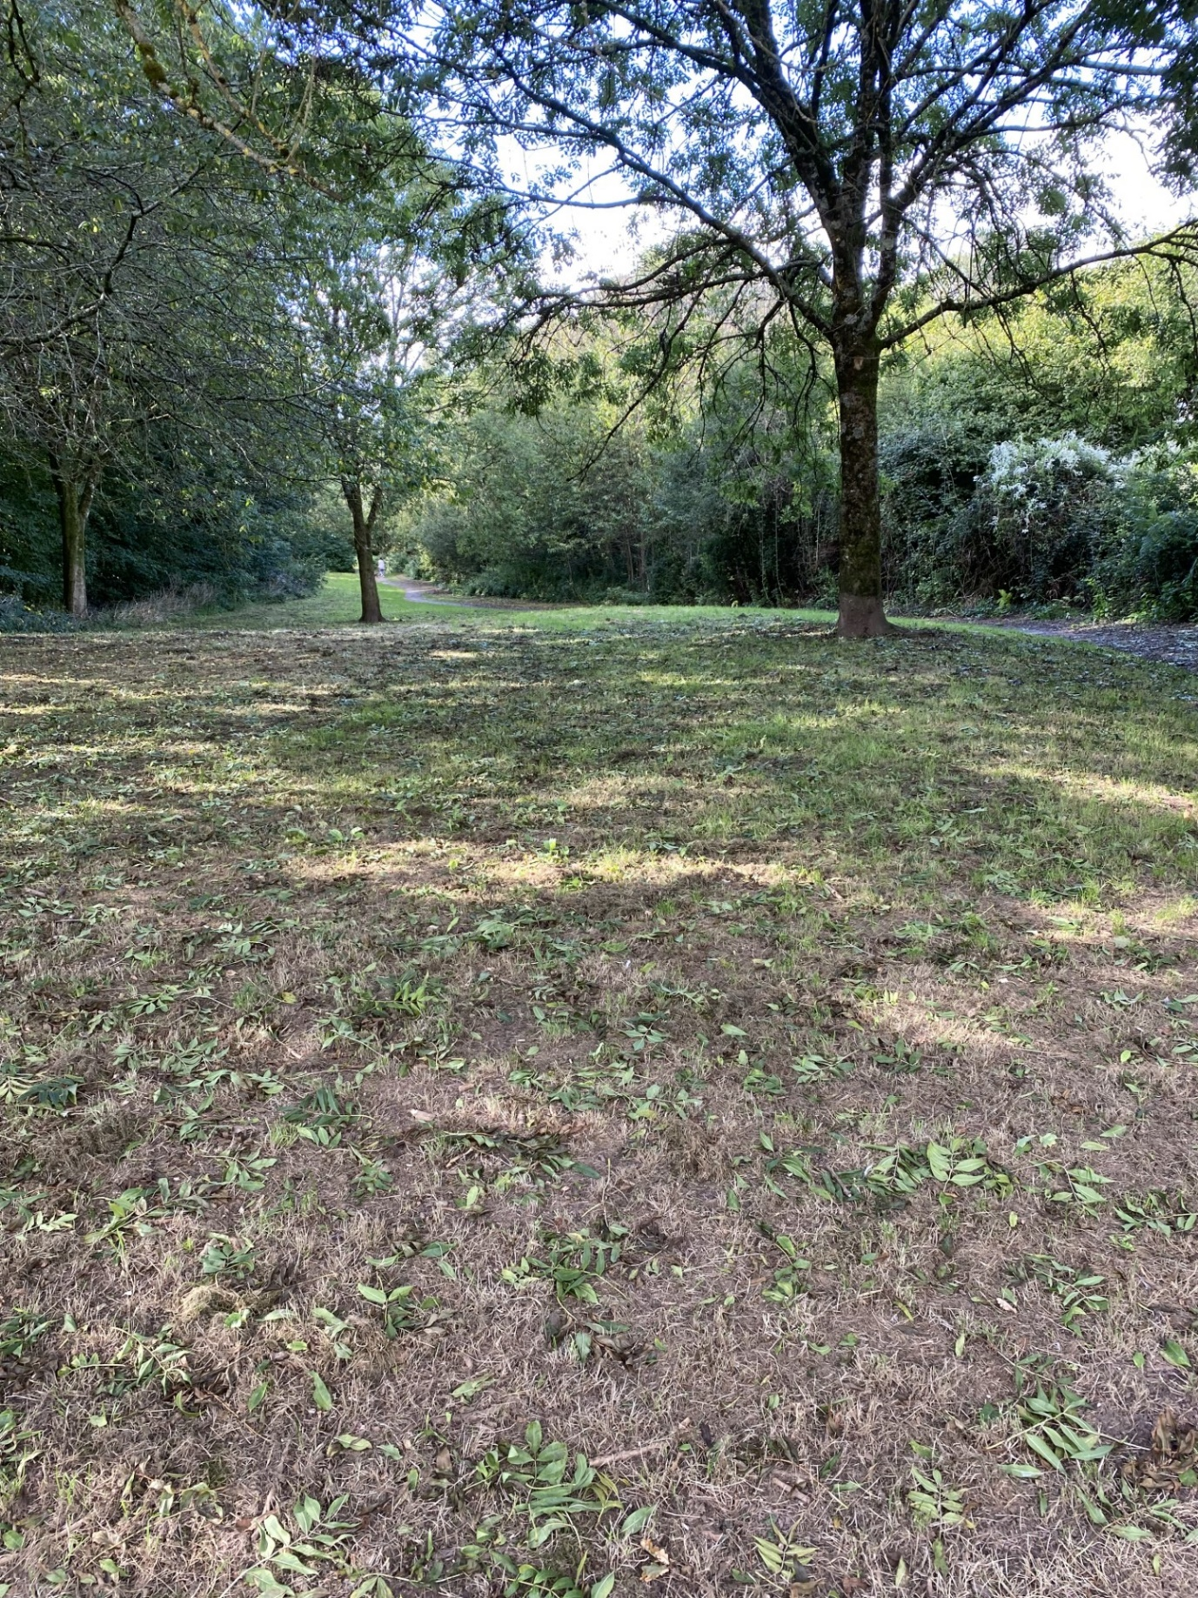
(Source: Herdman, 2023)

Task 2 – The Learning Journey
1200 words I have 1267 -
The photograph that has been taken for this piece of work shows an expanse of open-ended play opportunities for children to carry out. The children can explore, investigate, question and experiment in the environment, which allows for a holistic way of learning mathematical and scientific concepts in the outdoors.
Today we were going to the school field to look for insects which links to a story we had read previously. The story provided lots of discussions on insects, so I wanted to expand on the learning and interest.
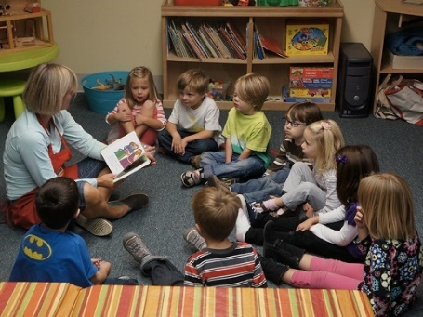 (Source: Adventures in Storytime (and beyond), 2023)
Before leaving, I explained there was a bag if children would like to bring anything back for further investigation. The children got their wet weather gear and I pretended to put my wellies on a child, they said, “no, that’s too big for me, I have little feet”, so I asked, “who has big feet then?” the child laughed, and said, “you have big feet”. We measured feet and I agreed I did have big feet, so put the welly on.
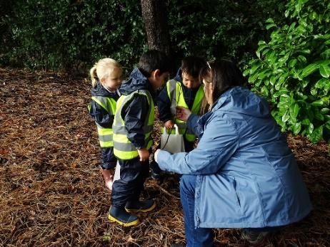 (Source: Stockport Grammar School, 2021)
We stepped into the field a flock of birds flew from the trees, a child shouted, “that frightened me, there were loads, how did they fit in that tree?” One child said “ I can climb up there, watch” he ran over to the tree and started to climb, while another tried to swing from a branch which promptly snapped. Another child said, “it’s too tall, you need a ladder”, a different child said, “ no, you are too heavy it will snap like it just did, birds are light”.
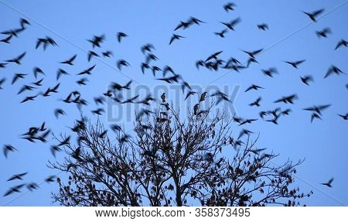(Source: Bigstock, no date)
I asked if the children would like to find objects that they think are heavy and light so we could investigate them, some joined in whilst others went to a different tree which had fallen and started to walk across the trunk, they started to think about how it had fallen and after discussion they decided “the wind did it”.
I provided the children with baskets and left rulers, measuring tapes, and weighing scales nearby. The children collected items and showed each other what they had found, one child said, “ I’ve got the heaviest as mine is huge, see?” Another child said “no that will be light, it’s a stick”, then a child shouted “I need help” I helped them with a rock that they said “will be heavy as my grandad throws rocks in the river and they make a big splash”, I brought it back to where the children were and stepped back to allow them to explore, investigate and question each other. They each took turns using the tools I provided and discussed colours, shapes, sizes, and weights of the items. After a while they all agreed that the rock was the heaviest and the flower was the lightest, but the big stick was “cool” and wanted to bring it back to school. This activity links to the exploring pathway in the non-maintained curriculum where children are given opportunities to explore, invest and discover in their environments Welsh Government (2022) and progression step 1 of the mathematical and numeracy section in the new curriculum where it states I can investigate, collect, and record data found in my environment Welsh Government (2022).
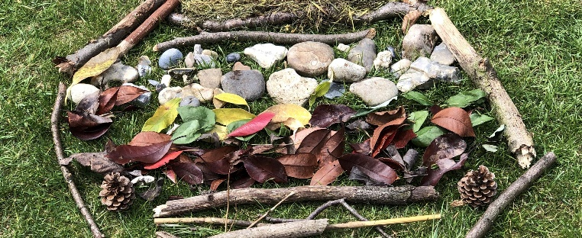 (Source: Sarah Ransome, no date)
I then went over to children looking at some bushes, I listened to their conversations about spiders, and how they found webs everywhere, so this “must” be where they live, so I offered them magnifying glasses. I also provided pots and factual books. The children continued to search until one child said, “I’ve found something”, the other children went over to look. One child declared “it’s an ant, another child said “no it’s too big” the third child asked if I knew what it was, so I suggested we had a look in the books to see if we find it. We each started to search the books to see if we could match insect. The child who found it said, “it’s a millipede, and showed us a picture from her book, but the other children disagreed and said, “a millepede has a million legs, and this has 1,2,3,4,5,6 legs, so it’s not that”, “oh yeah, and he has claws on his back,” said the child. We continued to search the books when a child said, “I think I’ve found it ”, the children looked back and forth at the insect and agreed, we had found an earwig. I read facts about the ear wig like where they live and what they eat. I asked where we should put him and they all agreed we should take him back to where we found him, so he was able to go back into the dark like we had just learnt.
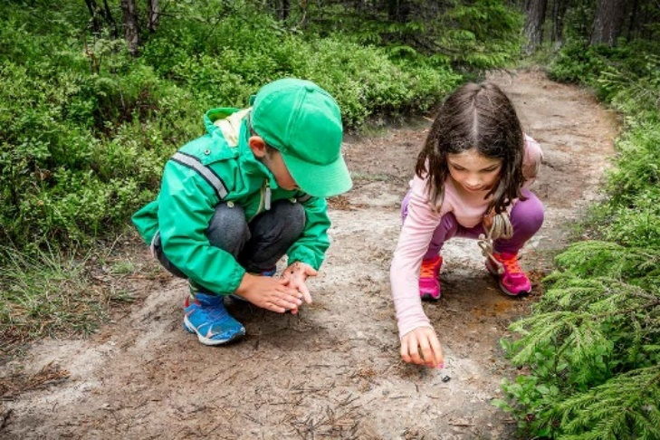 (Source: Go Valley Kids, 2023)

Another group of children had collected different items for a den they wanted to build. They had a range of sticks, stones, leaves and conkers and decided to use the big tree as support so that it made a “big circle triangle around the trunk”. They placed the sticks against the tree, but when they looked again, they realised they were “too small to fit in” even after placing them at different angles, “ right let’s sort the sticks out, we need long sticks so that we can all fit in” said one child. The children sorted the sticks into categories of “short” and “long” and realised that they didn’t have enough long sticks so set off to find more, they carried back long sticks together and set them out again. One child said, “right we have 1,2,3,4,5,6,7,8,9,10,11 sticks, I’d say we need 20, so let’s go and get more” they found more long sticks and started to construct the den warning each other to “be careful”.
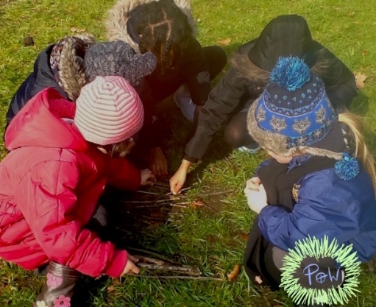 (Source: Play of the wild, 2019)
Once the sticks were “safe” they tested it out and decided they need a “carpet”, one child said, “it must be soft”, so they decided the softest thing they had collected were the leaves, so laid those on the floor. One child asked, “why are there so many leaves on the floor?” I explained that the seasons are changing and we are now starting to experience Autumn, a child interrupted and said, “in Autumn leaves fall off trees and change colour” I agreed then another child said, “and the squirrels shake them off when they collect acorns ready for Winter when there isn’t any food for them”, which we all laughed at.
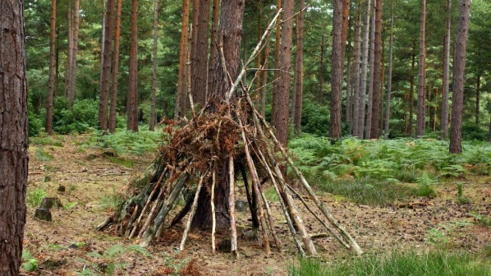 (Source: Have fun outdoors, 2022)
The children stepped back and admired their den, but noticed the items they had left, “what can we do with the other bits?”, said one child. “We could make pictures like in school”. The children each made a picture, one made “just circle stones”, whilst others used all the items, but followed the similar patterns. This activity links to the physical pathway Welsh Government (2022) where the child is able to express themselves in large and small spaces and the science and technology progression step 1 Welsh Government (2020) in exploring properties of materials and choosing different types of material for particular uses.
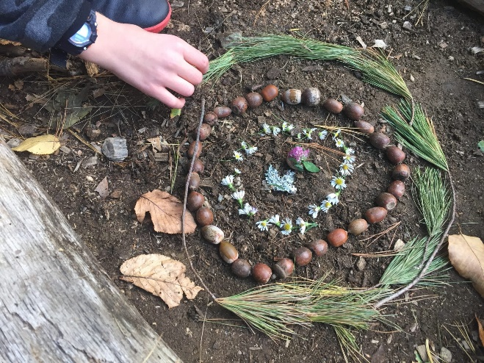 (Source: Childhood by Nature, 2018)

Just before we left, we sat down and looked through the items we had collected, we took turns in investigating and discussing what we could use them for. We discussed how it would be different if it was a different type of weather or season and the children all agreed that they enjoyed having the freedom to run and explore.

Task 3
1000words I have 962..
RISK BENEFIT ASSESSMENT

Location / Activity: | School Field | Date: | 17th September 2023
Assessor: | Natalie Herdman | Review date: | 17th October 2023

The boxes in the table below will expand as you type into them; pre-entered text is simply for illustration. You should delete irrelevant items and replace with text relevant to your circumstances.
Your overall risk rating – Low, medium or high – is based on your judgement about whether the BENEFITS of the activity or opportunity outweigh the RISKS.

Experience exploring outdoor space in photograph | How will young people BENEFIT from this activity? | Hazards and associated risks | Who is at risk? | PRECAUTIONS in place to reduce the risk of injury | Overall risk after precautions  RATING: L/M/H
Exploring the area including to find items such as conkers, stones, leaves, sticks, plants, insects, and wildlife | Opportunities for exploring the environment, make observations and communicate ideas.  Opportunities to count and sequence items that they can touch and things they cannot touch,  Physical development of gross and fine motor skills as they reach, collect and bend for items.  Develops immunity to germs as they collect items.  Develops social and communication skills.  Allows for exploration, investigation, and curiosity to be developed. | Children could wander off.  Fallen trees, branches which could lead to injuries such as scratches, infections, bruises.  Bites, stings – Allergies to bites  Poisonous plants, such as nettles  Dangerous items could be in the field – such as rubbish and animal faeces.  ‘Stranger danger’ – nobody other than school staff should have access but could happen. | Children and adults | Ensure ratios are maintained.  Staff are to be vigilant of all areas – look out for any potential dangers and rectify.  Appropriate clothing worn for activity.  Give guidance to children about where they can and cannot go.  First aid kit, mobile phone and qualified first aider to attend walk.  Awareness of everyone’s medical needs.  Activities prior to attendance on what is dangerous, e.g., nettles, glass, and strangers.  Reminders to children not to taste anything.  Use water provided to wash hands | L
Experience exploring outdoor space in photograph | How will young people BENEFIT from this activity? | Hazards and associated risks | Who is at risk? | PRECAUTIONS in place to reduce the risk of injury | Overall risk after precautions  RATING: L/M/H
Walking on different types of uneven surfaces | Opportunities to develop spatial awareness.  Supports the development of vestibular balance.  Develops opportunities for mathematical and scientific language and understanding of gradients, textures, and forces. | Slips, trips, and falls which could cause injuries such as cuts, bruises, sprains, and other injuries | Children and adults | Appropriate footwear to be worn.  First aid kit, mobile phone and qualified first aider to attend walk.  Staff are to be vigilant of all areas – look out for any potential dangers and rectify.  Prior to attending the field, children given opportunities to develop walking on different surfaces such as using steppingstones, and wobble boards to walk along.  Discussions on walking slowly to start with to allow them to become familiar with new surfaces.  Appropriate footwear to be worn | L
Experience exploring outdoor space in photograph | How will young people BENEFIT from this activity? | Hazards and associated risks | Who is at risk? | PRECAUTIONS in place to reduce the risk of injury | Overall risk after precautions  RATING: L/M/H
Bug hunting | Opportunities for learning about living things.  Opportunities to share curiosities with others.  Opportunities to build empathy for the environment and develop an awareness of their impact on the world | Bites, stings – Allergies to bites  Overgrown bushes could lead to injuries such as scratches and infections.  Slip, trips, and falls could cause bruising and sprains. | Children and adults | First aid kit, mobile phone and qualified first aider to attend walk.  Staff are to be vigilant of all areas – look out for any potential dangers and rectify.  Awareness of any allergies  Awareness of dangerous plants.  Awareness of dangerous insects. | L
Experience exploring outdoor space in photograph | How will young people BENEFIT from this activity? | Hazards and associated risks | Who is at risk? | PRECAUTIONS in place to reduce the risk of injury | Overall risk after precautions  RATING: L/M/H
Den building | Opportunities to explore properties of materials for certain uses.  Opportunities for types of schema play  Opportunities to develop mathematical and scientific understanding as they discuss number, size, weight, colours, and shapes.  Offers opportunities for creativity, imagination, and teamwork.  Develops problem-solving skills | Slips, trips, and falls could cause injuries such as cuts, bruises, sprains, and other injuries.  Items collected could cause cuts, bruises, or infections | Children and adults | Adult supervision  Staff are to be vigilant of all areas – look out for any potential dangers and rectify.  First aid kit, mobile phone and qualified first aider to attend walk.  Prior discussions on risk of items likely to be found in the field. | L
Experience exploring outdoor space in photograph | How will young people BENEFIT from this activity? | Hazards and associated risks | Who is at risk? | PRECAUTIONS in place to reduce the risk of injury | Overall risk after precautions  RATING: L/M/H
Freedom of space which allows children to run, jump, roll, crawl, and climb | Ability to be curious about how they can interact physically with the world around them.  Ability to explore movement and direction and develop their muscles.  Develop their understanding of different textures, from soft grass to hard stones, and sticks.  Develop their understanding of the world around them – seasons and how different weather can alter the environment.  Ability to be free from the constraints of the classroom and dictate their own learning through their interests. | Children may wander off.  Risky play where they are more active may cause slips, trips and falls, cuts, and bruises. | Children and adults | Ensure ratios are maintained.  Appropriate clothing worn.  First aid kit, mobile phone and qualified first aider to attend walk.  Give guidance to children about where they can and cannot go. | L

Task 4
1800 WORDS
The role of the adult in supporting and engaging children in mathematical and scientific concepts in the outdoors is essential as they facilitate the children’s play by providing a stimulating environment which encourages children’s curiosity, discovery, experimentation, prediction and gives them opportunities for trial and error (Welsh Government 2022).
Learning through Landscapes (2023a and 2023b) maintains that the outdoors can provide opportunities where the children can experience mathematical and scientific exploration in ways such as weather, seasons, building, matching, sorting, learning about minibeast and wildlife and by listening to the noises that surround them.
Tovey (no date) suggests that the Froebelian approach has an increasing relevance for children’s play and learning as Froebel believes that children learn best through self-directed first-hand experiences, which offers the space and freedom to try new things like exploring, experimenting, and investigating the world around them. This enables children to learn concepts such as speed, gravity, gradients and gives opportunities for meaningful learning in all areas. If adults create this environment Froebel believes it would develop a child’s imagination, curiosity, creativity and fosters health and well-being. Tovey (2013) says that an adult needs to be able to observe, support and extend on children’s learning, encourage curiosity and questions, and help them to problem solve. Adults should help children to reflect and extend their thinking by having meaningful conversations. However, if the adult does not have the ability to nurture a child’s curiosity and engagement, they could lose opportunities for learning.
Bilton (2010) agrees with Froebel and believes that outdoor learning is an environment that caters for all children’s need and should be available daily. Bilton (2010) states that being outdoors enables children to have space and time to follow their current interests. White (2020) concurs with Froebel and Bilton (2010) and states that given the choice outdoors is where children are most likely to choose to play, so providing opportunities for real life experiences and playful exploration of materials enables them to learn about the world around them.
According to Pound (2006) Malaguzzi also agrees with Froebel and believes that the outdoors is important for children and claims the outdoors to be the ‘third teacher’. Malaguzzi suggests that the adults are to be partners, nurturers, guides, and researchers to the children as they play outdoors.
Tinney (2022) says that adults need to take time to evaluate the outdoor environment they provide for children as it is an integral part of their learning experience. Tinney (2022) believes that an adults role is to observe children and adapt areas in accordance to their play, they may provide loose parts which develops children’s imagination, curiosity and creativity, or they could allow risky play, but take time to explain the risks rather than not allowing it. This will develop the child’s confidence and enable them to be more competent which links closely with the four purposes in the Welsh Government (2021) new curriculum for schools and the Welsh Government (2022) curriculum for the non-maintained settings, as they want children to be ambitious, capable learners, enterprising and creative contributors, ethical and informed citizens and healthy and confident individuals.
Additionally, Play Scotland (no date) says that loose part play is more widely acknowledged after Simon Nicholson’s article the theory of loose parts. Nicholson recognised that children have a need to make and build things, which develops their curiosity and supports their discovery and invention. Play Scotland (no date) also discussed Gibson’s (1979) affordance theory which describes how everybody views things differently and suggests that allowing children to experience the outdoors in their own way enables them to develop their curiosity, discovery, and invention. Both theories are brought to life in the outdoors as children can explore different types of loose parts, the environment, different types of weather and seasons. The outdoors enables children to have a sense of freedom and space that allows them to connect to the world. Lastly Play Scotland (no date) say that an adult’s role in this type of play is to recognise children’s play processes and learn when they need to step in.
Pratt (2011) believes that if children are provided with opportunities for outdoor play, it enhances their ability to learn mathematical concepts as the outdoors provides authentic real-life experiences which allows children to learn through their senses.
Carbon (2013) agrees that children learn through their senses and says that being outdoors provides perfect opportunities for exploration as it enables children to scaffold their learning, as outdoors, they can feel the weight of items they find, they can see the colours of things which will further develop their knowledge.
Gompertz, Hincks, Hincks Knight (2011) agrees with Pratt (2011) and says that children learn scientific concepts in the outdoors as it enables them to connect with the world around them and begin to see how things work. In being outdoors their observational skills develop and they start to realise the effect they have on the world and begin to develop a sense of empathy for living things too.
Learning through Landscapes, (2023c) state that the Welsh Government believe outdoor learning has potential to develop several skills such as enabling pupils to develop their imagination and curiosity, allows them to gain empathy for the environment and enables them to assess and experience risk which develops their resilience and confidence. Welsh Government (2022) suggests that the new curriculum will also allow children to be open and relaxed which will provide rich and authentic opportunities to stimulate the children’s senses, which links to Pratt (2011) and Carbon (2013) research into how young children learn through their senses.
However, research undertaken by Bento and Dias (2017) suggests that time outdoors is being restricted due to changes in society, which is disconnecting people from the natural world. Bento and Dias’ (2017) research was carried out in a Portuguese childhood centre and they found that a culture of fear can affect how the adult feels towards outdoor play.
Bento and Dias (2017) recognised work from a recent study at a kindergarten that limited the time children had in the outdoors, especially during the winter months. Bento and Dais (2017) also recognised the work of a rural kindergarten who took the initiative to create an outdoor project, however they too did not use the outdoors as they found the indoors to be safer, so to overcome this they provided training and asked the adults to carry out observations on the children whilst playing outdoors, which showed children taking risks, socializing and connecting with the natural environment.
Benton and Dais (2017) say that exploring the natural world is important to capture children’s attention and interest in the world around them. A child’s sense of discovery and fascination can enable them to make connections with the natural world and enable mathematical and scientific concepts to be learnt, such as weight, volume and time as they use the natural resources available to them. The adults in this environment also must feel comfortable and motivated during their time outdoors otherwise it will affect how the children view the outdoors.
Furthermore, Bilton (2020) carried out research into how teachers felt about outdoor teaching and acknowledged that values have an impact on how teachers view outdoor learning, the research showed, teachers who valued the outdoors were those who themselves had good experiences as a child. Another item to note was the lack of training into outdoor provision, as many of the teachers gave limited responses to what children can learn in the outdoors, so if training was provided would this be worthwhile if the teacher had adverse feelings towards the outdoors? Research undertaken by (Kalburan, 2022, p.1-15) investigated how preschool teachers developed after undertaking training on outdoor learning. Research demonstrated that like (Bilton,2020, p.12-20) it showed that play experiences can be affected by teachers’ values, knowledge, and experiences. However, the research showed how the course had evolved their pedagogical approach in children’s development and their own personal development.
Moreover, Learning through Landscapes (no date) agrees with (Bilton,2020, p.12-20) and believe that for children to gain the best out of the outdoors you need to have adults who value and enjoy being outdoors themselves. The adults need to recognise the potential of supporting children’s well-being and development and be able to create a safe and stimulating environment, which promotes experimentation, discovery, and curiosity which are skills linked to mathematical and scientific thinking.
Additionally, according to Waters and Rekers (2019) research is being undertaken into the outdoor classroom, and some of the items under consideration are the impact on risk negotiations and early scientific enquiry as children explore the natural world around them. Waters and Rekers (2019) acknowledge that for this type of learning to take place there are several issues to consider. Firstly, adults responsible for the children will need to understand the children and their development, so the child’s play becomes a learning experience without the need for adult led activities. Secondly, Waters and Rekers (2019) acknowledge the availability of quality outdoor spaces and adults own values and feelings towards the outdoors, especially regarding risk due to litigation and own fears. Lastly, inclement weather can be a barrier due to adults in the setting and parental views.
Ryder Richardson (2014) believes the outdoors provides deeply engaging experiences for children with opportunities for learning about items such as living things, plants and many other real-life materials and says that adults are crucial to unlocking children’s potential. Ryder Richardson (2014) states that adults mostly have a more relaxed approach to the outdoors and will play more with the children, which in turn means that the children respond differently as some are less inhibited in the outdoors. This links to research undertaken by McInnes et al. (2013) who say that children who are given more opportunities for self-directed play with an adult nearby watching for play cues, developed a greater use of language than those who were undertaking an adult led activity.
White (2014) agrees with Ryder Richardson (2014) and says that children need engaging adults who value and enjoy the outdoors, as they can see the potential outdoors can have for the children’s well-being and all areas of development including mathematics and science. White (2014) acknowledges that there are barriers to children being outdoors such as parents concerns over safety, but stresses that it is the job of the adults to facilitate opportunities for outdoor play.
White (2014) also acknowledges research by (Waller, 2007) who describes the adults role as a reflector, thinker, researcher and the co-constructors of knowledge and believes that having these skills adults are then able to identify and build on children's interests, scaffold their play, provides opportunities for child-initiated play free from adults gaze and enables them to impart information about the natural world and their environment which allows for sustained shared thinking.
The Welsh Government (2022) curriculum for non-maintained settings recognises the importance of the role of the adult too, and believe that for meaningful and holistic learning to take place it starts with the adult. The adult needs to be interested and skilful in what they are providing and must be observant as the children play, so that they can plan enriching experiences linking to the children’s needs and interests. When the children are exposed to the engaging experiences and environments this will allow for cross curricular learning as the children will be exposed to natural ways of learning things such as quantity, number, shapes, and patterns and be able to compare, sort and identify items. The authentic experiences allow the children to connect with the world around them and gain an understanding of how they can look after it, the children will be able to learn how things work and solve problems. Children are also able to learn through their senses and have empathy for the environment they are in.
Worth (2020) suggests that young children are not just curious questioners, they like to actively take part and think about things. They are motivated by the need to know, so that they can understand and make sense of the world, which is why the adult must have the same motivation to develop the children’s natural curiosity of scientific enquiry. Worth (2020) says that adults need to provide stimulating environments with exposure to the natural world and be able to model, mentor, challenge and guide young children. Worth (2020) also points out that for children to develop an understanding they need to have formed relationships to allow for cooperative and collaborative conversations, they need to be able to share thinking, listen to others and debate any ideas this allows for the scientific enquiry where they ask questions, use prior knowledge to predict, and plan what to do next.
Skinner and Stevens (2012) point out that children can learn mathematical concepts through being actively involved, exploring, being creative and thinking in a critical way. Skinner and Stevens (2012) believe that adults need to be co-players and children need to be the co planners of their learning and believe that outdoors is a way in which children can learn about mathematical concepts in a larger and more natural way, as there opportunities for den building, digging, climbing, making potions and finding collections of different items. When the children carry out these types of activities it allows for them to marvel, discover and take risks that they may not be able to inside.

References
Adventures in Storytime (and beyond) (no date) Basic Storytime plan. [Image] Available at: www.adventuresinstorytime.com/p/by-time-i-started-doing-storytime-at.html (Accessed 16 September 2023).
Bento, G. and Dias, G. (2017) ‘The importance of outdoor play for young children’s health development’, Porto biomedical journal, 2 (5), pp.157-160. DOI: 10.1016/j.pbj.2017.03.003
Bigstock (no date) Birds flying tree in the foreground. [Image] Available at:- https://bigstockphoto.com/image-358373495/stock-photo-birds-flying-and-tree-in-foreground (Accessed 16 September 2023).
Bilton, H (2010) Outdoor learning in the early years. Management and innovation. 3rd edn. Oxon: Routledge.
Bilton, H. (2020) ‘Values stop play? teachers’ attitudes to the early years outdoor environment, Early Child Development and Care’, Early child development and care, 190(1), pp. 12-20. DOI: 10.1080/03004430.2019.1653548
Carbon, L. (2013) The wisdom of nature out my back door. Available at: https://www.communityplaythings.com/~/media/Files/CPUS/Library/Training%20Resources/Booklets/Wisdom%20of%20Nature (Accessed 23 September 2023).
Childhood by Nature (2018) Mandalas: A practically perfect form of nature art. [Image] Available at: - https://www.childhoodbynature.com/mandalas-a-practically-perfect-form-of-nature-art/ (Accessed 16 September 2023).
Gompertz, B., Hincks, J. and Hincks, R. (2011) ‘Science and technology outside the classroom.’ in Waite, S. Children learning outside the classroom. London: Sage Publications Ltd.
Go Valley Kids (2021) Bug hunt! Crafts, snacks and local field trip adventures. [Image] Available at:- https://govalleykids.com/bug-hunt (Accessed 16 September 2023).
Herdman, N. (2023) [Personal image].
Have fun outdoors (2022) Den building kits and ideas, how to build a den outside. [Image] Available at:- https://www.havefunoutdoors.co.uk/den-building-kits-and-ideas/ (Accessed 16 September 2023).
Kalburan, NC. (2022) ‘Experiences of teachers after training on outdoor education in early childhood’, Journal of adventures education and outdoor learning, Volume(ahead-of-print), pp. 1-15. Available at: https://doi.org.ezproxy.uwtsd.ac.uk/10/1080/14729679.2022.2147970
Learning through Landscapes (no date) A shared vision and values for outdoor play in the early years. Available at:- https://www.bristolearlyyears.org.uk/wp-content/uploads/2020/06/ltl-vision-and-values-web-1.pdf. (Accessed 17 September 2023).
Learning through Landscapes (2023a) Outdoor learning ideas. Available at: https://www.ltl.org.uk/free-resources/swoof/age-early-years/subject-science/ (Accessed 23 September 2023).
Learning through Landscapes (2023b) Outdoor learning ideas. Available at: https://www.ltl.org.uk/free-resources/swoof/age-early-years/subject-mathematics/ (Accessed 23 September 2023).
Learning through Landscapes (2023c) How outdoor learning can help you fulfil the four purposes of the new curriculum for Wales. Available at: https://ltl.org.uk/news/how-outdoor-learning-can-help-you-fulfil-the-four-purposes-of-the-new-curriculum-for-wales (Accessed: 21 September 2023).
McInnes, K. et al. (2013) ‘The nature of adult–child interaction in the early years classroom: Implications for children's perceptions of play and subsequent learning behaviour’. European Early Childhood Education Research Journal, 21:2, 268-282, DOI: 10.1080/1350293X.2013.789194.
Play of the Wild (2019) Teaching length to kindergarten children using sticks. [Image] Available at:- https://playofthewild.com/2019/11/19/teaching-length-to-kindergarten-children-using-sticks/ (Accessed 16 September 2023).
Play Scotland (no date) Loose Parts Play: A toolkit. Available at: https://www.playscotland.org/wp-content/uploads/1-Loose-Parts-Play.pdf (Accessed 23 September 2023).
https://www.playscotland.org/wp-content/uploads/1-Loose-Parts-Play.pdf
Pound L. (2006) How children learn. London: Practical Pre-School Books.
Pratt, N. (2011) ‘Mathematics outside the classroom’, in Waite, S. Children learning outside the classroom. London: Sage Publications Ltd.
Ryder Richardson, R. (2014) Creating a space to grow. Developing your enabling environment outdoors. 2nd edn. Oxon: Routledge.
Sarah Ransome (no date) Art by Sarah Ransome. [Image] Available at: - https://www.sarahransomeart.com/blog/7-immersive-art-activities-for-kids (Accessed 16 September 2023).
Stockport Grammar School (2021) Packed month welcome juniors back to school. [Image] Available at:- https://www.stockportgrammar.co.uk/news-and-events/news/packed-month-welcomes-juniors-back-to-school/ (Accessed 16 September 2023).
Skinner, C. and Stevens, J. (2012) Foundations of Mathematics: An active approach to numbers, shape, and measure in the early years. London: Featherstone Education.
Tinney, G. (2022) ‘Outdoor play’, in Waters-Davies, J. Introduction to Play. London: Sage Publications Ltd.
Tovey, H. (2013) Bringing the Froebel approach to your early years. Oxon: Routledge.
Tovey, H. (no date) Outdoor play and exploration. Available at: https://froebel.org.uk/uploads/documents/FT-Outdoor-Play-Pamphlet.pdf (Accessed 23 September 2023).
Waters, J. and Rekers, A. (2019) ‘Young children’s outdoor play-based learning’, Encyclopedia on early childhood development. Available at: https://repositiory.uwtsd.ac.uk/id/eprint/1003 (Accessed 23 September 2023).
Welsh Government (2020) Science and Technology. Available at:- https://hwb.gov.wales/curriculum-for-wales/science-and-technology/descriptions-of-learning (Accessed 12 September 2023).
Welsh Government (2020) Mathematics and Numeracy. Available at:- https://hwb.gov.wales/curriculum-for-wales/mathematics-and-numeracy/descriptions-of-learning (Accessed 12 September 2023).
Welsh Government (2021) Introduction to curriculum for Wales guidance. Available at:- https://hwb.gov.wales/curriculum-for-wales/introduction/ (Accessed 17 September 2023).
Welsh Government (2022) A curriculum for funded non-maintained nursery setting. Available at: -https://hwb.gov.wales/curriculum-for-wales/curriculum-for-funded-non-maintained-nursery-settings/ (Accessed: 12 September 2023).
White, J. (2011) Outdoor provision in the early years. London: Sage Publications Ltd.
White, J. (2020) Play and learning outdoors: The practical guide and sourcebook for excellence in outdoor provision and practice with young children. 3rd ed. Oxon: Routledge.
Worth, K. (2020) ‘Science in Early Learning Environments’, in Cohen, L.E. and Waite-Stupiansky, S. STEM in Early Childhood Education – How science, technology, engineering, and mathematics strengthens learning. Oxon: Routledge.

