A report focussing on:

A local housing developer has received planning consent for FOGs on a new development in SA1

Prepared for:
D. Hughes

Created by:
B. Davies

Date completed:
Jan 10th , 2022

Table of Contents
1.0 | Summary of Report | Page 3
2.0 | Terms of Reference | Page 3
3.0 | Work Breakdown Structure | Page 4
4.0 | Construction Method Statements | Page 5 - 14
5.0 | Gantt Chart | Page 14-15
6.0 | Site Reports | Page 15-20
7.0 | References | Page 20
- Summary of Report

A local housing developer in Swansea has received plans consent for FOGs which are flat over garages, in a new site on SA1, I’ve been given floor plans and elevations to complete the report and through this I will produce a detailed work breakdown, a construction method statement for three major activities, Produce a gantt chart through Microsoft project showing the critical path, and finally I will develop and evaluate site reports for time cost and resources of the work activities.

2.0 Terms of Reference

The principal focuses are –
- To provide clear planning methods for the proposed FOGs
- Produce a clear and well-designed Gantt chart
- Develop site reports for the FOGs
- Produce risk assessments for the site
The report was created through the information that’s been provided and is aimed to be completed by the 11th of January 2022 with a hope for the project to begin construction on the 8th of February 2022.

3.0 Work Based Structure
4.0 Construction Method Statements

Method statement (1)
Project – Building Foundations
Site Address – Langdon Road, SA1, Swansea, Wales
Date of Works – 8/2/2022

Description
Building foundations for the new development housing residence in SA1

Process–
- Marking out level datum points
- Work out how much material needs to be removed
- Use string lines to mark out building foundations
- Mark out trenches
- Mark all corners
- Start digging the foundation trenches
- Introduce depth pegs and pour in concrete
(Bendall, 2021)
Access on site to be between the hours of 8am – 9pm.

Training
All workers and operatives are adequately trained to carry out all tasks.
All workers hold current certification requirements for carrying out work which are CSCS certification, ECS certification, JIB trade cards and working at heights training.

Legislation (hse.gov.uk, 2021)
- Health and Safety at work act 1974
- Workplace Regulations 1992
- Provision and Use of Work Equipment Regulations 1998
- The Personal Protective Equipment at Work Regulations 2002
- The Manual Handling Operations Regulations 1992
- The Construction Regulations 2015
- The Pressure Systems Safety Regulations 2000
- Pressure Equipment Regulations 1999
- CDM 2015 Regulations

Working at height
While working at height, workers must ensure that the area being worked on is cleared constantly to make sure there is a constant safe working space to prevent falls and slips while manual handling is taking place.

PPE Required
- Hard Hats
- Safety boots
- High Visibility Vests
- Safety Gloves
- Safety Glasses

Welfare (HSE.GOV.UK, 2021)
Requirements of welfare are supplied by client or the main contractor, these are usually within schedule 2 of the CDM Regulations 2015, All sites must have a minimum of welfare facilities available for workers which are
- Washing facilities next to both toilets and changing areas with a supply of cold and hot water which should be running water, with soap, towels, sufficient ventilation and sinks large enough to wash hands, face and forearms
- Drinking water which should be readily available
- Changing rooms and lockers which should allow you to securely store personal clothing not needed on site and on-site protective clothing.
- Rest facilities that should provide workers protection from wind and rain.
- Heating within rest facilities
- Toilets which can flush and are connected to draining pipes, BS6465-1:2006 recommends a ratio of 1 toilet to 7 persons and they must be emptied once a week.

First Aid

There will be a safety notice board onsite for all first aid information and there will also be a first aid box with equipment to handle the high number of workers who are working on the project, this will be provided by the principal contractor and people dependent on the number of workers on site will be nominated to take care of first aid procedures.

Emergency Procedures
The contractor will ensure that site emergency procedures are followed, and all information is given to workers at time of induction or when changes are made.

The Closest Hospital
The closest hospital is Morriston Hospital, Heol Maes Eglwys, Swansea, SA66NL, Wales.

Method statement (2)
Project – Building Masonry Walls
Site Address – Langdon Road, SA1, Swansea, Wales
Date of Works – 15/2/2022

Description
Building Masonry Walls for the new development housing residence in SA1

Process –
- Start brick wall at the corners
- Mix the mortar
- Lay the first course of bedding mortar
- Create brick pillars
- Cut the bricks
- Keep the pillars one course ahead and stick to 10mm joints
- Add coping stones
- Finish mortar beds
(Anon, 2019)

Training
All workers and operatives are adequately trained to carry out all tasks.
All workers hold current certification requirements for carrying out work which are CSCS certification, ECS certification, JIB trade cards and working at heights training.

Legislation (hse.gov.uk, 2021)
- Health and Safety at work act 1974
- Workplace Regulations 1992
- Provision and Use of Work Equipment Regulations 1998
- The Personal Protective Equipment at Work Regulations 2002
- The Manual Handling Operations Regulations 1992
- The Construction Regulations 2015
- The Pressure Systems Safety Regulations 2000
- Pressure Equipment Regulations 1999
- CDM 2015 Regulations

Working at height
While working at height, workers must ensure that the area being worked on is cleared constantly to make sure there is a constant safe working space to prevent falls and slips while manual handling is taking place.

PPE Required
- Hard Hats
- Safety boots
- High Visibility Vests
- Safety Gloves
- Safety Glasses

Welfare (HSE.GOV.UK, 2021)
Requirements of welfare are supplied by client or the main contractor, these are usually within schedule 2 of the CDM Regulations 2015, All sites must have a minimum of welfare facilities available for workers which are
- Washing facilities next to both toilets and changing areas with a supply of cold and hot water which should be running water, with soap, towels, sufficient ventilation and sinks large enough to wash hands, face and forearms
- Drinking water which should be readily available
- Changing rooms and lockers which should allow you to securely store personal clothing not needed on site and on-site protective clothing.
- Rest facilities that should provide workers protection from wind and rain.
- Heating within rest facilities
- Toilets which can flush and are connected to draining pipes, BS6465-1:2006 recommends a ratio of 1 toilet to 7 persons and they must be emptied once a week.

First Aid

There will be a safety notice board onsite for all first aid information and there will also be a first aid box with equipment to handle the high number of workers who are working on the project, this will be provided by the principal contractor and people dependent on the number of workers on site will be nominated to take care of first aid procedures.

Emergency Procedures
The contractor will ensure that site emergency procedures are followed, and all information is given to workers at time of induction or when changes are made.

The Closest Hospital
The closest hospital is Morriston Hospital, Heol Maes Eglwys, Swansea, SA66NL, Wales.

Method Statement (3)

Project – Installing the Roofing
Site Address – Langdon Road, SA1, Swansea, Wales
Date of Works – 15/2/2022

Description
Installing the Roofing for the new development housing residence in SA1

Process
- Install low level Ventilation
- Install Underlay support tray
- Install Underlay
- Measure for battens and roof tiles
- Install battens
- Lay the tiles
- Install Roof ridge
(Davis, 2020)

Training
All workers and operatives are adequately trained to carry out all tasks.
All workers hold current certification requirements for carrying out work which are CSCS certification, ECS certification, JIB trade cards and working at heights training.

Legislation (hse.gov.uk, 2021)
- Health and Safety at work act 1974
- Workplace Regulations 1992
- Provision and Use of Work Equipment Regulations 1998
- The Personal Protective Equipment at Work Regulations 2002
- The Manual Handling Operations Regulations 1992
- The Construction Regulations 2015
- The Pressure Systems Safety Regulations 2000
- Pressure Equipment Regulations 1999
- CDM 2015 Regulations

Working at height
While working at height, workers must ensure that the area being worked on is cleared constantly to make sure there is a constant safe working space to prevent falls and slips while manual handling is taking place.

PPE Required
- Hard Hats
- Safety boots
- High Visibility Vests
- Safety Gloves
- Safety Glasses

Welfare (HSE.GOV.UK, 2021)
Requirements of welfare are supplied by client or the main contractor, these are usually within schedule 2 of the CDM Regulations 2015, All sites must have a minimum of welfare facilities available for workers which are
- Washing facilities next to both toilets and changing areas with a supply of cold and hot water which should be running water, with soap, towels, sufficient ventilation and sinks large enough to wash hands, face and forearms
- Drinking water which should be readily available
- Changing rooms and lockers which should allow you to securely store personal clothing not needed on site and on-site protective clothing.
- Rest facilities that should provide workers protection from wind and rain.
- Heating within rest facilities
- Toilets which can flush and are connected to draining pipes, BS6465-1:2006 recommends a ratio of 1 toilet to 7 persons and they must be emptied once a week.

First Aid

There will be a safety notice board onsite for all first aid information and there will also be a first aid box with equipment to handle the high number of workers who are working on the project, this will be provided by the principal contractor and people dependent on the number of workers on site will be nominated to take care of first aid procedures.

Emergency Procedures
The contractor will ensure that site emergency procedures are followed, and all information is given to workers at time of induction or when changes are made.

The Closest Hospital
The closest hospital is Morriston Hospital, Heol Maes Eglwys, Swansea, SA66NL, Wales.

5.0 Gannt Chart
I have constructed a Gannt Chart through Microsoft Project which details the step-by-step process from planning to constructing the FOGs which concisely gives every detail on timing for the project; The chart will be attached in a link below as it wouldn’t allow me to save on a separate file. I have provided a screenshot as well that I have also provided below.
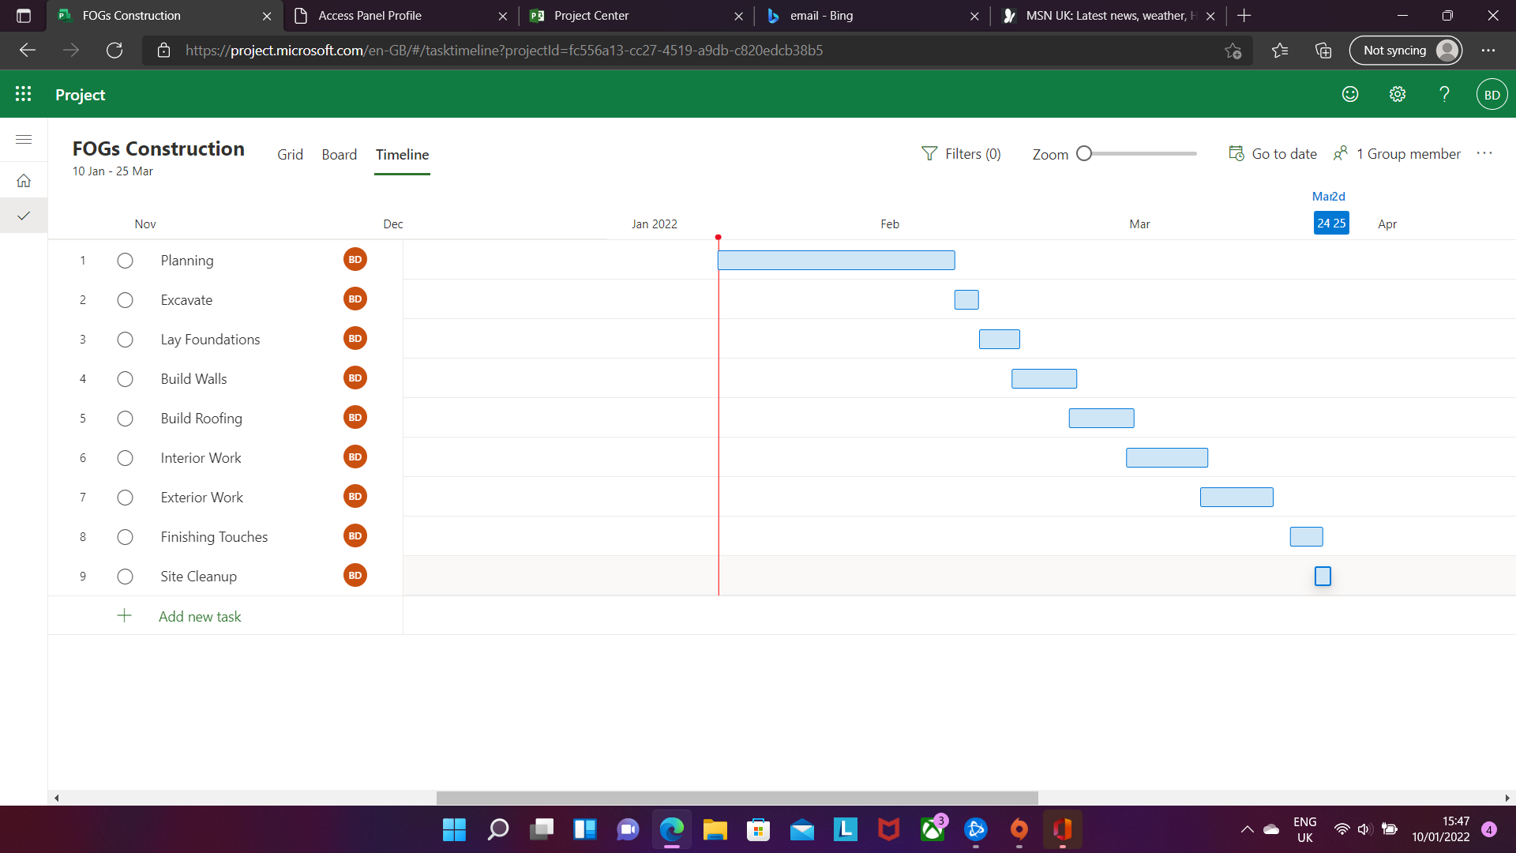

To access the project press the link below

https://project.microsoft.com/en-GB/#/taskgrid?projectId=fc556a13-cc27-4519-a9db-c820edcb38b5

Sign in details

Email – BenDavies@uwtsd911.onmicrosoft.com
Password – Uwtsd123

6.0 Site Reports

Report (1)

Project

FOGs construction, excavating for foundations to be built

Team

Davies Construction

Date of Visit

12:00 pm 09/02/2022
Contractor

Swansea Council

Site Address

Langdon Road, SA1, Swansea, Wales

Site Condition

Very good

Weather

Slight Rain

Work in Progress

Excavations for foundation work in 2 days

Observations

- Excavation going as planned
- 20 construction workers on site
- Trenches been dug ready to pour in concrete
- Rebar to be applied tomorrow then Concrete poured in after for the raft foundations

Report (2)

Project

FOGs construction, Walls being built

Team

Davies Construction

Date of Visit

2:00 pm 16/02/2022

Contractor

Swansea Council

Site Address

Langdon Road, SA1, Swansea, Wales

Site Condition

Very good and clean

Weather

Overcast

Work in Progress

Walls being built on foundations

Observations

- Construction going as well as planned
- 10 construction workers on site
- The first-floor walls have been built with brick on the outer wall and an inner timber wall
- Insulation has been installed
- Construction to be finished within the next few days

Report (2)

Project

FOGs construction, Interior Work

Team

Davies Construction

Date of Visit

1:00 pm 01/03/2022

Contractor

Swansea Council

Site Address

Langdon Road, SA1, Swansea, Wales

Site Condition

Very good

Weather

Windy

Work in Progress

Doors being fitted, Electric and heating work is being installed along with windows being fitted

Observations

- All work going very well as anticipated
- 4 electricians installing the electricity
- 2 glazers installing the windows
- 3 Plumbers doing the plumbing and heating
- 2 Carpenters installing doors and other projects
- Anticipated to be completed within a week.

  - References

June 2020, B.B. (2021). Building Foundations: A Step-By-Step Guide. [online] Homebuilding & Renovating. Available at: https://www.homebuilding.co.uk/advice/foundations-explained [Accessed 7 Jan. 2022].
Government, UK. (2021). Provision of welfare facilities during construction work HSE information sheet. [online] Available at: https://www.hse.gov.uk/pubns/cis59.pdf
Build It. Anon (2019). How to Build a Brick Wall (Steps with Pictures). [online] Available at: https://www.self-build.co.uk/how-build-brick-wall/.
Davis, L., H, S. and June 2020, ley 08 (2020). How to Build a Roof: A Step-by-step Guide. [online] Homebuilding & Renovating. Available at: https://www.homebuilding.co.uk/advice/how-to-build-a-roof [Accessed 6 Jan. 2020].

