
2022
Aaron Williams
1900369@uwtsd.student.ac.uk
Abstract
Cyberbullying is an issue in society which has gained little attention to it and the victims it affects. Evidence supports the claim by multiple literature sources showing statistics of especially younger people who have been cyberbullied. Although there have been studies on cyberbullying, its victims and police responses to it, there is still not enough to make an impact on systems like the education system to make a change. In response to this, primary research was conducted to provide to the little amount of literature that has been done to validate and support their findings and to attract others to further research it. Findings raise further questions regarding young people spending too much time unsupervised on electronic devices and the potential failure of the education system and police forces to support victims and to prevent it from happening again.
School: University of Wales Trinity Saint David
Course: Professional Policing
Deadline: 06/05/2022
Word Count: 8194
Victims of Cyberbullying and Dyfed Powys Police Response
  - Understanding Cyberbullying and the Effectiveness of Dyfed Powys Police Response to Victims of Cyberbullying.
Contents
Declarations 2
Acknowledgements 4
1. Introduction (1200) 5
Scope 5
Objectives 7
Overview 8
2. Literature Review (2500) 11
Objective 1 11
Objective 2 17
3. Research Methods (1500) 20
Introduction 20
Research Strategy 21
Data Collection 23
Framework for Data Analysis 24
Limitations 24
4. Findings (2000) 26
5. Conclusion (800) 45
6. Bibliography 51

Declarations
This work has not previously been accepted in substance for any degree and is not being concurrently submitted in candidature for any degree.
STATEMENT 1
This dissertation is being submitted in partial fulfilment of the requirements for the degree of BA/BSc.
STATEMENT 2
This dissertation is the result of my own independent work/investigation, except where otherwise stated.
Other sources are acknowledged in the Reference Section.
STATEMENT 3
I hereby give consent for my dissertation, if accepted, to be available for photocopying and for interlibrary loan, and for the title and summary to be made available to outside organisations.
STATEMENT 4
I hereby give consent for my dissertation, if accepted, to be available on the university’s IT system to those who have consent to use the system.

Student’s Name: Aaron Williams

Signed: A. S. Williams

Date: 04/05/2022

Acknowledgements

I want to greatly thank the two lecturers who supported me during this dissertation, Rhiannon Lloyd and Luke Roach who both supervised at separate times. Without their support I would have found it far more difficult to carry out this dissertation. However, their support has allowed me to find this process smooth and simple in its framework. Their help and support will always be remembered.
I would like to acknowledge my family and friend who supported me not only with words but actions during the period of writing this dissertation, their kindness will always be remembered.

Introduction

Scope

Cyberbullying is a vast topic and the difference with this topic is that other common issues such as knife crime and domestic violence are highly acknowledged among people whereas cybercrime, more specifically cyberbullying is not as commonly thought upon when thinking of crime. Therefore, a look into an uncommonly aware crime will allow for an interesting understanding of what it means to be a victim of being bullied via social media or the internet. The internet has grown in popularity since the early 2000s and so, anyone born after that period will likely grow up in a home with access to some form of social media which would give someone access to bully them. Furthermore, during the Covid-19 lockdowns, people have resorted to spending more time on smart devices and as a result, spending more time on the internet talking to people and during 2020 the UK internet users have doubled (BBC News, 2020).
When looking at the number of people who are victims of cyberbullying, 1.5 million young people in 2019 were bullied but half of them never told anyone about it (Ditch the label, 2019). Therefore, by examining the topic cyberbullying it allows for understanding of it and a further increase of the knowledge which people may not know. Furthermore, an extent of research will produce a wider scope of how cyberbullying affects the victims and their families. A look into the Dyfed Powys Police response will prove if their actions hold up enough response for victims and if there is enough support for them. Nartgün and Cicioğlu (2015) found relationships between young people’s internet use and cyberbullying behaviours. Jung et al (2014) similarly found a clear connection between cyberbullying behaviours and problematic internet use. Therefore, the benefits of this research will support future research into the issue of cyberbullying, as social media and internet evolve and the users increase, there will likely be a correlation between the increase of users and bullies. The look into information and actions that Dyfed Powys Police conduct will allow understanding if they are aware of the issue or not.
Furthermore, a blend of qualitative and quantitative data must be used to gather primary research which is first-hand gathered information used alongside secondary research. A questionnaire will be used and shared via the internet using open and closed questions to get answers which are qualitative data, which is answers and opinions from people and quantitative data which is numbers and statistics. For example, a qualitative question will look like, list different forms of cyberbullying you are aware of. Whereas a quantitative approach will ask to have you been a victim of cyberbullying? By using a range of questions and methods it will allow for a quality range of primary research methodology, linking strongly with the title. The advantage of using the internet is that anyone can answer it at any time which would be far more time effective than interviewing individual victims. Furthermore, it would be more cost-effective as paper and ink would not need to be used. The questionnaire can be sent anywhere on the internet, using Facebook and other means of social media to spread the questionnaire will allow for a range of age groups and locations, allowing to see if there are trends between ages groups in specific areas.
The target sample for the methodology is not particularly aimed for, but a questionnaire aimed towards younger people would be suitable due to the link between cyberbullying and young people. Although it would be interesting to know the ages of people who fill in the questionnaire to find out if particularly older people have had as many negative experiences as young people via people bullying on the internet.

Objectives

Two key research objectives are used to lay out the structure clearly. The first section will aim to examine and explore cyber bullying which is made up of key points which will cover different aspects of the topic. These include looking at the definition of both bullying and cyberbullying, comparing, and contrasting the definitions and looking at the difficulty of defining it for legislative purposes. Context will cover key elements of cyberbullying using statistics and websites which provide information on the effects of cyberbullying on victims. Looking at both physical and mental health effects will also link to signs of bullying. Alongside this, different forms of cyberbullying will be introduced which will address other issues of mental health.
The second objective will review the effectiveness of Dyfed Powys Police’s response to victims of cyberbullying by analysing information given by the police. Looking at prevention strategies and guidance will also highlight the police’s involvement with other agencies and organisations which help one another to combat the issue of cyberbullying. The information gathered for these research objectives will be a variety of key literature including books, journals, websites, government websites, articles and government laws and strategies. A wide range of secondary research results in effective research by analysing and evaluating the research previously conducted by other academics.

Overview

A brief overview of the dissertation structure:
Chapter 1 - Introduction
1. Research rationale - an explanation of the current issue of cyberbullying and why the research is important.
2. Aims and Objectives - containing the main aim of the research and the objectives used to meet the main aim.
3. Dissertation structure - an overview of the format of the dissertation and how the reader can navigate through it freely.
Chapter 2 - Literature Review
Chapter two includes a critical review of existing literature on cyberbullying. This is set out in a simple and clear way, showing main points through secondary research. The existing literature used covers understanding cyberbullying by defining cyberbullying, key context, forms of cyberbullying and effects of victims of cyberbullying. The second section will cover the Dyfed Powys Police response to victims of cyberbullying by highlighting prevention strategies and guidance, looking into key legislation, exploring methods of support for victims, and supporting events the police have been involved in.
Chapter 3 - Research Methodology
Chapter three will discuss why the approach of an online questionnaire was used for the section of methodology. Qualitative and quantitative will be explained and why they are critical for researching cyberbullying. A focus on the data collected will allow for a fresh view of the issue, allowing for new research to be found. The reliability and validity of the research methods will be explained in this chapter to strengthen their involvement in the study. A conclusion of this section will highlight any potential limitations to the research method used.
Chapter 4 - Discussion and analysis of research findings
Chapter four will discuss and analyse the research findings by firstly linking the data to the main aims and objectives of the study. It will show if the new information provides new positive data to the title question or if it negatively impacts it. Secondly, the findings will link to the previous research mentioned in chapter two. The research will either be like previous research, in for example the ages of cyberbullied victims, or it may be different and provide new insight into understanding cyberbullying. Patterns and trends will be explored, to see if the causes for bullying can be recognised or not by comparing research literature.
Chapter 5 - Conclusion and recommendations
Chapter five will draw together all key information and points made throughout the study into a conclusion. After examining the research, recommendations may be made which could praise or critique the work of Dyfed Powys Police in their response to victims of cyberbullying. A recommendation could also be made for future research by viewing the issues within the study to allow for a personal reflection. The final recommendation will look at the methodology used in the study and analyse whether the target sample was large enough or if the reliability was good enough.

Literature Review

Objective 1

Cyberbullying is a current issue worldwide affecting the mental health of individuals, primarily in adolescents during school years. Adolescence is one of the most important periods of human life due to the rapid growth of physical, cognitive, and psychosocial elements, this occurs from ages 10 to 19 (World Health Organisation, 2021). The Office for National Statistics (2020) found that in England and Wales around 1 in 5 children aged 10 to 15 experienced some type of online bullying. This highlights the adolescent’s use of social media in the digital age of internet usage exposing themselves to inaccurate, inappropriate, or unsafe content and creating an unhealthy environment (Chassiakos et al, 2016, Council on Communications and Media, 2016, O’Keffee, 2011). Quaglio and Millar (2020) suggest this unhealthy environment being addicted to the internet or having a negative impact on the cognitive development of the person.
Bullying is a term that usually involves two people, a bully and another, a victim. The bully abuses the victim through means of physical, verbal, or other ways which causes a sense of power on the part of the bully (Donegan, 2012, Helpguide, 2021). The characteristics of a bully are similar among the opinions of academics, their behaviour is repetitive and intentional, they are aggressive, hyperactive and want a power imbalance (Felipe et al, 2011, Nocentini et al, 2018, Thomas et al, 2015). The forms of physical abuse can be pushing, shoving, or hitting and verbal abuse could be spreading rumours about the victim (Petrosino et al, 2010). This could also come as a result of cyberbullying online, transitioning into physical abuse.
Except for physical abuse, although it can be accompanied by cyberbullying when the victim is in school, it does have additional characteristics, and the definition has more to it than traditional bullying. The first point is that the characteristics of bullying are carried over to the digital realm. The definition is that of traditional bullying but through electronic devices and it is simple for young people to be involved in this because they go along with newer technology, whereas adults would be less likely to (Kowalski et al, 2012). This definition focuses on the impact on the victim’s communication abilities as the bully can appear as different individuals with anonymity, thus being susceptible to further attacks (Englander, 2017). For example, if someone had a disability and could not communicate effectively, a bully could target them easier because they know that person cannot defend themselves. However, arguments against the vastness of the definition raise criticism. Alipan et al (2016) raise points such as the intent to harm may not be clear through technology as body language and tone are not considered. Likewise, if an uncompromising photo was taken once but uploaded to the internet it would be counted as repetition. The points show the difficult view of the definition of cyberbullying because intent cannot be proven as body language or the actual intent of why they did it would not be known.
To further understand the vastness of cyberbullying an in-depth view into the previous research will show how many young people are victims of cyberbullying around the world. Ybarra and Mitchell (2004) conducted a survey in the United States of America of 1,501 people aged 10 - 17 years old who used the internet daily. The results found that almost 1 in 5 (19%) were involved in some type of online harassment within the previous year. 12% of the survey had also been involved in being aggressive towards others through the internet. Ybarra et al, (2006) followed up in 2005 showed that 9% of the 1500 internet users were targets of online harassment, 32% of them reported chronic harassment (more than 3 times within the period), and 38% reported distress as a result of the harassment which was shown more by ages 10 – 12. Smith et al (2006) surveyed 92 students aged 11 - 16 years old from 14 different London schools in 2005. Results showed that 22% had been victims of cyberbullying at least once and 6.6% were being cyberbullied frequently and the most common means of this were via phone calls, text messages and emails. Li (2006) surveyed 264 Canadian students aged 12 - 14 years old from three junior high schools. About 25% had been victims of cyberbullying rather than traditional bullying and 17% reported that they had cyberbullied others and lastly 53.6% reported that they knew someone being cyberbullied.
Along with the issue of cyberbullying and the data which shows the victims, there is also a need to investigate the forms of cyberbullying as there are different ways someone can be a targeted. According to Kantar Public (2018), examining bullying will allow for the department of education to grasp the issue and so they can help young people. The types of cyberbullying would need to be examined which include text messages, emails, phone calls, pictures, video clips and others (Slonje and Smith, 2008). Furthermore, reports show figures and statistics for bullying overall by mentioning forms such as name-calling, social exclusion, robbery, threats of violence and actual violence, but fail to separate traditional bullying from cyberbullying by combining them into one topic and issue (Department for Education, 2015). Waasdrop and Bradshaw (2015) agree that there is an overlap between traditional bullying and cyberbullying due to the forms carrying over between each other.
Effects of cyberbullying may not be obvious like physical abuse, due to the lack of bruises or marks to the skin but have a strong impact on the emotional and mental health of cyber victims and may lead to anger, isolation, depression, illness and humiliation (Gordon, 2021). However, although the physical marks may not occur from the bully, they may come because of self-harm when the individual is being reluctant to tell parents about the issue or find themself struggling to ask for help (BullyingUK, 2021). According to Perren et al (2010), an investigation sought out students in Switzerland and Australia and found a link between victims of bullying and depression. It was also reported that cyberbullying victims reported higher levels of depression symptoms than traditional bullying. Fekkes et al (2004) conducted a cross-sectional study of 2766 school children aged 9 to 12 years old and found that bully victims had significantly higher chances for depression and psychosomatic symptoms which would lead to other health issues including headaches, abdominal pain, bedwetting, tiredness and depression. Kumpulianinen and Rasanen (2000), found that bullying negatively impacts children ages 8 to 15 and not only causes psychiatric symptoms, can also lead to further mental health issues in future and can lead to the individual never being able to recover from it. A great deal of the research into this area clearly states a strong link between cyberbullying and depression and is likely to occur if the individual cannot recover from it which can even lead to delinquent behaviour or substance use in later years (Neary and Joseph, 1994, Wigderson and Lynch, 2013, Wang et al, 2011, Mitchell et al, 2007).
When reviewing the seriousness of the harmful effects of cyberbullying, depression may lead to self-harm and potentially suicide in serious cases. Buksbazen (1976) reviews a case of suicide and the reasons why someone would take their life. In the case of Ronald who committed suicide, he overdosed on drugs, was rushed into hospital and committed suicide a few months later. The behaviour of someone who takes their life is in a desperate place, like someone who loses their business and may not become depressed or lose their mind but may consider the reasons to live, may have none and take the life (Kupfer, 1990). Understanding why people take their life is important because victims of cyberbullying go through similar experiences. The key theme among suicides is the sense of hopelessness, and studies show that being a victim of bullying can result in suicidal thoughts and attempts on their own life (Mills et al, 2014, Klomek et al, 2007, Hinduja and Patchin, 2010). According to Ditch The Label (2020) in an annual bullying survey of 13,000 young people, it found that victims who had been bullied within a year had an 11% rate of attempted suicides. The danger with suicide is that it can be built up both long term if someone is being bullied frequently and short term if someone is bullied harshly once at a critical point in their life (Joiner, 2005). Szumilas and Kutcher (2008) highlight the warning signs of suicidal behaviour which include feeling very depressed, feeling hopeless, being withdrawn from family and friends, loss of interest in activities once enjoyed and no longer taking care of the appearance which when put side by side to the cyberbullied victims makes the severity of the issue clear.
Tozer (2013) wrote an article about a case of a cyberbullying victim namely Joshua Unsworth aged 15 years who was bullied anonymously through a website and took his own life. Daniel Perry was another person aged 17 who was blackmailed by sexual content and took his life also (BBC News, 2013). There is no law that highlights bullying and so the decisions when prosecuting a bully must come from different legislation which links to a case which highlights a lack of protection in this area (Asam and Samara, 2016, Marczak and Coyne, 2012). Although there are no specific laws to prosecute bullies, there are many laws that act as a deterrent to prevent bullying. The Anti-Bullying Alliance (2021) highlights key legislation in bullying prevention, these include section 175 of the Education Act (2002) which places a legal duty for schools and local authorities to keep children safe and to promote their welfare. The Children Act (1989) protects children regarding self-harm or trauma from bullying by providing support from local authorities and schools. Section 89 of the Education and Inspections Act (2006) states that schools must ensure that good behaviour is encouraged among pupils to prevent forms of bullying. Other legislation such as the Malicious Communications Act (1988) and Protection from Harassment Act (1997) both protect individuals from threats or harassment whether physical or online. Finally, the Equality Act (2010) prevents the use of discriminatory language towards a person’s race, sex, or religion.
The Department for Education (2018) highlights that schools have no legal requirement to record, and report bullying incidents and advises schools should develop their own approaches for monitoring bullying. This again shows the lack of defining bullying in legislation and resorting to recommendations rather than legal guidance or strategic plans for bullying prevention. “Social researchers and education practitioners are struggling to keep up with the changing nature of bullying, and especially aspects of cyberbullying” (Paul et al, 2012, p. 492). This suggests that teachers within schools or people who work in the education department do not fully understand cyberbullying. The reason why some may not see the issue is due to their lack of use of the internet or electronic devices and so they do not understand how someone can be bullied via social media.
However, although there are no specific laws and no clear definition, there are multiple agencies and organisations which help and support the victims of cyberbullying. According to the Welsh Government (2011), there are two main ways to support and respond to cyberbullying. These include preventative work which is ongoing and provides an updated framework for schools and agencies and secondly, responsive work which happens when bullying is reported and then a response can come when looking into a specific case.

Objective 2

Firstly, the preventative work must come through raising awareness, giving information and developing the understanding of adults and young people of the issue. Thinkuknow (2021) supports people in delivering education and raising awareness of online child abuse and exploitation, which include cyberbullying, and they aim to prevent it before it occurs. Furthermore, websites such as the Suzy Lamplugh Trust (2019) and the NSPCC (2021) layout information based on specific types of cyberbullying. These include stalking and offering advice on preventing it or explaining the effects of cyberbullying and signs of someone being a victim which aim is to raise awareness to prevent it from happening. Dyfed Powys Police (2021) also give out information on certain topics like harassment, stalking, signs of stalking and mention cybercrime which covers crimes like fraud and fake websites. However, there is no clear information on cyberbullying and its signs, therefore only mentioning broad terms.
Dyfed Powys also has school liaison officers who provide a positive strategy to schools to enhance their knowledge, understanding, behaviour, values and skills regarding education, anti-social behaviour, and personal safety. Through this, student’s behaviours may change when they understand the effects of bullying on another person. Teachers, Personal and Social Education Coordinator and pupils agree that the program is informative, positive, and important in helping students understand the extent of current issues (Dyfed Powys Police, 2022).
Young people’s experiences regarding cyberbullying prevention are positive, they want to be involved in ways to promote good online behaviour, make people aware and share experiences of online bullying. Secondary school pupils were more so associated with online bullying rather than physical, so that would allow for a more specific plan to prevent online bullying (Child Commissioner for Wales, 2019). Lastly, according to Williams and Pearson (2016), in March 2015 the National Crime Agency launched the Cyber Crime Week of Action Campaign which aim to prevent and stop cyber-crime. Dyfed Powys Police also has a specialist Digital Cyber unit which work alongside Get Safe Online, which primarily focuses on helping people to stay safe while using the internet. This method would be the responsive work which was a direct response to cybercrime during that week in 2015. Other charities and organisations such as Crime Stoppers (2021), National Bullying Helpline (2021) and IWF (2021) also use this method of support when people have been a victim of bullying and are able to report the crime or talk to someone.
In conclusion, cyberbullying is an increasingly acknowledged issue in the world, but it still has not had the traction it should. Adolescent years 10 – 19 are important for brain function and growth in individuals and research shows that cyberbullying is often at its highest in this age group. Defining cyberbullying has been an issue for academics and certain key terms and words can be fitting for different opinions, but a basic definition has been agreed in legislation to have similar behaviour traits of a bully. Previous research by Ybarra and Mitchell (2004), Ybarra et al, (2006), Smith et al (2006) and Li (2006) have been conducted across multiple countries in forms of surveys and questionnaires that have found data of individuals who have been victims of cyberbullying. Different methods of cyberbullying have been explored to advance knowledge of the issue and to raise awareness of how people can become a victim. Serious effects of cyberbullying have been analysed to show the pain and suffering being a victim can cause and to show that other health issues can occur later in life. Cases of people who have taken their lives because of cyberbullying show the reality and severity of bullying that happens. Although no clear laws have been laid out to prosecute bullies, there are multiple organisations in place that work together with each other and Dyfed Powys Police to ensure the safety of the public. Furthermore, they are willing to use their resources to help anyone in need to prevent any single case of bullying. Young people’s opinions of cyberbullying prevention also have a positive outlook on the future to prevent further cases from happening.

Research Methods

Introduction

Upon review of the literature review conducted in chapter 2, issues were found in the literature. The primary gap was in relation to the Dyfed Powys Police response to victims of cyberbullying. Furthermore, pieces of legislation such as the Education Act (2002), Children Act (1989), Malicious Communications Act (1988) and the Harassment Act (1997) aim to prevent and punish people who bully online but there is no clear definition of cyberbullying in law, only characteristics of cyberbullying are mentioned.
Therefore, primary research is needed within this dissertation, to gather more relevant information on cyberbullying and increase the number of credible statistics. The primary research goes back to the dissertation’s objectives, which are in brief, to understand what cyberbullying is and its effects on victims and Dyfed Powys Police’s response to victims of cyberbullying. The questions will relate to the public understanding of cyberbullying, which will show if it is commonly acknowledged or not. Along with statistics of people who have or have not been cyberbullied, furthering research on the topic and potentially aiming towards a higher awareness of the issue.
Due to the gaps in the literature, credible primary research will allow for further exploration for others into the topic if the issue begins to rise in the future. This would not only benefit the reader but could have an impact on support programs or individuals who want to help victims of cyberbullying.

Chapter 3 will be made up of four primary sections being:
- Research Strategy - This will include the overall research strategy and why this method has been chosen. It will also show the intent of the sample target audience and why that target was chosen, including methods of sampling.
- Data Collection - This will cover the method used to collect the data and why this method is the most effective.
- Framework for data analysis - This will lay out how the data will be used and what it will be used for and how it will be analysed.
- Limitations and problems - This will focus on the challenges faced while conducting primary research. Limiting factors such as Covid-19 in preventing specific methods from being used.

Research Strategy

There are multiple styles of research strategies that have been analysed for the style of research methods. Case studies are popularly used due to the combining of qualitative and quantitative methods of data analysis further on (Gable, 1994). However, a different method is the Grounded Theory which is when data is gathered on a topic and the understanding and research grow throughout the work (Dey, 1999). The aim of this theory, highlighted by Glaser and Strauss (1967) is to discover a theory or generate one. This is done by means of going back and forth from primary and secondary research, growing in literature throughout a study. This method does partly suit this theory as the literature found can lead to further information into the objectives of this dissertation. It can only be partly used due to primary research being oftentimes firstly conducted after planning extensively which Chun Tie et al. (2019) describe a newer academic researcher may find difficult to do.
This dissertation will follow a combination of a case study and the Grounded Theory, as the research will have both qualitative and quantitative data along with discoveries of further information throughout. It will be beneficial together with characteristics from more than one method, giving a wider range of ways to gather, analyse and present data. The primary method however will be the survey method which analyses responses of individuals from questions given to them. This also is a benefit due to this method being recognised between 60 and 80 years and has evolved over those years (Groves et al, 2011).
There are multiple ways to sample a target population. These can include random, stratified, cluster and systematic sampling methods to name a few. Random sampling according to Bretch (1986) is when the data is collected at random and highlights the primary benefit being the unbiased selection of data. Stratified sampling according to Parsons (2017) is when a population is broken into groups (strata) which increases the efficiency of a sample design because the estimation of participants can be better estimated. An example of this could be splitting a classroom of 30 students by male or female. Thompson (1989) describes the cluster theory as effective in sampling data. Cluster sampling is like stratified sampling in that groups of strata are made but the data is collected at random from the groups (Henderson and Sundaresan, 1982). Finally, the systematic sampling method according to Yates (1948) is when samples are chosen at equal or regular intervals. This could be choosing a response for every tenth person on a list of questions.
The method of sampling that will be used is the random sampling approach. This will allow for responses to come from various groups to get a broader scope of victims of cyberbullying. Acharya et al. (2013) highlight that the whole population cannot be targeted. Therefore, since the target is anyone above the age of 18 the sampling method does not need to be specific, thus random sampling is favoured over the others.

Data Collection

There are multiple ways of approaching data collection. The method used for this research will be an online questionnaire. Jack and Clarke (1998) summarise that questionnaires’ can be a cost-effective research tool. Furthermore, the structure of the questionnaire should be pre-planned before being sent out, using various methods of questions to reach a wide scope of answers. On the other hand, interviews were thought about, but Wei and Moyer (2009) suggest a questionnaire is better due to it being able for collecting discrete pieces of information. This means also that the anonymity aspect can give people more confidence in giving their answers without the further questions of an interviewer.
Alongside methods of questions, there is also a foundation to each question, as one will either lean towards quantitative or qualitative data. Namazi (2003) describes a qualitative researcher as someone who presents deep and accurate information. In a questionnaire, these questions will focus more on an opinion that can be analysed and broken down, giving more than one point of information. Whereas quantitative data is different as Watson (2015) explains as data which is often collected through surveys or experiments in controlled trials. In other words, the data is collected more as statistics and values which can be analysed via graphs, tables and percentages.
The reason this data collection method was chosen is due to its vast benefits. Wright (2017) mentions that researching using the internet is beneficial because it is possible to reach audiences no matter their location. Time is a major advantage due to it being instantly uploaded once responses are submitted, this also makes it easier to send out the questionnaire in a timely manner. Lastly, unlike interviews in person, online questionnaires do not rely on paper and ink, so cost is considered. Furthermore, Huffman (2006) highlights a study done by library employees giving out anonymously via a survey online to other employees which showed to be successful in responses and for qualitative data to be evaluated.

Framework for Data Analysis

The analysis of the findings will be presented via graphs, charts, and tables to compare the data. The graphs will show a visual representation of the data and so will make it simple for the reader to understand and interpret. Charts will follow from the graphs which show the data into other forms like pie charts and percentages, once again to better visualise the findings. Finally, tables will be used to compare the data and recognise trends within the findings. Gelman (2012) argues that tables are better than graphs in their presentation of data because they show it in a more reliable fashion. However, both have their advantages and so both will be used.

Limitations

The primary limitation during this research is the impact of Covid-19 on potential methods such as face to face interviews. However, due to restrictions, it would be mindful that others may not feel comfortable meeting, therefore an online approach was a better choice. Regarding limitations to the sampled target audience, it may be noted that there is no guarantee of responses and if the responses can be fully credible, the credibility is hoped for those participants will answer truthfully for more accurate data. If they are not entirely truthful but answer some parts truthfully it will not be possible to separate the truth from the lies. Furthermore, it is not known how many responses will be gained when the questionnaire is handed out, this may result in potential delays of analysis due to the slow response times of the participants. Coughlan et al. (2013), claimed that due to the cost-effectiveness of the survey method that it is most used among researchers. However, they argue that there are other limiting factors such as representation and measurement of the data. This could lead to the analysis not being clear and accurate.

Findings

This chapter will reveal the results which are discussed previously in Chapter 3 - Research Methods. The questionnaire was sent out and responses were made which include their opinions on the matter of cyberbullying. The responses are anonymous; therefore, it is not known where these individuals are from, only their age is known. The questionnaire will be approached in a highly structured way. Firstly, a description of the data will be set out, to give visual and textual information to the reader for a simple understanding of the participant's answers. Secondly, this data will be analysed giving an interpretation of the data to understand what the answers mean to find potential trends among age groups. Lastly, the data will be synthesised, it will be linked back to the secondary research found in Chapter 2 - The Literature Review. Linking the primary sources to the secondary will allow for comparisons and contrasts between the data to establish trends or show information that has not yet been found. It may be noted too that the questionnaire is not related to Dyfed Powys Police effective to victims of cyberbullying, the questionnaire is meant to show the understanding and opinions of people regarding cyberbullying to help statistics for people researching cyberbullying in the U.K.

The following will contain a brief description of the responses to each question:

- What age group describes you?
This question was set out to, later, figure out what age groups the cyberbullying victims were.

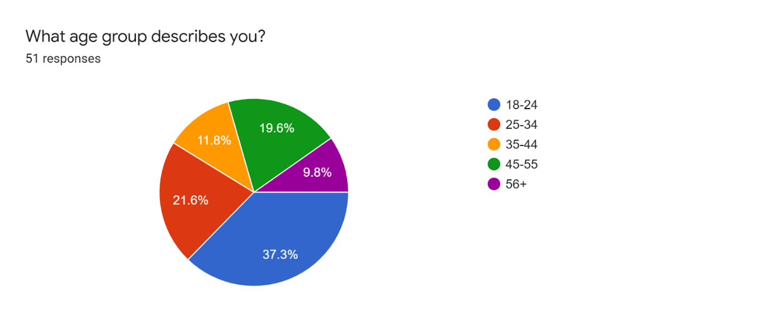
The majority was the age group of 18-24 (highlighted in blue) with 19 responses, followed by the 25-34 (red) with 11 responses, followed by the 45-55 (green) with 10 responses, 35-44 (yellow) with 6 responses and finally the 56+ (purple) age group with 5 responses. This is a relatively balanced response between the different age groups. The different age groups allowed for a more variety of responses when asked later how many times they were cyberbullied. Had the age group only been 18 - 24 years old the answer, later, would have been far different? Also, in relation to the literature review, lower age groups have been shown to suffer more from cyberbullying and so this will reflect on the opinions in the last two questions to see if people will respond by saying education will be a factor in preventing cyberbullying.

- What best describes your sex?
This question was asked to find out if there was a difference between males and females being victims of cyberbullying.

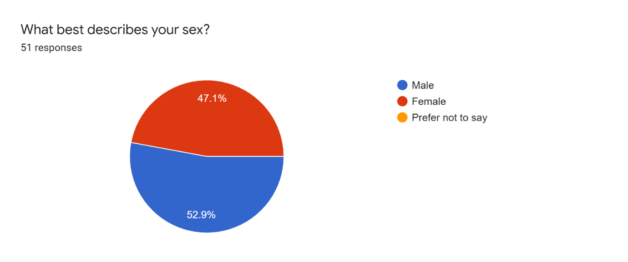

Once again, the males (27) and females (24) who participated in the questionnaire were balanced, this will be benefited the advanced analytics. It is good to see that both males and females were involved in the responses because it will show whether both sexes will have been victims of cyberbullying or not, backing up or adding to current statistics. Previous gaps in literature made no distinction between males or females being more susceptible to being a victim.

It may be noted that before question 3, a brief description of cyber bullying methods is given. This is what it says:

Common forms of cyberbullying include:

- Spreading secrets or rumours about people online.
- Sending mean texts to someone.
- Pranking someone's cell phone.
- Hacking into someone's gaming or social networking profile.
- Being rude or mean to someone in an online game.
- Pretending to be someone else to spread hurtful messages online.

- Have you ever been cyberbullied?
This was the beginning of figuring out who within the responses was cyberbullied in the past, different options were given to allow them to say how many times.
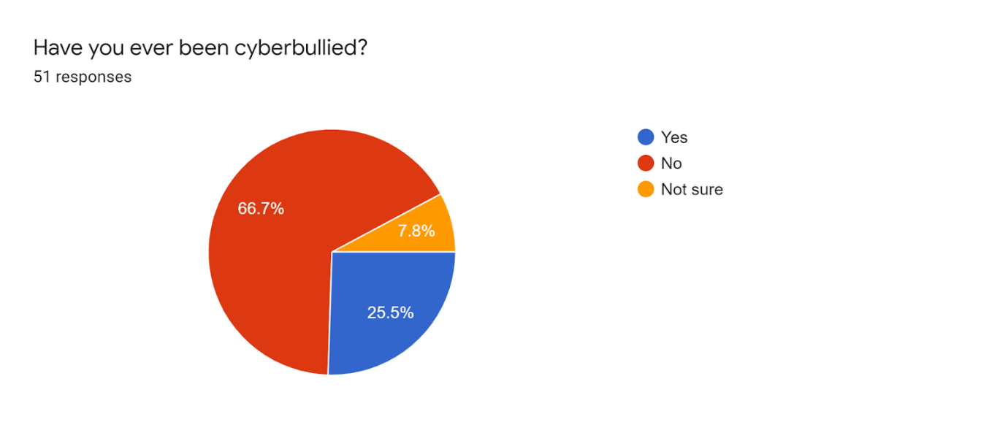

Most of the responses said no to being cyber-bullied which is highlighted in red at 66.7% or 34 responses. The yes responses were at 25.5% or 13 responses in blue and there were 7.8% or 4 who were not sure if they were or not, this might be due to a lack of memory of the incidents. Although the majority said no, there were still several people who admitted to being a victim. The questionnaire was primarily sent out to people who were involved in the education system, both students and staff. This means that the sample itself is good in relation to trying to find out if people who have had a good education have been victims of cyberbullying as it is most reported to be done during the adolescent years as shown by the Office for National Statistics (2020) in the literature review.

- If yes, how many times?
This was a further question to the previous one to figure out how many incidences of cyberbullying occurred within their lifetimes.

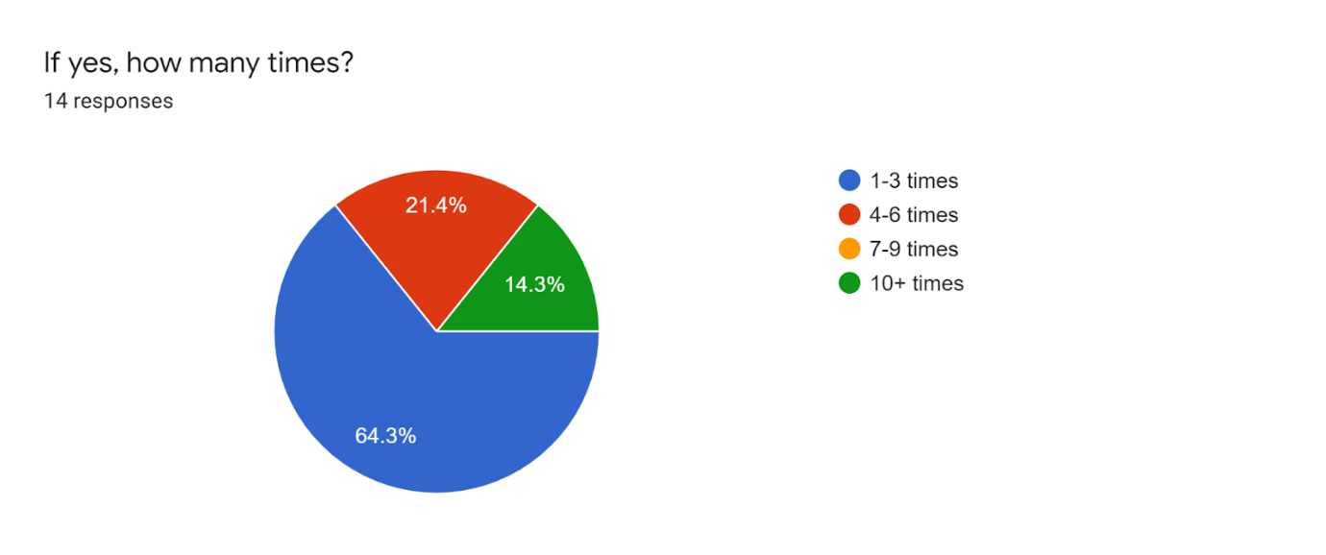

The majority that answered yes to the previous question answered 1-3 times which is 64.3% or 9 responses highlighted in blue. The second highest response was 4-6 times, which is 21.4% or 3 highlighted in red. Finally, the lowest response at 14.3% or 2 for 10+ times is highlighted in green. The answer of 1 - 3 times could likely be as a result of the bullying being stopped in some way.

- How many times have you been cyberbullied? (within the past 5 years)
This question aimed to change the focus from the lifetime period of potential incidents to a more recent timeframe of 5 years.

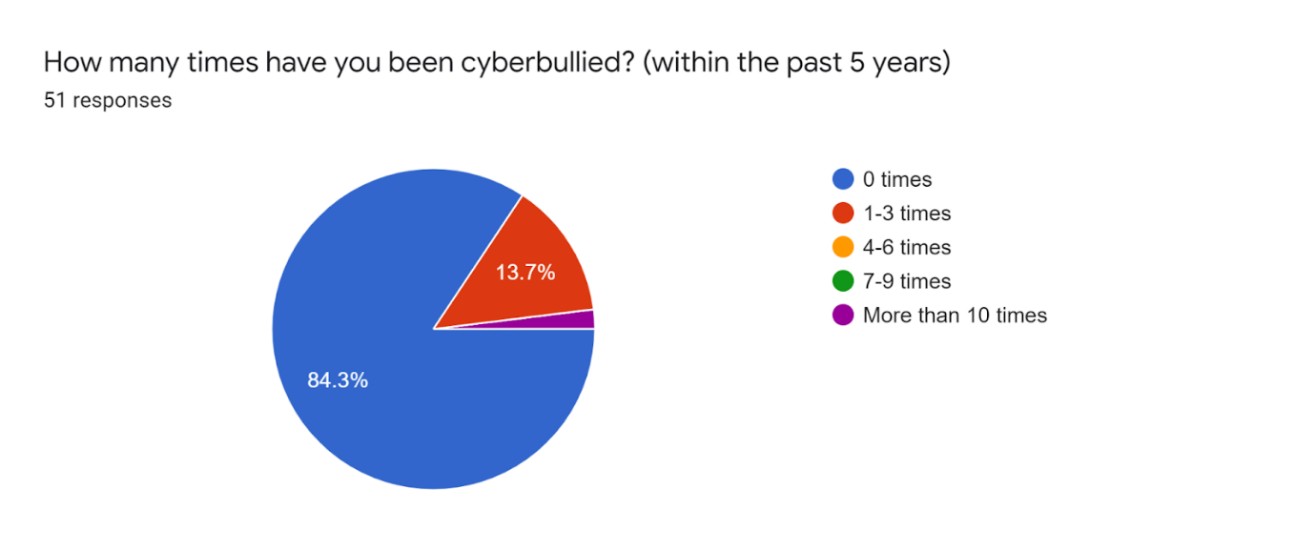

Many of the respondents said 0 times to this question which is 84.3% or 43 responses highlighted in blue. 13.7% or 7 responses said 1-3 times which is highlighted in red and the remaining 2% or 1 response said more than 10 times. The majority answered that 0 times within the recent 5 years could suggest that they were cyber-bullied at a younger age, not an older one. Once again linking back to the literature review finding that 1.5 million young people were victims in 2019 (Ditch the Label, 2019).

The following questions were opinions regarding specific statements noted, these questions were to understand the thought process of the responders to find out how much they knew about cyberbullying and its current impacts on society.

- Cyberbullying is on a rise

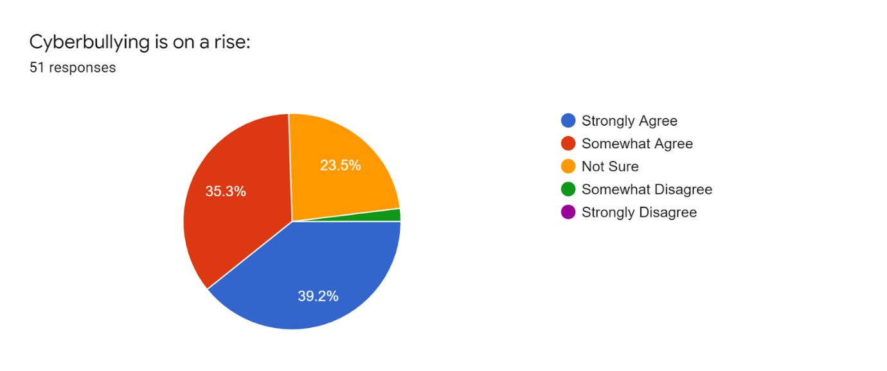

The highest response at 39.2% or 20 responses was strongly agreed and highlighted in blue. The second highest was somewhat agreed at 35.3% or 18 responses highlighted in red. The third highest was not sure at 23.5% or 12 highlighted in yellow and finally somewhat disagreed was at 2% or 1 response highlighted in green. The balanced answers suggest that people were not entirely positive that cyberbullying is on a rise and so shows that the issue is not openly talked about often or at all which also prevents laws from being written as shown by Paul et al, (2012) in the literature review.

- Incidents are most often reported by

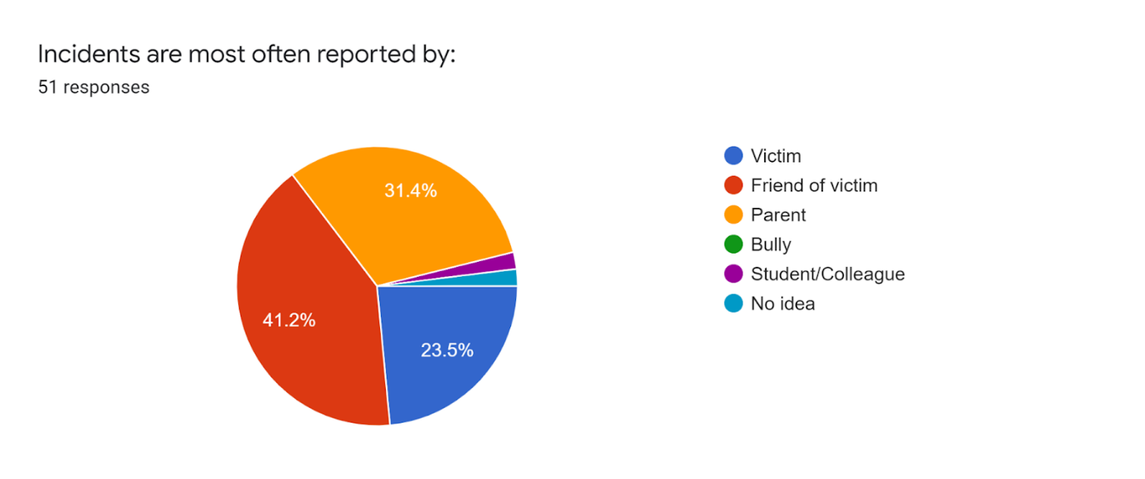

Most of the answer was the friend of the victim at 41.2% or 21 responses. The second highest answer was the parent at 31.4% or 16 responses. The third highest was the victim at 23.5% or 12 responses. The two equal minority 6 answers had no idea and the student/colleague at 2% or 1 response each. It is interesting for the highest answer not to be the victim. As in every case like this, the victim would first have to share or report the incident to someone before sharing it with the correct authorities.

- Cyberbullying most often occurs

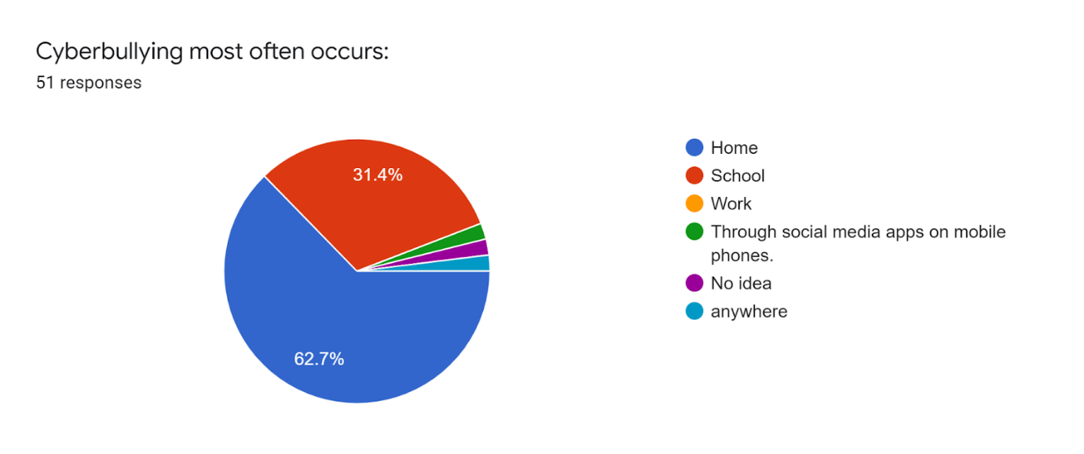

The majority answer was home at 62.7% or 32 responses. The second highest was a school at 31.4% or 16 responses. The three final answers were through social media apps on mobile phones, no idea and anywhere all at 2% with 1 response each. It is interesting here once again that home and school are the highest answers which strongly implies that the responders thought cyberbullying happens among younger people in schools, not older ones who work.

- Awareness of cyberbullying should be raised

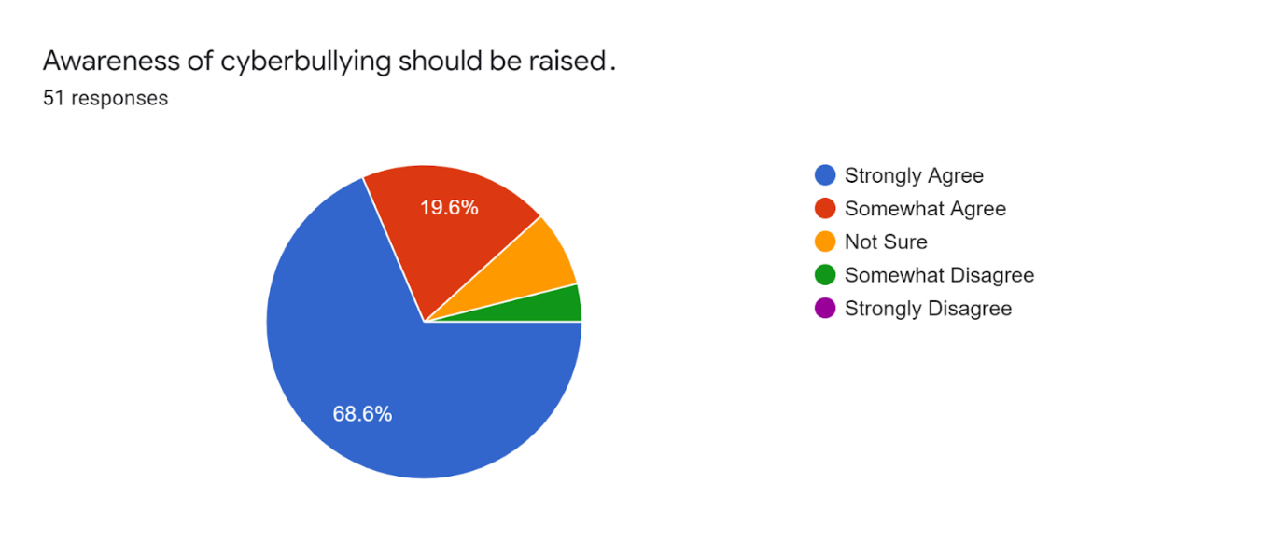

The majority answer was strongly agree at 68.6% or 35 responses. The second highest was 19.6% or 10 responses. Not sure is at 7.8% or 4 responses and somewhat disagree is at 3.9% or 2 responses. The answers do not only reflect the people who believe it should be raised but could also suggest that they themselves want to or should be more aware of cyberbullying.

- Do you feel like cyberbullying is more likely to occur among young people?

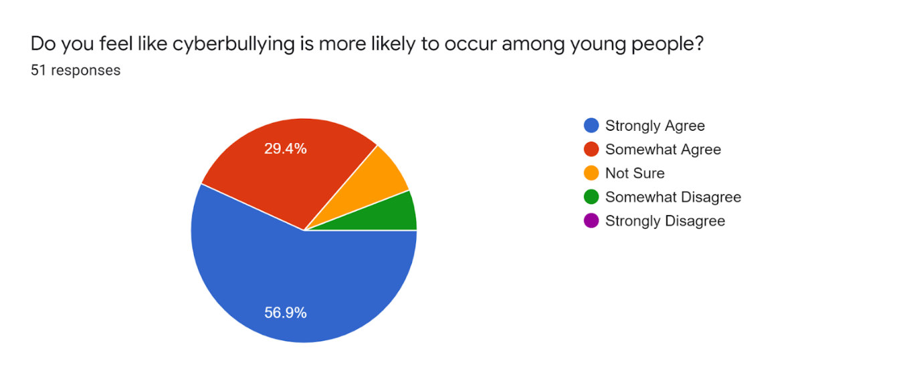

The majority answered strongly agree at 56.95 or 29 responses. The second highest answered somewhat agree at 29.4% or 15 responses. Not sure had 7.8% or 4 responses and somewhat disagree with 5.9% or 3 responses. The previous questions pointed to people believing that younger people are more likely to be cyber-bullied which was found out to be true in this question and once again linking back to the literature review.

- Cyberbullying has increased during the Covid-19 pandemic.

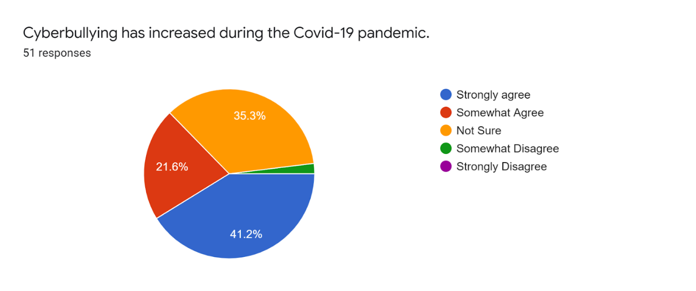

The highest answer was strongly agreed at 41.2% or 21 responses. The second highest was not sure at 35.3% or 18 responses. The third highest was somewhat agree with 21.6% or 11 responses. Lastly, somewhat disagree is at 2% with 1 response. The answers primarily support the statement that people were indoors more during the pandemic and as a result, cyberbullying would increase. This was found in literature, BBC News (2020) found that during covid-19 lockdowns internet usage increased.

The two final questions were optional open questions to allow for more detailed opinions.

- In your opinion, what would be an effective way in dealing with cyberbullying?

There were 45 responses to this question. Here are the responses:

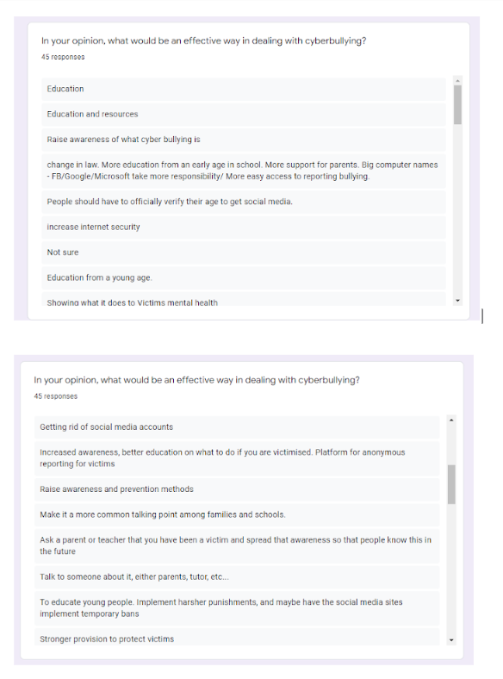

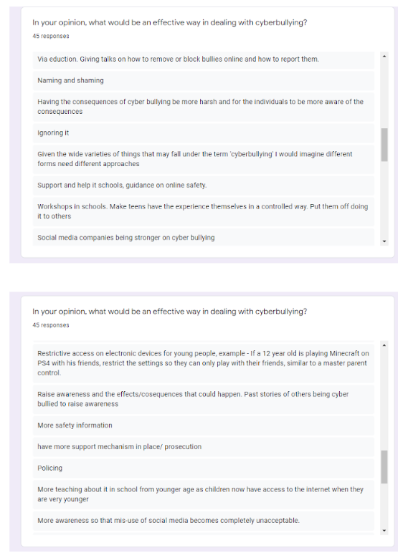

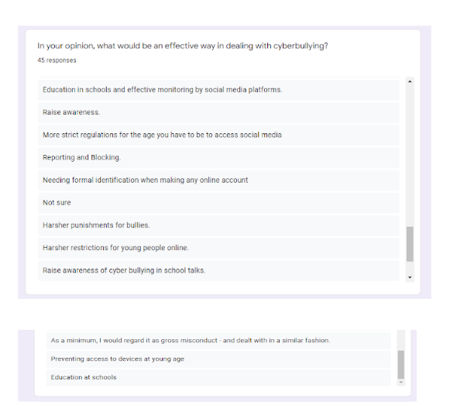

The main categories highlighted within the response primarily come under education, protection and ignoring/unsure. Some interesting points are raised within each category, the education answers raised points like making sure younger people understand the dangers of internet usage. Other points such as teaching young people how to report and block bullies online and this ties in with a lack of knowledge of how to use the internet safely. Protection was raised in different forms such as anonymous platforms for reporting, preventing access to devices at a young age, stricter regulations on social media and harsher punishments or stronger laws to be in place to protect people. Others then either were unsure or simply stated to ignore the situation in hope that it would resolve. Again, in relation to the literature, the primary focus of cyberbullying is found in and around the education system as it happens at younger ages and requires more support as also the respondents have stated.

- In your opinion, what makes someone vulnerable to cyberbullying?

There were 44 responses to this question. Here are the responses:
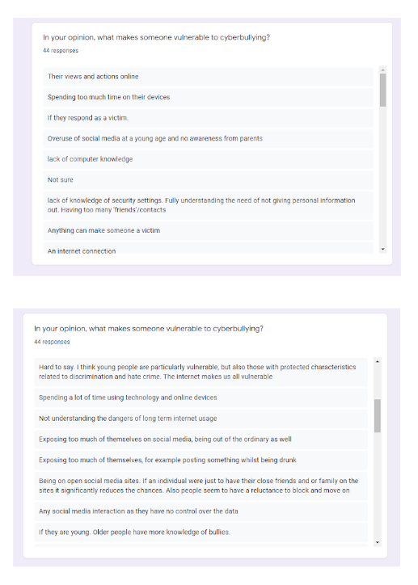

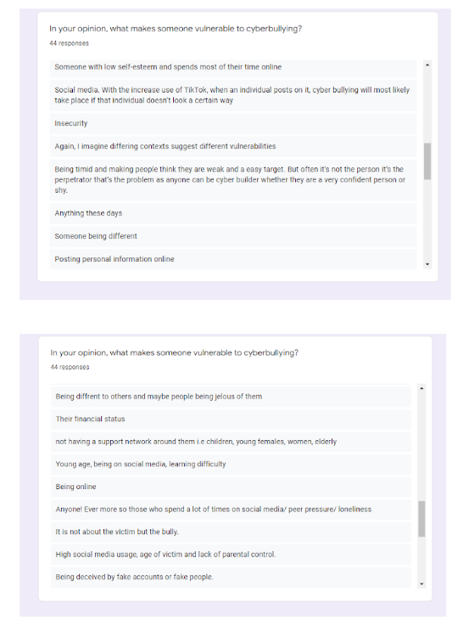

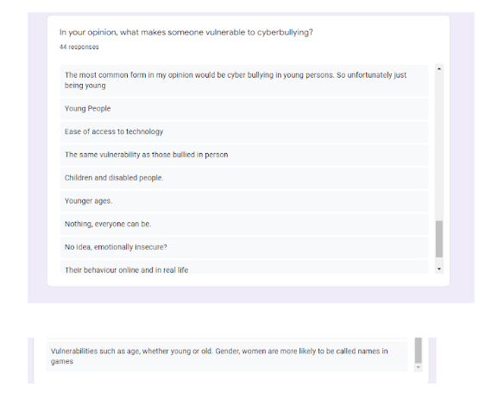

The main categories and common trends of responses for this question are the usage of the internet, lack of knowledge, anyone, young or vulnerable people and low confidence causes people to be vulnerable to cyberbullying. Similar trends are found in the answers here as in the previous questions. Most of the answers lay around the fact that they believe people are spending too much time on the internet or devices which makes them more vulnerable to being cyberbullied. This would be common as people spend more time online, their digital presence is known to more people which would increase the chances of them being cyberbullied. Younger ages are repeated along with disabled people and women who specifically are targeted more in video games as primarily males play them. Disabled people could be targeted because they cannot protect themself the same as someone who is not disabled as their mental capacity would differ. Someone with a lack of knowledge on how to use technology or the internet ties once again to education and the earlier years of adolescents when the brain improves the most as found in the literature by the World Health Organisation (2021). Lastly, others mentioned that anyone can be a victim of cyberbullying which then leads to different scenarios with different people. As someone with low self-esteem can trust someone online as a friend easier than someone who does not use the internet or social media as often.

Conclusion

The literature identified the key concepts of cyberbullying by looking at the definition to understand what it means to be cyberbullied. Further exploration led to statistics of young people specifically who were cyberbullied to add to the knowledge and understanding of the current issue in the United Kingdom. Although this information is important most of the literature revolved around the effects on victims of cyberbullying to look at brain function and how bullying can damage a young person’s confidence. The literature had statistics but lacked current information or more specific information which could link to the key objectives of this dissertation. To further support this first objective which was to explore cyberbullying and its effects on victims, the primary research was carried out to either support or oppose current literature.
The main conclusion gathered and lesson that can be drawn from this research is that cyberbullying is highly likely to occur at a younger age, as the literature supports. The answers given were of a majority 18 - 24 and by looking at the individual responses show that the 18 - 24 age groups said they have been a victim:
This is an example (response 7)
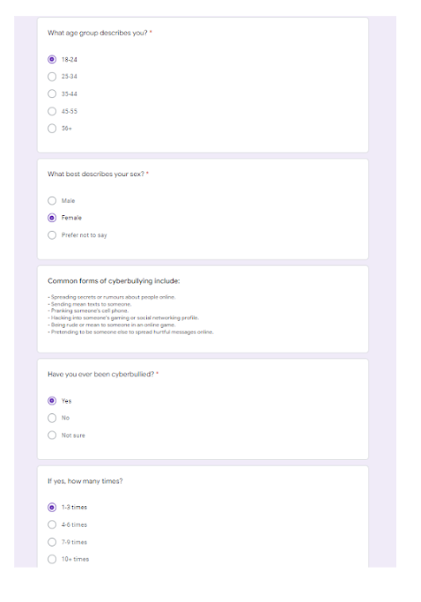

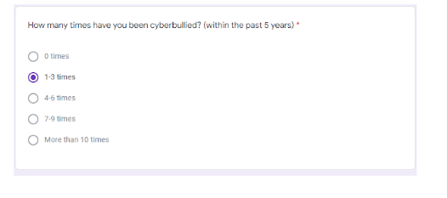

Another example (response 8)

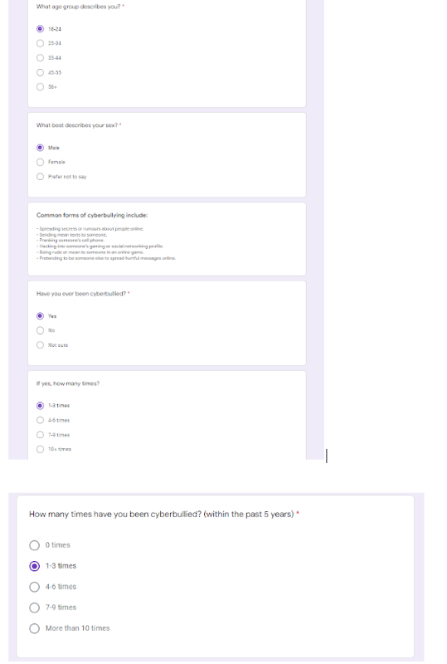

It is interesting that these two and other subjects have shown that the youngest age groups have been victims of cyberbullying that has happened over the last 5 years which is likely to be in their teenage years, except for those who it happened to them at 19 years old. However, this once again backs up the literature review statics because it shows that younger people are more likely to be cyberbullied due to their use of devices and the internet. To conclude this part, cyberbullying is less of an issue for adults at older ages.
The second objective was to look at the effectiveness of Dyfed Powys Police to victims of cyberbullying but as seen in the literature review there has not been done extensive research or studies showing how or what they do to prevent it and support victims. This was therefore not mentioned in the questionnaire because the whole point of this was to find out who was cyberbullied, this then could help other researchers or even the police force themself to help support victims or look further into the issue to find out causes. The barrier to this objective was that if questions regarding cyberbullying were asked, the questionnaire would have taken too long to fill out which would lessen the responses and would be too specific as the location of the responders is not known.
This dissertation can then give and receive recommendations, two types of recommendations will be given, first a recommendation for this study and secondly, one for future studies. To begin, regarding the questionnaire, the sample size and responses were good, but the questions may have been better fitting in relation to the second objective. For example, if more information would have been needed for the effective response of Dyfed Powys Police, questions such as: have you ever reported your bully to the police or asking at the beginning which area they are from. This then would give a better approach to answering the objective. Future studies could benefit from forming opinions and feedback from a specific area and force. Having information in a specific area would benefit not only the researcher but also those who are researching within an area, sharing this information and results would be beneficial to the police forces also.
Another recommendation would be adding another objective which would relate to the two current ones. Upon commencing research with both primary and secondary research, another fitting objective could be a closer look at the core of why cyberbullying exists both in literature and by hearing opinions of questionnaire responses to form an academic understanding and comparing that with the opinions of others to see if there is any difference. Future researchers would benefit from this as they could better combine their information into clear and conceive research which would benefit readers.
Finally, a recommendation could be made to the education system due to cyberbullying possibly being in every school in the United Kingdom. A better system in place would identify and support victims of cyberbullying. This would include support staff who can go to schools to give lessons to the students on cyberbullying and be available for them to speak to. Making their role hidden in a sense could more likely cause students to go to them to speak so that other students would not know why they are speaking to them, thus making it a more comfortable environment.

Bibliography

Acharya, A. S., Prakash. A., Saxena. P., Nigam. A. (2013) ‘Sampling: Why and How of it?’, Indian Journal of Medical Specialities, 4(2), pp. 330-333.
Available at: https://www.researchgate.net/profile/Anita-Acharya-2/publication/256446902_Sampling_Why_and_How_of_it_Anita_S_Acharya_Anupam_Prakash_Pikee_Saxena_Aruna_Nigam/links/0c960527c82d449788000000/Sampling-Why-and-How-of-it-Anita-S-Acharya-Anupam-Prakash-Pikee-Saxena-Aruna-Nigam.pdf
(Accessed: 06/03/2022)

Alipan. A, Skues. J, Theiler. S, Wise. L (2016) ‘Defining Cyberbullying: A Multiple Perspectives Approach’, in Wiederhold. G and Wiederhold. R (ed.) Annual Review of Cybertherapy and Telemedicine 2015: Virtual Reality in Healthcare: Medical Simulation and Experiential Interface, Amsterdam: IOS Press.

Anti-Bullying Alliance (2021) What does the law say about bullying?
Available at: https://anti-bullyingalliance.org.uk/tools-information/all-about-bullying/bullying-and-law/what-does-law-say-about-bullying
(Accessed: 14/11/2021)

Asam, E. A and Samara. M (2016) ‘Cyberbullying and the law: A review of psychological and legal challenges’, Computers in Human Behavior, Volume 65, pp. 127 - 141.
Available at: https://www.sciencedirect.com/science/article/pii/S0747563216305775?casa_token=qYrnmmQYMSMAAAAA:spomcMegtR1XNJ_ac8CkN5zaK3KfEvCij4nuSDTXkdSClWI2t-E8pIZ3QeZnkbgQSUlLoohwqPev
(Accessed: 14/11/2021)

BBC News (2013) Daniel Perry's death sparks cyber-blackmail probe.
Available at: https://www.bbc.co.uk/news/av/uk-scotland-24428437
(Accessed: 14/11/2021)

BBC News (2020) UK internet use doubles in 2020 due to pandemic.
Available at: https://www.bbc.co.uk/news/technology-55486157
(Accessed: 18/11/2021)

Bukabazen. C (1976) ‘ Legacy of a Suicide’, Suicide and Life-Threatening Behavior, 6(2), p. 106.
Available at: https://www.proquest.com/openview/3f10b0ea3872c646e3b9c2ac99993a2c/1?cbl=1820841&pq-origsite=gscholar
(Accessed: 10/11/2021)

BullyingUK (2021) Effects of cyber bullying.
Available at: https://www.bullying.co.uk/cyberbullying/effects-of-cyberbullying/
(Accessed: 10/11/2021)

Brecht, H. D., (1983). ‘Random sampling: Benefits and costs’, The CPA Journal (pre-1986), 53(000009), pp. 30.
Available at: https://www.proquest.com/docview/211882108?pq-origsite=gscholar&fromopenview=true
(Accessed: 06/03/2022)

Council on Communications and Media (2016) ‘Media Use in School-Aged Children and Adolescents’, Pediatrics, 138 (5) pp. 1- 6.
Available at: https://pediatrics.aappublications.org/content/138/5/e20162592.short
(Accessed: 31/10/2021)

Chassiakos, Y. L. R, Radesky. J, Christakis. D, Moreno, M. A, Cross. C and Council on Communications and Media (2016) ‘Children and Adolescents and Digital Media’, Pediatrics, 138(5), pp. 1 - 18.
Available at: https://pediatrics.aappublications.org/content/138/5/e20162593?noaccount=true
(Accessed: 31/10/2021)

Child Commissioner for Wales (2019) ‘Don’t worry, I’m here for you’ – Children and young people’s experiences of cyberbullying in Wales.
Available at: https://www.childcomwales.org.uk/wp-content/uploads/2019/04/Dont-Worry-Im-here-for-you-childrens-experiences-of-cyberbullying-in-Wales.pdf
(Accessed: 15/11/2021)

Children Act (1989) c.41
Available at: https://www.legislation.gov.uk/ukpga/1989/41/section/47
(Accessed: 14/11/2021)

Chun Tie, Y., Birks, M. and Francis, K., (2019). ‘Grounded theory research: A design framework for novice researchers’. SAGE Open Medicine, 7.
Available at: https://www.ncbi.nlm.nih.gov/pmc/articles/PMC6318722/#:~:text=Grounded%20theory%20is%20a%20well,and%20analysed%20using%20comparative%20analysis.
(Accessed: 06/03/2022)

Crime Stoppers (2021) Give information anonymously.
Available at: https://crimestoppers-uk.org/give-information/forms/give-information-anonymously
(Accessed: 15/11/2021)

Department for Education (2018) Approaches to preventing and tackling bullying Case studies.
Available at: https://assets.publishing.service.gov.uk/government/uploads/system/uploads/attachment_data/file/715359/Approaches_to_preventing_and_tackling_bullying_-_case_studies.pdf
(Accessed: 14/11/2021)

Dey, I. (1999). Grounding Grounded Theory: Guidelines for Qualitative Inquiry, San Diego: Academic Press.

Ditch the Label (2019) The Annual Bullying Survey.
Available at: https://www.ditchthelabel.org/wp-content/uploads/2020/05/The-Annual-Bullying-Survey-2019-1.pdf
(Accessed: 18/11/2021)

Ditch the Label (2020) The Annual Bullying Survey 2020.
Available at: https://www.ditchthelabel.org/wp-content/uploads/2020/11/The-Annual-Bullying-Survey-2020-2.pdf
(Accessed: 10/11/2021)

Donegan. R (2012) ‘Bullying and Cyberbullying: History, Statistics, Law, Prevention and Analysis’, The Elon Journal of Undergraduate Research in Communications, 3(1), pp. 33 - 42.
Available at: https://www.elon.edu/u/academics/communications/journal/wp-content/uploads/sites/153/2017/06/04DoneganEJSpring12.pdf
(Accessed: 01/11/2021)

Dyfed Powys Police (2021) Cyber Crime.
Available at: https://www.dyfed-powys.police.uk/advice/advice-and-information/fa/fraud/online-fraud/cyber-crime-fraud/
(Accessed: 15/11/2021)

Dyfed Powys Police (2021) Schools liaison.
Available at: https://www.dyfed-powys.police.uk/police-forces/dyfed-powys-police/areas/about-us/about-us/schools-liaison/
(Accessed: 15/11/2021)

Dyfed Powys Police (2021) Support Organisations.
Available at: https://www.dyfed-powys.police.uk/advice/advice-and-information/daa/domestic-abuse/support-organisations/
(Accessed: 15/11/2021)

Dyfed Powys Police (2021) What is stalking and harassment?
Available at: https://www.dyfed-powys.police.uk/advice/advice-and-information/sh/stalking-harassment/what-is-stalking-harassment/
(Accessed: 15/11/2021)

Education Act (2002) c.32
Available at: https://www.legislation.gov.uk/ukpga/2002/32/section/175
(Accessed: 14/11/2021)

Education and Inspections Act (2006) c.40
Available at: https://www.legislation.gov.uk/ukpga/2006/40/part/7/chapter/1
(Accessed: 14/11/2021)

Englander. E, Donnerstein. E, Kowalski. R, Lin, C. A, Parti. K (2017) ‘Defining Cyberbullying’, Pediatrics, 140(s2), pp. 148 - 151.
Available at: https://pediatrics.aappublications.org/content/140/Supplement_2/S148
(Accessed: 03/11/2021)

Equality Act (2010) The public sector equality duty.
Available at: https://www.equalityhumanrights.com/en/corporate-reporting/public-sector-equality-duty
(Accessed: 14/11/2021)

Fekkes. M, Pijpers, F. I. M, Verloove-Vanhorick, S. P (2004) ‘Bullying behavior and associations with psychosomatic complaints and depression in victims’, The Journal of Pediatrics, 144(1), pp. 17 - 22.
Available at: https://www-sciencedirect-com.ezproxy.uwtsd.ac.uk/science/article/pii/S0022347603006103
(Accessed: 10/11/2021)

Felipe, M. T, Garcia, S. d O, Babarro, J. M, Arias, R. M (2011) ‘Social Characteristics in bullying Typology: Digging deeper into description of bully-victim’, Procedia - Social and Behavioral Sciences, Volume 29, pp. 869 - 878.
Available at: https://www.sciencedirect.com/science/article/pii/S1877042811027777
(Accessed: 01/11/2021)

Gelman, A (2012) ‘Why Tables Are Really Much Better Than Graphs’, Journal of Computational and Graphical Statistics, 20(1), pp. 3-7.
Available at: https://www.tandfonline.com/doi/abs/10.1198/jcgs.2011.09166
(Accessed: 10/03/2022)

Glaser, B. and Strauss, A. (1967). The Discovery of Grounded Theory, Chicago: Aldine.

Gordon. S (2021) The Real-Life Effects of Cyberbullying on Children.
Available at: https://www.verywellfamily.com/what-are-the-effects-of-cyberbullying-460558
(Accessed: 10/11/2021)

Groves, R. M., Fowlers, F. J., Couper, M. P., Lepkowski, J. M., Singer, E., Tourangeau, R. (2011) Survey Methodology, New York: John Wiley & Sons.

Henderson, R. H., and Sundaresan. T. (1982) ‘Cluster sampling to assess immunization coverage: a review of experience with a simplified sampling method’, Bulletin of the World Health Organization, 60(2), pp. 253-260.
Available at: https://www.ncbi.nlm.nih.gov/pmc/articles/PMC2535957/pdf/bullwho00104-0095.pdf
(Accessed: 06/03/2022)

Helpguide (2021) Bullying and Cyberbullying.
Available at: https://www.helpguide.org/articles/abuse/bullying-and-cyberbullying.htm
(Accessed: 01/11/2021)

Hinduja. S and Patchin, J. W (2010) ‘Bullying, cyberbullying, and suicide’, International Academy for Suicide Research, 14(3), pp. 206 - 21.
Available at: https://pubmed.ncbi.nlm.nih.gov/20658375/
(Accessed: 10/11/2021)

Huffman, I. (2006) Online Questionnaire Software Advantages/Disadvantages.
Available at: https://cdr.lib.unc.edu/concern/masters_papers/ff3659295
(Accessed: 07/03/2022)

Internet Watch Foundation (2021) Hello & welcome to our reporting page.
Available at: https://report.iwf.org.uk/en
(Accessed: 15/11/2021)

Jack. B., and Clarke, A. M. (1998) ‘The purpose and use of questionnaires in research.’, Professional Nurse (London, England), 14(3), pp. 176-179.
Available at: https://europepmc.org/article/med/10095687
(Accessed: 07/03/2022)

Joiner, T. E (2005) Why People Die by Suicide, Cambridge: Harvard University Press.

Jung, Y. E, Leventhal. B, Kim, Y. S, Park, T. W, Lee, S. H, Lee. M, Park, S. H, Yang, J. C, Chung, S. K, Park, J. I (2014) ‘Cyberbullying, Problematic Internet Use, and Psychopathologic Symptoms among Korean Youth’, Yonsei Medical Journal, 55(3), pp. 826 - 830.
Available at: https://eymj.org/DOIx.php?id=10.3349/ymj.2014.55.3.826
(Accessed: 18/11/2021)

Kantar Public, Department for Education (2018) Our Future: Waves 1-3, 2013-2015, [data collection], UK Data Service, 2nd Edition.
Available at: https://beta.ukdataservice.ac.uk/datacatalogue/studies/study?id=7810&type=Data%20catalogue
(Accessed: 08/11/2021)

Klomek, A. B, Morocco. F, Kleinman. M, Schnonfield, I. S, Gould, M. S (2007) ‘Bullying, Depression, and Suicidality in Adolescents’, Child & Adolescent Psychiatry, 46(1), pp. 40 - 49.
Available at: https://www.jaacap.org/article/S0890-8567(09)61956-0/fulltext
(Accessed: 10/11/2021)

Kowalski, R. M, Liber, S. P, Agatston, P. W (2012) Cyberbullying: Bullying in the Digital Age, New Jersey, John Wiley & Sons.

Kupfer. J (1990) ‘Suicide: Its nature and moral evalutation’, The Journal of Value Inquiry, 24(1), p. 67.
Available at: https://www.proquest.com/openview/1a9aa3c243fa33139ddf9481ac2c721b/1?pq-origsite=gscholar&cbl=1819770
(Accessed: 10/11/2021)

Kupulainen. K and Rasanen. E (2000) ‘Children involved in bullying at elementary school age: their psychiatric symptoms and deviance in adolescence: An epidemiological sample’, Child Abuse & Neglect, 24(12), pp. 1567 - 1577.
Available at: https://www-sciencedirect-com.ezproxy.uwtsd.ac.uk/science/article/pii/S0145213400002106
(Accessed: 10/11/2021)

Li. Q (2006) ‘Cyberbullying in Schools A Research of Gender Differences’, School Psychology International, 27(2), pp. 157 - 170.
Available at: https://journals.sagepub.com/doi/abs/10.1177/0143034306064547?casa_token=iwH7J9HK_AEAAAAA:gL4y_2iEfZyyE1DZfHkrOs1XxCPVQpTz9OjI77pbbGn2rsWfP6xa35xxcGlpo0a0mXCpwThmRKNG4g
(Accessed: 07/11/2021)

Malicious Communications Act (1988) c.27
Available at: https://www.legislation.gov.uk/ukpga/1988/27/section/1
(Accessed: 14/11/2021)

Marczak. M and Coyne. I (2012) ‘Cyberbullying at School: Good Practice and Legal Aspects in the United Kingdom’, Journal of Psychologists and Counsellors in Schools, 20(2), 182 - 193.
Available at: https://www.cambridge.org/core/services/aop-cambridge-core/content/view/187A99FAD14EF1D54398D4770C7E82E1/S1037291100001114a.pdf/cyberbullying-at-school-good-practice-and-legal-aspects-in-the-united-kingdom.pdf
(Accessed: 14/11/2021)

Mills. C, Guerin. S, Lynch. F, Daly. I, Fitzpatrick. C (2014) ‘The relationship between bullying, depression and suicidal thoughts/behaviour in Irish adolescents’, Irish Journal of Psychological Medicine, 21(4), pp. 112 - 116.
Available at: https://www-cambridge-org.ezproxy.uwtsd.ac.uk/core/journals/irish-journal-of-psychological-medicine/article/abs/relationship-between-bullying-depression-and-suicidal-thoughtsbehaviour-in-irish-adolescents/642877503A84304CB6231A9CF683634B
(Accessed: 10/11/2021)

Mitchell, K. J, Ybarra. M, Finkelhor. D (2007) ‘The Relative Importance of Online Victimization in Understanding Depression, Delinquency, and Substance Use’, Child Maltreatment, 12(4), pp. 314 - 324.
Available at: https://journals-sagepub-com.ezproxy.uwtsd.ac.uk/doi/abs/10.1177/1077559507305996
(Accessed: 10/11/2021)

Namazi. M. (2003) ‘The Role Of Qualitative Researches’, Geography and Development, 1(1), pp. 63-78.
Available at: https://www.sid.ir/en/Journal/ViewPaper.aspx?ID=30072
(Accessed: 07/03/2022)

Nartgün, S. S and Cicioğlu. M (2015) ‘Problematic Internet Use and Cyber Bullying in Vocational School Students’, International Online Journal of Educational Sciences, 7(3), pp. 10 - 26.
Available at: https://www.researchgate.net/publication/282834912_Problematic_Internet_Use_and_Cyber_Bullying_in_Vocational_School_Students
(Accessed: 18/11/2021)

National Bullying Helpline (2021) The Bullying Directory.
Available at: https://www.nationalbullyinghelpline.co.uk/bullying-directory.html
(Accessed: 15/11/2021)

Neary. A and Joseph. S (1994) ‘Peer victimization and its relationship to self-concept and depression among schoolgirls’, Personality and Individual Differences, 16(1), pp. 183 - 186.
Available at: https://www-sciencedirect-com.ezproxy.uwtsd.ac.uk/science/article/abs/pii/0191886994901228
(Accessed: 10/11/2021)

Nocentini. A, Fiorentini. G, Paola, L. D, Menesini. E (2018) ‘Parents, family characteristics and bullying behavior: A systematic review’, Aggression and Violent Behavior, Volume 45, pp. 41 - 50.
Available at: https://www.sciencedirect.com/science/article/pii/S1359178918300375
(Accessed: 01/11/2021)

NSPCC (2021) Bullying and cyberbullying.
Available at: https://www.nspcc.org.uk/what-is-child-abuse/types-of-abuse/bullying-and-cyberbullying/
(Accessed: 15/11/2021)

Office for National Statistics (2020) Online bullying in England and Wales: year ending March 2020.
Available at: https://www.ons.gov.uk/peoplepopulationandcommunity/crimeandjustice/bulletins/onlinebullyinginenglandandwales/yearendingmarch2020
(Accessed: 31/10/2021)

O’Keeffe, G. S, Clarke-Pearson. K and Council on Communications and Media (2011) ‘The Impact of Social Media on Children, Adolescents, and Families’, Pediatrics, 127(4), pp. 800 - 804.
Available at: https://pediatrics.aappublications.org/content/127/4/800.short
(Accessed: 31/10/2021)

Parsons, V., (2017). ‘Stratified Sampling’, Wiley StatsRef: Statistics Reference Online, pp. 1-11.
Available at: https://onlinelibrary.wiley.com/doi/abs/10.1002/9781118445112.stat05999.pub2
(Accessed: 06/03/2022)

Paul. S, Smith, P. K, Blumberg, H. H (2012) ‘Revisiting cyberbullying in schools using the quality circle approach’, School Psychology International, 33(5), pp. 492 - 504.
Available at: https://journals.sagepub.com/doi/full/10.1177/0143034312445243?casa_token=JQOmKnsWScUAAAAA%3ApIdZ9vTblLFYKYrc2X1_XmFPE1jULHhq6Q4N50l0iPMv42ELxpeAS5o9qfSQjl6Yf_qpWD4z8oQE3g
(Accessed: 15/11/2021)

Perren. S, Dooley. J, Shaw. T, Cross. D (2010) ‘Bullying in school and cyberspace: Associations with depressive symptoms in Swiss and Australian adolescents’, Child and Adolescent Psychiatry and Mental Health, 4(28).
Available at: https://capmh.biomedcentral.com/articles/10.1186/1753-2000-4-28#citeas
(Accessed: 10/11/2021)

Petrosino. A, Guckenberg. S, DeVoe. J, Hanson. T (2010) What Characteristics of Bullying, Bullying Victims, and Schools Are Associated with Increased Reporting of Bullying to School Officials? Issues & Answers.
Available at: https://eric.ed.gov/?id=ED511593
(Accessed: 01/11/2021)

Protection from Harassment Act (1997) c.40
Available at: https://www.legislation.gov.uk/ukpga/1997/40/section/1
(Accessed: 14/11/2021)

Slonje. R and Smith, P. K (2008) ‘Cyberbullying: Another main type of bullying?’, Scandinavian Journal of Psychology, 49(2), pp. 147 - 154.
Available at: https://onlinelibrary.wiley.com/doi/10.1111/j.1467-9450.2007.00611.x
(Accessed: 08/11/2021)

Smith. P, Mahdavi. J, Carvalho. M, Tippett. N (2006) An investigation into cyberbullying, its forms, awareness and impact, and the relationship between age and gender in cyberbullying.
Available at: https://static.lgfl.net/LgflNet/downloads/online-safety/LGfL-OS-Research-Archive-2006-Goldsmiths-Cyberbullying.pdf
(Accessed: 07/11/2021)

Suzy Lamplugh Trust (2019) NATIONAL STALKING HELPLINE.
Available at: https://www.suzylamplugh.org/pages/category/national-stalking-helpline
(Accessed: 15/11/2021)

Szumilas. M and Stanley. K (2008) ‘Youth and suicide’, Canadian Medical Association, 178(3), p. 286.
Available at: https://www.proquest.com/docview/204836073?pq-origsite=gscholar&fromopenview=true
(Accessed: 10/11/2021)

Thinkuknow (2021) Supporting you to deliver education and raise awareness of online child abuse and exploitation.
Available at: https://www.thinkuknow.co.uk/professionals/
(Accessed: 15/11/2021)

Thomas, H. J, Connor, J. P & Scott, J. G (2015) ‘Integrating Traditional Bullying and Cyberbullying: Challenges of Definition and Measurement in Adolescents – a Review’, Educational Psychology Review, Volume 27, pp. 135 – 152.
Available at: https://link.springer.com/article/10.1007%2Fs10648-014-9261-7#citeas
(Accessed: 01/11/2021)

Thompson, S. K., (2012) ‘Adaptive Cluster Sampling’, Taylor Francis Online, 412, pp. 1050-1059.
Available at: https://www.tandfonline.com/doi/abs/10.1080/01621459.1990.10474975
(Accessed: 06/03/2022)

Tozer, J (2013) ‘Schoolboy, 15, bullied to death by trolls on the internet: friends say vile posts drove him to despair’, Daily Mail, 8th April.
Available at: https://www.dailymail.co.uk/news/article-2305332/Joshua-Unsworth-15-bullied-death-trolls-internet.html
(Accessed: 14/11/2021)

Waasdrop, T. E and Bradshaw, C. P (2015) ‘The overlap between cyberbullying and traditional bullying’, The Journal of Adolescent Health, 56(5), 483 - 488.
Available at: https://pubmed.ncbi.nlm.nih.gov/25631040/
(Accessed: 10/11/2021)

Wang. J, Nansel, T. R, Iannotti, R. J (2011) ‘Cyber and Traditional Bullying: Differential Association With Depression’, Journal of Adolescent Health, 48(4), pp. 415 - 417.
Available at: https://www-sciencedirect-com.ezproxy.uwtsd.ac.uk/science/article/pii/S1054139X10003435
(Accessed: 10/11/2021)

Watson, R. (2015) ‘Quantitative research’, Nursing Standard (2014+), 29(31), p. 44.
Available at: https://www.proquest.com/docview/1784954827?pq-origsite=gscholar&fromopenview=true
(Accessed: 07/03/2022)

Wei. L., and Moyer, M. G. (2009) The Blackwell Guide to Research Methods in Bilingualism and Multilingualism, New Jersey: John Wiley & Sons.

Welsh Government (2011) Respecting others: Cyberbullying.
Available at: https://gov.wales/sites/default/files/publications/2018-05/respecting-others-cyberbullying.pdf
(Accessed: 15/11/2021)

Wigderson. S and Lynch. M (2013) ‘Cyber- and Traditional Peer Victimization: Unique Relationships With Adolescent Well-Being’, Psychology of Violence, 3(4), p. 297.
Available at: https://www.researchgate.net/publication/263920031_Cyber-_and_Traditional_Peer_Victimization_Unique_Relationships_With_Adolescent_Well-Being#pfb
(Accessed: 10/11/2021)

Williams. M and Pearson. O (2016) Hate Crime and Bullying in the Age of Social Media Conference Report.
Available at: https://orca.cardiff.ac.uk/88865/1/Cyber-Hate-and-Bullying-Post-Conference-Report_English_pdf.pdf
(Accessed: 15/11/2021)

World Health Organisation (2021) Adolescent health.
Available at: https://www.who.int/health-topics/adolescent-health#tab=tab_1
(Accessed: 31/10/2021)

Wright, K. B. (2017) ‘Researching Internet-Based Populations: Advantages and Disadvantages of Online Survey Research, Online Questionnaire Authoring Software Packages, and Web Survey Services’, Journal of Computer-Mediated Communication, 10(3).
Available at: https://academic.oup.com/jcmc/article/10/3/JCMC1034/4614509?login=true
(Accessed: 07/03/2022)

Yates, F., (1948) ‘Systematic sampling’, The Royal Society, 241(834), pp. 345-377.
Available at: https://royalsocietypublishing.org/doi/abs/10.1098/rsta.1948.0023#
(Accessed: 06/03/2022)

Ybarra, M. L, and Mitchell, K. J (2004) ‘Online aggressor/targets, aggressors, and targets: a comparison of associated youth characteristics’, The Journal of Child Psychology and Psychiatry, 45(7), pp. 1308 - 1316.
Available at: https://acamh.onlinelibrary.wiley.com/doi/full/10.1111/j.1469-7610.2004.00328.x?casa_token=nQCx5Ypf5LEAAAAA%3AqJ2rePbvDtbcOqPk_tWXKM4vMC-kK6_xbG4PzvTJ5GWYMCfmnnnOJt2WV_kPHUzevi-5KyUUoEszoEGz
(Accessed: 07/11/2021)

Ybarra, M. L, Mitchell, K. J, Wolak. J, Finkelhor. D (2006) ‘Examining Characteristics and Associated Distress Related to Internet Harassment: Findings From the Second Youth Internet Safety Survey’, Pediatrics, 118(4), p. 1.
Available at: https://pediatrics.aappublications.org/content/118/4/e1169
(Accessed: 07/11/2021)

