Module Title: Certificate of Higher Education in Skills for the Workplace
Assignment Title: Academic and Employability skills

Tutor:
Submission date:
I declare that this report is mine own work.
Silviya Spasova - 1817128

Contents

Introduction 1
Skills I need for academic success 2
Time Management………………………………………………………………………………………………………………………… 2
Research Skills ……………………………………………………………………………………………………………………………….4
Referencing skills……………………………………………………………………………………………………………………………5
Critical Thinking …………………………………………………………………………………………………………………………….6
Academic writing 7
Employability skills 8
Team Working ………………………………………………………………………………………………………………………………..8
Communication Skills ……………………………………………………………………………………………………………………9
Problem Solving …………………………………………………………………………………………………………………………….9
Organisational skills 9
Capacity 9
Working under pressure ………………………………………………………………………………………………………………9
Self- Motivated………………………………………………………………………………………………………………………………9
Conclusion 9
References ……………………………………………………………………………………………………………………………………10

Introduction
As part of my work, I need to think about and carefully combine the academic and employability skills that I have experienced and cared for at the university and at the workplace. I will give proof of all the class work I have accomplished and explain what my strengths and weaknesses are, what I need to enhance, so that I can be appealing to the employer.
We develop our abilities as different personalities for various periods. It depends on how much effort we make. I will develop these academic and employability skills during my degree, although this may not be so fast, because I have already stated that we are all developing differently. It is a major challenge for me, I can realise it, but in the long run it will be beneficial for me.

Skills I need for academic success
Academic skill is about helping me to develop the research and study skill, which must help me today and in the future. Good academic skills can contribute to the academic success that reflects my full potential. But again, to remind, that no one of these skills will find me, I need to put my effort and develop it. The study skills are usually very important for enabling me to study well. Here are some of skills which my study in university will help me to develop.
Time management
Time management is important not only for my study, it is helpful and in workplace. When we plan our time, we must always ask:’ I am using my time effective? Time management is the process by which time spent in specific operations is planned and controlled in order to improve effectiveness and productivity. This include a delicate balancing act, depends on different needs of person in field of working, social life, family, passion, personal interests and time-finite commitments. The use of time effectively allows the person to ‘choice ‘on their own time and pragmatism for spending management activities. (Wikipedia)
Developing my time management as a pupil will assist me on a regular basis, but, as I have mentioned earlier, it will increase my prestige and position to this ability. Diary, records, activity records, clever workspace, organised documentation and the scratchpad are tools which might assist me to organise my time. The priority matrix can also be used to organise my duties to suitable classifications.
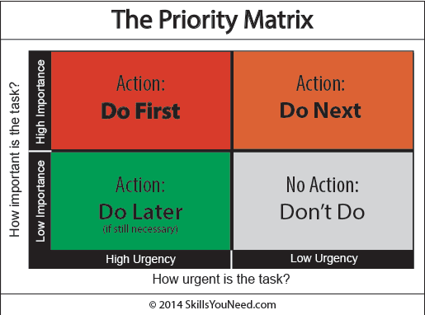
https://www.skillsyouneed.com/ps/time-management.html
It is very essential to mention here that we must check at our dairy more frequently, so no one is forgotten and moving about or putting it into a major or pressing section. The best way to schedule my work is to record it on a weekly basis. This was done as a classroom practice that was useful and understanding.
Fig.1 simple example of to do list
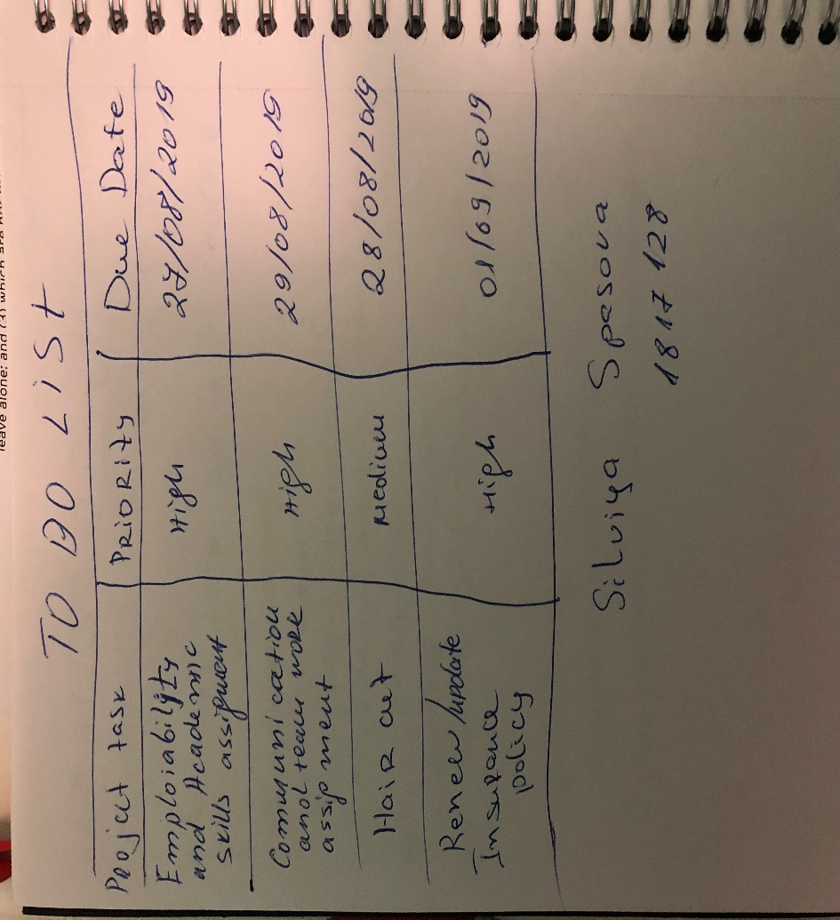

Research skills
Finding, searching, finding, collecting, analysing, interpreting and assessing data which are important to the topic being studied is research capability. Even though we don't understand, we all search. The Internet is an extremely important component of our life. It is a way of investigating using search engines (like Google). Everything is researching whether you're finding inexpensive flights or a great restaurant. We can research using methods like internet, books, journals, articles, studies etc. I can demonstrate my research skills writing this assignment and making presentation in other study modules. Of course, has many ways this skill to be presented. It is important for employer to have this skill as it shows that I have ability to propose fresh thoughts and assist the company to adapt to the changing world in which we reside.
One of the important things when we are searching whenever for writing assignment or some other projects is taking a note. It must contain short information which to navigate us after. Here are some tips of how we can take notes.
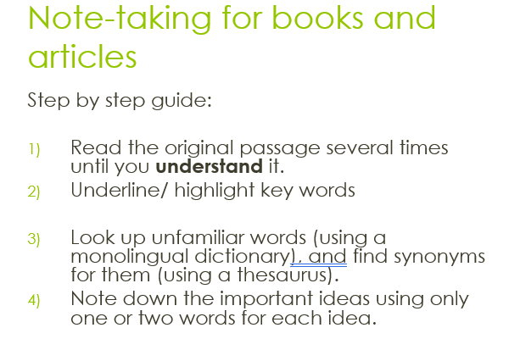
https://moodle.uwtsd.ac.uk/mod/resource/view.php?id=186826
Note taking help us to concentrate and make a sense of text.

Referencing skills
When I am writing my assignment or any other documents and using someone else words it is very important that to be referenced to prevent plagiarism. This means that I need to include detailed information on sources used both in text as citation and in bibliography list. In my class, the Harvard referencing system was introduced. We had exercise also which I will linked in the end of my assignment as pdf. How to reference a specific type of resource?
- Book and e-books
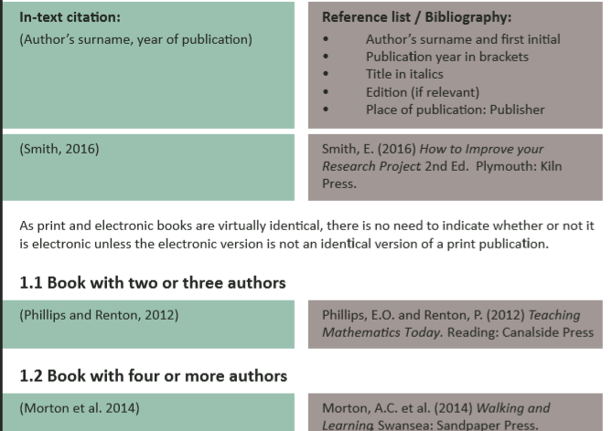
https://moodle.uwtsd.ac.uk/pluginfile.php/260020/mod_resource/content/0/UWTSD%20Harvard%20Referencing%20Guide%202018.PDF
- Journals and newspapers articles
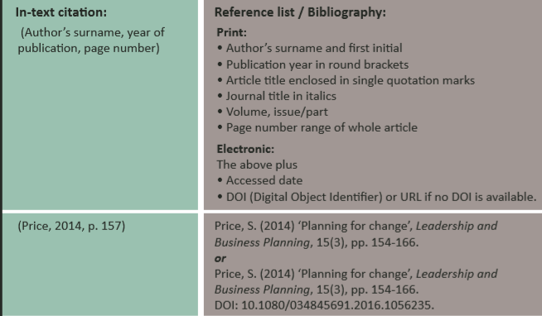
https://moodle.uwtsd.ac.uk/pluginfile.php/260020/mod_resource/content/0/UWTSD%20Harvard%20Referencing%20Guide%202018.PDF

- Internet information
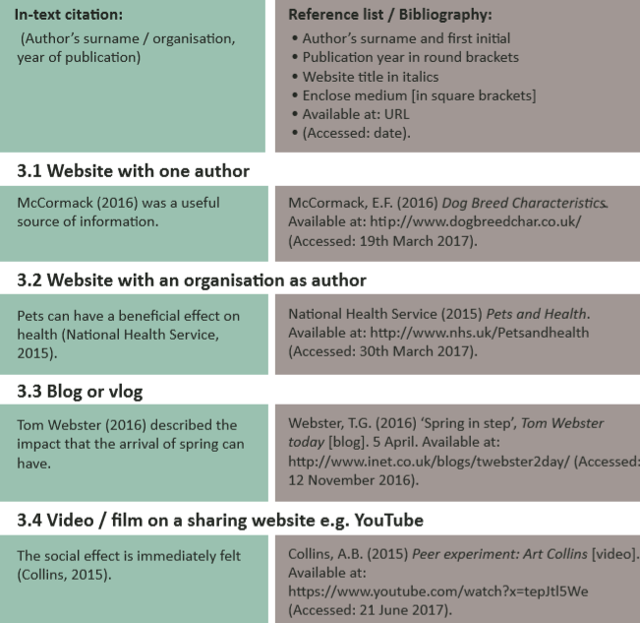
Week 5 lectures https://moodle.uwtsd.ac.uk/pluginfile.php/260020/mod_resource/content/0/UWTSD%20Harvard%20Referencing%20Guide%202018.PDF
Critical thinking
‘Critical thinking is the development and use of information beyond memory and repetition’. (Morgan ,2017) It is a ‘critical thinking’ that is usually meant negative and painful rather that helpful, but it could not be seen by some.’ Critical thinking’ reality implies both, but one cannot be defined as it means much more.
Our abilities are diverse and include observation, analysis, interpretation, reflection, assessment, inferences, explanations, problem solving and decision making. We must be able to: think objectively and critically about a subject or problem. Identify the various arguments with respect to a specific problem. Recognize weaknesses or adverse points found in proof or argument. Evaluate a point of perspective to establish how powerful or effective it is. Notice what consequences a declaration or argument could have. Provide organized reasoning for the argument we would like to create and support.

Academic writing
Academic writing is a specific theme used for my course in official essays and in other tests. It needs a formal language, a logical structure and proof. I need to know and develop this skill throughout my time at the University.
- Planning my assignment
To demonstrate my knowledge of the subjects I will have to submit an assignment for each module. It is my opportunity not only to demonstrate your understanding about my topic, but also my capacity to work in time and generate excellent quality job.
Have various of options to plan my assignment but what I used is simple checklist available from
https://my.cumbria.ac.uk/media/MyCumbria/Documents/Library/Planning-Checklist.pdf
- Structure of assignment
A good structure of my assignment is key to ensuring my reader can follow my argument. If I am writing an essay, my overall structure will be an introduction, main body and conclusion.
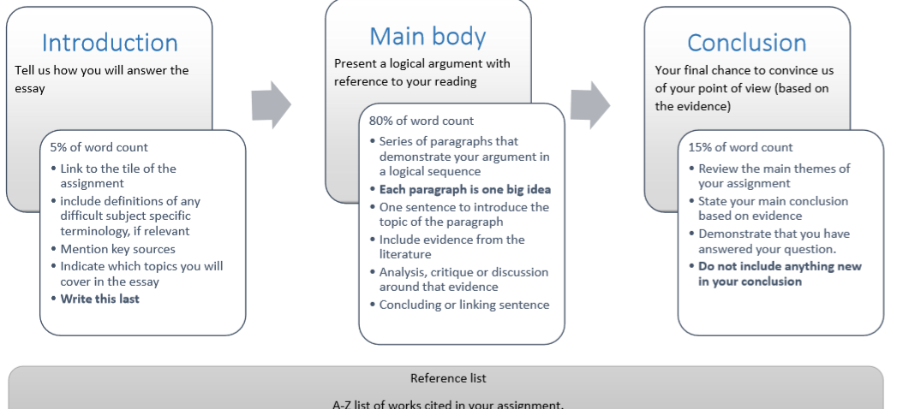
https://my.cumbria.ac.uk/media/MyCumbria/Documents/Library/Essay-structure.pdf

- Paragraph and sentence structure
Longer sentences, more complete phrases can be an objective because they constitute a more advanced type of storytelling. While academic writing phrases may be quite lengthy, you do not need to imitate them consciously yet.
A section is about a given subject, a set of phrases. They discuss one of the author's primary thoughts on the subject together. The same concept influences all the phrases in one section. The distinct ideas or aspects of the subject are discussed by each section. Usually, a section has three fundamental components: the subject phrase–informs you the primary concept. Phrases to support–the primary concept information. Sentence concluded-cycles or summarises the primary concept.
- Paraphrasing and summarising
According to dictionary paraphrasing mean to describe the (something composed or spoken) significance by distinct phrases, in order to make it clearer. Conveys the same meaning as the initial text. Uses phrases distinct from the initial script Prevents plagiarism. Proves your knowledge about the original source.
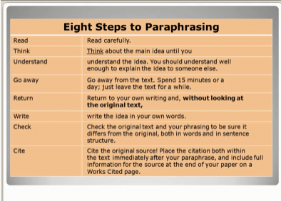
https://moodle.uwtsd.ac.uk/course/view.php?id=6958
Summarising should let someone know that they haven't written the text. Follow the same order / logic as the initial with a nice chapter framework. Be paraphrased and quoted in full. Do not include our views
- Format and style – in my assignment description, I we given that I need to write Arial or Calibri and the best size is 12.

Employability skills
As well as skills specific to the job you're searching for, employers are also looking for overall work abilities. These are sometimes referred to as' employability abilities' or' soft abilities.' These kinds of abilities will make you stand out. Even if you don't believe you have any work abilities, we might not be correct. Different individuals describe these abilities in varying respects, but they might usually be separated into the following categories:
- Team working
The abilities liked to work well with other individuals are known as interpersonal skills. Good communication skills enable you to engage efficiently as a team member, meet the expectations of customers and clients, negotiate, make choices and solve issues with others, and usually work efficiently with other staff. Well-honoured interpersonal skills enable us to empathise and create relationships with peers and clients, leading to a stronger and less stressful operating setting.
- Communication
These are the skills required to deliver or receive accurate messages to and from other people by speaking or writing, without any misunderstandings. This include verbal and non -verbal communication as active listening. I wildly explain communication skills in my assignment for Communication and Team Working.
- Problem Solving
The abilities needed to work efficiently with others to recognise, define and resolve issues, including decision-making on the best approach. Of course, it is also feasible to create choices and fix issues on your own, but the need to do so with others adds an extra dimension to the scenario.

Organisational skills
Organisational abilities are also important in the assessment of employability abilities. suggests that this is the element of being methodological and structured. It depicts the capacity to plan in such a way as to assist meet time limits and objectives. A person has the capacity to monitor his or her progress in the job in order to ensure that they are on track to meet the necessary goals. Planning and organising require such stuff as creating programme timelines and meeting deadlines. Examples of ways you can develop or enhance your planning and organising abilities include: developing a study schedule and sticking to it while traveling abroad or across the country to manage your job time, study and family responsibilities to help organise a special event to organise a group get-together.

Capacity
The ability to learn and adapt is extremely classed in employability abilities. Those people who possess this ability are always always passionate about their job. They tend to discover ways to learn from their errors. This operates for the advantage of both the employer and the staff. It's simple to avoid a catastrophe once individuals acknowledge their errors and are prepared to learn from them.
- Working under pressure
Employers are very much committed to working on time limits and under pressure. This ability is portrayed when a person I deal with stress goes within a time limit that must be met. Incompetent people will break down along the manner and will not be able to produce.
- Self -motivated
Using one's initiative and being self-motivated is also extremely ranked. It involves having thoughts that can be converted into fact. There must be a powerful private drive where a person does not wait for orders to finish a certain assignment.

Conclusion
Finally, I can claim that for my future studies and practice I have learned and created abilities. The planning and organization of my reading and IT abilities has taught what the employee wants. At the end of my appointment, I carry out all my house and school job in pdf as proof of every student's employability and educational qualification I acquire through courses.
https://d.docs.live.net/50b5230688e0cee1/Documents/Silvia%20assigment/materiali%20i%20lekcii/class%20work%20.pdf

References
Class work (2019). Exercises in class. [online]. available from: https://d.docs.live.net/50b5230688e0cee1/Documents/Silvia%20assigment/materiali%20i%20lekcii/class%20work%20.pdf
Lectures (2019). Academic and Employability skills. UWTSD. [ online]. Available from: https://moodle.uwtsd.ac.uk/course/view.php?id=6958 [assessed : 24/08/2019]
Morgan P. (2017). The Business Student’s Guide to Study and Employability. Sage Publication LTD. p.47 – p.296
My. Crumbia (no date). Writing skills. University of Crumbia. [online]. Available from: https://my.cumbria.ac.uk/Student-Life/Learning/Skills-Cumbria/Academic-Writing/ [Assessed: 24/08/2019]
Skills you need (no date). Learning Skills. Skillsyouneed. [online]. available from : https://www.skillsyouneed.com/learning-skills.html [assessed: 22/08/2019]

Skills you need (no date). Critical thinking. Skillsyouneed. [online]. Available from: https://www.skillsyouneed.com/learn/critical-thinking.html [ assessed: 24/08/2019]

Skills you need (no date). Employability skills: Skills you need to get a job. Skillsyouneed. [online].Available from: https://www.skillsyouneed.com/general/employability-skills.html [Assessed: 24/08/2019]

Taylor J. (2018). Employability skills. Essaytyping. [online].Available from: https://www.essaytyping.com/employability-skills/ [Assessed : 24/08/2019]

Week 5 lectures (2019). Harvard Referencing Handbook. UWTSD. [ online]. Available from: https://moodle.uwtsd.ac.uk/pluginfile.php/260020/mod_resource/content/0/UWTSD%20Harvard%20Referencing%20Guide%202018.PDF [assessed:23/08/2019]

Week 3 lectures (2019). Note Taking. UWTSD. [online]. available from: https://moodle.uwtsd.ac.uk/mod/resource/view.php?id=186826 [ Assessed: 22/08/2019]

Wikipedia (no date). Time Management. Wikipedia. [online]. Available from : https://en.wikipedia.org/wiki/Time_management [Assessed: 21/08/2019]

