
restaurant menu
BMIH4002

June 9, 2022
Nasima khatun
LECTURER: LOLA VILLARD

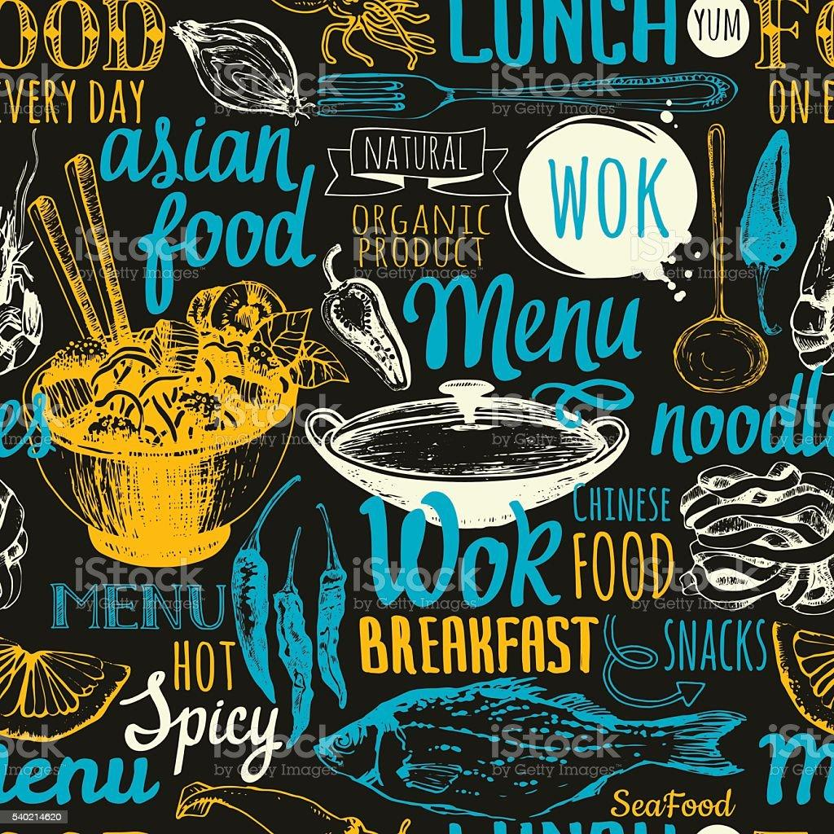
Menu
We are offering a menu with varieties of food for our customers. It is in our continuous attempt try to deliver the quality food to the customers.
Found on the 4-star hotel standard, we have not set the high rates of our food. The price of our food is affordable in our restaurant than the different other four start restaurants.
Now we have discounts on all our wines for 20%. We have kept discount of 10% for other food on the menu. As we changed the decoration of our hotel, we are now giving this offer and the whole offer will be lasting for 2 months.
We concentrate on social media outlets for delivering food through online strategies. people can order our food from our Facebook Page, WhatsApp number, and Instagram page and from our website. We also have a contact number for our customers to directly call us for ordering food and the customers can also order our food from Just eat.
We are open 24 hours and deliver our food 24 hours both online and offline.
We deliver food within 30 minutes.
We have access to all sorts of cards and cash for pay.
We have included return policy in our system. If any clients can discover any unexpected aspects on food or our delivered package, they can approach us with a complaint about it and can return our food. We give food again for free.
We consider consumers’ complaints seriously. If any clients give any complaints about our food, it is our obligation to solve the situation asap.
We charge £5 as the delivery charge. However, this charge can vary based on the locality.
We give two pairings of red wine for our chosen and special menu.
We furthermore have takeaway service option for our customers.

Welcome to Our
Hotel Trinity
Address:
Wales Swansea,
UK
+44 (0) 334 575 8888
Appetizer
Mushroom dish £5.09
Deep-fried mushroom served with cheese, sauce, onions, garlic sauce £6.09
Mixed Salad £2.09
Fruits salad served with yoghurt, butter, honey, juice
soft drinks£3.09
Mix Fruit Salad £2.09
Mixed fruit salad served with yoghurt, butter, honey, juice, or soft drinks £4.09
Spicy Corn £3.09
Sweet Corn £3.09
Corn with cheddar cheese, creamy sauce, juice, or soft drinks £4.09
Corn with curry flavors, barbecue sauce
Chicken Fries £5.09
5 pcs chicken with gravy tomato sauce, chili sauce
5 pc chicken with cheese, sauce, creamy cheese sauce and soft drinks £9.09
Nachos £5.09
Topa £3.09
Cashew Nuts Salad £3.09
Chicken Cashew Nuts Salad £4.09
Cashew nuts chicken, sauce, cheese, onions, mayonnaise,
Seafood Salad£6.09

Breakfast
British Breakfast
Bread with or Nutella, eggs of any style, fruits, yoghurt, juice, tea, or coffee £6.09r
Subtle Breakfast
Eggs, chicken cut in slices, pancake with honey syrup, tea, or coffee £5.99
English Coffee Breakfast
Eggs, bread, butter, muffins, pancake, fruits juice, tea, or coffee £4.55
Fruits Breakfast
Mixed fruits salad, Strawberry yoghurt, salad, juice, avocado toast, strawberry juice, banana Oreo milkshake, cake & muffin, tea, or coffee £4.20
Royal Breakfast
Toast bread with butter, cheese or Nutella, honey salad, fruit salad, fruits, juice, chocolate milk, tea, or coffee £3.99
Eggs Royal Breakfast
Poached egg, toast bread with butter, coffee £4.09
Omelet Breakfast
Cheese, onion, mushroom, tomato sauce, juice, milk, coffee £2.09
Easy Dine Special Breakfast
eggs of any style, cheese, muffin with honey syrup, cereal, bread with butter, mushroom, muffin, salmon, yoghurt, mango, strawberry, fruit shake, milkshake, fresh juice. £7.70

Scheduling
Breakfast Time: 7 AM to 10 AM
Lunch Time: 12 PM to 4 PM
Dinner Time: 7 PM to 12 PM

Main Course (Lunch & Dinner)
Rice Bowl
Rice with saucy chicken, eggs, soft drinks, desert £7.09
Barbecue Rice Bowl
Rice served with barbecue chicken with cheese, salad, coleslaw, soft drinks
£7.29
Beef Rice Bowl
Rice with beef curry, eggs, salad, coleslaw, soft drinks
£6.09
Seafood Rice Bowl
Rice with a mixture of crabs, squid, coleslaw, soft drinks, desert
£8.09

Easy Dine Special Dish
Ramen, mixed salad, steak bones, wines (any two) £7.09
Rice served with chicken, salads, soup, wines (any two) £8.09

Coffee
Espresso £5.50
Cappuccino £4.40
Latte (Caramel/Hazelnut Latte)
£4.90
Soft Drinks £3.30
7up £3.30
Britvic £3.30
Coca cola £3.30
Coke zero £3.30
J20 £3.30
Jax Coco£3.30
Lipton £3.30
Lemonade £3.30

Dessert
Chocolate Brownies £4.30
Strawberry Brownies £4.10
Chocolate Cake£4.21
Cheesecake £4.21
Creamy Cheesecake £4.64
Red Velvet Cheesecake£4.65
Plain Fruit Cake £2.96

Note: TEWCh food.gov.uk/ratings I ganfod sgör hylendid buyd ein busnes neu
gofinnwch inni beth yw ein sgör hylendid bwyd wrth archebu / Go to food.gov.uk/ratings to find out the food hygiene rating of our business or ask us
for our food hygiene rating when you order
Side Dish
Potato Wedges £2.09
French Fries £2.09
Onion Rings£3.09

Soup
Clear Soup £3.09
Thai Soup£4.09
Mixed Seafood Soup £4.00
Chicken Soup£2.90

Wine bottles
Rose Wine £8.09
White Wine £9.09
Red Wine £9.09

Hygiene Ratings: 4 stars

References
Egendorf, L. (2006). Food. Greenhaven Press, Thomson, Gale.
Erdem, S. (2021). Investigating the effect of restaurant menu labeling on consumer food choices using a field experiment. British Food Journal. https://doi.org/10.1108/bfj-04-2021-0432
Fisanick, C. (2010). Food. Greenhaven Press/Gale, Cengage Learning.
Kim, Y., Sauerwald, P., & Sukpatch, K. (2021). Are you looking for a special menu? An examination of variety seeking behavior for Promotional Menu (VaPM) Model. International Journal of Gastronomy and Food Science, 23, 100295. https://doi.org/10.1016/j.ijgfs.2020.100295
Menu transparency new website. (2006), 36(2). https://doi.org/10.1108/nfs.2006.01736bab.005
Mill, J. (2021). On Liberty. GENERAL PRESS.
Pieńkowski, J. (2009). Food. Walker.
Sala, P., Contò, F., & Fiore, M. (2019). Food. Emerald Publishing Limited.

