Declaration/Statements page

DECLARATION

This work has not previously been accepted in substance for any degree and is not being concurrently submitted in candidature for any degree.

Signed ...................................................................... (candidate)

Date ........................................................................

STATEMENT 1

This work is the result of my own investigations, except where otherwise stated.

Other sources are acknowledged by footnotes giving explicit references. A bibliography is appended.

Signed ..................................................................... (candidate)

Date ........................................................................

STATEMENT 2

I hereby give consent for my work, if accepted, to be available for photocopying and for inter-library loan, and for the title and summary to be made available to outside organisations.

Signed ..................................................................... (candidate)

Date ........................................................................

‘A Critical Evaluation of the Affiliation Between Trade Unions and Young Workers.’

Dissertation Written by:
Steven Vanstone

P138685

Abstract:

Britain’s young workers are; concentrated in sectors characterised by precarious working conditions and high staff turnover, at particular risk of being low paid, and are more vulnerable to exploitation than other groups of workers. Therefore, it is important that young people have a voice at work. So why is it that only 16.2% of young workers are part of a trade union?
The economic development in the UK over the past 50 years has seen a retreat from manufacturing and rise in the service sectors. British trade unions have struggled to adapt to the challenges of the new economic environment. Recent union trends suggest that the decline in union membership has slowed but still remains at the lowest point since 1995.
This dissertation sets out to critically evaluate the affiliation between trade unions and young workers, initially by reviewing the relevant academic literature which has directly informed the primary data collection exercise. 51 young workers (18-30) were surveyed to obtain their experiences at home,in work, and their involvement with trade unions. Additionally,three trade union representatives were interviewed to collect data from experienced practitioners in the field.
The data collected provides an interesting insight the working lives of young workers in Britain today. This confirmed that young workers generally show low levels of engagement with trade unions, have a lack of understanding of the benefits and protections that trade unions can offer them. Although 80% of respondents suggested that trade unions are relevant in today’s working environment, the vast majority have never been a member of a trade union. This directly highlights weaknesses in the current union recruitment strategy which is preventing young workers from becoming trade union members.

Table of Contents
Table of Figures 7
Chapter One – Introduction 8
1.1Introduction 8
1.2 Aims and Objectives 8
1.3Background 9
1.4 Rationale 10
1.4.1 Recent Union Trends 10
1.4.1.1 Decline in Union Membership 10
1.4.1.2 Change in Union Demographics 10
1.4.1.3 Public and Private Sector Membership 13
1.4.1.4 Personal job characteristics 14
1.5 Conclusion 15
Chapter Two – Literature Review 16
2.1 Introduction 16
2.2Aims and Objectives 16
2.3 Models and their relationships 17
2.3.1 Young Workers 17
2.3.1.1 Difficulties of Recruiting Young Workers to Trade Unions 18
2.3.1.2 Young Workers and Trade Unions 18
2.3.1.3 Challenges That Young Workers Face 21
2.3.1.3.1 Low Pay 21
2.3.1.3.2 Poor-quality Jobs 23
2.3.1.3.3 Lack of Training Opportunities 24
2.3.1.3.4 Over-qualification 25
2.3.1.3.5 Weak Opportunities for Progression 25
2.3.1.3.6 Underemployment 26
2.3.1.3.7 Precarious working conditions 27
2.3.1.3.8 No voice in the workplace 28
2.3.2 Trade Unions 30
2.3.2.1 Trade Union Recruitment 30
2.3.2.2 Trade Union Identity 33
2.3.3 Union Technology Framework 34
2.4 Conclusion 36
Chapter three – Methodology 38
3.1 Introduction 38
3.2 Aims and Objectives 38
3.3 Research Design 39
3.3.1 Research Philosophy 39
3.3.2 Research Approach 40
3.3.3 Research Strategy 41
3.3.4 Time Horizon 42
3.3.5 Research Sample 43
3.3.6 Primary Data Collection 43
3.3.7 Data Analysis Methods 44
3.4 Validity 45
3.5 Reliability 45
3.6 Resource Utilisation 46
3.6.1 Cost 46
3.6.2 Researchers Skills 46
3.6.3 Time 46
3.7 Ethics 46
3.8 Conclusion 47
Chapter Four - Data Analysis 48
4.1 Introduction 48
4.2 Aims and Objectives 48
4.3 Survey 48
4.3.1 Survey analysis 48
4.3.2 Demography 49
4.3.3 Work Experience 57
4.3.4 Union Involvement/Awareness 67
4.4 Interview 75
4.4.1 Interview analysis 75
4.5 Conclusion 79
Chapter Five - Conclusion and Recommendations 81
5.1 Introduction 81
5.2 Limitation of the study 81
5.3 Achievement of Aims 82
5.4 Conclusion 83
5.5 Recommendations 84
Appendix 1 - Gant Chart 92
Appendix 2 -Sample of Survey Questions 93
Appendix 3 - Excel Spreadsheet with Survey Data 101
Appendix 4 - Sample Interview Questions 102
Appendix 5 - Interview 1 Transcription 104
Appendix 6 - Interview 2 Transcription 108
Appendix 7 - Interview 3 Transcription 112
Appendix 8 - Interview analysis table 118

Table of Figures
Figure 1- Trade Union Membership Levels in UK 1995-2015 (Department for Business Innovation & Skills, 2016) 10
Figure 2- Employee Trade Union Density by Gender 1995 – 2005 (Department for Business Innovation & Skills, 2016) 11
Figure 3- Trade Union Density by Gender and Ethnicity 2015, (Department for Business Innovation & Skills, 2016) 12
Figure 4- Trade union membership and sector, 1995 to 2015 (Department for Business Innovation & Skills, 2016) 13
Figure 5- Age of trade union member’s 1995 and 2015 (Department for Business Innovation & Skills, 2016) 14
Figure 6- The research ‘Onion’ adapted from (Saunders, et al., 2015) 39
Figure 7- Demography - Q1 Age of Survey Respondents 49
Figure 8- Demography - Q2 Gender 50
Figure 9- Demography - Q3 Highest Level of Academic Qualification 51
Figure 10- Demography - Q4 Highest Level of Parent's Academic Qualification 52
Figure 11- Demography - Q7 Number of Dependent Children 53
Figure 12- Demography - Q8 Living Situation 54
Figure 13- Demography - Q9 - Political Affiliation 55
Figure 14- Work Experience - Q1- Employment Status 57
Figure 15- Work Experience - Q3 – Sector 58
Figure 16- Work Experience - Q2- Sector of employment 59
Figure 17- Work Experience - Q3- Previous Sector of Employment 60
Figure 18- Work Experience - Q6 - Number of Job Roles 61
Figure 19- Work Experience - Q7 - Zero Hour Contract 62
Figure 20- Work Experience - Q8 - Hours Taken Away by an Employer 63
Figure 21- Work Experience - Q11 - Which Channel is used to Seek Advice on Workplace Issues 64
Figure 22- Work Experience - Q12 - How Secure do You Feel at Work 65
Figure 23- Work Experience - Q13a -Has Your Employer offered you any Training in the Past Three Months 66
Figure 24- Work Experience - Q13b - Have You Taken These Opportunities 66
Figure 25- Union Awareness/Involvement - Q1 - Union membership 67
Figure 26- Union Awareness/Involvement - Q2 - has a trade union ever approached you 68
Figure 27- Union Awareness/Involvement - Q3 - If so, which union have you been involved with? 69
Figure 28- Union Awareness/Involvement - Q4A - I am aware of the current trade union agenda 70
Figure 29- Union Awareness/Involvement - Q4B - My parent/guardian have belonged to a trade union in the past 71
Figure 30- Union Awareness/Involvement - Q5 - Do you think that trade unions are relevant 72
Figure 31- Union Awareness/involvement - Q7 – Is cost a factor in not joining a union. 73
Figure 32- Union Awareness/Involvement - Q9 - Rank preference for modes of communication 74

Chapter One – Introduction

Introduction
This research project has been designed to critically evaluate the affiliation between trade unions and young workers. Taking a specific view on declining union membership, aging trade union membership, key issues that prevent young workers from joining trade unions, whilst also considering the implications of the macro business environment affecting trade unions today.
This chapter will provide an overview of the aims and objectives for this dissertation project provide key definitions for terms used within this investigation, set the context in which the issue is to be investigated with a basic background of the key themes, and finally provide a rationale as to why this pertinent issue demands investigation today.

1.2 Aims and Objectives
The overall purpose of this dissertation is to critically evaluate the affiliation between trade unions and young workers. This study will be completed by implementing the following objectives;
- Critically review the underpinning literature with a focus on trade union membership, specifically union efforts to prevent further decline, attract new members, and maintain their relationships with young workers aged 18-30.
- Design an appropriate research strategy that will enable the collection of primary data which includes; an online survey targeting young workers (18-30) regarding their awareness and involvement with trade unions, and a series of interviews with members of trade unions to discuss their efforts to attract and maintain relationships with young workers.
- Evaluate the primary research and enable synthesis with reviewed literature.
- To generate recommendations for a future debate this encourages review and comment from trade union practitioners.

Background
Labour unions or trade unions are organisations of workers acting collectively who seek to protect and promote their mutual interests through collective bargaining. They help workers in issues like fairness of pay, good working environment, hours of work, and benefits. They represent a cluster of workers and provide a link between management and workers (De Cenzo & Robbins, 1993).
The past fifty years have seen an advancement of the working environment in the UK. A retreat from manufacturing and rise in the service sectors have been greatly accelerated by the globalisation agenda, which has been driven and facilitated by; the adoption of open economic policies to promote a cross-border flow of capital and labour, technological advancements making transport and communication on a global scale much cheaper, and increased international competition which is heightened by low-wage economies in China, India, and Mexico (BERR, 2008).

In the UK, trade unions have struggled to adapt to the challenges of the new economic environment. The traditionally white, male dominated workforce has been fundamentally altered by the uptake of women and international migrants into the workforce. The devolution of public services to the private sector has acted to reduce the traditional strength of trade unions by a stark reduction of trade union membership in the private sector (Bryson & Forth, 2010).
The period 1964-2014 has been a time of unprecedented change for trade unions that Nowak (2015) broadly divides into three distinct phases; Growth, Decline and Stability.

1.4Rationale

1.4.1 Recent Union Trends

1.4.1.1 Decline in Union Membership
Trade union membership currently lays around 6.5 million in 2015. The level of overall members remained largely unchanged from 2014 except a non-statistical increase of 0.6% (36,000 members); current membership levels are well below the highest recorded levels of union membership (13 million) during 1979.
In 2015, the proportion of employees that are trade union members fell 0.3% to 24.7%, from 25.0% in 2014. This is the lowest rate of trade union membership recorded since 1995. Since then the proportion of union members has declined by 7.7%, from 32.4% in 1995 as shown in Figure 1 below.
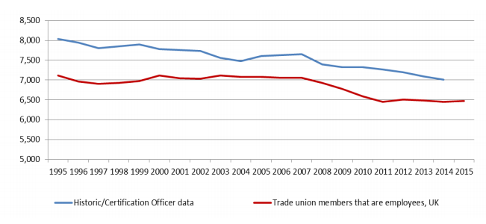
Figure 1- Trade Union Membership Levels in UK 1995-2015 (Department for Business Innovation & Skills, 2016)

1.4.1.2 Change in Union Demographics
The demographics of trade union members continue to change, as figure 2 (below) shows, the long-term trend of a decline in male union membership has continued. During 2015, the proportion of male employees that are trade union members has declined to its lowest point in the past 20 years at 21.7% (2.9million).
In 1995, the proportions of male employees belonging to a union were 35%, compared to 29% for women. Leading to 2002, high reductions in membership among males acted to narrow this gap. By 2002, the proportions of male and female union members were equal at 29% for both genders. Since 2002, the decline in male trade union members has continued with a fall of 7% from 28.7% in 2002 to 21.7% in 2015.
The decline in proportion of members for females has been much weaker. The number of female trade union members in 2015 increased by 36,000 however remained stable as a proportion of female employees at 27.7%. Since 2002, union membership for females has remained relatively stable, although between 2010 and 2015 there was a slight dip, which has since stabilised.
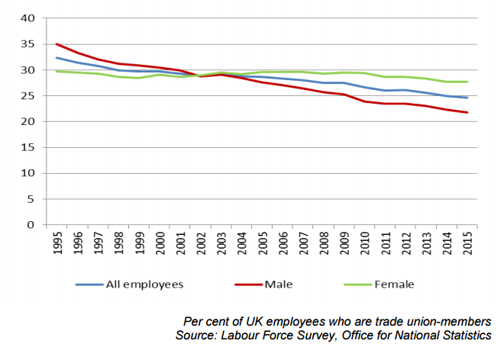
Figure 2- Employee Trade Union Density by Gender 1995 – 2005 (Department for Business Innovation & Skills, 2016)
A higher proportion of UK born employees (26.2%) belong to a trade union, compared with (16.6%) of non-UK born employees.

Figure 3 below, shows that the proportions of members that are union members were highest within the ‘white ethnic group at 25.3%, and the ‘Black or Black British’ ethic group, at 24.4%. Union membership appear lower in other ethnic groups; with ‘Asian or Asian British’ composing of 18.8%, ‘Mixed’ 18.1% and ‘Chinese or other ethnic group’ making up 16.1%.

There is a higher proportion of female members over male members in the ethnic groups ‘white’, ‘mixed’, ‘Asian or Asian British’. This difference is most clearly pronounced within the ‘Asian or Asian British’ ethnic group with a proportion of women who are union members being 23.6% compared to 15.1% for males within this group. Interestingly, this effect is reversed in the ethnic groups; ‘Black or Black British’ and ‘Chinese or other ethnic groups’ where the highest proportions of union members account to males. 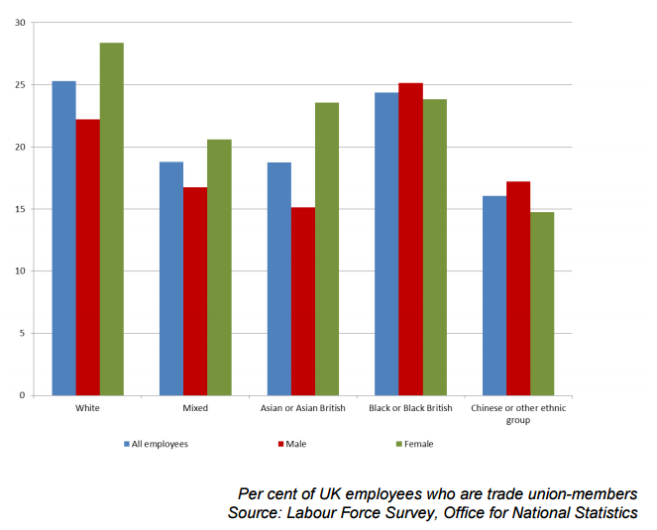
Figure 3- Trade Union Density by Gender and Ethnicity 2015, (Department for Business Innovation & Skills, 2016)

1.4.1.3 Public and Private Sector Membership
Figure 4 below, demonstrates that despite a slump around 2010-2011, overall public sector membership increased by 381,000 between 1995 and 2015. Additionally, private sector membership declined by 905,000 in the same period.
Within the private sector, union membership has been in overall decline since 1995, the most severe losses occurring between 2007 and 2010. This reduction can be attributed with a high number of redundancies following the financial crisis of 2008. Since 2010, union membership in the private sector has been in a sustained increase, which is evident by assessing the rise in union membership from 2010 to 2015 of 206,000 private sector union members.
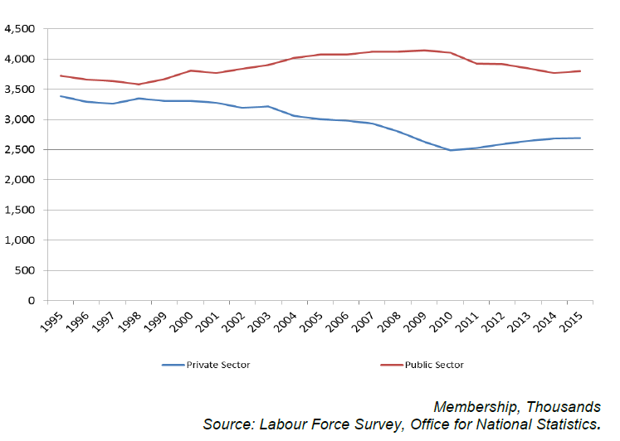
Figure 4- Trade union membership and sector, 1995 to 2015 (Department for Business Innovation & Skills, 2016)

1.4.1.4 Personal Job Characteristics
Women are more likely to be union members than men are, with reference to figure 3 above the proportion of female union members has increased by 10% in the period 1995 to 2015, from 45% to 55%. Employees with a disability are more likely to be union members. In 2015, 15.1% of employees that are union members were classified as disabled. This is slightly higher than the 12.6% of all employees who are classified as disabled.
Trade union membership age is increasing; in 2015, 39% of trade union members were aged 50+. The proportion of trade union members in each age category below 50 has fallen, whilst the proportion of members aged 50+ has increased. This effect could be attributed to the increase in retirement age, which has resulted in an aging workforce. Additionally this trend also highlights a gap in union strategy, which may be failing to recruit younger members.
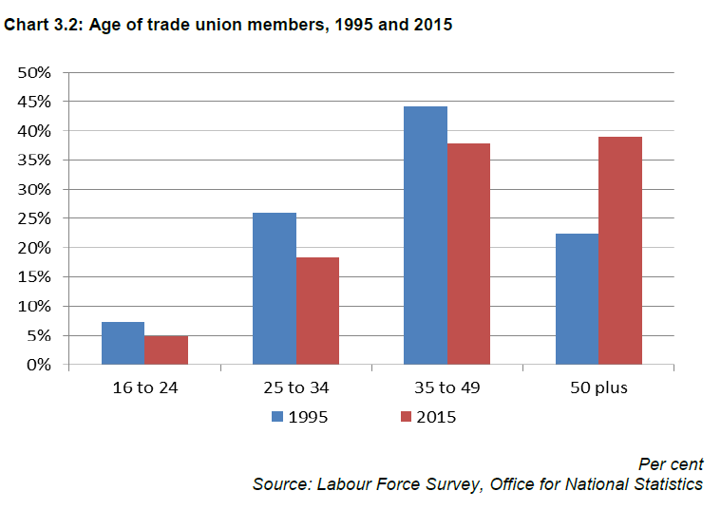
Figure 5- Age of trade union member’s 1995 and 2015 (Department for Business Innovation & Skills, 2016)

1.5Conclusion
Trade unions are organisations of workers which act collectively to seek to protect and promote their mutual interests through collective bargaining. Over the past 50 years, trades unions have struggled to keep up with the advancements in the economic environment in the UK.
The development of trade unions over the past 50 years of can be categorised in three phases; growth, decline, and stabilisation. Recent union trends suggest that the decline in union membership has slowed but still remains at the lowest point since 1995. The trend of a decline in male union membership continues, whilst the decline in female membership has reduced.
By reviewing public and private sector membership, it’s clear that union membership in the public sector has increased since 1995, whereas union membership in the private sector has fallen. Additionally, it appears that there is an aging effect in trade union membership, a trend which highlights a gap in union strategy in which trades unions are failing to recruiting young workers. Unless trades unions are able to correct this and begin attracting young workers to the union movement, their ability to remain competitive in the challenging work environment in the UK will diminish.
This chapter has acted as an introduction to this dissertation research project; it has outlined the scope of research and the rationale behind the chosen topic, along with the proposed aims and objectives of this investigation. Chapter 2, the review of literature, sets to explore the literature from a range of published materials to further explore the key themes of this investigation.

Chapter Two – Literature Review

2.1 Introduction
The purpose of this chapter is to conduct a review of the available literature, which underpins and informs the data collection exercise. Relevant literature sources include; journal articles, academic textbooks, government publications, literature and guidance published by trade unions and the Trade Union Congress (TUC). The chapter will retain a specific focus on declining union membership, aging trade union membership, the key issues that prevent young workers from joining trade unions, with considerations of the implications of the macro business environment affecting trade unions today.

Aims and Objectives
The overall purpose of this dissertation is to critically evaluate the affiliation between trade unions and young workers. This chapter will be completed by implementing the following objectives;
- Critically review the underpinning literature with a focus on trade union membership, specifically union efforts to prevent further decline, attract new members, and maintain their relationships with young workers aged 18-30.

2.3 Models and Their Relationships

2.3.1 Young Workers
Young people are regularly characterised as more vulnerable than their elder counterparts within the employment relationship because of inexperience, low job attachment, and lack of knowledge and bargaining capacity (McDonald, et al., 2007).
Excessive levels of youth unemployment and challenging transitions from education into the labour market have become a reality for many young people in the UK, but this is not unique position. Rather, it is part of a wider global context. Although the matter of high youth unemployment was evident before the financial crisis, it has been exacerbated by the recent years of recession, weak growth and austerity politics (Kretsos, 2014).
Bell and Blanchflower (2010) analyse the current rise in youth unemployment following the financial crash with a particular focus on United Kingdom and the United States. They conclude that young workers were significantly more affected by the ongoing crisis that other social groups, because of the coalition government’s policies of spending cuts and tax increases. Leading to the abolishment of schemes to help young people find work, reduction in the number of university places and the loss of 600,000 public sector jobs which directly affected nearly 750,000 jobs in the private sector.
Academic literature has shown a pertinent interest in discussing and validating the results of public policies in this field, as well as governmental responses to the problems of youth with the design and implementation of measures such as activation policies (Greer & Doellgast, 2011). Additionally, research has been instigated to question the quality of employment contracts in Europe, which has inspired additional attention to the issue of precarious employment for youth (Standing, 2011). The increase in the number of zero hour and temporary contracts along with high unemployment rates has facilitated the expansion of “atypical” contractual conditions.
Young workers have a harder time finding stable well-paid employment and are particularly affected by the wider changes in global economic conditions. As such, changes have seen an increase in employee insecurity and instability (Hodder & Kretsos, 2015).

2.3.1.1 Difficulties of Recruiting Young Workers to Trade Unions
A recent TUC and Union21 (2011) collaboration identified a number of distinct barriers which prevent young people from joining the union movement. These were categorised into four main themes:
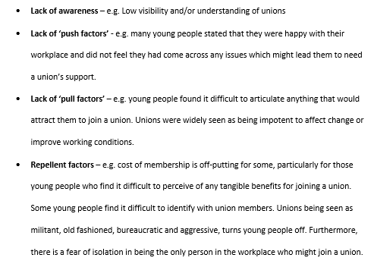

2.3.1.2 Young Workers and Trade Unions
It should be noted that, in contrast to data on labour market participation, the quality of data covering young workers in trade unions is very uneven, regarding the different definitions of ‘young’, whether the data apply to the level, or the rate of unionisation, and the country coverage.(Pascual & Waddington, 2000)
The last three decades have highlighted real concerns for trade unionists and the fundamental role of trade unions in the defence of worker dignity and greater equality of opportunity. Murray (2017) argues that the symptoms of union decline converge in a vicious circle: Secular declines in union membership, an apparent weakening of membership engagement, difficulty in connecting with new constituencies, and the emergence of alternative and less institutionalised forms of collective action. Murray notes that despite minor success stories, which ensure worker organisation and dignity, give regular cause for celebration, the absence of big or even consistent victories make for a disappointing assessment.
As the position of young workers in the labour market is becoming increasingly precarious, it could be expected for them to lean towards trade unionism to increase their prospects of job security. However, it appears that most young workers remain disengaged from trade union activity and trade unions are suffering with a loss of membership and an increasing age effect (Visser, 2006). In this context, the future existence of trade unionism depends on how far trade unions can grasp the complex work reality and the needs of young people (Kretsos, 2011).
Significant unemployment levels and difficult transitions into the youth labour markets pose significant challenges for organising and recruiting young workers (Simms, et al., 2013). Furthermore, low youth union density is also driven by trade union inefficiencies (lack of trade union democracy, gerontocracy in union leadership, inappropriate communication channels with youth).
An increase in flexible, temporary, and part-time work, particularly amongst young people in sectors where union organisation is weak or non-existent, it is widespread and effectively excludes such workers from the opportunity to be union members (Tailby & Pollert, 2011). Levels of union membership have also suffered as successive governments sought to decollectivize the employment relationship (Brown, et al., 1997). A movement towards this position was has been assisted by the promotion of anti-unionism amongst employers (McCabe, 2007; Gall & Dundon, 2013).
Past research on trade unions and young members has primarily focused on quantitative studies of young people’s propensity to unionise, and underlying factors specific to young people, such as their attitudes towards trade unions. Waddington and Kerr (2002) found little evidence that the ‘younger’ generations have a reduced propensity to unionise than their elder counterparts, although they do find significant evidence, which allows one to construct a picture of the barriers that young workers face when joining unions. In the forms of; workplace size, employer resistance and disaffection towards those that purvey the union messages, namely older male workers.
Dufour-Poirer and Laroche(2015) suggest that in order to involve younger workers, that trade unions must engage in a dialogue on union purpose, educate and offer opportunities for socialisation through governance structures and, once involved, accept the challenges to sets of values that the involvement of these young members bring forwards. This analysis is echoed in other studies highlighting the need for unions to engage with younger workers, to make a place for them within structures, and in doing so, to change in the process (Hodder & Kretsos, 2015). This change has the potential to attract young workers to join a trade union and act to maintain present membership levels.
Young employees are less likely to be union members than employees are in general. In the UK, only 16.2% of employees aged 21-30 are members of a trade union, compared with 24.6% of all employees (Bates, 2016, p. 16). Britain’s young workers are less likely to be unionised in the private sector, where the vast majority work, as only 8.9% reported union membership, compared to 13.9% of all employees. Decreased levels of union membership are also apparent in the public sector, where 46.3% of young workers report being unionised, compared to 54.3% of the entire workforce.
Young workers are less likely to be union members if they work in health and social care. This industry combines a range of occupations, including local authority clerical workers and social care staff (who are generally regarded as union members), as well as those working in private childcare settings and care homes (who are significantly less likely to be unionised). However, given their low pay and concentration in the private sector, it can be assumed that a significant proportion of Britain’s young workers in this industry are in the latter group. This would explain their lower rate of unionisation in this industry, which has occurred due to the privatisation of public services, and the dismantling of the trade’s union movement, this change has caused fragmentation within this sector, with private companies having a lower inclination towards trade unions (Bates, 2016).
The difficulties of collective organisation in the part-time and transitional lower-tier service sector translate to low unionisation rates amongst youth. The lack of success of unions is mirrored in the apathy and lack of awareness among youth about the benefits of unionisation (Tyyska, 2008).

2.3.1.3 Challenges That Young Workers Face
Public debate and the research agenda has focused largely on two groups of young workers: Neets and graduates. Neets are those not in employment, education, or training. This group are often disadvantaged, and their present inactivity has the potential to have long-term scarring effects on their future employment and earnings. Graduates also give cause for concern, recent increases in tuition fees mean that young people are leaving university with significant debt, and a degree is no longer a guarantee of a decent career.
A recent publication from the TUC (Bates, 2016), attempts to uncover the experiences of workers that are often disregarded, workers that don’t fit into either category. They are employed and nearly three-quarters (73.4%) did not attend further education. This group of employed young people without degree-level qualifications has been largely overlooked in public debate, and has also often been absent from the research agenda. They are ‘the missing middle’ and the investigation has compiled a framework of challenges that these workers encounter throughout their careers.

2.3.1.3.1 Low Pay
Young workers being paid less than older workers are not a new phenomenon. However, a recent report from the resolution foundation (Corlett & Gardiner, 2015), found that young workers are at particular risk of being low paid, where that is being defined as gross hourly earnings (excluding overtime) of below two-thirds of the median. This report also argues that young people have been particularly affected following the financial crisis, with mean hourly earnings for 22-29 year olds having fallen by 12.7% since 2009, relative to 9.3% for all employees.
There are both direct and indirect mechanisms which lead to low pay for young workers, age can act as a proxy for labour market experience, and the jobs that are open to young people are often in sectors where low pay is prevalent. Low pay is more common in the private sector compared to the public sector, a large determinant of this reflects the characteristics and skills required for the two workforce groups. The differences are much lower amongst men, whilst there is evidence of a positive public sector pay differential amongst women(Cribb, et al., 2014).
Age also effects wage thorough the variation in national minimum wage rates. The TUC has voiced opposition towards the government’s recent introduction of the national living wage (currently set at £7.50/hour) has excluded 21-24 year olds. Bates (2016), suggests that young workers are being paid less than older colleagues for the same work, which can lead to discourage younger employees and undermines the TUC’s principle of a fair day’s work for a fair day’s pay.
Young women are particularly vulnerable to low pay, Previous TUC research has shown that amongst young people aged 22-30 there is a gender pay gap of 8.5%. This increases to 15.0% for people who have studied vocational qualifications, which is the case for a large proportion of Britain’s young workers. This is likely a consequence of ongoing occupational segregation of young women (Trade Union Congress, 2015).
Low pay has a significant impact for young workers, nearly two-thirds (62.6%) of Britain’s young workers live independently of their parents or relatives. This factor may prevent younger workers from joining a trade union. Additionally almost three in ten (28.7%) have a dependent child to care for. Young workers often face the same living costs as older workers; they need to pay rent, council tax, bills, food, transport etc. Young workers are generally not entitled to the same levels of social security, particularly if they do have children. For this reason, young people often live in poverty(Stephens & Blenkinsopp, 2015). It is therefore surprising that young workers that receive low pay are not drawn into the trade union movement. Especially given their commitments to a fair wage and fair employment for all.

2.3.1.3.2 Poor-quality Jobs
Britain’s young core workers are concentrated in a relatively small number of sectors, with nearly half (47.0%) working in retail, health and social care (notably in the private sector) and in hospitality (Bates, 2016).
The growth of low-skilled, low-paid jobs amongst young people can be seen as a consequence of the polarisation of the labour force. Since the mid 1990’s, jobs which have traditionally been occupied by those with middling skill levels and attracted middling pay (e.g. white collar administrative roles) have been lost – either to automation or to foreign countries. In contrast, there has been a growth in high-skilled ‘knowledge intensive’ jobs, also a growth in low-skilled roles. According to the UK commission for employment and skills (UKCES)(2014), these trends appear to be continuous.
Furthermore, the shrinking of the public sector means that it employs fewer people, including fewer young people. This causes concerns for young workers as work in the public sector is often regarded as good quality employment, providing decent pay and pensions, and setting a benchmark in terms of equal opportunities (Bramah, et al., 2009). Trade unions should take the opportunity to strengthen links within the public sector in order to maintaining the levels of trade union membership in this sector with a view to increase union participation amongst these workers.
These long-term shifts mean that Britain’s young workers, even those with relatively strong qualifications, find it harder to secure mid-level jobs. Unable to access the high-skilled market, their primary option is to find low-skilled work. The lower end of the labour market is characterised by low pay and insecurity. In retail, for example, many employers have opted for a low road strategy when it comes to profit making. The highly competitive environment facing many retailers, including as a result the growing number of discount retailers, has increased pressures to reduce costs (Goos & Manning, 2003). Many young workers describe their work as stressful, characterised by ever-changing targets, feeling understaffed, overstretched, and unsupported by senior management(Hay, 2015).

2.3.1.3.3 Lack of Training Opportunities
Nearly two-thirds (59.9%) of Britain’s young workers had neither participated in or been offered training in the previous three months, despite the fact that young workers are generally more likely to be receive training than other groups (Bates, 2016).
Other researchers have highlighted the lack of training; Roberts(2012) reported that retail employees consistently reported a lack of genuine training opportunities. Although some workers are been given the change to gain an NVQ in retail, but those who had chosen to take this had found that it did not represent a programme of learning – it was merely rubber-stamping what they already knew.
It is likely that the limited training opportunities available to Britain’s young workers represent the industries that they are concentrated in. Retail and care sectors invest less per employee and per trainee than employers in the economy as a whole, whilst employers in the catering sector receive an average amount. However, there are large inefficiencies in this spending, with a large amount spent on induction training as a result of high staff turnover (Devins, et al., 2014).
In general, the training offered in the lower end of the labour market often relates to an employee’s induction, or legal obligations such as health and safety training. At this end of the labour market, training is rarely linked to opportunities for development and progression. The job roles young people typically enter are also the jobs deemed a low priority for upskilling. This has a direct impact on disadvantaged young people’s ability to progress in the labour market (Keep & James, 2010).

2.3.1.3.4 Over-qualification
Workers employed in jobs, which fail to use the skills gained through education, or training are considered overqualified. There is a long-term trend of growing levels of over qualification in the labour market, and that over qualification is especially high amongst young people(Felstead & Green, 2013). This is true of both graduates and non-graduates.
As the UK higher education sector has expanded, more graduates than ever before are finding themselves in jobs that in previous generations would have been filled by non-graduates. There appears to be an increase in in the number of jobs stating that a degree is a minimum requirement, even in situations where a degree is not obviously critical to the role. This is true of a number of management and professional jobs, and increasingly intermediate office, technical and sales jobs. This phenomenon is known as occupational filtering down (CIPD, 2015). There is also an increase in over-qualification of non-graduates. The recent increase in the number of graduates has changed the jobs available to non-graduates, pushing them into lower-skilled work.
Successive governments have set a strategy to increase educational attainment, for example by increasing the participation age. Young people now must remain in education, training, or apprenticeships until they are 18 years old. However, as the situation of Britain’s young workers demonstrates, these supply-side initiatives have not stimulated a corresponding demand, and firms are not effectively using the skills present in their workforce. Over qualification also has a long-term scarring effect on wage levels(Roberts, 2012).

2.3.1.3.5 Weak Opportunities for Progression
There has been significant research into progression at the lower end of the labour market. An investigation into the retail, care and hospitality industries noted few employers in these industries actively supported the progression of staff, and the “general view of employment in each of the sectors appears to emphasise employment as a ‘job’ rather than a stepping stone to a career within the sector” (Devins, et al., 2014, p. 4).
Lloyd and Payne’s (2012) investigation into progression in the café sector in the UK revealed that promotion to positions above café assistant often felt to be unachievable, as a result of the relatively small number of positions available, and in some cases undesirable. The pay rise on promotion was small (20-50p per hour), despite these positions demanding significantly more responsibility and demanding longer hours and greater flexibility.
With the loss of many middle-ranking jobs which traditionally acted as stepping stones, allowing those in lower-ranking jobs to progress through promotion and skills development. The loss of these jobs has meant that many lower-ranking jobs have become a dead end, with only a very small proportion of workers able to progress within their field. This is impacted by an increasing supply of graduates taking up management roles, and a lack of investment in the workforce by employers.
It looks unlikely that the jobs that Britain’s young workers work in could be stepping-stones to more, secure, better paid work; instead they are likely to become trapped in low pay for long periods of time (Berrington, et al., 2014).
Weak opportunities for progression are a factor that can prevent workers from joining trades unions, especially in the ‘gig economy’ where workers frequently move from sector to sector to find suitable employment. The ambiguity of these employment practices act to disintegrate a collective identity and reduces the propensity of workers to join trade unions.

2.3.1.3.6Underemployment
Underemployment describes when a worker has a job, but it does not provide as many hours as they would like/are able to work.
This is a significant barrier for young workers as it can lead to workers being trapped in jobs where they cannot earn the income they need to achieve a decent quality of life. TUC analysis has shown that young people are significantly more likely to be underemployed than all workers, and this is especially true for workers aged 18-24. Young workers are 60% more at risk than employees are in general, and more than a third of part-time workers are Britain’s young workers, 37.5% of them stated that they are currently working part time, as they are unable to find a full time job (O'Grady, 2015; Bates, 2016).
High levels of underemployment amongst Britain’s young workers is a likely consequence of the sectors that they work in, as part time work is popular amongst retailers, as it allows them to adjust and maintain staffing levels for fluctuations in activity, so they can match staff to peak trading days and hours.

2.3.1.3.7 Precarious Working Conditions
Young people’s experience at work is becoming increasingly characterised by precarious working conditions, such as zero-hours contracts or very shout-hour contracts, agency work, temporary jobs or fixed term contracts. The flexibility of such contracts can be of significant benefit to employers, especially those in retail and hospitality sectors where young people are concentrated, as they allow employers to respond to fluctuations in demand and hence, minimise excess labour costs (Bates, 2016).
Such contracts can be beneficial to young workers, particularly whilst they are in full time education. However, precarious working conditions are often associated with a significant pay deficiency, a loss of basic rights, and greater vulnerability to exploitation in the workplace. There is also a significant loss of stability, making it difficult for young workers to plan for the long-term (Hudson, 2015).
Britain’s young workers are concentrated in sectors characterised by precarious working conditions and high staff turnover, which has an impact on all employees. As high staff turnover leads employers to be unwilling to invest properly in the development of their employees. The familiarity of being an employee in a transient workforce leads to perceptions of insecurity, and makes workers feel as if they should be grateful to have a job at all. This can lead workers into feeling that they should take what they have, rather than voice their concerns and expect their employers to take them seriously(Hay, 2015).
The lack of opportunities for training and development can lead to high turnover, even where the individual’s contract itself is not precarious. The retail sector is characterised by churn, where workers do not view opportunities for progression with their current employers, so instead move between retailers in an attempt to advance their career, these horizontal job changes are rarely advantageous (Roberts, 2012).
The nature of precarious working conditions is perhaps one of the largest factors, which acts to prevent young workers from joining trade unions. The disintegration of the employment environment has been a present factor throughout the careers of most young workers who believe that is the nature of the work environment. Their lack of knowledge around the purpose of trades unions and the potential benefits that union membership can offer which acts to prevent young workers from trade unionism and collective forms of expression at work.

2.3.1.3.8 No Voice in the Workplace
Only 16.2% of young workers in the UK are members of a trade union, and only 20.5% have their pay or working conditions affected by union arrangements, including young workers in the private sector. This is likely to be a consequence of the industries that young workers are concentrated in, as unions are less well organised in retail, hospitality, and other increasingly casualized workplaces. Higher casualization leads workers to feel less attachment to their workplace, and as such, workers are more likely to question the benefits of unionisation (Bates, 2016).
However, when examining workers in health and social care, 41.5% are aware of unions being present at work, and 40.6% are members of a trade union. Yet, amongst young workers, 30% report being aware of trade unions in the workplace, but only half (15.2%) are union members (Bates, 2016).
This implies that Britain’s young care workers are working in unionised workplaces, but less than one quarter are trade union members. This could indicate that many young workers in the care industry think of their current positions as a temporary stage in their lives, and as such, believe that trade unions offer them very little. Many low-paid workers, particularly in retail and hospitality, have purely functional relationships with jobs and do not consider them central to their life or their identity (Hay, 2015).
This could also indicate that union messages are failing to reach and resonate with young workers in these sectors. Many younger low-paid workers do not fully understand the role of unions or the benefits or protection that membership could offer. Some may consider that the cost for union membership is a low priority, especially when they are struggling to cover household bills on their minimum wage. Additionally, young workers may be dissuaded from joining a trade union, as they believe that comprehensive layers of employment legislation adequately protect them.
Young workers are more vulnerable to exploitation than other groups of workers; therefore, it is important that young people have a voice at work. As young workers often feel that poor treatment at work is the norm, and many feel that this cannot be challenged, as they are unaware of their rights. ACAS(Forth & Metcalf, 2014), found that young people are often reluctant to attempt to resolve workplace issues and are more likely to respond to problems by leaving their job, this can be because of their lack of experience in the labour market, or a lack of confidence to challenge the authority of those above them. Some may even be reluctant to complain for fears that this may jeopardise their position at work.

2.3.2 Trade Unions

2.3.2.1 Trade Union Recruitment
British trade unions appear, in some degree, to participate in mechanism of social partnership, or have successfully negotiated collective agreements on issues specifically affecting young workers (Simms, 2012), but not to the same extent as other countries. There are examples from France, of innovative bargaining in this area including the motor manufacturer PSA Peugeot Citroen, the publisher Bayard, and the postal service La Poste. However, in Britain, the collective bargaining mechanisms that focus on young workers, mainly concern issues of pay (mainly national minimum wage)(Kretsos, 2014).
Weak bargaining structures, restrictive labour laws, and even a lack of political optimism forces British trade unions to be more proactive and more strategically oriented to the organising approach than boosting membership from collective bargaining and strike activity. Although, there are some successful examples of trade unions negotiating with employers the transition of young people into work. Trade unions in Britain have started engaging with employers around how young works move from workplace-based training schemes into employment, typically focusing on ensuring the provision of stable employment after training(Simms, 2012).
For example, The Broadcasting, Entertainment, Cinematograph, and Theatre Union (BECTU) has established an ‘entrance membership’ that is heavily subsidised, and offers young people not yet in work, advice on interview techniques and access to forums to discuss the transitions into work. While the Communications Union (CWU) and Union of Shop, Distributive, and Allied Workers (USDAW) have been involved in negotiation to ensure high-quality work experience schemes with employers, such as Tesco, and even negotiating adult wage rates for all workers in supermarkets(Kretsos, 2014).
Reduced subscription rates are also used to expand youth union membership, student union memberships have been established in a number of unions in order to attract more young students to union organisation and to the union movement in general. The TUC run a young workers forum, which is an advisory committee to the TUC General Council, which meets every two months across the UK. At a recent Young Workers Conference, it was clear that TUC policy has shifted in a direction that makes the TUC more inclusive for young workers, whilst providing more space for initiative for its affiliated member union organisations. In this context, the union from which the delegate is a member now determines the upper age limit for the TUC Young Workers Forum. The TUC’s Organising Academy supplies resources and teaching materials which meet the demands of workers in general, however there is no specific programmes offered for organising young workers although there are a lot of connotations and interrelated materials which may settle some demand from young workers (Kretsos, 2014).
The TUC has increased the emphasis placed on young workers. This has shown through the commitment of British trade unions to provide a seat position for the secretary or leader of the youth committee of the union organisation in its executive board. In March 2014, the TUC held the first annual ‘National Young Workers Month’. The TUC has also launched a number of activities that aim to incorporate youth into the trade union movement, including the first ever TUC Youth Campaign Award, and the organisation of several events around the country(Kretsos, 2014).
Typical cases include the GMB’s first ever ‘National Young Members Network’, The Equity’s ‘Young Creatives’ event, some joint events between Unite and Young Labour, ‘Young Worker Weeks’ by the BECTU and video and online campaigning by other unions including the National Union of Journalists and Unison(Hodder & Kretsos, 2015).
The TUC also coordinates the ‘Union into Schools’ project, which has been considered as one way to improve education about trade unionism amongst young people since it became TUC policy in 2006. The TUC has a dedicated website designed to promote the ‘Unions into Schools’ programme, developed with the support of ‘Union learn’. At the centre of the programme, the website is ‘designed to help schools incorporate education about trade unions into a range of curriculum-linked work at a secondary level’ (TUC, 2014a).
The Scottish Trades Union Congress (STUC) runs a similar series and has held events which encourages students to write and perform songs relating to key union themes called ‘Unions into Schools Song Festival’ (Anderson & Walker, 2014).
From a review of the relevant literature, it appears that the most common approach in attracting, recruiting, and organising young workers in Britain is related to either establishing semi-autonomous Youth Forums or organising and implementing campaigning activities. Nether less, “there is not even one specific campaign targeting at young people despite the strong interest of union’s leadership about the issue, the allocation of significant resources to strategic organising and to the education of young workers and other vulnerable groups” (Kretsos, 2014).
In this context, there is still a way to go, according to a survey by Union21 (2011), most young workers seek advice and guidance relating to workplace issues through three channels, none of which are related to trade unions. Those channels most frequently used were found to be:
- The internet (Google)
- Employer/Line managers
- Parents, Friends, Relatives
The TUC has instigated an effective gateway access to information about employee rights and representation support or campaigning and networking with other young workers. In essence, a wide array of workplace concerns among young workers does not result in stronger engagement with trade union representatives in the workplace.

2.3.2.2 Trade Union Identity
Trade unions, their members and their families face a challenging period under a hostile government with an unbalanced economic recovery that is set to make the same mistakes of the past. This is set against and unknown future following the EU referendum and the rise to power of the right in the Conservative Party.
The result of the EU referendum will have a dramatic effect on the priorities of the TUC and Britain’s trade unions in the months ahead. The referendum debate has heightened tensions around immigration and national identity, which has been exploited by politicians on both sides of the debate. It also brought the inequalities between the nations and regions of the UK to the forefront once again and highlighted the harmful impact that uncontrolled globalism and years of deregulation, cuts and underinvestment have had on less prosperous communities. In the coming months, trade unions must ensure that the response of a Conservative government to the economic crisis facing the UK does not penalise ordinary working people (Trades Union Congress, 2016).
The Trades Union Council’s 16/17Programme of work has highlighted the following programme of work, which sets out the broad structures to which trade union councils should be working; bearing in mind that priorities may change in the coming months.
At the (2016) conference, the trade union councils committed to reaching equality and aim to build a strong and sustainable trade union movement under the following five main headings:
- Protecting workers rights and the right to strike and promoting trade unionism and building union organisation.
- An end to austerity economics
- Making devolution and decentralisation work for people
- Reaching out to young workers
- Fighting racism and Fascism

2.3.3 Union Technology Framework
The growth of information communication technologies (ICT’s) has heightened the debate about trade union’s representative and participatory functions. It is argued that the use of ICTs will further undermine the role of trade unions in favour of different forms of participation towards more issue-oriented groups, protest networks and individualised forms of participation. There are recent initiatives by the TUC to develop internet-based services to attract new; younger members demonstrate that some in the union movement are alert to such possibilities (Ward & Lusoli, 2003).
In collective or ‘organised’ labour disputes, social media has the power to rapidly organise disparate groups of individuals across increasingly fragmented workplaces, where trade union representatives are thinly spread and struggle to maintain the direct personal contact which had previously existed. It also provides unions struggling to connect with younger workers a means to communicate with this group via a medium with which the younger generation are, on the whole, comfortable (Holmes & Harwood, 2011).
It can be argued that trade unions in the UK have been slow to embrace social media for campaigning and organising. However, there is evidence that this is beginning to change. In 2010, the TUC created a ‘social media portal’ for the 2010 congress, which pulled together a number of social media resources and feeds around various campaigns. For instance, campaigns against the government’s deficit reduction programme have made considerable use of social media platforms (Holmes & Harwood, 2011).
Another prominent example is provided by unison, who have recently orchestrated a Facebook-driven campaign against the government’s austerity measures. The site, based on the Facebook platform, also includes location-based services driven by Google maps. However, it does not immediately ask for details to join unison, merely to sign up to this particular campaign. Details on how to join unison are provided on subsequent pages of the site(Holmes & Harwood, 2011).
This is evidence of one type of ‘digital activism’ model of organising whereby people are encouraged to sign up to a single issue campaigning site (e.g., against cuts, or against Brexit) before the idea of formally joining the union is raised. It can be argued that the adoption of the internet and social media tools by individuals is hugely empowering, undermining the need for unions to provide advice and guidance.
The freedom that social media brings carries its challenges as well as opportunities for the traditional conduct of employment relations. On the one hand, the ease of availability of information in the era of open data creates a platform in which unions and representatives have freer access to the kind of information that is often the subject of conflict.
This is because disputes often pivot around issues of transparency, business progress, affordability of pay, and comparability within and between organisations on terms and conditions. In this sense, easier data access reinforces aspects of the Information and Consultation Regulations which contain provisions supporting greater dissemination of information about businesses’ economic situation and employment prospects(amongst other issues). Yet, if organisations fall short of the perceived norm in terms of open data this may prove controversial. Moreover, where transparency is resisted, trade unions and employees may seek to obtain and interpret information independently, bringing greater risk of disputes. Where either party gains information from their opponents’ camp, there may well be a significant shift in the bargaining power of one party over the other (Holmes & Harwood, 2011).
Despite the recent developments within traditional union structures, the overall response of unions to the challenge has so far been inadequate in terms of organising, provision of services and public relations. Union websites typically reach relatively small audiences. Despite this focus, they make poor or little use of the technology to provide enhanced services, in terms of job and union training and members’ support. In addition, unions were found to score minimally on the participation index, offering members few opportunities of real engagement, including the possibility of joining online. If, as some argue, the main problem of the unions is not the low demand of unionisation and activity, but rather the insufficient offer of participatory opportunities, then the opportunity ICT’s offer in this respect has not, as yet, been seized(Ward & Lusoli, 2003).

2.4 Conclusion
This chapter has acted to review the relevant literature with a specific focus on declining union membership, aging union membership, and the key issues which prevent young workers from joining trade unions. Young workers are more vulnerable than other groups and are at a higher risk of exploitation in the workplace. In general, young workers face less favourable conditions of employment and have been most negatively affected by the 2008 recession and as such have seen an increase in employee insecurity and instability.
Trade unions have witnessed a trend of decline in union membership, a weakening of membership engagement and the emergence of less institutionalised forms of collective action. As the position of young workers in the labour market becomes increasingly precarious, it could be expected that they would lean towards trade unionism to increase their prospects of job security. Unfortunately this does not seem to be happening and it appears that most young workers remain disengaged from union activity. As a result, trade unions are suffering with a loss of membership and an increasing age effect.
Low pay, poor-quality jobs, lack of training opportunities, over-qualification, underemployment, precarious working conditions and a lack of voice in the workplace are all challenges that young workers face. Union 21 and the TUC suggest that a lack of awareness of union purpose and the benefits of union involvement, a lack of push factors, a lack of pull factors and repellent factors prevent young workers from joining trade unions. Arguably, the increase in precarious employment, the disintegration of the employment contract, and the fragmentation within the industries that young workers are concentrated are the most prevailing influences for a reduction in union involvement for younger workers.
Weak bargaining structures, restrictive labour laws, and a lack of political optimism requires British trade unions to create a proactive, strategically oriented organising approach. It appears that the most common tactic is to establish semi-autonomous youth forums or organising campaigning activities.
Although there is some evidence of unions embracing ICT’s and social media this process has been slow and inadequate in terms of organising a technically enabled generation. The TUC has created and is working to establish a gateway access to information about employee rights and representation to support campaigning and networking with other young workers. The future of trade union existence depends on how far trade unions can grasp the complex work reality and the needs of young people, and to what extent they are able to harness the power of social media to rapidly organise disparate groups of individuals across increasingly fragmented workplaces.
“Chapter three - Methodology” will act to clarify the overall research methodology adopted for this study and why, it will also reflect on the limitations of the chosen methodology and methods used.

Chapter three – Methodology

3.1 Introduction
This chapter breaks down the research process implemented, explaining which data collection methods have been included within this investigation, accompanied by a justification for the selected method and approach adopted in data collection to achieve the research objectives of this study.
Creswell (2008) describes research as process of steps used to collect and analyse information to increase our understanding of a specific issue or phenomenon. Research is usually carried out in three steps: Pose a question, collect data to answer the question, and present an answer to the question.
This investigation has been conducted using the research ‘onion’ methodology developed by Saunders et al (2015). The research onion, which can be seen in figure 6, encompasses the entire research process in a series of layers: The research philosophy, research approach, research strategies, time horizons, finally constituting the data collection methods to be utilised.
For this study, a post-modernist philosophy has been applied with a deductive approach to data collection. However, the aim of this investigation does not seek to test for a particular hypothesis, but to review with respondent’s influences, which might later be incorporated into a testable hypothesis. The data collection exercise utilises a mixed methods approach, quantitative with the use of online survey and qualitative in the form of a series of open-ended interviews over a cross-sectional period.

3.2 Aims and Objectives
The overall purpose of this dissertation is to investigate the relationship between trade unions and young workers. This chapter will be completed by implementing the following objectives:
- Design an appropriate research strategy that will enable the collection of primary data which includes; an online survey targeting young workers (18-30) regarding their awareness and involvement with trade unions, and a series of interviews with members of trade unions to discuss their efforts to attract and maintain relationships with young workers.

3.3 Research Design
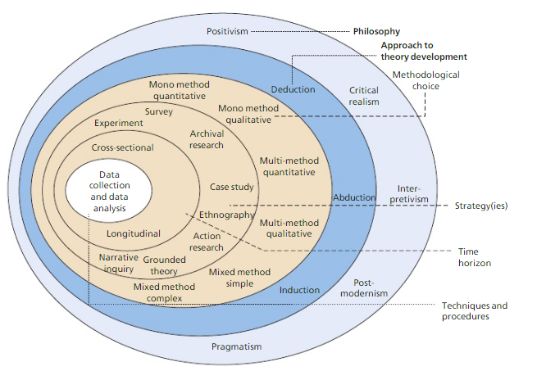
Figure 6- The research ‘Onion’ adapted from (Saunders, et al., 2015)

3.3.1 Research Philosophy
For the purpose of this study, a postmodernist philosophy has been applied to the data collection methods. Postmodernism is sometimes used interchangeably with concepts such as de-constructivism and post-structuralism. Postmodernism rejects any notion of social ‘emancipation’, emphasising instead multiplicity, ambiguity, ambivalence, and fragmentation(Grey, 2004). Postmodernism positively views fragmentation as an opportunity for choice. Hence, postmodern analysis often focuses on themes within advertising, lifestyles, fashion, sub-cultures and gender. Therefore, this philosophy fits well within the objectives of this investigation, which examines young workers (18-30).
In terms of research, the primary task becomes deconstruction of texts to expose how values and interests are embedded within them. The focus becomes not one of how the texts describe the ‘reality’ of the world, but how the social world becomes represented, and how meanings are produced(Williams & May, 1996). Texts are therefore seen as social practices, embedded with multiple values and stakes, not the reporting of independent, objective judgements. As evident in contrast to other epistemologies, postmodernism stresses a ‘becoming’ ontology (Grey, 2004).
Post-modernism differs from most other approaches in two fundamental ways. The first is that rationality and logic are not important to attaining knowledge; the second is that knowledge can be contradictory. Because of the contextual nature of knowledge, individuals can hold two completely incongruent views of one subject at the same time(Kilgore, 2001).
Though truth is central to postmodern thinking, it is not the search for truth that is valued. In contrast, the postmodern mind challenges what is accepted truth. Kilgore (2001) makes several assertions about the postmodern view:
- Knowledge is tentative, fragmented, multifaceted and not necessarily rational.
- Knowledge is socially constructed and takes form in the eyes of the knower.
- Knowledge is contextual rather than “out there” waiting to be discovered.
For that reason, knowledge can shift as quickly as the context shifts, the perspective of the knower shifts, or as events overtake us. The label of postmodernism defines a shift in culture over time.

3.3.2 Research Approach
A deductive approach to research has been adopted for this study. Deductive research approach allows the researcher to establish a hypothesis by using theory. Then a variety of data and information is collected by the researcher, which is analysed to confirm or reject the hypothesis to resolve issue (Gill & Johnson, 2010).
Chapter 2 of this dissertation is the result of a detailed examination of previous research and academic theory associated with trade unions and young workers in order to create a grounding for data collection within that specific topic area. The literature review has been used to formulate questions for data collection.
According to Saunders et al (2015), researchers in the 20th century criticized the deductive approach stating that deductive approach help establish cause-effect links between specific variable without taking in to account the human interpretation.

3.3.3 Research Strategy
For the purposes of this investigation a mixed methods strategy has been adopted. The mixed methods strategy will follow that of a sequential explanatory design, which is categorised by the collection and analysis of quantitative data, followed by the collection and analysis of qualitative data. The purpose of which is to use the qualitative results to assist in explaining and interpreting the findings of the quantitative study(Creswell, 2003).
A mixed methods approach has been selected for this investigation as it takes advantage of using multiple ways to explore a research problem. Although a mixed methods approach increases the time required for the investigation and could possibly lead to unequal data sets, a mixed methods approach has been deployed to complement the strengths of two individual approaches, and concurrently reduce the weaknesses of using a single research approach and to build increased validity into the data collected(Biddix, 2013).
Initially in the form of a quantitative survey that will be used to construct a database that will help identify trends in the opinions, experiences and behaviours of a sample of respondents. Surveys are useful to find small amounts of information from a wider sample in hope of identifying general claims (Driscoll, 2011).
Following the survey, a series of semi-structured interviews will be conducted using a smaller sample of practicing trade union activists and organisers with the intent to gain more thorough and detailed accounts of the opinions and experiences of experts in the field.
The use of a survey allows for collection of a sizable amount of data from a chosen population in an economic way. The survey method of data collection is based on the questioning of respondents. Respondents are asked a variety of questions (e.g. demographic, lifestyle, attitude, behaviour, intentions). The questions may be asked verbally, in written form, or in an electronic format. There should be great care taken during questionnaire design as questions should be; standardised, applicable to a mass audience, tends to ask ‘what’ and ‘how’ questions, and are used to collect a large amount of data. Surveys are economical and often relatively quick to administer. Statistical significance requires a large sample, in order to allow generalisations from the sample to the wider population (Saunders, et al., 2015).
The use of in-depth, semi-structured individual interviews allow for broad topics of discussion, where the respondent is able to develop ideas and themes as the interview is conducted and the interviewer uses prompts to probe and guide the conversation within the broad areas identified.The semi-structured interview will include open-ended questions. The interviewer may contribute but there is mainly one-way information flow. The interviews will be recorded, which will allow the interviewer to be present throughout the interview process. This will allow the interviews to be transcribed later and allow a thorough record of the interview process for later analysis(Crabtree & Cohen, 2006).
The data collected during this study will be analysed with the use of descriptive statistics with the aim of further informing the discussion surrounding the affiliation between trade unions and young workers.

3.3.4 Time Horizon
This research aims to explore the relationship between trade unions and young workers. For this research, a cross-sectional approach has been selected. A cross-sectional time horizon allows the researcher to create a ‘snapshot’ relating the area of interest at a given moment of time(Creswell, 2008).

3.3.5 Research Sample
A convenience, non-probability sample has been chosen for data collection. Saunders et al (2015), distinguish between probability sampling and non-probability sample based on their ability to be generalised. A convenience sample refers to; members of the population are chosen based on their relative ease of access and low cost (Saunders, et al., 2015).
A non-probability sample cannot be used to infer from the general population in statistical terms. While probability-sampling methods are suitable in large-scale studies concerned with representativeness, non-probability sampling may be more suitable for an in-depth study into complex social phenomena (Small, 2009).
The target sample for the survey will be young workers aged 18-30. This sample of young workers has been selected for investigation per the objectives to ascertain the judgement of this population group, to investigate how informed they are regarding key ideas, concepts, policies and practical application of the key themes contained within the research objectives.
The target sample for the interviews will be practicing trade union activists and organisers. This sample is selected for investigation per the objectives to ascertain the judgement of specialist practicing union administrators, who are informed about key ideas, concepts, policies and practical application of the key themes contained within the research objectives.

3.3.6 Primary Data Collection
Primary data refers to data that were previously unknown and which have been obtained directly by the researcher for a particular research project(Currie, 2005).
Respondents are asked to complete a self-administered online questionnaire. This questionnaire will collect a large amount of quantitative data, and a small set of qualitative data. The data collected will be analysed in numerical form using descriptive statistical methods.
In order to quantify the data collected from the questionnaire, Likert scales will be utilised which enable statements of opinion to be directly translated into numerical data. Additionally, embedded into the questionnaire will be open-ended questions, in order to collect a small sample of qualitative data from the standardised quantitative survey. Change practitioners often adopt this technique in an attempt to triangulate data sources, with hope to seek convergence amongst data sets. This method is appreciated as an effective means to offset inbuilt biases from both sets of data (Creswell, 2003).Combining the use of closed-ended and open-ended questions within the same survey has recently gained popularity due to the ability to capture the benefits of both quantitative and qualitative data collection methods at a low cost to the researcher (Erickson & Kaplan, 2000).
Vitale et al (2008), noted that a mixed method approach administered through a survey may result in respondents who are asked open-ended questions following a series of closed-ended questions are less likely to respond, or significantly less likely to leave extended or insightful answers than if asked solely a series of open-ended questions in an interview format.
Beal and Dawson (2007), support the use of Likert-type scales in the investigation of multilevel data sets, rather than lower level data sets in order to prevent unintentional censoring of data in order to suit the research objectives. Likert scales are particularly useful in research areas where quantitative research is the ‘gold standard’ (Aliaga & Gunderson, 2005).
The completed questionnaires represent important data that will be for analysis and will help to inform the discussion surrounding the relationship between trade unions and young workers.

3.3.7 Data Analysis Methods
Qualitative and quantitative data has been used in this research. Qualitative data has been used to study the literature around the areas highlighted within the research objectives and define the constructs that for the basis of the research questions. Quantitative data was collected primarily with the help of questionnaire, Spreadsheet analysis and formulation of descriptive statistics in the forms of graphs and charts have been utilised to display trends and important features of the dataset collected.

3.4 Validity
Saunders et al (2015), Define validity in two ways;
1) The extent to which data collection method or methods accurately measure what they are intended to measure.
2) The extent to which research findings are really about what they profess to be about
The questions formulated in the primary research were directly influenced and derived from a review of the academic theory. Research techniques have been discussed with an experience dissertation supervisor in order to reduce the risk of observer and participant error.

3.5 Reliability
Reliability is “the extent to which data collection technique or techniques will yield consistent findings, similar observations would be made or conclusions reached by other researchers or there is transparency in how sense was made from the raw data.”(Saunders, et al., 2015, p. 609)
All of the data collection has been logically derived from the literature, the data collection procedures have been verified by an experienced dissertation supervisor.
Every attempt has been made to ensure that the researcher remains objective and unbiased throughout the investigative process. Bias was limited by deriving the questions for primary data collection from the underpinning literature, a neutral vocabulary was adopted throughout the primary investigation, an initial pilot study, completed by colleagues and subject specialists before completion and the questionnaire was signed off by the experienced dissertation supervisor prior to data collection.

3.6 Resource Utilisation

3.6.1Cost
This dissertation project is not awarded any financial resources. Therefore, the investigation is to be completed using computer software and programmes provide free by the University of Wales Trinity Saint David.
Such resources include; access to the Microsoft 365 package namely; Word, Excel, OneNote.
The survey in the primary investigation will be completed using a free online platform to reduce data collection costs.
The researcher will cover any additional costs such as the costs for travel to complete interviews for the primary investigation and printing costs.

3.6.2Researchers Skills
The researcher has previous experience of reviewing appropriate literature for investigations at this level, therefore the organisational and technical knowledge of the researcher will be utilised through the data collection stage of this investigation.
Data is collected from a convenience sample and the data analysed using descriptive statistics drawn from spreadsheet analysis using Microsoft Excel. The analysis will draw on the researcher’s prior experience using Excel analysis in previous research investigations.

3.6.3 Time
The researcher constructed a Gantt chart, which is visible in Appendix “X”. This was used as a benchmark to ensure relevant progress has been made throughout this investigation to accommodate the given timeframe.

3.7 Ethics
A completed ethics form has been submitted alongside this dissertation to ensure that all ethical considerations are made before the commencement of research. For this investigation, the main ethical risk identified as the collection of potentially sensitive data. Lee and Renzetti (1990), define sensitive topics as topics with which the research may involve a potentially moderate cost, or more appropriately severe cost to those participating. These costs could be psychic costs i.e. guilt, shame, or embarrassment. Alternatively, potential risks could be condemnation or sanction following discovery of participation in such research. Thus, for this reason all primary data will be collected anonymously.

3.8 Conclusion
This methodology chapter has acted to clarify the overall research methodology adopted for this study and why, it has also been an opportunity to reflect on the limitations of the chosen methodology and methods used. Chapter 4,Data Analysis, sets to present, explore, and analyse the findings from the primary investigation as described within this chapter.

Chapter Four - Data Analysis

4.1 Introduction
This chapter will examine and discuss the data collected through the primary investigation as detailed within “Chapter Three - Methodology”. The raw data from the survey exercise has been entered into an Excel spreadsheet for data analysis, as visible in “Appendix 3”.
Further, this chapter will be used to analyse the responses to a series of structured interviews that were undertaken to gain quality responses from respondents involved in recruiting young workers to trade unions. The interviews will be analysed using a summary table as visible in “Appendix 8”, drawing analysis from common responses from interviewees in order to aid the overall analysis and provide an extra detail to the data collection exercise.

4.2 Aims and Objectives
The overall purpose of this dissertation is to investigate the relationship between trade unions and young workers. This chapter will be completed by implementing the following objective
- Evaluate the primary research and enable synthesis with reviewed literature.

4.3 Survey

4.3.1 Survey analysis
The survey was divided into three sections; Demography, Work Experience, and Trade Union Awareness/Involvement.
In terms of responses to the study, there were 51 surveys completed. It is important to note that the majority of respondents completed all three sections of the survey; however, there was a slight reduction in the number of responses for section three of the survey “Union Awareness/Involvement”. This section was able to produce some very interesting data, it could be assumed that respondents were unsure or unable to answer some of the questions aimed at assessing their awareness of trade unions and as such, left some questions in the section unanswered.

4.3.2 Demography
The first section of questions in the survey were to determine the demographics of the survey sample. The only requirement that respondents had to meet were that they were aged 18-30, as per the target sample set out in the aims and objectives of the study and explained in chapter 3, methodology.

Figure 7- Demography - Q1 Age of Survey Respondents
Question one of the survey was aimed to collect the participant’s age. This was the first question asked to ensure that the respondents were within the targeted age group. As such, the question utilised a dropdown menu option to select ages ranged from 18-30.
There is a good range of ages covered from 18 – 30, however the age range “28” produced no responses, there was at least one respondent from every other age presented.

Figure 8- Demography - Q2 Gender
Question 2 as shown in figure 8, intended to learn the gender of respondents; it is evident that there is an unequal proportion of female to male respondents, with 63% of respondents being female and 37% being male. Additionally, the options “Transgender” and “prefer not to disclose” were available for respondents but neither were used throughout the data collection exercise.

Figure 9- Demography - Q3 Highest Level of Academic Qualification
Question 3 asks respondents to select their highest academic qualification; the leading response indicates that the highest level of academic qualifications came from Higher Education (BA, BSC, or Equivalent) for 49.0% of respondents. This can be explained by the expansion of the Higher Education (HE) sector as discussed in “2.3.1.3.4 – Over qualification” This appears to be in line with the literature, and appears as a result of the knowledge intensive economy in the UK, which regularly seeks graduate calibre applicants for positions which previously would have been filled by non-graduates.
23.5% of respondents answered that their highest level of academic qualification came from Further education (A-Level, International Baccalaureate BTEC Diploma or Equivalent) and 15.7% of respondents answered that their highest level of academic qualifications came from Secondary Education (GCSE, BTEC Certificate or Equivalent). The literature suggests that non-graduates are commonly pushed into lower-skilled, low paid positions in sectors, which are greatly fragmented and often non-unionised because of occupational filtering down.

Figure 10- Demography - Q4 Highest Level of Parent's Academic Qualification
Question 4 examines the parents of the respondents highest academic qualification, the leading response indicates that the highest level of academic qualification for respondent’s parents came from Secondary Education (O-level or Equivalent) for 41.2% of respondents. This is a stark difference to the highest level of academic qualification by respondents, but is also in keeping with the demands of the economy at the time of their entrance to the working environment, where higher academic qualifications were demanded far less than the economy of today. This suggests that a higher proportion of the respondent’s parents would have been employed in lower skilled work, traditionally where union membership was strong.
27.5% of respondents answered that their parent’s highest level of academic qualifications came from Higher Education (BA, BSC, or Equivalent) and 13.7% of respondents answered that their parent’s highest level of academic qualifications came from postgraduate education (Masters, PHD, or Equivalent). This coming from a period of free higher education and suggests that parent who achieved higher levels of academic qualifications would have entered the workplace in higher-skilled working environments which were traditionally not unionised.

Figure 11- Demography - Q7 Number of Dependent Children
Question 7 enquired whether respondents had any dependent children, 84% reported that they have no dependent children, thus 16% of respondents reported having dependent children; where 8% reported having one child, 6% reported having 2 children, and 2% reporting having three dependent children. As discussed in “2.3.1.3.1 – low pay” workers with dependent children are more likely than those without to live in poverty due to the additional costs of caring for a child. Therefore, it could be expected that those with greater family responsibilities would be more willing to engage with the trade union movement given their commitment to fair employment and a fair wage to all.

Figure 12- Demography - Q8 Living Situation
Question 8 probed respondents living situation, 50.9% of young people surveyed reported that they are currently living in social or private rented accommodation, 37.3% reported that they are currently living with parents/family and 11.8% reported owning their own home. This is a far cry away from the intentions of the Thatcherite government’s introduction of right to buy scheme which aimed to increase the number of homeowners in the UK, with the majority of young workers paying up to a third of their annual salary towards rent.

Figure 13- Demography - Q9 - Political Affiliation
Question 9 asked to examine respondent’s political affiliation, 27% reported having no political affiliation, which suggests a degree of disengagement between young workers and the political system in the UK. Meanwhile, 35% of respondents reported an affiliation to the labour party and as such, it would be expected that this proportion of respondents would be more empathetic towards trade unions and the overall union agenda given the fundamental relationship between trade unions and the labour movement.
Additionally, 10% of respondents reported an affiliation towards the Conservative Party and it could be presumed that this proportion of respondents would hold a degree of apathy towards the trade union movement as a result of the attempt to dismantle trade unions and reduce collective bargaining from successive conservative governments.
4% of respondents ‘preferred not to say’, the final 24% of respondents reported being affiliated with various other parties across the political spectrum in the UK.

This survey sample represents a fragment of the age 18-30population in the UK, each respondent signifies a potential trade union member, however it is their experiences in the working environment and their involvement and awareness of professional trades unions that will ultimately influence their decision whether or not to join a union.

4.3.3 Work Experience
The second section of survey aimed to discover the respondent’s involvement in the employment environment.

Figure 14- Work Experience - Q1- Employment Status
Question 1 asked respondents about their current employment status, 41.2% of respondents reported working full time only. An additional 2% reported working full time whilst being a student and another 2% responded working full time whilst under an apprenticeship.
19.6% reported working part time alongside their studies as a student. The rise of zero hour and flexible contracts may appear convenient for students who work alongside their full time education. However as discussed in “2.3.1.3.7 Precarious working conditions”, young workers are more likely to receive significant pay deficiencies, a loss of basic employment rights, and a greater vulnerability to exploitation In the workplace than older workers as a result of precarious working conditions.
15.7% of respondents reported their employment status as student only.
11.8% reported working part time only, which could suggest that this proportion of respondents may be in part time employment as they are unable to find suitable full time employment as discussed in “2.3.1.3.6 Underemployment”. This is likely a consequence of the limited employment opportunities within sectors where young workers are often concentrated.
4% of responses were unemployed; either looking for work or not. As discussed in “2.3.1.3.1 Low Pay”, young workers may not be entitled to the same levels of social security benefits than their elder counterparts, particularly if they have dependent children. This increases the risk of young workers living in poverty, as they are unable to find suitable employment and receive less support from the government.

Figure 15- Work Experience - Q3 – Sector

Question 3 examined which sectors respondents currently worked in, 77% of respondents reported working in the private sector, young workers are less likely than other workers to be unionised in the private sector; where only 8.9% reported being unionised compared to 13.9% of all workers. Workers in the private sector often earn lower wages than those in the public sector, which may reflect the required skills and characteristics required for the two work groups as discussed in “2.3.1.3.1 Low Pay”. Trade unions often find it difficult to organise under the fragmented landscape of the private sector and as such should aim to increase their presence within these workplaces.
21% of respondents reported working in the public sector. Although unionisation rates appear to be higher in the public sector; where 46.3% of young workers report being unionised compared to 54.3% of the entire workforce. Higher levels of unionisation may be apparent in the public sector as a direct result of a large-scale reduction in public services following the financial crash of 2008, it can be suggested that due to the unusual volatility within the public sector, more employees of all ages are engaging with their unions. As discussed in “2.3.1.3.2 Poor-quality Jobs”, trade unions should take this opportunity to secure their position with regards to maintaining and even building on current union engagement within the public sector.
Just 2% reported working in the third sector.

Figure 16- Work Experience - Q2- Sector of employment
Question 4 explored which sector respondents currently worked in 22 of respondents reported currently working within; retail, hospitality, and health and social care, the service sectors in which young workers are often concentrated. The increase of flexible, temporary, and part time work in these sectors, which are usually highly fragmented and union organisation is low. This directly excludes a large number of young workers from the trade union movement. At a time where the labour market is becoming increasingly precarious, it could be expected for them to lean towards trade unionism to increase their job security as discussed further in “2.3.1.2 – Young Workers and Trade Unions”.

Figure 17- Work Experience - Q3- Previous Sector of Employment
Question 5 explored which sector respondents had previous experience of working in, respondents were allowed to select as many options as applicable and as such; the options retail, hospitality, health, and social care were reported 58 times collectively.
This indicates that a number of respondents spent some time during their early career concentrated within retail, hospitality or health and social care, and evidently as they progress through their career have moved away from these sectors into various other sectors. Presumably into sectors with a higher chance of development and career progression.

Figure 18- Work Experience - Q6 - Number of Job Roles
Question 6 requested the number of positions that respondents have held throughout their career with an available range of 1-10shown in figure 18.
Only one respondent (2%) stated that they have only held one position throughout their career. The mode response; being reported by 21.6% of respondents, was 5 positions. One respondent claimed to have held up to 10 positions since beginning their career. As discussed in “2.3.1.3.7 precarious working conditions” and “2.3.1.3.3 Lack of training opportunities”. The lack of training and development opportunities within industries and sectors in which young workers are concentrated results in workers feeling that there are is little opportunity for progression with their current employers and as such, individuals move between employers with a view towards receiving additional progression opportunities; however, these horizontal job changes are rarely advantageous. There is a direct opportunities here for unions to increase the amount of training and development opportunities to members in order for them to feel more secure and fulfilled in their working life.

Figure 19- Work Experience - Q7 - Zero Hour Contract
To question 7, 57% of respondents stated that they have at some point in their career worked on a zero hours contract; which is typical in retail, hospitality and health and social care as a means of handling the fluctuation of the required workforce at peak times as explored in “2.3.1 Young Workers”. The increase in the use of zero hours and flexible contracts has facilitated a rise in atypical contractual conditions, which leave young workers with less favourable conditions of employment conditions than other groups in the workforce.

Figure 20- Work Experience - Q8 - Hours Taken Away by an Employer
The increase in precarious working conditions has resulted in a reality where employers are able to reduce the number of hours that employees are required to work with little notice, in order to maintain acceptable staffing levels. As such, question eight questioned respondents whether they had previously had hours taken away by an employer.
To this question, 33.3% stated “definitely yes” to and a further 21.6% stating “probably yes”. This illustrates that 54.9% of respondents have previously had their hours reduced by their employer. As explored further in “2.1.3.6 Underemployment”, young workers are most at risk of becoming trapped in jobs where they cannot earn enough money to maintain a decent quality of life and may lead to them feeling insecure in work.
7.8% responded “probably not” and a further 31.4% stated “definitely not”. This suggests that 39.2% of respondents have not had hours taken away from their employers.

Figure 21- Work Experience - Q11 - Which Channel is used to Seek Advice on Workplace Issues

Question 11 explored which channel respondents would most likely use to seek advice on workplace issues, respondents were allowed to select as many options as applicable and as such;
“Employer/Line Manager” was selected by 35 respondents and appears to be the most frequently selected channel to seek advice on workplace issues. The option “Friends and Family” was the next favourable selection, chosen by 31 respondents suggesting that respondents would most regularly ask their friends and family or employer/line manager for advice.
The responses “Trade Union Representative/Website” and “Google” were both selected by 8 respondents, a significantly lower number than “Employer/Line Manager” and “Family and Friends”.
As discussed in “2.3.2.1 – Trade Union Recruitment” a union21 survey suggested that the most common channel used by young workers to seek advice on workplace issues were; “Employer/Line Manager”, “Friends and Family” and “Google” none of which had any affiliation to trade unions at all. This seems to be accurate for this dataset, with “Employer/Line manager” and “Friends and Family” being the most highly selected options, whereas “Google” and “Trade Union Representative/Website” both had an equal, albeit lower number of selections from respondents.
This indicates that young workers are drawn to other, perhaps more gainful channels, to receive advice on workplace issues than they would going to a trade union representative/website. Which alludes to disengagement of young workers from the trade union movement.

Figure 22- Work Experience - Q12 - How Secure do You Feel at Work
Question 12 set to investigate how secure respondents felt in their current employment; the majority of respondents (51%) reported feeling “somewhat secure” whereas 16% of respondents reported feeling “extremely secure”.
24% of respondents appeared indifferent about their current security and selected “neither secure nor insecure”. However, 9% of respondents reported feeling “somewhat insecure” in their current employment, as discussed in “2.3.1.3.7 Precarious working conditions” the lack of knowledge around the potential benefits of union membership offers directly acts to prevent young workers from trade unionism and forms of collective expression at work. None of the respondents selected “Extremely insecure”.

Figure 23- Work Experience - Q13a -Has Your Employer offered you any Training in the Past Three Months
Question 13A, asked whether respondents had been offered any training or development opportunities in the past three months.47% of respondents answered “No” to this question which could suggest that these workers are concentrated in the retail and care sectors which invest less per employee and per trainee than employers in the economy as a whole, as explored in “2.3.1.3 Lack of Training opportunities”.
However, 53% of respondent’s answered “Yes” to this question and of those respondents, Figure 24 shows that 100% of respondents that were offered training took advantage of these opportunities. Nonetheless, it is important to note that at the lower end of the employment market, training is rarely associated with opportunities for progression, which has a direct impact on disadvantaged young people’s ability to progress in the labour market.

Figure 24- Work Experience - Q13b - Have You Taken These Opportunities

4.3.4 Union Involvement/Awareness
The final section of survey is designed to identify the level of trade union awareness/involvement of the respondents.

Figure 25- Union Awareness/Involvement - Q1 - Union membership
Question 1 asks the respondents to select the most appropriate sentence; 86.4% of respondents selected the option “I have never been a member of a professional trade union”. This shows the extent of the issue, as over three quarters of young workers surveyed had never been involved with a trade union at work. This presents a huge challenge for unions in terms of trying to inform young workers of the advantages that trade unionism can offer them in their working career.
11.3% of respondents selected the option “I am currently a member of a professional trade union” and 2.3% of respondents selected the option “I have previously been a member of a professional trade union”. In this instance, it could be possible that the respondent has been a member of a trade union in one of their earlier job positions but failed to carry their union involvement forward to their new job. This raises the issue for trade unions of employees moving from sector to sector and being unable to carry their union membership into their new position, this is a direct result from the fragmentation of the current working environment.
That suggests 13.6% of respondents that are currently union members or have previously been members of a trade union. As discussed in “2.3.1.2 Young Workers and Trade Unions” where Bates (2016) reports that 16.2% of young workers reported being union members, the figure from this dataset is slightly lower than the national average for young workers.

Figure 26- Union Awareness/Involvement - Q2 - has a trade union ever approached you
Question 2 enquires whether respondents have been contacted by a trade union to become a member. 21.7% of respondents stated “Yes” to this question, as question one indicates 16.2% of respondents have been involved with a trade union; this suggests that 5.5% of the respondents that were approached by a union representative failed to become involved with a trade union. This highlights the failing on the part of trade unions of being able to communicate the value of union membership to perspective members effectively.
78.3% of respondents stated “no” to this question; that suggests that over three quarters of respondents had never been approached by a member of a union with the view to join or if they had been, the interaction made very little impact and failed to appear to be a viable option for therespondents. This shows a failure of the current union strategy, as a vast majority of respondents appear to have fallen through the gaps of the union recruitment model.

Figure 27- Union Awareness/Involvement - Q3 - If so, which union have you been involved with?
Question 3 enquires to which unions respondents have been involved with 5 respondents reported belonging to USDAW, the union which represents shop workers. This appears to fit in with the literature as it is suggested that young workers are often concentrated in retail, health and social care, and hospitality. This shows that USDAW (more so than other unions listed) has found a way to present their message across to workers about the value that union membership offers, especially in fragmented service sectors in which young workers are often concentrated as discussed further in “2.3.1.3.2 Poor-quality Jobs”.
There were also respondents that reported affiliation with NASUWT, Royal College of Midwives, and British Medical Association. These unions are vocational unions, which represent professions, usually in the public sector. It appears that these unions (although limited from this dataset) have improved rates of unionisation amongst specialist working groups.
Question 4 contained a series of Likert type scales for respondents to select the most appropriate response from a list of the following responses “Strongly Agree”, “Somewhat Agree”, “Neither Agree nor Disagree”, “Somewhat Disagree” and “Strongly Disagree”. It is important to note that not all respondents completed this question; it could be presumed that respondents lack the knowledge or experience to answer this section of questions.

Figure 28- Union Awareness/Involvement - Q4A - I am aware of the current trade union agenda
Question 4a asked whether respondents were aware of the current trade union agenda, to this question there were 12 responses of “Strongly Disagree”, the highest number of responses in this question. A further six respondents selected the option “somewhat disagree”, this indicates that 18 of the respondents are unaware of the current union agenda.
Five respondents selected “Strongly Agree” to this question and a further six respondents selected the response “somewhat agree”, this indicates that 11 of the respondents are aware of the current union agenda.
This poses a problem for trade unions as more of the respondents to the questionnaire admit that they are not aware of the current union agenda than claim that they are. This shows a clear barrier for young workers joining a union, as they are unaware of what unions stand for or can offer them, as discussed further in “2.3.1.2 Young Workers and Trade Unions”.
Question 4B enquired whether the respondent’s parents/guardians had belonged to a trade union in the past; 13 respondents answered “Strongly Agree”, a further 9 respondents answered “Somewhat Agree”. Thus, 22 respondents acknowledge that their parents have previously been involved with trade unionism at some point in their careers. It could be assumed that parents or guardians who have previously been involved with trade unions would pass on their experiences to their children; however, it appears that this has not had a particularly positive effect on their children’s propensity to join a trade union.
Figure 29- Union Awareness/Involvement - Q4B - My parent/guardian have belonged to a trade union in the past
Furthermore two respondents selected “somewhat disagree”. As section two, question 11 of the survey suggests; young workers frequently ask their friends and family for advice on workplace issues. It could be suggested that in this case since their parents have not been involved in a union movement, they would not suggest this route of action to their children.

Figure 30- Union Awareness/Involvement - Q5 - Do you think that trade unions are relevant

Question 5 asks respondents whether they think that trade unions are relevant in today’s working environment; 80% of respondents answered “Yes” resulting in 20% of respondents answering “No”.
This is a surprising result, as only 13.6% of respondents had reported being previously involved with a professional trade union. This suggests that there is a long way to go for unions to relay the real value of trade union membership to young workers, who overwhelmingly suggest that they think that trade unions are relevant in the current economic climate; however appear not to be joining unions in their workplaces.

Figure 31- Union Awareness/involvement - Q7 – Is cost a factor in not joining a union.
Question 7 inquires whether cost is a barrier to joining a trade union. For the 34.8% of respondents that selected “Yes” for this question, cost was a factor for not joining a trade union. Young workers who are often at the lower age of pay scales and at the beginning of their careers may find it difficult to connect the value that union membership offers compared with the monetary commitment. As discussed further in “2.3.1.1 Difficulties in recruiting young workers to trade unions”
65.2% responded “No”, indicating that cost was not a factor in a decision not to join a trade union, however earlier questions indicate that 86.4% of respondents reported never being part of a trade union. Therefore, other barriers are preventing young workers from trade unions, other than the cost of membership.

Figure 32- Union Awareness/Involvement - Q9 - Rank preference for modes of communication
Question 9 requested that respondents rank modes of communication in order of preference from 1-7, their options were “Email” “Face to face at work” “Face to face elsewhere” “Newsletter” “Telephone” “Website” and “Mobile phone application”.
“Email” is highly ranked most frequently, 18 respondents ranked it as their first preference for communication. “Email” received top three ranks by 34 respondents. “Website” most frequent ranking was 2nd by 12 respondents although it was present throughout each of the rank options. “Website” received top three ranks by 25 respondents. “Telephone”, “Face to face at work”, “Face to face elsewhere” and “Mobile Phone app” all received varied rankings by respondents, but none were overwhelmingly associated with a particular rank.
“Newsletter” had the lowest overall preference. The frequency of newsletters ranking gradually increases towards the lower end of the ranking; with it being ranked in the lowest three ranks by 35 respondents. This suggests that the young workers sampled would prefer to receive communication from trades unions through email and websites, whilst respondents selected newsletters to be their least preferred mode of communication.

Interview

4.4.1 Interview analysis
The interviews were recorded and transcribed later, full interview transcriptions are available in “Appendix 5, 6, and 7”. The interview data has been compiled into a summary table to aid the analysis which is available in “Appendix 8”.
The sample for the interviews were practicing trade union activists and organisers from a range of different unions that operate across different sectors in the UK including; UCU – which serves lecturing and teaching staff, USDAW– which covers all aspects of retail including supermarkets, distribution, head office and maintenance, and Wales TUC - which acts as an affiliate to other trade unions in the UK.
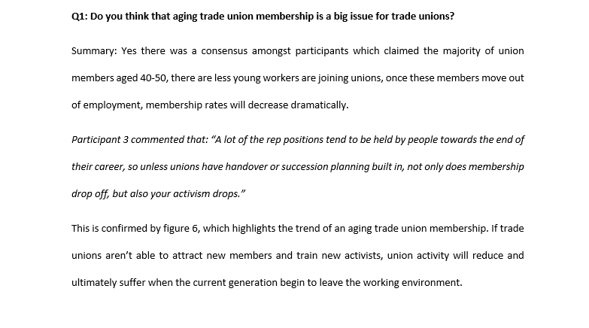
The following analysis will detail the question asked and a summary of the responses received by participants, the analysis will be aided by direct quotes taken from individual participants.

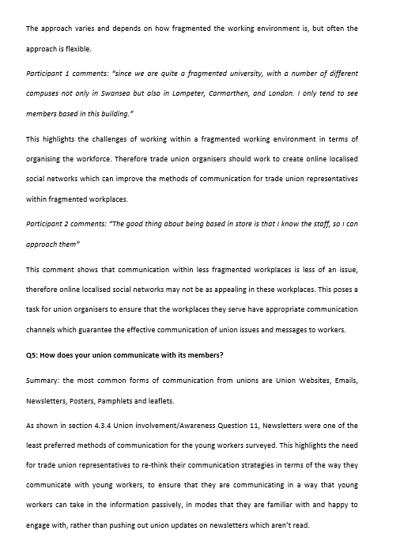
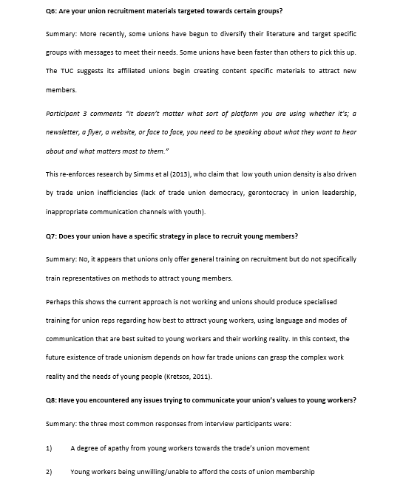
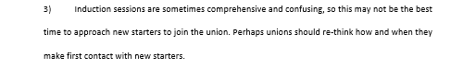

4.5 Conclusion
The data collection exercise received 51 responses from survey respondents ages 18-30 and detailed interviews with three trade union representatives.
80% of young workers surveyed advocated trade union relevance in the current working environment, which is surprising considering only 13.6% of respondents have previously been union members. This is slightly below the national average 16.2%.
86.4% of respondents reported never being a member of a trade union, which confirms the extent of the issue and supports the view that young workers aren’t joining trade unions. There was a consensus amongst interviewees that an aging trade union membership is an important issue for trade unions.
41.2% of the respondents are working full time, 19.6% are working part time alongside their studies whilst 11.8% report only working part time only. Within this, 21% are working within the public sector, 77% of respondents are working in the private sector. It appears that a large proportion of the respondents begin their career working within retail, health and social care, hospitality. However, figures 16 and 17 indicate that respondents begin moving out of these sectors into positions which offer a more comprehensive career path and opportunities for progression.
57% of respondents had previously been employed on a zero-hour contract, and 54.9% of respondents reported having hours taken away by their managers. Respondents reported having up to 10 job roles throughout their career, where most respondents reported having 5 job positions which appears typical for young workers in the current employment environment.
Interviewees cited that the fragmentation of industries that young workers are concentrated, and the increase in casualization and erosion of the employment contract, as some of the main barriers which prevent young workers from joining a trade union. This appears to support the data collected from the surveys. This fragmentation also affects how union representatives structure their approach to recruiting new members. In highly fragmented workplaces there appears to be a greater challenge in terms of communication, this issue is not as pronounced with workplaces that show less fragmentation.
Additionally, 18 respondents reported being unaware of the current trade union agenda, compared with 11 respondents which claimed they were. This apathy on the part of young workers was suggested by interviewees as one of the main issues that representatives encounter whilst trying to communicate their union’s value to perspective members. This poses a problem for trade unions as a lack of knowledge of trade unionism is a direct barrier which prevents young workers joining trade unions.
Respondents reported that their preferred methods of communication were email and websites, whilst newsletters appeared to be the least preferred, whilst the interviewees suggested that the most common forms of communication from unions are Union Websites, Emails, Newsletters, Posters, Pamphlets and leaflets. This highlights the need for trade union representatives to re-think their communication strategies in terms of the way they communicate with young workers, to ensure that they are communicating in a way that young workers can take in the information passively.

Chapter Five - Conclusion and Recommendations

5.1 Introduction
This chapter aims to provide a critical evaluation of the affiliation between trade unions and young workers. First, detailing the limitations of the study in terms of research methodology and research approach before an appraisal of the research objectives. This is followed by the conclusion, which aims to inform the discussion surrounding trade unions and young workers before finally, presenting an assortment of recommendations for trade union organisers and representatives in order to prevent further decline, maintain current levels of union engagement, and ultimately attract a new generation of young members to their unions.

5.2 Limitation of the Study
There are a number of limitations associated with the research methodology and approach that should be considered. A principal limitation of this study is that it has been carried out by an individual at postgraduate level with limited financial ability, amongst a competitive workload within a set timeframe. For this reason, an experienced dissertation supervisor has been allocated to this project to inspect the progress being made by the researcher and to reduce investigator error or bias during the research process. Furthermore, the supervisor can verify the reliability of the data collected through the method described in chapter 3.
There were some limitations with reference to research design. For instance the size of the sample for the surveys and securing interviews with practicing trades union organisers and representatives within the given timeframe.
A further limitation of the research design was that surveys were administered online without the presence of the researcher. This meant that the researcher had little opportunity to motivate respondents to participate or even ensure conscientious responses from those who did. One problem with not presenting questions face-to-face is that each participant may interpret questions differently, which may lead to the results collected being subjective. Additionally, respondents may have difficulty grasping the meaning of some questions that seem clear to the investigator, it is for that purpose that a pilot study was conducted before the full release of the online survey.
Another limitation in terms of reliability is that the sample was collected within the South Wales area and this possibly limited the range of responses.

5.3 Achievement of Aims
This investigation has fulfilled all four of the research objectives as stated in section 1.2 Aims and Objectives. Chapter two was used to fulfil the first objective, which successfully reviewed the key literature around trade unions and young workers. Due to the extensive nature of the topic under investigation, it was necessary to evaluate the literature and assess which aspects were most relevant to include within the literature review.
Chapter three details the research methodology behind the primary investigation as set out in objective 2. The selected sample surveyed regarding their awareness and involvement with trade unions were aged 18-30. The survey achieved 51 responses and the data was analysed using spreadsheet analysis and descriptive statistics. The sample for the interview was practicing trade union organisers and representatives. This sample was selected as it was assumed that they would be knowledgeable in the key themes for this investigation. The interviews were completed by three participants and the data was summarised using an analysis table which is available in “Appendix 8”.
Chapter Four proceeded to analyse the data collected as part of the primary investigation in order to evaluate the findings and generate conclusions. These conclusions will act to inform the theory and allow the assembling of recommendations for trade union organisers and representatives to follow.
This discussion chapter has been developed to generate recommendations for a future debate which encourages comment from trade union practitioners.

5.4 Conclusion
Trade unions have witnessed a trend of decline in union membership, a weakening of membership engagement and the emergence of less institutionalised forms of collective action. As the position of young workers in the labour market becomes increasingly precarious, it could be expected that they would lean towards trade unionism to increase their prospects of job security unfortunately this does not seem to be happening and it appears that most young workers remain disengaged from union activity
Weak bargaining structures, restrictive labour laws, and a lack of political optimism requires British trade unions to create a proactive, strategically oriented organising approach. It appears that the most common tactic is to establish semi-autonomous youth forums or organising campaigning activities.
Although there is some evidence of unions embracing ICT’s and social media this process has been slow and inadequate in terms of organising a technically enabled generation
the collection of primary data which includes; an online survey targeting young workers (18-30) regarding their awareness and involvement with trade unions, and a series of interviews with members of trade unions to discuss their efforts to attract and maintain relationships with young workers. 80% of young workers surveyed advocated trade union relevance in the current working environment, which is surprising considering only 13.6% of respondents have previously been union members. This is slightly below the national average 16.2%.
57% of respondents had previously been employed on a zero hour contract, and 54.9% of respondents reported having hours taken away by their managers. Respondents reported having up to 10 job roles throughout their career, where most respondents reported having 5 job positions which appears typical for young workers in the current employment environment. Interviewees cited that the fragmentation of industries that young workers are concentrated and the increase in casualization and erosion of the employment contract, as some of the main barriers which prevent young workers from joining a trade union. Additionally, 18 respondents reported being unaware of the current trade union agenda, compared with 11 respondents which claimed they were. This apathy on the part of young workers was suggested by interviewees as one of the main issues that representatives encounter whilst trying to communicate their union’s value to perspective members.
The future of trade union existence depends on how far trade unions can grasp the complex work reality and the needs of young people, and to what extent they are able to harness the power of social media to rapidly organise disparate groups of individuals across increasingly fragmented workplaces.
These findings hold implications for trade union organisers and representatives, the conclusions of the primary data collection exercise were in line with expectations following the literature review in chapter 2. This confirmed that young workers generally show low levels of engagement with trade unions, have a lack of understanding of the benefits and protections that trade unions can offer them. Although 80% of respondents suggested that trade unions are relevant in today’s working environment, the vast majority have never been a member of a trade union. This directly highlights weaknesses in the current union recruitment strategy which is preventing young workers from becoming trade union members.

5.5 Recommendations

Trade unions should attempt to diversify the services that they offer to their members. Using the example of BECTU as discussed in “2.3.2.1 Trade Union Recruitment” unions could offer additional workplace training, interview preparation, work placements for jobseekers to ease the transition into the working environment and increase member engagement.
Trade unions should attempt to reinvigorate momentum on the “unions into schools” initiative which provides teachers and activists with resources and information to tell the story of trade unionism and make the case for continued and increased relevance.
Trades unions should look into the wider employment environment and newly developing technical industries to maximise their coverage across the employment spectrum. This analysis will aid in targeting specific industries where trade unionism is struggling to get a foothold and they can propose specific policies and relationships to organisations which operate within these sectors.
Trade union organisers and representatives should push to consolidate and reform social media offerings and online content to ensure that they are produced using appropriate language and format which young workers will be receptive to.
Trade unions should continue to develop specific literature which targets “young workers” the TUC should set this as a minimum requirement rather than just a suggestion to individual unions.
Trade unions should look to European trades unions who have built continuous successes, i.e. in France with La Poste and Peugeot Citroen, and attempt to establish best practice which can be trialled on a smaller sample in the UK and rolled out if appropriate.
The TUC should strengthen their connection with National Union of Students, students involved with their students unions are prospective trade union activists and organisers who are already familiar with the structure and organisation of trades unions and as such will hold the potential to understanding how these structures can be changed to welcome a new generation of trade union members.
The TUC should investigate the feasibility of a general TUC membership, rather than a membership with a specific trades union. This membership will allow young workers operating within a fragmented employment environment to be able to carry their union involvement from job to job without having to re-register and change their payment methods. This could mean that young workers are able to remain part of the wider trade union movement if their current employer has a weak union presence or even none at all.

6.0 Bibliography
Aliaga, M. & Gunderson, B., 2005. Interactive Statistics. 3rd ed. New Jersey: Prentice Hall.
Anderson, T. & Walker, P., 2014. A Better Way to Work in Scotland. [Online]
Available at: http://www.stuc.org.uk/unions-into-schools
[Accessed 1 3 2017].
Bailey, J., Price, R., Esders, L. & McDonald, P., 2010. Daggy Shirts, Daggy Slogans? Marketing Unions to Young People. Journal of Industrial Relations, 10 Feburary, 52(1), pp. 43-60.
Bates, F., 2016. Living for the weekend? Understanding Brtiain's Young Core Workers, London: TUC.
Beal, D. J. & Dawson, J. F., 2007. On the Use of Likert-Type Scales in Multilevel Data. Organisational Research Methods, 10(4), pp. 657-672.
Bell, D. N. & Blanchflower, D. G., 2010. UK Unemployment in the Great Recession, London: Sage.
BERR, 2008. Globalisation and the changing UK economy, London: Crown copyright.
Berrington, A., Tammes, P. & Roberts, S., 2014. Economic precariousness and living in the, Southampton: Centre for Population Change.
Biddix, J. P., 2013. Mixed Methods Research Designs. [Online]
Available at: https://researchrundowns.com/mixed/mixed-methods-research-designs/
[Accessed 15 2 2017].
Bramah, M., Mudd, A., Carroll, N. & Wing, M., 2009. Speaking Up For Public Services, London: Trade Union Congress.
Brown, W., Deakin, S. & Ryan, P., 1997. The effect of british industrial relations legislation 1979-97. National Institute Economic Review, 161(1), pp. 69-83.
Bryson, A. & Forth, J., 2010. Trade union membership and influence 1999-2009, London: London School of Economics and Political Science.
CIPD, 2015. Over-qualification and skills mismatch in the graduate labour market, London: Chartered Institute of Personnel and Development.
Collis, J. & Hussey, R., 2003. Business Research: A practical guide for undergraduate and postgraduate students.. 2nd ed. Hampshire: Palgrave Macmillan.
Corlett, A. & Gardiner, L., 2015. Low Pay Britian, London: Resolution Foundation.
Crabtree, B. & Cohen, D., 2006. Qualitative Research Guidelines Project. [Online]
Available at: http://www.qualres.org/HomeSemi-3629.html
[Accessed 15 2 2017].
Creswell, J. W., 2003. Research design: Qualitative, quanititative, and mixed methods approaches. 2nd ed. Thousand Oaks: Sage.
Creswell, J. W., 2008. Educational Research: Planning, conducting, and evaluating quantitative and qualitative research. Upper Saddle River: Pearson.
Cribb, J., Emmerson, C. & Sibieta, L., 2014. Public Sector Pay in the UK, London: The Institute for Fiscal Studies.
Currie, D., 2005. Developing and Applying Study Skills. London: Chartered Institute of Personnel and Development (CIPD).
De Cenzo, D. A. & Robbins, S. P., 1993. Human Resource Management: Concepts and Practices. London: Wiley.
Department for Business Innovation & Skills, 2016. Trade Union Membership 2015: Statistical Bulletin, London: Crown Copyright 2016.
Devins, D., Bickerstaffe, T., Mitchell, B. & Halliday, S., 2014. Improving Progression in Low-Paid, Low-Skilled Retail, Catering and Care Jobs, London: Joseph Rowntree Foundation.
Driscoll, D. L., 2011. Introduction to primary research: Observations, Surveys, and Interviews. Writing Spaces, Volume 2, pp. 153-174.
Dufour-Poirier, M. & Laroche, M., 2015. Revitalising Young Workers' Union Participiation: A comparitive analyisis of Two Organisations in Quebec (Canada). Industrial Relations Journal, 34(5), pp. 446-460.
Erickson, P. I. & Kaplan, C. P., 2000. Maximising qualitative responses about smoking in structured interviews.. Qualitative Health Research, Volume 10, pp. 829-841.
Felstead, A. & Green, F., 2013. Underutilization, overqualification and skills mismatch: Patterns and Trends, Edingburgh: Joint Skills Committee.
Ferns, S., 2011. Delivering for Young Workers, London: Unions21 / TUC.
Forth, J. & Metcalf, H., 2014. Young people's experiences in the workplace, London: ACAS.
Gall, G. & Dundon, T., 2013. Global Anti-Unionism. Hampshire: Palgrave Macmillan.
Gill, J. & Johnson, P., 2010. Research Methods for Managers. London: SAGE.
Goos, M. & Manning, A., 2003. Lousy and Lovely Jobs: the Rising, London: London School of Economics.
Greer, I. & Doellgast, V., 2011. Marketization and Institutional Change: From an Idea to Its Social Effects. Madrid, University of Madrid.
Grey, D. E., 2004. Doing Research in the Real World. 1st ed. London: Sage.
Hall-Jones, P. & Cradden, C., 2006. The UK New Unionism project. [Online]
Available at: http://www.newunionism.net/library/workplace%20democracy/Hall-Jones%20and%20Cradden%20-%20The%20UK%20New%20Unionism%20Project%20-%202007.htm
[Accessed 16 2 2017].
Hay, C., 2015. What do low-paid workers think would improve their working lives?, London: Joseph Rowntree Foundation.
Heery, E. & Salmon, J., 2000. The Insecure Workforce, London: Routledge.
Hodder, A. & Kretsos, L., 2015. Young Workers and Trade Unions. London: Palgrave Macmillan.
Holmes, W. & Harwood, P., 2011. Social media and its impact on employers and trade unions, London: ACAS.
Hudson, M., 2015. The Decent Jobs Deficit: the human cost of zero-hours working in the UK, London: Trades Union Congress.
Keep, E. & James, S., 2010. What Incentives to Learn at the Bottom End of the, Cardiff / Oxford : ESRC Centre on Skills, Knolwedge and ORganisational Performance.
Kilgore, D. W., 2001. Critical and Postmodern Perspectives on Adult Learning. New Directions for Adult & Continuing Education, Spring 2001(89), pp. 53-62.
Kretsos, L., 2011. Union Responses to the Rise of Precarious Youth Employment in Greece. Industrial Relations Journal, 42(5), pp. 452-472.
Kretsos, L., 2014. UK Report on Young Workers and Trade Unions, London: YOUnion.
Lansley, S. & Reed, H., 2013. How to Boost the Wage Share, London: Trade Union Congress.
Lee, R. M. & Renzetti, C. M., 1990. The problems of researching sensitive topics. An overview and introduction. The American Behavioural Scientist, 33(5), pp. 510-530.
Lloyd, C. & Payne, J., 2012. Flat Whites: Who gets progression in the UK Cafe sector?. Industrial Relations Journal , 43(1), pp. 38-52.
McCabe, D., 2007. Individualisation at work?: Subjectivity, Teamworking, and anti-unionism. Organization, 14(2), pp. 243-266.
McDonald, P., Bailey, J., Oliver, D. & Pini, B., 2007. Compounding Vulnerability?: Young workers' Employment Concerns and the Anticipaetd Impact of the Work Choices Act. Australian Bulletin of Labour, 1(2-3), pp. 137-154.
Murray, G., 2017. Union Renewal: What can we learn from three decades of research?, Montreal: Sage.
Nowak, P., 2015. Past and Future of Trade Unionism. Employee Relations, 9 July, 37(6), pp. 683-191.
O'Grady, F., 2015. Under-employment won’t return to pre-crisis levels until 2023, says TUC. [Online]
Available at: https://www.tuc.org.uk/economic-issues/labour-market/britain-needs-pay-rise/under-employment-won%E2%80%99t-return-pre-crisis-levels
[Accessed 4 2 2017].
Pascual, A. S. & Waddington, J., 2000. Young People: The Labour Market and Trade Unions, Warwick: Youth Committee of the European Trade Union Confederation.
Pollert , A. & Charlwood, A., 2008. Vulnerable workers and problems at work: who experiences problems at work, what problems to they experience, what do they do about them and what are the results, Bristol: University of West England.
Roberts, S., 2012. Gaining skills or just paying the bills? Workplace learning in low-level retail employment. Journal of Education and Work, 26(3), pp. 267-290.
Roberts, S., 2012. No snakes, but no ladders’:Young people, employment, and the low skills trap at the bottom of the contemprorary service economy, London: Resolution Foundation.
Saunders, M., Lewis, P. & Thornhill, A., 2015. Research methods for business students. Fith ed. Essex: Pearson.
Simms, M., 2012. Young Workers During the Crisis: Hit Hardest and Scarred Longest, London: Unions21..
Simms, M., Holgate, J. & Heery, E., 2013. Union Voices, Developing Organising in the UK, London: IRL Press.
Small, M. L., 2009. "How many cases do I need?" On science and the logic of case selection in field-based research.. Enthography, Volume 10, pp. 5-38.
Sowemimo, M., 2015. Labour's Eleventh Hour: Winning on the economy with a purpose, London: Compass.
Standing, G., 2011. The Precariat: The New Dangerous Class. London: Bloomsbury.
Stephens, M. & Blenkinsopp, J., 2015. Young people and social security: an international review. [Online]
Available at: https://www.jrf.org.uk/report/young-people-and-social-security-international-review
[Accessed 4 2 2017].
Tailby, S. & Pollert, A., 2011. Non-unionised young workers and organising the unorganised. Economic and Industrial Democracy, 32(3), pp. 499-522.
Trade Union Congress, 2015. Young women with vocational qualifications earn 15% less than men, finds TUC. [Online]
Available at: Young women with vocational qualifications earn 15% less than men, finds TUC
[Accessed 3 2 2017].
Trades Union Congress, 2016. Trades Union Council's Programme of work 2016/2017. [Online]
Available at: https://www.tuc.org.uk/sites/default/files/2016%20to%202017%20Programme%20of%20Work-%20Final.pdf
[Accessed 8 3 2017].
TUC, 2014a. Unions Into Schools. [Online]
Available at: http://ebctuc.co.uk/
[Accessed 1 3 2017].
TUC, 2014. TUC Equality Audit: improving representation and participate in trade unions, London: Trades Union Congress.
Tyyska, V., 2008. Youth and Society: The Long and Winding Road. 2nd ed. Toronto: Canadian Scholars' Press Inc. .
Undy, R., 2012. Trade Union Organisation 1945-1995. [Online]
Available at: http://www.unionhistory.info/britainatwork/narrativedisplay.php?type=tradeunionorganisation
[Accessed 29 11 2016].
Visser, J., 2006. Union membership statistics in 24 countries. Monthly Labour Review, Volume January, pp. 38-49.
Vitale, D. C., Armenakis, A. & Feild, H. S., 2008. Possible Priming Effects?. Journal of Mixed Methods Research, 87(2), pp. 87-105.
Waddington, J. & Kerr, A., 2002. Unions Fit for Young Wokers?. Industrial Relations Journal, 33(4), pp. 298-315.
Ward, S. & Lusoli, W., 2003. Dinosaurs in Cyberspace? British Trade Unions and the Internet, London: SAGE Publications.
Warren, R. & Tweedale, G., 2002. Business Ethics and Business History: Neglected Dimensions in Management Education. British Journal of Management, Volume 13, pp. 209-219.
Wielnius, P., 2004. Enemies within: Thatcher and the unions. [Online]
Available at: http://news.bbc.co.uk/1/hi/3067563.stm
[Accessed 1 12 2016].
Williams, M. & May, T., 1996. Introduction to the philosophy of Social Research. London: UCL Press.
Williams, S., 2014. Introducing Employment Relations: A Critical Approach. 3rd ed. Oxford: Oxford University Press.
Wilson, R., 2014. Working Futures 2012-2022, Cambridge: UK Commission for Empolyment and Skills.

Appendix 1 - Gant Chart
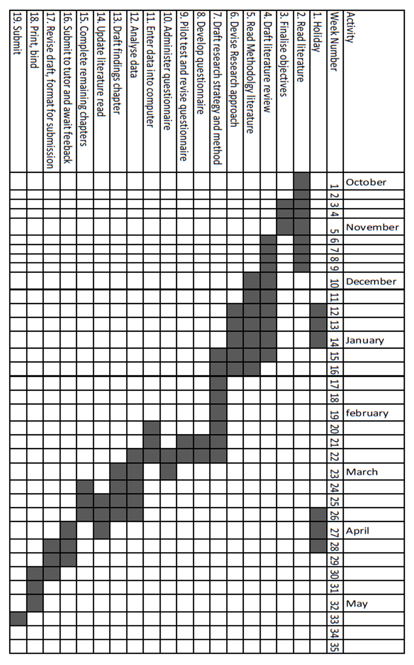

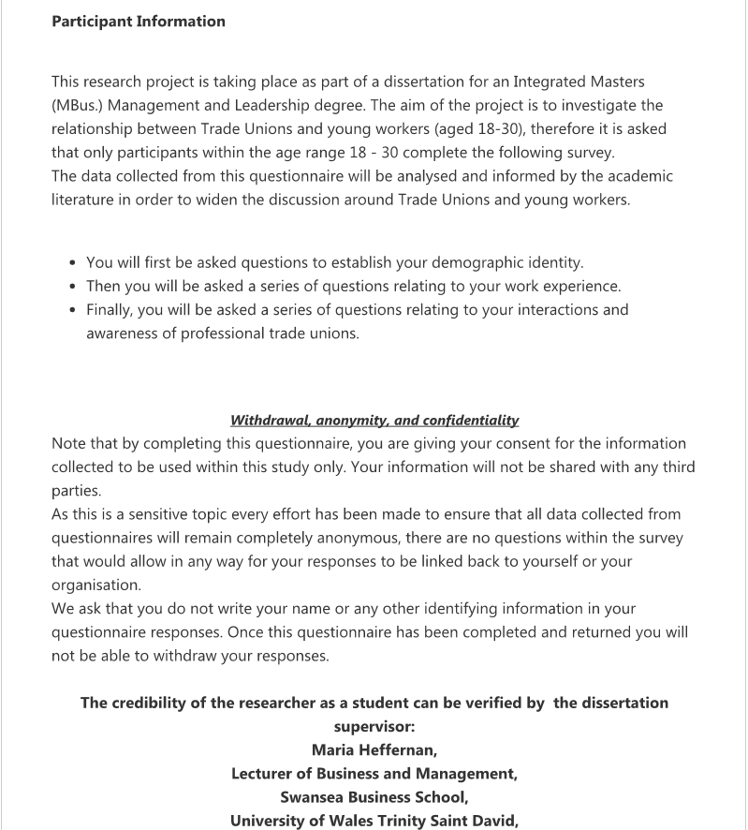
Appendix 2 -Sample of Survey Questions
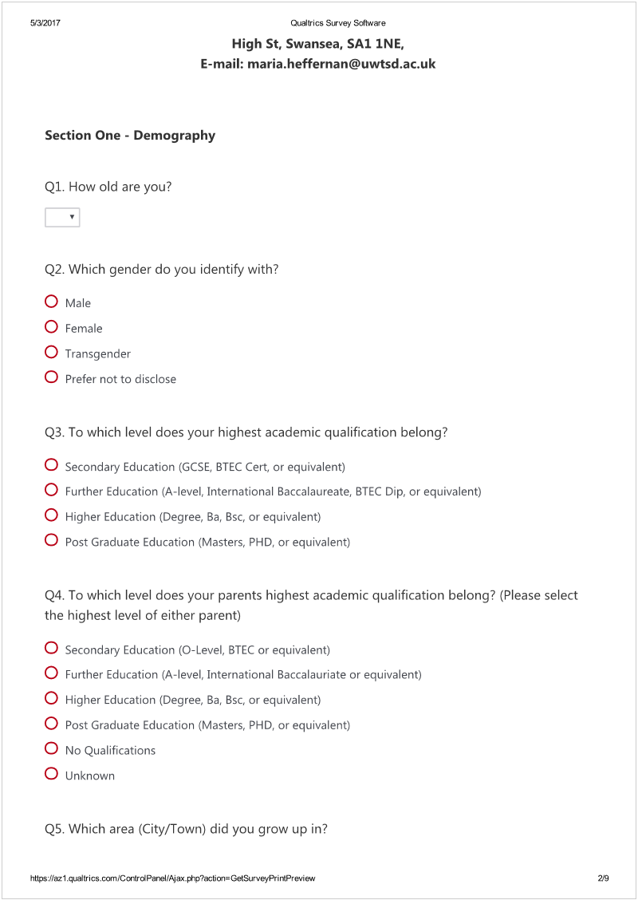
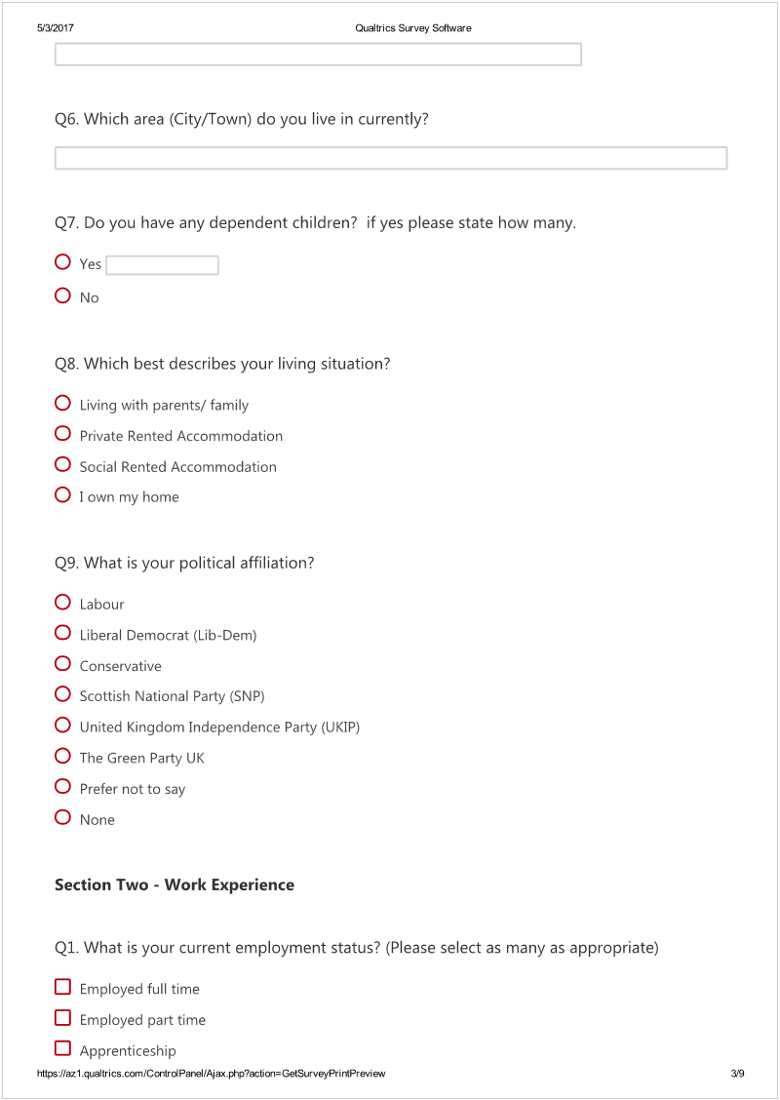
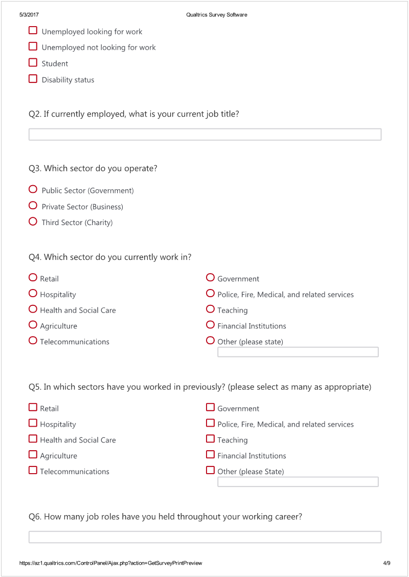
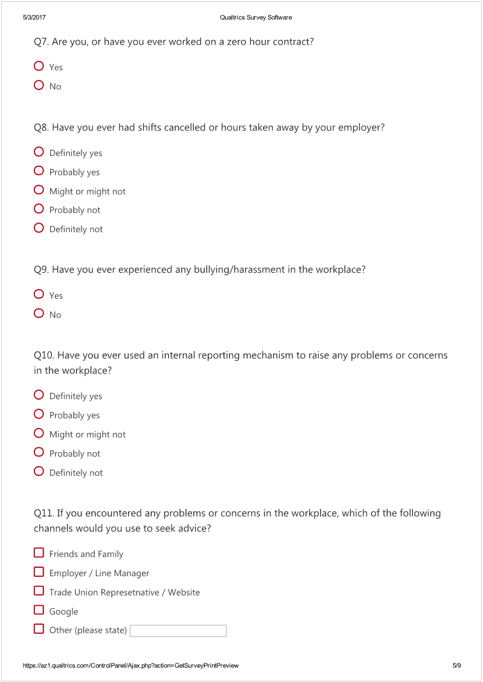
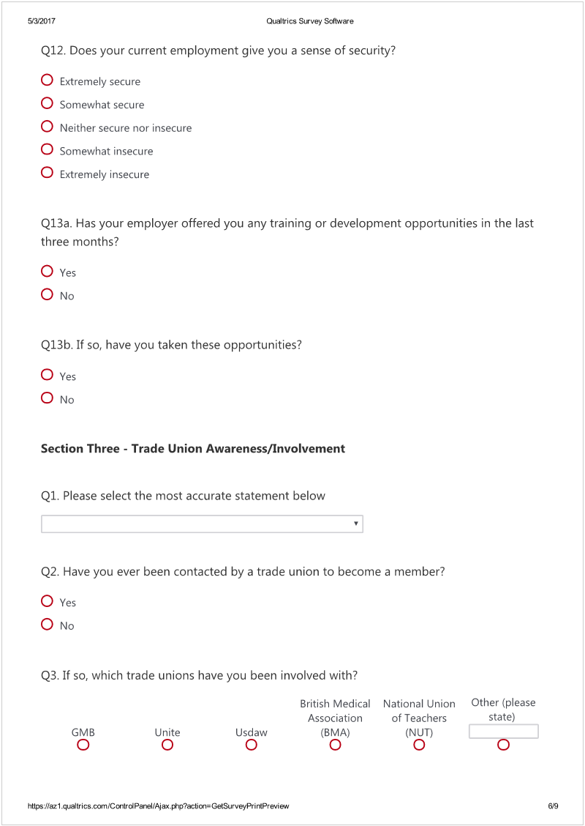
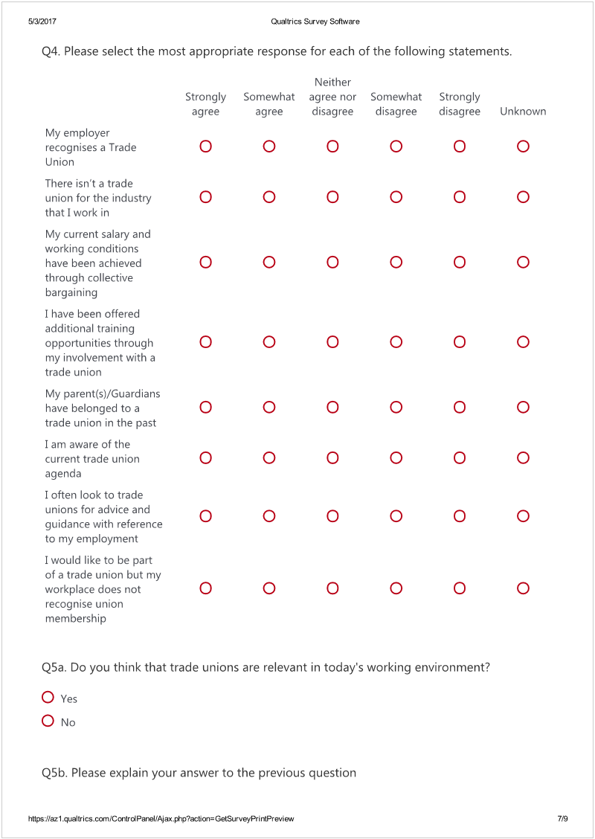
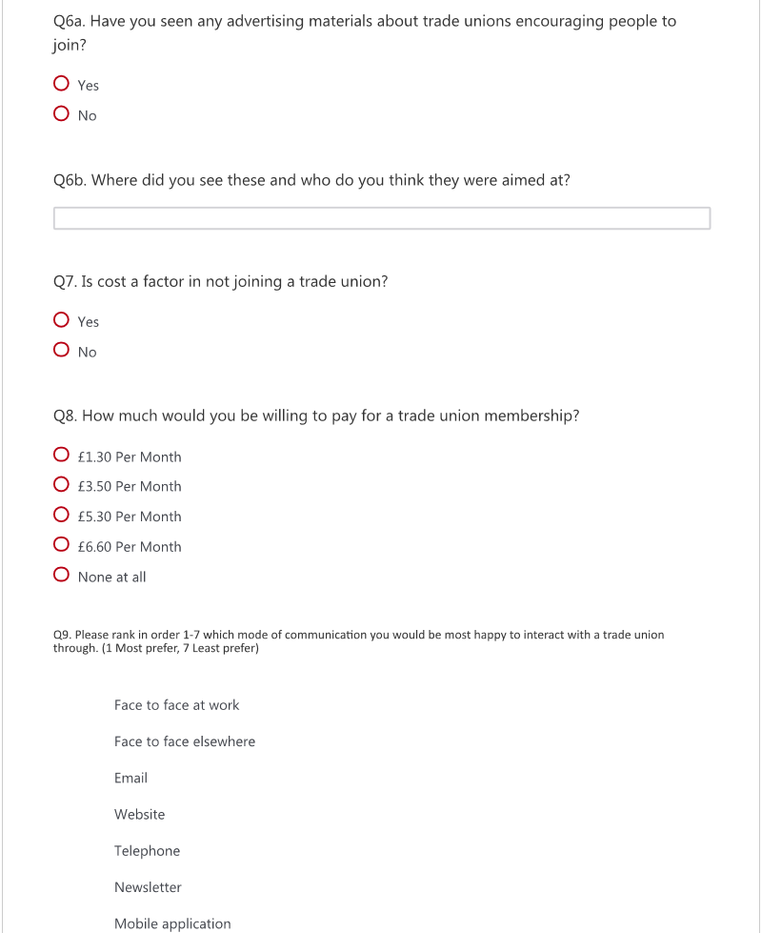


Appendix 3 - Excel Spreadsheet with Survey Data



Appendix 4 - Sample Interview Questions
Can you tell me how you first became involved in trade unionism?
How long have you belonged to your Union?
What Union are you currently involved with? What sectors do you cover?
Could you describe in as much detail as possible how you reach out to workers in order to attract them to your union?
What does your Union/Branch act to attract workers to trade unions?
Do you have a separate approach to attract young workers?
Have you encountered any issues trying to communicate your union’s values to young workers?
Does your specific trade union have a strategy in place to recruit young members?
Do you think that trade unions are relevant to young workers in the current working environment?
Have you received any specialised training on recruiting young members?
How frequently do you approach workers to attract them to your trade union?
How do you recruit new members? Can you give me examples of methods and materials used?
Who are your recruitment materials targeted towards?
In your current position, how often do you approach workers about union issues?
How does your union communicate with its members? Trough newsletters, website, emails…
What do you think could attract younger workers to your union?
What tangible benefits does your union membership offer?
Do you think they are attractive benefits for young workers?
Do you think that trade unions appropriately represent young workers?
Do you think that aging trade union membership is a big issue for trade unions?
What are the main barriers for joining a union?
Why do you think young people aren’t joining trade unions?
What do you think the main benefits of trade union membership are in general?
And for young workers?

Appendix 5 - Interview 1 Transcript

Participant 1
I: How long have you been a part of a trade union?
P1: About 15 years
I: Can you tell me how you first became involved in trade unionism?
P1: Well, I started working here in 1995 and I came from a chartered accountant background, this was my first job in HE, the vast majority of chartered accountancy firms aren’t unionised so I’d never came across trade unions before, I must admit that for the first 5 or 6 years working here I wasn’t involved in the union. But then there were a few changes in Swansea institute of HE becoming Swansea Met Uni and in the education industry as a whole so that’s when I really became involved in the trade union around 1999/2000 after I’d been here about 5/6 years after I joined.
I: Which Trade Union are you currently involved with?
P1: UCU, we are a recognised union in the vast majority of universities UK and the largest recogniser of academic staff in HE and FE in the UK.
I: What sectors of employment does this union cover?
P1: Lecturers/Teaching staff (academic side)
I: Do you think that aging trade union membership is a big issue for trade unions?
P1: Yes, definitely. We have experienced and had discussions with the committee at UWTSD about the age profile of the membership. I actually look after the database of members here, and Lampeter and Carmarthen after the merger and you can see the pattern in the database where, I am not sure of the percentage but I would say that at least 50% of the membership are over 40. It seems that there’s a pattern a lot of the newcomers to UWTSD not so keen joining UCU, there definitely is an aging membership.
I do a corporate induction session where we go in and talk about the benefits of joining the union, but there definitely is a tendency for new starters not to join.
I: What sort of responses do you get when you go into those induction sessions?
P1: Not any in that way as such, it is only usually a 15-20-minute slot, so it is not really a question and answer session, it’s more of an information giving session. They are able to email or speak to me thereafter, but it’s very rare people do take up that option.
I: What are the main barriers for joining a union?
P1: Not only in education, but in other industry’s as well, I think the main barrier as far as young people is concerned Is 1) the type of industries that perhaps the great majority young people are working in be it retail, call centres, service industries that aren’t usually unionised. Because of that I think that a lot of young people don’t have an understanding of what a union is all about and what a union can do for them. And the benefits of a union.
I’ve been having a look at some of the research which is out there – and a lot of people are saying that they may well have been interested but I didn’t know what the trade union could do for me or even if there is one or my employer doesn’t recognise one. So I think a lot of It comes down to a lack of knowledge and the type of industries that young people are working in that are the largest barrier to unions is suppose.
I: In your current position, do you approach workers about union issues how often are you involved in this activity?
P1: As far as the recruitment side of things, I tend to the corporate induction sessions, mainly an information giving session where we explain what UCU can offer to employees. We also do regular coffee mornings for example where it’s more of an informal environment that gives the possibility for members and non-members to approach members of the committee in an informal setting, which gives them a better opportunity to ask questions compared to the induction sessions. In addition, we have regular newsletters, I am the newsletter editor as well, and so we send out a newsletter, going through issues that UCU is involved with both inside the university and the wider union group. These then are distributed to both members and non-members. I think that’s a good way of imparting information about the type of issues that the union is involved with and any progress being made in discussions.
I: So do you give them out to members in the university?
P1: We email them actually; we have a subscription list of members and non-members so we send them out usually on a quarterly basis. We have only started doing that in the last 2-3 years and so far, it has received some good feedback.
It is quite a good way to keep everybody informed, since we are quite a fragmented university, with a number of different campuses not only in Swansea but also in Lampeter, Carmarthen, and London. I only tend to see members based in this building (the business school) and I rarely go to mount pleasant, so we have found it’s a really good way to impart information and to try and push some of the success stories and positive movements that we have managed to make in recent times.
I: How does your union communicate with its members? Through newsletters, website, emails…
P1: There is a national website, most of the campaigns are organised nationally from the UCU office in London, so they distribute materials like pamphlets, posters, down to me. We do have the option to
We haven’t as yet, as most of the issues are the same type of ones that are organised nationally. The more local ones are usually more discussions of practices and policies within the university rather than campaigns as such.
I: Do you think that trade unions are relevant to young workers in the current working environment?
P1: I think so definitely yes, especially speaking in terms of the education sector. There are so many changes happening at the moment, one with Brexit, and two with a fall in student numbers, which is quite a big problem for universities for this academic year.
I: Does your trade union have a strategy in place to recruit young members?
P1: Yes, there is a recruitment strategy. We have nationally organised recruitment weeks, they aren’t directly targeted at young workers per se, they are aimed at all workers but within each university, they would be the ones we target because that is where the shortfall in membership is. The national office has set weeks, usually one in each academic term which is classed as a UCU recruitment week and those are ones where we distribute additional information via email and that’s when we tend to hold those coffee mornings, which are open then to all staff not just members to come in and speak to staff about what the union can offer them, so that’s organised both centrally and locally as well.
I: Have you encountered any issues trying to communicate your union’s values to young workers?
P1: Yeah, I think one of the main issues that I have experienced trying to get younger workers into our union is a degree of apathy that often is a factor from younger workers towards unions. Whether that stems from a lack of knowledge of what the union can offer to them or whether its apathy in general I am not quite too sure.
Also some of the responses that I get is that some people believe that unions are of good to them, only when there is a problem. For example, if they had a problem in work they could think “oh I’ll go and see what the union can offer me in support” but I they don’t have a problem or they have never had a problem they can perhaps have a problem seeing what the union can offer them. Which is a shame really because there are a lot of other advantages to being part of a union, especially in reactions to trying to improve working conditions, and even pay as well. So it’s a lot more than just a fall-back mechanism if you get into trouble, which often happens to be some people’s viewpoint.
Another one that I come across quite a lot is people saying, which might be a bit of a problem at the lower end of the pay scale, that they can’t afford it. The UCU membership is actually staggered, the monthly subscription rates vary according to your salary and there are different tiers or membership. But again, it is a commitment I suppose, a monetary commitment to be part of the union and if people say that they can’t afford it, that’s as far as it goes with them.
I: Have you received any specialised training on recruiting young members specifically?
P1: No, the members of the committee have had a variety training across different aspects in relation to UCU work; casework, recruitment, bargaining. As far as the recruitment side of things the training has not been target at young workers per se, rather targeted at people across the board, but I guess that the principles apply to young workers to.
Although the vast majority of people who come into HE tend to be 30+
I: What tangible benefits does your union membership offer to young workers?
P1: I think what I would say as far as the benefits of being a member of UCU within the university to all workers, the young amongst those. I think it’s having the opportunity to improve your own working conditions and the HR policies and procedures. We have been really lucky at UWTSD since the merger in that HR and the senior management team have been very willing to engage with the union and we have had a number of meetings where certain issues which affect members are discussed and we look at ways of improving that.
I think one of the main benefits that has come about in recent years is that we now have a much better policy in terms of working from home; In the old Swansea met, in certain faculties there was the viewpoint with certain deans where they would walk around at half four and would look to see whether someone was in their office. Which isn’t the nature of academia. I think maybe it was something do with them being from an older generation, so they had this opinion that their monitoring of staff would be based on input and not output and whether you were actually sat at a desk at a particular time of the day.
So that’s one positive movement that’s been achieved and I try and put that across when we’re looking at recruiting young members and we have a much more flexible policy now on working from home.
In addition, workload has been a big issue in a lot of unis now. In the last two years we have developed a working load monitoring system for academic staff. So there should then be transparency with exactly what your workload is through the academic year. Moreover, that links in with the appraisal scheme then, so if you think on completing your profile that you are being over -worked or vice versa, if the dean thinks you are being under-worked, at least then there is that transparency of information. So I think those are two particularly positive steps that have affected the academic staff in the university both young and old, and it’s trying to get that message across to the younger members that these are the positive things that we’ve achieved for you.

Appendix 6 - Interview 2 Transcript
I: How long have you been a member of a Trade Union.?
P2: So it’s not my entire life, but since I started working for Tesco in 2000, so about 17 years
Can you tell me how you first became involved in trade unionism?
When I became a rep about 6 years ago, I became a rep when vacancies came up. I’d had a few problems with a manager bordering on bullying, it was a really bad time, and I was an elected counsellor at the time. I felt like I knew my rights but speaking out for yourself is really hard, there was a bit of a confidence issue, but I thought if he was able to do this to me, then it would happen to other people.
So when the vacancies came up I made the move to becoming a union rep. I’ve been a part of the union for longer than that but I’ve been in a representative role for the last 6 years.
I think that when something happens to you it’s really hard, it so emotional for you that sometimes you can’t think straight. So having somebody there to support you really makes a difference.
I: Which Trade Union are you currently involved with?
P2: Usdaw
I: What sectors of employment does this union cover?
P2: More supermarkets, but also places like boots… they also represent peters pies, it’s a really wide range. In Tesco, they cover shop workers, distribution, the warehouses, main office and maintenance now.
They also represent; Morrison’s, boots, Wilkinson’s, Sainsbury’s, I’m not sure outside of that but I’ve been on courses and have met people from these sectors.
What’s quite nice about Usdaw is that they have a partnership agreement with Usdaw which is very robust, it’s very detailed, from benefits to disciplinary, and the difference between grievance disciplinary and performance disciplinary and how they are each handled is quite different. But the actual process they have is very robust because they have a really good working relationship with Tesco.
Whereas when we go to training, and we see the Wilkinson and Morrison’s agreements they have 2-3 page agreements whereas Tesco have a a5 binder filled with information and you can go to the online portal “my Tesco” and find all of the information you need. They are really open about their policies than a lot of the other unions.
USDAW take part in wage negotiations, and recently Morrison’s have increased their wages to the recommended living wage (£8.10) (rather than national living wage), but finding out what the staff had to give up in order to receive the pay increase. It’s was really interesting because of the fact that Sainsbury’s put their wage up too, but to do so, all staff lost Sunday and overtime premiums. So it’s nice to be able to see the differences in these companies and how they treat their staff.
I: What are the main barriers for joining a union?
P2: I don’t like the fact that trade unions support one political party, I think that they have a better chance of 1) getting membership and 2) a stronger fighting position focusing their muscle against all parties whereas they currently seem to be very reluctant to move against labour. I think that actually puts them at a bit of a disadvantage at the moment.
I think that we are coming to a point where trade unions will not support a particular political party anymore, I think that point is coming because it does affect how people perceive a trade union.
You can vote to say that your money doesn’t go towards a political party in a union but if there is even a thought that the $6 you’re paying a month, $1 of that goes towards a political party that they don’t support. I can see why people may be put off by that fact.
I think another thing is that there have been quite big losses by trade unions, where they have had to cave on lots of things. I think that there is a little bit as well as that people don’t want to come together as a group as much anymore. I mean, we all depend on our jobs and the income they bring. So the idea of rocking the boat and going on strike can sometimes be quite difficult.
I: What does your Union/Branch do to attract people to trade unions?
P2: We work with Frankie and Benny’s to get 20% off with your Usdaw card, and there are deals with the co-op to get loans and slightly better rates, offers on car insurance, you can get cashback on online purchases. But all USDAW members receive information about the offers by email and they can log-on to the USDAW website and get information of what offers are currently running, some things like money off NHS dentists, holidays, Virgin experience days, a free 1hr legal consultation which can be about anything, selling your house, your divorce, anything really the union just set up the appointment and you can get free legal advice which some people find really helpful.
another thing that Usdaw offer is a free will writing service, so lots of our members have taken up this option, that’s usually done by a team which comes into the staff room and talks to people about the process and book appointments for them to go in and get their will sorted with free advice.
We also do campaigns around October and the run-up to Christmas called “respect for shop workers” and the idea behind it is that shop workers around the holidays are often abused by customers, and the idea is to promote that these are people, not just uniforms and these people have feelings. So that works to support the staff on the checkouts and the shop floor.
I: So do you often use any of these benefits?
P2: I have done in the past, they are very similar to the benefits that Tesco gives to all employees, and they are good. They are great for younger workers because you can access it all online. But I tend to notice that older staff don’t tend to use them as much because they can’t access it on the internet or don’t know how.
I: How frequently do you approach workers to attract them to your trade union?
P2: So there are two different ways, part of the agreement that Tesco have with USDAW Is that we approach new starters during their induction, where we show a video and try and recruit people through that. What sometimes happens is that people say well I’m not really sure… so you give them the forms, tell them where they can find you and just keep in touch with them if they want to take it any further.
Another thing we do is that we map the store, so basically we go through our membership roll and check where our members are. This can tell us In which departments there are a lack of union members and what we’ll do is carry out targeted campaigns to try and bring those people into the union.
Again, there are people in the store who look to join the union because of their experiences in work.
The good thing about being based in store is that I know the staff, so I can approach them and say I know you aren’t part of the union, is there any particular reason you aren’t, is there anything we can do for you or any way I can talk you into joining.
I: Are your recruitment materials targeted towards specific groups- Please give examples?
P2: Yes, we have targeted leaflets for: ‘young workers rights’ ‘flexi workers rights’ ‘disabled workers rights’ ‘pregnancy’ ‘Health and safety’ there are lots of different types, they tend to target specific people, because people get overwhelmed with a big booklet so giving them short precise bits of information and then they direct them to a phone number or website for further help and advice or information. Every time I go to Cardiff I pick up a load of all of them so that I can hand them out where appropriate.
I: How does your union communicate with its members? Through newsletters, website, emails…
P2: So we mostly use leaflets and emails, there is an option online to join the mailing list, however not everybody in this store has signed up for that. But other than that, we are sent updates in newsletters and forms that are left in the staff room so people can pick them up themselves. They also send out posters to store which get displayed on the union boards near the staff entrance.
I: Why do you think young people are not joining trade unions?
P2: I think it’s difficult. It’s quite odd, you have two groups of young people. Those who are students or the people who leave school and go straight into a job. They usually are on a low wage, and are given a small amount of hours and they find it very difficult the idea of paying to be part of the union. Even though it’s not a huge amount of money every month, in terms of the benefits they get from the membership.
You see a lot of the time that through their employment problems arise and they find that actually they need the union at some point, so that’s usually when they join.
I don’t think that’s the worst case in the world because at least they recognise that there is someone in their corner and they join. I understand why you can’t charge a reduced amount for membership for young workers, because at the end of the day you are still getting the same amount of support as people who pay the whole amount.
And then you get the students who don’t want to join the union because they don’t think they will be there long enough to do anything about it.
Sometimes you see that their parents have had bad experiences in the past with unions so that turns them away. A few years ago we had a significant number of members leave the union because they felt that the union hadn’t done well enough in helping them secure a bank holiday over the Christmas holidays, there was a big uproar and lots of people left the union.
What we have found is that a lot of those people have re-joined the union, they eventually realised that it wasn’t a problem with the union failing, but rather it being a sector-wide issue.

I: Does your trade union have a strategy in place to recruit young members?
P2: Not particularly, when we recruit we aim to recruit as many members as possible, we don’t specifically target young workers. We are able to tailor our approach towards each type of member so we are quite flexible with our strategy depending on who we are trying to get to join.
We do have lots of flexi-workers which we try to target. Because their contracts are so different to other peoples in store we need to make sure that they are aware of the terms of their contracts.
I: Have you encountered any issues trying to communicate your union’s values to young workers?
P2: No, because people are usually really nervous, and it can feel like you are over whelming them. A lot of the people who are starting are 16/17 so this is their first job, perhaps they haven’t worked before, so they don’t want to say no so they usually just accept what you say. Sometimes we leave materials with them and approach them again later.
It also depends on the group, sometimes you approach them 2 hours into their induction, sometimes after 4 hours, so you have to be aware of that, and be careful not to overload them with information.
One of the things we do in this case is give them free pens. It’s a gimmick but it does work in getting the union into people’s minds.

Appendix 7 - Interview 3 Transcript
I: How long have you been a member of a Trade Union.?
P3: 8 years
I: Can you tell me how you first became involved in trade unionism?
P3: My grandfather was always a part of the union when he grew up, so unionism and activism is something he passed down to me. It wasn’t until I started looking for work after my degree that I became involved in unionism.
I: Which Trade Union are you currently involved with?
TUC
I: What sectors of employment does this union cover?
P3: Affiliate to other trade unions in the UK, act to structure policy and campaigns for our affiliated unions and act to support them internationally, nationally, regionally, and locally.
I: Do you think that aging trade union membership is a big issue for trade unions?
P3: Yes absolutely, in the living for the weekend research, looking at young core workers, less than 10% are in a trade union compared to 25% of the population in general. The vast majority of our membership is aged between 40 to 50 I think. So if we don’t get young members in to backfill, that age group continues to move forward and we eventually fall off a cliff. Research has shown that once union density in any country reaches below 20%, it’s very difficult to pick that back up again. Also one of the problems we have, and this is a difficult one we have. Is that a lot of the rep positions tend to be held by people towards the end of their career, so unless unions have handover or succession planning built in, not only does membership drop off, but also your activism drops. You can still have lots of members, but it’s the reps that argue for the pay rise, or stands up for members if they are being bullied so if you lose them, you lose the troops on the ground that are making the difference.
So yeah, age is a problem and it’s something that the TUC has recognised. That’s the reason that for the past two years the TUC has been doing a lot of research into what draws young workers into unions and what the problems are. Last year we launched the living for the weekend project. This congress, we’re going to be launching more information about that and more of our findings.
Unions realise that we might have to get to the point where we change how our overall structures work, which is a huge change for unions but it’s got to the point where it’s do or die.
I: What are the main barriers for joining a union?
P3: This is a really complicated question when it comes to challenges, I think the crux of the problem is that the vast number of young workers are employed in industries where unions are not represented. So retail, hospitality, and care are the three big ones. And the problem with those industries is that your traditional work contact doesn’t exist in the way it did in the past; you have casualization, zero hour’s contracts, and all of the rest of it. So it’s very transient. You may have a post come through and work three months at one location and then move on to the next. It’s difficult then for the way that unions have been organised in the past to attract those people.
Why would you join one union just to be there for three months and then move to a completely different sector?
So that becomes a difficult challenge, and that raised questions on whether there should be a general union membership, so if you change employer and different sectors your membership moves over.
I’m not sure how well that would work, I’m not sure whether people would feel invested enough to do that, so that is a problem.
Also the fact that people are earning less money overall, when it comes to cost of trade union membership, so the challenge for trade unions on that one really is to re-frame that from looking at it as a cost, to looking at is for its value. For instance “I can’t afford not to be part of a union”
If you’re on minimum wage, depending on how many hours you work, if everyone there was to join a union, that union has a much better chance of getting the workers onto a living wage. And that living wage would offset your union subsidy, so it’s a no brainer that way. Although it’s difficult to get everyone together to take on an employer so that’s a challenge. Some people might think, “Oh I might get sacked”
It’s the same idea with employment tribunals and the costs involved, people are less likely to stand up for themselves than before because the safety net has been removed.
It’s a mixture of us not being in the right sectors, a transient workforce, the erosion of the employment contract, and the cost of membership, coupled with trade unions being unable to use the right language to connect with younger members to allow them to see the relevance for themselves in the current climate. So it’s a perfect storm of all of those things really and it’s such a difficult one to challenge.

I: What do you think the main benefits of trade union membership are in general?
P3: One of the arguments I usually use, when it comes to people who are against the costs of membership. For example if they argue against £12 p/m, what I do is try and push that value aspect over to them. And say, if you were in a meeting with your boss and he says because of reason 1 reason 2 and reason 3, you’re being dismissed. Would you pay £12 a to have a rep sit next to you and argue that reason 1 hasn’t been investigated properly and reason 3 isn’t applicable so to go forward with this would be unfair dismissal and be able to save your job.
That would be the best £12 I’ve ever spent to have someone give me that support.
A document we have produced – “The union advantage” highlights lots of the research that we have submitted to the welsh government in terms of repealing the trade union bill in wales, that unionised workplaces are actually safer places to work, because you have health and safety representatives and that is fact. I’m not just saying this, but that was part of government research which they have stopped conducting in 2006, because it showed that there are safer workplaces, less employment tribunals, lower turnover in staff. So it saves the public purse money in that sense and for the individual, it’s just knowing that you have someone there to fight you’re corner if you need it.
One of the points raised in living for the weekend is that young workers are more likely to be exploited, but less likely to realise that they are, that’s a big challenge for trade unions, because how do you get someone to join something to protect them if they don’t realise they need protection.
Some of the answers that have come back were – one person said “we get payed less than similar companies, but because we all get less, they think it’s fair”
Or people say things like “we have to come in early for team meetings, but aren’t paid for the extra time, but since we all have to come in early, I don’t see this as being unfairly treated.” Which is a difficult challenge there.
However if all of the staff members belong to a trade union that wouldn’t happen because you would have someone there to fight your corner.
A lot of people don’t want to be the one to go and talk to the boss, because I don’t want to be the one that’s told off. So if you are part of a union, you can go and tell your union rep and they can approach your manager for you, and not have to mention that you are the one that raised the query. But the union is only as strong as its membership.
Also you have training opportunities. I have an example of a BECTU rep, they are a broadcast union, where she was a camera operator, and what tends to happen is that in an attempt to get work experience she was filming rugby fixtures in the principality stadium, but she was doing it for free.
So after a while she thought well this isn’t experience anymore, I should be getting paid to do this, so she got in touch with BECUT, and she wasn’t a member at this time. And a BECTU member said she should do this to sort it out. So the BECTU rep sat her down and helped her draft a letter explaining the situation, and out of that she was given a full time job. If she didn’t go to the union in that case she would probably still be working for free, or she may have moved to a different sector by now.
So that union has since offered her lots of additional training which would have cost her a fortune if she had been doing it on her own, so career development is a good reason to be part of a trade union.

I: What does your Union/Branch do to attract people to trade unions?
P3: Because we don’t recruit members ourselves we tend to organise generalised campaigns, research based projects, at the moment we have recruited 100 volunteers from across different sectors, young workers, and we have them making “WhatsApp diaries”, so every day we will send them a question relating to how they feel about work, or does this happen in your workplace? And we’re gathering that research to find out what is going on and we’ll play with different ideas of what would appeal to them more, and what works or doesn’t work in the workplace, and we’ll test it on them as a way to inform unions on ideas that we have collected.
Another thing we did was a technical skills audit, trying to find out the minimum that unions should be doing in terms of how good their websites and social media should be, we have sent the survey out to all of our affiliates and asked them to fill that in, and then we paid for social media experts to visit the unions and talk them through strategies to up their game in different areas.
We have a young members forum, and run young workers campaigns but it’s difficult because we aren’t recruiting members ourselves, we aren’t getting those one-to-one conversations so it’s mainly about informing and equipping unions with everything we can so that they can recruit young members
So we do a collection of different things really.

I: In your current position, how often do you work with unions to approach workers?
P3: Not as much as I probably should, and that’s partly because we’re a small organisation. When people think about the TUC they think its 100’s of people across loads of floors, but in reality that’s not the case. So we try and do lots of different things, but we have streamlined recently to focus on key issues and concentrate on those.
Currently I’m writing something which is going to go to our next general council, I recently spoke at an Usdaw conference, where I was informed that they have 80,000 members across the UK aged under 27, but they have difficulty still in attracting young workers. And they get difficulties in setting up a young workers forum, which is odd because they have 80,000 young people. Which is a lot. And why aren’t they being involved?
So I suggested to ask them, which seems a simple answer but this is something that hadn’t been thought of before. So we’ve put a survey together asking them “what made you join a union”, “Why aren’t you’re friends part of a union” “what more could your union do to communicate with them” “what direction would you like to see your union go in the future”- those sort of questions, so we have sent that off to their young members, so when we get those results back we’ll look for patterns and anything that stands out. From that then we’ll pick a division, run a small scale campaign, and if that works we’ll roll it out nationally. If it doesn’t we’ll go back to the drawing board and see what else we can find.
And since we made the survey using survey monkey and the mailing lists are already there, there are basically no costs involved.
When we do campaigns we usually do street stalls, which personally I don’t like. For the reason that the people you want to speak to are usually not out because they are in work. The ones that do walk past are usually on their lunch and don’t want to be bothered, so the only people that end up speaking to you are people that are well meaning, but not your target audience and whilst I like hearing their stories and chatting, this isn’t what the aim of the process is for, and the union gets nothing from that.
So we decided that we needed to change focus in terms of our outreach activities. We launched an event launched last year at green man festival… and because of the type of festival it is, nobody would want to be handed loads of leaflets, whilst there are bands on and they are drinking beers, why would they come and speak to you? So we made something we called a “fair-pay ground” and it’s basically like an old school fayre, and each game was a campaign tool. – So we used a “beat the buzzer” game, and as people walked in we would ask them if they were part of a union, and had two handles, a big one and a smaller one. And if they were part of a union they would get a bigger handle, because life is easier in a union. So even if they weren’t part of a union they found it funny, and they are leaving there with that message “life is easier in a union” and taking that with them. So it’s not about recruiting people there and then, but slowly building the idea of what unions do and how they make you stronger.
Whilst it’s difficult to quantify the outcomes of that exercise, I think that I have had a lot more conversations there with people that weren’t part of a union, I definitely think that it helped to raise awareness and helped to appeal to people there who now know what a union is, and people were coming back and brining their friends with them and helping to spread that message by themselves then.
I: Are your recruitment materials targeted towards specific groups- Please give examples?
P3: Yeah, its one of the things that I have recently spoken to with our reps for the young workers update, and what I said was
If you don’t speak young people’s language with an offer that they think is beneficial to them, they aren’t going to listen to you.
You can see lots of examples where unions try to use leaflets which are generic, trying to be all things to all people and they end up being nothing to nobody at the end of the day. I think that most unions have taken that on board now, and will start or have started producing specific messages to young people. For example, as important as pensions are, there’s no point speaking to 16/17 year olds about their pensions, because that’s not on their radar. They just want to know how much they are being paid and when they’ll get it. That’s the concern, so focus on (in the same way as businesses do) broadening their portfolio and targeting different messages at different groups. I think that the unions are starting to do that in practice.
It doesn’t matter what sort of platform you are using whether it’s; a newsletter, a flyer, a website, or face to face, you need to be speaking about what they want to hear about and what matters most to them. Some unions are just catching up with this, but some cottoned on years ago and are much more advanced in their offerings.
I: How do you think that unions can best communicate with their members?
P3: I think we need to have a higher social media presence than we have now, it’s a problem of getting the message to places that young workers can come across your message, without searching for it. So we need to re-assess how we are getting those messages out, we can’t keep on relying on newsletters to get our messages over, because people simply don’t read them.
You need to be able to have a two-way conversations where they can ask questions and get a response, you can do things like that on union websites for example; if you go to the sky website a small popup box that appears asking “how can I help” – but union websites don’t tend to use those kind of apps, and only 1 in 3 workplaces has a rep on sight. So you have 2/3 workplaces with no rep, and nobody to directly talk to. You do have the option of sending an email but then you have to wait for a response, and that doesn’t work for young people.
We criticize organisations like Uber and Deliveroo, but the reason they are successful, and particularly successful with the core of young people that we struggle to get to, is because you can get what you want, and get it instantly. It’s seamless. So I think that we need to replicate that if we want to be successful in reaching the same group of people.
So I would like to see popup boxes on union websites where you can ask general union questions such as “can my boss do this” and have someone on the other end who can answer that question for you. Alternatively, even if it is a BOT, or Artificial intelligence. It’s also a way to get up to date information on your members, simply by asking “do you still work at this workplace” that makes sure your membership details are more robust.
With the trade union bill in place, there are going to be more and more legal challenges for out databases so that helps with that. Even if it’s a more complicated problem, it can be arranged for a union rep or officer to come and visit you.
I think we need to uptake more of these technologies, perhaps even scrap paper copies of documents, you can have a mobile app, you can have videos of people discussing “best practice” or suggesting solutions to problems.

I: Have you encountered any issues trying to communicate your union’s vision to young workers?
P3: Because I haven’t had that much contact face to face with young workers, no.
I dare say that unions have those stories because they are on the front line, but because I’m mostly in the office and working creating campaigns, I like to think they work, but unless they come back and tell me I don’t really know.
So no, but I would be interested to know what challenges or barriers there are to what we present, and the reasons why. Because sometimes until campaigns are properly carried out we just don’t know how they will translate.

Appendix 8 -Interview Analysis Table
Interview analysis | Interview 1 | Interview 2 | Interview Three | Summary
Which Trade union are you currently involved with? | UCU | USADW | TUC | A range of different unions that operate across different sectors in the UK.
Which Sectors of employment does your union cover? | Lecturers and Teaching Staff (academic side) | It’s the shop workers union, which covers all aspects of retail; Supermarkets, distribution, warehouses, head office, and maintenance. | Affiliate to other trade unions in the UK, act to structure policy and campaigns for our unions and support them internationally, nationally, regionally, and locally.
Do you think that aging trade union membership is a big issue for trade unions? | Yes definitely.  I would say that 50% of the members are over 40  It seems that there is a pattern; many of the newcomers to UWTSD are not joining the union. |  | Yes absolutely. Only 10% of Britain’s young core workers are union members compared to 25% of the population. The vast majority of members are aged between 40-50. Union rep positions are usually held by those at the end of their careers, so once those members leave the workplace, we lose the union representatives to. | Yes  Majority of union members aged 40-50  Less young workers are joining unions, once these members move out of employment membership rates will decrease dramatically.
What are the main barriers for joining a union? | - The type of industries that young people are working in (retail, Health & Social care, Hospitality)  - A lack of knowledge from young workers on what union membership can offer them | - The association of trade unions with the labour party  - Recent losses by trade unions  - A lack of community in workplaces today  There are two main groups of young workers;  1) People who join straight from school; who don’t really understand what the union can offer them, and do not want to pay for membership. Usually until they encounter problems at work.  2) Students who do not want to join the union because they do not think they will be working there long enough for it to make much difference for them. | - The vast numbers of young workers are employed in industries that unions are not represented  - An increase in casualization, flexible/zero hour contracts.  - Lower wages, people are less-willing to pay membership costs.  - Unions unable to connect with young workers in language that effectively communicates union value. | - The fragmentation within the industries that young workers are concentrated  - An increase in casualization and erosion of the employment contract  - Apathy towards trade unions from young workers  - The costs associated with union membership.
What do you think are the benefits of union membership? | - Having the opportunity to improve working conditions and HR policies and procedures  - We now have a much better policy on working from home, which is much more flexible than previous policies. | - Lots of exclusive member deals on holidays, restaurants, healthcare, legal advice and a free will writing service  - “Respect for shop workers week” in the run up to Christmas | - Having a trained representative to fight your corner in workplace disputes  - Unionised workplaces are generally safer places to work  - Additional training and development opportunities | - Better working conditions and a safer working environment  - Having someone to represent you in workplace matters  - Membership benefits, discounts and offers.
How frequently do you approach workers to attract them to your union? | At corporate induction sessions: which are used to give new starters information concerning the university’s agreement with the union and what benefits are available.  Also informal coffee mornings during UCU recruitment weeks, which allow a more informal setting for members and non-members to approach their union. Usually once every academic term.  Because the University is quite fragmented, it can be difficult to communicate with all of the staff effectively. | Approach new starters during induction sessions, where they show a video and try to recruit people through that.  Another thing we do is mapping the store, so they check the membership roll and check which departments have union members. From that, they are able to target campaigns towards departments where there is a lack of union members.  Because all of the staff are situated on site, it is a lot easier for the union reps to know all of the staff and from that know who is a union member and who isn’t. | As we work with alongside unions, we do not recruit members ourselves. We tend to organise generalised campaigns and research projects.  We have a young member’s forum and run young workers campaigns, but it is difficult because we are not approaching members ourselves we do not get to have those one-to-one conversations, so our job is mainly equipping unions with everything we can so that they can go out and recruit young members to their unions. | Generally first contact is at corporate induction sessions,  The approach varies and depends on how fragmented the working environment is, but often the approach is flexible.  Usually various points throughout the year there are opportunities for union reps to approach workers about union issues.
How does your union communicate with its members? | - From the national website  - Head office produce; Leaflets, Pamphlets and Posters which are displayed around the university.  - We send out newsletters to a mailing list | - Most of the communication comes through emails and leaflets, there is an option to join the mailing list, but not all members select this.  - We are sent updates in posters, newsletters and forms that are left in the staff room for people to see/ pick up. |  | Communication in the form of:  Union Websites, Emails, Newsletters, Posters, Pamphlets and leaflets.
Are your union recruitment materials targeted towards certain groups? |  | Yes, we have targeted leaflets for “young workers’ rights”, “flexi workers’ rights”, “disabled workers rights”, “Pregnancy”, “Health and Safety”. There are many different types, which target specific groups. | That’s one of the things that I’ve recently spoken to our reps in our latest young workers update, if you don’t speak young people’s language with an offer that they think is beneficial to them, they aren’t going to listen.  You can see many examples where unions try to use leaflets, which are generic, trying to be all things to all people, and they end up being nothing to nobody at the end of the day.  Some unions are just catching up with this, but some cottoned on to this years ago and are much more advanced in their offerings. | More recently unions have begun to diversify their literature and target specific groups with messages to meet their needs.  Some unions have been faster than others to pick this up, but the TUC suggests to its affiliated unions to begin creating more content specific materials to attract new members.
Does your union have a specific strategy in place to recruit young members? | No, the members of the committee have general training on recruitment, which targets people across the board rather than specifically targeting young workers. However, I guess that the principles apply to young workers too. | No, our recruitment drives aim to recruit as many member as possible, we do not specifically target young workers. We are able to adapt our approach towards each type of member so we are quite flexible with our strategy depending on who we are trying to get to join. |  | No, it appears that unions only offer general training on recruitment but do not specifically train reps with methods to attract young members.  Perhaps this shows that the current approach is not working and unions should produce specialised training for union reps concerning how to attract young workers specifically.
Have you encountered any issues trying to communicate your union’s values to young workers? | 1) a degree of apathy from young workers towards the trade union movement in general  2) Some people think that unions are only useful to them if they have problems in the workplace  3) Workers at the lower end of the pay scale are often claim to be unwilling or unable to afford the union membership fees. | No, during the induction sessions they are usually quite nervous. Many of the new starters are around 16/17 so they usually just accept what you are telling them.  Sometimes if we feel that they are being overwhelmed, we will leave them with materials and then approach them later.  One of the things we do is give them free pens, it is a bit of a gimmick but it works in getting the union into people’s minds. | No, because I have not had that much contact with young workers face-to-face.  The unions themselves will have those stories because they are on the front line, I’m mostly in the office working to create campaigns, I like to think that they work but unless they come back and tell me; I don’t really know.  I would be interested to know what challenges or barriers there are to what we present, and the reasons why. Sometimes until campaigns are properly carried out, we just do not know how they will translate. | - A degree of apathy from young workers towards the trades union movement  - Young workers being unwilling/unable to afford the costs of union membership  - Induction sessions are sometimes comprehensive and confusing, so this may not be the best time to approach new starters to join the union. Perhaps unions should re-think how and when they make first contact to new starters.

