Psichology

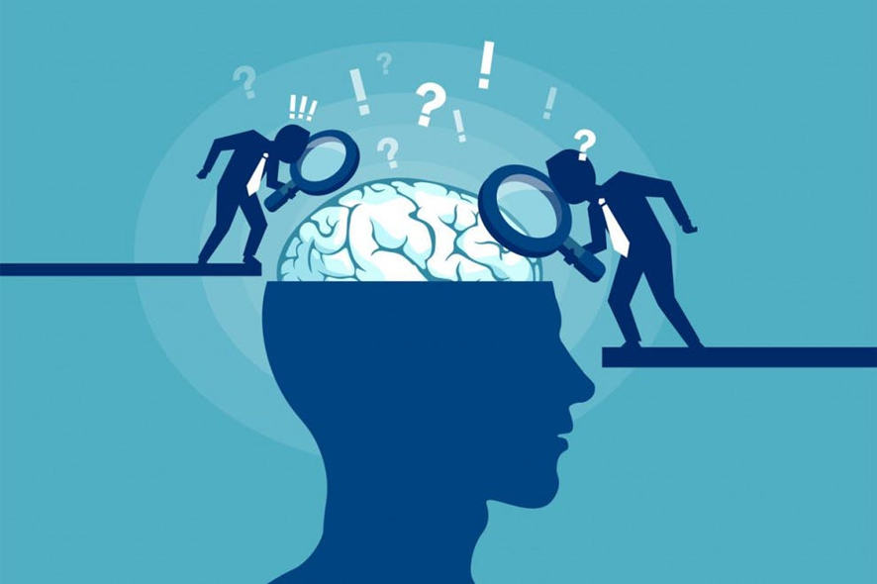

Student name: Luana Sequeira
Student ID: 2114278
Module name: Psychology for Health and social care
Module code: BMHP4003
Lecturer: Giya Ganguly

Table of contents

1.Introduction 3
2. Psychological life span (Erikson) 4
3. concret experience 6
4. In my future career 7
5. Conclusion 8
References 9

1.Introduction

The complexity of human behavior makes psychology a discipline full of different approaches. Humans have been studying our way of behavior for centuries and there are still many unsolved riddles. Developmental psychology is a scientific approach which aims to explain growth, change and consistency though the lifespan. This discipline looks at how thinking, feeling, and behavior change throughout a person’s life.
During this course we have studied psychological life span theories as are:
- Freud’s Theory of Psychosexual
- Erikson’s Theory of Psychosocial
- Piaget’s Stages of Cognitive Development
- Kolhberg’s Theory of Moral Development
Freud (1856–1939) believed that personality develops during early childhood. For Freud, childhood experiences shape our personalities and behaviour as adults. Freud viewed development as discontinuous; he believed that each of us must pass through a series of stages during childhood, and that if we lack proper nurturance and parenting during a stage, we may become stuck, or fixated, in that stage. Freud’s stages are called the stages of psychosexual development. According to Freud, children's pleasure-seeking drives are focused on a different part of the body, the erogenous zone, at each of five stages of development: oral, anal, phallic, latency, and genital.
Piaget (1896–1980) is another stage theorist who studied childhood development. Instead of approaching development from a psychoanalytical or psychosocial perspective, Piaget focused on children’s cognitive growth. He believed that thinking is a central aspect of development and that children are naturally inquisitive. However, he said that children do not think and reason like adults. His theory of cognitive development holds that our cognitive abilities develop through specific stages, which exemplifies the discontinuity approach to development. Awe to a new stage, there is a distinct shift in how we think and reason.
Kohlberg (1927–1987) attempted to extend Piaget’s ideas about stages of cognitive development to moral development, suggesting that morality too was developed over a series of stages throughout life. To develop this theory, Kohlberg posed moral questions to people of all ages and placed them in particular stages based upon analysis of their answers. Using this framework, Kohlberg claimed that more males than females reach higher stages and that females seem to be appear in their moral reasoning abilities.
In this reflective account I will discuss the development of my learning about Erikson's theory, which theory was presented in class by my presentation group.

2. Psychological life span (Erikson)

Erikson states that people must go through 8 stages for healthy development. Erikson's stages of psychosocial development encompass a series of concepts that allow us to understand how human beings develop from childhood to adulthood. It is considered the basis of evolutionary theory and is made up of 8 stages, each marked by a conflict. The resolution of each conflict at its due stage is what allows the person to find their potential for growth. If this does not happen, it is to be expected that problems will arise when facing new challenges in the following stages.
In other words, if the person does not optimally overcome the conflicts of each stage, he or she may not develop the skills required to face the challenges in a subsequent stage. In particular, the first 4 stages focus on childhood, while the other 4 range from adolescence to old age.
Like Freud, Erikson noted that personality develops through a series of stages. However, while Freud based his theory on psychosexual stages, Erikson focused on psychosocial development. That is, how interaction and social relations influenced the development and growth of the human being.
According to my research, we know that Erikson's stages of psychosocial development have been questioned, this theory has played an important role in the development of social and scientific studies. Their contributions have made it possible to understand to a large extent how a person acquires and shapes their personality and social identity. Based on this, strategies have been developed to deal with those critical situations that the person cannot resolve. In turn, it has been useful for the management and prevention of disorders such as anxiety and depression.
However, on the other hand, the fact that the stages are sequential in age stages is questioned too. He does not study issues such as personal traits or personal motivation, and this limitation renders the theory incapable of giving meaning to much of the current understanding of human personality.
Another drawback is the fact that Erikson considers that adolescence is defined as the period in which the search for identity occurs, which will define the person in their adult life, But now the question is, if that person will seek identity in adolescent or can it occur in another stage?
As I explained earlier in Erikson's theory there are 8 stages which are classified according to age ranges. Now if at stage 1 trust and mistrust (from birth to 18 months) the first task of the ego is the development of trust. That is, children learn to trust or not trust others. In this, the quality of the maternal relationship plays a major role. If parents or caregivers expose the baby to a relationship of affection and trust, later the child will develop the feeling that the world, especially in the social sphere, is safe.
On the contrary, if the parents do not create that safe environment, if they reject the baby or if they do not meet their basic needs, the baby will develop mistrust. It will manifest itself with feelings of frustration, insecurity and insensitivity to what is happening in the environment. Now, assuming that I have successfully passed this stage and the following ones as well until reaching stage 6, at this stage, adolescents become young adults. It happens between 21 and 39 years old. Although the need to respond to the wishes of the environment to "fit in" is still present, limits are beginning to be drawn on what the person is not going to sacrifice to please others. And now it turns out that I am having problems, the role of my parents also comes into play, which makes me feel that I am not capable of leading my life according to the advice and scolding, could it be said that I am going through the first stage again?, it is possible to live in two stages at the same time? These are some of the questions that were on my mind a lot as I learned more about Erikson.
I could say that it is a very interesting and helpful theory, although there is much to discuss about some points that he did not leave very specific.

3. concret experience

Theories of development have made great contributions to the discipline of psychology. As a student and human being this discipline made aware of many difficulties that I have been having in my personal life. Throughout this module we study different aspects in the field of psychology, including human behavior (we learnt the role various hormones), With this I have learned how to live and improve my day-to-day habits, by this I mean that through this discipline and the knowledge that emerges from it, it is possible to better balance emotions and give expectations a more realistic perspective, among other aspects. Investigating more about these hormones, I discovered that they are also called happiness hormones, and they are:
Serotonin.
Dopamine.
Endorphins.
Oxytocin.
This hormones help promote happiness and pleasure while reducing depression and anxiety. You can give these feel-good hormones a natural boost with some simple activities.
Serotonin: get some sunshine; go for a walk; practice meditation (mood stabilizer that improves sleep, reduces anxiety and increases happiness)
Dopamine: eat a sweet treat; listen music (drive your brain’s reward system)
Endorphins: essential oils do exercise; watch comedy (reduce stress and increases pleasure)
Oxytocin: give hung; pet your dog/cat; hold hands; cook
This last one surprised me a lot, because I knew that hugging my brother was a therapy for me, every time I felt sad I just needed his hug to feel better but I didn't understand why and now everything makes more sense.

4. In my future career

Once working on this reflection I am aware once again that this subject is much more necessary than I thought. It will help me in my future career as a midwife. From my point of view, I believe that before helping others, it is important to help oneself and have control over oneself and only then be able to move on to the next stage and help others. As a midwife, it is important to help pregnant women understand their feelings and changes because it is a period of many changes, psychological help is also important because it is not always a good stage, also helping to live with traumas and many more things.

5. Conclusion

From my personal point of view, this reference helped me a lot to better understand the rest presented in class, it also helped me in my personal life since it changed my way of seeing and understanding certain things that I did not understand and had no answer for. To this day I can say that this module has much more importance than we give it.

References

- Alicia Cook (2022) How to write a reflection pepper. Available at: https://www.wikihow.com/Write-a-Reflection-Paper
- Dr. kaushik Bharati. 2021 Erikson’s Theory of Psichosocial Development: Why is it Still Relevant Today
- Kendra Cherry (2022) Erikson's Stages of Development. Available at: https://www.verywellmind.com/erik-eriksons-stages-of-psychosocial-development-2795740
- Patricia H Miller (2010) Theories of developmental psychology
- 2022 Critical Analysis Of Erikson's Theory Of Psychosocial Development

