Module Title: Education: Past, Present, Future
Module Code: ECES4001/C
Module Lecturer: Ross Phillips
Student Name: Gundo Susso

Table of Contents
1. Contested Issue 1: The Impact of Online Learning and Remote Education Post-COVID-19 3
1.1 Introduction 3
1.2 Overview of the Contested Issue 3
1.3 Why is this Issue Contested? 4
1.3.1 Supporters’ Arguments 4
1.3.2 Opponents’ Arguments 5
1.4 The Impact and Importance of the Issue 7
1.5 Conclusion 7
2. Contested Issue 2: The Future of the Welsh Language in Education 9
2.1 Introduction 9
2.2 Overview of the Contested Issue 9
2.3 Why is this Issue Contested? 10
2.3.1 Supporters’ Arguments 10
2.3.2 Opponents’ Arguments 11
2.4 The Impact and Importance of the Issue 13
2.5 Conclusion 13
3. References 15

Contested Issue 1: The Impact of Online Learning and Remote Education Post-COVID-19

Introduction
The COVID-19 pandemic changed the mode of delivery of education in the UK significantly. Most of 2020 and 2021 were characterized by online learning as the predominant form of teaching (Pregowska et al., 2021). Contributed by the motivation of public health, the transition to remote learning compelled schools, colleges, and universities to rapidly transition to the digital platform. This abrupt shift created a controversial debate regarding the future of education with both good and bad results coming out. Online learning was perceived as a needed modification in the time of the pandemic. Its negative long-term effects on the learning, social development, and educational equality of students are still very disputable. The proponents contend that it has flexibility and accessibility.
According to critics, it includes the digital divide, the quality of education, and mental-health implications to the students (Oben et al., 2026). In this section, the current controversy of online learning during the post-pandemic world will be examined. It will discuss the advantages and obstacles of this change and speculate on the future of education.

Overview of the Contested Issue

Similar to numerous other nations, the UK encountered the unprecedented problem of school closures and a transition to online education in March 2020 because of the COVID -19 pandemic (Garmpis et al., 2026).
Such a radical shift involved a fast shift to the digital platform, including Zoom, Microsoft Teams, and Google Meet, and both students and teachers adjusted to a new learning environment (Kumar et al., 2026).

What appeared to be a temporary measure to deal with the pandemic turned into a fundamental part of education and influenced the way it is delivered significantly. With the continuation of the crisis, it was clear that online education was not a temporary solution but that it could become a long-term solution that can transform education over the next few years (Najjar, et al., 2025).
The rapid adoption of online education by the government demonstrated that technology can sustain education even in the instance of school closure. Nonetheless, it also exhibited a substantial set of challenges, especially, the digital divide. Students with poor backgrounds faced significant difficulties since they lacked access to the relevant devices as well as access to the internet (Ersoy, 2023). This has brought concerns about equality in education because richer families can more readily be involved in distance education and those with lower income can hardly afford to do so (Golden, et al., 2023).
In spite of these obstacles, online learning was also associated with such advantages as increased flexibility. The benefits of home-based learning were obvious because students with different schedules or those unable to cope with traditional schooling would study at their own pace. However, the transition to online learning has raised concerns regarding the quality of education, the absence of physical interaction, and the psychological effect of the situation on the students (Stoian, et al., 2022). The long screen time, isolation and the lack of real-life support are also something that is concerning when it comes to the long-term impacts on the well-being of students and their academic performance.

Why is this Issue Contested?

Supporters’ Arguments
The issue of online learning is a trending topic since individuals are divided on the implications of this method as far as the quality of education and equity is concerned. It is alleged to provide the flexibility that standard classrooms can often lack (Li, 2022). Students have the ability to learn at their convenience, and this allows them to combine school with either employment, family or medical issues. This is particularly useful to non-traditional students like working parents or students with health issues who otherwise would be unable to attend a face-to-face class.
Proponents believe that online education offers tremendous access to education. According to Hafezy (2023), the distance between schools or the necessity to travel can often prevent students enrolling in the traditional programs due to geographical and logistical barriers. Online education eliminates these barriers, which provides more opportunities to the students who otherwise could not attend a face-to-face classroom (Yeh and Tsai, 2022). This makes the academic environment to be more inclusive, and it breaks the barriers of place and transport.
Online learning is extolled with the fact that it can integrate a plethora of multimedia tools and technologies that can enrich the entire learning process. The advocates state that interactive videos, web-based tests, and common virtual spaces help students become more dynamic and innovative (Muir et al., 2022). Such tools would be utilized with numerous learning styles which could not be easily accomplished in traditional settings. Online education, therefore, can be seen to be an efficient and versatile solution to good education and inclusivity and flexibility simultaneously.

Opponents’ Arguments

On the other hand, rivals of online learning highlighted various issues. The major issue is the digital divide. Students, particularly underprivileged ones, do not have access to technology or a strong internet connection to do online learning, which puts them on an uneven footing (Banerjee, 2022). Research indicates that low-income families are the most affected group of students, increasing the educational disparity (Golden, et al., 2023).
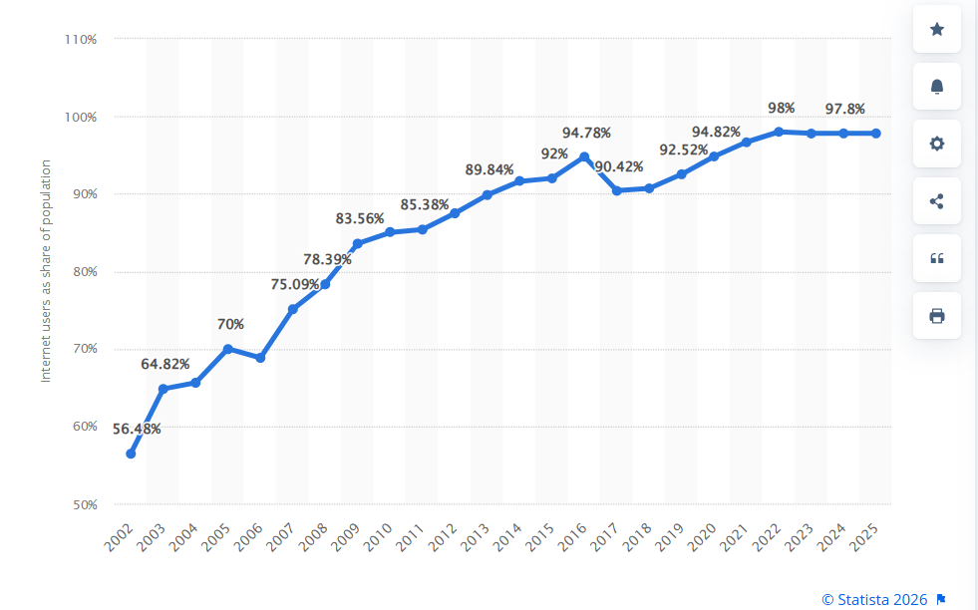
Figure - Share of individuals using the internet in the United Kingdom (UK) from 2002 to 2025
(Statista, 2024)
Opponents argue that online learning lacks the crucial social interaction and practical learning experience, which are necessary to have a balanced education (Everiss, 2024). Face-to-face classes would develop social skills, teamwork, and community feeling, which are difficult to achieve over the internet. Also, reduced face-to-face teacher-student interaction may reduce student interest and activity.
Also, there is also the issue of the effect on the mental health of the students. Remote learning is correlated with the feeling of loneliness, stress, and anxiety in students due to the isolation and screen time. A lot of students do not know how to balance their studies and life at home, which results in burnout (Hoter and Rutlinger Reiner, 2023). The teachers also experience challenges in engaging, controlling classes, and helping required by the students in an online setting.

The Impact and Importance of the Issue
Online learning has transformed the process of providing lessons and learning to students (Lemay et al., 2021). The quick shift to the digital environment has brought to the fore the need to change the educational system and offer more access to technology, especially in low served communities. A problem exists in digital divide. Absence of adequate technology leaves the students behind, enhancing social inequalities (Helsper, 2021). Pollution by the internet has been a significant worry by policymakers seeking to attain a fair education system. The debate about the means of filling this gap is, according to Azouri and Karam (2023), a continuous one, particularly, with the rise of hybrid learning models, which can be characterized as a mix of face-to-face and online learning.
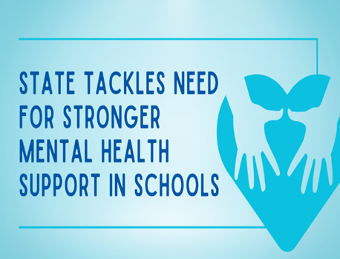
The pandemic suggested the need for mental health assistance in schools. The learning process was isolated because of online learning which exposed students to higher levels of anxiety and stress (Akpinar, 2021). Schools have been made more significant in securing mental well-being. Academic studies should not be isolated in learning, but it ought to support social and emotional development of students.
Finally, the controversy of online learning poses bigger questions of what education is expected to resemble in the future (García-Morales et al., 2021). Is it to be technology driven or is it time to revert to the traditional face to face methods? Although online learning is more flexible and inclusive, its effectiveness in the long term lies in its implementation and on the need to tackle the existing inequalities in access.

Conclusion
UK education was altered by online learning and switching to remote learning in the COVID-19 pandemic. It provides flexibility and innovation, yet it also lays an emphasis on serious problems: access gaps, lack of social interaction, and mental health issues. This discussion reveals the bigger issue of the process of technological adjustment and equitable access to good education. In the future, the pandemic will inform the UK changes in teaching approaches and policies.

Contested Issue 2: The Future of the Welsh Language in Education

Introduction
The Welsh language and its role in the education system is a persistent controversy in the devolved education system in Wales. Welsh Government has done a lot in the development of Welsh-media education, with the intention of creating a bilingual country (Williams, 2025). However, the future of Welsh in school is also disputed, and there are divergent opinions on the degree to which it should be given importance and the need to balance between Welsh and English education. The advocates of Welsh language education state that it is a crucial part of the Welsh culture. Critics, in turn, are worried about the feasibility and affordability of the Welsh-speaking schools (Pierce, 2023). They doubt that resources are not better utilized elsewhere and fear the gap in skills of students who may have to work mostly in English. This part will discuss the controversial question of Welsh language in education and will discuss the opposing arguments and the problems in the promotion of Welsh as a language of instruction.

Overview of the Contested Issue
Wales has a rich history and people regard Welsh language as a significant element of the culture. The Welsh Government has recently been concerned with increasing the number of Welsh speakers, with the goal of one million speakers by 2050 (Williams, 2025). In order to achieve this target, it has encouraged Welsh- medium schools and made children speak Welsh at a young age. However, Welsh-medium education has been controversial to develop.
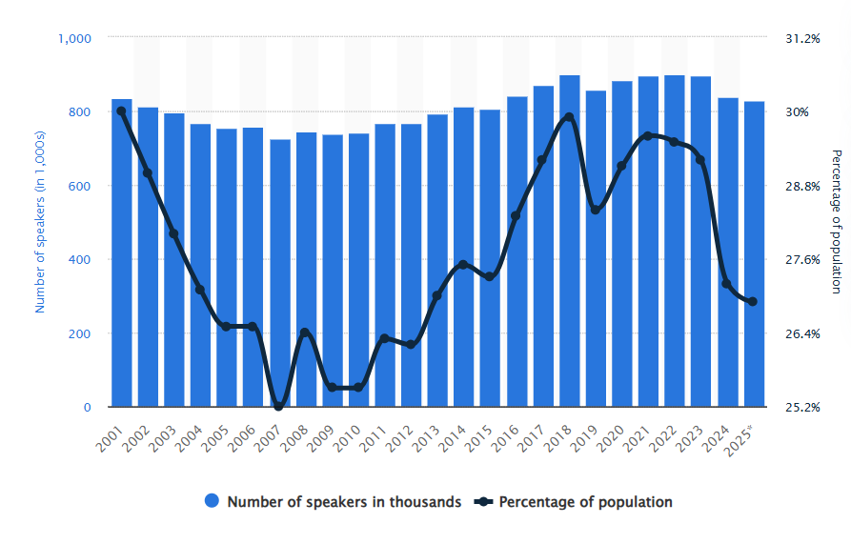
Welsh Language Speakers
Statista (2025)
The contentiousness of this question is the conflict between the wish to maintain and advance the Welsh language and the practical issues of offering the Welsh-language education to every student (Pierce, 2023). Although the Welsh Government has promised to increase Welsh provision in Welsh medium, there are fears that these figures may not be achieved particularly in parts of Wales where Welsh is not predominantly spoken.

Why is this Issue Contested?

Supporters’ Arguments
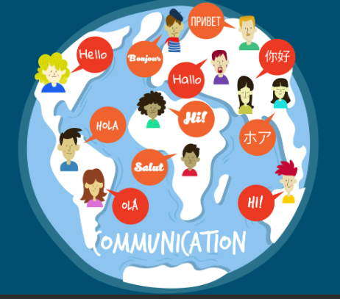
The controversy regarding Welsh-medium education is very controversial. The discussion is influenced by cultural, political and practical factors (Ward et al., 2025). Proponents also claim that Welsh is a crucial part of Welsh national identity and Welsh culture (Begun, 2025). The language is said to save Welsh culture and history. These traditions are essential in the preservation of the traditions by the next generations. Advocates are of the opinion that by introducing the Welsh language in schools, the young generations will learn to speak the Welsh language with fluency, making the language alive (Williams, 2025).).
The controversy regarding Welsh-medium education is very controversial. The discussion is influenced by cultural, political and practical factors (Ward et al., 2025). Proponents also claim that Welsh is a crucial part of Welsh national identity and Welsh culture (Begun, 2025). The language is said to save Welsh culture and history. These traditions are essential in the preservation of the traditions by the next generations. Advocates are of the opinion that by introducing the Welsh language in schools, the young generations will learn to speak the Welsh language with fluency, making the language alive (Williams, 2025).
The proponents believe that teaching Welsh in schools enhances unity and national pride in Wales. They claim that placing Welsh as the medium of instruction in schools will allow the Welsh Government and schools to strengthen the sense of attachment of students to the rich history and the cultural heritage of Wales (Harris et al., 2026). This, in its turn, reinforces the national identity and social cohesion. Thus, the Welsh language advocates feel that Welsh-based education must take a central seat in the education agenda in the country (Russell, 2025).

Opponents’ Arguments
Those who have been against the increased emphasis on Welsh-medium education argue it presents practical issues. The biggest issue, as Davies (2022) suggests, is the shortage of qualified teachers who can educate in Welsh. Many areas of Wales lack Welsh-speaking teachers, so it is difficult to satisfy the demand of Welsh-medium education (Pierce, 2023). There is also a concern by critics regarding the expense of increasing the Welsh-medium education, particularly in areas where the Welsh language is not widely used. They state that money can be used to enhance the situation in literacy and numeracy instead of placing the heavy emphasis on the promotion of the Welsh language (Pember et al., 2021).
The other issue is that of language among the students who do not speak Welsh at home. In most urban areas of Wales, such pupils usually have problems keeping up with Welsh-language education, and that fact may damage their educational results (Gareth and Teresa, 2023). The critics argue that this might increase the disparity between Welsh-speaking and non-Welsh-speaking students and it will be more difficult to have the education system that will address the needs of everyone.
Individuals who have resisted the escalated focus on Welsh-medium education assert that there are practical challenges of the policy. The largest assertion, as Davies (2022) puts it, is the lack of qualified teachers who can teach in Welsh. A significant portion of Wales does not have Welsh-speaking teachers; thus it is challenging to meet the need to receive Welsh-medium education (Pierce, 2023). This shortage of teachers compromises the possibility of ensuring a high standard of teaching consistently, and this may decrease the quality of teaching in subjects. Another point that is brought out by the opponents is the expenses involved in increasing Welsh-speaking education, especially in areas where Welsh is not widely spoken. They propose that the money could be more beneficially spent on literacy and numeracy levels - pressing the educational demand.
Pember et al. (2021) note that the promotion of the Welsh language may redirect the resources towards the subjects that are critical to the future employability of the students, including the STEM fields. Also, critics allege that Welsh-medium education stress will marginalise English-speaking students and cause inequalities in education. The controversy all boils down to the need to find a balance between Welsh language and culture promotion and the overall educational objectives (enhancing academic success and eliminating skills deficiencies in the competitive world economy).

The Impact and Importance of the Issue
The encouragement to use Welsh in schools emphasizes bigger debates of the intersection of culture, language, and national identity (Rosiak, 2023). The Welsh Government has a goal of cultivating the Welsh speaking communities in order to ensure that the language remains alive and continues to be transmitted to the new generations.
Nevertheless, equity issues are also brought up by the drive towards Welsh-medium schooling. The growth of these kinds of programs may leave gaps between students in non-Welsh-speaking areas and those who may not be able to appreciate the benefits of bilingual programs (Wilks & O’Neill, 2022). Ensuring that all students can perform well irrespective of their background and language skills is one of the biggest challenges facing the education system in Wales.
The controversy of Welsh language in education is also connected with the larger political issues of the role of the state in supporting cultural heritage (Evans and Williams, 2024). Is it important that the government gives emphasis to a particular language or is emphasis put on offering good education in the most spoken languages? This discussion is especially important because Wales is passing through post-devolution identity and strives to enhance its correspondence to Welsh language.

Conclusion
Welsh education is a disputed issue that has raised a larger debate of preserving culture and offering equality in education. Welsh speaking schools are needed to preserve the heritage of the Welsh and continue with the language to ensure that it is present among the future generations. However, these schools also possess several issues: they are not well distributed across the country, there is a shortage of resources, and not all teachers are qualified and know Welsh. Such problems make it difficult to provide equal and quality education, especially in the non-Welsh areas.
Wales targets a target of one million Welsh speakers in 2050- this is what needs to be planned and invested in it. To be able to access it, we must be able to balance between promoting language and educating all students in high quality irrespective of their language. This can be done through improving the aspect of teacher training, allocating resources and curriculum development. The Welsh-speaking schools’ controversy will still be there to see what will become of Wales concerning its culture and education and the solution to this is to come up with a system that would allow diversity in culture and high-level education to every learner.

References
Akpınar, E. (2021). The effect of online learning on tertiary level students mental health during the COVID-19 lockdown. The European Journal of Social & Behavioural Sciences, 30(1), pp.52-62.
Azouri, M. and Karam, J. (2023). From in-person to hybrid learning mode. In Governance in Higher Education: Global Reform and Trends in the MENA Region (pp. 61-88). Cham: Springer Nature Switzerland.
Banerjee, M. (2022). The digital divide and smartphone reliance for disadvantaged students in higher education. Journal of Systemics, Cybernetics and Informatics, 20(3), pp.31-39.
Begun, V. (2025). Exploring the relationships between the Welsh language, investment, and identity at Wales’ universities (Doctoral dissertation, University of Oxford).
Bonner, E., Prys, C., Mitchelmore, S. and Hodges, R.S. (2025). Defining economic impact on minority languages: The case of Wales. Journal of Multilingual and Multicultural Development, 46(9), pp.3135-3151.
Davies, L.B. (2022). ‘There’s not much demand for it’: evaluating the concept of demand in Welsh-medium and bilingual provision in further education. International journal of bilingual education and bilingualism, 25(7), pp.2527-2542.
Ersoy, N.S. (2023). Empowering Inclusion: Addressing Barriers in Distance Learning for Disadvantaged Groups. Turkish Online Journal of Educational Technology-TOJET, 22(4), pp.52-60.
Evans, N. and Williams, C. (2024). Globalising Welsh Studies: Decolonising history, heritage, society and culture (p. 336). University of Wales Press.
Everiss, D. (2024). Exploring the online learning experiences of health and social care students (Doctoral dissertation, University of Essex).
García-Morales, V.J., Garrido-Moreno, A. and Martín-Rojas, R. (2021). The transformation of higher education after the COVID disruption: Emerging challenges in an online learning scenario. Frontiers in psychology, 12, p.616059.
Gareth, R. and Teresa, L.R. (2023). Educational Inequality in Wales: Some Problems and Paradoxes 1. In Poverty and Social Inequality in Wales (pp. 71-92). Routledge.
Garmpis, A., Garmpis, S., Panagiotarou, A., Antonopoulou, H. and Halkiopoulos, C. (2026). Student Attitudes and Experiences with Distance Learning During COVID-19: A Framework for Hybrid Education. Societies, 16(1), p.24.
Golden, A.R., Srisarajivakul, E.N., Hasselle, A.J., Pfund, R.A. and Knox, J. (2023). What was a gap is now a chasm: Remote schooling, the digital divide, and educational inequities resulting from the COVID-19 pandemic. Current Opinion in Psychology, 52, p.101632.
Hafezy, R. (2023). The role of digital technology in distant learning. International Journal of Education and Learning Research, 6(1), pp.37-56.
Harris, A., Jones, M. and Bryant, A. (2026). Towards equity and quality in education: Analysing contemporary reform in Wales. Education Policy Analysis Archives, 34.
Helsper, E. (2021). The digital disconnect: The social causes and consequences of digital inequalities.
Hoter, E. and Rutlinger Reiner, R. (2023). Preventing academic burnout and ensuring the wellbeing of teachers returning to academic studies. Journal of Adult and Continuing Education, 29(1), pp.41-68.
Kumar, S.J.S., Lee, C.E.C., Lee, A.S.H., Crosling, G., Arulanandam, B.V. and Azizan, S.N. (2026). Online teaching during the Covid-19 pandemic: Perspectives from lecturers and administrators in Malaysian universities. Knowledge Management & E-Learning, 18(1), p.60.
Lemay, D.J., Bazelais, P. and Doleck, T. (2021). Transition to online learning during the COVID-19 pandemic. Computers in human behavior reports, 4, p.100130.
Li, D. (2022). The Shift to Online Classes during the COVID-19 Pandemic: Benefits, Challenges, and Required Improvements from the Students' Perspective. Electronic Journal of E-Learning, 20(1), pp.1-18.
Muir, T., Wang, I., Trimble, A., Mainsbridge, C. and Douglas, T. (2022). Using interactive online pedagogical approaches to promote student engagement. Education Sciences, 12(6), p.415.
Najjar, N., Rouphael, M., Bitar, T. and Hleihel, W. (2025, February). The rise and drop of online learning: adaptability and future prospects. In Frontiers in Education (Vol. 10, p. 1522905). Frontiers Media SA.
Oben, A.I., Hui, X., Quanguo, L. and Bahtilla, M. (2026). The danger of building walls around scientific knowledge: implications for higher education teaching and learning in the era of open science. Distance Education, pp.1-16.
Pember, S., Tilley, H., Price, J. and Peixoto Vale Gomes, L. (2021). Supporting the Welsh lifelong learning system.
Pierce, A. (2023). The relationship between the Welsh language and Higher Education participation and experience (Doctoral dissertation, Cardiff University).
Pregowska, A., Masztalerz, K., Garlińska, M. and Osial, M. (2021). A worldwide journey through distance education—from the post office to virtual, augmented and mixed realities, and education during the COVID-19 pandemic. Education Sciences, 11(3), p.118.
Rosiak, K. (2023). The role of language attitudes and ideologies in minority language learning motivation: A case study of Polish migrants’(de) motivation to learn Welsh. European journal of applied linguistics, 11(1), pp.26-52.
Russell, P. (2025). The Assessment of Welsh as a Second Language-A report on current Welsh language assessment practices in mainstream English medium primary schools.
Statista (2024) Internet penetration in the United Kingdom from 2002 to 2024, Statista. Available at: https://www.statista.com/statistics/1124328/internet-penetration-uk/ (Accessed: 29 December 2025).
Statista (2025). Welsh language speakers, Statista. Available at: https://www.statista.com/statistics/383043/welsh-language-speakers/ (Accessed: 30 December).
Stoian, C.E., Fărcașiu, M.A., Dragomir, G.M. and Gherheș, V. (2022). Transition from online to face-to-face education after COVID-19: The benefits of online education from students’ perspective. Sustainability, 14(19), p.12812.
Tahak, M. and Moghaddas, B. (2025). Resolving the bilingual advantage paradox: The role of individual differences in executive function. Focus on ELT Journal, 7(2), pp.98-113.
Ward, R., Collins, B. and Rowlands, I. (2025). Studying through the medium of Welsh at higher education: a mixed-methods investigation. Journal of Multilingual and Multicultural Development, pp.1-22.
Wilks, R. and O’Neill, R., (2022). Deaf Education in Scotland and Wales.
Williams, C.H. (2025). Welsh Initiatives Promoting Language Use Opportunities and Outcomes. In Official Language Regimes: Transformation and Innovation (pp. 193-268). Cham: Springer Nature Switzerland.
Yeh, C.Y. and Tsai, C.C. (2022). Massive distance education: barriers and challenges in shifting to a complete online learning environment. Frontiers in Psychology, 13, p.928717.

