Building Evaluation  Construction Technology 2 | Abstract  New Student Accommodation  Caitlyn Moore

Table of Contents
Introduction 2
Environmental impact 3
Life cycle 5
Privacy & Security – 7
Aesthetics 8
Façade Greening and SUDS – 9
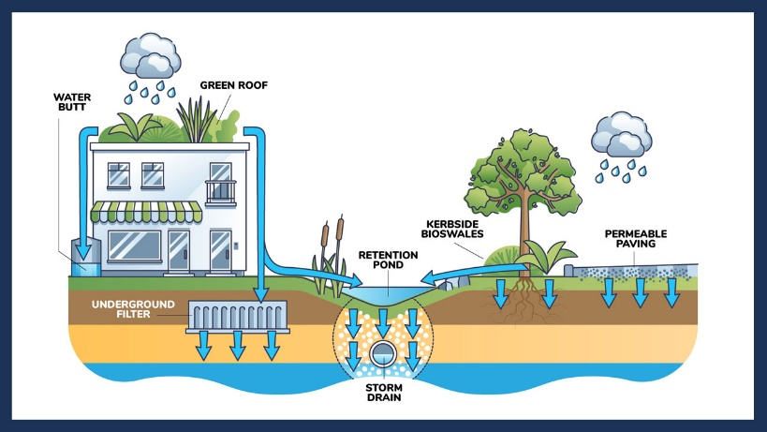 10
Flexibility in Design and Use – 10
Conclusion - 12
References 14
Bibliography 15

Introduction
The proposed student accommodation is located on Swansea’s waterfront. The site location is classified as a brownfield site, a rectangular shape with panoramic views across the river Tawe into Swansea town centre. The site location benefits from being surrounded by a diverse range of developments such as restaurants, office blocks and residential multistorey buildings. The locations provide a great opportunity to construct a building which will also contribute to the area’s aesthetics.
The design aim is to create a student accommodation building that also reflects the original aesthetics of the area. To achieve this the design will integrate traditional elements such as a pitched roof and a red brick external façade.
The building will be constructed using both traditional and modern methods, to be precise a ‘hybrid’ approach will be used to deliver the building that is efficient and aesthetically pleasing. An example of modern methods of construction that will be used is the use of prefabricating the concrete planks off site and having them delivered to construct.
Overall, the project will deliver an integrated, aesthetically pleasing, and structurally efficient student accommodation building that reflects the original character of the industrial period.

Environmental impact

Orientation -
The orientation of the proposed building on Swansea’s waterfront plays a crucial role in reducing the buildings impact on environmental footprint by improving the energy efficiency. There is an opportunity with this design to utilise passive design strategies due to the river Tawe being a stone’s throw away and the brownfield site that the building will sit upon. (Brian James, 2018)
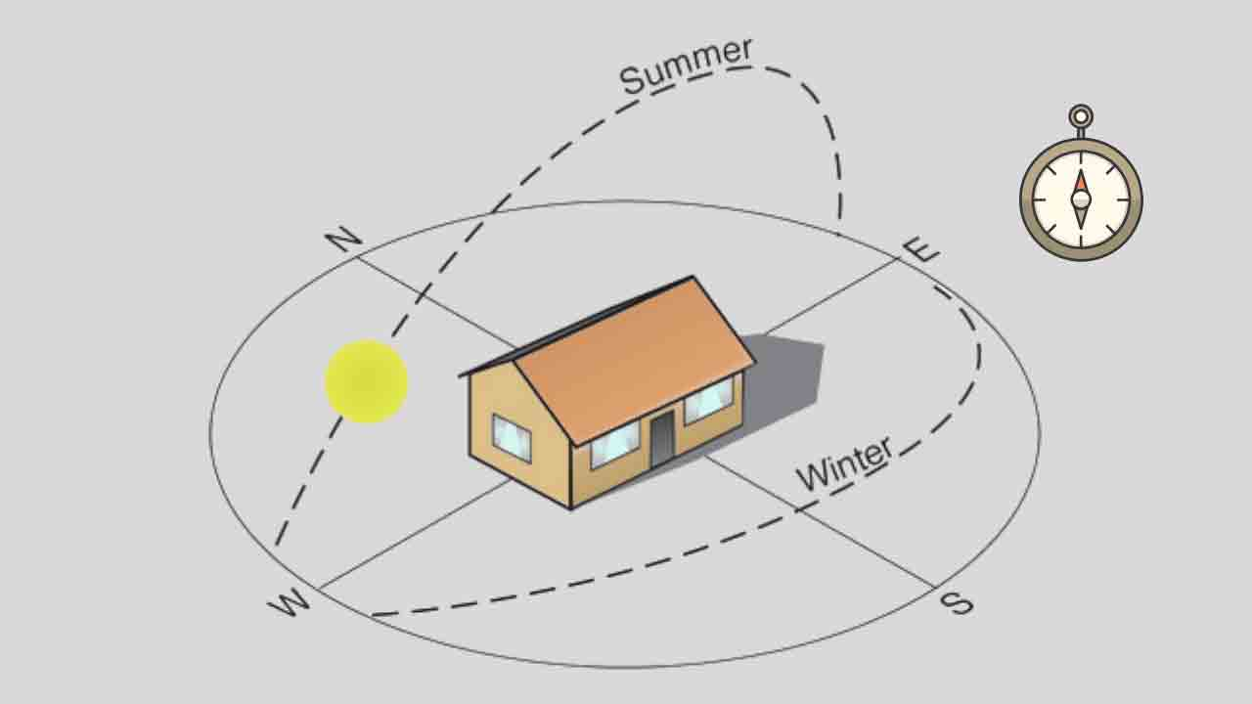 (Civil Seek, 2019)

Optimising Daylight –
Orientation allows buildings maximise the amount of natural light intake which reduces the need for artificial lighting. With buildings facing South and Southwest. The use of large aluminium framed windows as specified in the design allow natural light into living spaces whilst also maintaining thermal performance which contributes to - (Jarvis, 2025)
- Lower electricity usage for artificial lighting.
- Reduced carbon footprint.
- Improved mental wellbeing for the occupants as the artificial lighting can cause health problems.
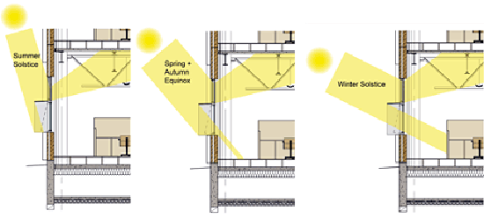 (Guide, n.d.)

Overheating during the summer periods with a South facing façade can be avoided by using deep window reveals, solar shading, or brise soleil could be integrated into the design to block out the sun through summer, but allow the winter sun to enter through, brise soleil has also been integrated into the design on some of the surrounding buildings.

Solar Dazzle –
Solar dazzle occurs when a façade is reflective which can lead to discomfort. However, in this case the façade is brick which isn’t a reflective material, the only reflective material on the building would be the aluminium windows which means only a minor amount of glare will occur. This happens due to the sun convergence when a reflective structure has multiple elements that allow the sun rays to focus which then creates the glare.

Maximising Natural Ventilation –
The layout of the multiple blocks designed to span across a variety of heights from 3 storeys to 5 for example enables better ventilation by avoiding ‘deep’ plan designs. Cross ventilation is utilised when building façades are aligned to the most frequent wind direction which in Swansea usually comes from the Southwest.
The benefits of the above are:
- Indoor temperatures in the summer periods will be cooler without the use of air conditioning.
- Reducing mechanical ventilation which will result in reduced energy consumption.
- The air quality indoors should improve.
As previously mentioned MVHR units will be integrated into the design, and these will contribute to the flow of ventilation around the building. (Raphael Bigrou, 2024)

Energy Consumption Reduction –
The combination of natural daylight and cross ventilation results in reduced energy consumption.

- Lighting loads decrease.
- Heating and air conditioning demand isn’t as high.
- This reduces strain on centralised systems such as gas-powered boilers and MVHR units.
The integration of solar panels on the pitched south facing roof will also benefit from sun exposure, improving efficiency and renewable energy. (Tony Taylor, 2023)

Minimising Environmental Impact –
Strategic orientation reduces dependence on non-renewable energy sources whilst also enhancing the buildings compliance with Approved Document L, which relates to the conservation of fuel and power. Also, supporting the sites adaptation to the local marine environment.
The raised ground floor level also ensures resilience against heavy rainfall ensuring a flood risk plan is in place.

Life cycle
The projected life cycle of the proposed student accommodation development in Swansea has been considered carefully at design stage and material selection to ensure that the building can perform well for over 60 years. The use of durable, low maintenance materials and climate resilience construction methods contribute to the life and environmental sustainability of the development.
To assess the level of greenhouse gas emissions which are generated through a buildings life cycle and the materials used to construct the building an embodied carbon calculation is completed. This calculation is important because the majority of emissions will likely be produced during the construction phase, by carrying out these types of calculations the construction industry can be more environmentally friendly which is crucial.

An example of an embodied carbon calculation looks like the below –
In-situ reinforced concrete floor slab –
Area = 100 m2
Thickness = 0.2 m
Volume = 100 m2 x 0.2 m = 20 m2
Emission (Type Cem 1) = 300 kg
Calculation –
Embodied carbon = Volume x emission factor
= 20 m3 x 300 kg = 6,000 kg Co2
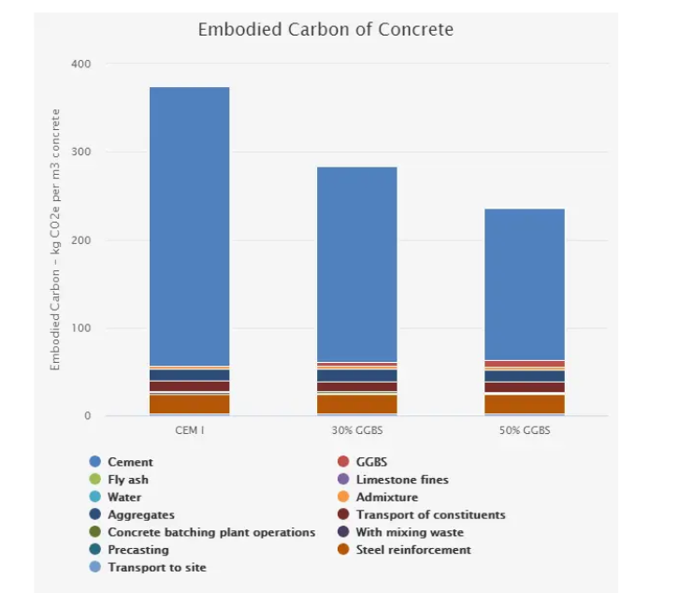

Structural Frame Durability -
The use of a reinforced concrete structural frame offers many advantages to provide durability such as:
- Corrosion resistance which is essential for the marine environment.
- Low permeability which helps prevent moisture ingress and extends the life span of the frame.
- Minimal maintenance is required when compared to steel and timber frames.
- Fire resistance and structural stability provides safety and reduces the risk of failure.

External Envelope -
The external façade is designed with red bricks which sit over a concrete block inner wall with insulation which is a very durable system. Brickwork has an extremely good life span with low maintenance. Expansion joints are incorporated into the design to prevent cracking and the aluminium windows are treated to withstand marine atmosphere.

Roofing System -
Concrete tiles have an estimated 50-year life span and the membranes used underneath them have an estimated life span of 20-30 years.

Privacy & Security –
The building has been designed to ensure privacy and security are prioritised for example the design has incorporated self-contained units for the students with secure layouts which reduce noise transfer whilst ensuring personal space. The windows are lockable and ensure privacy so you can look out, but no one can look in.
Access control measures have also been incorporated into the design to ensure that only key holders can gain access into the building. The whole building is monitored via CCTV which is usually a typical design element in most buildings. Adequate outdoor lighting with secure entry points have also been designed to avoid potential disturbances from the nearby nightlife in the restaurant down the road.
Overall, the design does support a secure and private space suitable for students to live in.

Sustainability and End of Life Considerations –
The use of locally sourced materials and prefabricated components reduces the level of embodied carbon of construction.
Rainwater harvesting and solar panels promote long term environmental benefits and reduce utility demands.

At the end of the building’s life cycle, materials such as concrete, bricks and the aluminium windows can be recycled which will again support economy. If the building doesn’t stay as student accommodation for its full life cycle, then there is an option to renovate the building to suit residents meaning the building would become apartments or offices for example.

Material | Estimated Life Span | Key Maintenance Requirements
Reinforced Concrete | 60-100 years | Crack monitoring
Brick Façade | 80-100 years | Repointing every few decades
Aluminium windows | 40-50 years | Coating checks
Concrete Roof Tiles | 50-60 years | Membrane inspection
Timber Roof Trusses | 40-60 years | Moisture protection
MVHR and Heating Systems | 15-25 years | Filter and component replacement
Drainage System | 30-50 years | Regular inspection to jet

Overall, the buildings projected life cycle has been optimised through material selection. The structure is expected to require minimal maintenance, this contributes to lower whole life costs, reduced environment impact and a stable safe environment. (Jarvis, 2025)

Aesthetics
The design of the student accommodation has been designed to reflect the areas industrial heritage whilst still meeting modern standards. Key aesthetic elements are the red brick façade and the pitched roof which are very similar to the surrounding buildings.
The varying building heights help to blend in with the surrounding designs. The ground floor café and gym offer a warm welcome to the community.
The sustainable features such as solar panels and rainwater harvesting not only reduces the environmental impact but also compliments the modern architectural style.
Overall, the development integrates well into the historical background.

Façade Greening and SUDS –

Potential for Green Facades -
The proposed student accommodation is well suited for green facades mainly because of the sun exposed elevations. The reinforced concrete structure and hybrid construction allows for easy integration of green systems.

Key benefits –
- Reduces heating and cooling demands.
- Absorbs rainfall which helps towards flood management in the high-risk area.
- Air quality filters pollutants and supports urban wildlife.
- Exposure to greenery improves mental health.
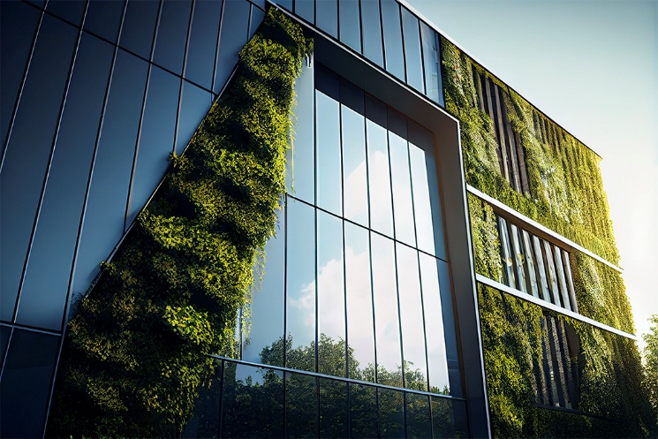 (Walls, n.d.)
Green facades can be applied to avoid conflicting with buildings industrial aesthetic, especially on internal or less visible walls. They do require regular maintenance, but the environmental benefit makes them a more valuable addition. (S.M. Sheweka Dr, 2012)

Potential Implementation of SUDS
Sustainable urban drainage systems (SUDS) would be well suited for the site as it is a brownfield site, and it is very close to the river Tawe with a high flood risk status.
Key Opportunities for SUDS:
- Green roofs and rain gardens can absorb rainfall and filter through.
- Permeable paving for walkways to reduce surface water runoff.
- Attenuation tanks could be installed to control water release.
- Rainwater harvesting which is already planned can support water efficiency.
Benefits:
- Reduces flood risk and pressure on sewers.
- Improves water quality.
- Helps meet regulatory requirements and sustainable goals. (Jarvis, 2025)

Flexibility in Design and Use –

Flexibility to Adapt to Changing User Needs -
The design of the student accommodation demonstrates several features that support long term flexibility and adaptability.
- Modular and Hybrid Construction:
The use of hybrid construction, a mix of in-situ and prefabricated elements enable future modifications with little disruption. Precast planks allow for easier internal layout changes and the potential for reconfiguration of units for different occupancy.
- Reinforced Concrete Frame:
The reinforced concrete frame provides a strong open span structure which allows internal non load bearing walls to be removed and placed elsewhere which is ideal for expanding units and adapting rooms.
- Mixed use Ground Floor Design:
The ground floor features can be repurposed easily for multi-use over time if required.
Overall, the building is designed structurally to adapt to future needs which extends its relevance over time.

Potential Alternative Future Use –
Suggestion: Co-living or Affordable Housing
If the demand for student accommodation declines in the years to come the building can be repurposed as a co-living development or affordable housing as the demand for affordable housing is crucial and it is likely to stay that way.
Why it is a suitable alternative:
- The existing layout with private rooms and shared amenities meets the requirements for co-living developments.
- Ground floor space can be utilised as a communal area for residents.
- The location of the property being in the centre of Swansea means public transport and employments opportunities are close.
- The adaptable concrete frame will allow the rooms to be reconfigured to more private apartments for affordable housing schemes.

Conclusion -
To conclude the proposed student accommodation at Swansea is a well-considered project that has a balance of structural design, sustainability and adaptability for the future. The decision to construct the frame in reinforced concrete with the mix of hybrid construction methods ensures that the building is structurally durable whilst also allowing for internal flexibility in the future.
The design of the building provides a feel for the industrial heritage and the surrounding buildings by using materials such as red brick and pitched roof as previously stated. There is a potential to enhance the environmental performance of the building through including green facades and SUDS, both of these methods contribute to the site’s environmental status.
The building provides the capacity to make adaptions if needed in the future to alternative living proposals as previously mentioned co-living and affordable housing, this is possible due to the adaptable layout and location of the building. The qualities ensure that the building is socially relevant and economically durable for the future.
Overall, the project successfully integrates an in-depth design, sustainable methods of construction, and future proof meaning which ensures it is a durable building.

References
Brian James, 2018. Orientation of Building and Rooms [A Complete Guide], s.l.: Civil Seek.
Jarvis, 2025. Durable Solutions for Minimising Construction Site Emissions and Waste, s.l.: Jarvis.
Jarvis, 2025. Optimising Daylight in Residential Spaces. [Online]
Available at: https://www.jarvisbuild.co.uk/optimising-daylight-in-residential-spaces/#:~:text=In%20this%20comprehensive%20article%2C%20we%20will%20explore%20strategies,and%20building%20regulations.%20Now%2C%20this%20might%20seem%20counterintuitive%E2%80%A6
[Accessed 25 April 2025].
Raphael Bigrou, 2024. Maximizing Natural Ventilation: Essential Tips for Building Design Optimization. Green Building Solutions, 7 December, p. 1.
S.M. Sheweka Dr, 2012. Green Facades as a New Sustainable Approach Towards Climate Change. Energy Procedia, Volume 18, pp. 507-520.
Tony Taylor, 2023. Eight Strategies to Reduce Energy Use in Buildings, Hereford: Communion Architects.

Bibliography
Orientation of Building and Rooms [A Complete Guide].
Optimising Daylight in Residential Spaces – Jarvis Contracting
Maximizing Natural Ventilation: Essential Tips for Building Design Optimization - Green Building Solutions
Eight strategies to reduce energy use in buildings - Communion Architects
Durable Solutions for Minimising Construction Site Emissions and Waste – Jarvis Contracting
Green Facades as a New Sustainable Approach Towards Climate Change - ScienceDirect
Implementing Sustainable Drainage Systems (SuDS) in UK Developments – Jarvis Contracting
Concrete Embodied Carbon Footprint Calculator - Circular Ecology

