Student Name: Iulian Bugaciu  Student ID: 2229782  Module Title: Foreign Languages and Cultural Awareness  Module Code: BMIH5003  Lecturer: Heidi Prosser  Date: 09.02.2024 | 
ASSIGNMENT 1: PORTFOLIO
(4 Components)

Component 1: Professional Reflection (500 words +/- 10%)

Weighting: 25%
The hospitality industry has a high level of customer engagement, and the quality of the services improves with more interaction processes. There is the involvement of customers of different languages in the hospitality sector and it raises the problem of the language barrier. It has been a challenge for HR managers in different organisations and the area of language differences reduces the level of consumer satisfaction in the hospitality industry. I have faced a similar situation in my workplace of professional area. The barrier in language causes problems in the cultural aesthetics and communication. In my professional area of Rossington Hall, I have witnessed cultural misunderstandings. There has been situation of miscommunication between me and the foreign tourists from the region of Italy. The language fails to make the situation peaceful, and it reduces the hospitality culture of the organisation. Cultural elements are vital to keep the performance of the organisation and the employees stable in the industry (Christiansen et al., 2020). The effects of the cultural barrier effect the tourism activities (Mariani et al., 2020). The main reason for the incident in Rossington Hall is the matter of myself not understanding the customer`s order. They have asked for a `corretto` coffee while I was convinced that it`s a usual coffee / Americano. When they were trying to explain that it`s a very short Espresso I have understood the issue and the order has been sorted.
Professional area provides the scope to improve the relative working experiences and I have had different levels of experience during the practice session in Rossington Hall. I have observed that professional skills and interpersonal skills are needed for the inclusion of different training programs that will help me to improve my communication skills. There are multiple scopes for business development in the hospitality industry. Communication skills are one of the creative skills for managers in the hospitality sector (Weber et al., 2020). It will help the manager the similar situations of a language barrier in a more efficient way. Organisations in the hospitality sector are in the arena of expanding their business to attract more foreign tourists. I learned that cultural misunderstanding can create a high amount of loss in brand value and hampers customer satisfaction. The development of the business needs an improved way of professional approach to providing diverse experiences to the customers. Rossington Hall is one of the premium organisations in the region of the UK and has a history of providing quality services (Rossingtonhall, 2024). I have to set the planning for the training process to learn communicative and other interpersonal skills in a more effective way. In the development of a career in the hospitality sector, there is a need for excellent observation skills. I have a quality sense of observation and I have observed the situation carefully during the incident of cultural misunderstanding in the professional area. More enhancement in the skills of observation will be helpful in providing a better level of customer service.

References:
Christiansen, B., Branch, J.D. and Karmowska, J. 2020 Cultural Factors and Performance in 21st Century Businesses. Hershey : IGI Global.
Mariani, M.M., Borghi, M. and Okumus, F., 2020. Unravelling the effects of cultural differences in the online appraisal of hospitality and tourism services. International Journal of Hospitality Management, 90, p.102606.
Rossingtonhall, 2024. ABOUT US [Online] Available at: <https://rossingtonhall.co.uk/about-us/#:~:text=The%20land%20that%20is%20now,leased%20him%20the%20Rossington%20Estate.> [Accessed on: 27th January 2024]
Weber, M.R., Lee, J. and Crawford, A., 2020. A suggested best practices for enhancing performance of soft skills with entry-level hospitality managers. Anatolia, 31(1), pp.76-87.

Component 2: Training Plan (500 words +/- 10%)

Weighting: 25%

Identified cultural misunderstanding (in a few words) :
Cultural misunderstanding is one of the common problems in the hospitality sector. The identified case and the reason for the misunderstanding is the language barrier during the time of interaction and the development of communication. Tourists in the hospitality sector come from different regions and cultures. The linguistic barrier is one of the common problems that affect cultural diversity in the hospitality and tourism sector (Koc, 2020). The improvement of the business is needed to expand the business in the hospitality sector, and it can be enhanced with the factors of communication improvement.

Training plan (Why/What//Who/Where/When):
The planning of the training leads to the process of skills development for the staff in the hospitality sector. I have observed that the main problem in the hotel is the lack of customer interaction. I have the suggestion of a training plan that helps to improve the necessary skills of the employees and reduce the situations of cultural misunderstanding. The arena of increasing the interaction process needs a high level of communication between the staff with the customers in the hotel. I feel that the training process will enhance the core knowledge of the employees in the organisation and boost their confidence in receiving the guests. There will be multiple layers in the procedure of training as the step-by-step planning is useful to provide the basic needs of the training. The maintenance of cultural aesthetics and beliefs is necessary to keep a respectable relationship between the staff and the customers. The perception of the employees is crucial to enhancing the quality of diversity in the hospitality industry (Mistry et al., 2023). The training will be provided by the professionals to boost the quality and efficiency of the training process. I have observed that the location of the hotel is the most suitable place for the process of the training. I have suggested that early morning will be the effective time for the training. The recruitment policies of the hotel are strong and talented employees are selected for duty in Rossington Hall.
The plan of the training program includes different tasks that will improve the basic skills of the employees. The main focus of the training will be the process to improve the quality of the customer satisfaction. Customer satisfaction is one of the primary elements to have an impact on the performance of the organisation (Fernandes Sampaio et al., 2020). The employees of the organisation need to learn different languages in the training program. It will be beneficial for the organisation to increase the rate of brand value and invite more foreign customers. I feel that I have faced a typical and embarrassing situation in my professional area due the cultural misunderstanding and the language barrier. In a consequence of the training program, I will share my experiences and the guidance to motivate the employees. The enlargement of the workforce will help to keep Rossington Hall ahead of the competition in terms of hospitality services.

References:
Fernandes Sampaio, C.A., Hernández Mogollón, J.M. and de Ascensão Gouveia Rodrigues, R.J., 2020. The relationship between market orientation, customer loyalty and business performance: A sample from the Western Europe hotel industry. Tourism and Hospitality Research, 20(2), pp.131-143.
Koc, E., 2020. Cross-cultural aspects of tourism and hospitality: A services marketing and management perspective. Routledge.
Mistry, T.G., Okumus, F. and Orlowski, M., 2023. Employee perceptions of diversity management in the hospitality industry. International Hospitality Review, 37(2), pp.265-285.

Component 3: Student Self-Reflection (500 words +/- 10%)

Weighting: 25%
The process of the training program is helpful for the development of skills and to maintaining the cultural aesthetics in hospitality services. I will share my obtained knowledge and experience for the scheduled training with the help of Gibbs' reflective model.
Description
Description is the first stage in the reflective model, and it helps to provide a brief explanation of the situation. The main priority of the training is the development of the communication skills and to reduce the language barrier. The language barrier is a major problem for tourists to different destinations (Nomnian et al., 2020). I have had the opportunity to develop the skills and confidence from different sessions of the training.
Feelings
Feelings is the next stage of the cycle, and it is related to the observation of the feelings of different individuals in a situation. I have observed that during the process of the training, there are several employees who failed to gather the proper range of knowledge regarding cultural awareness. The maintenance of crosscultural aesthetics is essential to keep the flow of business performance and the brand value of an organisation (Maheshkar and Sharma, 2018). I have been excited to learn different types of professional skills that will help to improve the skills of customer engagement.
Evaluation
Evaluation is referred as the next step of the reflective cycle that helps to express the overall learning of the situation. I have completed the full process of the training and got the knowledge of the cultural differences. The process of managing cultural differences will help to develop the skills of leadership in an individual (Abramson and Moran, 2018). I have been fortunate to attend the training and to get the knowledge of different professional skills. Language proficiency is one of the primary needs for employees in the role of customer engagement. I have found it difficult to get the knowledge of key areas decision making to improve customer efficiency.
Analysis
The analysis is the next stage of Gibb’s reflective cycle that helps to provide the scope of analysis of the overall experience of a situation. I have observed that the training session provides reliable ideas about the importance of language in the hospitality industry. The professional skills of language development help to expand the business of hospitality in the foreign market. I have completed the training, and it has helped the skill development for professional purposes.
Conclusion
The key aesthetics of the training program help to improve the skills of the employees in the consequence of serving high-quality services to the customers. The cultural misunderstandings can be eliminated with the skill regarding language proficiency.
Action Plan
An action plan helps to develop the core strategy to strengthen the weak areas in the professional career. I have faced difficulties in acquiring the proper knowledge regarding the skills of decision-making. I have to practice on a daily basis to keep the skill of analysing a situation. It will help me to develop the skills of making quick decisions and to improve customer service.

References:
Abramson, N.R. and Moran, R. 2018 Managing Cultural Differences: Global Leadership for the 21st Century. 10th Ed. Abingdon: Routledge.
Maheshkar, C. and Sharma, V. 2018 Handbook of Research on Cross-Cultural Business Education. Hershey: IGI Global.
Nomnian, S., Trupp, A., Niyomthong, W., Tangcharoensathaporn, P. and Charoenkongka, A., 2020. Language and community-based tourism use, needs, dependency, and limitations. Austrian Journal of South-East Asian Studies, 13(1), pp.57-79.
Petrc, A.Š., Mikinac, K. and Miškulin, D., 2021. FOREIGN LANGUAGE ABILITY IN HOSPITALITY BUISNESS. Tourism in Southern and Eastern Europe..., 6, pp.775-788.

Component 4: Training Presentation (6 Slides)

Weighting: 25%
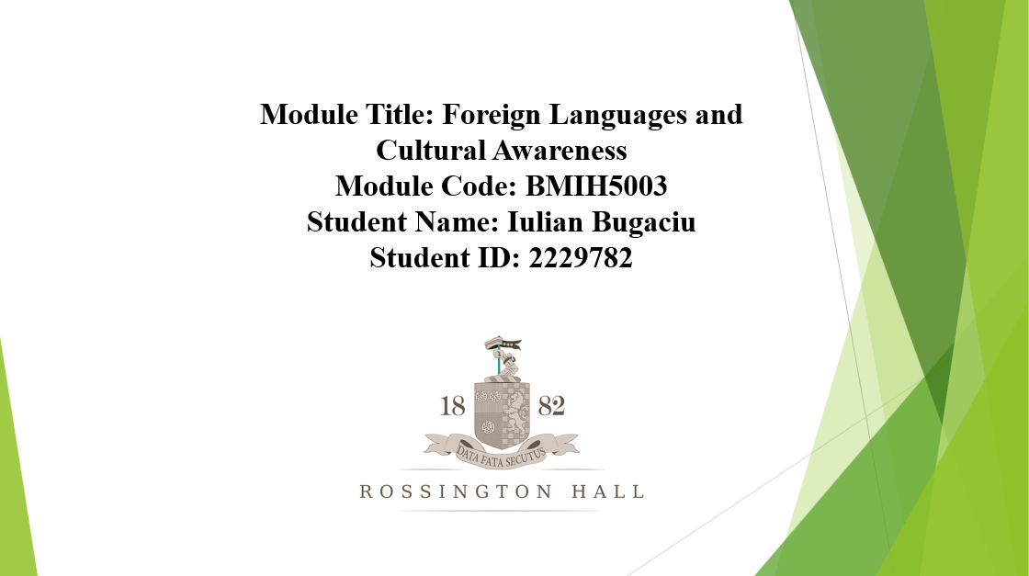
[Content Slide 1]
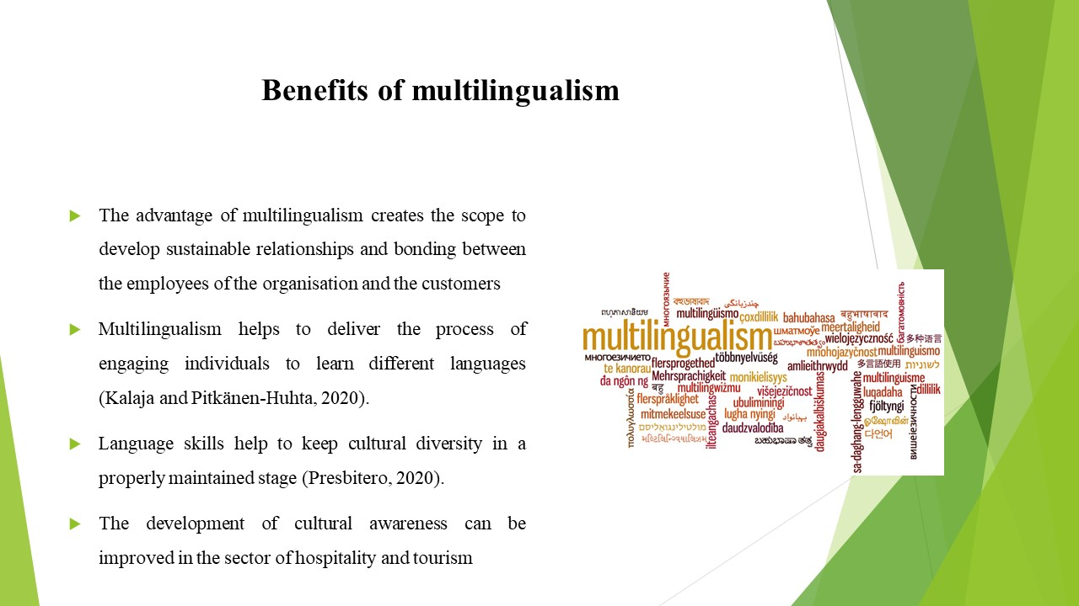
The hospitality sector involves the travelling of tourists from different destinations. Multilingualism helps to deliver the process of engaging individuals to learn different languages (Kalaja and Pitkänen-Huhta, 2020). It will be helpful for the staff in the hospitality industry. The process of interaction is crucial in the hospitality sector. The development of cultural awareness can be improved in the sector of hospitality and tourism. The development of the hospitality industry can be done with the process of expanding the business in a foreign destination. It will help to attract the tourist from the international boundaries. The advantage of multilingualism creates the scope to develop sustainable relationships and bonding between the employees of the organisation and the customers. Language skills help to keep cultural diversity in a properly maintained stage (Presbitero, 2020). Multilingualism and its knowledge are beneficial for local communities to engage more with tourists.

[Content Slide 2]
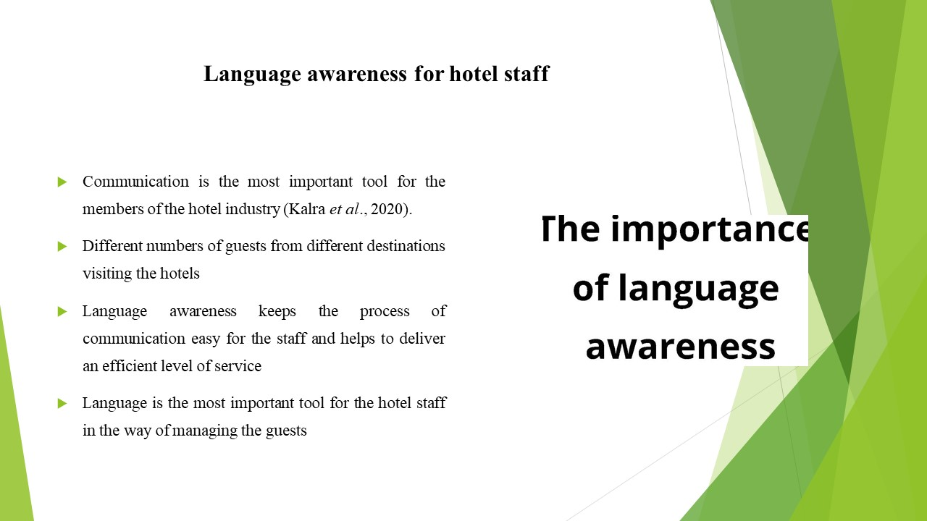
Language is the most important tool for the hotel staff in the way of managing the guests. The main advantage of language awareness is the improvement of communication skills. Communication is the most important tool for the members of the hotel industry (Kalra et al., 2020). It helps to improve the level of customer satisfaction and to deliver a way of improving the brand value. There are different numbers of guests from different destinations visiting the hotels.

[Content Slide 3]
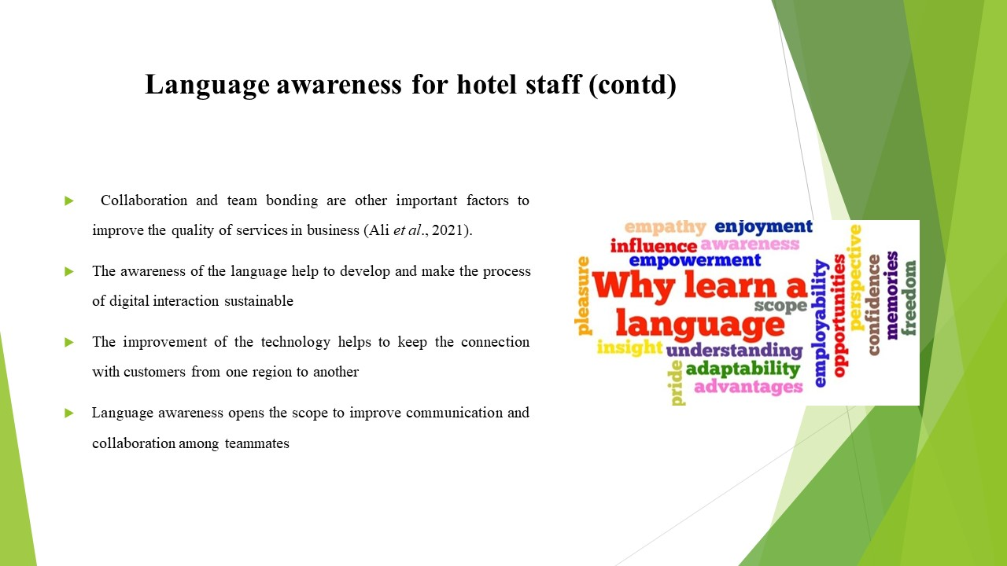
The digital world has enabled various ways to improve the hospitality sector. The improvement of the technology helps to keep the connection with customers from one region to another. The skills of language proficiency and the awareness of the language help to develop and make the process of digital interaction sustainable. Collaboration and team bonding are other important factors to improve the quality of services in business (Ali et al., 2021). Language awareness opens the scope to improve communication and collaboration among teammates.

[Content Slide 4]
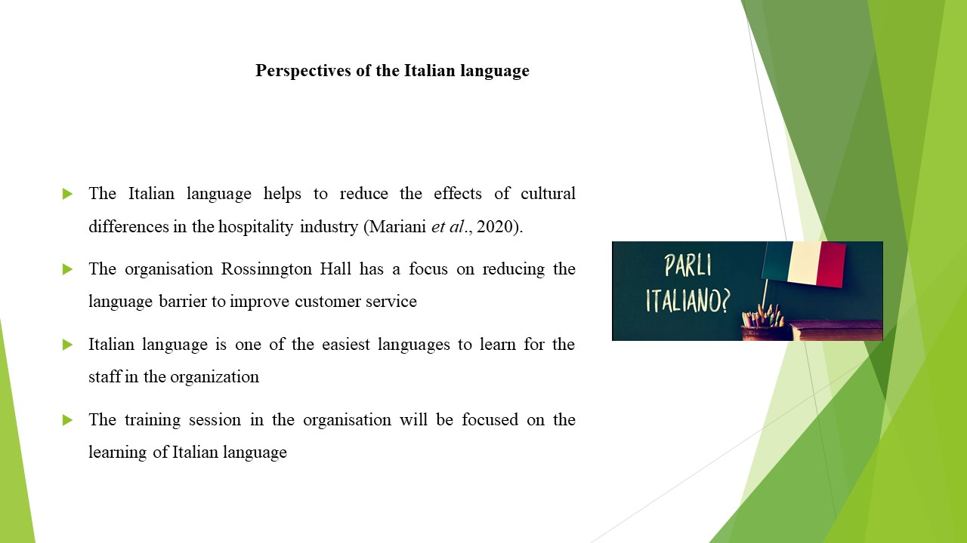
Languages play an important role in the development of the services in the hospitality industry. The organisation Rossinngton Hall has a focus on reducing the language barrier to improve customer service. The training session in the organisation will be focused on the learning of Italian languages. The citizens of Italy, San Marino and parts of Switzerland commonly use the Italian language. The Italian language helps to reduce the effects of cultural differences in the hospitality industry (Mariani et al., 2020). It is one of the easiest languages to learn for the staff in the organisation.

[Content Slide 5]
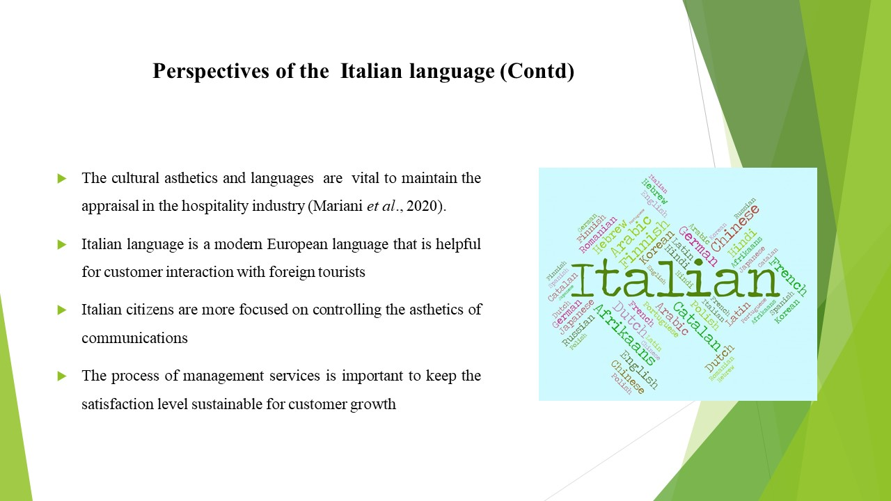
The process of management services is important to keep the satisfaction level sustainable for customer growth. The cultural aesthetics and languages are vital to maintain the appraisal in the hospitality industry (Mariani et al., 2020). Italian citizens are more focused on controlling the aesthetics of communications. It is a modern European language that is helpful for customer interaction with foreign tourists. Also, root of this language is Latin.

References (no screenshots):
Ali, M., Li, Z., Khan, S., Shah, S.J. and Ullah, R., 2021. Linking humble leadership and project success: the moderating role of top management support with mediation of team-building. International Journal of Managing Projects in Business, 14(3), pp.545-562.
Kalaja, P. and Pitkänen-Huhta, A., 2020. Raising awareness of multilingualism as lived–in the context of teaching English as a foreign language. Language and Intercultural Communication, 20(4), pp.340-355.
Kalra, D., Ghazal, T.M. and Afifi, M.A., 2020. Integration of collaboration systems in hospitality management as a comprehensive solution. International Journal of Advanced Science and Technology, 29(8s), pp.3155-3173.
Mariani, M.M., Borghi, M. and Okumus, F., 2020. Unravelling the effects of cultural differences in the online appraisal of hospitality and tourism services. International Journal of Hospitality Management, 90, p.102606.
Presbitero, A., 2020. Foreign language skill, anxiety, cultural intelligence and individual task performance in global virtual teams: A cognitive perspective. Journal of International Management, 26(2), p.100729.

