Contents
Why I chose my tool? 2
What information I used? 2
How I created my artefact? 2
What changes I made? 3
Feedback? 3
Final explanations? 3
Reference List 4

Ds2

Why I chose my tool?
I chose Excel because it is good for creating tables and working with numbers. (DigiCentre, n.d ). It helps me analyse data and create charts, which makes the information easier to understand (Microsoft, 2024).

What information I used?
I used the information provided in the scenario. The scenario contained a weekly city bike rental summary.
The scenario showed the bike types and the total rentals for each type of bike.

How I created my artefact?
I used Excel to create my artefact. I entered the bike rental data from the scenario into a table. Then I created a bar chart to compare the number of rentals for each bike type. The chart helped me see that the Standard Bike had the highest rentals.

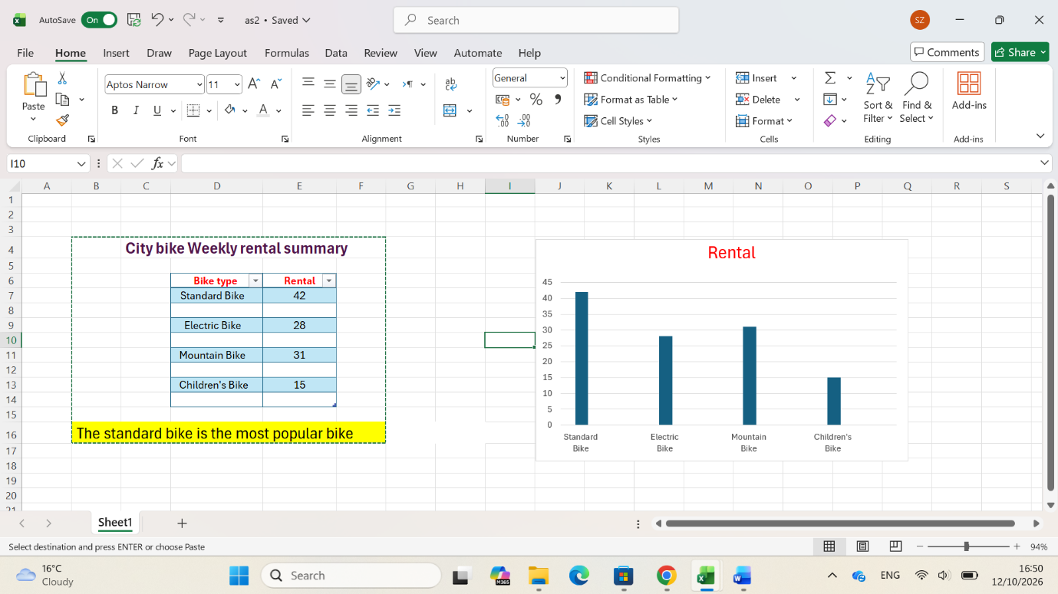

What changes I made?
I made the data clearer by creating a table and a chart. I added colours, a title. These changes improved my work by making the information easier to understand and helping me identify the most popular bike quickly.

Feedback?

I was confused about how to use in-text citations and the reference list, so I asked my tutor to explain it to me.
I learned how to present information more effectively using charts and colours, which made my work clearer and more visually appealing. This experience showed me the importance of working with others and learning from their knowledge.

Final explanations?
The chart makes it easy to compare the number of rentals for each bike type and shows that the Standard Bike was the most popular, with forty-two rentals. This artefact helped me analyse the data clearly and present the information in an effortless way. It could help the staff understand customer demand and make better decisions about bike rentals.

Reference List
DigiCentre, University of Wales Trinity Saint David (n.d.) Bitesize Excel – Understanding pivot tables (Accessed: 19 October 2026).

Microsoft (2024) Microsoft Excel. Available at: https://www.microsoft.com/microsoft-365/excel (Accessed: 19 October 2026).

