BUSINESS PLAN PROPOSAL

MEMORY BOX
PHOTO STUDIO

TEODORA GAVRILA (1816784)
16.03.2020

EXECUTIVE SUMMARY

The purpose of this business plan is to demonstrate the potential income earned through a successful photo studio.
The start-up business venture developed by four partners as a Limited Company.
We are very confident that our skill and our passion will lead us to success and help us to be in top 3 photo studios from Swansea.

TABLE OF CONTENTS

Executive summary…………………………………………………………………… 2
Table of contents……………………………………………………………………… 3
Introduction……………………………………………………………………………. 4
Main body……………………………………………………………………………… 6
Conclusion……………………………………………………………………………. 27
Appendices …………………………………………………………………………... 28
References........................................................................................................ 29

INTRODUCTION

Our Business
The purpose of our amazing photographs is to record unique moments in people’s lives.
Most people only use professional photo studios for rare occasions, such as weddings, yearbook photos or photographs of children.
Also, because the customer must initiate the call, there are many special moments missed, and the studios lose potential business.
Babies grow rapidly, people are busy, and if there is too much time between the images, those moments will be lost forever.
Today, we all have a mobile phone or a camera, but when it comes to a special occasion, you will have to call a professional, to get the best results.

Memory box Photo Studio will deliver this much needed service, by targeting families of professionals with new-born babies. We will deliver a package to parents for baby pictures – this will account for 40 percent of our business, and we will then further build a relationship with our customers over the forthcoming years for continuous album images.
It is estimated that the funding requested in this programme would result in a secure annual net income by year 3.

The launch of Memory Box Photo Studio will bring an exciting an innovative service, that is different to the normal professional photography services in the area. In addition to us being a spectacular place to visit, this engaging photo studio will be a comfortable part of a family's life, helping them capture and share special moments in a digital world.

We compete in a niche market, and we can deliver an outstanding rival beating service in the premium segment.
Our studio is designed to enrapture and delight our customers, with amazing displays of the special moments in our lives. And of course, our prints are always delivered to the highest standard.

Name of the Business
The name of the studio will be ‘Memory Box - Photo Studio’.

Objectives
We LOVE photography, and this has motivated us to bring the same energy, enjoyment and fun to a wider audience. And to successfully accomplish this, we are trying to keep it simple.

Our objectives are:
- To Delight our Customers
- Generate a comfortable net profit by the third year.
- Build easily replicated groups of products, but still allow flexibility in our packages (at a premium cost to the Customer) and deliver a user friendly fast and enjoyable service to all.
- To have a sustainable customer relationship programme, (with repeat business) using a structured call plan that will keep us always on top of the needs of each of our clients, and up to date with the very latest innovations.

MAIN BODY

Company Ownership

Memory Box Photo Studio will take form of a partnership (Limited Company) where the economic activity includes all four stakeholders as follows:
Viorel Melinteanu is our passionate photographer with more than 10 years’ experience in the field which helped him to develop his professional skills, improve and update his skill set by attending different courses, workshops and events.
Teodora Gavrila (Sales Manager) is passionate about people and I like to be surrounded by children and families, but what I like the most, is to be part of families important moments and if I can help by making a difference in their life this would bring me more happiness than anything else.
Simona Gavrila (Marketing manager) has a passion for beauty will take care of our business marketing strategies trying to implement strategies in order to sell our product and target the best customers.
Catalina Grosu (HR manager) will take care that or our employees will be fully trained and with a reasonable experience so that our customer can receive the best services. She will also make sure that all the steps in recruiting process will be respected.

The studio will be in Swansea city centre, being easy to spot by possible customers. The site offers the necessary framework for all specific activities, such as photo sessions, image processing, printing and customer interaction.
We're expecting a stable economy with sustainable growth and gradual interest in our business growing. We also expect that in the first two years our rivals will not follow our approach.
With this, our strategy is likely to affect what our rivals are paying for digital content, because they can see how successful it is in bringing in both repeat business and new business.
This company is expected to become profitable in May 2023, following the completion of the start-up ads and as customers begin to discover our services.
Key to success
Our keys to success are:
Target marketing for the gateway products of baby pictures, high school photos, wedding albums, business photography (Product photography, Photos for business profiles, Corporate photography)
Developing connections with our customers, and with our exceptional personal customer service, we will convert once-in-a-lifetime customers into repeat customers.
Our programme monitors the current needs of customers for images and takes the initiative to contact them for appointments.

Our products:
- baby pictures

- portraits for home or office

- senior pictures for the high school yearbook

- family pictures to send to family members

- family, individual or business websites

- portraits for business cards, such as for real estate agents

- portraits for brochures and annual reports

- wedding pictures

- christening parties

- birthday parties

- dogs photo sessions

- wildlife and travel photography

- wedding pictures

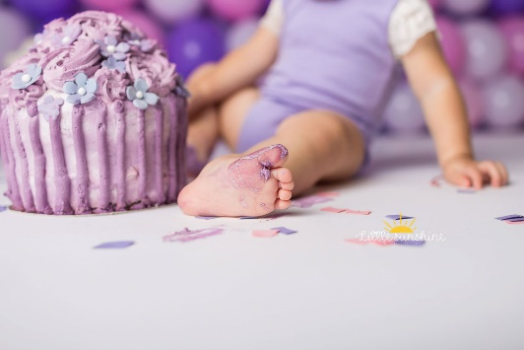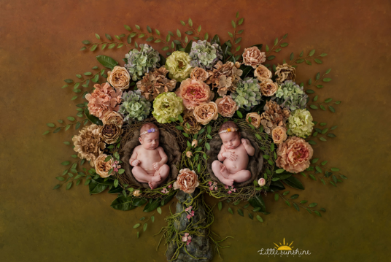

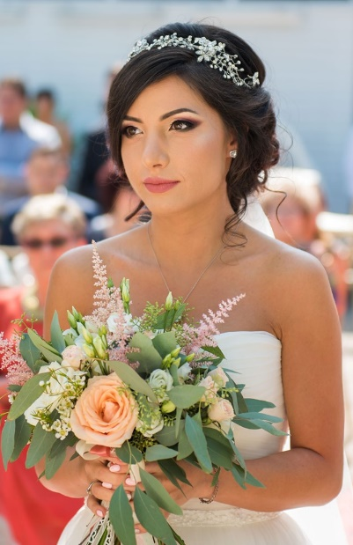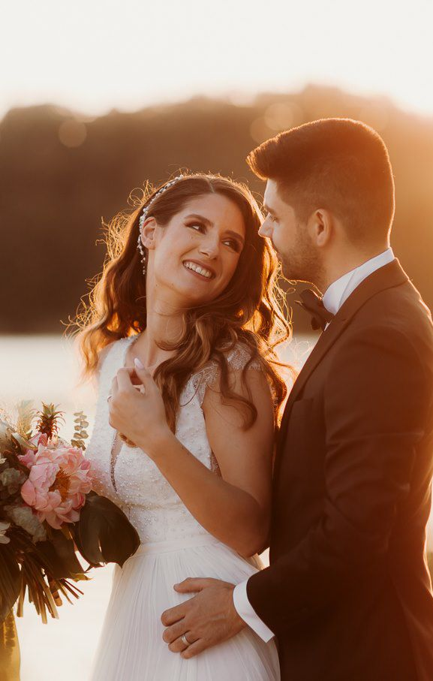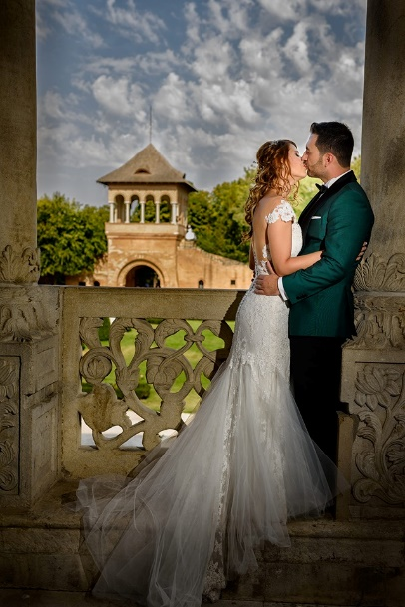

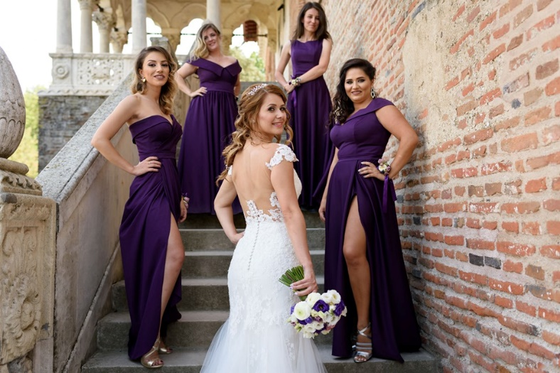

Zach and Jody Grey (2020), ‘3 secrets for free wedding stress’ , Available at: https://l.facebook.com/l.php?u=https%3A%2F%2Fcc.colesclassroom.com%2Fstress-free.

Financial resources (start-up expenses)

Equipment
Equipment expenses will be £8307

- 1 camera NIKON D750 -£965
Photography went digital. Digital cameras replace analogue cameras quicker than the video stores replace VHS with DVDs. Currently mobile phones are equipped with digital cameras.
The uses of photography have expanded as well because of Web pages on the Internet and email. Digital images are needed for printing uses as well, for such uses as brochures and business cards.

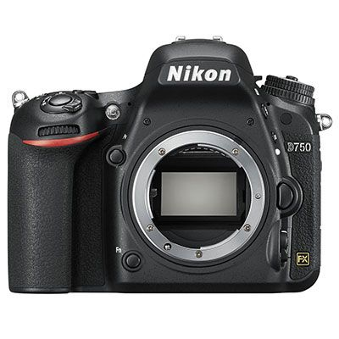

- 2 laptops DELL XPS 13 13.3" Intel® Core™ i7 Laptop - 512 GB SSD, Gold-£1500×2
For the most part, picture studios have moved to digital format as it also allows fast editing and manipulation. They were less likely to make digital files open to consumers at an affordable rate, and this is a trend we hope to capitalise on.


- 1 printer CITIZEN CY-02 Professional Photo Printer - £750

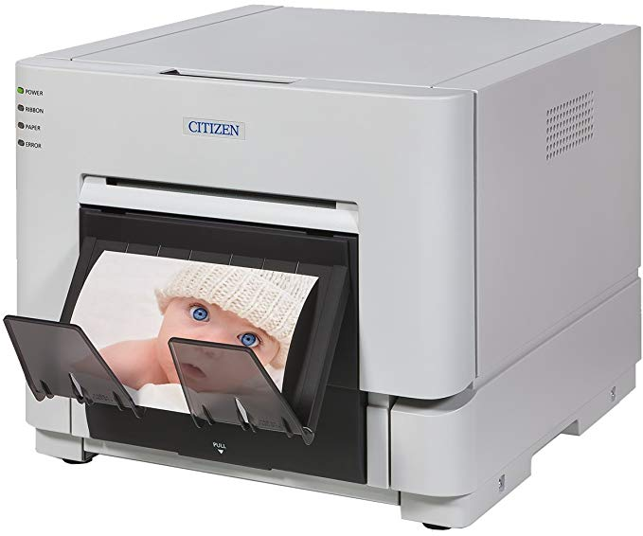

- 1 set of professional lights- Elinchrom D-Lite RX 4/4/2- £1200

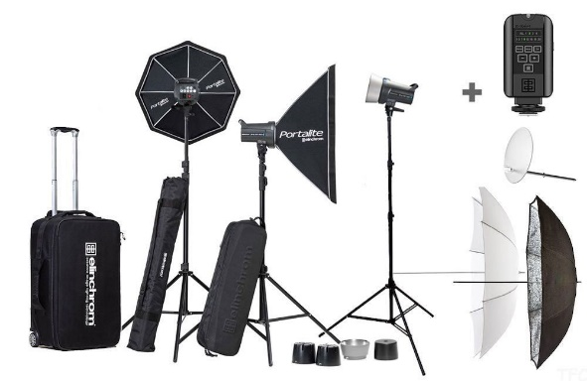

- 1 drone- DJI Mavic 2 Zoom -£1.089

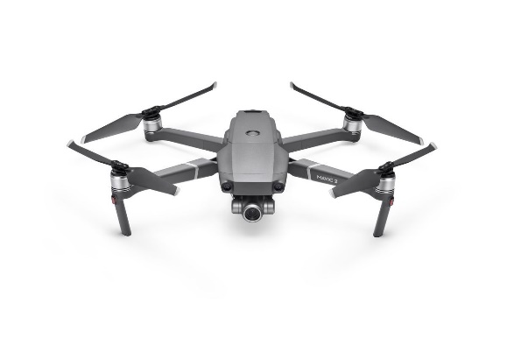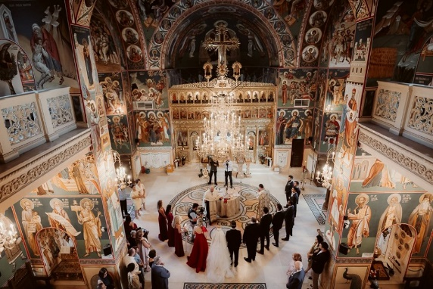

- 2 computers - DELL Inspiron 3470 Intel® Core™- £576×2



- 2 monitors (HP 27fw Full HD 27" IPS LCD Monitor)-£178×2

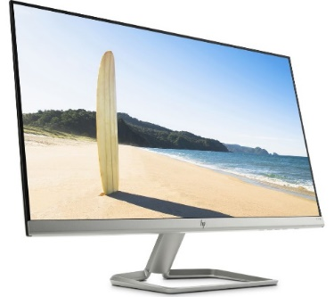

- One television (TOSHIBA 50U2963DB 50" Smart 4K Ultra HD HDR LED TV)-£298

This television is going to be located on reception where people can see pictures, videos on audio on a musical background.

- Photography backdrops- £73

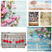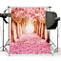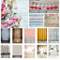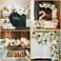
We will have lots of different backdrops for different occasions or tastes so we can make all our customers happy.

Furniture expenses (£2153)
- 1 reception desk and chair- £680
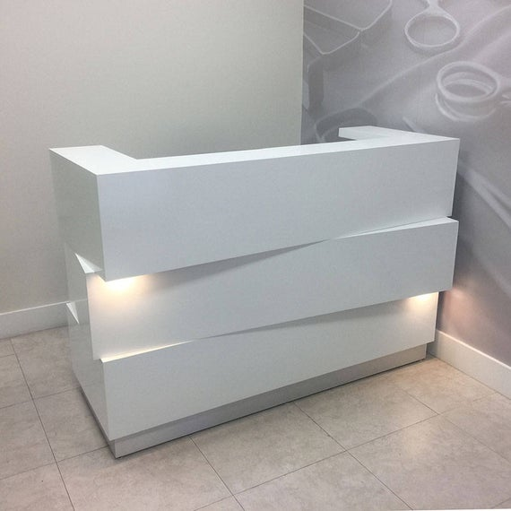

- 1 settee for reception-£458
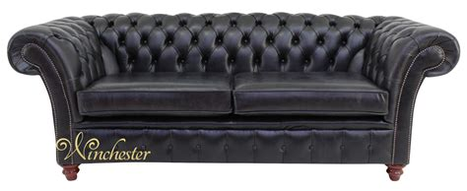

- Different chairs for in studio (kids and adults-£790
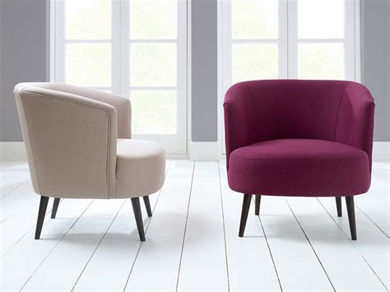
When having a family photo session family members accompanying them will have a comfy place to wait for their turn and also will be kids friendly so they can relax in a warm atmosphere before the session starts.

- Floating shelves-£225
We will use this shelves for our albums so that our clients can see the quality of the pictures before they use our services.
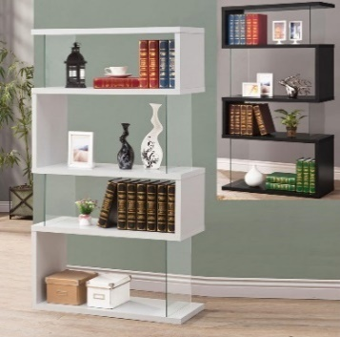
- 1 desk for our office- £850


Annual rent £12000
We will also benefit of 3 months rent free as a help from owner, just enough time to organise, paint, redecorate and make everything ready for our first customers.
For a stunning design Simona Gavrila with her experience in beauty and design will help us to obtain the most organised studio photo from area.

External marketing equipment (£2000)

From the report gathered from our feasibility studies, we have been able to identify some platforms that will help us effectively create awareness and promote our photography business. Here are the platforms we intend making use of to promote and advertise our business:
- Place adverts on national newspapers and local radio
- Leverage on the internet and social media platforms like Instagram, Facebook et al
- Attend photography exhibitions and conferences
- Engage in roadshow from time to time
- Distribute our fliers and handbills to targeted areas from time to time
- Door to door and word of mouth promotions
- Billboards in the most crowded area of the city such as buss stations, commercial centres and big shops, schools, enterprises
- Media (website page)
Memory box photo studio will have a website page which can help our clients to see our products and packages and get answers to the most common questions.
As everything goes technological these days, we also have a questionnaire for our customers which can help us to gather information about what our customers would like to receive but you can also can see customers responses.

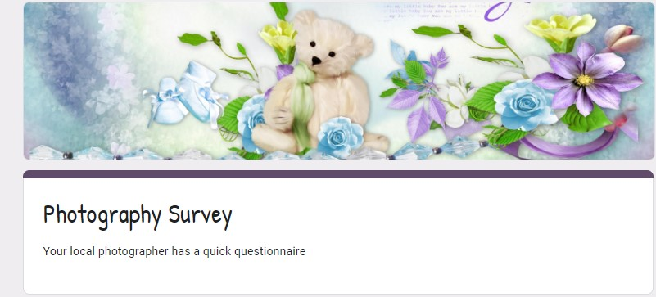
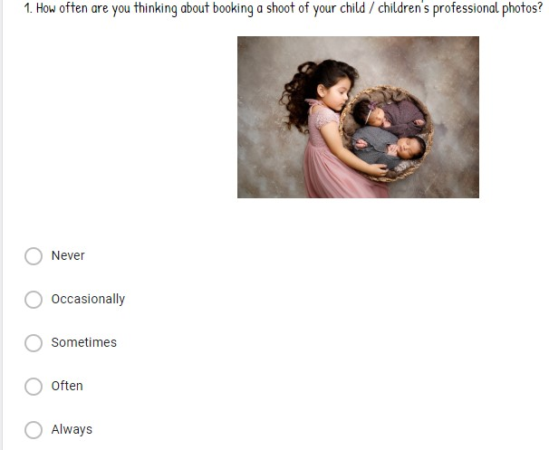
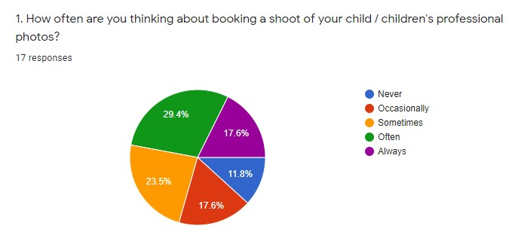

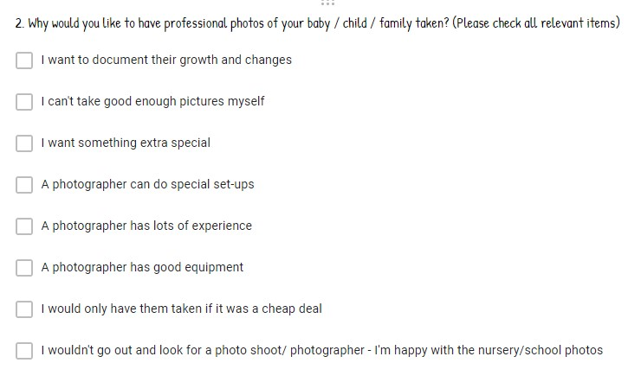
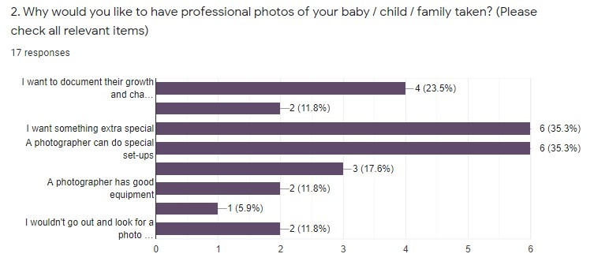

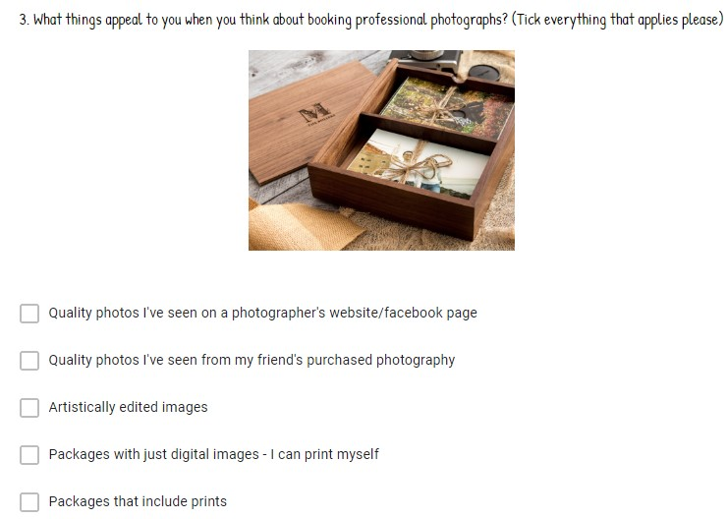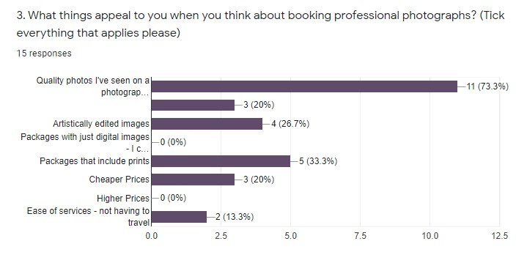
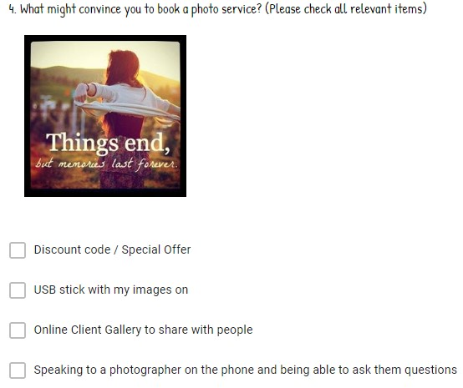
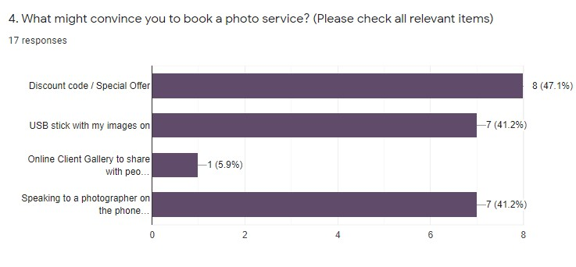

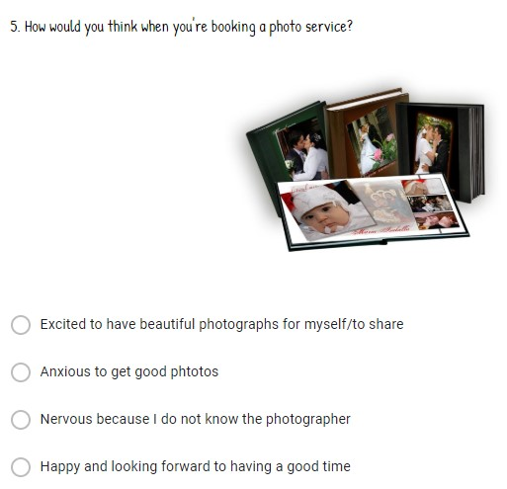
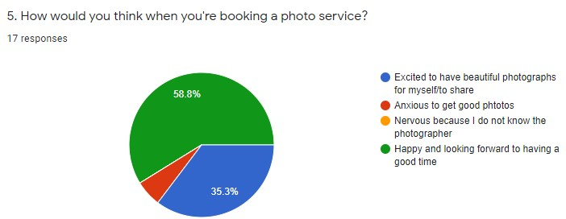
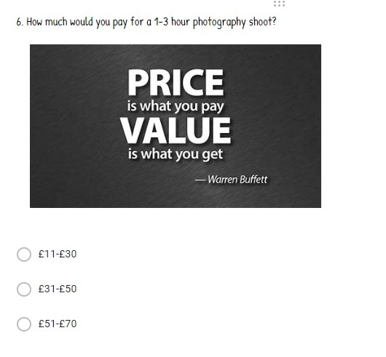
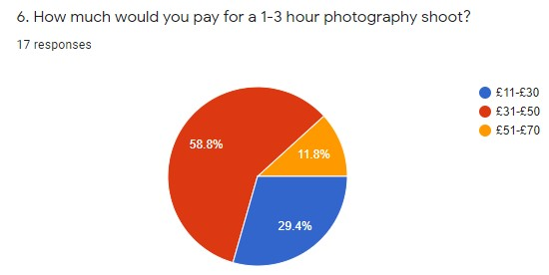

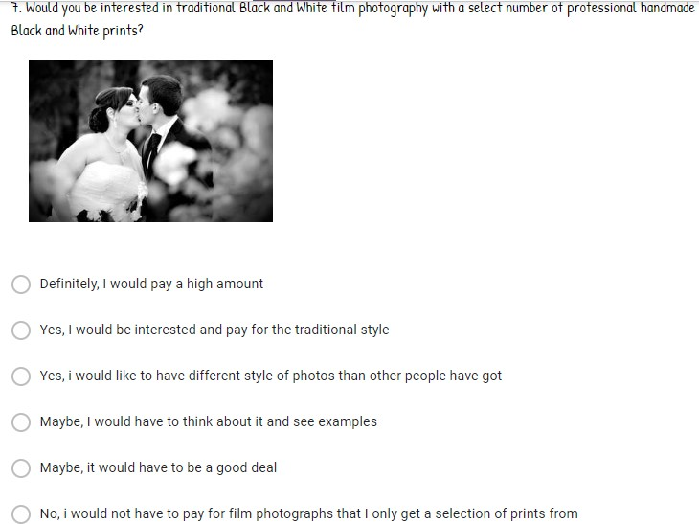
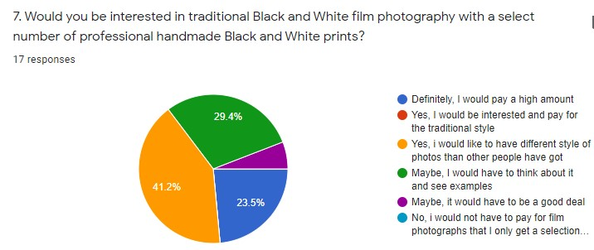

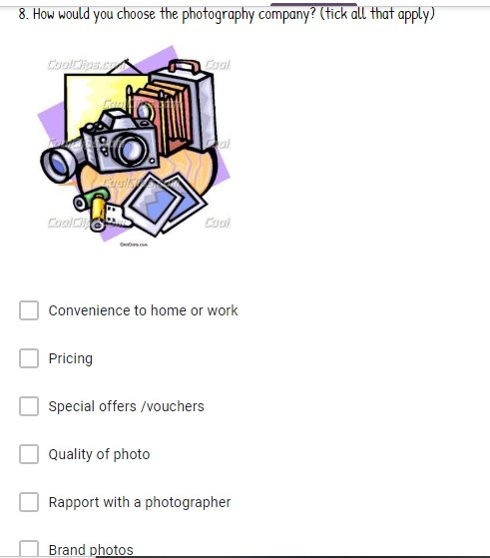
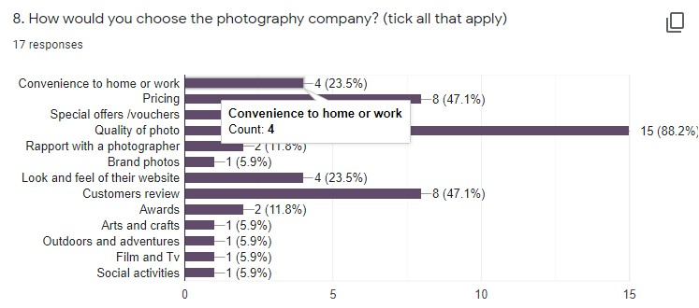
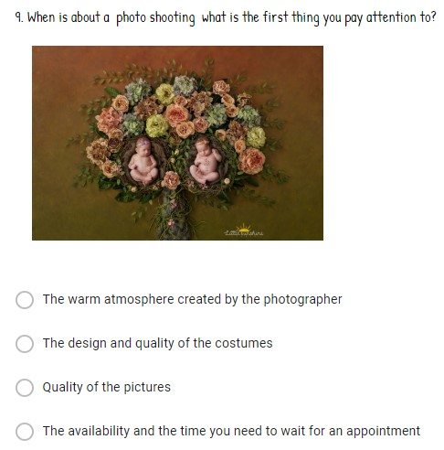
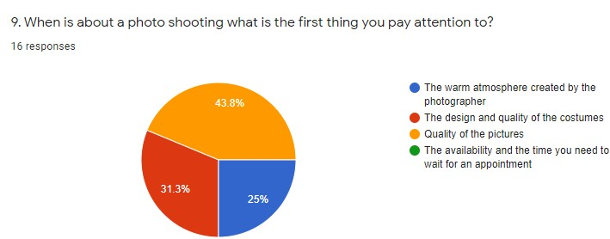

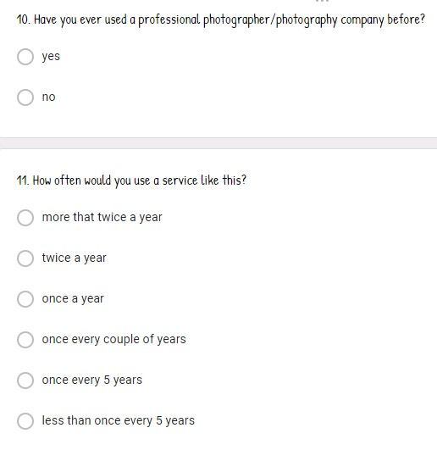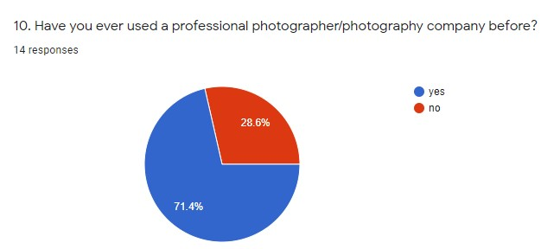
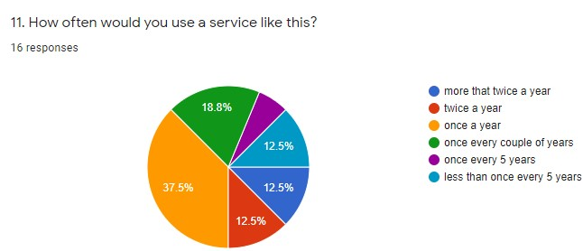
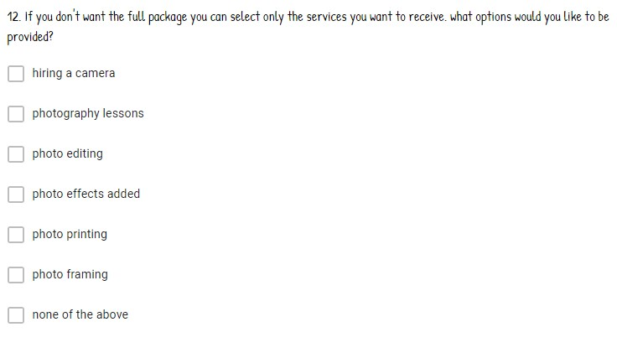

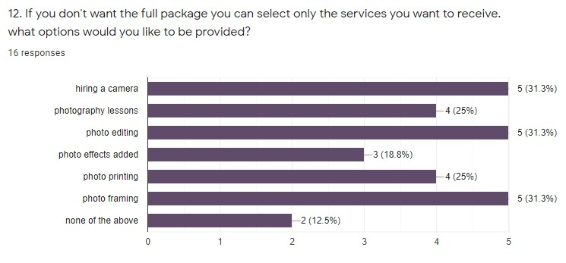

Business rates £2500

Insurance (shop insurance and liability)-£3450

Utilities and deposits £3515

In order to move the equipment to deferent events, we will buy a van on finance and we will have a rate of £150 monthly.
Accountancy will be kept by my father’s company which means, we will be able to save an important amount every month.
The remaining money we will keep for unexpected expenses but also to buy equipment that can help us improve our business.

Our mission
Memory box Photo Studio helps consumers maintain memories and show themselves in the best light. Through developing relationships with our customers and calling them with timely reminders for new photos we rely on repeat business.
We render images of professional quality accessible in digital format with ease.
Our mission is to satisfy the customers.
One of our strategies will be to give customers the best services they ever received, so they can recommend us to their friends and families.
By recommendation from someone who has used their services, buyers are more likely to try a specialist. If this is not available, they will most likely look in the Yellow Pages, but increasingly online, particularly if they're young.
We do this by using a pricing structure that makes our digital images a staple of the household, also making it fun for them to come here or have us at home.
University graduate families are more likely to be academics, with the means and taste for artistic portraits. In the city centre area, there are about 5000 these families.

Our Target Market
- Young Executives
- Intended couples planning to get married
- Churches and other religious centres
- Schools
- Wedding planners
- Corporate Executives
- Event Planners
- Families

Targeting Baby Pictures: They will be soliciting baby pictures by correlating public birth records with target family post codes. Baby images will be the key to our ongoing image services for the infant and the whole family.
We'll also target female workers and working spouses because in these households, women make the majority of purchasing decisions.
The business landscape is divided between luxury photographers of premium magazines, moderate skilled photographers who often pose their subjects, and picture studios the same day.
The trend among our target customers is towards more digital photography and more digital picture sending over the Internet. When the environment becomes more technological, it needs more personal support from people.
People who pay for professional photo portraits are usually status-conscious professionals who have children and so we segmented the city centre area according to family social status. We used schooling as a way of assessing social status.
Since women make most buying decisions in families, our main target market is educated women of the middle ages.
Some of the aspects that will make us stand out in the industry, include our offer of quality photography, at rock bottom rates in our city at all times.
Even more than this, we have gone further to invest in a CRM platform that will help us effectively win new clients over, and also help us effectively manage our existing client base.
Our customers will benefit of free parking spaces and a play area, very useful for those families with more than one child.

Conclusion

In conclusion, we are confident that following the research we have conducted; this is a viable business proposition.
Our business strategy would occupy a niche in the marketplace that is not currently filled by a competitor.
The costings are sound, and the scheduled break even / profit timescale is attainable.
As a partnership, our passion, enthusiasm and skill sets will ensure that we have a sound foundation to build upon.

Appendices

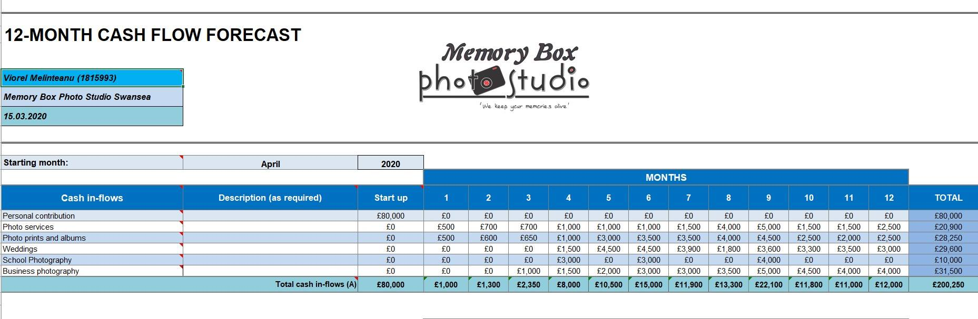
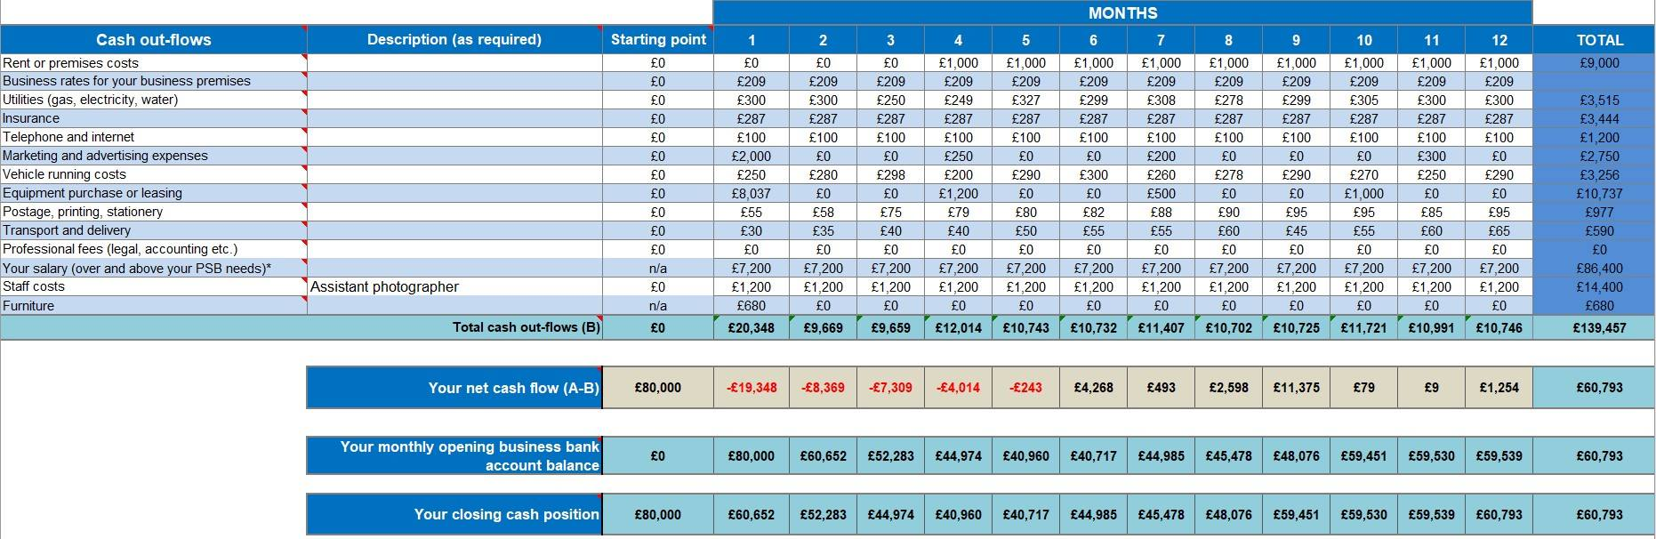
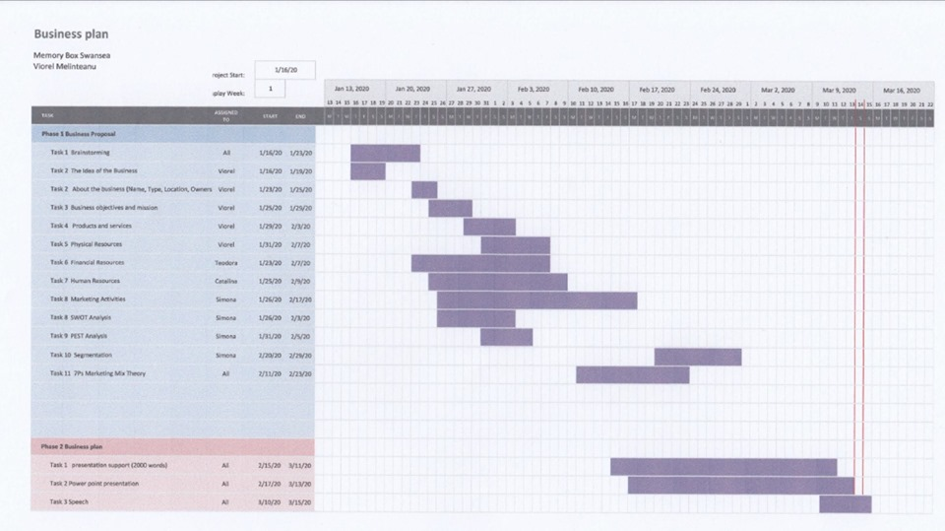
References

- ACAS (2020), Training Courses. Available at: https://www.acas.org.uk/training-courses, (Accessed: 07 march 2020)

- Alexander H. (2019). How to do a business plan Available at: https://www.rocketlawyer.com/gb/en/sem/business-plan?gclid=EAIaIQobChMItq69lcSd6AIVBsjeCh3jBwRQEAAYAyAAEgJhEPD_BwE (accessed: 02 march 2020)

- Amazon UK (2020), Furniture, Available at : https://www.consumersearch.com/web?qo=semQuery&ad=semA&q=sitting%20room%20furniture&o=777445&ag=fw11&an=google_s&rch=intl345&gclid=EAIaIQobChMIst3gg82d6AIVAcreCh2NKArQEAAYASAAEgIevvD_BwE (Accessed 10 March 2020 )

- Ana, H. (2018), ‘How to create a Marketing plan’ Available at: https://l.facebook.com/l.php?u=http%3A%2F%2Fwww.entrepreneur.com%2Fmarketing%2Fmarketingbasics%2Fmarketingplan%2Farticle43018.html%3Ffbclid%3DIwAR3id0GC6hNQ-UTQv2eDt07wJ_apBMH2XZ41PRaBWcUKGwVX4RxNbaykCS8&h=AT1k9qeovqHZisndxsiq2gs7KzIUB8Kk_MIgWS1NwyW-9J7SDNflkfWbow_ebu-9CKsMiRO4mzsr31bPEKDr-YU92rxNYZl7N7xTVlmG_lZ_UkOuWLyuOyGV7z1nmiPHJSGbJpnFSiZ00wFU7vo (Accessed: 27 Feb 2020)

- Cohen, William A.. (2005). The Marketing Plan. Fourth Edition. John Wiley & Sons, Inc.

- eBay UK (2020), ‘Nikon cameras’ Available at: https://int.search.tb.ask.com/search/GGmain.jhtml?searchfor=ebay+laptops&enableSearch=true&rdrct=no&redirect=CPC (accessed at: 05 March 2020)

- Kerin, Hartley, Berkowitz, Rudelius. (2006). ‘Marketing’. Eighth Edition. McGraw-Hill Irwin.

- Lehmann, Donald R. & Winer, Russell S. (2002). ‘Analysis for Marketing Planning’. Fifth Edition. McGraw-Hill Irwin.

- UK government (2020), ‘Practical advice for businesses’ Available at: https://l.facebook.com/l.php?u=http%3A%2F%2Fwww.businesslink.gov.uk%2Fbdotg%2Faction%2Flayer%3FtopicId%3D1073869186%26fbclid%3DIwAR1kbf5A8x4B8DhZqjrv5paKB8HCaVJQ9RzB6Zk8B9FW6ypl8HaxucfiolU&h=AT1k9qeovqHZisndxsiq2gs7KzIUB8Kk_MIgWS1NwyW-9J7SDNflkfWbow_ebu-9CKsMiRO4mzsr31bPEKDr-YU92rxNYZl7N7xTVlmG_lZ_UkOuWLyuOyGV7z1nmiPHJSGbJpnFSiZ00wFU7vo (Accessed: 12 March 2020)

- UK Government (2020), ‘Setting up a business’ Available at: https://www.gov.uk/browse/business/setting-up, (Accessed: 07 March 2020)

- Zach and Jody Grey (2020), ‘3 secrets for free wedding stress’ , Available at: https://l.facebook.com/l.php?u=https%3A%2F%2Fcc.colesclassroom.com%2Fstress-free-weddings-registration%3Ffbclid%3DIwAR1ShNXG9kxrPDqtmQuuzmKkZTjvll9GdlWa39IO29kPlOnLv6FBIrCeulI&h=AT1k9qeovqHZisndxsiq2gs7KzIUB8Kk_MIgWS1NwyW-9J7SDNflkfWbow_ebu-9CKsMiRO4mzsr31bPEKDr-YU92rxNYZl7N7xTVlmG_lZ_UkOuWLyuOyGV7z1nmiPHJSGbJpnFSiZ00wFU7vo, (Accessed: 11 March 2020)

