 BSc Professional investigation
Module BMPI6000 - Project Proposal
Student Name: Liz Evans
Supervisor Name: Alison Cooke

Research Question
A critical evaluation of policies relating to the Police attendance at sudden deaths.

Literature Review
Using a review of peer-reviewed journal articles and other academic sources, provide a rationale for your research project.
No national policy exists in relation to the attendance of Police at incidents of unexplained death and policies are inconsistent. Doyle, (2011) identified the risks associated with this prior to 2009.
Very little recent academic research exists in this area since, identifying a gap making this research more appealing.
The role of the Police is to exclude criminality as a cause of death. This assessment should be conducted by a trained and experienced investigator (Doyle, 2011). This is the Policy in Wales; Police will take primacy of the incident and deal with the Coronial process. The role of the Ambulance is solely medical to determine life extinct. Dyfed Powys Police also require CID attendance. Some Ambulance Trusts and Police forces have a different policy. Ambulance service solely respond in cases meeting certain criteria.

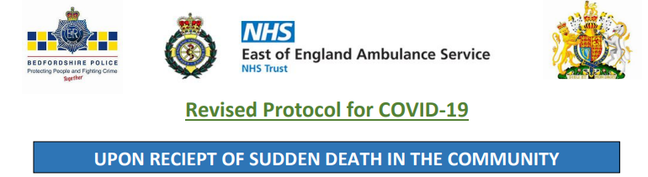
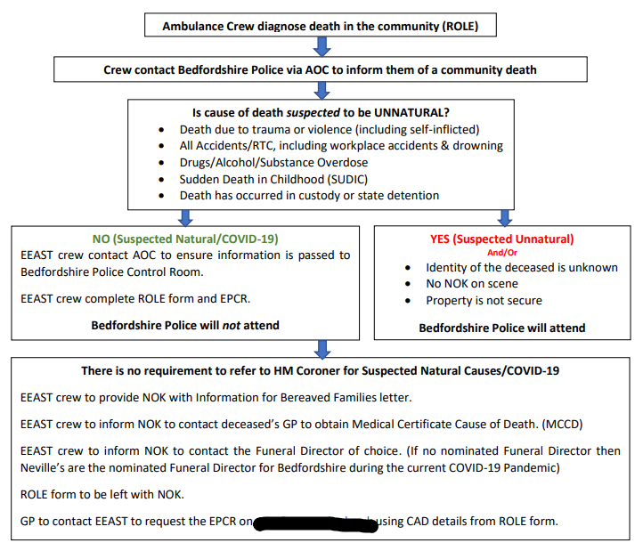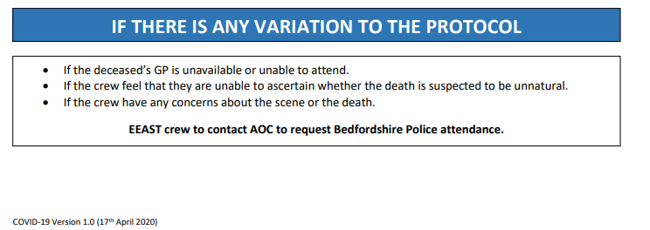East of England Ambulance Service NHS Trust, 2020.
This results in the responsibility of assessing and determining “suspicious” with Ambulance Service personnel. It is only at this point that Police are first notified of the death and requested to attend, perhaps also CID.
The College of Policing Standard Operating Procedure (First response to Sudden and unexplained death), specifies guidance upon which factors Police Officers should be assessing at the scene and recording in their decision-making rationale in addition to their existing training in the Codes of Ethics (College of Policing, 2014), and critical thinking methods. (College of Policing, n.d.). Caution must be exercised in determining suspicious or not since valuable evidence will be lost if not preserved at the earliest opportunity.
Despite the majority of Homicides being clearly apparent from visible injury, (ONS, year ending 2021), some do not. Ambulance Service personnel are not investigators, they do not all have Body Worn Cameras to secure and preserve evidence of the incident, they do not conduct searches and may not have the requisite training to effectively assess features of suspicious circumstances.
For example, knowledge which may fall beyond their skill set considerations;
- suspicious behaviour of persons present beyond the variable reactions of trauma response (Simon, 2021, pp. 216, 217).
- Hypostasis or Rigor inconsistent with conditions. (Payne-James and Jones, 2020, pp. 55-58).
This policy places a considerable amount of accountability upon the Ambulance Service personnel.
Forensic Pathology refers to traumatic events causing a surge of adrenaline sufficient to have fatal implications in persons with underlying health conditions, this is more prevalent in the elderly. Such event may not be physical violence and death may not be immediate. The result is direct causational death from crime. (Shepherd, 2021, pp. 372-376). Police officers have immediate access to such intelligence relating to the location, the deceased and therefore the previous incident should influence their decision making. Ambulance service do not and may be more likely to bias towards determining a rational non-suspicious medical cause. Without such knowledge or access to intelligence to conduct an objective assessment, it is impossible to improve accuracy.
Vulnerability is an increased risk factor in “staged deaths” since the elderly, drug/alcohol addicts are more likely to suffer ill-health which is then presumed to be the cause of death. Detectives, are prone to bias towards criminality. (Shepherd, 2019). Investigators, in theory, should be more likely to identify foul play due to advanced training however, the absence of any incorporated psychological theory, may impact upon their decision-making skills. (Beauman, 2007, p. 68).
However, criminality has been missed by Police and appropriate early investigation opportunities have been lost. Officers have failed to be objective and have been influenced by financial factors and the vulnerability of the deceased as referred to by Etzioni (2014). Recommendations were made for National Policy and improved training for Police. Jones, (2016, p. 145). He makes reference to “a ‘fatal call’ – can lead to a failed investigation and someone ‘getting away with murder. Jones (2016, pp. 221). There are several external influences to contribute towards unintentional bias in decision making such as emotion, financial, pressure, training, overconfidence. A slower, analytical though process is likely to be the more accurate. (Kahneman, 2011, cited in Etzioni, 2014). That said, any profession is susceptible to bias. (Kahneman et al. 2011, cited in Etzioni, 2014).
Homicide can be inherently covert to avoid detection, killings staged as natural attracts minimal scrutiny. (Havard, 1961 pp. xv, 253, cited in McGowan, 2012, p. 174). An example of so-called covert killings being Harold Shipman (Smith, 2013), whereby consequently, responsibility was placed upon the Coroner to detect such killings. (Kesselring, 2006, p. 20).
Whilst it is not the role of the Coroner to investigate Homicide or Manslaughter, it is considered to be their duty to identify such crime which may have passed unnoticed by Police. Such cases which are identified by failures in the initial Police investigation or in providing sufficient documentation are referred back to Police. (McGowan, 2012).
Literature and research refers to Police attendance at unexplained deaths. If failures have been identified in Police practice, when Officers have advanced knowledge and training, the rationale for Ambulance Service only attendance seems fraught with danger in missing suspicious deaths which could result in litigation against the Police and loss of public confidence (Doyle, 2011). This certainly a thought-provoking decision-making rationale.
(For clarity, this study will be confined to unexpected and unexplained deaths in adults aged 18+ since other procedures apply for incidents outside of these parameters).

Method

Aim(s):
The aim of this study is to establish if the inconsistent policies in relation to Police attendance at unexplained deaths result in any increased risk that suspicious circumstances are being missed at an early opportunity resulting in investigative opportunities from timely Police/CID intervention being lost.

Objective(s):
- Identify policies relating to the attendance at unexplained deaths of The East of England Ambulance Service, Bedfordshire Police Constabulary, The Welsh Ambulance Service and Dyfed Powys Police force.
- Compare and contrast the detail of such policies, including relevant training given in this area to identify the strengths and weaknesses.
- Evaluate the risk of missed criminality
- Recommend if a standardised, national guidance would be best practice to meet the objective of reducing the risk of missed criminality in unexplained death.

Design: Quantitative or qualitative?
Quantitative Primary data
The questionnaire is limited to 10 open and closed questions in order to be attractive and achievable to participants, given consideration to their demanding frontline response roles. This should improve participation rates. Focus groups were considered however, due to geographical distance and difficulties with logistics of assembling frontline response, shift working staff and abstracting them from their important role, short questionnaires were deemed to be the more appropriate method and can be completed electronically, in a few minutes down time independently.

Qualitative Secondary data
To establish what material already exists, a peer reviewed literature review will be conducted from journals, books, studies, dissertations, policies/procedures, statistics. Sources will be the University library, Google Scholar, College of Policing library and open-source internet search (Office for National Statistics). Search terms will be, decision making in criminal investigations, bias in critical thinking, guilt psychology, post offence conduct, covert killings, errors by Police in determining criminality in unexplained death, preservation/loss of evidence in initial response to scenes of unexplained death. Establish if lack of initial investigation is an issue when cases are being referred back from the Coroner.
179

Sample: Who/what, how many, where from, sampling method.
Participants will be from Bedfordshire Police, Dyfed Powys Police, East of England Ambulance Service, Welsh Ambulance Service. They are similar in make-up and should provide a fair comparison, one is my own Police force and one outside. Points of contact within these organisations are already known wo will assist with providing details of persons who can provide authorisations and facilitating the distribution of questionnaires. 20 Police Officers in total, 10 from each Police force, 5 each from response and CID. 20 Paramedics, 10 from each area. This is to ensure a fair comparison sample and manageable data response. The Survey Monkey application will be used to facilitate the survey since it anonymises participant details, it is free for the sample size proposed and self-data analyses. In the event of participant not responding, this will be explained in the final dissertation.

Analysis: What will you do with the data when you have collected it and why?
Ethics: Briefly cover any ethical issues that you need to consider
Written authority will be sought from organisations to complete the survey as will for their material to be included in the study. The aim of the study will be introduced at the beginning of the questionnaire. This will state that it is anonymous and voluntary. By its completion, they provide consent. There is no requirement to answer all questions and they may withdraw. Any personal or professional association with any participant will be declared. The study will be my own work, referencing of other’s work to ensure integrity and no plagiarism. Participants will all be professionals in their role therefore no vulnerability issues.

A review of the data analysis conducted by Survey Monkey will be carried out to ensure accuracy and detail. Any issues identified may result in further analysis using the Braun & Clark 2006 thematic analysis tool. Analysis will identify recurring themes from numerical data (e.g., frequency of agreement). Free text responses from open questions will be analysed for common themes, these will be subjective to interpretation (e.g., reason for agreement). This will be compared against literature review to identify further themes then further comparison and contrast against the hypothesis to establish if it supports or otherwise.
Adjustment to the proposal may be considered in the event of insufficient primary or secondary data to meet the objective.

Proposed Timeline
Since time is limited due to a demanding and inconsistent work role and additional caring responsibilities, the following timeframe is approximate and realistic to recognise progress.

Anticipated Outcomes (300 words max)
Briefly explain what you hope to achieve with this research project (i.e. could your findings influence practice, policy or training?).
The research may identify if there is a current risk with the current policies. It will analyse which of the current policies is the more proportionate response to meet its objective. It may recognise knowledge deficits and areas requiring improvement in training including who is in such need i.e. Frontline police officers, paramedics. The study may lead to recommendations for amendments to the current policies and highlight the requirement for a consistent national policy.

Reference.
Currently explored
Beauman, A. (2007) Handbook of Criminal Investigation. Oxford: Willan Publishing Ltd.
College of Policing 2013. Training and accreditation. [online] Available at: www.app.college.police.uk/app-content/investigations/investigative-strategies/financial-investigation-2/training-and-accreditation/ [Accessed 4 March 2022]. First published: 23 October 2013 Last modified: 27 August 2014.
College of Policing. 2014. Code of Ethics. [online] Available at: www.college.police.uk/ethics/code-of-ethics [Accessed 4 March 2022]
College of Policing. First Response to sudden and unexplained death. Available at [online] : App.college.police.uk. 2022. First response to sudden and unexplained death. [online] Available at: www.app.college.police.uk/app-content/major-investigation-and-public-protection/domestic-abuse/first-response/ [Accessed 4 March 2022]. First published: 16 September 2015 Last modified: 24 February 2022.
College of Policing. n.d. We Analyse Critically - College of Policing. [online] Available at: https://profdev.college.police.uk/competency-values/we-analyse-critically/ [Accessed 4 March 2022]
Doyle, M. (2011) ‘Non Suspicious Deaths (or is it?). The duties and responsibilities of the Police.’ The Journal of Homicide and Major Incident Investigation, 2011. pp.47-53.
Etzioni. A. (2014) Humble Decision-Making Theory. Available [online] at: www.tandfonline.com/doi/citedby/10.1080/14719037.2013.875392?scroll=top&needAccess=true [Accessed 6 March 2022]. pp. 611-619.
GMB. 2021. Ambulance service faces 'utterly unprecedented' crisis. [online] Available at: www.gmb.org.uk/news/ambulance-service-faces-utterly-unprecedented-crisis [Accessed 4 March 2022]
Jones, D. (2016) Fatal Call - Getting Away with Murder : A study on influences on decision making at the initial scene of unexpected death. Ph.D. University of Portsmouth.
Kesselring, K. (2006) Detecting ‘Death Disguised’. History Today, 56(4)
McGowan, C.R. (2012) Frustration of purpose: public health and the future of death investigation in England & Wales. PhD thesis, London School of Hygiene & Tropical Medicine. DOI: https://doi.org/10.17037/PUBS.04651218. pp. 137, 174, 178.
Payne-James, J. and Jones, R. (2020) Simpson's forensic medicine. 14th ed. Boca Raton: CRC Press.
Scribbr. (2019) How to do Thematic Analysis. A step-by-step guide & examples. Available at : www.scribbr.com/methodology/thematic-analysis/ [Accessed 26 March 2022]
Shepherd, R. (2019) Unnatural causes. 2nd ed. London: Penguin Books.
Shepherd, R. (2021) The Seven Ages of Death. 1st ed. London: Penguin Books.
Simon, L. (2021) Bricks Without Straw Build Mansions in Hell: Constructing Guilt With Post-Offence Conduct. Canadian Criminal Law Review, 25(3).
Smith, D. (2013) The Shipman Inquiry. London. Presented to UK Parliament ref Cm 5853.
University of Auckland. (n.d). Thematic Analysis. Available at : www.thematicanalysis.net [Accessed 26 March 2022]
Some material identified for further reading
Emmerichs. M.B. (2001) Getting away with Murder?: Homicide and the Coroners in Nineteenth-Century London. Social Science History, 25(1), pp. 93–100. Available at : [online] https://doi.org/10.1215/01455532-25-1-93
Hurwitz. (2004) Murder most medical, disposal most discreet. The Lancet (British Edition), 364, 38–39. https://doi.org/10.1016/S0140-6736(04)17635-6
Meissner, C.A. (2002) Kassin, S.M. “He's guilty!”: Investigator Bias in Judgments of Truth and Deception. Law Hum Behav 26, pp.469–480. Available at : [online] https://doi.org/10.1023/A:1020278620751

Appendix
Proposed Questions (tick box which applies)
- Please identify your role Ambulance Paramedic/Technician
Response Police Officer
CID/Detective

- Does the policy in your area which applies to reports of unexplained death routinely require Police to attend in all cases?
Yes
No

- In the event of Police attendance to all cases, does that apply to
Response Officers
Response and CID Officers
Not Applicable

- Do you feel that your training is adequate to be confident in assessing suspicious circumstances/criminality as a potential cause of death?
Yes
No
- Please explain your answer

- What potential issues/risks do you believe there to be with the current policy which applies to your role?

- Are you aware of any past or current issues? Please explain.

- Who do you believe is the most appropriate agency and role (as listed above) in attending and assessing suspicion in cases of unexplained death? Please explain why?

- Do you believe that it is proportionate for Ambulance Paramedics/Technicians to be accountable in making this assessment?

Yes
No

- Please explain why?

