

University of Wales Trinity Saint David
School of Engineering
Project Proposal
Design and Development of UAV
Daniel Grelak
1901993
16.10.2022

Introduction.

Proposed project concerns design and development of Unmanned Aerial Vehicle (UAV). UAV is an aircraft that does not carry a human operator and is capable of flight under remote control or autonomous programming (Y.B. Sebbane, 2016). In the last two decades drones’ development advanced significantly and now they are being used in many industries, where they help people with tasks that could be difficult in the past. By their use people can reach places that are not easily accessible faster and without the risk of injury. They can also be programmed to carry out the task without a need of human operator which further increases the possible usage.

Aims of the project.

Aim of a project is to design UAV based on conducted research, then to develop it to functioning state. Additionally initial idea is to include parts (flight controller, sensors like lidar, cameras etc.) that will allow drone to operate autonomously and to avoid obstacles. These targets will be assessed further after successful completion of a base drone and will depend on a timescales and ability to program functions correctly.
Project will include:
- Design of a frame and all its components to contain parts required to function of a drone. Initial idea is to 3D Print parts from Solidworks files.
- Design of the electrical circuits for all electronic parts of the assembly. Project will also require custom PCB’s.
- Evaluation of a frame components to assure ability to withstand forces acting on a drone.
- Assemble of a drone from 3D printed parts and bought components.
- Programming of a flight controller to allow autonomous missions.

Reasons for and relevance of the project.

Designing a drone and developing it from the scratch require delving into range of engineering subjects like: Stress Analysis, Engineering Design, FEA, CFD, Electronics, Control Systems and Programming. To be successful in finalising the project, base ideas behind it must be valid and have confirmation in theory. Therefore, project is a good evaluation and summary of all the aspects of engineering that were discussed and taught during the course at the university as will also require some further research and study of areas that weren’t. Furthermore, that project could be good showcase of abilities and knowledge to future employers.

Timescales and provisional work plan.

To be successful in the project some timescale is required for initial planning of work that needs to be done, otherwise it may be difficult to keep up with the tasks. Provisional tasks, periods and finish dates till end of the year can be seen in Figure 1.

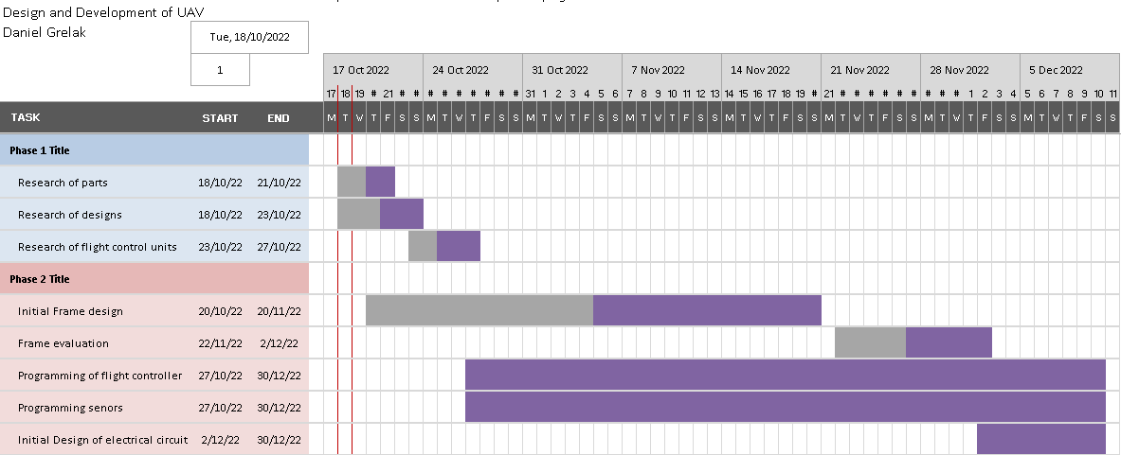

Figure 1. Gantt Chart of tasks till end of 2022.

Timescales does not contain research already done and will be more accurate and updated for Interim Viva in January 2023.

Background Research.

To this date plenty of initial research has been carried out. Areas of research include:
- Types of drones – drones can be split in few categories, depending on number of motors used or shape of the frame. Initial idea of the project is to design x-shaped quadcopter. This type of UAV is broadly used and popular among hobbyists as well as in professional applications.
- Parts required – drone to operate require number of parts, among others: Battery, ESC (electronic speed controller), motors, GPS etc.
- Types of flight controllers – flight controller is a brain of a drone, that controls motors and ESC. There are many types of FC’s and software that is used to control the drone.
- Drone Programming – to allow drone to operate autonomously or to avoid obstacles programming is necessary. Coding language depends on the type of FC and software.
- Thrust and other forces acting on a drone.
- Types of sensors – drone can be equipped with various sensors that enhance its abilities.

Further research will be carried out and initial list of necessary technical papers is as follows:
- Tal, D. and Altschuld, J., 2021. Drone technology in architecture, engineering and construction. John Wiley & Sons Inc.
- Mendoza, J. and Gonzales- Villela, V., 2021. DRONES TO GO. [S.l.]: APRESS.
- BESTAOUI SEBBANE, Y., 2020. SMART AUTONOMOUS AIRCRAFT. [S.l.]: CRC PRESS.
- Cazaurang, F., Kumar, M. and Cohen, K., 2020. Multi-rotor platform-based UAV systems. ISTE PRESS.
- MATTHES, E., 2022. PYTHON CRASH COURSE. [S.l.]: O'REILLY MEDIA.

Facilities Required.

Project require access to computer software for design, evaluation and development of components:
- Solidworks
- Ansys
- Flight Controller Software (Ardupilot, Px4 etc.) – will be decided in the future phase of a project.
- Matlab
- Proteus
- Python

Additionally, project require hand tools for assembly of the parts and 3D printer for development of the frame components.
At this point all necessary facilities are available.

References
- BESTAOUI SEBBANE, Y., 2020. SMART AUTONOMOUS AIRCRAFT. [S.l.]: CRC PRESS.

