Amazon knowledge Information Systems
BMSW5106

Tian Currie 2010067
Knowledge and Information Management Skills for the Workplace

Contents
Amazon Introduction 2
Knowledge Requirements 3
Operational 4
Tactical 5
Strategic 5
Management Information Systems (MIS) 5
Transaction Processing Systems (TPS): 6
Customer Relationship Management System 6
Comparison with Competitors 7
Strengths and Weaknesses of Amazon's TPS and CRM systems 7
TPS 7
CRM 8
Challenges in Deploying Information Systems in Amazon 9
Technical Challenges 9
Organisational Challenges 9
Recommendations 10
Conclusion 11
Reference list 12

Amazon Introduction
Founded in 1994 selling books to buyers online (Hall, 2022), Amazon has subsequently grown its operations and product portfolio to become one of the world's largest ecommerce organisations (Peters, 2021). According to Statista (2022), Amazon's market value exceeds one trillion US dollars, making it one of the most valuable firms in the world, allowing third-party vendors and brands to sell their products and services to potential clients via its online platform, it has become a one-stop shop for many customers, resulting in a huge increase in product availability. Many articles have investigated
Amazon's customer-centric approach and its capacity to generate revenue through value chain management strategies (Chaffey and Ellis-Chadwick, 2022). Amazon's value chain management allows them to give more personalised service by simplifying each step of giving value to customers. As a consequence of the company's investment in everything from raw supplies to exporting final items, modern technologies such as data analytics, artificial intelligence, and machine learning have sped up processes (Lincoln IV, 2018). According to Lincoln (2018), Amazon's use of value chain management methodologies should be recognised for its efficacy in decreasing costs, enhancing quality, and boosting customer happiness, all of which contribute to the company's development and success.
Focusing on innovation and creating new goods and services that cater to the shifting demands and tastes of its consumers is one of Amazon's primary competitive advantages. The company's endeavours into digital media (Amazon Prime Video), home automation (Amazon Echo), and cloud computing (Amazon Web Services) serve as examples of this.

Figure 1: Amazon Key Information
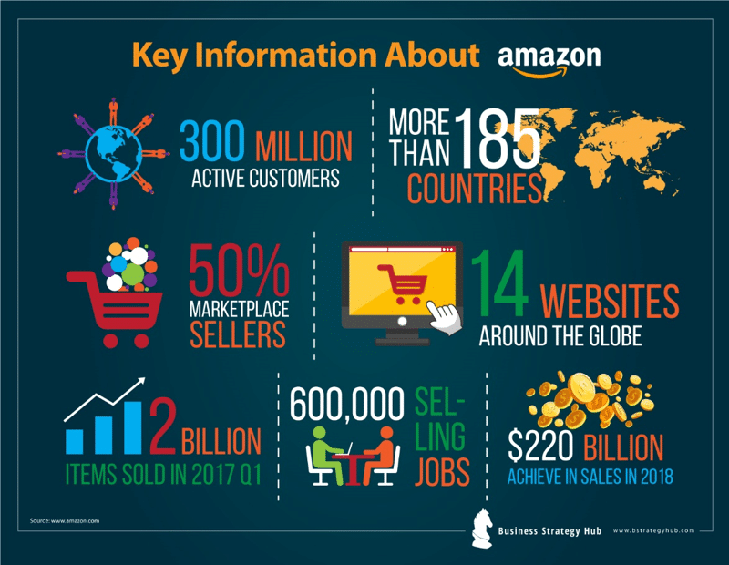
(Gupta, 2020)

Knowledge Requirements
The foundation to Amazon's success is its ability to use both explicit and implicit knowledge in decision-making. Collins (2013) explains that codified explicit knowledge—such as data, procedures, and manuals—can be transmitted and transferred easily. Contrastingly, tacit knowledge is personal and experiential, making it challenging to communicate and convey as highlighted in the figure below. Given the importance of both types of knowledge, Amazon has put in place a number of knowledge management programmes to aid in decision-making at all levels.

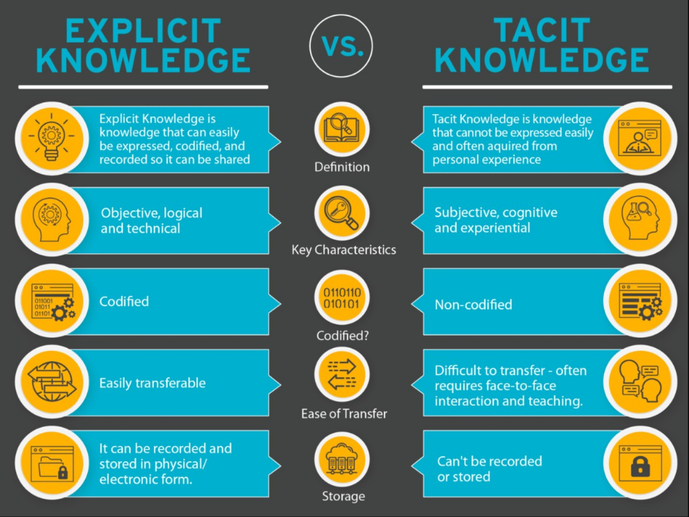
Figure 2: The Difference Between Explicit and Tacit Knowledge
The range of knowledge required by Amazon is extensive, including understanding of consumers, goods, operations, the supply chain, and rival companies. As part of its customer-centric strategy, Amazon mines and analyses a massive customer database to get significant knowledge about its customers, including their preferences, purchase histories, and behaviour (Eisingerich & Kretschmer, 2008). In order to support its extensive product selection, Amazon has a strong product knowledge management system that contains product descriptions, photos, reviews, and ratings that assist customers in making educated purchasing decisions (Eisingerich & Kretschmer, 2008).

Operational
Amazon uses explicit information at the operational level to increase efficiency and cut expenses (ref). For instance, to improve inventory management, order fulfilment, and delivery procedures, the company uses its enormous data archives, which are evaluated using advanced analytics and machine learning algorithms. Amazon is able to quickly meet customer demand in this way, cut waste, and react to market developments. For instance, Amazon forecasts client demand using data analytics, stocks the proper products in the right quantities, and ensures timely delivery (Amazon, 2022). Amazon's employment of robotic technology in its fulfilment facilities is a clear example of the corporation employing explicit information at the operational level. Amazon has refined its robotic picking system by integrating data and analytics to increase productivity and accuracy, resulting in faster and more reliable order fulfilment for customers (Amazon, 2022).

Tactical
When deciding how to allocate resources and put strategies into action at the tactical level, Amazon leverages both explicit and tacit information. An example of this can be seen by the way Amazon makes use of its extensive consumer data to recognise and anticipate trends and client preferences, enabling it to create new goods and services that cater to the demands of its customers (Denning, 2019). The business uses its employees' experience and expertise, as well as tacit knowledge, to develop and carry out new plans and drive innovation (Seidler‐de Alwis and Hartmann, 2008).

Strategic
At the strategic level, Amazon makes important decisions that have an impact on the long-term success of the business using both explicit and tacit knowledge. For instance, to assess possible investment possibilities and market trends, Amazon makes use of explicit knowledge such as financial statistics, market analysis, and industry reports. The business also makes strategic decisions about mergers and acquisitions, new business endeavours, and long-term investments by drawing on the expertise and judgement of its management such as the purchase of Whole Foods (Cusumano, 2017) and was highlighted in their 2020 Annual Report " Our senior management team has significant experience and expertise in relevant areas, and they use this knowledge to guide our strategic decision-making process” (p,13)
Amazon's success can be linked to its capacity to use tacit and explicit knowledge to make decisions at all organisational levels. The company's knowledge management systems and culture of innovation make it easier to acquire, share, and use knowledge to increase operational effectiveness, create new goods and services, and decide strategically on the direction the company will take in the future. The company's knowledge management systems, communication channels, and data-driven approach enable it to make informed decisions quickly and effectively at all levels of the organization.

Management Information Systems (MIS)
As defined by Laudon & Laudon (2018), a management information system (MIS) is a computer-based technology that assists businesses in gathering, organising, and analysing data to aid decision-making processes. Amazon use various MIS to improve operational efficiency, streamline business processes, and improve decision-making capabilities across the organisation (Adebisi, 2016).

Transaction Processing Systems (TPS):
Organisations utilise transaction processing systems (TPS), which are automated systems, to organise and record daily business activity such as orders, payments, and inventory changes (Laudon and Laudon, 2018). TPSs are built to manage massive amounts of data in real time and deliver up-to-date information for decision-making. Regarding Amazon, TPS is used to manage the company's online retail activities. To guarantee that items are delivered accurately and efficiently, for example, the system handles transactions such as customer orders, payments, and delivery details in real-time (Al Imran, 2014)
Customers of Amazon may choose from a wide range of handy and tailored services. One such service is the 1-click buy option, which enables users to place orders for goods with only a single button click, eliminating the need to complete an order form. The required data is automatically provided to the registered client via Amazon's secure server. Moreover, Amazon employs secure server software to guarantee the encryption and security of all credit/debit card transactions (UK About Amazon, 2018).
Amazon also provides its sophisticated recommendation algorithm as a service. This system keeps track of each order placed by the consumer and makes product suggestions based on their prior purchases and search history. To deliver the most pertinent suggestions, this system employs "linking" and "data mining." To make the best possible suggestions and improve the consumer browsing experience, every move or search request made by the customer is monitored (Linden, Smith and York, 2003).
Also, Amazon offers a user-friendly dynamic search engine that enables users to quickly narrow down their search results from millions of alternatives. To assist users in finding what they are looking for quickly and conveniently, this system offers a number of catalogues and searching options. Ultimately, Amazon's individualised services and cutting-edge technologies aid in giving its consumers a flawless and pleasurable purchasing experience (Baldwin, 2020).
As it maintains a significant amount of data and ensures that orders are fulfilled quickly and correctly, Amazon's TPS is a crucial part of the company's business strategy. By implementing TPS, Amazon is able to keep its supply chain productive and provide its customers with high-quality service. The TPS is also used to keep track of inventory levels, helping Amazon manage its stock and make sure it always has the products that its customers want on hand (Fulfilment by Amazon, n.d.). Amazon has become one of the largest internet merchants in the world as a result.
Real-time data availability is one of TPS's main advantages for Amazon. For effective decision-making in a dynamic business environment like e-commerce, real-time data is essential. The TPS helps Amazon to keep track of its operations in real-time, spot any problems, and take rapid remedial action. By making sure that purchases are processed fast and precisely, this has helped Amazon maintain a high level of customer happiness.

Customer Relationship Management System (CRM)
The Customer Relationship Management system at Amazon is used to control client interactions and raise customer satisfaction. The CRM system gathers and examines customer information, like as preferences, shopping habits, and opinions, in order to acquire understanding of their requirements and behaviours (Chua, 2011; Siby and George, 2021). With the use of this data, Amazon can modify its marketing initiatives, product suggestions, and customer support to better suit the requirements and expectations of its clientele.
The CRM system is also used to handle consumer requests, complaints, and queries (Kaur, 2016), enabling Amazon to address any problems as soon as they appear and to the best of its ability. This improves customers' overall perception of the business and fosters customer trust and loyalty (Goldsmith, 2016; Anshari et al., 2019). Moreover, the technology enables Amazon to recognise its most important clients and provide them with customised promotions and rewards to increase their loyalty.
Amazon's (CRM) system is vital for running effective marketing campaigns since it improves customer data analysis, answers their needs, and delivers personalised incentives and ideas based on their previous purchases. The CRM also stores their personal and financial information to make it easier for them to repurchase with a single click. Nonetheless, it is critical to follow data privacy regulations such as the General Data Protection Policy (Binns, 2013)
Amazon's CRM system includes a suggestion feature that generates product recommendations based on previous purchases and viewing patterns of users, increasing revenues, and enhancing the customer experience. Customer service is also aided by technology, which provides quick and effective answers to problems and allows employees to access client information. Because of its customers and CRM usage, its services have evolved over time, including the birth of the Kindle and the rise of Amazon Prime Video. CRM provides organisations with a full awareness of their customers' demands, allowing them to incorporate AI into the system, improve their goods and services, and retain their present clientele (Sunneklep, 2019).
Ultimately, the CRM system is essential to Amazon's business strategy since it enables the corporation to develop close, long-lasting relationships with its clients, increase their contentment, and encourage more sales. The success of the company may be attributed to Amazon's ability to provide a smooth and personalised experience to its customers by utilising customer data and insights.

Comparison with Competitors
- Cutolo, Hargadon and Kenney (2021) discovered that Amazon's real-time data processing capabilities provided it a considerable edge over Walmart's system, which was found to be obsolete and deficient in real-time data accessibility in a research comparing the TPS systems of Amazon and Walmart.
- When comparing the CRM strategies of Amazon and eBay and identified that while both companies used customer data to modify their marketing strategies, Amazon had an advantage over eBay due to its individualised customer service and quick response to customer inquiries (Dunne, 2020) and Amazon's system was particularly effective at identifying customer needs and preferences and providing personalised recommendations and promotions.
- According to a research by the American Customer Satisfaction Index (2020), Amazon outperformed Walmart in terms of customer satisfaction in the e-commerce industry. Based on the survey, Walmart's customer service is one of the company's weak points, with consumer complaints frequently unaddressed or remedied too slowly.

Strengths and Weaknesses of Amazon's TPS and CRM systems
TPS and CRM systems are critical components of Amazon's business model, playing critical roles in the company's decision-making processes across numerous areas such as operations, sales and marketing, finance, and human resource management (HRM). Yet, it is vital to critically examine these systems' strengths and weaknesses, as well as how they help the business make successful decisions on various functions.

TPS
One of Amazon's TPS's primary advantages is its capacity for handling large numbers of transactions, which is crucial for a business of Amazon's size and scope. Real-time transaction management and tracking are handled by the TPS, which also provides quick updates on stock levels, order fulfilment, and shipment. By assuring accurate order fulfilment, eliminating mistakes, and delays, this enables Amazon to streamline its operations and boost customer happiness and loyalty (Fulfilment by Amazon, n.d.). Furthermore, Amazon's TPS offers insightful data insights that support successful decision-making in a variety of capacities, including sales and marketing. For instance, the recommendation engine on Amazon leverages information from TPS to make product recommendations to users based on their browsing and purchase histories. This method of personalised marketing improves consumer satisfaction and raises the possibility of cross-selling and up-selling (Woo and Mishra, 2020; Lynn Segarra et al., 2016).
The susceptibility of Amazon's TPS to system failures or cyberattacks, however, is a significant flaw. The TPS is heavily reliant on technology, and any malfunction might have a negative impact on the business's operations and image. Amazon therefore makes significant investments in cybersecurity measures to shield its TPS from outside attacks and maintain business stability (AWS, 2019). The fact that Amazon's TPS depends so much on technology is another weakness that should be considered. System failures or downtime might arise, which delays transaction processing and lowers customer satisfaction. Also, because to the growing transaction volume, the TPS may be unable to handle the strain, which would result in more delays and a possible loss of business to rivals. Amazon must therefore spend money on backup systems and consistently test the TPS to make sure it can sustain peak transaction volumes (Chen and Popovich, 2003).

CRM
Moving on to CRM, Amazon's capacity to gather and analyse customer data in order to present individualised suggestions and promotions is one of its significant assets in this field. It is much simpler for the corporation to adjust its marketing efforts to certain client categories because to Amazon's CRM system, which is quite adept at recognising customer requirements and preferences. Amazon can foster closer ties with its consumers and boost their loyalty and repeat business by providing this personalised experience (Bilgihan, Kandampully and Zhang, 2016). The scalability and adaptability of Amazon's CRM system also enable the corporation to respond to shifting consumer demands and industry trends. Due to its agility, Amazon is able to stay one step ahead of its rivals and keep holding the top spot in the market (Barger, Peltier and Schultz, 2016; Chen & Popovich, 2003).
Yet, Amazon's CRM system has a big vulnerability in that it can jeopardise client privacy. Many pieces of information on each customer are gathered by Amazon, including their browsing and purchase history, location information, and even voice commands given to devices like Alexa. Amazon must take action to guarantee that consumer data is kept and utilised properly because this data collecting may potentially lead to privacy and data security problems (O'Neil, 2016).
The possibility of privacy violations or data breaches, which may result in a loss of consumers' confidence and legal repercussions, is another flaw in Amazon's CRM system. Although Amazon has put in place safeguards like encryption and access limits to preserve the security and privacy of consumer data, there is still a chance of a breach that might harm the company's image. To reduce this risk, ongoing monitoring and security enhancements to the CRM system are required.

Challenges in Deploying Information Systems in Amazon
While these systems provide many benefits, their implementation can present significant challenges, Technically and organisationally. Recommendations for enhancing knowledge development within the business should be taken into consideration in order to overcome the difficulties connected with deploying TPS and CRM systems at Amazon and improve knowledge development within the company.

Technical Challenges
As Patel (2022) highlighted, system compatibility is a big technological hurdle that comes with installing TPS and CRM systems at Amazon. Integration with Amazon's current systems, such as the order fulfilment and inventory management systems, is required. Incompatibility can result in system failure, duplicate data, and a delay in order processing. Moreover, because Amazon has operations in several nations, TPS and CRM systems need to be able to accommodate diverse payment options, tax regimes, and currencies.
The TPS and CRM systems' scalability presents another technological difficulty. These systems must be able to handle growing transaction volumes, user traffic, and customer data as Amazon's company expands. Problems with scalability can lead to data loss, performance lag, and system breakdowns (Lee et al., 2020). Integrating old systems is a further challenge in adopting TPS and CRM solutions. Due to fast growth through acquisitions, the firm now has a complex IT architecture with a number of systems running on several platforms. The process of integrating these systems with modern TPS and CRM systems may be challenging and time-consuming, requiring a lot of resources and knowledge. For instance, after the acquisition of Whole Foods, the company encountered difficulties integrating its pre-existing systems with Amazon's systems, causing interruptions and inventory management concerns (Gelfand et al., 2018).

Organisational Challenges
When TPS and CRM systems are implemented in Amazon, organisational challenges are commonly encountered. Employee training is one of these difficulties. A sizable portion of Amazon's workers must learn how to utilise the new technologies efficiently. Insufficient training can lead to user mistakes, system outages, and decreased productivity (Hsin Chang, 2007).
Resistance to change is another organisational challenge. Existing workers at Amazon may object to the adoption of TPS and CRM systems because they see a danger to their job stability or concern that the new systems would interfere with their regular working procedures. Change resistance can cause system rollout delays, low staff morale, and poor productivity (Ahearne et al., 2012).
The requirement for efficient communication and collaboration across many departments presents an additional organisational hurdle. IT, marketing, sales, and other departments must work together cross-functionally for these solutions to be implemented successfully. Lack of coordination and communication across these divisions may result in inconsistent data, malfunctioning systems, and lower production (Laudon & Laudon, 2018).

Recommendations
The organisation should do a comprehensive examination of its existing systems to identify potential compatibility concerns in order to overcome the technological obstacles of installing TPS and CRM systems in Amazon. The solutions Amazon chooses should also be adaptable, scalable, and able to handle high transaction volumes. To make data exchange and communication between legacy and new systems simpler, one way is to utilise software to fill the gap between them. To make the integration process simpler, another choice is to progressively phase out the old systems and replace them with more up-to-date, standardised systems (Momoh, Roy and Shehab, 2010).
Addressing organisational issues, Amazon should offer thorough training courses to staff members to make sure they are aware with the features and capabilities of the new technologies. To lessen employee resistance to change, the business should also explain to staff members the advantages of the new processes. Employee rewards for adopting new methods can help promote acceptance and lessen opposition as suggested by Anderson, Jolly and Fairhurst (2007). Also, Chatterjee et al., (2020) highlighted that management might give rewards to employees to stimulate their involvement and cooperation in the implementation of new systems. Amazon could create cross-functional teams and give defined roles and responsibilities to each member of the team to encourage successful communication and collaboration. This can guarantee that all departments are working towards the same overarching aims and objectives as the business.
Both technical and organisational difficulties are important when adopting TPS and CRM systems in Amazon. Nevertheless, Amazon may overcome these difficulties and enhance knowledge growth inside the organisation by selecting scalable, adaptable, and compatible technology and offering extensive staff training and communication. If Amazon is successful in putting these processes in place, it will be able to better service its consumers and compete in the e-commerce industry, which is constantly expanding.

Conclusion
A big part of Amazon's success may be attributed to its successful knowledge management techniques. Amazon has shown a strong commitment to exploiting knowledge as a fundamental driver of its business operations, as seen by its data-driven decision-making procedures. Amazon has been able to consistently innovate and outperform its rivals in the quickly changing retail sector by placing a high priority on the collecting, organising, and transmission of information. But, as the business grows and diversifies its operations, it will be crucial for Amazon to be flexible and modify its knowledge management policies to suit the demands of emerging markets and sectors. Ultimately, the way that Amazon handles knowledge management is a useful model for companies trying to thrive in the data-driven economy of today.
Amazon makes choices at all levels of the business using both explicit and tacit information, helped by various approaches to knowledge management. They leverage explicit information to increase efficiency at the operational level, while at the tactical level, they use both explicit and tacit knowledge to allocate resources and predict trends. At the strategic level, they combine both sorts of knowledge to make critical decisions that will lead to long-term success. Amazon's innovative culture and knowledge management tools make it simpler to acquire, share, and apply data.
Amazon's usage of MIS, particularly TPS and CRM systems, has been key to the company's e-commerce success. These solutions have enabled Amazon to efficiently manage its supply chain, optimise its operations, and give its consumers with a seamless and personalised experience. To ensure their sustained success and consumer trust, it is critical to address the limitations of these systems, such as vulnerability to system failures, data breaches, privacy concerns, and ethical challenges.

Reference list
Adebisi, A.S. (2016). The Role of Management Information System and Factors Influencing Strategic Decision making Processes in an Organization. TEXILA INTERNATIONAL JOURNAL OF MANAGEMENT, 2(2), pp.25–32. doi:https://doi.org/10.21522/tijmg.2015.02.02.art003.
Ahearne, M., Rapp, A., Mariadoss, B.J. and Ganesan, S. (2012). Challenges of CRM Implementation in Business-to-Business Markets: A Contingency Perspective. Journal of Personal Selling & Sales Management, 32(1), pp.117–129. doi:https://doi.org/10.2753/pss0885-3134320110.
Al Imran (2014) Al Imran, M.A., 2014 A study on amazon: information systems, business strategies and E-CRM.
Amazon (2019). Amazon Logistics. [online] Amazon.com. Available at: https://logistics.amazon.com/.
Amazon (2020). 2 0 2 0. [online] Available at: https://s2.q4cdn.com/299287126/files/doc_financials/2021/ar/Amazon-2020-Annual-Report.pdf.
American Customer Satisfaction Index (2020). Press Release Retail and Consumer Shipping 2019-2020. [online] The American Customer Satisfaction Index. Available at: https://www.theacsi.org/news-and-resources/press-releases/2020/02/25/press-release-retail-and-consumer-shipping-2019-2020/ [Accessed 5 Apr. 2023].
Anderson, J.L., Jolly, L.D. and Fairhurst, A.E. (2007). Customer relationship management in retailing: A content analysis of retail trade journals. Journal of Retailing and Consumer Services, 14(6), pp.394–399. doi:https://doi.org/10.1016/j.jretconser.2007.02.009.
Anshari, M., Almunawar, M.N., Lim, S.A. and Al-Mudimigh, A. (2019). Customer relationship management and big data enabled: Personalization & customization of services. Applied Computing and Informatics, [online] 15(2), pp.94–101. doi:https://doi.org/10.1016/j.aci.2018.05.004.
AWS (2019). Cloud Security – Amazon Web Services (AWS). [online] Amazon Web Services, Inc. Available at: https://aws.amazon.com/security/.
Baldwin, G. (2020). How Does Amazon’s Search Algorithm Work? [online] www.omniaretail.com. Available at: https://www.omniaretail.com/blog/how-does-amazons-search-algorithm-work.
Barger, V., Peltier, J.W. and Schultz, D.E. (2016). Social media and consumer engagement: a review and research agenda. Journal of Research in Interactive Marketing, [online] 10(4), pp.268–287. doi:https://doi.org/10.1108/jrim-06-2016-0065.
Bilgihan, A., Kandampully, J. and Zhang, T. (Christina) (2016). Towards a unified customer experience in online shopping environments. International Journal of Quality and Service Sciences, [online] 8(1), pp.102–119. doi:https://doi.org/10.1108/ijqss-07-2015-0054.
Binns, R. (2013). How Do They Do It? Amazon’s CRM Success Story. [online] Expert Market. Available at: https://www.expertmarket.com/uk/crm-systems/amazon-crm-case-study.
Chaffey, D. and Ellis-Chadwick, F. (2022). Digital Marketing: Strategy, Implementation and Practice. 8th ed. Harlow, England: Pearson.
Chatterjee, S., Tamilmani, K., Rana, N.P. and Dwivedi, Y.K. (2020). Employees’ Acceptance of AI Integrated CRM System: Development of a Conceptual Model. Re-imagining Diffusion and Adoption of Information Technology and Systems: A Continuing Conversation, 618, pp.679–687. doi:https://doi.org/10.1007/978-3-030-64861-9_59.
Chen, I.J. and Popovich, K. (2003). Understanding Customer Relationship Management (CRM). Business Process Management Journal, [online] 9(5), pp.672–688. doi:https://doi.org/10.1108/14637150310496758.
Chua, A.Y.K. (2011). How Web 2.0 supports customer relationship management in Amazon. International Journal of Electronic Customer Relationship Management, 5(3/4), p.288. doi:https://doi.org/10.1504/ijecrm.2011.044693.
Collins, H.M. (2013). Tacit and explicit knowledge. Chicago, Ill.: University Of Chicago Press.
Cusumano, M.A. (2017). Amazon and whole foods. Communications of the ACM, 60(10), pp.24–26. doi:https://doi.org/10.1145/3132722.
Cutolo, D., Hargadon, A. and Kenney, M. (2021). Competing on platforms. [online] Available at: https://brie.berkeley.edu/sites/default/files/mitsmr-cutolo_hargadon_kenney_2021.pdf.
Denning, S. (2019). How Amazon uses metrics to drive success. Strategy & Leadership, 47(6), pp.9–14. doi:https://doi.org/10.1108/sl-08-2019-0121.
Dunne, C. (2020). eBay vs Amazon - The Complete Comparison Guide (2020). [online] RepricerExpress. Available at: https://www.repricerexpress.com/ebay-vs-amazon/.
Fulfilment by Amazon (n.d.). Fulfillment by Amazon (FBA) | How It Works - Amazon. [online] sell.amazon.com. Available at: https://sell.amazon.com/fulfillment-by-amazon?ref_=asus_soa_rd&.
Garg, V.K. and Venkitakrishnan, N.K. (2008). Enterprise resource planning : concepts and practice. New Delhi: Prentice-Hall Of India.
Gelfand, M., Gordon, S., Li, C., Choi, V. and Prokopowicz, P. (2018). One Reason Mergers Fail: The Two Cultures Aren’t Compatible. [online] Harvard Business Review. Available at: https://hbr.org/2018/10/one-reason-mergers-fail-the-two-cultures-arent-compatible.
Goldsmith, R.E. (2016). The Goals of Customer Relationship Management. International Journal of Customer Relationship Marketing and Management, 1(1), pp.16–27. doi:https://doi.org/10.4018/jcrmm.2010090402.
Gupta, S.K. (2020). Amazon SWOT 2019 | SWOT analysis of Amazon | Business Strategy Hub. [online] Business Strategy Hub. Available at: https://bstrategyhub.com/swot-analysis-of-amazon-amazon-swot/.
Hall, M. (2022). Amazon.com. In: Encyclopedia Britannica. [online] Available at: https://www.britannica.com/topic/Amazoncom.
Hsin Chang, H. (2007). Critical Factors and Benefits in the Implementation of Customer Relationship Management. Total Quality Management & Business Excellence, 18(5), pp.483–508. doi:https://doi.org/10.1080/14783360701239941.
Kaur, J. (2016). Customer Relationship Management: A Study of CRM Policies of Different Companies. Global Journal of Finance and Management, [online] 8(2), pp.153–159. Available at: https://www.ripublication.com/gjfm16/gjfmv8n2_05.pdf.
Kiadehi, E. and Mohammadi, S. (2012). Cloud ERP: Implementation of Enterprise Resource Planning Using Cloud Computing Technology. J. Basic. Appl. Sci. Res, [online] 2(11), pp.11422–11427. Available at: https://wp.kntu.ac.ir/mohammadi/32.pdf.
Laudon, K.C. and Laudon, J.P. (2018). Management information systems: managing the digital firm. 15th ed. New York, New York: Pearson.
Lee, J., Singh, J., Azamfar, M. and Pandhare, V. (2020). Chapter 8 - Industrial AI and predictive analytics for smart manufacturing systems. [online] ScienceDirect. Available at: https://www.sciencedirect.com/science/article/pii/B9780128200278000083.
Lincoln IV, C.E.A. (2018). Porter Analysis: A Business Strategy of Amazon.com Through a Value Chain and Comparative Advantage Analysis of Amazon’s Trademarks and Intangibles. [online] Ssrn.com. Available at: https://papers.ssrn.com/sol3/papers.cfm?abstract_id=3291668.
Linden, G., Smith, B. and York, J. (2003). Amazon Recommendations. [online] Available at: https://www.cs.umd.edu/~samir/498/Amazon-Recommendations.pdf.
Lynn Segarra, L., Almalki, H., Elabd, J., Gonzalez, J., Marczewski, M., Alrasheed, M. and Rabelo, L. (2016). A Framework for Boosting Revenue Incorporating Big Data. Journal of Innovation Management, [online] 4(1), pp.39–68. doi:https://doi.org/10.24840/2183-0606_004.001_0005.
Momoh, A., Roy, R. and Shehab, E. (2010). Challenges in enterprise resource planning implementation: state‐of‐the‐art. Business Process Management Journal, 16(4), pp.537–565. doi:https://doi.org/10.1108/14637151011065919.
Nicolas-Sans, R. and Bustos Díaz, J. (2022). Amazon, AliExpress and eBay. ESIC Digital Economy and Innovation Journal, 1(2), p.e049. doi:https://doi.org/10.55234/edeij-1-2-049.
O’neil, C. (2016). Weapons of math destruction: How big data increases inequality and threatens democracy. London: Penguin Books.
Patel, M. (2022). Effective Tips For Tackling Major Challenges Associated With CRM In 2023. [online] www.linkedin.com. Available at: https://www.linkedin.com/pulse/effective-tips-tackling-major-challenges-associated-crm-patel- [Accessed 5 Apr. 2023].
Peters, L. (2021). Global top online store sales 2018. [online] Statista. Available at: https://www.statista.com/forecasts/860716/top-online-stores-global-ecommercedb.
Seidler‐de Alwis, R. and Hartmann, E. (2008). The use of tacit knowledge within innovative companies: knowledge management in innovative enterprises. Journal of Knowledge Management, 12(1), pp.133–147. doi:https://doi.org/10.1108/13673270810852449.
Siby, A. and George, J.P. (2021). Influence of Customer Relationship Management for the Success of E-Business. Information and Communication Technology for Competitive Strategies (ICTCS 2020), pp.473–481. doi:https://doi.org/10.1007/978-981-16-0739-4_45.
Statista (2022). The 100 largest companies in the world by market capitalization in 2021. [online] Statista. Available at: https://www.statista.com/statistics/263264/top-companies-in-the-world-by-market-capitalization/.
Sunneklep, C. (2019). How a CRM is The Secret Behind Amazon’s Success. [online] Medium. Available at: https://medium.com/@christinasunneklep/how-a-crm-is-the-secret-behind-amazons-success-bd228e70b389 [Accessed 6 Apr. 2023].
UK About Amazon. (2018). 1-Click. [online] Available at: https://www.aboutamazon.co.uk/news/innovation/1-click.
Woo, J. and Mishra, M. (2020). Predicting the ratings of Amazon products using Big Data. WIREs Data Mining and Knowledge Discovery. doi:https://doi.org/10.1002/widm.1400.

