Programme: MBA Sustainability Leadership

Module: BMSP7004D - Leading Sustainability Change

Assessment 2

Student Name: David Lavin
Student Number: 2218070

Introduction
Change is constant and affects every market, industry, and organisation.
When introducing change across an organisation, typically the company will alter one or more of its major operational or structural components, such as culture, the underlying technologies or infrastructure it uses to operate, or its internal processes. By extension, organisational change management is the process of guiding organisational change to a successful resolution, and it typically includes three major phases: preparation, implementation, and follow-through (Stobierski, 2020).
Change is transformative but can instil fear in those impacted, such as employees. “Change is external, and transition is internal”. (Bridge, 2012) As such, when implementing the organisational change, it is important to ensure that there is also a transition; a psychological process that allows people to come to terms with the new situation.
One way of defining a change initiative is as a “systematic approach that deals with the transition or transformation of organizational goals, core values and culture, and processes or technologies.” (360training, 2022)
In the context of the following discussion, I will pick up on the proposed change initiative (relating to organisational culture) outlined in Assessment 1, undertake research on the key requirements/components of a robust change initiative, design a change initiative plan, and define the goals I plan to integrate within the plan. I will also attempt to detail the components of the plan (including the overarching change strategy) and the key components I considered for my selected organisation that will help ensure a robust and effective implementation for the specified ‘change’.

Organisational Change – What is the starting baseline?
Within an organisation, the goal of every change initiative is to successfully execute strategies and methods that bring about change, as well as assisting people in accepting and adapting to it.
Change initiatives may be implemented to, for example:
- Solve a problem.
- Better align the organization with changing conditions
- Respond to new business demands.
- Improve methods of working
- Take advantage of an opportunity
However, to effectively implement this change, there must be an understanding of what the organisation is trying to change, this may be – its structure and purpose, its people, or its culture. Any change initiatives should also be framed within a wider context of internal and external stakeholders. Finally, there needs to be a mandate for change.
The culture of an organisation is its personality and character. ‘Organisational culture is made up of shared values, beliefs, and assumptions about how people should behave and interact, how decisions should be made and how work activities should be carried out.’ (Chartered Management Institute , 2015)
Our organisation, the Royal Commission for Jubail and Yanbu (RCJY) is an autonomous organization of the Saudi Arabian Government. The commission is governed by a board of directors and its chairman reports to the Council of Ministers. The mission of the RCJY is to: "Plan, promote, develop and manage Petrochemicals and Energy intensive industrial cities through successful customer focus and partnerships with investors, employees, communities and other stakeholders." (Wikipedia, 2024)
Although RCJY was established in 1975, Jizan (the location where I work) has only relatively recently been added as a Royal Commission entity in its own right. From my observations we appear to have an approach and culture of sustainability that is immature, underdeveloped, and does not optimise the potential benefits and value that could be realised with a more integrated and coordinated sustainability policy and plan. This is reflected at leadership level, as well as our procedures, the awareness and understanding of our employees, and across the supply chain. Consequently, I would like to focus this change initiative on driving meaningful change in the culture of the organisation towards sustainability.
In terms of the external context, the system, these observations are consistent with a high-level PESTLE analysis of the organisation. The current priority of the Royal Commission is to attract investors into the city. Many of these investors are from overseas and are seeking to do business sustainability. Consequently, this means that the Riyal Commission need to adapt and update their strategy to focus more on sustainability – this also aligns with Saudi Arabia’s Vision 2030 (for which sustainability is one of the main pillars) and the Kingdom’s pledge to reach net-zero emissions by 2060.

How does the organisation change?
The way organisations respond to change varies – some organisations are agile, flexible, and are willing to actively embrace change, others are more cautious and considered in terms of accepting and planning for the implementation of change.
Every organisation’s business case for sustainability will be different, and organisations that commit to sustainability ‘can face complex, enterprise-wide, and transformational change with broad impacts on their customers, people, and other stakeholders’. (McNeive, 2024)
But in response to investor and regulatory pressures, and a growing consciousness about climate change, sustainability is gaining momentum. Increased sustainability brings benefits, including:
- Enhanced financial performance – in terms of cost reductions, revenue growth, and innovation.
- Greater employee retention and engagement.
- Improved operational efficiencies – cumulative efficiencies from streamlining at the organizational level.
- Stronger risk management, resilience, and competitiveness
- Better alignment with global goals and initiatives – e.g., greater obligations in terms of sustainability reporting (McNeive, 2024)
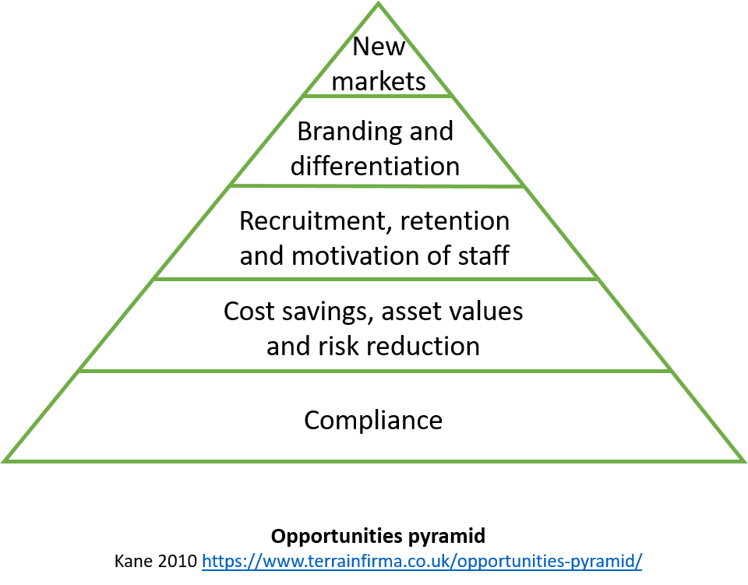
Kane sees compliance as an underpinning foundation. (Walker, 2018)
In preparing for organisational change, the organisational change must first be defined to aid understanding about why it’s critical, and garner support for the change from the workforce. Once these essentials are in place, a roadmap can be created which clearly articulates and measures success and explains how the business—and relevant stakeholders—will be affected.
To optimise the potential success of an organisational culture change, consideration must be given to:
- Inviting and engaging the whole organization to be part of the cultural change process.
- Creating a safe and trusting environment for people to share their thoughts and opinions.
- Ensuring everyone feels heard.
- Helping people find their own ‘whys’ for the change.
- Visualising your common dream about the future together.
- Making it clear how people can be involved throughout the change journey. (Memon, 2022)
Leaders are key to changing a company's organisational culture – they should ‘walk the walk…’ and be able to impact, not impose, change within the organisation. Similarly, frequent communication — both upward and downward — is a necessity during the change process. By conspicuously conveying the vision of the desired future, through repetitive messaging will help to ensure that change permeates and establishes itself throughout the organisation. ‘Leaders clearly and visibly dedicated to change have been found to be one of the singular success factors of culture change.’ (Wharton@Work, 2014)

How does change happen?
Organisational change seeks to achieve organisational objectives and is driven by many different forces including customers, markets (e.g. competitive pressures), legislation, and technology.
‘People are at the centre of many changes in the workplace’. (Tracey, 2024) In parallel with ensuring business continuity, the commitment of the organisation’s people must be maintained throughout any change.
Unless implemented properly, many change initiatives fail to achieve their intended outcomes with potentially significant impacts. Change initiatives fail for many reasons, including:
- ‘Lacking an understanding of the type and complexity of the change.
- Not addressing individual impacts and emotions associated with the change, leading to resistance.
- Failure to create a culture of change.
- Lack of visible commitment to change, particularly by senior leaders.
- Poor communication of the reasons for the change.
- Individual and group resistance to change’ (Tracey, 2024)
People are threatened by change and, as individuals or part of a group, may try to block, disrupt, or otherwise derail an attempt to introduce change - resistance to change. Often this resistance to change is unrelated to the change itself and is based on a fear of personal losses. Therefore, it is vital to diagnose the cause of any employee resistance, such that the focus of the effort required to address the issues presented can de determined.
‘Change is complex and there isn’t a single solution to managing it’. (Tracey, 2024) According to the ‘Ten guiding principles of change management’ report by pwc (strategy& (formerly Booz and Company), 2004), the following are key guiding principles for transformational change:
- Address the human side of change systematically:
- Change starts at the top and begins on day one:
- Real change happens at the bottom:
- Confront reality, demonstrate faith, and craft a vision:
- Create ownership, not just buy-in:
- Practice targeted over-communication:
- Explicitly address culture and attack the cultural centre:
- Assess the cultural landscape early:
- Prepare for the unexpected:
- Speak to the individual as well as to the institution:
However, depending on the pace of change sometimes a faster response is needed. This together with issues around communication and resistance to change make choosing the most appropriate change strategy a fundamental tenet of a successful organisational transformation. In implementing a change in the organisational culture around sustainability to the organisation which I work for, I think I would consider applying a hybrid of the resistance to change model combined with the Satir Change Model as this is a relatively young and immature entity.
The Satir Change Model provides a framework for fostering collaboration, resilience, and innovation throughout the change process. It emphasises the human element of change, ‘recognising that change is not simply a matter of implementing new processes or systems but of engaging with people on a deep emotional level’. (Abbas, 2023) As we don't really have a sustainability plan, this model should help with engaging and informing employees about the change and getting them invested and motivated to implement the change.
Whereas the Resistance to Change Model will help with understanding and effectively managing any resistance. In our organisation, this resistance is likely to come from non-national team members who are intentionally less motivated and productive. Any change to their circumstances would be seen as a threat and this will need to be managed to ensure that the process is not derailed. This model seeks to build trust by being honest, keeping commitments and investing in relationships with tailored communications as another cornerstone.
The key with this model is to understand the true nature of resistance. Rather than the technical change, ‘employees usually resist the social change, i.e., the change in their human relationships that generally accompanies technical change.’ (Lawrence, 1969) This can derive from the attitudes or employees and their misconceptions of the change.
Management can deal constructively with these staff attitudes by encouraging staff to think in different ways and emphasizing new standards of performance.
‘For transformation to succeed, the change needs to align strategic and cultural aspirations.’ (Tracey, 2024) To create a supportive and goal-consistent culture, the organisations’ strategic goals are the starting point for change. Challenges will be encountered, and the plan needs to be flexible enough to adjust to, and address these as they arise.
Once the change is implemented, by for example reinforcing relevant beliefs and behaviours, outcomes should be continuously assessed, performance against goals tracked, and goals readjusted as necessary (Plan, Do, Check, Act).
Successes should be celebrated, and open discussion and debate encouraged through this process to enable more proactive, opportunistic change to happen (within the context of the change and its goals) that allows movement away from the old business model.

The changes you want to make.
Organisational change can help an organisation to remain competitive. ‘A change management strategy is a detailed plan or approach to facilitate the effective implementation of organizational changes.’ (Creasey, 2024)
Change strategies offer a mechanism to minimise the negative effects that may arise from the change, while allowing an organisation to capitalise on the transformation. An effective change strategy can allow an organisation to potentially better pre-empt how change(s) can affect them. Ideally, the change should be planned from the onset of an initiative and managed proactively.
There are three main types of change management strategies:
- Developmental -- incremental change management strategy with a focus on improving an existing process, product, or service, through making minor adjustments to improve efficiency or effectiveness.
- Transitional -- focused on moving from one state to another, involving a shift in processes, structures, or systems; and
- transformational change – often disruptive and fundamentally changes the organization or business and its way of operating with potential for long-term benefits.
Each strategy can be used to achieve different goals while serving different purposes. Ultimately, having a change management strategy benefits the organisation, and helps make the transition change brings smoother while ensuring the organisations reaches the desired outcomes.
A well-defined change management strategy can be used to achieve the organisation’s identified goals by:
- Manage resistance to drive adoption - can help with identifying the root cause of resistance behaviours in people and other stakeholders. Once these various root causes are identified, targeted solutions can be implemented, including:
  - Q&A sessions – To build understanding and trust, openly share the reasons for and benefits of change.
  - Stakeholder engagement – To instil a sense of ownership enlist those impacted by the change to create the solution.
  - Feedback loops – Ongoing feedback enables adjustments to be made based on real-time inputs thereby making the process more inclusive.
- Communicate proactively to gain commitment and support – effective communications are required to build awareness and trust, and bolster the change management strategy and implementation. Strong stakeholder engagement is an important component of effective change management.
  - Proactive communication – keeping everyone informed and involved with regular communication across all stakeholders,
  - Transparent discussions – Openly sharing how people will be supported during the process.
  - Targeted messages – the strategy should define the “who” and “what” of communication.
- Minimise disruption during change – The daily operations of an organisation can be disrupted by change.
  - Step-by-step planning – lays out the activities and tactics required to enable people to adopt to change.
  - Phased implementation – allows people to adjust at appropriate moments and keep the plan on track.
  - Well-timed communications –will reduce confusion, anxiety and resistance behaviours that may be barriers to progress.
- Equip impacted people and teams with critical skills - Change breeds doubt, preparing and equipping people for their individual roles during change gives them the knowledge and ability they need to support and implement the change.
  - Functional know-how – Provide training and development opportunities so impacted people are ready to use the solution in their work.
  - Supervisor skills – People managers help to manage resistance within teams and communicate and liaise with leadership.
  - Sponsor guidance –An effective change management strategy shows executives the way to perform their roles during change.
- Maximize return on investment (ROI) - Change can be costly, requiring time, money, and resources. By maximizing ROI through increased adoption, reduced resistance and improved efficiency, change becomes a catalyst for growth and organization gains a competitive advantage.
  - Increased adoption – Effective communications and skill-building enable greater employee engagement with, and commitment to, the change.
  - Reduced resistance – Proactive strategies help with avoiding and mitigating barriers to change.
  - Improved efficiency – ‘Effective frameworks and processes drive a streamlined path to proficiency, speed of adoption and ultimate utilization’. (Creasey, 2024)
In terms of the organisation that I work for, to support the change initiative and validate the change management strategy, the Three Horizons model could be applied as a framework to enable our management to think about the current situation, the desired (or anticipated) future and the transition between the two, identifying those aspects of the current situation which will and won’t fit with the emerging future. Two cornerstones of this emerging future would be the realisation of our smart city concept inhabited by a community that live and work in a sustainability orientated ecosystem.
In addition, the organisation should align their initiative with the United Nations. Sustainable Development Goals (UN SDGS), as a way of envisaging the desired future, understanding current impacts, and analysing where the organisation is succeeding or has opportunities to do so.
Engaging People.
Whilst focusing on the specific target of change, those who are involved should be identified. ‘These are the key players and stakeholders – the individuals, groups of people or organisations who have a stake in the thing you want to change, or in how it will be if it is changed. Having a stake means either that they can influence whether the change happens or not, or that they will be impacted on by the change.’ (Walker, 2018)
As a solid foundation for change, it is essential to build relationships with stakeholders. For these communications to be effective there’s no substitute for face-to-face meetings. Having that tangible and immediate connection with people will enable you to determine what’s important to them.
It is crucial to involve people earlier rather than later, based on a Engage – Deliberate – Decide approach which better takes account of people’s needs, concerns and aspirations.
When people are resisting change, they are sensitive and vigilant against contradictory messages, flaws, and a lack of alignment between what people say and what people do. Consequently, it is important to involve people ‘in coming up with the detail and giving them a real opportunity to interrogate the core concept, is a particularly important way of avoiding unnecessary emotional barriers.’ (Walker, 2018)
In communicating any message on change, the various methods, and platforms available (e.g., social media, etc.), should be used and tailored to the preferences of stakeholders.
Communication is one aspect of change; another is people’s behaviours. ‘Behaviour change is hugely influenced by routine, habits and social norms.’ (Walker, 2018)
These sources of influence include:
- Making the undesirable desirable.
- Surpassing your limits.
- Harnessing peer pressure.
- Finding strength in numbers
- Designing rewards and demand accountability.
- Changing the environment.
In this respect the use of ‘nudges’ can be beneficial.
Planned Change.
With a mandate for change, and the right kind of management support, organisations can plan and implement their change programme. In our organisations, we will need to build this mandate by approaching senior management, understanding more about their priorities and pressures, and convincing them sustainability can create value and deliver opportunities.
Scoping the mandate for our change initiative should include involvement of employees from within the organisation, together with one or two key stakeholders, to gain a shared initial understanding of:
- the status quo, and the associated opportunities or threats.
- the ‘desired future’, in broad terms the kind of change this implies:
- the relationship between this and the prevailing culture:
- ideas about how to get from now to the desired future.
Similarly, when putting together a business case as part of the initiative, short-term and long-term predictions about the context and drivers, and the impact this difference in time scales has on the case need to be considered.
To determine success, the initiative is assessed against the central tenets the organisation aspired to achieve with the programme. This entails collecting evidence about:
- the difference that has been made, from an external facing perspective.
- the difference that has been made, from an internally focussed lens: and
- how are the organisation’s change performing (e.g. what has worked, what hasn’t worked, etc.).
Once the initial promotion of the change initiative has been heralded and the change allow to permeate through the organisation and gain a foothold, it is important to nurture and embed this into the organisational culture. ‘Embedding is partly about getting the changes intimately bound up with the written policies, procedures, targets, and strategies – the ‘artefacts’ of the organisation.’ (Walker, 2018) Embedment will be reflected as ‘the way we do things round here’ once it becomes cemented within the culture of the organisation.
Finally, ‘Monitoring is a part of embedding, as well as being critical to understand what impact the change has had in the world.’ (Walker, 2018) Monitoring should include information that allows management to make rapid adjustments if things are not having the intended impact.

Appendix A

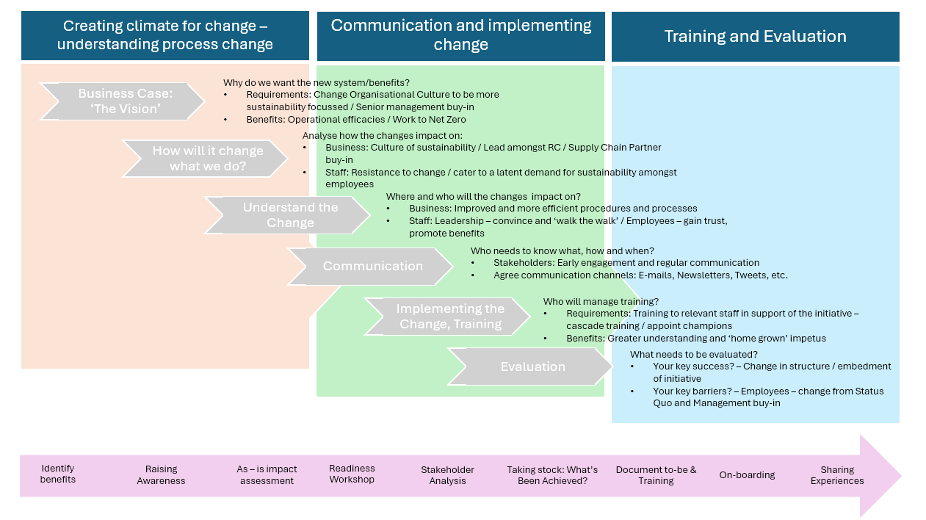

References
360training. (2022, December 19). CHANGE INITIATIVE: KEYS TO SUCCESSFUL CHANGE IN YOUR ORGANIZATION. Retrieved from https://www.360training.com/: https://www.360training.com/blog/change-initiative#:~:text=The%20change%20initiative%20definition%20includes,Improve%20methods%20of%20working
Abbas, T. (2023, April 29). Satir Change Management Model Explained with Examples. Retrieved from https://changemanagementinsight.com/: https://changemanagementinsight.com/satir-change-management-model/
Bridge, W. (2012). Organisation Change: Theory and practice. Thousand Oaks, CA: Sage Publications.
Chartered Management Institute . (2015, November ). Checklist 232 - UNDERSTANDING ORGANISATIONAL CULTURE. Retrieved from http://www.managers.org.uk/
Creasey, T. (2024, May 10). What Are Change Management Strategies? Retrieved from https://www.prosci.com/: https://www.prosci.com/blog/change-management-strategy
Lawrence, P. R. (1969, January). https://hbr.org/. Retrieved from How to Deal with Resistance to Change: https://hbr.org/1969/01/how-to-deal-with-resistance-to-change
McNeive, A. (2024, January 17). Change Management for Sustainability. Retrieved from https://www.prosci.com/: https://www.prosci.com/blog/change-management-for-sustainability
Memon, M. (2022, August 23). https://howspace.com/. Retrieved from Changing organizational culture: The complete guide: https://howspace.com/blog/changing-organizational-culture-complete-guide/
Stobierski, T. (2020, January 21). https://online.hbs.edu/. Retrieved from ORGANIZATIONAL CHANGE MANAGEMENT: WHAT IT IS & WHY IT’S IMPORTANT: https://online.hbs.edu/blog/post/organizational-change-management#:~:text=Organizational%20change%20refers%20to%20the,operate%2C%20or%20its%20internal%20processes.
strategy& (formerly Booz and Company). (2004). Ten guiding principles of change management. pwc.
Tracey, H. (2024, May 08). Change management - Explore how to manage, enable and support change management initiatives effectively. Retrieved from https://www.cipd.org/: https://www.cipd.org/en/knowledge/factsheets/change-management-factsheet/#:~:text=Organisational%20change%20is%20constant%20and,change%20effectively%20can%20be%20significant.
Walker, P. (2018, December 13). THE BUSINESS CASE FOR SUSTAINABLE DEVELOPMENT. Retrieved from https://www.penny-walker.co.uk/: https://www.penny-walker.co.uk/blog/2018/12/12/the-business-case-for-sustainable-development
Wharton@Work. (2014, September ). Five Steps for Managing Culture Change. Retrieved from https://executiveeducation.wharton.upenn.edu/: https://executiveeducation.wharton.upenn.edu/thought-leadership/wharton-at-work/2014/09/managing-culture-change/
Wikipedia. (2024, May 17). Royal Commission for Jubail and Yanbu. Retrieved from https://en.wikipedia.org/: https://en.wikipedia.org/wiki/Royal_Commission_for_Jubail_and_Yanbu

Although embedded within the Royal Commission, I am employed by Saudi Arabian Parsons Ltd., who have been engaged to provide professional services to the Royal Commission as a Project Management Consultancy.
PESTLE analysis identifies and evaluates how Political, Economic, Social, Technological, Legal, and Environmental factors impact business operations. The strategic planning framework helps business and project managers in the decision-making process. https://pestleanalysis.com/what-is-pestle-analysis/
Saudi Arabia aims to diversify its economy away from its traditional income sources. The Kingdom is endeavouring to tackle the issues of poverty, inequality, climate change, prosperity, peace, justice, education, health, social protection, and the availability of employment opportunities, and, realising the intersecting nature of these issues, makes sure they are all included in its national strategy. https://www.my.gov.sa/wps/portal/snp/content/SDGPortal/!ut/p/z0/04_Sj9CPykssy0xPLMnMz0vMAfIjo8zi_QxdDTwMTQz93YMt3AwCzXyMg1wMAw0NLA31g1Pz9AuyHRUBEXub1w!!/
Resistance to change is the reluctance of people to adapt to change. Employees can be overt or covert about their unwillingness to adapt to organizational changes. This opposition can range from expressing their resistance publicly to unknowingly resisting change through micro-resistance, language, or general actions. https://whatfix.com/blog/causes-of-resistance-to-change/#:~:text=Resistance%20to%20change%20is%20the,%2C%20language%2C%20or%20general%20actions.
https://www.prosci.com/blog/change-management-strategy
EDD stands for Engage-Deliberate-Decide. This approach positively engages with people’s concerns and needs, inviting them into the conversation at an early stage to share the job of understanding the complexity and to create innovative and robust solutions. Rather than blocking or stifling objections and doubts, they are teased out and explored through deliberative conversations. chrome-extension://efaidnbmnnnibpcajpcglclefindmkaj/https://static1.squarespace.com/static/53f5e2eae4b0593b948c9e4c/t/547f6e43e4b0c27762e5896e/1417637443121/feb09_engage_deliberate_decide.pdf
These are micro changes in the settings in which people make the choices that you want to influence: it’s influence without coercion. (Walker, 2018)

