

University of Wales Modular M.A. (Ed.) Programme

1503804
Student Number……………………………………………………………………

Overcoming Educational Disadvantage in Wales

Level: MA(Ed)

Assignment Number: 1 2 3 4

Tutor: Miriam Norton

Acknowledgements

I would like to thank my supervisor, Miriam Norton, for her guidance and support in the writing of this report. I would also like to acknowledge the guest speakers from the sessions relating to this module who provided a very useful insight into the topic. Thanks also go to School X for their willingness to provide information and participate in interviews to inform this report.

Abstract

This report looks at the extent of the attainment gap between pupils eligible for free school meals (e-FSM) and those who are not (n-FSM) in Wales and the effects of social disadvantage. It then examines School X and compares their approach with the literature surrounding strategies designed to close the attainment gap. It focuses on aspects of parental and community influence as well as teaching and learning policy, particularly the use of ability setting. They key findings were that a ‘one size fits all’ approach will not suffice. Schools need to carefully evaluate the issues that they face and ensure that interventions tackle the factors that prevent an equality of opportunity for all. The recommendations focus on strategies that increase parental and community involvement in the life of the school. They also address changes to teaching, particularly in the use of mixed ability sets and using CPD to support this process through co-planning differentiated lessons in line with the school teaching and learning policy.

Contents

Section……………………………………………………………………………………………………Page Number

- Introduction………………………………………………………………………………….p. 4

- Literature Review………………………………………………………………………….p. 4
2.1 – Use of the PDG and Guidance on what works……………………….p. 4
2.2 – Community…………………………………………………………………………..p. 5
2.3 – Parents…………………………………………………………………………………p. 6
2.4 – Schools…………………………………………………………………………………p. 7

- Methodology………………………………………………………………………………..p. 9

- Findings………………………………………………………………………………………..p. 10
4.1 – Data……………………………………………………………………………………..p. 10
4.2 – Estyn…………………………………………………………………………………….p. 10
4.3 – School Development Plan…………………………………………………....p. 11
4.4 – Pupil Development Grant……………………………………………………..p. 12
4.5 – Interviews and School Policy………………………………………………..p. 12

- Conclusion……………………………………………………………………………………p. 14

- Recommendations……………………………………………………………………….p. 14
6.1 – A No-Excuses Culture…………………………………………………………..p. 14
6.2 – Mixed Ability Setting…………………………………………………………..p. 15
6.3 – Use of CPD and Department Time……………………………………….p. 15
6.4 – Family Lunch……………………………………………………………………….p. 15
6.5 – Shared Timetable of Homework and Activities……………………p. 15

- Appendices…………………………………………………………………………………p. 17

- Bibilography ………………………………………………………………………………p. 30

1 Introduction

This report investigates the impact of socio-economic disadvantage on educational attainment through an exploration of the literature and a specific school context. It aims to identify key recommendations with the aim of further reducing the socio-economic attainment gap.

The school concerned will be referred to as School X to protect anonymity (BERA, 2011). School X is a mixed comprehensive valleys school admitting pupils from 11-18. They have 1011 pupils on roll and 25.7% eFSM pupils compared to a national average of 17% (My Local School, 2017). With over a quarter of the student body being eligible for free school meals, ensuring that school policy focuses on narrowing this gap is crucial.

The socio-economic attainment gap is one of the key priorities for the Welsh Government as one third of children in Wales live in poverty (Egan et al, 2014). One report states that ‘by 16, children receiving free school meals achieve 1.7 grades lower at GCSE’ (Grigg et al, 2014, p.5). This is an issue that spreads beyond social justice in the classroom with concerns over the cost to the taxpayer as well as the future impact on the economy due to the unfulfilled potential of these pupils (Waldfogel and Washbrook, 2010, p. 2). Therefore, this issue is the responsibility of everybody from policy makers down to individual classroom teachers. The introduction of the Pupil Development Grant (PDG) in 2013 (Egan et al, 2014) highlighted poverty as a key issue and it has been used to support many strategies and interventions.

2 Literature Review

2.1 Use of the PDG and Guidance on ‘What Works’

One of the key findings has been that several interventions have only been possible due to this grant suggesting that a focus on sustainable interventions needs to be a focus of school policy (Welsh Government, 2017). The other key factor to appreciate is the importance of personalisation and individual context. This is a fact emphasised in the Estyn Annual Report which acknowledged that a less effective use of the PDG was when schools copied successful counterparts without adapting to their own context (Estyn, 2017, p. 34).

The issue of stereotyping is a common observation throughout the literature. A key example of this is the list of ‘common school characteristics of FSM students’ outlined by Egan et al (2014). These include having low social and cultural capital, increased likelihood of behavioural issues and additional learning needs (ALN), trouble with key skills and an increased likelihood of being in a lower set with poorer teaching. Whilst these are important issues to be aware of and come from a vast body of experience and research, it is essential that the expectations of such issues do not in turn cause them to occur. This is reinforced by research from the Joseph Rowntree Foundation (2012) which found that the aspirations of children from low-income families are often underestimated. One more radical suggestion from a survey by the National Education Union and Child Poverty Action Group (2018) is that free school meals should be given to every child to remove the attached stigma. This presents economic issues and does not address the issues related to poverty at home for these pupils. However, it does emphasise the issues surrounding separating pupils into groups and the impact this has on their treatment. Similarly, one of the key points made throughout is of high expectations for all pupils, not setting different targets based on expectations dictated by background (Grigg et al, 2014; Crehan, 2016; Birbalsingh, 2016; Estyn, 2017). This links to the concern over the ethics of closing the gap and whether the gap narrowing would suggest a lack of progress from the pupils at the higher end or that schools are inhibiting their progress by focusing resources on the lower end (Crehan, 2016; BERA, 2010).

To have these high expectations, significant focus needs to be on what strategies work within the classroom in terms of improving pupils’ attainment. One of the key sources referred to is the Sutton Trust Toolkit which suggests that feedback, metacognition and peer tuition are most successful while the least effective have been additional ineffective teaching assistants(TA’s); ability grouping and performance related pay (Welsh Government 2014b). The evaluation of the PDG by the Welsh Government (2017) supports this although acknowledges mixed responses to the Sutton Trust Toolkit, emphasising a need for close inspection to how they are being used. For example, interventions run by a TA can be significantly more productive if the TA is qualified or trained in that area. They also emphasise the importance of attendance and behaviour as key factors for the use of PDG. However, hiring additional TA’s and behaviour and attendance staff requires a significant amount of money, a concern with the temporary nature of such grants.

This emphasis on pastoral elements such as attendance and behaviour show the range of factors that can contribute to this attainment gap. Estyn (2017) reported that by KS4 around 40% of eFSM pupils have attendance under 90% which equates to four weeks of teaching missed (p.32). The importance of this link cannot be underestimated as teaching and learning can only have an impact if the pupil is present.

A range of factors to help a child develop resilience are needed including intrinsic ones such as: a secure base; good self-esteem and a sense of self-efficacy as well as extrinsic ones such as: one secure relationship attachment; access to wider support of family and friends; and positive nursery, school and/or community experiences (C4EO, 2010, p. 24). If these are compromised then schools, particularly secondary, have a much larger challenge on their hands. Most studies acknowledge the importance of parental and community influence but a study by BERA (2010) emphasises that only 10-20% variance in attainment is due to school-level factors. Therefore, this link with parents and the community becomes even more important. However, this is not to take away from the importance of the role of a school as it is ‘well placed to engage and support families and communities’ (Welsh Government, 2014c).

2.2 Community

As emphasised previously, everybody has a part to play in narrowing the gap and the influence of community cannot be ignored. Cleverlands (2016) by Lucy Crehan examines the most successful education systems around the world and one aspect noted about the Japanese system was how ‘the government took it upon itself to educate the population about the importance of education, alongside establishing the education system’ (p. 84). This addresses community in the widest sense and puts it at the heart of the citizens rather than just the policymakers. This is not as clearly embedded in the United Kingdom with several alternative routes being provided and an influx of role models who have achieved without the backing of a formal education. This includes YouTubers such as Daniel Howell (2011) who made a video about dropping out of college which received nearly four million views, emphasising the wide reach of such a message about education. This provides support for the new curriculum which looks at ‘areas of learning’ and the development of key skills rather than attainment in individual subjects (Donaldson, 2015). Thus, the recommendation of using the PDG to connect with members of the community or local businesses becomes an ever more sensible intervention (Welsh Government, 2017).

A key finding was that ‘the main benefit to local communities has been improved access to school premises and resources, especially for physical exercise and information and communications technology’ (Estyn, 2008b, p.4). However, whilst this increases their reputation within the community, it does little to actively engage the community in the life of the school. Welsh Government (2014) have run a wide range of initiatives from Communities First to tackling specific issues ranging from health, family support and early years’ education. One of the key issues with such interventions is identified by the Joseph Rowntree Foundation (2007) who acknowledged the sheer volume of interventions and the need for careful monitoring of their impact and addressing factors at different levels. This suggests that again, an individual focus and addressing of specific needs is important.

One of the best ways this can be achieved appears to be within the school community through collaboration with other schools or the transition process (Egan et al, 2014; BERA, 2010). This will automatically provide a more personalised approach by creating cohesion across the school community. A focus on transition will also benefit a secondary setting as Estyn (2017) note that ‘arrangements for working with families and local communities are stronger in primary than secondary’ (p. 30). By working within a specific community, the schools can focus on challenges or opportunities available within that context whilst also providing security for the parents in the transition process. It is important that this process personalised to make it effective and benefit the community. In his report, Donaldson suggests that transition needs to involve more face to face conversations instead of simply transferring data (Donaldson, 2015, p. 82).

The sharing of best practice should exist at different levels, one suggestion being that ‘high performing local authorities will help others to develop effective strategies to improve outcomes, including through the effective use of children’s centres and alignment with local troubled families’ programmes’ (Department for Education, 2017, p. 14). This shows the importance of Local Authorities being a source to draw together community resources and assist in this collaborative effort. One of the key issues identified with such an approach is accountability (DofE, 2017).
Crehan (2016) identifies that in more successful systems accountability means ‘responsibility and answerability, rather than culpability and liability’ (p. 256). This is an issue identified by BERA (2010) as they point out improvements to one school can impact others as they then attract more advantaged pupils and how the scrutiny on individual schools impacts this.

2.3 Parents

One of the key recommendations of using the PDG is to engage parents and families with the learning process (Egan et al, 2014; Welsh Government, 2014). A review of literature found that ‘parental involvement in the form of ‘at-home’ interest and support is a major force in shaping pupils’ educational outcomes’ (Desforges and Abauchaar, 2003, p. 22). This links to their findings that the values demonstrated by the parent are perceived by the student and in the best cases then internalised by them (p. 35.) This is clear as when parents and the school don’t work together this leads to resentment from the child as one party is offering a more attractive offer (Birbalsingh, 2016, p. 214).
In terms of support evidence suggested that parents lost confidence in their ability to help their children as they got older, a process which would be curtailed even more quickly if the educational level of the parents is lower (Williams et al, 2002 cited in Desforges and Abauchaar, 2003). This trend is very closely linked to the socio-economic attainment gap as parental involvement is ‘strongly influenced by family social class, maternal level of education and material deprivation’ (Desforges and Abauchaar 2003, p. 4).
If we consider the discussion around community, education being a priority of the society in general would surely assist in these factors. This would require parents to remain actively engaged with education, whether that be in supporting their child or upskilling themselves: ‘identifying effective parenting programmes is crucial, given the prominent role that differences in parenting play in explaining cognitive gaps’ (Waldfogel and Washbrook, 2010, p. 36).

Parents may have negative associations with school if their own educational experience wasn’t particularly favourable. Therefore, the DCSF suggests that schools should consult children and parents more closely in what is offered both academically and in an extra-curricular sense which will also provide an insight to the existing barriers to their participation (DCSF, 2009). Not only does this involve the wider community in the life of the school, it also relates to the importance of individual context which is echoed throughout as a key element.

Grigg et al (2014) outlined three main aspects of parent/school relationships that are important and are as follows: welcoming schools; parents as co-educators and tailored projects. These require a range of inputs on the school’s behalf from the basics of communication to contributing to adult classes. However, in terms of adult education, this can be an element where the community or collaboration plays a bigger role.

There is a branch of research which examines genetic influence on the attainment gap in schools. One study examined twins to see if environment influenced attainment. Their results suggested that ‘much more of the variance of GCSE scores can be attributed to genetics than to school or family environment’ (Shakeshaft et al, 2013). However, they are careful to point out that this should not be used to justify inequities but suggests it favours a more personalised learning system. Whilst these results could appear worrying, the fact that they looked at twins shows individual differences rather than different background differences as a point of comparison. The point raised about more personalised learning does contribute to the argument of not generalising children by background.

2.4 Schools

As the Department for Education (2017) noted ‘school improvement and professional development for teachers and leaders are one and the same thing’ (p. 17). One of the best ways to support this, as mentioned before is collaboration. Crehan outlines how teachers should be encouraged to plan and evaluate together so that they are supported and constantly learning from one another (Crehan, 2016, p. 251). With a clear focus on the desired outcomes and guidance from senior leadership, it is a low cost and effective way of ensuring a unified approach as well as providing professional development. Estyn (2008) identified that ‘in the best examples, heads of department involve all staff in regular self-evaluation and use data well as part of this process’ (p. 9) thus emphasising the importance of informed, carefully planned and well-communicated interventions.

As outlined previously, many other factors affect the attainment gap such as behaviour and attendance. One way that the Welsh Government (2013) suggests the PDG can be used is by using the arts to engage those who do not see themselves as academically gifted. However, they make it clear that it should be ‘part of a planned programme of learning’ (p.7). Therefore, this would form part of a larger strategy where teaching and learning isn’t just focused within the classroom. This again echoes the new curriculum which gives ‘greater emphasis to the development of skills, alongside, or embedded in, a traditional subject or ‘area of learning’ approach’ (Donaldson, 2015, p. 7). This can be linked to the research by the Joseph Rowntree Foundation (2012) which suggests that aspirations should be changed by focusing on behaviours rather than attitudes. If pupils become invested in an arts programme, this can in turn impact on attendance and behaviour resulting in a more positive association with the educational environment. If the arts intervention is linked to a planned programme of learning, there are clear benefits to using the PDG to fund such an intervention.

One of the key successful strategies outlined in terms of the classroom is metacognition (Education Endowment Fund, 2018). This is growing in popularity but one concern is outlined by Leutwyler (2009) who suggested that ‘traditional curricula and instructional practices are insufficient for promoting metacognitive thinking’ (cited in Ellis et al, 2014, p. 4017). This again supports the new curriculum where combining different skills and problem solving is a key focus which will allow a more focused approach to metacognition. A clear strategy needs to be devised and shared clearly amongst all staff, assisted by co-planning of the curriculum to ensure the benefits of such a system. This is reinforced by Scharlach (2008) who suggests that metacognition needs to be consistent and across multiple lessons to show an impact on learning (cited in Ellis et al, 2014, p. 4018).

One of the strategies which has shown negative effects, yet remains surprisingly popular is ability grouping (Education Endowment Fund, 2018). One of the biggest issues with this is that once pupils are placed into an ability set they are treated as though they are identical, a complete contradiction to the importance of personalisation (Boaler, 2000). When it is acknowledged that there is a trend of pupils from lower socio-economic groups being in lower sets, the fact that a study showed 27% of pupils in a low ability set found the work too easy suggests why they become disengaged with school (Boaler, 2000). This enforces the concern over a glass ceiling effect; a problem which would directly contradict the efforts towards closing the gap.

One of the issues raised by Lucy Crehan (2016) is that some feel mixed ability setting fails to stretch the brightest (p. 44). Some look at streaming as ‘a means of increasing societal efficiency by contributing to the proper selection and channelling of national human resources’ (Ansalone, 2010, p. 5). Yet, if co-planning was used effectively in terms of setting challenging targets with a clear strategy in how to support all pupils towards this, regardless of background, this allows a far more efficient and cohesive use of resources.
In Cleverlands it is noted that the leading education systems had common standards that all were expected to reach and those struggling were supported through additional teaching and tutoring (Crehan, 2016, p. 247). Ability setting creates the risk of targets that are dependent on a variety of factors instead of finding different approaches to reach, or exceed, the same target for every pupil.
It has been found that one of the key reasons for maintaining this system of streaming is for the ease of teachers, when what is needed is a clear strategy, directed by strong leadership, for accommodating the wide range of diversity in classrooms (Ansalone, 2010, p. 14)

One Australian study found that while it ‘does not influence average academic achievement, streaming does result in an increase in the gap between the academic performances of high and low streamed students’ (Johnston and Wildy, 2016, p. 48). This clearly shows that the potential of pupils is, in some cases, being limited by the expectations placed on them by their setting. Whilst an improvement in attainment for all is good, if the gap still exists then it highlights a continuing inequity in the system which needs to be addressed. The main benefits to pupils in higher sets are highlighted by Ansalone (2010) as different content, a different style of teaching and different teacher expectations, all of which provide an experience different to that of the lower sets. These sets are more likely to experience a frequent change of teachers, non-specialist teachers and lower-level work (Boaler, 2000).
Considering that peer tutoring is also amongst the top effective strategies, streaming seems to provide a barrier to this when it is a strategy which could easily be exploited in mixed ability groups (Welsh Government, 2014b).

3 Methodology

The first approach was to analyse the available data and comparisons made locally and nationally (My Local School, 2018; All Wales Core Data Sets, 2016). This provides opportunities of learning from schools in similar and different situations. However, there are limitations to this as they provide averages and this does not account for the variance or changing FSM numbers in each cohort. Despite this it provides a clear picture of the gap as well as raising questions about the differences between different phases.

The next step was to examine the School Development Plan and use of the PDG. This provided a useful starting point to evaluate the difference between what has been planned and what has been successful. It also helped to form the questions for what needed to be investigated further and demonstrates the priority and ethos of the school when approaching the attainment gap issue.

The findings from these two then informed a series of questions for interviews that took place with key members of staff, including those whose role is funded by the PDG. This presents issues as those who are dependent on the PDG could have a more subjective view. There is also a risk involved with interviews as those answering questions are aware that the information will be used for a report into the school, although the anonymity aspect could address this to an extent (Opdenakker, 2006). Yet, the justification of decisions by these individuals is highly important when evaluating the different strategies used and how they fit in with the individual aims of the school. These were then used to inform overall judgements in line with the literature reviewed and evidence from the data.

4 Findings

In general, the findings indicate a strong focus on raising the attainment of all with a clear Teaching and Learning Policy in place. However, the attainment gap persists despite various pastoral interventions.

4.1 Data

One of the most significant findings is the differences between KS3 and KS4 in terms of level of attainment (see Appendix A). There are several factors that could influence this but one of the essential similarities is that an attainment gap is present in both, showing that this is a key issue.

Examination specifications have changed recently, hence the difficulty in using year on year comparisons. In terms of the L2+ threshold, School X’s attainment has improved in terms of overall school performance and that of n-FSM pupils. Engagement with school could be a contributing factor if we are looking at stereotypical traits of FSM pupils; combined with a new, more challenging examination this could provide a partial explanation. However, this should be taken with a strong degree of wariness as it relies on stereotypes. The variance of different cohorts is also a consideration, especially when examining the previous trend of FSM performance.
Despite overall attainment being significantly higher at KS3, the results continue to show an attainment gap. Cohort variance is again an important factor to consider, and the difference between the internal assessment at KS3 and external at KS4. The most important aspect to note is the persistence of a gap, suggesting that there is a consistent problem and the signs of a gap at GCSE are evident throughout KS3. This could be used to help focus interventions, particularly around the barriers FSM pupils face may face with external examinations.

In terms of benchmarking, the school is in red at both KS3 and KS4 (see Appendix 2), showing support for collaboration with other schools as suggested by the literature review. This is supported by the data from the All Wales Core Data Set (see Appendix 3). Every school, and Wales as a country, shows a significant attainment gap but School X’s is considerably larger. Again, cohort size and variance needs to be considered but as has been made clear throughout, the fact that such a gap exists in the first place needs to be a key focus.

4.2 Estyn

The school was last inspected by Estyn in 2013 thus due care should be taken with the comments made. However, it is helpful to see how the school has progressed or maintained standards since then.

One of the issues identified was that ‘work is not closely matched to pupils’ different abilities’ (Estyn, 2013, p. 7). This could have been a key contributing factor to the decision to introduce streaming, allowing teachers to tailor work more easily, although this introduces its own issues as outlined earlier. They noted that ‘equality of opportunity is well established within the school’s work and pupils are encouraged to raise their aspirations and challenge stereotypes in their option choices’ (Estyn, 2013, p. 8). This is still consistent today with the school motto of Aspire and Achieve evident throughout the school and a part of the uniform. However, as evidenced in the literature review, it is far more effective to change behaviours rather than attitudes so ensuring that this ethos is a foundation and result of the teaching and learning policy is important.

In terms of community work, they observed that pastoral staff work well with external agencies to support pupils (Estyn, 2013, p. 7). This is continued today with a variety of external agencies brought in to support emotional wellbeing and health concerns such as anti-smoking programmes, peer mentoring and educational experiences.

Communication with parents is raised as a key strength of the school (Estyn, 2013, p. 8). This is continued now with parents being a central aspect of the behaviour and rewards policy and clear communication of news relating to the school via text, the school website and social media.

4.3 School Development Plan (SDP)

The School Development Plan (see Appendix 4) is a key component of assessing how the school is working towards closing the attainment gap and the level of priority this holds.

One of the most significant areas to note is the intention to close the gap between FSM and n-FSM pupils by 5% at KS3 and KS4 where in fact the opposite has happened with a significantly wider gap evidenced in Appendix 1. This would suggest that a far more focused effort is needed on this if the target is to be achieved. Again, factors such as the changing qualifications need to be considered but it is the gap rather than general attainment in response to a challenging exam which is the issue here.

They also identify the need for a well embedded tracking system which is used to support and challenge pupils. This is used well in terms of identifying pupils for intervention, however could be used to greater effect in terms of planning whole school strategy and collaborative teaching and learning projects to raise attainment.

The uptake of ‘Pupil Offer’ activities is mentioned and the tracking of uptake from FSM pupils. This is significantly more difficult as there is no regular timetable of activities for pupils. There are many opportunities advertised and departments try to provide a range of opportunities. However, with no focused timetable it is impossible to gain an accurate picture of uptake and evaluate the impact.

4.4 Pupil Development Grant

The use of the PDG is outlined on the school website and shows a focus on nurturing FSM and vulnerable pupils (see Appendix 5). This is a factor to note in terms of the eligibility for the interventions offered being open to a wider range than strictly FSM. In terms of morality, it is difficult to use resources just to help one group of pupils, however it must be considered when looking at the data and the gap between two specific groups. This therefore raises the question of the crude financial distinction between FSM and n-FSM and who can be considered as needing extra support.

There is a clear focus on the hiring of staff to address additional factors such as attendance, behaviour and interventions. This is important in terms of the emotional support provided to pupils and helping to tackle issues that create barriers to learning for them. These staff are used generally and while a lot of the pupils they may encounter are FSM this is not specific, again suggesting a less specific focus on narrowing that particular gap. Yet with over a quarter of the school being FSM, it is important to remember individual context and that in some schools a wider focus and use of resources is more suitable.

They also outline teacher and training costs associated with tackling the impact of disadvantage. This is limited and it is not a constant focus of department or staff meetings, which should be a consideration considering the extreme gap in recent results. As the literature suggested it is important that the effort is consistent across the school and teachers are working more collaboratively.

4.5 Interviews/School Policy

One of the central themes to arise from the interviews was the importance of nurturing disadvantaged pupils, an important factor considering the basic needs that some do not have made available to them (see Appendix 6). This pastoral support includes interventions such as a breakfast club, therefore fulfilling a basic need outside of learning time and creating a positive link with school.

However, pastoral support should not be at the cost of the no-excuses culture recommended throughout the literature. The behaviour support team noted that many pupils they track closely for behaviour are FSM. When this is the case, it is important to find a strategy that means school is a place where those differences can be forgotten rather than become an excuse for not receiving the same educational experience as their peers.

In terms of community working, the school has several connections that are used well such as work with external agencies in providing educational experiences for pupils. They also partner with local schools in the area to provide a wider variety of sixth form courses. Clearly this would only benefit FSM pupils if their attainment was high enough to pursue their studies at sixth form. Therefore, introduction to such opportunities earlier and the inclusion of this collaboration into extra-curricular or educational activities could be a way to develop this into a strategy for FSM pupils.
School X does have a strong enhanced transition offer available to feeder primary schools (see Appendix 8). This includes use of facilities, collaborative planning, educational experiences and a focus on activities to prepare vulnerable pupils. To have such a wide range is clearly very beneficial for staff and pupils alike, however careful evaluation should be a priority. Including aspects of this into professional development could be a useful way of creating a stronger community approach towards closing the gap. This is particularly relevant given that community is such a strong influencing factor and primary schools play such a key role in the foundation of pupils’ learning.

Parental engagement is a strong focus on School X and plays a key role in the behaviour and rewards policy with both negative and positive communication included. Whilst this is beneficial for those parents who are actively engaged it raises concern over parents who have barriers to engaging with school, particularly on the sanctions side. Therefore, engaging them from the beginning in their duty to support their child could prevent possible resentment at the first point of communication being a reaction to a negative event. As Lucy Crehan noted in Cleverlands (2016), parents in Japan are sent a list of responsibilities at the start of the year which includes marking aspects of homework and supporting their learning at home (p. 85). School X have started to engage parents more with homework using Classcharts so parents can see what their child has been set. However, this is not fully embedded yet and only provides a superficial level of engagement. Guidance on how parents can assist their child should become a key part of the communication between schools and parents. This does not mean an expectation of becoming experts in the subject, but being engaged in their learning process which the literature review showed can lead to pupils internalising the value of education.

Tracking data is gathered half-termly by School X and used to identify pupils who require intervention which is in turn supported by PDG funding. This data is also used carefully to identify ‘challenge’ groups in Year 11 to effectively distribute human resources. However, the collection of FSM data is rarely used to target specific interventions to close the attainment gap. This could be down to the belief of the school that it would be immoral to focus resources just on one group of pupils. However, when the literature and data is examined and we see the gap between the two groups, there is clearly a level of support that FSM pupils require which they are not receiving.

The main teaching and learning approach to raising attainment across the school is the new PET programme (Principles of Excellence in Teaching – see Appendix 9). This includes carefully researched strategies chosen in line with the needs of the school and their pupils thus including consideration of the FSM population. CPD is held in line with these different strategies providing a common approach to teaching and learning across the school. It has had a positive effect so far however the main means of measuring this is through formal observations. Regular, informal observations between staff and through senior leadership could be a more accurate way of evaluating how embedded this practice is and measuring the impact it is having.

One of the main points of contention between the literature and school policy is the use of streaming and ability setting. School X’s belief is that the variance of needs is too wide to provide effective teaching in a mixed ability set. However, with the implementation of the PET programme providing a common approach to teaching and learning, this should be a key factor in re-evaluating the use of setting. With the high proportions of FSM pupils in lower sets, thus removing the ability to interact with and learn from peers with different talents, it shows a clear pattern that feeds into the attainment gap. Similarly, the observation by the behaviour team of incidents tending to be focused in those sets suggests that pupils are receiving a more disruptive experience. By setting pupils, targets for their achievement are in line with how they are placed, therefore creating the glass-ceiling effect outlined previously. Whilst setting targets is important to demonstrate progress, mixed ability sets would reduce the possibility of limiting this progress as there would be a wider spectrum of ability and work available.
If more regular, informal observations of the implementation of PET; focused CPD on strategies to tackle attainment gaps; and co-planning of differentiated lessons were a key point of development then mixed-ability grouping would certainly be a viable option to pursue to remove the social stereotypes and their impact.

5 Conclusion

The findings have shown that School X has a clear approach to raising attainment across the school and a focus on using community links to provide opportunities for learning. However, with the consistent gap in attainment between FSM and n-FSM pupils it is evident that there are factors in the lives and education of FSM pupils which are not being catered for and giving them the equality of opportunity that their wealthier peers may have. The main conclusion that can be drawn is that whilst a nurturing approach is essential in terms of providing the care that some pupils are unable to receive at home, a no-excuses culture is important when it comes to closing the attainment group. Schools need to focus on developing strategies that address the needs of FSM pupils and in turn balance the playing field instead of allowing socio-economic differences to influence the progression of their school day; whether that be placement in a lower set or behavioural and pastoral issues.
After an examination of the literature and the current strategies of School X, a number of recommendations have been generated which could help to fulfil the community, parental and educational aspects that are providing a barrier to the achievement of FSM pupils.

6 Recommendations

In light of these findings, the recommendations are as follows:

6.1 A No-Excuses Culture

A no-excuses culture should be implemented upon the moment of entry to the school and involve parents in the process so that expectations are clear and objective, thus reinforcing the high expectations for all ethos. This applies from the basics of having correct equipment for the school day through to expectations of behaviour. There should be no excuse for not bringing a pen to the lesson; by allowing this and providing it for them, pupils are being denied the opportunities to develop their independence. Classroom and corridor protocol should be taught explicitly and consistently across every area of the school and could even be included in the transition process in terms of preparing the pupils for the expectations of secondary school thus removing the opportunity for excuses when they start. The behaviour and rewards policy should be adapted to reflect this, with a more centralised system that removes the opportunity for excuses such as clashing detentions or being unaware of what qualifies as a warning and what is severe enough for a detention. These criteria should be clearly available to parents from the start with expectations of their input also included to avoid any opportunity for excuses over a lack of clarity or consistency in approach.

6.2 Mixed Ability Setting

With the ongoing embedding of the new PET programme, serious consideration should be given to mixed ability setting. The regular tracking data will still allow interventions to be planned but the inclusive strategies and opportunities for peer learning will provide pupils with a more enriching learning environment that provides a wider range of challenge. It also removes the glass-ceiling effect of what pupils in different sets are expected to achieve, thus resulting in a more personalised approach which will benefit pupils significantly more than a broad definition of what somebody of that ability should achieve. This does however need to be implemented carefully in line with the next recommendation.

6.3 Use of CPD and department time

CPD is currently used to provide training and guidance in different areas of PET. Whilst this is beneficial it should be tailored more carefully to how this can be used to benefit different abilities. Department time specifically should be used for the co-planning of these strategies and their subject-specific use, providing challenge for all. Particularly if the recommendation of mixed-ability setting was implemented, then planning carefully differentiated lessons and how PET can be used to support this would reduce the strain on teachers of catering to such a wide spectrum of needs.

6.4 Family Lunch

One of the issues raised earlier is the stigma around free school meals and the stereotypes associated with that label. Some schools are now adopting a family lunch approach which creates a beneficial community experience (Birbalsingh, 2016). By doing this all pupils are engaged in an experience with their peers and teachers that provides routine and an opportunity to develop important communication skills. It also ensures all pupils are eating at the same time, thus removing opportunities for behavioural incidents and any differences in the provision for different pupils. Topics of conversation can also be introduced to cover important social topics and provide an experience that pupils may not be experiencing elsewhere. This can be extended to include guests such as parents or members of the local community to create a true community experience that exposes pupils to conversations with a variety of people.

6.5 Shared timetable of homework and activities

A clear activity timetable should be established at the start of the year with expectations of the level of engagement from pupils set by the school rather than activities being run when there is time and being spread by word of mouth amongst pupils. Activities should be carefully structured around learning experiences and allow the school to carefully measure the uptake and impact. This timetabling should also be applied to homework so that again, pupils have a clear understanding of workload expectations thus removing the opportunity for excuses of being unsure what homework they have or being overloaded by too many different subjects at one point. Both timetables should be shared with parents, and the expectations attached to them to allow parental engagement with their child’s experience. Activities such as homework clubs, or learning with parents could be included to provide further engagement and an opportunity to engage with pupils’ learning with the support of the school.

7 Appendices

Appendix A – FSM and n-FSM attainment at KS3 and KS4

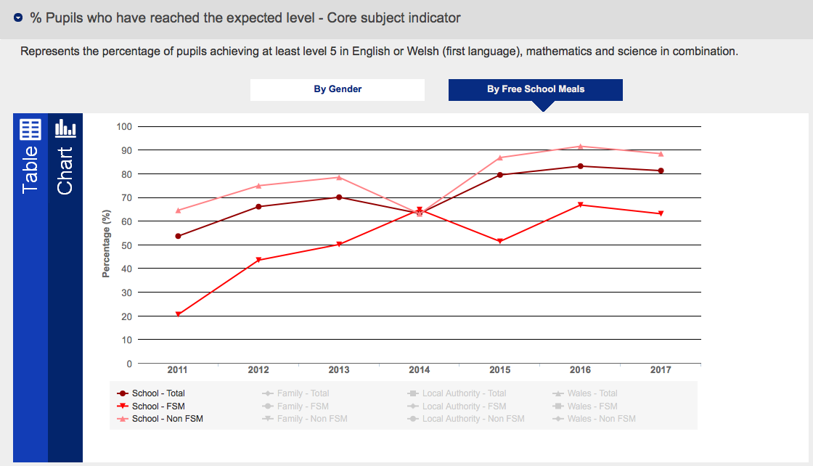

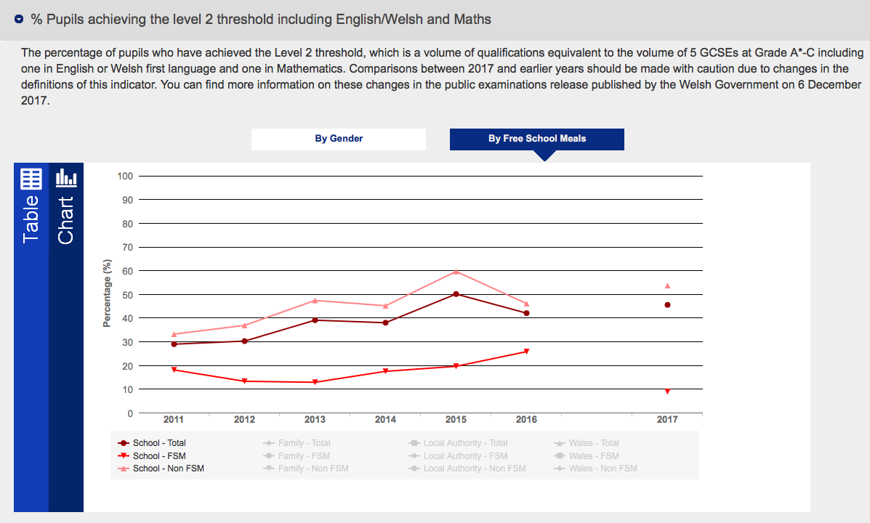

Appendix 2 – Benchmarking CSI at KS3 and L2+ at KS4

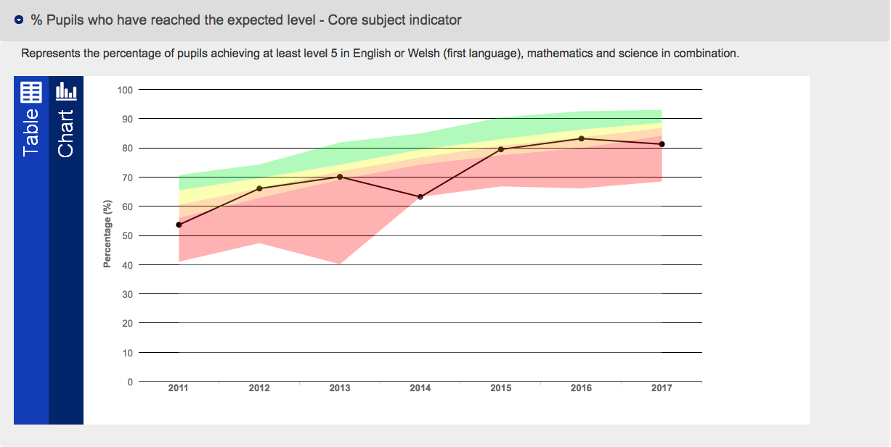

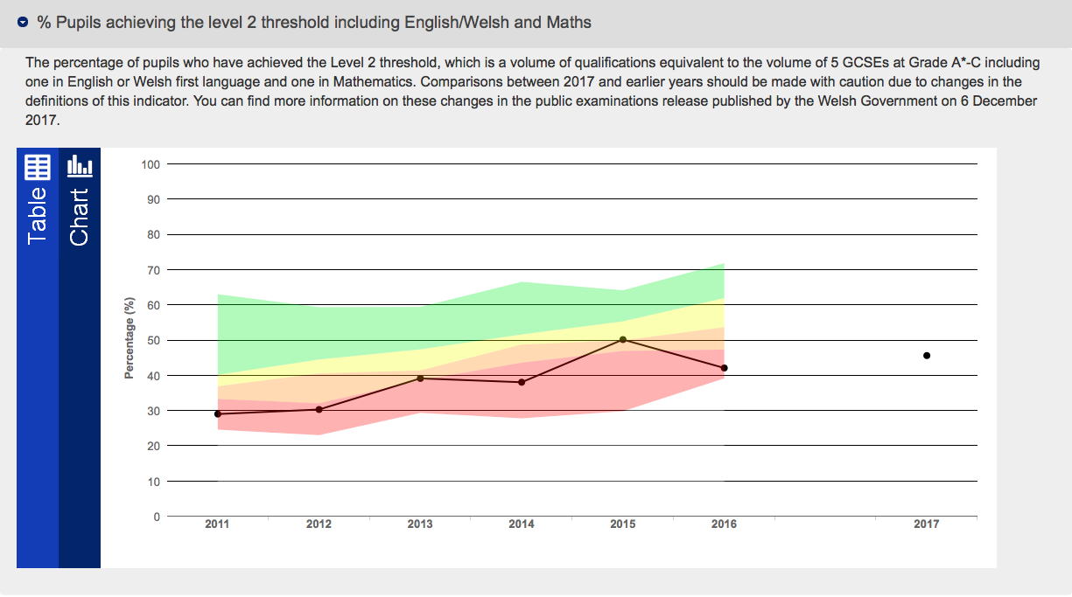

Appendix 3 – All Wales Core Data Set L2+ Threshold (2016)

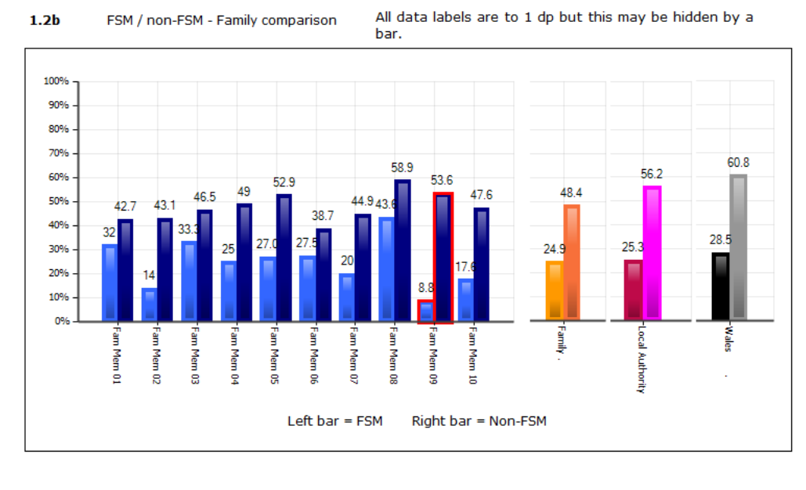

Appendix 4 – School Development Plan Extracts

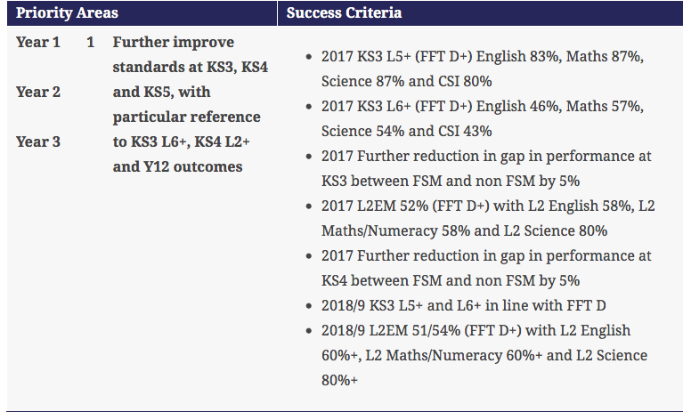

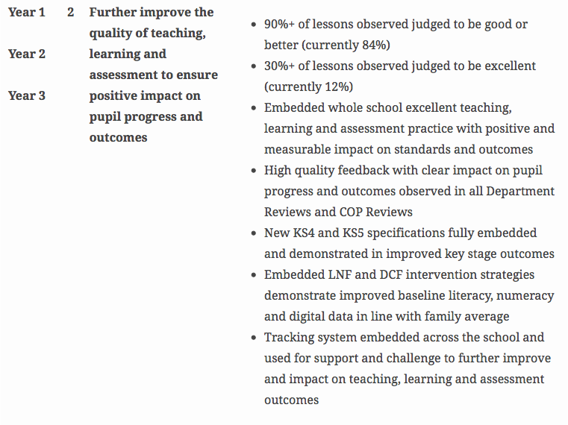

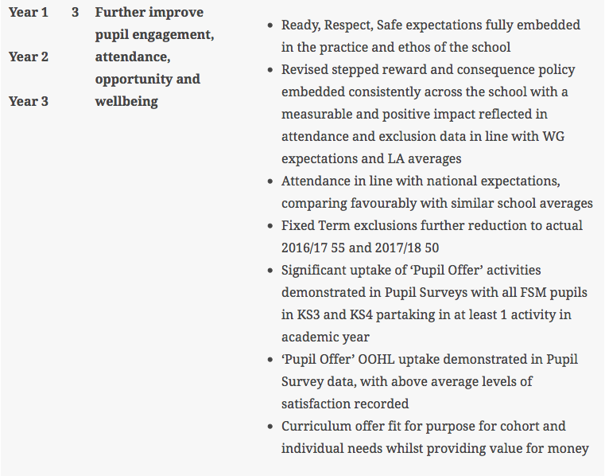

Appendix 5 – Pupil Development Grant as seen on website

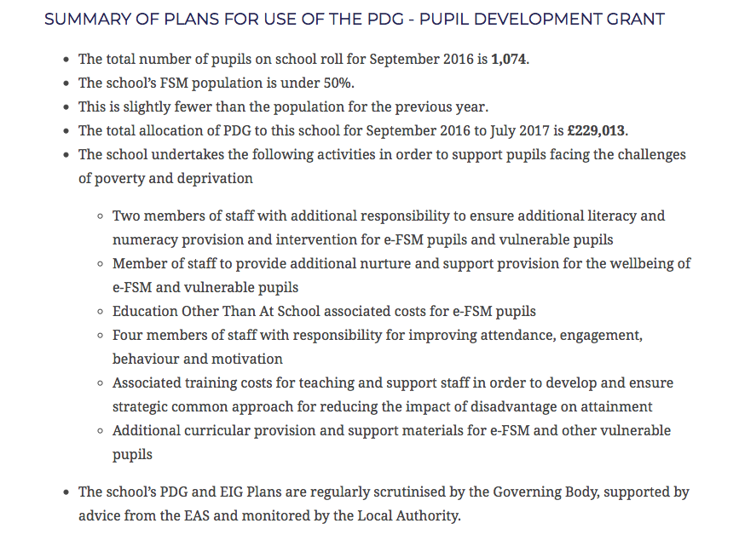

Appendix 6

Interview with Headteacher and Deputy Headteacher

- Why is there such a gap between FSM and n-FSM?

Depends on the context of the cohort when they come in. Many EATOL or ALN. Problems arising early on in primary as they are expected to parent as well as teach so pupils behind in learning.

- How is tracking data used?

Pupils are tracked half-termly throughout the school. FSM pupils tracked carefully to identify any issues. Challenge groups shared in Year 11 so staff aware of expectations.

- Does the school have a clear strategy for raising the attainment of FSM pupils?

Belief that it would be unethical to have a strategy for raising the attainment of one group alone. PET (Principles of Excellence in Teaching) programme designed and tailored to the school, all important part of raising attainment. Interventions tend to be on pastoral side or literacy/numeracy intervention.

- How much of a part does behaviour have to play in this issue?

Nurture manager there to support pupils who are struggling and behaviour support team. Understanding needed of difficult situations they face and that education is sometimes not their priority.

- Why use ability setting when the evidence suggests it is ineffective?

Too wide a range of ability in classes. Placing undue stress on teachers and too difficult to differentiate that level of variance. Seen positive results, particularly in top sets.

- How is the impact of interventions measured?

No specific interventions for FSM so unable to measure this impact. Tracking data and external tests provide data.

Interview with Behaviour Support Staff Notes

- Paid for through PDG funding
- Supports use of ability setting as focuses the problems and easier to deal with
- Majority of pupils on their records for mentoring are FSM apart from Year 11 where majority is SEN
- Clear link between attendance and FSM
- A lot of work done with parents. Draw up plans with parents in school on how to tackle behaviour, monitored throughout that.

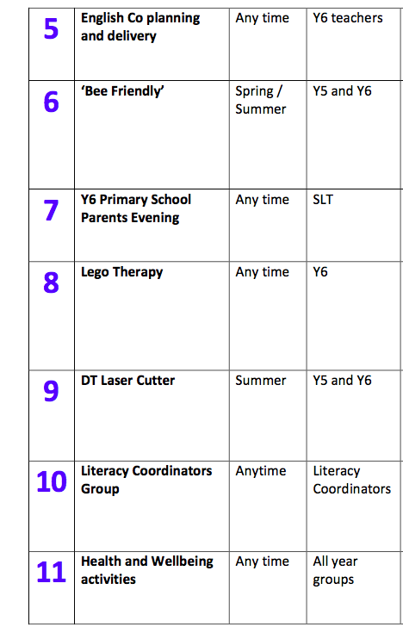
Appendix 7 – Enhanced Transition Offer

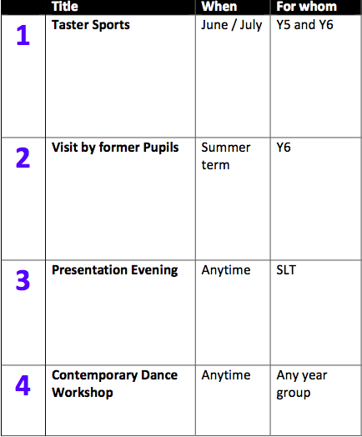







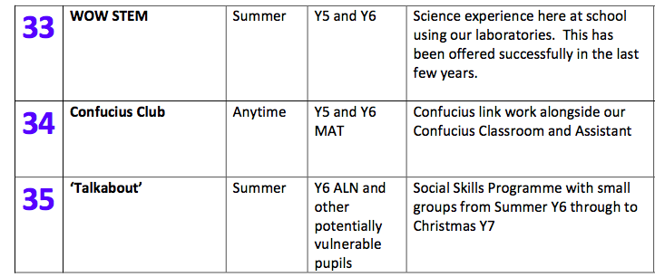

Appendix 8 – Screenshot of PET page



8 Bibliography

Ansalone, G. (2010) Tracking: Educational Differentiation or Defective Strategy. Contemporary Educational Research Quarterly, Volume 34 (2).

BERA (2010) Social inequality: can schools narrow the gap? BERA: Macclesfield. Available at: www.bera.ac.uk/system/files/Insight2-web_1.pdf‎. Accessed: 12 January 2018

BERA. (2011), Ethical Guidelines for Educational Research
Birbalsingh, K., ed., (2016) Battle Hymn of the Tiger Teacher: The Michaela Way. Woodbridge: John Catt Educational Ltd.

Boaler et al. (2013) Students' Experiences of Ability Grouping—disaffection, polarisation and the construction of failure. British Educational Research Journal. Available at: https://onlinelibrary.wiley.com/doi/abs/10.1080/713651583 Accessed: 25 March 2018.
Crehan, L. (2016) Cleverlands. London: Unbound.

Cummings, C., Laing, K., Law, J., McLaughlin, J., Papps, I., Todd, L., and Woolner, P. (2012) Can changing aspirations and attitudes impact upon educational attainment? Joseph Rowntree Foundation. Available at: http://www.jrf.org.uk/sites/files/jrf/education-attainment-interventions-full.pdf . Accessed: 2 February 2018.

Daniel Howell. (2011) College Dropout [Youtube video]. Available at: https://www.youtube.com/watch?v=j0HkSWVsYOw. Accessed: 28 March 2018.

DCSF (2009) Breaking the Link between special educational needs and low attainment: Everyone’s business. Available at: http://www.advanced-training.org.uk/resources/Universal/breaking_link_between_sen_and_low_attainment.pdf. Accessed: 1 April 2018.

Department for Education. (2017) Unlocking Talent: Fulfilling Potential: A plan for improving social mobility through education. Available at: https://assets.publishing.service.gov.uk/government/uploads/system/uploads/attachment_data/file/667690/Social_Mobility_Action_Plan_-_for_printing.pdf. Accessed: 1 April 2018.
Desforges, C. and Abouchaar, A. (2003) The impact of parental involvement, parental support and family education on pupil achievement and adjustment: A literature review. Department for Education and Skills. Available at: https://www.nationalnumeracy.org.uk/sites/default/files/the_impact_of_parental_involvement.pdf Accessed: 1 April 2018.

Donaldson, G. (2015) Successful Futures: An independent review of Curriculum and Assessment Arrangements in Wales. Cardiff: Welsh Government.

Dunne et al. (2007) Effective Teaching and learning for pupils in low attaining groups. UCL Institute of Education. Available at: http://dera.ioe.ac.uk/6622/. Accessed: 25 March 2018.
Dyson, A., Gallannaugh, F., Humphrey, N., Lendrum, A., Wigelsworth, M. Narrowing the gap in educational achievement and improving resilience for children and young people with additional needs. C4EO. Available at: http://www.c4eo.org.uk/themes/schools/educationalachievement/files/educational_achievement_research_review.pdf Accessed: 2 February 2018.

Egan, D. Saunders, D. Swaffield, L. (2014) Making Effective Use of the Pupil Deprivation Grant. Cardiff: University of Wales.

Ellis et al. (2014) An Analysis of research on metacognitive teaching strategies. Procedia – Social and Behavioural Sciences, Volume 116, pp. 4015 – 4024.

Estyn (2008) The use of performance data in local authorities and schools.

Estyn (2008b) Provision of community-focused services and facilities by schools

Estyn (2017) Estyn Annual Report 2016-2017.

Fielding, M. (2001). ‘Students as radical agents of change’. Journal of educational change, 2(2), pp. 123-141.

Grigg, R. Egan, D. McConnon, L. Swaffield, L (2014) The Good News…..What Schools in Wales are doing to reduce the impact of poverty on pupils’ achievement. Wales: Centre for Equity in Education.

Johnston, O. and Wildy, H. (2016) The effects of streaming in the secondary school on learning outcomes for Australian students – A review of the international literature. Australian Journal of Education, Volume 60 (1). Available at: http://journals.sagepub.com/doi/abs/10.1177/0004944115626522. Accessed: 2 April 2018.

Joseph Rowntree Foundation (2007) A Review of Research on links between poverty and education. Available at: https://www.jrf.org.uk/report/review-research-links-between-education-and-poverty Accessed: 12 January 2018

National Education Union and Child Poverty Action Group. (2018) Child Poverty and Education: A survey of the experiences of NEU members. Available at: http://cpag.org.uk/content/child-poverty-and-education-survey-experiences-neu-members. Accessed: 23 March 2018.
Opdenakker, R. (2006) Advantages and Disadvantages of Four Interview Techniques in Qualitative Research. Forum: Qualitative Social Research, Volume 7 (4).

Shakeshaft NG, Trzaskowski M, McMillan A, Rimfeld K, Krapohl E, Haworth CMA, et al. (2013) Strong Genetic Influence on a UK Nationwide Test of Educational Achievement at the End of Compulsory Education at Age 16. PLoS ONE. Available at: https://doi.org/10.1371/journal.pone.0080341. Accessed: 1 April 2018

Sutton Trust/Education Endowment Foundation ( 2014) The Sutton Trust/EEF Teaching and Learning Toolkit. London: Education Endowment Foundation

Waldfogel, J. and Washbrook, E. (2010) Low income and early cognitive development in the U.K. The Sutton Trust. Available at: https://www.suttontrust.com/research-paper/low-income-early-cognitive-development-u-k/. Accessed: 1 April 2018.

Welsh Government (2013) Using the Pupil Deprivation Grant in support of arts and cultural activity. Cardiff: Welsh Government.

Welsh Government (2014) Building Resilient Communities: Taking Forward the Tackling Poverty Action Plan. Cardiff: Welsh Government.

Welsh Government (2014b) Guidance for Using the Pupil Deprivation Grant: What Really Works? Cardiff: Welsh Government.

Welsh Government (2014c) Rewriting the Future. Cardiff: Welsh Government.
Welsh Government (2017) Evaluation of the Pupil Deprivation Grant. Cardiff: Welsh Government.

School Data and Information

Estyn (2013), Inspection Report School X 2013.

School Website - Protected for anonymity (BERA, 2011)

Welsh Government (2016) All Wales Core Data Sets – Protected for anonymity (BERA, 2011).

Welsh Government (2016), ‘School X’, Available at http://mylocalschool.wales.gov.uk/school.htm?estab=6764065&lang=eng [Accessed 1 April 2018]

