Student name: Anton Rumenov Mihaylov
Student ID: 2030908

MANAGEMENT ECONOMICS- LCBB5008

ASSIGNMENT 1

Executive Summary
This particular report is aimed to evaluate the economic aspects, such as the demand of customers and sales of Walmart in the international and national context. It has been identified that the market growth of Walmart has increased due to the policy of providing groceries at the lowest possible price. It is enabling the company to increase its market share and gain economic benefits. The policy of Low Price Leadership is able to help the company to increase the demand in all the markets by focusing on reducing its expenditure.

Table of Contents
Introduction 3
Description of the Business 3
Identification of Demand and Market Equilibrium 4
Price of Substitutes 4
Price of Complements 6
Consumer Income 6
Consumer Taste and Preferences 8
Consumer Expectation of Price 8
Demographics 9
Indication of Demand 9
Substitution Effects 9
Income Effects 11
Pricing Policy 12
Conclusion 13
Reference List 14

Introduction
This particular report is aimed to critically evaluate the economic data of Walmart, which is an American multinational retail organization. The importance of making policies regarding the organizational, international and national context will be presented here. The evaluation will be done with the application of several economic contexts, such as price elasticity, and cost analysis, along with supply and demand. Additionally, the impact of government policy on the managerial decisions in Walmart in the global domain will also be presented in this assessment. The reason for selecting the company will also be duly evaluated in this particular assessment.

Description of the Business
Walmart is one of the largest supermarket chains in the world, which is an America-based company. The products of the company include a one-stop shopping experience from the combination of grocery stores with fresh bakery, electronics, dairy products, home furnishing, toys and apparel (Mantha et al. 2020). It is functioning in the retail industry of different countries, such as the UK, China, Canada, South Africa and others. The selected product is determined as grocery, which is one of the primary aspects that has increased the brand name and brand value of the company in the international domain. The selected and targeted customer base of the company includes middle-class families, which is also increasing the economic growth of the company.
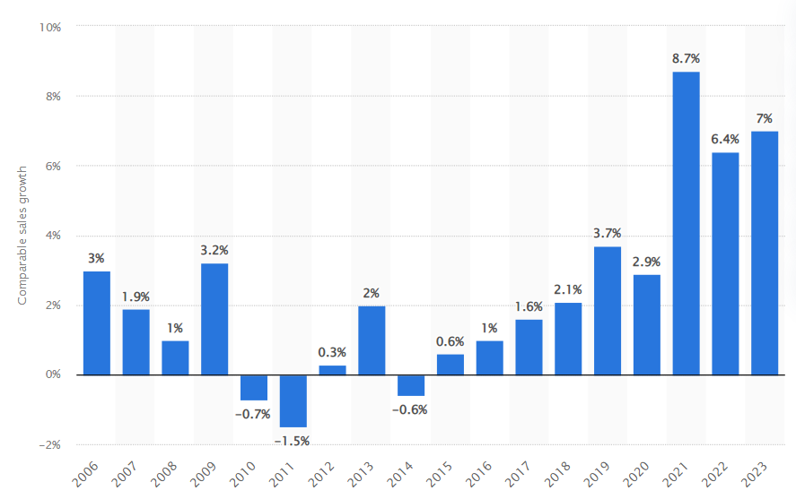
Figure 1: Walmart’s Sales Growth in the US
(Source: Statista, 2023)
It has been identified from Figure number 1 that Walmart has increased its sales growth in the US. The growth has increased from the year 2003 to 2023. It has achieved increased sales growth in 2021, which is expected to increase more at the end of 2023. The sales growth has made the company one of the largest grocery stores in the world, which is consistently attracting customers and gaining economic benefits. The company has developed its brand image with its slogan, which is "Always Low Prices".
The reason for choosing the company and products is the economic benefits it is gaining over its largest competitors. Moreover, the competitors of Walmart are Amazon, Costco, Alibaba, Best Buy, Tesco, and others.
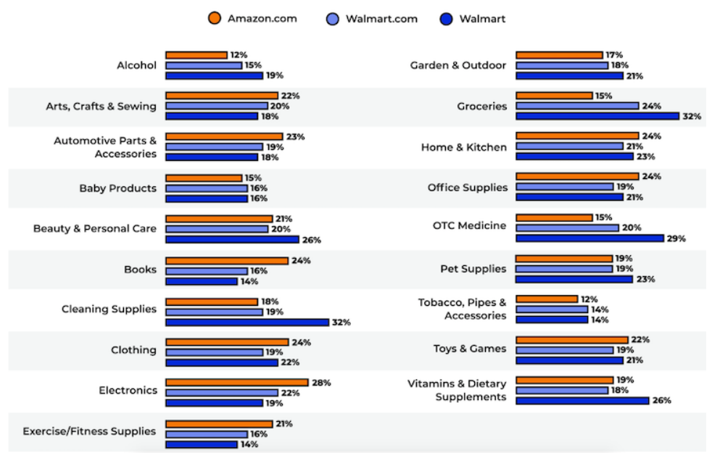
Figure 2: Comparison of Sales between Amazon and Walmart
(Source: Supermarketnews, 2023)
This particular figure evaluates the comparison of sales of groceries between Walmart and Amazon. It has been identified that the sales of groceries have increased in Walmart more than in Amazon. Thus, this particular company and the grocery sector have been selected here. It has also been evaluated that Walmart has become the preferred purchase destination for customers around the world.

Identification of Demand and Market Equilibrium

Price of Substitutes
Customers in the international domain are focused on reduced grocery prices, as the increased inflation rate is increasing the price of all necessary commodities. The groceries provided by Walmart are preferred by most of its consumers due to the lower price than the other brands (Pandey et al. 2021). The price of groceries, such as milk, bread, eggs, and others are lower in Walmart than in its competitors, which is making the company one of the preferred destinations to purchase groceries.
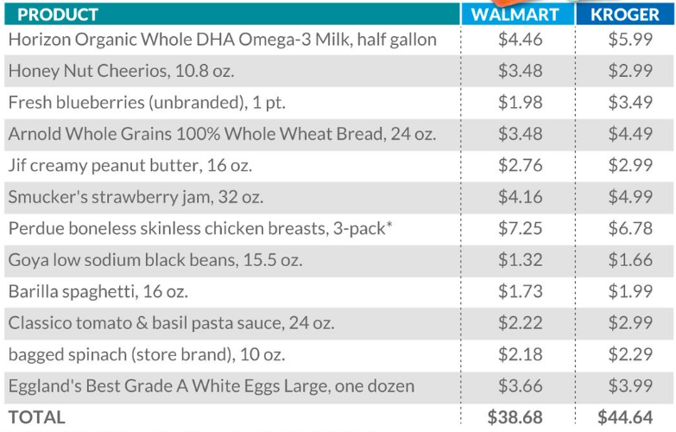
Figure 3: A Comparison between a few Grocery Products between Walmart and Kroger
(Source: Marketwatch, 2023)
It has been identified from Figure 3 that the prices of groceries are lower than one of its competitors, Kroger. The ability of Walmart to provide groceries at a lower price is enabling the company to gain economic and competitive advantages from different countries.
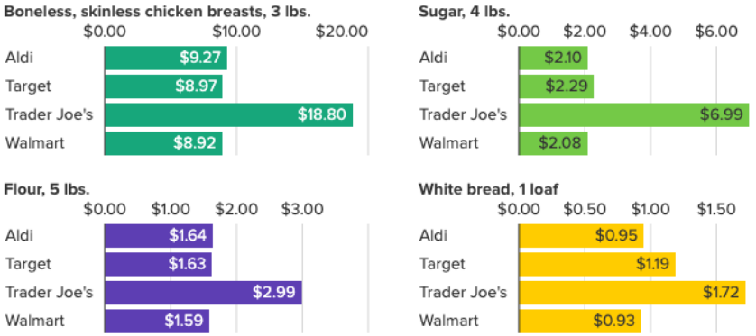
Figure 4: Comparison of Grocery Price
(Source: Acorns, 2023)
This particular figure has evaluated that the price of groceries is less than other competitors, such as Target, Aldi, and Trader Joe's. All the listed products are available at the lowest possible price in Walmart, which is enabling the company to gain competitive economic growth and advantages. It is also increasing the demand among customers in the international arena.

Price of Complements
The food retail market share is able to evaluate the price difference between Walmart and its largest competitors. The price of complementary goods has an impact on the decisions made by customers to make a purchase of their essential commodities. The price difference between Walmart and other companies is able to help them make a proper decisions of making purchases.
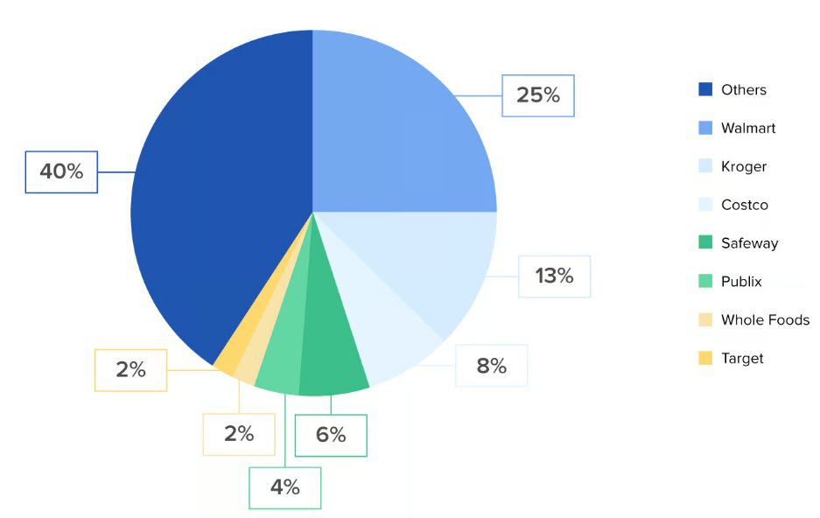
Figure 5: US Food Retail Market Share
(Source: Toptal, 2023)
Figure 5 has presented the food retail market share of different companies functioning in the US. The food share market captured by Walmart is larger than its competitors, Kroger, Costco and others. Different US-based companies are unable to compete with Walmart due to the lower price. This graph also evaluates that Walmart is able to capture the market due to the reduced price of grocery complements (Heien and Pompelli, 1989). Moreover, the reduced price is also increasing the demand of customers regarding the purchase of complementary products. The reduced price is also increasing the demand consistently among consumers in the US, along with the global arena.

Consumer Income
The income level of consumers has a drastic effect on the demand for products provided by different companies. The income level of customers is also influencing the economic growth of Walmart. The economic slowdown due to the pandemic is drastically affecting the demand for groceries that are available at a higher price. On the contrary, the availability of groceries at a lower price is influencing customers in the international arena to make purchases from Walmart.
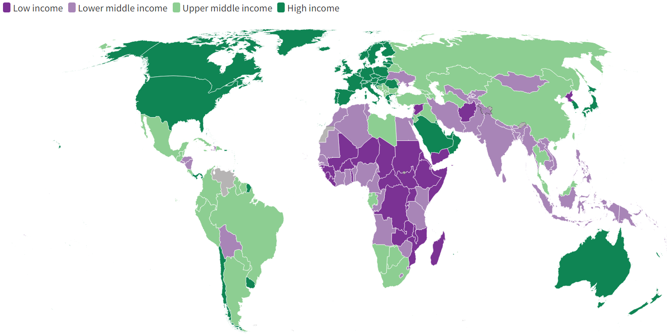
Figure 6: Global Income
(Source: Worldbank, 2023)
This figure specifically evaluates the income level of individuals in different countries. It has been understood that income level is affecting the demand for groceries provided by different firms. It is increasing the demand for groceries provided by Walmart, as they are available at a lower price. The decreased income level is increasing the demand for Walmart in the global arena, along with the US. It is providing economic benefits to Walmart and the firm is able to gain competitive advantages.
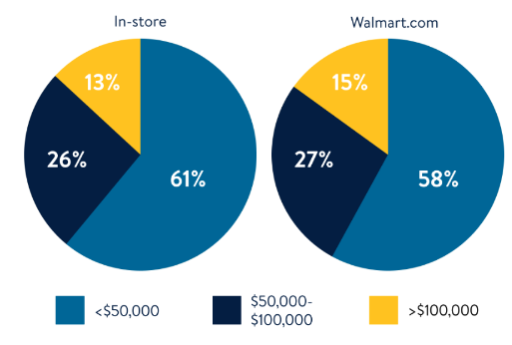
Figure 7: Consumer Current Annual House-hold Income
(Source: Walmart, 2023)
The average house-hold income at the annual level has been identified in Figure 7. It has been evaluated that 41 percent of customers choose to make purchases from Walmart due to their income level. It is also increasing the demand for Walmart groceries.

Consumer Taste and Preferences
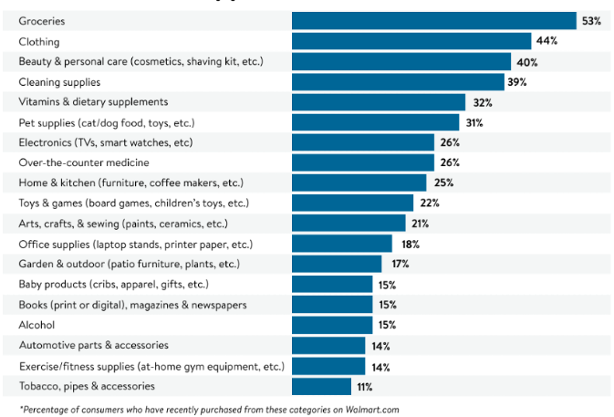
Figure 8: Top Groceries Purchased by Walmart Customers
(Source: Walmart, 2023)
This graph has evaluated that the purchasers of Walmart prefer to buy groceries from Walmart due to the lower price. The increasing inflation rates in all the countries and reduced income levels as per the growth of the inflation rate. The preference of customers to make purchases from Walmart due to the lower price is increasing the demand in all the countries it is functioning (Aigner-Walder, 2015). The tastes of customers have changed to lower priced goods due to their increased expenditure and reduced income, which is attracting them towards the grocery products provided by Walmart. In addition, the lower price is increasing the demand for Walmart in all countries, along with the US.

Consumer Expectation of Price
The economic slowdown after the pandemic, lower incomes reduced per capita income and other factors are drastically affecting the expectations of consumers. Most individuals are forced to focus on lower-priced products due to their low-income levels (Andreyeva et al. 2010). Increased demand is able to change the price of products both in an increased or reduced manner. The lower price and income are keeping the expectation of purchasers to reduce grocery prices. It is influencing the sales of Walmart, as the firm is selling groceries at a lower price than its competitors. It is also increasing the demand for Walmart products in different markets of the global domain. The expectation of consumers towards lower prices is also increasing the sales of Walmart due to the offers provided by the organization.

Demographics
The low birth rate in Austria is able to increase the expected population share of aged individuals in the country. Moreover, the increased population of aged individuals in the country is able to affect the consumption rate of groceries and demands (Andreyeva et al. 2008).
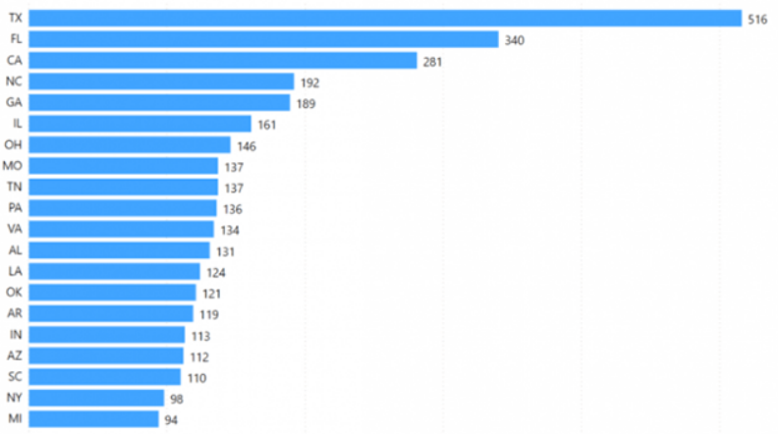
Figure 9: Number of Walmart Stores in different States of the US
(Source: Startupbonsai, 2023)
The number of Walmart stores in different states has been presented in this graph, which evaluates that the company has a large number of the loyal consumer base in the country. Moreover, Walmart is serving more than 230 million customers from its stores. The number of stores is determined as 10500, which are serving all the customers in different areas. Contrarily, the increased demand and the lower price of Walmart groceries are attracting more purchasers of the firm. It is also increasing the demand due to the increased number of loyal consumers of Walmart in the international arena.

Indication of Demand

Substitution Effects
The demand for groceries is increasing in the international arena due to the increasing global population. The increased amount of population is influencing the rate of consumption, which affects the demand. Price discrimination is an aspect that influences the purchasing decision of buyers regarding both necessary and luxury products.
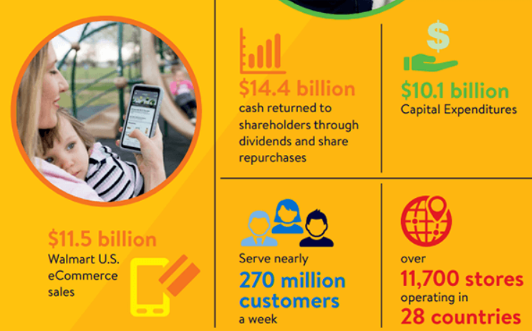
Figure 10: Countries, Customers and Growth of Walmart in 2018
(Source: Startupbonsai, 2023)
Figure number 10 evaluates that Walmart is operating in 28 countries and serving more than 270 million customers as per the data of the year 2018. It evaluates that the company has earned more than 11 billion dollars from e-commerce sales in the United States. The customers prefer the products of the company as grocery is determined as necessary. Moreover, the price of groceries is lower than in other countries, which is also attracting a large population towards the firm. The number of stores of Walmart has also increased due to the increasing demand of buyers, which is influencing sales growth.
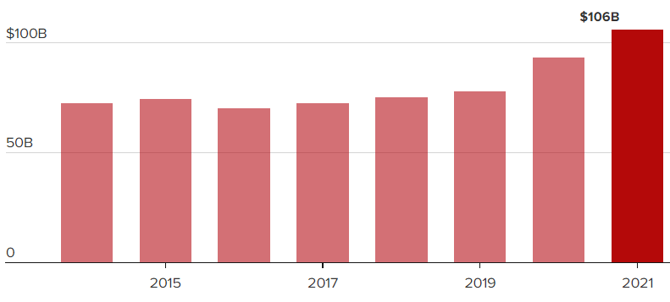
Figure 11: Annual Total Revenue of Walmart
(Source: Cnbc, 2023)
The annual total revenue by Walmart has been presented in this particular graph. The graph has presented that the total revenue of Walmart has increased in the year 2021 than the previous years. It has reached its highest point in the year 2021 from 2015. Furthermore, Walmart is able to earn the revenue, as the customers view the products as their necessity. This specific aspect of all the customers is allowing Walmart to gain benefits by increasing the demand. In addition, the demand of customers is increasing due to the lower price (Griffith, 2004). Thus, it is determined to be more elastic. Increasing demand from the customers is allowing the firm to gain competitive advantages in the global arena, as it is increasing the sales of groceries. Additionally, the increasing population is also raising the consumption of groceries, which is also influencing the demand of the purchasers.

Income Effects
The data on sales of products are able to evaluate the income levels of individuals in a particular market. The sales of necessary goods, such as groceries, are able to evaluate the income of the population of a particular place or market. The reduced income rate of the world population during the pandemic has affected their decision of purchasing goods. Moreover, the stock price of a company is able to evaluate the average income of its buyers.
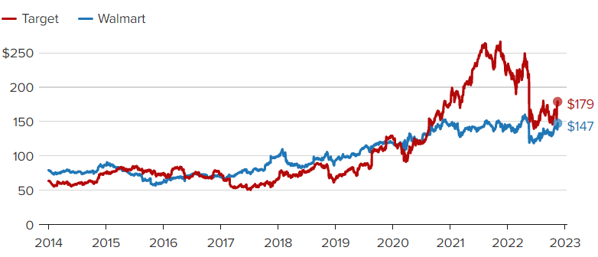
Figure 12: Targeted and Achieved Stock Price of Walmart
(Source: Cnbc, 2023)
The increased income of customers is able to raise the stock price, which Walmart is gaining in the international arena. It has been evaluated from Figure 12 that the difference between the expected and achieved stock price of Walmart is less. It presents that the income level of the buyers is good, which is also increasing the demand for groceries from the company. Furthermore, the demand can be increased more, as it is determined as elastic.
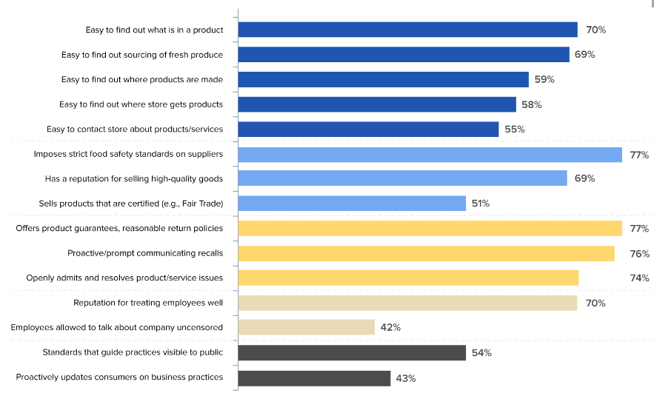
Figure 13: Store Behavior that Influences the Purchasing Behavior of Customers
(Source: Toptal, 2023)
This figure represents the store behaviour that influences the behaviour of customers and their decision or making purchases. It has been identified that these aspects are essential for companies to achieve more economic growth by increasing demand. In addition, the store's behaviour is able to influence the demand of customers by increasing their needs, along with loyalty. Walmart is able to gain competitive advantages due to these aspects by increasing demand. Thus, it is possible for the company to focus on improving these aspects in all its stores, and increase the demand (Shapiro, 1987). The possibility of increasing demand through the improvement of these aspects is making the income effects more elastic. The firm has the opportunity to increase the demand in all the markets by focusing on these aspects to increase demand from purchasers in the international arena. The demand is consistently increasing due to the low-priced products and store behaviour of Walmart.

Pricing Policy
The analysis has evaluated that the customers are focused on low-priced goods, which Walmart is already providing. It is essential for the company to implement the policy of low prices to attract more customers and compete with its rivals. The policy followed by Walmart is "Every Day Low Cost (EDLC)" and "Every Day Low Price (EDLP)". These two strategies are enabling the company to increase sales and meet the increased demand of customers (Gupta et al. 2021). These two policies are allowing the firm to control the expenses to pass the savings to its customers. It is also consistently building the trust of purchasers by providing groceries at the lowest price possible. The policy of Walmart Pickup is also enabling the customers to order online and get free pickup from the nearest store (Bangura and Lee, 2020). Moreover, the policy of Money-Back-Guarantee is increasing the trust of customers by evaluating that the quality of groceries is good and properly checked.
However, the policy of Low Price Leadership is able to help the company to maintain the price of groceries and provide them to the customers at a lower price than the competitors. The strategy and the policy of Low Price Leadership will be effective for Walmart, as it will help the company to leverage its store size by allowing customers to get benefits if they make purchases directly from suppliers. It will help in reducing the price of goods and increase the demand in the international domain (Fonseca, 2019). The policy of Low Price Leadership will help the company to remain competitive by increasing the demand of customers. It will also increase the loyalty of the purchasers in all the markets. In addition, an appropriate value could be provided to the customers through this policy, which will increase the demand for groceries in the firm. Additionally, the policy of discounts on a specific day every week could also help the company to increase the demand based on the aspect of low-priced groceries.

Conclusion
It is concluded from the report that Walmart has increased its growth due to the increased demand of customers. The aspect of low prices of groceries is increasing the demand of customers in the global arena. It is also increasing the sales of Walmart in all the markets it is functioning. Moreover, the aspect of increased consumption, loyalty, and store behaviour is helping the company to attract more buyers and increase the demand. Walmart is gaining competitive advantages due to the policies it has implemented. However, it is essential for the firm to adopt the policy of low-cost leadership to gain increased benefits by increasing the demand of consumers in the global arena.

Reference List
Acorns.com. 2023. https://www.acorns.com/learn/saving/grocery-store-price-comparison/. [Accessed on: 04.04.2023]
Aigner-Walder, B., 2015. Effects of the Demographic Changes on Private Consumption: An Almost Ideal Demand System Analysis for Austria. Journal of Economic & Social Studies (JECOSS), 5(1).
Andreyeva, T., Long, M.W. and Brownell, K.D., 2008. The lmpact of Food Prices on Consumption: A Systematic Review of Research on the Price Elasticity of Demand for Food. Ethics, 36(2), pp.256-270.
Andreyeva, T., Long, M.W. and Brownell, K.D., 2010. The impact of food prices on consumption: a systematic review of research on the price elasticity of demand for food. American journal of public health, 100(2), pp.216-222.
Bangura, M. and Lee, C.L., 2020. House price diffusion of housing submarkets in Greater Sydney. Housing Studies, 35(6), pp.1110-1141.
Cnbc.com. 2023. https://www.cnbc.com/2022/11/17/walmart-and-targets-quarterly-results-lay-bare-retailers-differences.html. [Accessed on: 04.04.2023]
Fonseca, M.A., 2019. Endogenous Price Leadership with Asymmetric Costs: Experimental Evidence. Studies in Microeconomics, 7(1), pp.59-74.
Griffith, G.R., 2004. The impact of supermarkets on farm suppliers. australian economic review, 37(3), pp.329-336.
Gupta, V., Ivanov, D. and Choi, T.M., 2021. Competitive pricing of substitute products under supply disruption. Omega, 101, p.102279.
Heien, D. and Pompelli, G., 1989. The demand for alcoholic beverages: economic and demographic effects. Southern Economic Journal, pp.759-770.
Mantha, A., Arora, Y., Gupta, S., Kanumala, P., Liu, Z., Guo, S. and Achan, K., 2020, May. A large-scale deep architecture for personalized grocery basket recommendations. In ICASSP 2020-2020 IEEE International Conference on Acoustics, Speech and Signal Processing (ICASSP) (pp. 3807-3811). IEEE.
Marketwatch.com. 2023. https://www.marketwatch.com/story/walmart-vs-kroger-how-their-prices-compare-on-milk-bread-eggs-and-other-grocery-essentials-11667573005. [Accessed on: 04.04.2023]
Pandey, R., Dillip, D., Jayant, J., Vashishth, K., Nikhil, N., Qi, T.J., Kee, D.M.H., Mei, T.C., Xin, R.Y.K. and Qhi, L.Y., 2021. Factors Influencing Organization Success: A Case Study of Walmart. International Journal of Tourism and Hospitality in Asia Pasific (IJTHAP), 4(2), pp.112-123.
Shapiro, M.D., 1987. Measuring market power in US industry.
Startupbonsai.com. 2023. https://startupbonsai.com/walmart-statistics/#:~:text=Walmart%20serves%20approximately%20230%20million%20customers%20and%20has%20over%2010%2C500,46%20banners%20across%2024%20countries. [Accessed on: 04.04.2023]
Statista.com. 2023. https://www.statista.com/statistics/269412/sales-growth-of-walmart-in-the-us/. [Accessed on: 04.04.2023].
Supermarketnews.com. 2023. https://www.supermarketnews.com/consumer-trends/survey-walmart-edges-out-amazon-grocery-destination. [Accessed on: 04.04.2023]
Toptal.com. 2023. https://www.toptal.com/finance/mergers-and-acquisitions/amazon-vs-walmart-acquisition-strategy. [Accessed on: 04.04.2023]
Walmart.com. 2023. https://marketplace.walmart.com/9-things-about-walmart-customers/#:~:text=In%20addition%20to%20fast%20shipping,because%20Walmart%20offers%20free%2Dshipping. [Accessed on: 04.04.2023]
Worldbank.org. 2023. https://datatopics.worldbank.org/world-development-indicators/the-world-by-income-and-region.html. [Accessed on: 04.04.2023]

