DIGITAL SKILLS AND RESEARCH METHODS
BMSW4003

Laura Pino
1915292

Terry Walcott

University of Wales Trinity Stain David

01/09/2020

TABLE OF CONTENTS

1. Introduction ………………………………………………… p. 3
2. Literature Review…………………………………………… p. 3
3. Methods ……………………………………………………. p. 4
3.1 Participant ………………………………. p. 5
3.2 Materials ………………………………. p. 5
3.3 Procedure ………………………………. p. 6
4. Results and Discussion ……………………………………. p. 6
5. Conclusion ………………………………………………… p. 16
6. References ………………………………………………… p. 18
7. Appendix ………………………………………………….. p. 20

ABSTRACT

In this historical period, everyone finds themselves forced to communicate via web-based software, with work colleagues and lectures from home safely.
This report will discuss the primary and secondary data analysis, types of data and will focus in particular on the virtual learning environments topic.
Through a questionnaire, via students’ answers, this report will be able to analyse the results and examine their approaches to web-based school learning, identify the factors and the benefits of this system and finally consider the disadvantages that can ensue.

INTRODUCTION

The virtual learning environment is an online-based system where educators can deliver lessons by teaching students via digital solutions (Tophatmonocle Corp.,2020).
These classes and lectures are being delivered using applications such as Microsoft Teams.
This software programme allows the teacher to host a virtual lesson with the use of the internet, camera and microphone technology.
Since February 2020, these technology systems have increased in the educational processes, due to the recent COVID-19 global pandemic, which has caused all educational systems to move online due to the inability for people to attend classes in person. The questionnaire that will discuss in this report will identify and analyse the potential positive and negative aspects of the virtual learning environment through primary data collection, in relation with the class lessons system, before the COVID-19 pandemic.

LITERATURE REVIEW

The increase in the use of technology in the virtual learning environment has changed the new educational method giving an impetus to the use of new tools in the pedagogical field.
The use of the app Microsoft Teams, gives the teacher and student the ability to communicate and interact together, with it the communication can be maintained at all times between them.
It is important to engage in cooperative learning that references methods encouraging students to work together and be interactive during online lessons. This is an approach that focuses on the student, as learning must be an active collaboration between teacher and student (G., Mayende, A., Prinz, G., M., 2017).
Regardless of how structured this environment is, there will always be a difference in the approach to these systems among students (G., Ivanova, A., Smrikarov, 2004).
Furthermore, this research has focused on how much the use of system such as virtual learning affects the student’s experience, how it can benefit them and what could be the shortcomings that derive from its use (N., K., Elfaki, I., Abdulraheem, R., Abdulrahim, 2019).
Thus, in this context, a questionnaire with twenty-four questions carried out by twenty-seven students of thirty, showed that 49% prefer and find this type of educational system convenient, while 51% argue the opposite.

METHODS

As the University of Southern (2020) suggests, the part of the methodology describes the steps that the researcher has to take to collect the necessary information; explaining the steps that have been used to understand the problem being analysed, then the reader is able to evaluate them and can thus judge the reliability of the research. In other words, it describes the specific methods of data collection that the study has followed to arrive at a final result.
A questionnaire is a type of primary data and as Moodle explains, the primary data is a source of original data in which they are collected in person by the researcher to obtain direct answers to a specific purpose. Therefore, the questionnaire helps to detect if the virtual learning is a system in which students are comfortable learning or if it is uncomfortable and unproductive for them.
As Maund (2017) suggests, in contrast to primary data, secondary data is all data that one researches through other sources such as books, academic journals and internet websites.
In other words, these fonts for being selected by an author, criticised and then rewritten according to their own vision and knowledge. Therefore, secondary data is reviewed by third parties, consequently, for a researcher, evaluating these sources can be cheaper and faster.
Methodology is divided into three main parts such as participant, materials and procedure sections.

1. PARTICIPANT Section

The questionnaires’ subjects were University students who are directly involved in the virtual learning environment.
Twenty-seven students out of thirty responded, twelve male and fifteen female, with an average age of 29. They all answered twenty-four questions, of which the first four were personal: the gender of the student; the age; the original native language and the university they are attending.
Being able to identify the latter information is useful for showing research that the samples under examination are actually involved in the online study.
The results show that 59% of the twenty-seven students come from Trinity Saint David University, while the other students attend colleges from Italy and France.
This will help in the final purpose to evaluate the results taking into account the views of foreign students, which is important because you have a broad overview of the various thoughts, to then compare and evaluate them in a more comprehensive way.

2. MATERIALS Section

The questionnaire consists of a mixture of multiple-choice questions and open-ended answers.
The latter were useful during the analysis because they gave the students the opportunity to express their individual visions regarding the virtual learning environment and it therefore clarified their position on the subject.
Furthermore, the order of the questions had to be decided so that it followed a logical sequence in the discourse.
The questionnaire examines four areas such as: the balance of the involvement between student and teacher during the lessons; the organisation of time during a day and week; in regard the communication, how it was affected and changing by the virtual learning; finally, what they would like to change in this system.
These four key points were chosen to help develop a conclusion during the discussion through the analysis and evaluation of them.

3. PROCEDURE Section

After evaluating and studying the questions to propose to the students, they were transcribed on Microsoft Forms, which is an application suitable for generating questionnaires in a professional format; it is also possible to execute the questionnaire from any internet-capable laptop, tablet or phone. Hence, these different opportunities facilitate students to fill in the questions, and for the researcher, speeds up the process of data compilation as the programme automatically assembles the answers. The Microsoft Forms’ system then provides us with visual graphs and an Excel table, delivering a direct view of the results.
After the main areas of assessment had been identified, the questionnaire was tested to guarantee the layout and functionality was clear.
Once created and tested, the Microsoft Forms programme generated a html link to be shared, via email, with the targeted students. This link, once clicked, opened up a webpage containing the questionnaire. One then had to continue to answer each question in turn and could not submit the answers until all questions had been completed on the page.
Once sent to the twenty-seven students and each one had been completed in time, the examination could then be commenced. It involved opening the answers via the Excel page and then processing one by one through graphs that best showed the percentage of single answers, in order to be commented and discussed in the appropriate section.

RESULTS AND DISCUSSION

In this section the report will interpret and evaluate the results of the questionnaire (Data Analysis Tutorial, 2017) and it has analysed four main areas of this research and they are: student involvement during virtual learning; how does the virtual learning influence student time management; how has the communication changed; and in the end, what improvements can this organisation establish through the students’ opinions.

Regarding the first area of examination, the involvement of the student in lessons, the results in Fig.1 show that 56% of responses were negative in regard to concentration during the lessons, also in Fig.2, 48% of students commented “no” when asked about the engagingness of the virtual lessons. In both cases the majority supports the negative response, subsequently, following the lessons from home, for the majority, they feel it creates a more comfortable and relaxing environment, as supported by Fig.3, in which 74% gave positive responses.

Fig. 1

Fig. 2

Fig. 3

As stated by the New York Time (2020), the student's learning also depends on their responsibility to commit their self, this means that if the student does not apply themselves in the first place, for the teacher, it will not be easy to interact with them and make the lesson engrossing.
This is demonstrated in Fig.4, where 65% say they do not interact well with the teacher, potentially as they are not putting in as much effort or attention to the lesson.

Fig. 4

Furthermore, this lack of interaction can result in distraction from the student, for example having the ability to use the internet could be a reason for a disconnect in concentration, unless it is used correctly to help them better understand a topic that is being covered in class. In fact, Fig.5 states that 74% of students use the internet during the lesson to better examine a topic.

Fig. 5

Kozar (2016) argues, that the use of devices such as the webcam during the lesson brings benefits in terms of attention, as it is possible to communicate more effectively in this way with the use of visual prompts and body language. Thus, in Fig.6 the students responded positively to the adoption of the webcam during the lesson.

Fig. 6

The second section concerns the management of free time that the virtual learning environment leaves available. Considering that their average hours of study is approximately eight per week, it can be seen from Fig.7, that 74% of students responded positively to this question and as one student reports in New York Time (2020), this system allows them to devote more time to exams. This statement is consequently confirmed by Fig.8, which states with 81% that they have more time to study.

Fig. 7

How does the virtual learning influence your daily routine
does the virtual learning influence your daily routine an

Fig. 8

In area three the report examined how and if communication has changed. Even before the world pandemic, applications such as WhatsApp or FaceTime were used effectively to interact with each other; in fact, the question in Fig.9, which asks if the communication in the group tasks takes place successfully via new platforms such as Microsoft Teams, consisted of 73% positive answers.

Fig. 9

Responses to the open question asking what will change during the group task, pupil’s answers were prevalent: it will not change much. This is because, the use of the apps mentioned above has already been tested for some time, indeed, this is confirmed by Fig.10 and 11, when they were asked if they could use the new app to communicate with the university.

Fig. 10

Fig. 11

In Fig.12 and 13, the communication between teacher and student is discussed and whether this pedagogical system is a barrier, being 99% non-native English speakers.
As Kozar (2016) argues, having, for example, the active webcam increases the communication between the lessons, indeed, one has the possibility to express oneself also through the use of body language, from which it is possible to give a non-verbal communication.

Fig. 12

Fig. 13

Furthermore, it is confirmed from Fig.14, that 48% of students affirm that they need more support during the final task.

Fig. 14

Finally, the fourth area is dedicated to the student's opinion, open questions numbered 15/16/24, in which the questionnaire asks about their benefits, disadvantages and their opinions about this system; helping draw conclusion from the research. In fact, carrying out the lessons from home has largely confirmed the comfort that comes with it, also financially it saves money, while a negative implication is that the relationships between colleagues inevitably fail.

CONCLUSION
Creating this questionnaire made it possible to understand that ideally the students would prefer to interact more with the lecturers during the lessons, and that following them from home makes them feel more at ease, but increasingly distracted, as opposed to being in a physical university context. Furthermore, the virtual learning method saves time that can be spent in completing the final assignments.
The average age of the twenty-seven students is 29, this has facilitated their adaptation to the new school system, as they are already practical and confident in using various technological programs to communicate daily.
In conclusion, I argue, in compliance with the necessary timing that this pandemic requires, that the physical school environment is clearly more pedagogically engaging; also, it is important, in this new environment, to maintain the relationships that were being built before the COVID-19 pandemic.

REFERENCES

G., Ivanova, A., Smrikarov, (2004). ‘Some Approaches to implementation of Virtual Learning Environments’. International Conference on Computer Systems and Technologies. IV. 1- 25. Avalibale at:
https://www.researchgate.net/publication/237242343_Some_approaches_to_implementation_of_virtual_learning_environments
(Accessed: 17th August 2020).

G., Mayende, A., Prinz, G., M., (2017). ‘Improving Communcation in Online Learning Systems’. In Proceedings of the 9th International Conference on Computer Supported Education (CSEDU). Volume 1, pages 300-307. Available at:
https://www.researchgate.net/publication/314676933_Improving_Communication_in_Online_Learning_Systems
(Accessed: 17th August 2020).

Kozar, O., (2016). ‘Perceptions of webcam use by experienced online teachers and learners: a seeming disconnect between research and practice, Computer Assisted Language Learning’. Available at:
https://www.tandfonline.com/doi/abs/10.1080/09588221.2015.1061021
(Accessed: 9th August 2020).

Maund, A. Schriek, M. and Tinkler, P. (2017). ‘Certificate in Higher Education: Skills for the Workplace’. Student Yearbook. Sage Publications

Moodle, week two. ‘Methods of Data Collection’.

New York Times, (2020). ‘Teachers and Students Describe a Remote- Learning Life’. Available at:
https://www.nytimes.com/2020/04/23/education/learning/coronavirus-teachers-students-remote-learning.html
(Accessed: 9th August 2020).

N., K., Elfaki, I., Abdulraheem, R., Abdulrahim, (2019). ‘Impact of E-Learning vs Traditional Learning on Student’s Performance and Attitude’. International Journal of Medical Research & Health Sciences, 8(10):76-82. Available at:
https://www.ijmrhs.com/medical-research/impact-of-elearning-vs-traditional-learning-on-students-performance-and-attitude.pdf
(Accessed: 17th August 2020).

Top Hat Corp. Glossary, (2020). ‘Virtual learning Environment’. Available at: https://tophat.com/glossary/v/virtual-learning-environment/ (Accessed: 8th August 2020).

USC University of Southern California, (2020). ‘6. The methodology’. ‘Organizing Your Social Sciences Research Paper’. Available at:
https://libguides.usc.edu/writingguide/methodology (Accessed: 9th August 2020).

Vermont E. Streams project, (2017). ‘Module 6: Summarizing Results and Drawing Conclusions’. ‘Data Analysis Tutorial’. Available at: https://apps.epscor.w3.uvm.edu/web/streams/PDFFiles/tutorials/Data_Analyses_Tutorial_Module6.pdf (Accessed: 7th August 2020).

APPENDIX

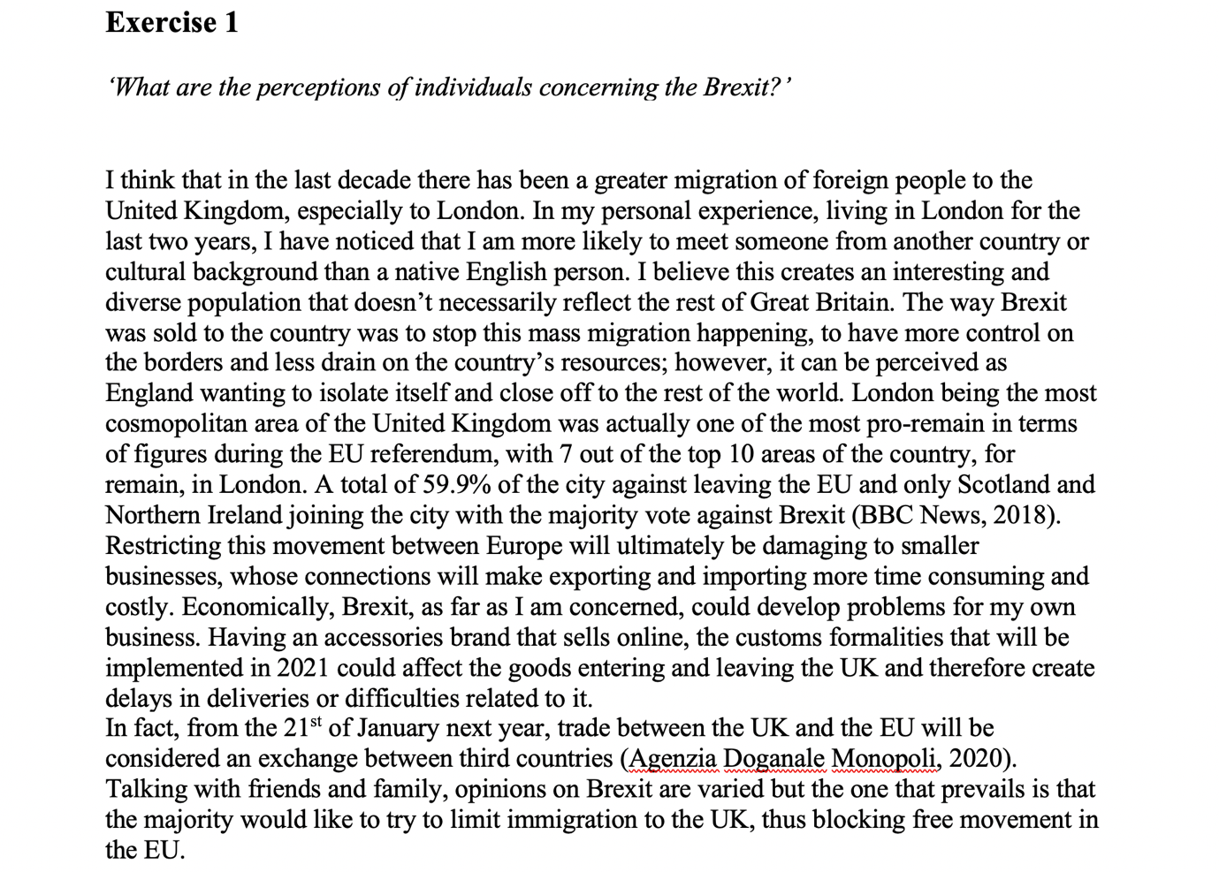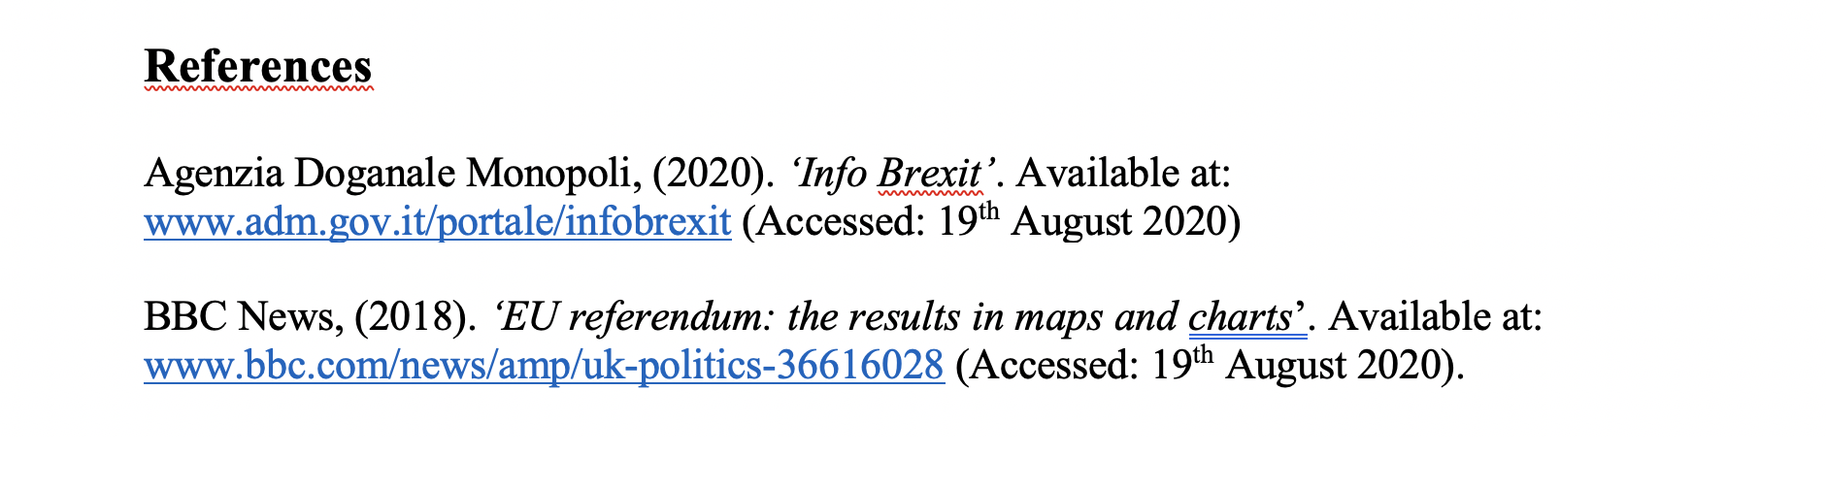
Example 1: in class exercise.

