Workplace Culture and its Importance on Organisation

Executive summary
The workplace culture is very important in the organization context and the workplace culture of Lonmin Plc is described in this report. The workplace culture is very important in the organizational context. The company is a metal producer in the international market. There are various kinds of rules and regulations are existed to process the every function of the organization. The evolution of the organization and the relevant rules and procedures behind the evolution of the company is described in the report. There are some influential factors that affect the culture of the organization. These influential factors are critically described in the report. The SWOT and PESTLE analysis is described in the context of the organization

Table of Contents
Executive summary ii
Introduction 1
1. Background of Lonmin Plc 2
2. Critical assessment of workplace culture of Lonmin Plc 3
2.1 Evaluation of the culture of the organization 3
2.2 Considering the relevant policies, procedures and legislation to the support the evaluation of the organization 6
3. Critical evaluation of Lonmin Plc and the environment which the company operates 9
3.1 Environmental factors associated with Lonmin Plc 9
3.2 Influential elements of organizational culture of the company 11
4. SWOT analysis of Lonmin Plc 13
5. PESTLE analysis of Lonmin Plc 15
6. Critical evaluation of ethical and cultural behaviour of the organization 17
Conclusion 19
References 20

Introduction
The workplace culture of a company encompasses different kinds of factors. The set of visible and non-visible component of a company and their function to achieve the goal of the business is called the workplace culture. The characteristics of the company, rules and policies of the company, government support and procedures, nature of the business, employees and many other things are related to the workplace culture. In this report, Lonmin Plc is chosen to describe the workplace culture and the effective communication for the organization. The border of the organization and the influential factors that have significant effect on the company are also important element of the workplace culture. The ethical behaviour of the organization is also considered to describe the organizational culture.

1. Background of Lonmin Plc

Lonmin Plc is a producer of platinum and other types of metals in the international market. The company is the market leader in the international market. Lonmin Plc has many branches in all over the world. To produce the platinum and gold metal the company spends huge time for the investigation of mine. The human resource management of the organization is very organized. Different types of managers of the organization are associated with the growth of the organization. To make the growth of the organization, the company is associated with innovation. The employees of the company are mainly focused to increase the function of the organization.
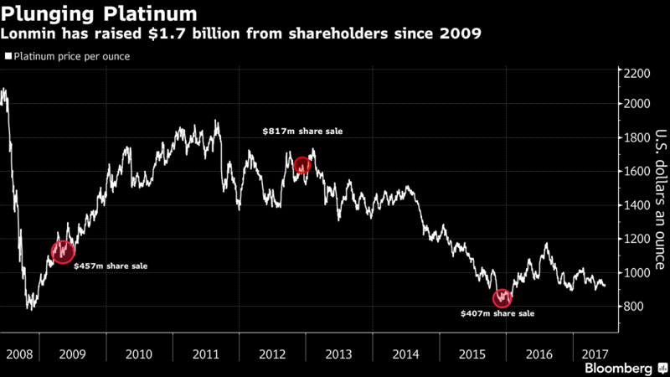
Market share of Lonmin Plc
The company is basically a labour intensive company. The performance of the employees in the organization is directly related with the success of the organization. More than 30,000 employees are associated with Lonmin Plc. The function of the company is diversified in many countries of the world. It has about 82 branches all over the world. There are much platinum and metal producer company are existed in the international market. Hence, Lonmin Plc has to compete with different kinds of companies in this industry. About 31% of total market share is grabbed by the company. The rest of the share is grabbed by other companies of this particular industry.

2. Critical assessment of workplace culture of Lonmin Plc

2.1 Evaluation of the culture of the organization
Lonmin Plc is a metal producer company. The company is mainly related to the production of platinum production. The gold is also the product of the company. For this reason, the company invests a huge amount of money for the investigation of the mine around the world. After finding the mine appropriate for the company, it completes some legislation formalities to the extraction. It has huge personnel that are actively related to achieve the goal of the business. Due to the enhancement of the metal products around the world, the activity of the company is also increased (Bank Muñoz et al, 2011).
It has norms, policies and the different kinds of rules to attain the objective of the company. The leadership style of the company is very important thing in the organizational culture. As the activities of the company are practiced in the different countries, it is also related to the foreign culture. Lonmin Plc is a multinational company. For this reason the company has different types of policies for the different countries.
The company has huge human resource. For this reason the company has an extra focus on the human resource management. Lonmin Plc has taken various kinds of wise step to control the employees of the company. For the better output, the company has arranged the training session for the employees (Beamish, 2012).
The market of metal is very competitive. There are many primary producer metal companies in the market of whole world. The culture of the company is based on the competition in the international market. The quality of the product of the company is very high in order to beat the competitors of the company. Besides, Lonmin Plc leadership style is related to the unique heritage and culture in the international market.
Communication is a method to contract with the different types of parties of the organization. To achieve the competency in the communication, an organisation has to appoint the skilful employees in this sector. Intellectual communication is very important for the effective communication of an organization. Lonmin Plc maintains the intellectual communication. The company has arranged different types of workshop program to attract the talented employees that are best suited for the organization. The company is also related to the intercultural communication. In this case, the organization is related with the different culture that the company is involved. To communicate the different culture of the organization, the managers of the company maintain the better experience for the intercultural communication (Blessinger and Hrycaj, 2013).
Lonmin Plc has different kinds of communication channel. In the communication channel, the functions are performed in the different kinds of styles. The company faces oral communication, written communication, and verbal non-verbal, formal and informal communication. The culture of the communication of the company is assessed below:

Source: (Clegg, 2013).
Formal communication of the company is performed by the paper and emails. The official declarations by the different kinds of managers are known as the formal communication. The employees of the company are ruled by the various kinds of formal communication. It is a significant rule in the culture of the company.
Informal communications denotes to the communication that have no formal base. In these types of communication, the employees and different kinds of managers are related. The communication among the employees and the communication other than the formal communications are known as the informal communication of the company (Collinson, 2010).
In the workplace of the organization the oral communication is mainly performed in maximum time. Besides, the informal communication of the organization is performed by the oral communication.
The formal communication is mainly performed by the written communication. The written communication has the formal base. The communication with the external parties of the organization is incurred by the written communication.
Verbal communication is incurred by the voice of the employees and the managers of the organization. The managers in the workplace manage the employees in the workplace by the verbal communication. To maintain the employees the verbal communication is very significant (Cox, 2009).
Non-verbal communication is denotes to the communication other than the verbal communication. The non-verbal communication is mainly incurred among the managers and the employees. The short types of communication among the employees and the managers are incurred by the non-verbal communication.

2.2 Considering the relevant policies, procedures and legislation to the support the evaluation of the organization
To evaluate the organization critically, it must be mentioned that the structure of the organization is highly affected by the organizational culture. The culture of Lonmin Plc is based on huge number of employees. In this case to maintain the personnel is very critical issue. For this reason Lonmin Plc is associated with the hierarchical organizational culture.
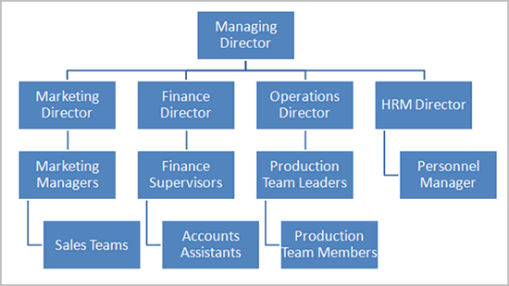
Source: (Crittenden and Claussen, 2010).
In the hierarchical organization different kinds of managers are involved in the structure of the organization. The chain of command is strictly maintained in the case. The coordination among the employees of the organisation can be brought by the hierarchical organization. As the structure of the organization depends on the efficiency of the managers, it is very significant in the workplace culture.
The hierarchical organization is the expand level of tree structure of organization. In the various level of the organization, different kinds of employees and managers are involved in the organization. Though the span of control in the hierarchical organization is relatively medium, it has high level of coordination level. The coordination among the employees of the organization is brought by the hierarchical structure of the organization (Eliot, 2016).
The cost in the structure of the organization is relatively high. The managers of Lonmin Plc have to incur some extra cost for these types of organization. In the decision making function, the organization needs some extra times. As many kinds of managers and employees are related to these kinds of organization, the communication level is relatively slow in the organization than that of other structure of the organization.
The decision making function of the organization is very critical task for the managers of the organization. In the decision making function, there are various kinds of process. The managers of Lonmin Plc critically evaluate the process of decision making function. The process of decision making function is described below:
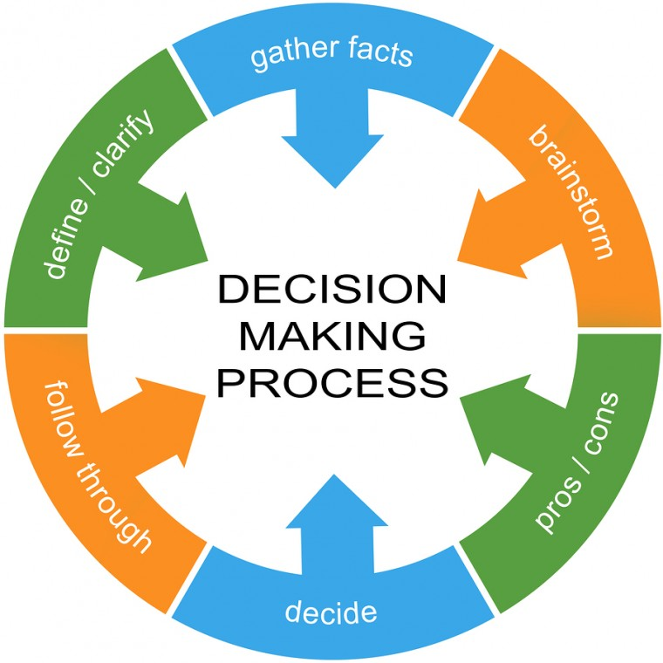
Source: (Furusten and Werr, 2013).

In the every level of the function of the organization, it feels the conflict in the decision making. The managers of Lonmin Plc follow the decision making process for the better function in the decision making.
At first the managers of the organization critically evaluate the problems. By defining the problems, the managers enable to know the condition of the problem. For example, to negotiate about the mine of metal the managers of the organization define the condition of the mine and the geographical structures (Garber, 2010).
In the definition of the problem, the managers gather the necessary facts and figures to take the more effective decision. In this function, the relevant information about the problem makes the managers associated with the decision making function. By informing about the pros and cons of the problem in the decision making criteria the managers can be taken the effective decision for the organization.
After that, the managers of Lonmin Plc take the effective decision for the company. In this case, the company follow different types of rules and procedures in taking the effective decision. In taking the relevant decision for the company, the managers of Lonmin Plc make conversation with the personnel of the company. By the participation of the employees in the decision making, the decision making function is more smooth. The managers can easily take the effective decision that is best suited for the organization. The discontent of the employees of the organization may be removed by the participating of the employees in the decision making function (Iedema, 2013).

3. Critical evaluation of Lonmin Plc and the environment which the company operates

3.1 Environmental factors associated with Lonmin Plc
The function of Lonmin Plc is operated in wide range of area. There are various kinds of influential factors that are highly related to the culture of the organization. By the evaluation of the company, some influential factors are found in the workplace culture of the company. They are explained as follows:

Source: (Jang et al, 2011).
As Lonmin Plc is a multinational company, it operates its activities in the different countries. To operate its activities in the different countries, it is associated with the different types of environmental. The environmental factors play a vital role for achieving the goal of the organization. The function of these environmental factors and its effect to the organization are explained in order to explain the workplace culture of the organization.

Customers: By analysing the broad environment of the company, it is found that customers are vital party of the organization. Customers are the ultimate users of the company. The customers purchase the gold and platinum metal from the company. As these are the luxurious products, mainly, the high class of people are the customers of the company. Besides the individual customers, various kinds of business and groups are the customers of the company (Lee, 2015).
Competitors: In the goal and platinum metal market, there are some strong competitors are existed in the international market. Basically, these types of companies are the competitors of Lonmin Plc. The company has some rules and procedure to behave with the competitors.
Suppliers: The suppliers supply the company various kinds of materials in the production function. The prices of the product of the company are also related to the suppliers. It the suppliers take higher price from the company for the raw materials, the price of the metal will be increased.
Technology: The technology is an important environmental factor of the company. In the function of the company, the technological efficiency is seen in the front line. To make the alluring design of the metal product, the company use the technology. In the investigating of the mine, different types of analysis, the company uses the technology. Mainly, the technological efficiency makes the company more efficient in the production of platinum metal (Potterfield, 2014).
Economy: In various kinds of countries the economic efficiency is measured by the platinum and the luxurious goods. For this reason to boost the economy, these types of products are highly demanded. In the function of the company in different types of company, the economic effects are seen.
Legal dimension: The function of the company is operated according to the legal dimension. There are some rules and regulation is the international business. The company also performs the requirement of the legal dimension. The activities of the company are operated according to the rules and regulation prescribed by the legal dimension UK law (Sims and Gioia, 2017).

International dimension: The function of the company is operated internally. In the different kinds of organization the functions of the company are practiced. In the international market, the company follow the international rules. In exporting the products of the company, it is associated with paying the tax and tariff regularly.

3.2 Influential elements of organizational culture of the company
In the organizational culture there are many influential elements. These influential elements have the very important effect on the culture of the organisation. These influential elements of the workplace culture are explained below:

Source: (Spilka, 2016).
Man: Man denotes to the peoples related to the organizational culture. It is very significant factor in the culture of the organization. The employees and the management body of Lonmin Plc are denotes as the factor Man. The company has huge personnel. All level of employees is related to achieve the organizational goals. In the operation of the organization and the decision making function the men are related to this. For this reason, it is said that the organizational culture is highly related to the men.
Machine: The production function, distributing function and the other organizational function are not solely possible the employees of the organization. In this case, the machines are needed. The technological advancement makes the efficiency of machine in the modern world. In the all level of function of the organization, the use of technology is mandatory (Waddington et al, 2016).
Materials: In the production function Lonmin Plc use different types of materials to produce the metal products. These materials are collected from different sectors. It is the duty of the managers of the organization to identify the source of the materials in the production. By identifying the important source, the managers of the organization can increase the flow of material into the company.
Money: Money is the media of judging the solvency of the business. The products and assets of the organization are measures in the point view of money. The products of the organization are valued in different monetary value. Besides, the relations with the third party of the organization are determined by the terms of money (Williams and Dellinger, 2017).
Methods: The procedures used in the organization are knows as the method used in the organization. Various kinds of methods can be used in the organization. To solve the financial problem of the organization and producing products, different kinds of methods are used. In solving the problem is the organization it use the best method and it is an important element of workplace culture.
Market: In the regular activities of the organization, it has emphasized on the market. Both domestic and international market is focused by the company. The price of the metal products in the international market plays a vital role in setting the price of the products of the organization.

4. SWOT analysis of Lonmin Plc
The different types of environmental factors of the organization are discussed in the report. These environmental factors have very significant effect on the organization. The functions of the organization are also affected by the cultural factors. The effects of these factors are evaluated from the point view of different kinds of analysis. They are explained below:
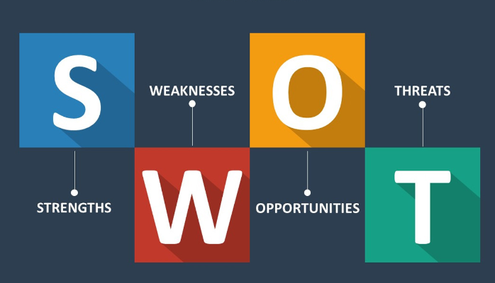
Source: (Zemke et al., 2009).
SWOT analysis describes the strength, weakness, opportunity and threats of the environmental factors in the organization. The SWOT analysis is described as follows:
Strength: The company has the golden heritage it the workplace culture. In the hierarchical structure of the organization, the managers of the organization, control the strictly. The flow of power of the company is distributed in the planned manner. In the decision making, the discontents of the employees are not existed for the organization. It is very significant strength for the company. The company abides the legal provision according the law of United Kingdom. For this reason the activities of the organization are out of questionable. In treating the customers the company supply the high demanded goods to the customers. It increased the demand of the customers in the market. Lonmin Plc is also following some unique procedures to beat the customers in the international market (Appenzeller, 2011).

Weakness: As the company has many employees, it is very hard task to control them. The control span of the company is relatively low than that of other organization in the international market. Though the individual decision making criteria of the organization is very easy, the group decision making or participation decision making criteria of the organization is very complex. As Lonmin Plc use the hierarchical organizational structure, the decision making tasks of the organization is very hard.
Opportunities: The Company has very opportunity to grow rapidly in the international market. As the company use the invention of technology in the function of the company, it can grow fast. Lonmin Plc can arrange the online order from the customers for different types of metal products. By this function, the demand of the customers can be assessed easily by the company. According to the demand of the customers the company thus supply the products to the customers. The international marketing of the company will be boosted also by the different types of organizational factors in the culture of the company (Darley et al, 2013).
Threat: The metal production companies in the international market in increasing rapidly. It is a threat for the company. Besides, the cost of the organization in producing the platinum metal products is also increasing rapid. Various types of promotional procedure taken by the competitors in the international market can switch the customers of the company. It is the major threat for the organization.

5. PESTLE analysis of Lonmin Plc

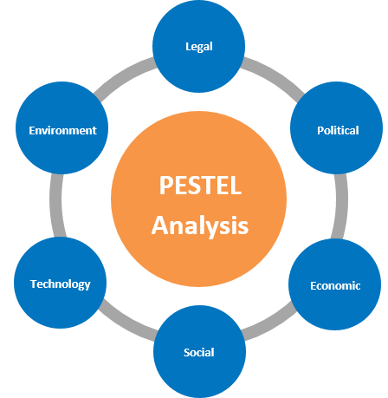
Source: (Kerns, 2015).
The PESTEL analysis of Lonmin Plc can be analysed in this section. By the critical evaluation of the function of the organization, the PESTEL analysis is organized here. The evaluations of PESTEL analysis by the different types of factors are explained below:
Political factors: Gold and Platinum materials are used as the reserve of different countries. In this case, the government of different countries are involved. They want to collect more metal products to the national exchequer. For this reason the governmental barriers for extra supplying of metal products can be seen in some cased. Sometimes the government can restrict to supply the metal products to the different kinds of countries in the world (Litschert and Nicholson, 2014).
Economic factors: The cultural behaviour of Lonmin Plc has a significant effect on the economy. The economy can be boosted by the wise function by the managers of the company. By the international policy of the company can play a vital role in the economy of the country?
Social factors: The Company has very significant effect on the economy. The personnel of the organization are related to the social function of the organization. The activities of the company is bounded the provision of the society. Besides, the activities of Lonmin Plc are associated with the wellbeing of the society (Olitzky and Sabath, 2012).
Technological factors: Lonmin Plc is highly affected by the technology. The invention of the society plays a vital role for the growth of the organization. Various kinds of promotional function of the company are performed by the technological factors. In the supplying of the metal products, the company also use the technology in all sectors.
Environmental factor: The environment of the organization is employee based. There is very good environment for the employees. The employees of the organization are treated well for the good workplace condition for the personnel. The chain of command of the organization is followed so that all employees can perceive their responsibilities on the organization.
Legal factors: The legal rules and procedures are maintained perfectly in the organization. The company is not associated any types of illegal operations. In searching mine and metal production, the company is followed the rules and regulations as per the United Kingdom.

6. Critical evaluation of ethical and cultural behaviour of the organization
Ethical activities are denoted as the functions of the organization that are enforceable by the law of a country. The ethical practice of an organization enhances the confidential level. Lonmin Plc is related to various kinds of ethical function in its operation. The company maintains ethical behaviour in all level of function of the organization. In the human resource management, marketing function, production function and the public relation function, the company is highly related to the ethical and cultural behaviour. The most significant ethical and cultural behaviour of the organization are described as follows:
Remuneration: Lonmin Plc follows the standard method for the remuneration in the international market. The company do not deprive the employees in the remuneration. The standard price in the international market for the remuneration is followed by the company. It is a significant way for the ethical behaviour of the company (Stolz, 2015).
Employee’s annual leave: The employees of the Lonmin Plc can get the facilities in the annual level. The company allows about 35days annual leave for the employees of the organization. In this annual leave time, the company do not cut any salary of the employees. It can be the appropriate definition of the company in the ethical behaviour.
Maternity leave: The culture of the organization is associated with the maternity leave for the female workers. In the human resource management of the company, there are various kinds of employees are associated. The company arranges the maternity leave for the female worker. In this case the company allow 12month or more for the female workers for the maternity leave. In this time the salary of the employees are paid or unpaid. The matter of salary depends on the conditions (Potterfield, 2014).

Free medical service for the employees: Lonmin Plc has different types of procedure for the medial aid of the employees of the organization. The employees are involved in mine and the factory of the company. The company manage the health services for the employees for any injury. In case of serious injury, the company offer the monetary and nonmonetary help for the employees of the organization.
Reward system: Lonmin Plc is associated with the reward system in the management function. The managers of the company set different types of target for the employees. By the fulfilment of the targeted criteria the employees can be awarded. The reward system for the employees for the acknowledgement of unique activities is the goods ethical practice of the organization.
Long service awards: The long service award for the senior employees of the organization is another ethical behaviour of the organization. Lonmin Plc arranges some awards for the different aged employees. The employees are associated with the organization more than the 25 years can be awarded by the organization. The ethical behaviour of the organization to give respect to the senior employees is seen in this behaviour (Beamish, 2012).
Insurance for the employees: The Company arranges various kinds of insurance scheme for the employees of the organization. For example, the company arranges the life insurance and accident insurance scheme for the employees. The facilities are given to the employees on free. It is very important ethical behaviour in the culture of the company.
Prohibiting discrimination: In the organization, different types of employees with different race are involved. The company has policies to prohibit the race discrimination in the workplace. The culture of the organization is convenient for the different types of employees of different race. In the ethical behaviour of Lonmin Plc, it prohibits colour, race, ethnic, disability, age, sex and many other confidential issues.

Agency issues: Agencies issues are related with the function of the managers of the organization. As the company is a public limited company, it is operated by different kinds of managers. In many organizations, the managers are associated with the agency problems. Sometimes, the managers focus on the personal gaol and take less risk that should take in place. Taking mode than moderate risk, the managers deprive the shareholders from extra profit. This agency issue created by the managers are strictly prohibited by the company (Garber, 2010).

Conclusion
The workplace culture of Lonmin Plc is described critically in the report. The elements in the workplace culture and their effect to the organization are assessed properly. There are some environmental factors that play vital roles to achieve the goal of the organization. These environmental factors are critically discussed in the report. In the culture of the organization, the aggregate functions of different factors are seen for Lonmin Plc. Hence, the ethical behaviour of the company in its culture is discussed and the ethical factors that affect the company are evaluated. Different types of analysis on the environmental factors of the company are arranges in the report. Finally, the procedures, legislations and rules adopted by the company in the workplace culture are evaluated properly for the completion of the report.

References
- Bank Muñoz, C., Kenny, B. and Stecher, A. (2011). Walmart in the Global South.
- Beamish, T. (2012). Silent spill. Cambridge, Mass.: MIT Press.
- Blessinger, K. and Hrycaj, P. (2013). Workplace culture in academic libraries.
- Clegg, S. (2013). Handbook of organization studies. London: Sage Publ.
- Collinson, D. (2010). Managing the Shopfloor.
- Cox, R. (2009). The anatomy of influence. Ann Arbor (Mich.): UMI Books on demand.
- Crittenden, P. and Claussen, A. (2010). The organization of attachment relationships. Cambridge: Cambridge University Press.
- Eliot, G. (2016). The mill on the Floss. New York: Open Road Integrated Media.
- Furusten, S. and Werr, A. (2013). The organization of the expert society.
- Garber, P. (2010). Conducting Workplace Investigations. Amherst: HRD Press.
- Iedema, R. (2013). Discourses of post-bureaucratic organization. Amsterdam: Benjamins.
- Jang, Y., Ott, J. and Shafritz, J. (2011). Classics of organizational theory.
- Lee, J. (2015). Addressing domestic violence in the workplace. Amherst, Mass.: HRD Press.
- Potterfield, T. (2014). The business of employee empowerment. Westport, Conn.: Quorum Books.
- Sims, H. and Gioia, D. (2017). The thinking organization. Ann Arbor: University Microfilms International.
- Spilka, R. (2016). Writing in the workplace. Boulder, Colo.: NetLibrary, Inc.
- Waddington, P., Badger, D. and Bull, R. (2016). The violent workplace. Cullompton, UK: Willan.
- Williams, C. and Dellinger, K. (2017). Gender and sexuality in the workplace.
- Zemke, R., Raines, C. and Filipczak, B. (2009). Generations at work. New York: AMACOM.
- Appenzeller, H. (2011). Ethical behavior in sport. Durham, N.C.: Carolina Academic Press.
- Darley, J., Messick, D. and Tyler, T. (2013). Social influences on ethical behavior in organizations. Hove: Psychology.
- Kerns, C. (2015). Value-centered ethics. Amherst, Mass.: HRD Press.
- Litschert, R. and Nicholson, E. (2014). The corporate role and ethical behavior. New York: Petrocelli/Charter.
- Olitzky, K. and Sabath, R. (2012). Striving toward virtue. Hoboken, N.J.: KTAV Pub. House.
- Stolz, S. (2015). Ethical issues in behavior modification. San Francisco: Jossey-Bass Publishers.

