Individual Business Model Canvas with entrepreneurial reflection
using appropriate academic models.

STUDENT NAME/ ID NUMBER: CATALINA TRASC/ 2018162
MODULE TITLE/CODE: ENTREPRENEURSHIP BMIH5001
LECTURER NAME: NEIL DYER
Word count: 1623+549

PART 1: 1500 Word Essay
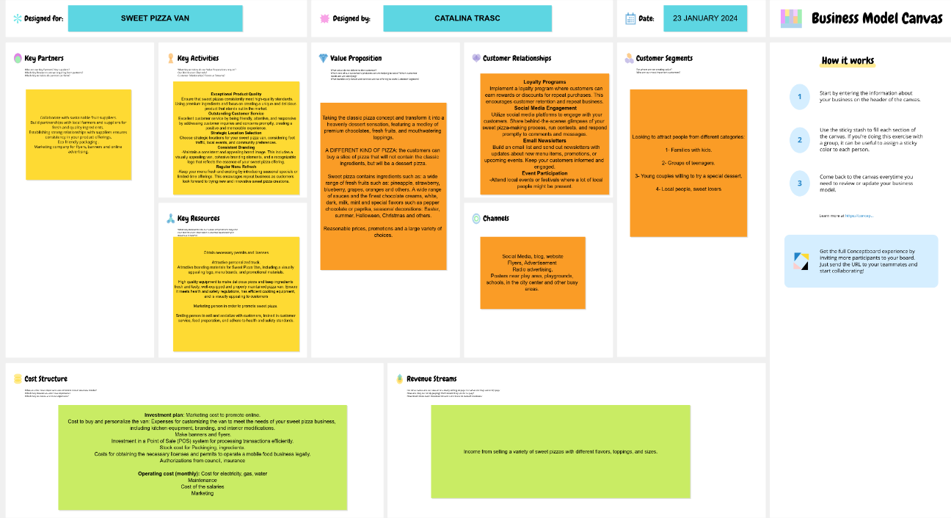
Fig. 1 Business Model Canvas ( Business Model Canvas ‒ Conceptboard )
The beginning of any business, regardless of the field of activity, consists in drawing up a business plan.
A business model outlines how a company intends to generate revenue and achieve profitability through its operations. The Business Model Canvas, created by a team under the direction of Alexander Osterwalder and Yves Pigneur, offers a visual representation of crucial components. Effectively creating it necessitates thorough consideration of various aspects of the business. Conducting a feasibility analysis plays a pivotal role in the decision-making process, determining whether to proceed or not. This analysis involves a meticulous examination of product/service details, market dynamics, industry factors, and financial data, conducted with sufficient granularity to instill confidence in the outcomes. Assessing the targeted market and industry is indispensable in gauging the feasibility of a business concept. ( Mariotti, Steve, and Glackin, 2015)
The hospitality business proposal is to produce and sell to customers a pizza totally different from the classic one, a dessert pizza that will contain fruits, sauces and creams, based on chocolate and other kind of sweets. The business will initially start in a food caravan located in the center of Swansea City on Oxford Street, according to the permits obtained. Each category from BMC will be discussed below, explaining the business plan for the Sweet Pizza Van proposal.
At the moment the main competitors on the market are waffles, crepes, donuts Krispykreme (Krispykreme.co.uk, 2024) is one of the most famous in the area and churros producers. None of them are selling exactly the same products, but all of them can be found in the area, they are street food desserts as well and are using more or less the same ingredients, so they are in the same niche.
Value proposition - the combination of products or services that delivers value to specific customer segments.
The idea of this type of street food is to attract customers through a well-known product, but which is in the same time totally different from the variant they are used to. This pizza doesn’t contain the classic ingredients. It is a dessert pizza that is both healthy and delicious and satisfies the tastes of a large audience through the variety of fruits, sweets and toppings available.
Sweet pizza contains ingredients such as: a wide range of fresh fruits such as: pineapple, strawberry, blueberry, grapes, oranges and others. A wide range of sauces and the finest chocolate creams, white, dark, milk, mint and special flavors such as pepper chocolate or paprika, seasonal decorations: Easter, summer, Halloween, Christmas and others.
It is fitting for a business, while aligning prices in its market, to ensure that it competes with its counterparts based on the quality of its product. (Tracy, 2003), so reasonable prices, promotions and a large variety of choices will be available.
Customer segments - The diverse sets of individuals or organizations aimed to be reached.
A customer strategy is a thoughtfully devised plan that leads to optimal customer responsiveness. (Manning et al., 2010, p.161)
Since the products marketed are sweets, the target customers will be: families with kids, groups of teenagers, Krispykreme (Krispykreme.co.uk, 2024) is targeting the same categories, due to the specifics of products that are especially loved by children and adolescents, young couples willing to try a special dessert and of course all other local people that are sweet lovers are welcomed to enjoy the specialties.
Customer relations - The nature of relationships envisioned for each customer segment.
Customer relationship management (CRM) is the procedure of identifying and categorizing customers to formulate a suitable relationship strategy, enabling the organization to acquire, retain, and expand its business. (Tanner et al., 2009, p.96).
In order to maintain a relationship with the customers, loyalty programs will be implemented, where customers can earn rewards or discounts for repeat purchases. This encourages customer retention and repeat business.
Enhanced connections between buyers and sellers underscore the necessity for increased and improved cooperation and collaboration. (Vargo and Lusch, 2004)
Because young generation is the targeted customer profile, utilize social media platforms to engage with your customers it is a suitable way to use. Share behind-the-scenes glimpses of your sweet pizza-making process, run contests, and respond promptly to comments and messages.
Event participation it is also important as attending to local events or festivals can make a good image promotion and a lot of people will be attracted by smell, presentation and curiosity.
Channels - The planned approach for communication and reaching each customer segment.
To promote the business to local community it is important to chose the best way to get with your product to the right possible customers. Marketing is the interaction between the enterprise and the customers it aims to serve. Owner-managers prefer personal marketing methods as they enable small businesses to stay connected with the market, offering a prompt response to customer requests through regular interactions. (Stokes and Wilson, 2010). Chosen channels for Sweet Pizza Van are social media: Facebook, Instagram, Tik-Toc, Pinterest, blog, website, flyers and posters, radio advertising because the main customers will access those methods.
Revenue streams - The generated revenue.
The income from selling a variety of sweet pizzas with different flavors, toppings, and sizes. In the near future planning to make deliveries for private events like birthdays, company events and others.
Key activities - Key elements required for the success of the business model.
In an article in Manning et al.,1999, says that each buyer requires personalized treatment, therefore the Sweet Pizza van will try to adapt to the requirements of the audience and create for each customer the perfect slice of pizza for his taste.
Exceptional product quality: ensure that sweet pizzas consistently meet high-quality standards. Using premium ingredients and focus on creating a unique and delicious product that stands out in the market.
Outstanding customer service: excellent customer service by being friendly, attentive, and responsive by addressing customer inquiries and concerns promptly, creating a positive and memorable experience. Non-verbal communication, encompassing facial expression, voice tone, handshake, gestures, appearance, and posture, constitutes crucial elements of a relationship strategy. (Manning et al., 2010).
Strategic location for sweet pizza van, considering foot traffic, local events, and community preferences, as mentioned on Swansea City Centre, on Oxford Street.
Consistent branding: maintain a consistent and appealing brand image. This includes a visually appealing van, cohesive branding elements, and a recognizable logo that reflects the essence of your sweet pizza offering.
Regular menu refresh: fresh and exciting by introducing seasonal specials or limited-time offerings. This encourages repeat business as customers look forward to trying new and innovative sweet pizza creations.
Key resources - Critical assets necessary for the functionality of the business model.
The key resources necessary to start and develop Sweet Pizza Van are: attractive personalized van, the necessary permits and licenses, attractive branding materials for Sweet Pizza Van, including a visually appealing logo, menu boards, and promotional materials, high-quality equipment to make delicious pizza and keep ingredients fresh and tasty, well-equipped and properly maintained pizza van. Ensure it meets health and safety regulations, has efficient cooking equipment, and is visually appealing to customers because all those aspects offer a plus in customer’s eyes.
For collating and customizing the food truck will collaborate with Hansign Graphics, Swansea’s premium print company. Also for banners and other printings for local promotion. (Hansign, 2024)
Also marketing strategy it is a key resource in order to get promoted well and a smiling person to sell and socialize with customers, trained in customer service, food preparation, and adhere to health and safety standards, will help to grow the sales.
Key partnerships – The interconnected network of suppliers and partners essential for the functionality of the business model.
Taking into account the fact that is a street food business it is very important the products quality, so collaboration with sustainable fruit suppliers and build partnerships with local farmers and suppliers for fresh and quality ingredients it is essential. Also other partners like Takeawaypackaging (takeawaypackaging.co.uk, 2024) for packaging products and Libertymarketing (Libertymarketing.co.uk, 2024) for marketing activities has to be taken into consideration for better results in selling.
The main food partnerships will be: Welsh Fruit Stocks (Welshfruitstocks, 2024) for fresh seasonal fruits, Wickedly Welsh Chocolate Company for chocolate sauces (WickedlyWelsh, 2024), nuts, cereals and others collaborate with The Ludlow Nut Company (Ludlownut.co.uk, 2024) and other partnerships will be made in time.
Cost structures - The interconnected network of suppliers and partners essential for the functionality of the business model.
The cost will be divided in two main categories: investment plan, that is made at the beginning and operating costs that are monthly and they have almost same value each month, with small variation.
Investment plan contain the cost to buy and personalize the van, cost for obtaining the necessary licenses and permits to operate a mobile food business legally, insurance, cost for a marketing strategy including banners and flyers, POS system, and stock cost ( Rae, 2008)
Operating cost involve marketing, cost of ingredients, salaries, electricity, gas, water and maintenance.
In conclusion, in order to win customers, in a competitive market, you must bring a novelty to your business. This can consist of decorating the street van in a unique mode, packaging the product in special packages or why not in the clothing of the sellers. Any idea or technique should be used to attract customers and leave them a memory that will bring them back, so they become loyal customers and tell friends about this business.
For the success of a business in hospitality sector, all aspects mentioned in the business plan are important, but the most important is the investor's passion for his business and his knowledge in the field, so he can be able to face competitors and to have a plus in front of them.

References
App.conceptboard.com (2024) Available at: Business Model Canvas ‒ Conceptboard Accessed on: 23 January 2024.
Barringer, B. R. & Ireland, R.D. (2018) Entrepreneurship: Successfully Launching New Ventures, 4th Ed., Prentice Hall: New Jersey.
Hansign.co.uk (2024) SWANSEA'S PREMIUM PRINT COMPANY. Available at: Hansign Custom Graphics in Swansea - Vehicle decals, body wraps and signage. Accessed on: 01st February 2024.
Krispykreme.co.uk (2024) Love our community. Available at: Love Our Community | Krispy Kreme. Accessed on: 01st February 2024.
Libertymarketing.co.uk (2024) Creating, managing, and strategising your Facebook ads. Available at: PPC Services - PPC Agency - Liberty Marketing. Accessed on: 1st of February 2024.
Ludlownut.co.uk (2024) The Ludlow Nut Company. Available at: The Ludlow Nut Co: Premium Nuts, Cereals and Dried Fruit. Accessed on: 28th January 2024.
Manning G. L. Reece B. L. Ahearne M. (2010). Selling today: Creating customer value (11th ed.). Pearson Education International.
Mariotti, S. and Glackin, C. (2012) Entrepreneurship: Starting and Operating a Small Business (3rd Ed), London: Prentice-Hall.
Nelson Oly Ndubisi, Sonny Nwankwo, (2013) Enterprise Development in SMEs and Entrepreneurial Firms: Dynamic Processes. IGI Global.
Rae, D. (2008) Entrepreneurship: from opportunity to action, 2nd Ed., Basingstoke: Palgrave Macmillan.
Stokes D. Wilson N. (2010). Small business management and entrepreneurship. Mason, OH: Cengage.
Takeawaypackaging.co.uk (2024) Sustainable takeaway packaging for Eco-conscious brands. Available at: Takeaway Packaging | Food, Drinks and Accessories. Accessed on: 27th January 2024.
Tanner J. , J. F., Ahearne, M., Leigh, T. W., Mason, C. H., & Moncrief, W. C. (2005). CRM in sales-intensive organisations: A review and future directions. Journal of Personal Selling & Sales Management, 25(2), 170–180.
Timmons, J. & Spinelli, S. (2008) New Venture Creation: Entrepreneurship for the 21st Century, McGraw Hill: Boston.
Tracy B. (2003). Analysing the competition. Value-Added Selling, 21, 2.
Vargo S. L. Lusch R. F. (2004). Evolving to a new dominant logic for marketing. Journal of Marketing, 68, 1–17. 10.1509/jmkg.68.1.1.24036
Zimmerer, T.W. & Scarborough, N.M. (2011) Essentials of Entrepreneurship, 6th Ed., Prentice Hall: New Jersey.
Welshfruitstocks (2024) Available at: Fruit Bushes, Strawberry Plants & Other Soft Fruit Plants from Welsh Fruit Stocks Plant Nursery. Accessed on: 27th January 2024.
Wickedlywels (2024) Wickedly Welsh Chocolate. Available at: Chocolate Gift Boxes and Hampers – Wickedly Welsh Chocolate. Accessed on: 28th January 2024.
Williams, S. (2021) FT Guide to Business Start Up: The most comprehensive guide for
entrepreneurs, 32nd Ed., Financial Times Press: Harlow.

PART 2: 500 Word reflective essay
The main aim of this reflective essay is to reflect upon my results of the test and critically evaluate my entrepreneurial motivations using the Gibbs reflective cycle, which has the following structure: description, feelings, evaluation, analysis, conclusion and action plan each of them with her purpose in order to help you analyze better and get best actions from your analyze. Gibbs said that without a reflection, an experience can be easily forgotten, that’s way it is important to reflect upon our experiences and learn from our mistakes. (Gibbs, 1988)
There are several reflective methods, like the ERA cycle, Driscoll’s What Model, Kolb’s Experiential Learning Cycle, Gibbs’ Reflection Cycle and others. (University of Cambridge, 2023)
First of all in order to analyse the test results it is primordial to know what an entrepreneur skills and abilities are and also what a reflective writing involves. Entrepreneurship involves identifying opportunities and creatively managing resources to bring about innovation and change. Continuous reforming and adaptation are crucial in navigating the dynamic landscape of business. (Legge and Hindle, 2004). According to (Gartner, 1989) entrepreneurs create organizations.
The test contained around 52 questions and it was very interesting. I was curious, excited and nervous to find out the results, as I was thinking several times to start my own business but all the times I found different reasons that step me back.
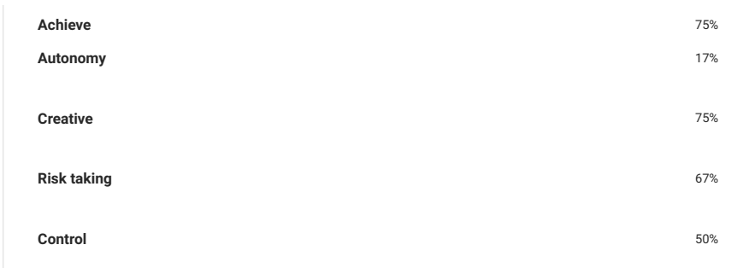
Fig.1 Test results ( get2test.net )

The overall result of the test was that I am an occasional entrepreneur with a score of 61% and that I have strengths in some of the enterprising characteristics. After receiving the test results, I tried to see if I agreed or not with the percentages obtained in each category. From some points of view I saw myself in the description, but with others I am not completely agree.
In my analysis I will focus on the aspects that I consider most relevant from this test results.
75% score of need for achievement reflects the fact that I am a person orientated to the future, that I rely on my own abilities, responsible and persistent in my aims, goal orientated and willing to work long and hard to complete my tasks. I feel that those characteristics describe my very well and I know that fact that I could do a good job by opening a business and why not to become an entrepreneur, is just that I don’t believe enough in myself and my ideas.
The test results said 67% on risk-taking, which I am not completely agree, because fear is the main reason for I didn’t had any business until now. I am overthink of a lot of aspects and I don’t like to go on the risk actions even if I am totally agree with the theory that if you don’t risk, you don’t win.
In conclusion, the test was a good method to understand my entrepreneurial skills better and to give a nudge in trying to start my business as I have a lot to offer to the world.
As an action plan, in the near future I am thinking of doing some courses in order to increase my self-confidence and how to see myself better trying to highlight my strengths and also to learn how to manage a team in a professional manner.

References
Gartner, W. B. (1989). “Who Is an Entrepreneur?” Is the Wrong Question. Entrepreneurship Theory and Practice, 13(4), 47-68. https://doi.org/10.1177/104225878901300406
Get2test.net (2024) Get2 test for enterprising potential. Available at: General Measure of Enterprising Tendency v2 - GET2 (get2test.net) Accessed: 09th January 2024
Gibbs, G. (1988) Learning by Doing: A Guide to Teaching and Learning Methods. Oxford: Further Education Unit, Oxford Polytechnic.
Legge, J. and Hindle, K. (2004) Entrepreneurship: Context, Vision and Planning, Palgrave Macmillan, Basingstoke.
University of Cambridge (2023) Reflective Practice Toolkit. Available at: https://libguides.cam.ac.uk/reflectivepracticetoolkit/models (Accessed: 20th January 2024)

