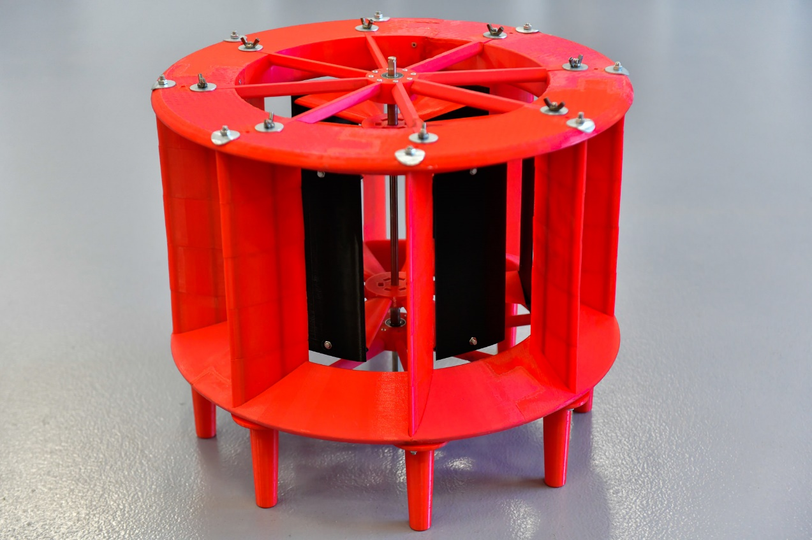

Business Report

AVAWT
Augmented Vertical Axis Wind Turbine
Christopher Davies 2126255 |  | 13/05/2023

CONTENTS
Page 01 Cover page
Page 02 Contents
Page 03-04 Project overview – Purpose, Position and Pathway
Page 05-06 Partnerships, Procurement and Production
Page 07 Rationale, Resources and Reality Check
Page 08 Investment Appraisal Tools – Strengths & Weaknesses
Page 09-14 Assumptions, Analysis and Action
Page 15-16 Iterations, Innovation, and Investment
Page 17-19 Appendix 1 – Notes relating to Spreadsheet model
Page 20 BIBLIOGRAPHY

Word Count excluding Cover Page, Contents Page, Appendix 1, and Bibliography = 2,563 (including references)
NB – The spreadsheet model supporting this report and the PPT presentation is available in Appendix 1A which is submitted as an Excel spreadsheet file and can be used for further sensitivity analysis.

Project Overview
1. Purpose, Position and Pathway

1.1 Purpose
The development of an augmented vertical axis wind turbine requires careful consideration in terms of its value proposition.
Our core strategic purpose is to catalyse the development, application, and adoption of resource efficient technologies.
Resource efficiency, in the context of energy usage, includes both minimising consumption and optimising clean energy generation.
Developing the AVAWT is therefore fully aligned with our corporate strategic purpose which includes renewable (and usable) energy generation.

1.2 Position
This report has been prepared to present a clear picture of where we are, where we are going, and how we plan to get there.
Our position can be summed up as follows:
- After 2 years of development and testing in our R&D ‘skunkworks’ we have 3 small working prototype AVAWTs which are undergoing wind tunnel and flume testing.
- Results have been encouraging and one notable feature of the device is its inherent stability, which opens the possibility of wider scale deployment on flat roofs of buildings everywhere whether in urban, coastal, or rural locations.
- We are now waiting for results from independent tests which will provide a power curve for the AVAWT confirming both its efficacy and potential value.

1.3 Pathway

The pathway ahead looks straightforward but has some key milestones which may also be considered as stage gates in our innovation management process.
Moving on from our current position the milestones can be summarised as follows:
- Year 0 - Obtain results from independent wind tunnel testing.
- Year 0 - Calculate the power curve to determine its potential value.
- Year 1 - Create a digital twin of the AVAWT which can be refined by further iterations of physical prototypes (this might be a collaborative project with UWTSD)
- Year 1 - Develop the first commercial product based on Voice of Customer (VoC) (Cooper 2019) which will begin with assessing demand from the touring and static caravan sector (including motorhomes and campervans)
- In collaboration with supply chain partners, agree manufacturing lead times for a 250-350watt version of the AVAWT.
- Year 1 – Leisure Sector strategic marketing
- Year 2 – Receipts begin from sales to Leisure sector.

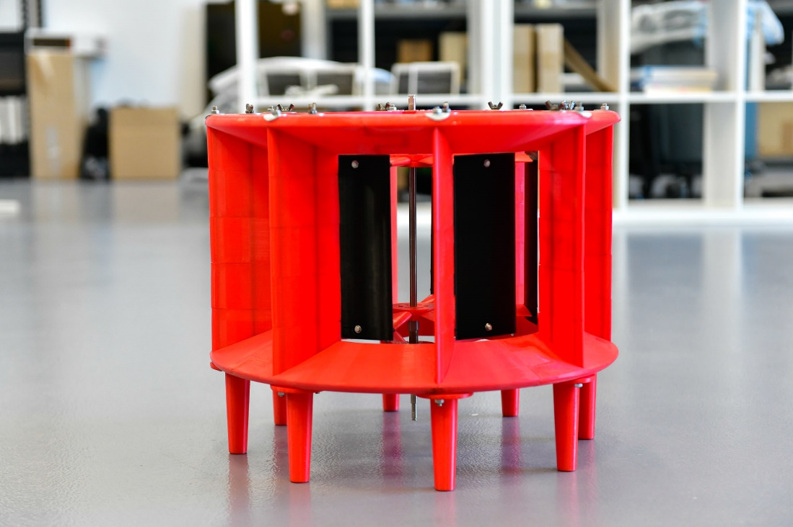

2. Partnerships, Procurement and Production

2.1 Partnerships
We will explore partnerships with:
- AMRC Cymru (material choice and manufacturing processes)
- UWTSD (Digital Twin)
- Caravan Club and Park Home Organisations (Voice of Customer)
- Supply Chain partners & Customer (early adopter) User Groups
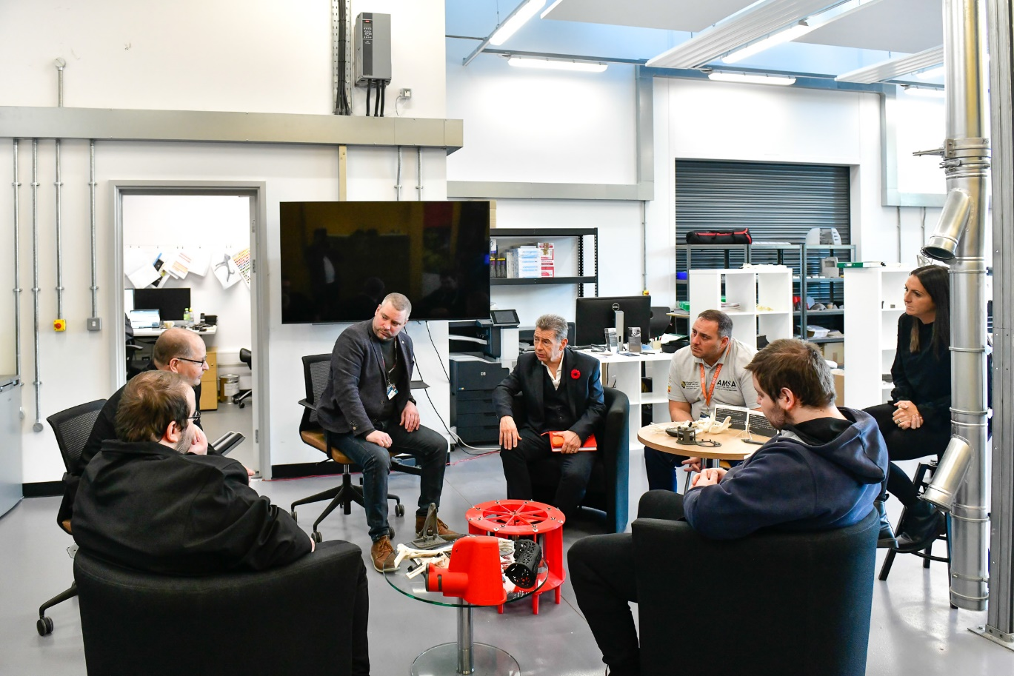
Early discussions with UWTSD about the creation of a digital twin for the AVAWT

2.2 Procurement
We will establish a resilient local supply chain and embrace open innovation by involving both our suppliers and customers in developing and adding further value to the AVAWT.
Working with local partners has the potential to catalyse the creation of sustainable business model and we aim to stimulate an active innovation ecosystem throughout the entire (envisaged) value chain.

2.3 Production
We will seek expert advice from AMRC Cymru for the selection of key component manufacturing partners.
Our role will be to design and specify components and assemble them in kit form for installation.
We are open to working with large organisations who share our corporate purpose and could assist in accelerating production, distribution, and adoption of the AVAWT product range.

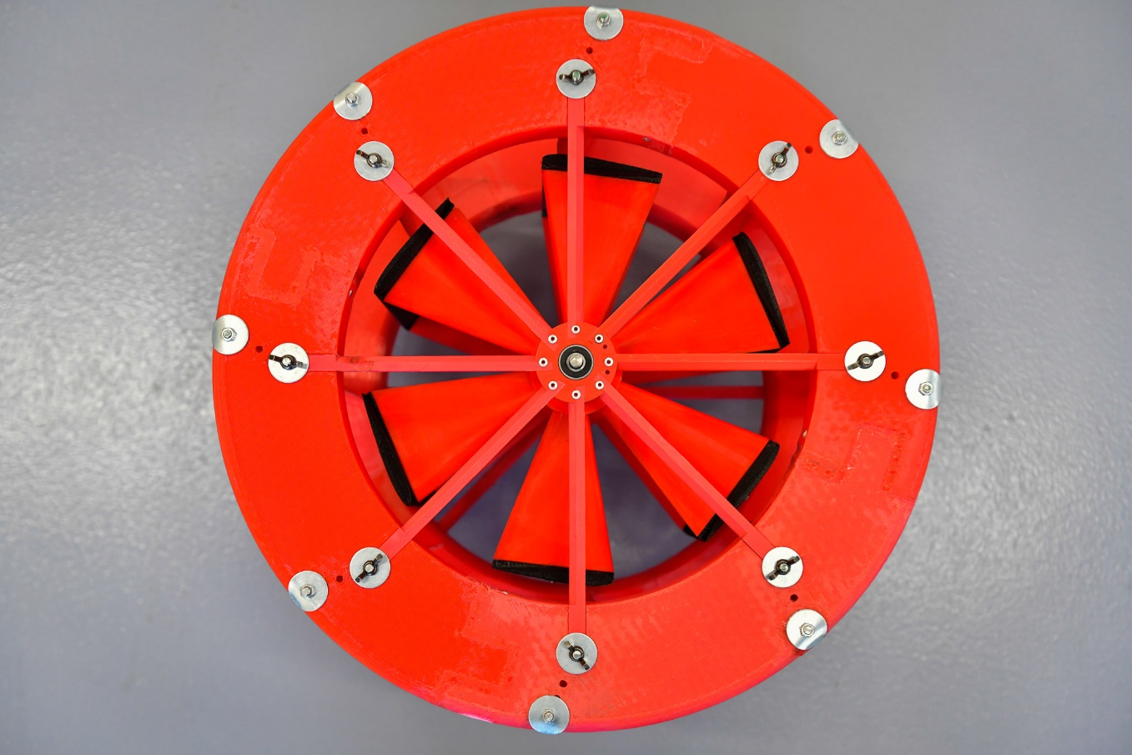
The view of this early prototype from above the device and shows its 6 aerofoils

3. Rationale, Resources and Reality-check

3.1 Rationale
Alignment with our strategic corporate purpose is clear, however we must be realistic about the availability of resources needed to reach our prescribed milestones.
The accounting adage ‘past costs are sunk costs’ conveys the fact that we should always consider future incremental costs and benefits and base decisions we make TODAY upon the future consequences of the choices we make (Atrill, McLaney 2021)

3.2 Resources
The resources needed today, which for the purpose of financial evaluation are regarded as ‘Year 0’ are estimated to be £20,000 and comprise key test equipment which will be needed for our ‘Year 1’ R&D activities.
Moving into ‘Year 1’ will only be triggered by successful test results and a viable power curve which demonstrates an attractive value proposition for customers.
‘Year 1’ project specific operating losses will arise from the opportunity cost of using the skills of our R&D Team internally. The revenue foregone which would have been generated by delivering external R&D services has been introduced as an opportunity cost (Atrill, McLaney 2021) to the project appraisal, to enable an intelligent and better-informed decision to be made.

3.3 Reality Check
Our enthusiasm must be tempered by the financial realities surrounding our proposed development programme.
The term ‘Frugal Innovation’ resonates clearly within our business, and we understand that financial viability is the key for making correct investment decisions.
In terms of investment appraisal there are a few well-known financial techniques used for decision-making, some of which are presented in the following table together with their strengths and weaknesses:

INVESTMENT APPRAISAL TOOLS – STRENGTHS & WEAKNESSES
Investment Appraisal Technique | Strengths | Weaknesses
Simple Payback Period | Easy to understand and calculate, useful for short-term projects | Ignores the time value of money, does not account for cash flows beyond the payback period (Maverick 2021)
Accounting Rate of Return | Uses accounting data that is readily available, simple to calculate (Murphy 2022) | Ignores the time value of money, does not account for cash flows beyond the investment horizon, focuses on accounting profits rather than cash flows (Murphy 2022)
Net Present Value | Accounts for the time value of money, considers all relevant cash flows (Gallo 2014) | Can be difficult to calculate, requires accurate estimates of future cash flows and discount rates. “You can mitigate the risks by double-checking your estimates and doing sensitivity analysis after you’ve done your initial calculation” (Gallo 2014)
Internal Rate of Return | Accounts for the time value of money, provides a rate of return that is easy to compare to other investments (Team 2021) | Can be difficult to calculate, may not provide a clear indication of the best investment option when comparing mutually exclusive projects. A project can have multiple IRRs in its lifespan when the cash flows fluctuate; therefore, the analyst cannot rely on a single IRR value (Team 2021).
Benefit-Cost Ratio | Accounts for the opportunity cost of funds, and is based upon the Net Present Value of a project (Murphy 2022) | Can be difficult to calculate, requires accurate estimates of benefits and costs (Hayes 2022)
Profitability Index | Accounts for the time value of money, provides a ratio of profitability relative to investment (Chen 2021) | Can be difficult to calculate, does not account for the opportunity cost of funds (Chen 2021)

4. Assumptions, Analysis and Action

4.1 Assumptions
The following key assumptions have been made for conducting our financial appraisal of the AVAWT R&D project:
- Year 0 - Capital Expenditure = £20,000
- Year 1 - Opportunity Cost (relating to revenue foregone by the R&D team from external sources) = £72,000
- Year 1 - Material Costs = £12,000 relating to further prototyping and development of a digital twin for the AVAWT
- The R&D equipment bought in year 0 will be depreciated over 5 years starting in Year 1
- The discount rate of 16% reflects our weighted average cost of capital and is used in calculating the Net Present Value of the project.
- Trading revenues will begin in Year 2 and the expected Gross Margin should be 46% before trading overheads (estimated at 10% of sales revenue)
- Conservative sales estimate for total sales in Year 2 = £90,000 increasing by a further £90,000 each year thereafter
- Expected sales estimate for total sales in Year 2 = £120,000 increasing by a further £120,000 each year thereafter

4.2 Analysis
We have looked at the shortcomings of various investment approaches and to overcome them our analysis will look at a combination of:
- Net Present Value (NPV)
- Simple Payback (for illustration only)
- Sensitivity Analysis – using the spreadsheet model provided in Appendix 1
Based upon our assumptions which are stated in 4.1, our AVAWT project is expected to return a NPV of £88,856 (using Conservative sales estimates).

4.2 Analysis (continued)
The simple payback period for this level of sales is between 3 and 4 years and can be calculated as follows:
- Year 0 - Cumulative Cash outflow = £20,000
- Year 1 – Cumulative Cash outflow = £104,000 (£20,000 + £84,000)
- Year 2 – Cumulative Cash outflow = £71,600 (£104,000 - £32,400)
- Year 3 – Cumulative Cash outflow = £6,800 (£71,600 - £64,800)
The question now is how long it takes to recover £6,800 during year 4?
We assume that year 4 revenues arise evenly over the course of the year.
Total net cash inflow expected in year 4 = £97,200
It will therefore take (£6,800/£97,200) x 12 (months) = 0.8395 months (say 1 month into year 4.
Simple payback is therefore 3 years and 1 month employing conservative sales estimates.
Employing basic sensitivity analysis (Gallo 2014), we can change the key variables in the spreadsheet model which is presented in Appendix 1. These key variables are highlighted in yellow (on the spreadsheet) and include:
- Capital Expenditure (cell reference C4)
- Cost of Sales % (cell reference B7)
- Trading Overhead expressed as a % of sales (cell reference B9)
- Cost of Capital %, which is the discount rate (cell reference B14)
- Year 1 Opportunity Cost re Income foregone (cell reference D3)
- Year 1 R&D Material Costs & Overheads (cell reference D5)
- Sales forecasts (cell reference E6:H6)
Our model also enables us to calculate the discount rate, which when applied, would return a nil value for NPV. This is known as the Internal Rate of Return (IRR) and there is also a simple Excel financial formula that can be used to calculate this rate. The IRR is shown clearly in the next graph where the project NPV is reduced to nil when a discount rate of 45.613% is applied.

4.2 Analysis (continued)
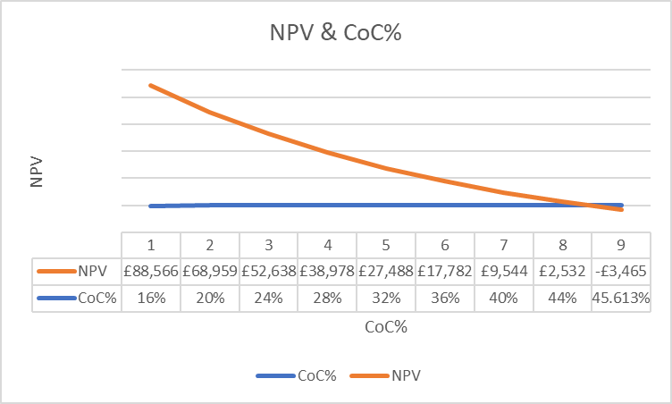
The following table shows the impact on the project NPV by changing the Cost of Sales % (using conservative sales estimates):
Cost of Sales % | NPV Calculated by Model
Base model = 54% | £88,566
2% Adverse movement = 56% | £78,511
17.617% Adverse movement = 71.617% | £0

The table (Cost of Sales v NVP) shows that we could tolerate an increase of 17.6% in our Cost of Sales % and still return a nil NPV when using a 16% discounting rate. This is illustrated in the next graph:

4.2 Analysis (continued)
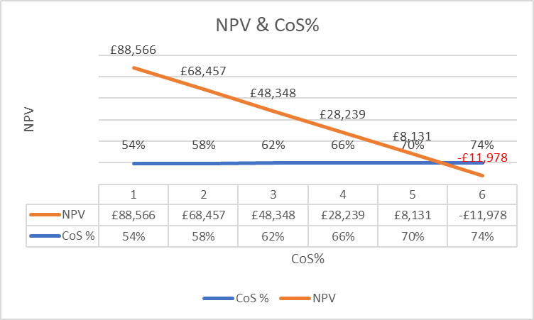This chart is taken from the data in Appendix 1 for the conservative sales forecast
What if our R&D Team was offered a research contract worth £150,000 in year 1 (which would represent an increase of £78,000 over the anticipated opportunity cost of £72,000)? What impact might this have on our decision?
Substituting £150,000 into our model for Year 1 ‘Contribution Foregone’, the revised NPV is calculated at £21,325 (using Conservative sales estimates). A screenshot of our model using these assumptions is shown below:

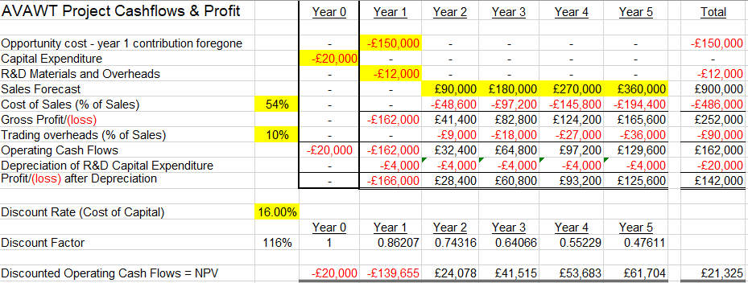

4.2 Analysis (continued)
Summary
Our financial model, using sensitivity analysis (Magni, Marchioni 2020), enables us to calculate the NPV of the AVAWT project in an intelligent and conservative manner.
The second page of the model predicts a NPV of £148,893 using ‘Expected sales levels’ and provides further comfort about the viability of the AVAWT project.
We have seen that a 16% Cost of Capital, using Conservative sales estimates, returns a NPV of £88,566. The IRR for this scenario is 45.61% (almost 30% more than our Cost of Capital) representing a healthy margin of safety.
We have also explored the impact of a significantly higher ‘Opportunity Cost’ being the revenue foregone by the R&D Team by focusing on the AVAWT project. Increasing the ‘Opportunity Cost’ in Year 1 by 108.33% still returns a positive NPV of £21,325.
Conclusion
Given that the AVAWT is fully aligned with our strategic corporate purpose, and that the R&D Team are fully motivated to achieve a positive outcome there are good reasons to look favourably on the results of our financial analysis modelling.
The model demonstrates a good level of resilience in the project and its ability to generate a positive NPV.
The simple payback analysis, assuming conservative sales levels and included for reference only, shows that the investment would be paid back within 3 years and 1 month.
The positive NPV stands up to significant adverse movements in the key variables, and therefore supplies a robust basis for adopting the AVAWT project.

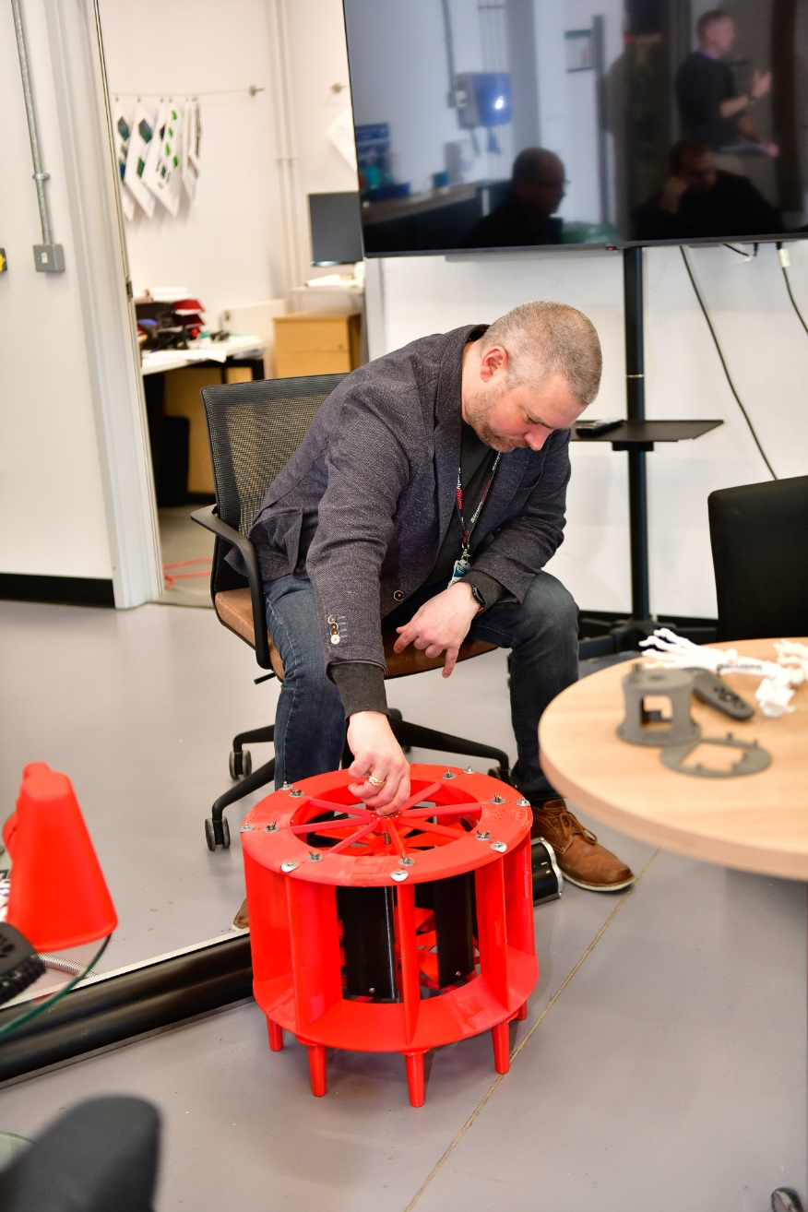
This model is indicative of the size undergoing wind tunnel testing
4.3 Action
Our conclusion, based upon the findings of the financial analysis, is that the AVAWT project should be adopted.
Prior to adoption, we must wait for the results of independent performance testing and confirmation that the device will offer an acceptable ‘power curve’.
The results from wind tunnel testing and the device’s power curve will act as a stage gate for our AVAWT, and if these are positive, the project will go ahead.
5. Iterations, Innovation, and Investment
5.1 Iterations
Year 1 activity will include the production of a series of prototypes, working closely with supply chain partners and potential user group representatives.
The leisure marketplace including static and touring caravans, campervans, and camping, will be explored. This project must be market led and determining customer pain points will be essential if we are to offer users an attractive MVP.
The first prototype will be aimed at the leisure sector and will be tested on a static caravan.

5.2 Innovation
Our MVP will be enhanced by sensors which can detect a series of performance indicators such as power generation, vibration, TS (tip speed) and other metrics which can be fed back to our product development team.
This will aid us to develop stronger user relationships and to keep in touch with our AVAWT products throughout their lifetime, facilitating predictive and proactive maintenance.
Our aim will be to offer solutions to customers which address some of their key pain points. These solutions will include:
- Portability
- Modularity
- Click-and-connect.
- Mountable and demountable with ease (possibly collapsible)
- Accessories such as far infrared heating mats (used for keeping vans warm and dry throughout the winter months)
- Telescopic mounting platforms for installation ease and versatility
- Use for off-grid generation of hydrogen via electrolysis (EY Team 2022)

5.3 Investment
Sources of Funds
The sources of fund that can be considered include:
- Internally generated cash profits derived from consultancy and channel partnerships.
- Short-term working capital using corporate credit-card facilities.
- Injection of additional equity from current shareholders
- Short-term Bank Loan (taken over a 4-year term)
- EIS (Enterprise Investment Scheme) provides incentives for early-stage investors to participate in companies with high growth potential, by giving them significant tax breaks to mitigate any potential losses (Pike, Neale et al. 2018) This may be attractive to high Net-Worth ethical investors with SDG (Sustainability Development Goals) in mind.
- A collaborative development partnership with UWTSD and/or AMRC Cymru could reduce some of the time and costs to complete the R&D schedule for Year 1 and thereby contribute as an effective substitute source of funding.
- Supply chain partners may be willing to help with the R&D activities on the basis that they will be beneficiaries of future production orders. This may include the provision of materials or components for trial and testing.
- Innovate UK or other sources of grant support may become available and continuous scanning will be important.

Appendix 1 (notes re Spreadsheet NPV model)
Notes re Key Variables for Financial Model in Appendix 1A
- We must keep all key variables under review and use sensitivity analysis to ensure that we make informed decisions.
- The first page reflects the Conservative Sales Levels which have been employed throughout the report for prudence.
- The second page of the model reflects Expected Sales
- The key variables are shown in the model by highlighting their cell reference locations in yellow
- News affecting any variables, such as the availability of a new R&D related support grant, must be notified and adjusted in the model as soon as our project’s eligibility is confirmed (including collaborative R&D projects)
- Benefit Cost Ratio (BCR) and Profitability Index (PI) are calculated for completeness but are not relevant to our AVAWT project as there are no other projects competing for the immediate use of our limited resources.
- The model does not reflect intangible benefits resulting from open innovation, where value chain partners may add significant value to the AVAWT in terms of material selection and manufacturing method.
- Fore completeness, the model also calculates the Benefit Cost Ratio (BCR), Profitability Index (PI), and the Accounting Rate of Return (ARR), but in the context of the AVAWT project we have adopted NPV and sensitivity analysis.

The spreadsheet model is submitted separately as Appendix 1A, for reference purposes, however we will now look at this model by using different values for some of the key variables to examine what impact there would be on the predicted Net Present Value (NPV).
The table below shows the key input variable values for a series of scenarios together with their predicted outcomes.
We have already adopted conservative sales projections which are 25% below expected achievable levels. This prudent approach has been retained throughout the appraisal process.

- Scenario 1 is our control model combination of variables
- Scenario 2 reflects a 10% adverse movement in each of the key variables
- Scenario 3 reflects a 15% adverse movement in each of the key variables
- Scenario 4 reflects a 20% adverse movement in each of the key variables
- Scenario 5 reflects a 20% adverse movement in each of the key variables except for the discount rate which is held at the control level of 16%
This table demonstrates the resilience of the project’s NPV even when all the key variables, except for sales, are each increased by up to 20%.
We can quickly observe that the negative NPV of -£3,479 flips back to a positive of £5,734 when we reduce the discount rate back to the control level of 16%.
The shortcomings of the ARR are evident because the 84% return shown in scenario 4, which results in a negative NPV of -£3,479, still suggests an attractive outcome. Indeed, the ARR’s lack of respect for the timing of cash-flows is perhaps its greatest weakness.
To finalise our review, we will look at the same table using ‘Expected Sales’ as opposed to ‘Conservative Sales’ and this can be found on the second page of the spreadsheet (supplied in the separate Appendix 1A)

Using the higher ‘Expected Sales’ levels, we see that the model predicts a positive Net Present Value even when all the cost related input variables are adversely increased by 20%.

BIBLIOGRAPHY
ATRILL, P. and MCLANEY, E.J., 2021. Management accounting for decision makers. Harlow, England: Pearson.
CHEN, J., May 31, 2021-last update, Profitability Index (PI) Rule: Definition, Uses, and Calculation. Available: https://www.investopedia.com/terms/p/profitability-index-rule.asp [May 15, 2023].
COOPER, R.G., 2019. The drivers of success in new-product development. Industrial marketing management, 76, pp. 36-47.
EY TEAM, Nov 15, 2022-last update, Energy and Resources - The 10 Point Pod. Available: https://www.ey.com/en_uk/energy-resources [May 15, 2023].
GALLO, A., 2014. A Refresher on Net Present Value. Harvard Business Review, .
HAYES, A., 2022-last update, Benefit-Cost Ratio (BCR): Definition, Formula, and Example. Available: https://www.investopedia.com/terms/b/bcr.asp [May 13, 2023].
MAGNI, C.A. and MARCHIONI, A., 2020. Average rates of return, working capital, and NPV-consistency in project appraisal: A sensitivity analysis approach. International Journal of Production Economics, 229, pp. 107769.
MAVERICK, J.B., 2021-last update, Limitations of Using a Payback Period for Analysis. Available: https://www.investopedia.com/ask/answers/062915/what-are-some-limitations-and-drawbacks-using-payback-period-analysis.asp [May 13, 2023].
MURPHY, C.B., 2022-last update, Accounting Rate of Return (ARR): Definition, How to Calculate, and Example. Available: https://www.investopedia.com/terms/a/arr.asp [May 13, 2023].
PIKE, R., NEALE, B., LINSLEY, P. and AKBAR, S., 2018. Corporate finance and investment : decisions and strategies. 9 edn. Harlow, United Kingdom: Pearson Education Limited.
TEAM, W., -12-06T04:32:00+00:00, 2021-last update, Internal Rate of Return (IRR). Available: https://www.wallstreetmojo.com/internal-rate-of-return-irr/ [May 15, 2023].

