Construction Technology 1

Swansea Foreshore Ice-Cream Parlour


Kieran Lamb

Index
- Pages 1-4
Desk top study & site walkover
1 - Introduction
1.1 - Precursory work check
1.2 - Assessment objectives
- Pages 4-9
2 - Documentary research
2.1 - Site location & history
2.2 - Potential receptors
2.3 - Mining activity
2.4 - Review of site’s planning history
2.5 - Site usage
2.6 - Geology & measures for concern
- Pages 9-12
3 - Site walkover
- Pages 12-16
4 - Conclusions & recommendations
4.1 - Site summary
4.2 - Remedial measures summary
4.3 - Monitoring summary
4.4 - Key risk drivers
4.5 - Conclusions
4.6 - Choice of substructure
4.7 - Uncertainties
4.8 - Recommendations
4.9 - Appendix
- Pages 16-25
5 - Recommendations for more detailed site investigation
5.1 - Desktop study
5.2 - Walkover study
5.3 - Planning a site investigation
5.4 - Ground investigation
5.5 - Use of trial pits
5.6 - Use of boreholes
5.7 - Creating & working in a safe environment
5.8 - Legal requirements
5.9 - Steps to developing a safe system
6 - Task assessment
6.1 - Hazard identification & risk assessment
6.2 - Defining safe methods
6.3 - Implementing the system
6.4 - Monitoring the system

Construction Technology One – Swansea Foreshore Ice – Cream Parlour
Desk Top Study & Site Walkover
- Introduction
The city and county of Swansea have chosen to enter into a joint agreement with Marriott Hotels to undertake the construction of a new restaurant, ice cream parlour and manager’s apartment on the Swansea foreshore. The proposed structure is to have a GIA (Gross Internal Area) of approximately 300 square metres at ground floor level. The ground floor area of the development will contain a restaurant, cafe bar, ice cream parlour, kitchen, food stores and a few storage facilities. At first and second floor levels, there is proposed to be a self-contained manager’s apartment and staff welfare facilities. These spaces are to have a GIA of approximately 150 square meters. In this report details of current site conditions, an investigation into historical site use and several other factors which could be relevant. Recommendations will then be given if further action is required prior to the investigation.
1.1 Precursory Work Check
Have the precautional checks/assessments stated below been carried out prior to the undertaking of the desktop study:
- Confirmation of site boundary? Yes
- Decision made on prioritisation of the site? Yes
1.2 Assessment Objectives
The former use of the site across the Swansea Bay area during the industrial boom in the 19th century may have had the potential to cause contamination. However, no other developments prior to this cause a great deal of concern regarding land contamination. This report will analyse ground conditions, the potential for contamination and a wide variety of other factors which may cause issues.
The aims of this desk top study are as follows -
- Analyse the geology and whether site contamination is present and if so, is it ongoing;
- Investigate whether the site was once an historic landfill site and if so has this caused any contamination;
- Investigate whether there is any chance of long term flood risk;
- Assess the challenges presented by coastal erosion and what precautions need to be taken if any;
- Investigate whether the site lies on a Nitrate Vulnerable Zone (NVZ);
- Investigate whether the site is located near or on a closed mining facility;
- Assess the history of pollution incidents on the site and in the surrounding area;
- Investigate previous planning and ongoing planning applications to check the status of the site and surrounding area.
2. Documentary Research
2.1 Site Location & History
Site Location - The site is located between County Hall and the Marriot Hotel taking up small areas of grassland with several trees and shrubbery also sharing an area of both adjacent facilities carparks.
Site Area - The building which is to share parts of the car park of both the Marriott Hotel and the County Hall is to have a GIA at ground floor level of approximately 300 square metres. At first and second floor levels there is to be a GIA of approximately 150 square metres.
Site Description -
Potential Contamination Sources - Hazardous substances may have/ still be present from the time of the industrial boom in the 19th century and as the seafront developed. Copper smelting had become a major industry in the lower Tawe valley in the 1800’s due to the abundant supply of coal.
Adjacent Land Usage - A few commercial properties are in the nearby vicinity including the Marriott Hotel on the north-easterly side in which the development is in partnership with. Also, within this area is the Maritime Quarter in which there is several residential and commercial properties. In the north-westerly direction lies the Central Library and the West Glamorgan Archive Service.
2.2 Potential Receptors
- Surface water
- Water absorption by surrounding vegetation
- The public
- Change of seasons
- Site workers on nearby projects
2.3 Mining Activity
Coal mining was extremely popular in and around the Swansea area during the industrial revolution, however, there is no evidence that the site we are building on lies on diminished material or above an abandoned coal mine.
2.4 Review of Site’s Planning History
Swansea council hold several previous planning applications around the site in question. Records of a development being carried out directly on the chosen site cannot be located. However, there have been a few developments on the adjacent commercial establishments over the years which can signify what kind of work has been carried out on the land.

Application | Summary of planning record / contaminated land conditions on decision notice.
2008/2026 | Commercial development (Approved)  Note - Swansea Marriott Hotel, Trawler Road, Maritime Quarter, Swansea, SA1 3BS - Fri 19th Dec 2008 - Smoking Shelter
2004/0516 | Residential/Commercial development (Approved) Note - Land East Of Marriott Hotel, Seagate And Ferrara Quay, Trawler Road, Maritime Quarter, Swansea - Mon 08 Mar 2004 - Residential/commercial development comprising: 29 storey tower with retail/leisure use (Class A1, A3, D2) and residential reception at ground floor, restaurant (Class A3) on part level 26, level 27 and level 28, and 124 residential units throughout the interim levels (Ferrara Tower); one six storey block with ground floor commercial uses (retail Class A1/A3 and Leisure Class D2) and 20 residential units above (Ferrara Block A); one part six storey/part ten storey block with ground floor commercial (retail Class A1, A2, A3 and Leisure Class D2) and 41 residential units above (Ferrara Block B) at Ferrara Quay. One six storey block incorporating commercial unit (Class A1, A2, and B1) and 47 residential units (Seagate Block A), one part seven/part 9 storey block with 41 residential units and commercial unit (Class A1, A2, A3, B1 and D2) (Seagate Block B) and two nine storey towers providing 18 residential units (Seagate Towers 1 and 2) at Seagate with a total of 234 undercroft parking spaces (78 spaces at Ferrara Quay and 156 spaces at Seagate). Refurbishment of Camona Drive multi-storey car park to provide an additional 67 parking spaces and associated areas of open space, landscaping, pedestrian routes and associated infrastructure.
A00/0903 | Commercial Development (Approved) Note - Wed 21 June 2000 - SINGLE STOREY EXTENSION TO SOUTH EAST ELEVATION TO PROVIDE ADDITIONAL KITCHEN, RESTAURANT AND NEW GYMNASIUM
98/0606 | Commercial Development (Approved) Note - Mon 27 April 1998 - Marriott Hotel Trawler Road,Maritime Quarter Swansea - SINGLE STOREY REAR EXTENSION INCORPORATING STAFF CANTEEN AND STORAGE/OFFICE ACCOMMODATION
95/0491 | Commercial Development (Approved) Note - Thu 20 April 1995 - Marriott Hotel Trawler Road,Maritime Quarter Swansea - SINGLE STOREY FRONT EXTENSION AND ALTERATIONS TO EXISTING ENTRANCE
93/0324 | Commercial Development (Approved) Note - Wed 17 March 1993 - The Marriott (Land East Of) Trawler Road,Maritime Quarter Swansea
2007/1013 | Commercial Development (Approved) Note - Thu 03 May 2007 - Western Entrance County Hall Oystermouth Road Swansea - Installation of internally illuminated advertisement panel, fully integrated into bus shelter
2006/2800 | Council Development (Approved) Note - Wed 20 Dec 2006 - County Hall Oystermouth Road Swansea SA1 3SN - Construction of two new canopies over entrances to proposed library and civic centre (Council Development Regulation 3)
2006/1729 | Council Development (Approved) Note - Mon 24 July 2006 - County Hall, Oystermouth Road, Swansea, SA1 3SN - Change of use of existing local government office accommodation within central core and south wing of County Hall to provide new central library (on ground and first floor) with new entranceway, plus separate cafe facility (Council Development Regulation 3)
2001/1028 | Council Development (Approved) Note - Tue 19 June 2001 - City & County Of Swansea, The Guildhall, Swansea, West Glamorgan, SA1 4PD - Enclosure of existing reception area with partitions to form new soundproof interview room (Application for Listed Building Consent)
92/0939 | Council Development (Approved) Note - Thu 06 August 1992 - County Hall -,Swansea SA1 3SN - SECURITY CAMERA TOWER IN CAR PARK. (CONSULTATION FROM WEST GLAMORGAN COUNTY COUNCIL)

2.5 Site Usage
The entirety of the site is mainly consisting of grass verge separating the two adjacent pathways coming off the main walkway across the seafront. The site boundary line infringes upon the car park owned by the Marriott Hotel and the car park for the County Hall. There are several plants and trees planted atop the grass verge areas which need to be investigated further.
2.6 Geology & Measures for concern
From using online resources and using the ‘mysoil’ application I have identified that the soil depth is deep with the main parent materials being riverine clay, sands and gravels. Since the ground is partially made up of riverine clay we must be extra cautious especially because there are several trees nearby. Clay soils are roughly made up of 40% water, however, trees can change this amount drastically throughout the year, causing the soil to shrink or swell. This can have a huge effect on the foundations of the building making it vital that the foundation type is suitable and that they are the correct depth to prevent movement. When completing the walk over inspection of the proposed site we will check the soil conditions to confirm these findings by feeling the soil. If the soil doesn’t crumble and is moldable then it is most likely clay, also looking for materials in the clay such as the sands and the gravels.
Generally, in Wales the clay is of a low plasticity however they still may carry some risk since we are building near the sea. Seasonal changes affect clay soils, causing them to swell up in the winter and shrink in the summer. The average soil temperature annually on our site is around 12.13°C, this tells us that the plasticity should be low in this area. However, precautions still must be taken as temperatures can drastically drop during the winter months. This is the reason as to why there are minimum foundation depths for each type of clay. The building regulations state that strip, trench fill or pad foundations must be cast at a minimum of 750mm in low plasticity areas.
However, these minimum foundation depths are not always good enough when there are many trees on the site which there is a fair few in our case. In drought conditions during the summer months the trees will suck moisture from the clay which in turn shrinks the soil and causes serious settlement and cracking in buildings with shallow foundations. In average weather conditions the clay will adapt to the way in which the trees use the water in this area and will be able to draw out what they need. Doing a thorough desk top study and walk over site inspection is crucial when planning to build on a site, the sooner defects are spotted and taken into consideration solutions can be put into place. Due to the fact that we have a number of trees on the site we must think carefully in regard to the construction process. Removing a mature tree after the construction process can prove very problematic, the clay won't always be able to contain the excess water and will swell with often enough force to move foundations, lift concrete ground floors and cause serious structural damage.
3 Site Walkover
A preliminary site inspection of the site was undertaken on the 20th of February 2018. The following photographs were taken during the site walkover which confirmed that the site is located beside a public walkway.

Photograph 1 – Link between main seafront pathway & secondary pathway
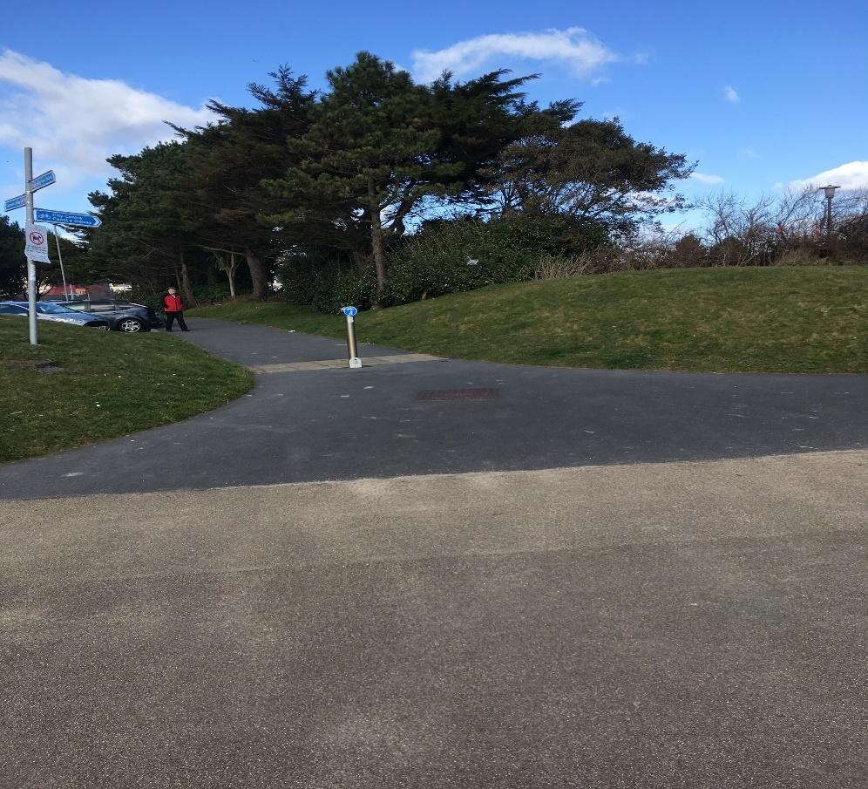

Photograph 2 – Site verges onto County Hall car park
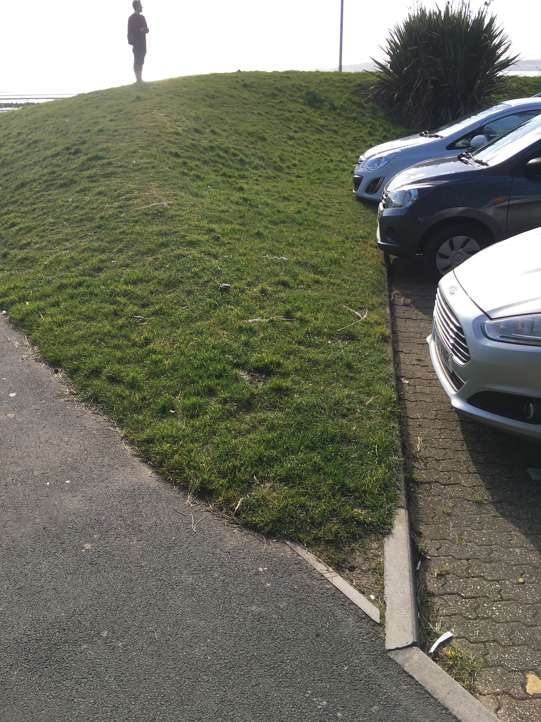

The main points of the site inspection are as follows:
- The site is generally flat apart from the grass embankment which is on an incline (Photograph 2)
- The site boundary infringes upon the carpark of the County Hall building (Photograph 2)
- There is a sign located on the grass embankment which may need to be relocated when designing (Photograph 1)
- The walkway past the site on the seafront is always open to the public so work will have to commence without it still being open (Photograph 1)
- There are several manholes on site which need to be investigated further (Photograph 3)
- There are several trees and shrubs located on site which may need to be removed or built around. Also, investigate their effect below ground to the subsoil. (Photograph 1 & 4)
- Site is located close to the sea – investigation into risk of flooding in the area & the ground conditions which were covered in the desk top study (Photograph 5)

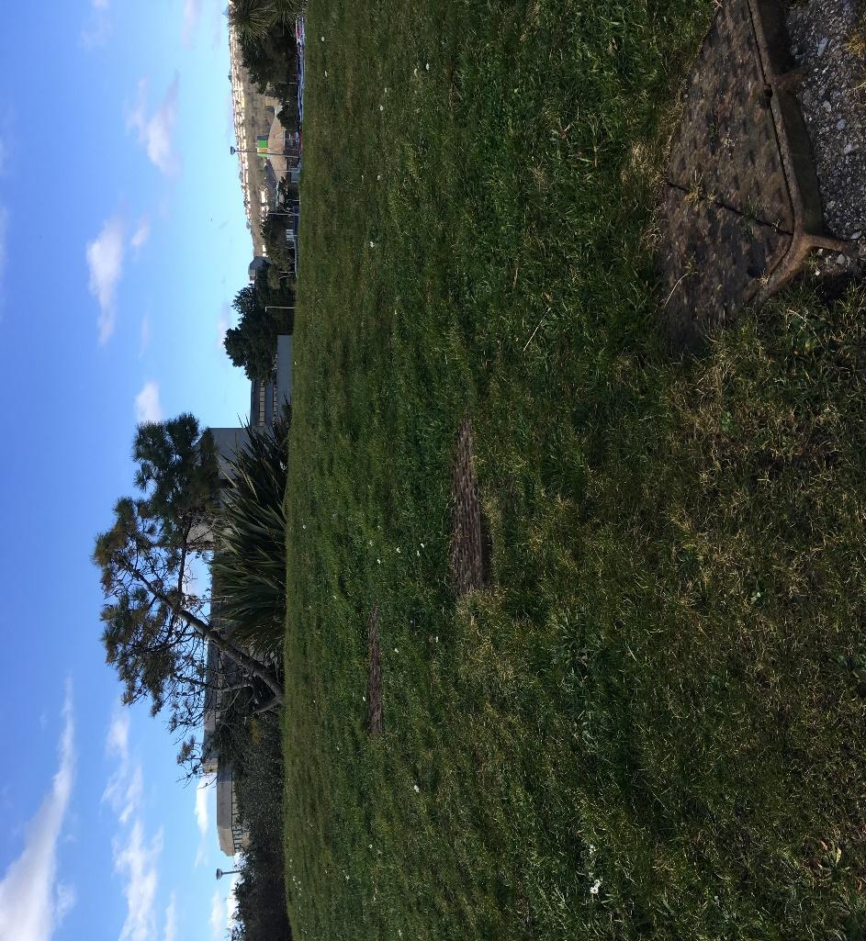
Photograph 3 – Manholes located on grass embankment

Photograph 4 – Number of trees & shrubbery on site
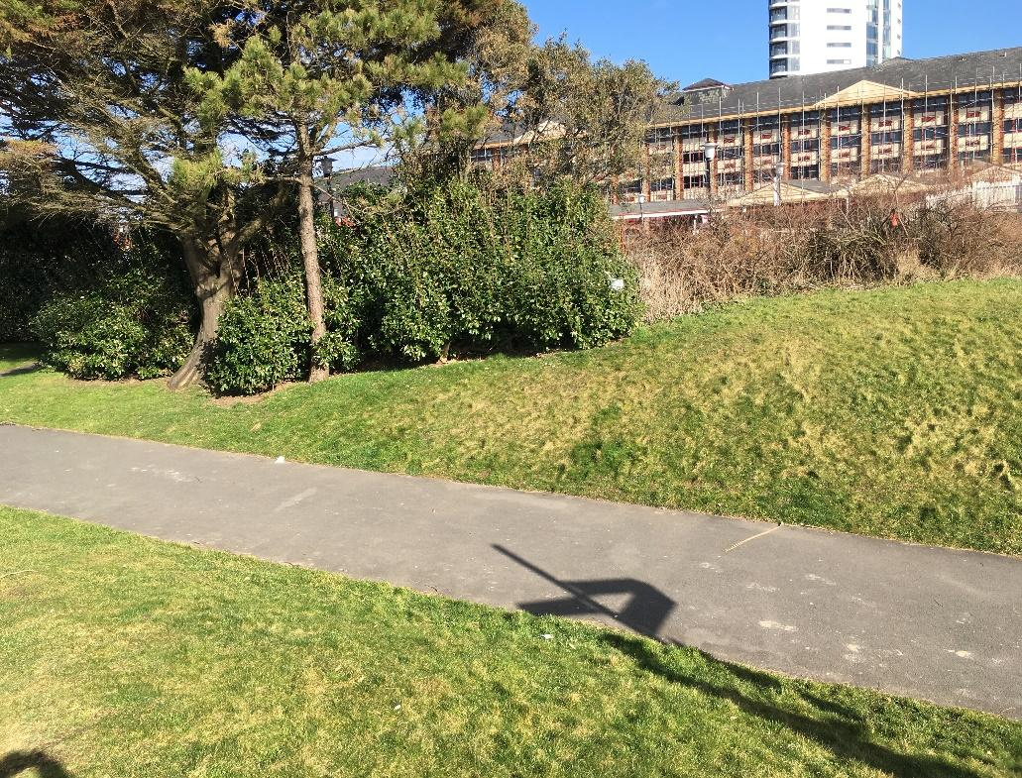

Photograph 5 – View out towards the ocean from embankment
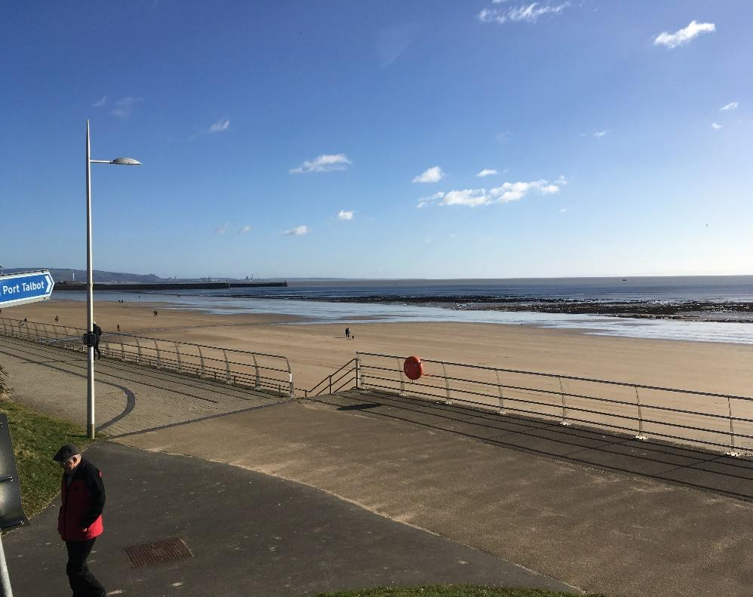

4 Conclusions & Recommendations
4.1 Site Summary
- Information on previous uses for the site location were not readily available, however it is believed that at some point it may have been mined for coal or other materials during the industrial boom in the 18th & 19th centuries.
- The ground level of the proposed structure measures approximately 300 square metres which will fit within the site with room to spare and not infringe upon the public pathway across the seafront.
- Site is located on a pathway into County Hall and the Marriott Hotel car parks coming off the main pathway across the seafront, two large grass embankments separate each facility.
4.2 Remedial Measures Summary
- Trees and shrubbery planted on embankments to create more of a borderline between the carparks and the pathway.
- Number of manholes on site on pathway and on the embankment, embankment contains drainage.
- Car blockade introduced on secondary pathway to ensure cars cannot fit down
- Sign introduced on grass embankment to guide people to various landmarks and facilities.
4.3 Monitoring Summary
- Tidal levels may be a cause for concern and will not to be monitored in the case of extreme flooding.
- The rate of coastal erosion should be monitored as it may weaken the ground and cliff face that the site is on.
- Wind speeds may also be a cause for concern in extreme weather events.
4.4 Key Risk Drivers
- Re-configuration of the drainage below ground level may prove difficult if required – foundation choice will influence this.
- Room to carry out the construction process without infringing upon the main walkway along the seafront. Making sure that construction work doesn’t interfere with the businesses adjacent to the site as much as possible.
- Site security because it is situated next to public walkways.
4.5 Conclusions
The key risk drivers identified above require further investigation to establish whether they can be worked around or combatted. It is not considered that the site is located on contaminated ground or that the ground conditions are unsuitable for construction to commence once all criteria is met.
4.6 Choice of substructure
From analysing all of the information gathered, trench foundations are the most suitable for this construction project and the site on which it will be constructed. It is important to note that the first 900-1200mm layer of clay is subject to movement due to expansion and shrinkage depending on the moisture content. Therefore, it is necessary to excavate foundations to a depth where the moisture content of the clay remains stable. Due to the fact that the site has a number of trees and vegetation near the depth of the foundations is crucial. The British Standard 8004 recommends a minimum depth of 1m for foundations, however for this specific project the foundations will be a minimum of 3m deep.
It is crucial to note that prior to concreting the foundations, the trench is often protected from heave by lining it with a compressible layer, e.g. clayboard.
4.7 Uncertainties
- There is very little information on the site’s history which makes it difficult to determine what the site use was previously.
- Drainage situated on site may not be able to be removed successfully if necessary.
- There are limitations on the way in which site security can be established on such an open site – risk of vandalism or theft would be particularly high.
4.8 Recommendations
Funding should be sought after for the following:
- Temporary soundproofing barriers to ensure that the noise on site doesn’t disturb the businesses and public to a high degree.
- A full below ground level survey and investigation into the drainage on site and who it supplies.
- High specification site security equipment and 24hr monitoring to ensure there is no criminal activity on site.
- An ecologist report on the site to make sure that the site doesn’t hold any protected wildlife.
This site should be reassessed and surveyed thoroughly after these works have been completed or put in place.

4.9 Appendix 1 – Site Location Map

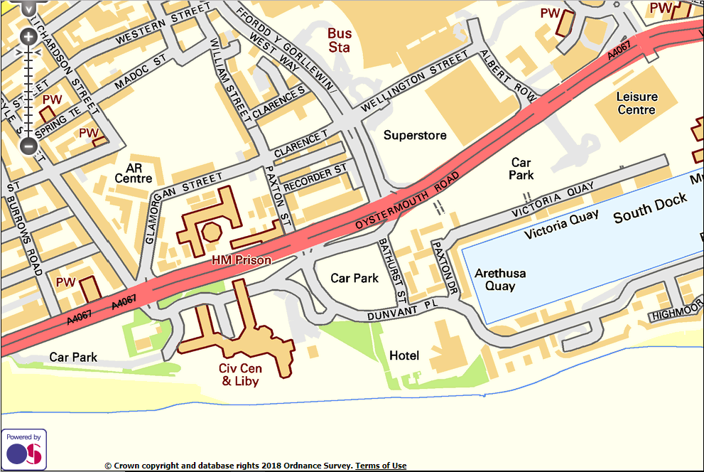

5. Describe with the aid of neat annotated, proportional sketches the recommendations that you would make for a more detailed site investigation
There are several crucial factors to remember when carrying out a detailed site investigation and gathering information about the proposed location of the project. The first step is to carry out a desktop study.
Building regulations state that all sites must be assessed by a desk study and a walkover survey. The desk study should always be carried out prior to any on site investigation to find out what work if any has been carried out before commencing with the work on site and the ground investigation. Furthermore, the desk study should always be carried out before the on-site investigation as it can be used to help plan the site walkover study and pinpoint which factors need to be addressed. The desk study involves gathering as much information about the site’s history and geology as possible through research.
The desk study aims to examine and pull together existing information from several sources to build up a pre-site walkover appraisal of possible geology and to consider the history and past uses of the site. This can provide us with a preliminary assessment of the environmental and geotechnical risks that may be associated with the chosen site. Looking into previous site investigations is also very important when carrying out a desktop study.
5.1 Desktop Study
Services records are an important part of the desk top study since services that are missing or hidden can be located such as sewers, electricity wires and phone cables. The information regarding services can usually be accessed for free by just contacting the relevant service providers in question. Sources such as electricity companies, gas companies, water companies, British Telecom and the local authority can be particularly useful.
A vital part of the desk top study is to also research and check for the location of former mines since these can cause a significant impact on if a project is to be carried out and the way of which construction proceeds. Locating these mines can often be a challenge, however, the best sources of information come from record offices, the local authority and the National Coal Board.
Taking all these recommendations and factors into account, it is essential that when carrying out a desk top study that as much information is obtained as possible. A thorough study can save vast amounts of time and drastically improve the quality of your overall site investigation.
5.2 Walk Over Survey
Carrying out a walk over survey of the site in question is essential and can provide a substantial insight into potential geological issues and site contamination. The walk over phase of the site investigation aims to identify several possible factors which let us know the best way in which the site can be built on.
The hydrogeology of the site needs to be investigated to identify whether you would be building above a well, on top of wet marshy ground, springs or ponds and streams. The slope instability of a site is also very important to analyse this can be identified by displaced fences and drains, hummocks on the ground or bent trees. A crucial factor which was mentioned in the desk top study is the presence of mining shafts on site. Sites on which mining has occurred often have subsidised ground, open cast mining can often be indicated by removed fence/hedge lines or diverted streams and rivers. Ease of access to the site is an important variable, possible issues which could prevent this are low overhead cables and watercourses.
By combining the research carried out during the desk top study and the site walkover the information gathered can be an extremely cost-effective stage in the investigation. The information collated can provide warning signs earlier rather than later in a development and help iron out any issues before they become even worse.
5.3 Planning a site investigation
The most important part of any proposed development is the extent of the full investigation of a site, this can include the use of trial pits and boreholes to gain a better understanding of the environment. The preparation of the site investigation report is also vital and should include the revised plans, sections, interpretations and recommendations for the design following the preliminary studies.
The geological structure and character of a site are factors which should be analysed thoroughly, an example of this can be testing the soil both in the laboratory and in-situ. Checking to see if the geological strata of the site is consistent throughout the region is important to see if any variations exist. Some areas of the ground structure may prove more difficult to work with and will require further investigation. When digging for foundations or excavating soil there may be areas in which the excavated material is unsuitable to be used as fill and will need to be replaced. Checks to see if any parts of the site would be prone to flooding are essential, investigation into high moisture content ground conditions and the option of groundwater lowering methods will need to be considered.

5.4 Ground Investigation
Ground investigation is information that can be gathered excluding the desktop and walk over surveys. There are a few techniques that can be used to investigate the ground conditions including the most common, trial pits and boreholes. Geophysical techniques such as the use of seismic surveys can also be implemented to identify underground rock formations and other variables in ground condition that may hinder construction.
5.5 Use of Trial Pits
Trial pits are a type of shallow excavation that go down into the earth to depth of no greater than 6m. This technique is used extensively at the ground surface for block sampling and to detect services lying below ground before borehole investigation.
It is important to remember that all trial pits deeper than a depth of 1.2m need to be supported. Furthermore, extra care should always be taken as gases such as carbon dioxide and methane can build up. If no gas detection equipment is available a breathing apparatus must be used always when working in the trial pit. There are a few ways in which trial pits can be supported, the use of timbering, steel frames with hydraulic jacks and battering or tapering the sides.
There are a few types of sample which can be retrieved from using a trial pit:
- Disturbed sample – Samples where the soil’s in-situ properties have not been retained.
- Block sample – A sample that is not completely undisturbed but retains some in-situ properties.
- Push in tube samples – Tube samples of the soil in a trial pit.
When using a trial pit, a log should always be kept recording the results and findings. The location, orientation, size of pit, depth scale, root structure, and water level among other factors should be recorded. Furthermore, the weather and temperature at the time of sampling should be noted as this can influence the soil. When the trial pit investigation is finished it is very important to try and fill it in and leave as little disruption as possible.
5.6 Use of Boreholes
Boreholes are used to determine the characteristics of the ground to a depth of usually around 6m, recovering undisturbed samples for further investigation of the geology of the site.
The results found from carrying out a borehole investigation can only provide an often-limited description of the subsurface. Therefore, comparing these findings with the information gathered during the desk top study becomes crucial. In theory, the higher the number of boreholes across a site correlates to how valid the end results will be. In the UK there are two principal boring machines that are used for site investigation, these include light percussive and drilling machines.
Light percussive is the method of making boreholes by striking the soil and then removing it with the most common method being the shell and auger. The light percussive category is used to describe several various tools that are suspended from a triangular tripod using a powered winch. Furthermore, the tools are then dropped down the borehole repeatedly whilst being suspended from the power winch.
There are several recommended tools which are commonly used for making boreholes, these include:
- Clay cutter – These are used in cohesive materials and are raised and lowered, therefore using its own weight to cut through the material.
- Shell – Shell’s are commonly used for boring in silts and sands. The shell has a similar use to the clay cutter but can catch material with a trap door at the bottom.
- Chisel – Mainly used for breaking up hard materials such as boulders and rocks. However, when chiseling on site additional payment is usually required and permission is required from the resident engineer before the work can commence.
Drilling is a process of boring that normally uses a combination of rotating action and hydraulic ram. There are several types of rig when it comes to drill boring, this depends on access and the type of ground expected from the desk top study. The three most common types of drill bits are:
- Double tube – This is where the outer tube rotates and allows the removal of dirt from the cuttings whilst the inner tube stays stationery and prevents the core from shearing. There are several distinctive designs of tube which vary the location of the flush discharge to prevent the sample eroding. Furthermore, it is crucial that the hole is larger than the tube so that the diamond bits are attached to the outside of the hole, this in turn allows the flush to rise to the surface.
- Triple tube – This drill bit incorporates a third tube to protect the core during extrusion and can have a split tube, which is then removed, or a plastic tube to provide even longer protection. Another alternative which is less effective is the incorporation of a nylon liner in a double tube.
- Retractable triple tube – This is a variation where the inner tube is attached to a retractor and can therefore extend beyond the cutting edge. This in turn provides complete protection to the core in softer rock, when working in harder rock where it is not necessary it retracts to become a standard triple tube. Furthermore, this can be used in alternating, soft/hard rock which is typical of a weathered mass.
- Core bits – These are usually diamond tipped and can either be surface set which means the diamonds are mounted into a matrix or added where a fine diamond dust is used in the matrix. In softer rocks the cuttings can get caught up in the matrix, therefore the softer the rock the larger the diamond cuts need to be.
5.7 Creating & working in a safe environment
A safe system of work is created through carrying out a procedure resulting from a mindful study of a task which identifies the hazards and risks before work is carried out. In theory, this system will therefore remove or at least minimise the hazards and the effect of which they might have. Generally, these safe systems of work are formal and are documented. However, they can also be informal and verbal, instructions are often given on the hazards and how to deal with them.
5.8 Legal requirements
The Health & Safety at Work Act (HSWA) 1974 states that employers must provide safe plant and systems of work without risks to health. Several regulations such as the Provision and Use of Work Equipment Regulations introduced in 1998 state that information and instruction on using work equipment safely must be given to employees. In turn, this is another more specific requirement to help provide safe systems of work. Employers have a common law duty of care to also provide a safe system of work, employees have the responsibility of following the system. To determine where safe systems of work need to be developed you must assess your organization's operations.
5.9 Steps to developing a safe system
There are five basic steps to developing safe systems of work:
- Assessing work tasks
- Identifying hazards and assessing risks
- Defining safe methods
- Implementing the safe system
- Monitoring the system

6. Step 1: Task Assessment
Every aspect of a given job or operation must be analysed and put into writing to ensure that nothing is missed or overlooked. The safe system of work is based on a thorough assessment of the task which is to be covered.
An assessment should be carried out by supervisory staff together with the workers involved, in turn, any assumptions your supervisors might have about methods of work doesn’t differ from reality. The workers may also be in the best position to help with preparing a safe system of work. Consulting workers exposed to risks either directly or indirectly is a legal requirement.
There are several variables which must be kept account of:
- What is used – plant, equipment, substances, potential machinery failures, the task’s electrical needs
- Error sources – possible human failures, short cuts
- Where the task is carried out – the working environment and its protection needs
- How the task is carried out – procedures, potential work method failures, task frequency, training needs
6.1 Step 2: Hazard Identification & Risk Assessment
It is essential to list the task’s elements and clearly identify the associated hazards that come with the given job. It is important to remember that the law requires that a ‘suitable & sufficient’ assessment of all risks that employees and other people may be exposed to.
The analysis is done differently depending on each job and its nature. If the job in question involves high loss potential, then formal hazard analysis techniques should be put into place. These can include a hazard & operability (HAZOP) study, fault tree analysis (FTA) or failure modes and effects analysis should be considered.
However, if the potential loss is lower, a more straightforward approach such as job safety analysis (JSA) could be used. If hazards cannot be removed then risks remain, procedures to ensure a safe method of work must be worked out.
6.2 Step 3: Defining Safe Methods
Supervisors or managers must be giving instructions to employees. Leaving employees to come up with their own methods of work safety is not acceptable. The chosen methods put into practice can be explained verbally or in writing.
Jobs require different safe systems depending on the levels of risk. A particularly minimal risk job may require only following safety rules or a previously agreed safety plan. However, a high-risk job may require a more formal and professional work permit for work to commence.
Risk level/ safe system type:
- Very high – permit to work
- High – written safe system or permit
- Moderate – safe system
- Low – written safe system
- Very low – verbal instruction
Documented methods should be written as clearly as possible in a non-technical style. Easy to read simple summary sheets should also be used.
Whichever method is chosen, the process is likely to involve:
- Setting up the task along with any necessary authorisation
- Planning job steps
- Stating the approved safe working methods, including how to get to and from the task area if required
- Conditions must be confirmed before work starts
- Dismantling/disposing of equipment/waste at the end of the project
6.3 Step 4: Implementing the System
Employers have the duty to ensure that they come up with and maintain safe systems of work. They must also make sure that their safe systems are effectively put into operation. They must also be reviewed and revised to take account of changed conditions or accidents.
Training is essential for all site workers. Employees must be:
- Adequately trained in specific systems of work
- Competent to carry out the work safely
- Aware of the systems and hazards which the safe methods aim to remove/reduce
It is essential that everyone appreciates the need for a system and its role of preventing accidents. Training may include:
- Why the safe system is needed
- What is involved in the work
- The identified hazards
- The precautions that have been decided
For the system to be successful there must be effective communication. The system’s details should be fully understood by everyone who works in it. The importance of discussing the proposed system with those who will have to work under it and those who must supervise its operation is vital.
Safe systems require work to come to a stop when an issue appears that is not yet covered by the system. Work should then not commence until a safe solution is found.
6.4 Step 5: Monitoring the system
Your system must be carried out on each occasion a job is carried out. Effective monitoring means regular checking to make sure that the system is still appropriate for the task and that it has been fully complied with.
Simple questions may include:
- Do workers continue finding the system workable?
- Are laid down procedure being carried out?
- Are procedures still effective?
- Have there been any changes that require the system to be revised?
A devised system that is not followed is not a safe system of work. There must always be sufficient supervision if the system is going to be followed and work going to be carried out safely. The level of required supervision depends on the employee’s experience and the complexity of the task.
Safe systems of work with, not replace stronger prevention controls such as good equipment design or physical safeguards.
It is essential that you review your system every year and ensure:
- Any new laws are considered
- Compliance with risk assessments
- Any accidents, injuries or diseases are considered to further improve controls
- Any new or modified equipment/plant is considered
- Safer substances are considered
- New working methods are used
- Advantages in technology are taken advantage of

References
- Websites
Year published - 2018
Page title - Simple Search
Website name - Property.swansea.gov.uk
Publisher - Swansea Council
URL - https://property.swansea.gov.uk/online-applications/
Access date - 25.02.18

Year published - 2018
Page title - Gower, Wales: coast and footpaths - free online Ordnance Survey map
Website name - Mapsta.net
Publisher - Ordnance Survey
URL - http://www.mapsta.net/uk-os/gower/
Access date - 03.03.18

Year published - 2018
Page title - 5 steps to developing safe systems of work
Website name - Elliswhittam.com
Publisher - Ellis Whittam
URL - https://www.elliswhittam.com/5-steps-developing-safe-systems-work/
Access date - 15.03.18

Year published - 2018
Page title - Welsh Government|Approved documents
Website name - Gov.wales
Publisher - Welsh Government
URL - http://gov.wales/topics/planning/buildingregs/approved-documents/?lang=en
Access date - 02.02.18, 15.02.18, 27.02.18, 18.03.18

- Literature
Authors - R.Chudley, Roger Greeno
Year published - 2008
City published - Oxford
Publisher - Butterworth-Heinemann

Author - Stephen Emmitt
Year published - 2010
Title - Barry's introduction to construction of buildings and advanced construction of buildings bundle
City published - United Kingdom
Publisher - Wiley-Blackwell

Author - Duncan Cartlidge
Title - Construction project manager's pocket book
Year published - 2015
City published - London
Publisher - Routledge, Taylor & Francis Group

