Abstract
The correlation between a person's IQ and ability to retain information has been widely researched. However, very little research has been done on how other characteristics may affect our ability to retain information. This report looks at how a person's Big Five traits (extraversion, agreeableness, conscientiousness, neuroticism, and openness) influence their memory (Winter et al., 2014). It concludes that extroverted people have better memories than introverts; more agreeable people have better memories than disagreeable people. More conscientious people have better memories than those who are less moral. People with higher levels of neuroticism tend to remember fewer facts about themselves. Still, they also tend to forget fewer adverse facts about themselves than those with lower levels of neuroticism. Finally, people with higher levels of openness remember fewer positive facts about themselves than those with lower levels of transparency.

Introduction.
Many people believe that personality affects how well you remember things, and this could be one of the reasons we all feel like our best friend can reflect everything. In contrast, we can't remember what happened yesterday. Let's test whether there is a correlation between memory and personality or if it's just us believing in myths. We will take this experiment to the next level by predicting whether people with certain characters have better memories than others based on their behavior and interests.
A proper understanding of personality is one of those things in life that we think we know when we see it but have little to no idea about (Woike et al. 2009). Individual personalities can seem to change from day to day, with each person possessing a unique set of qualities that make them who they are. Psychology has been studying personality for some time now, with millions of studies conducted on human behavior. However, much is still unknown about how personality works or what makes up an individual's character. What psychologists do know, however, is that there seems to be some connection between personality and memory. It appears as though people who possess specific characteristics also tend to remember events differently than others. The purpose of my study was to explore whether or not there is any correlation between memory and personality traits in humans.

Method

Participants

There were 35 participants in this study who were recruited through the EMS system, and this sample included both males (18) and females (15), as well as two non-binary/third gender people who were between the ages of 18 and 69.

Design

The participant's personality type was the IV, or independent variable, in this study, while the DV, or dependent variable, was the number of properly recalled words, which shows the participants' memory. This study used a between-subjects design since the data was obtained from people who rated as low extroverts and introverts and high extroverts on a single variable.

Materials

In this study, the extraversion sub-scale of the big five questionnaire, PowerPoint showing the list of words that the participants had to recall, and a list of words written by each individual participant when they did recall any words they could remember were all used, as well as the consent form, information sheet, debrief form, questionnaire, suberlabs, and SPSS software.

Procedure

They had to read an information leaflet and sign a consent form if they agreed to participate in the study. After that, they were given a questionnaire to complete. The participants had to first complete the Extraversion sub-scale of the Big Five Inventory (John et al., 1991). This is an eight-question survey with a five-point scale of strongly disagree to strongly agree responses. The participant was then asked to choose the response to a statement that they thought was the most applicable to them.

The participants were then given thirty seconds at the end of the presentation to name as many of the terms as they could remember after being shown ten words on a slide for two seconds apiece. Following that, they were instructed to write down as many words as they could recall without being timed, and then they were debriefed, where they could either withdraw or provide permission for the researcher to utilise their information.

Results
An independent samples t-test was used to examine the differences in memory recall between participants with high and low levels of extroversion. The homogeneity of variance was a critical factor in establishing the significance of a t-test result. This hypothesis asserts that the variance differences between two groups are identical, meaning that they are either identical or extremely similar. That is, as proved by my data analysis and the use of an independent samples t-test, there are no statistically significant differences in the variances of the two groups. According to the study's findings, there is no statistically significant difference in memory recall between strong extroverts, low extroverts, and introverts t (35) = -0.63, p> 0.05. As a result of this data, the theory that there is no significant relationship between personality and memory follows.

Discussion

My findings did not supported the original premise that there would be a significant relationship between levels of extroversion and memory recall. For example, the findings of Lei, Yang, and Wu the parents of the functional magnetic resonance imaging (FMRI) to localise the location of and changes in brain activity. They claimed, that extroverts had higher brain activity in the dorsolateral prefrontal cortex associated with memory and cognition. However, this study adopted a different approach since it was thought that proving a major difference between personality and how it affects memory would be challenging because personality can encompass a variety of attributes and can be interpreted in a variety of ways due to its subjective nature.

The participants may not answer the questions honestly because they want to be perceived in a favourable way, which is one of the study's drawbacks. Another drawback is that a participant may have forgotten a word but successfully answered it because they were too embarrassed to admit they had forgotten some of the words. These factors could have tainted my results' accuracy and validity.

In conclusion, while research has indicated that there may be a link between personality and memory, the initial idea has been proven inaccurate, and the findings of this study would argue that there is no substantial difference between degrees of extroversion and memory recall.

Reference List
Hastie, R. (1980). Memory for behavioral information that confirms or contradicts a personality impression. Person memory (PLE: Memory): The cognitive basis of social perception, 155-178.

Pazzaglia, F., Meneghetti, C., & Ronconi, L. (2018). Tracing a route and finding a shortcut: The working memory, motivational, and personality factors involved. Frontiers in human neuroscience, 12, 225.

Woike, B. A., Bender, M., & Besner, N. (2009). Implicit motivational states influence memory: Evidence for motive by state-dependent learning in personality. Journal of Research in Personality, 43(1), 39-48.

Winter, D., Elzinga, B., & Schmahl, C. (2014). Emotions and memory in borderline personality disorder. Psychopathology, 47(2), 71-85.

Zhang, Y., Pan, Z., Li, K., & Guo, Y. (2018). Self-serving bias in memories. Experimental psychology.

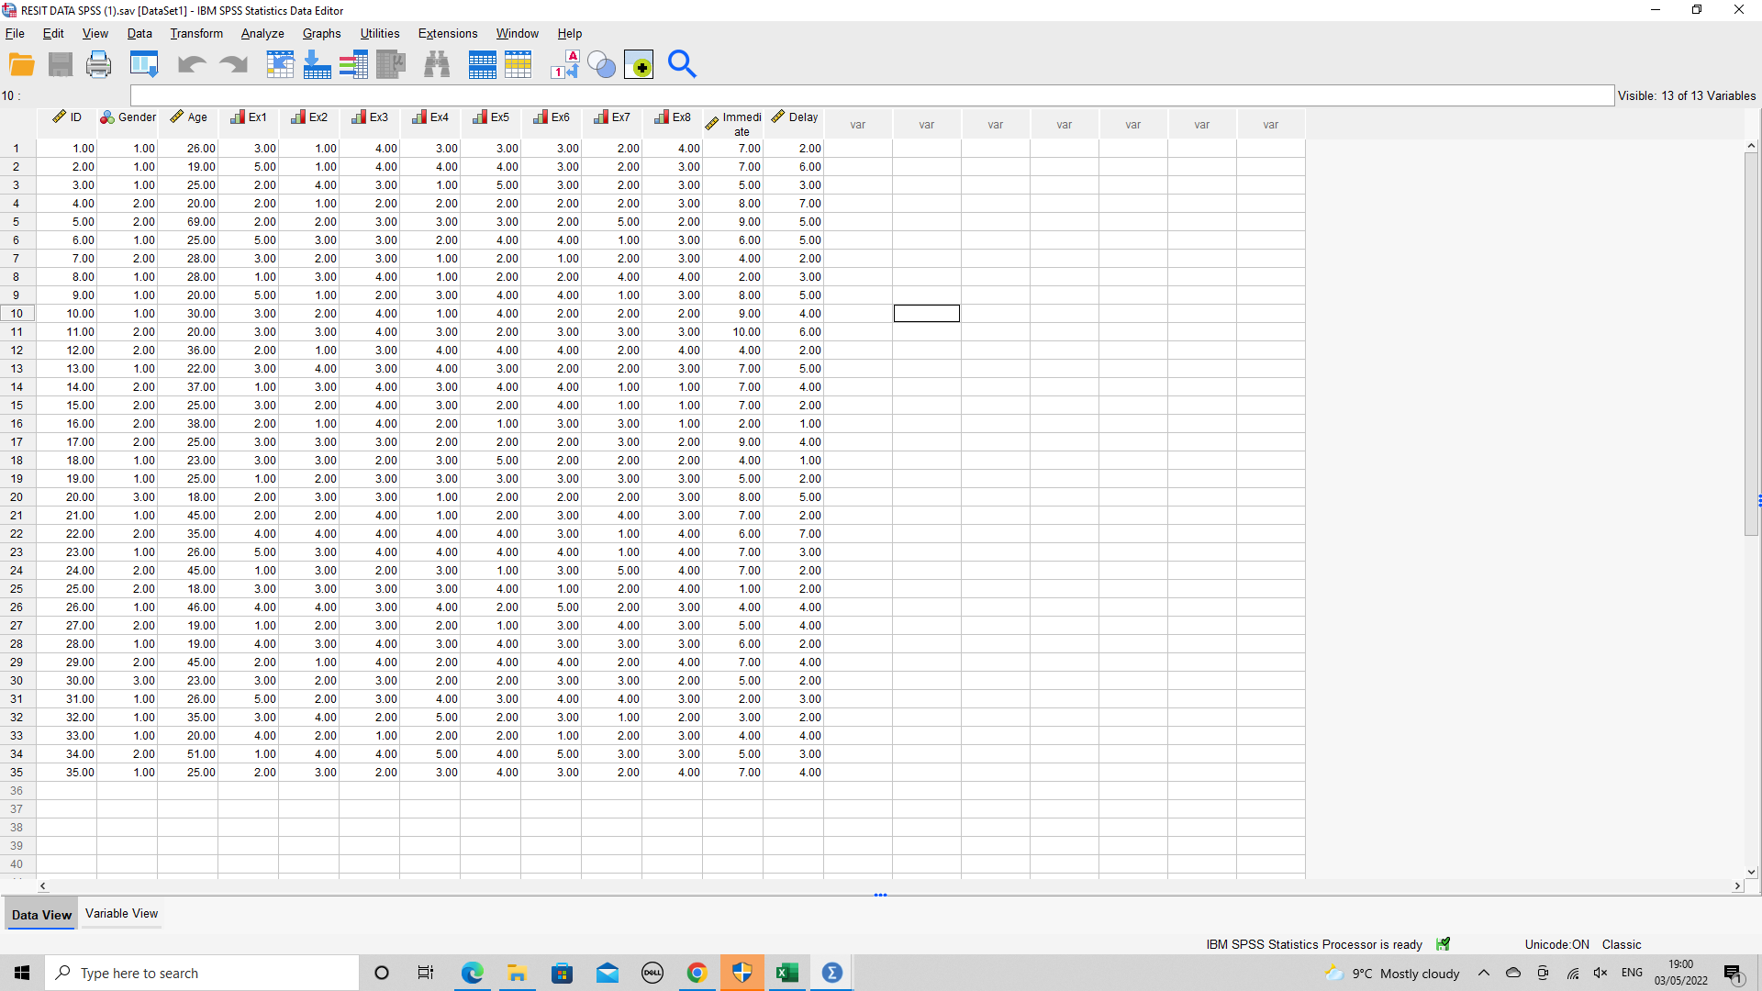
Appendix


