BMSW 4002
Effective Team Working and Communication
Zameer Ramzan - 2128773
Component 1

Report on Effective Team-working for business success

Module Tom: Dami Pokubo

Table of Contents
Introduction 3
How to develop an effective team and what team development stages model can be used 4
What team roles are needed to create an effective team 5
What are the benefits of teamwork? 6
What are the barriers to effective teamwork identified in this scenario 7
Conclusion 8
References 9

Introduction
This Report is on Effective Team-working for business success. Global e-commerce giant Amazon has set the ambitious goal of establishing three sizable warehouses in important European cities, including Berlin, Paris, and London. Tom Jackson is the project's Tom, and it seeks to promote quick and dependable delivery services across Europe. Before starting this project, Tom has to put together a team and assign duties and responsibilities for each team member to complete. The success of the project can be jeopardised if these problems continue. As a result, I'm requesting Tom to confer with Tom Consultant Company about any potential answers that would improve cooperation and collaboration for the project's successful completion- (Sheth, 2020)

How to develop an effective team and what team development stages model can be used
How to develop an effective team
A strong, cohesive, and productive team may be created and maintained by following these 5 essential steps:
1. Define the purpose
The team's goal should be clearly stated, along with the ultimate goal for which it has been assembled. Giving the organization a clean, motivating vision lays the groundwork for powerful cooperation and directs them once they need to make choices and encounter problems. (Sheth, 2020)
2. Assemble the team
High performance teams are made from people that fervently embody the imaginative and prescient, think their contributions count number, and are driven to place up their fine attempt. Every crew member need to admire, consider, and assist the others. Attaining a right stability of persona types will permit the organization to perform nicely together while also supplying each other with suitable challenges. (Gelderman et al, 20221)
3. Determine the goals
Breaking the imaginative and prescient down into smaller, more plausible goals and responsibilities is the subsequent degree once the crew has been constituted and bonded under a not unusual, compelling reason. (Sheth, 2020)
4. Set expectations
Through team meetings and one-on-one catch-ups, regularly assess the group's performance to make sure that progress is being achieved. Adjustments and enhancements may be implemented along the way by tracking and analysing progress. (Hofacker et al, 2020)

5. Monitor and review
Regularly acknowledge, praise, and celebrate team and Tom accomplishments. This will raise the group's morale and increase their drive to work hard going forward. Make sure the team members are consistently acknowledged for their good work and that the approach Tom chose motivates and encourages them to keep up their excellent contributions to the group's advancement. (Gelderman et al, 20221)
Tuckman team development stages model
Forming
People will first be uncertain about the crew's desires, how they fit in, and if they'll get in conjunction with one another when a new team first starts off evolved. They may be apprehensive, uncertain, or eager to begin. Something they will experience, they will turn to the group Tom for steerage. (Sheth, 2020)
Storming
the described limits are being pushed against throughout the storming level. When group members' proper personalities and favoured methods of operation assessment with those of others, conflict or friction may additionally broaden-(Sheth, 2020)
Norming
The squad enters the stage of norming gradually. As a result, disagreements start to be worked out; people learn to respect one another and Tom Tomhip. The team's biggest issue was lack of commitment. Mihaela and Spencer, two team members, weren't dedicated to the project's success since they were more interested in what they would get from it than what the team would accomplish. (Fairlie, 2020)

Performing
Tom group is now in the sector and operating at top efficiency. The team has a terrific danger of succeeding in its targets with perseverance and organised methods. The team members' ability to collaborate on the project was hampered by the adoption of an ineffective route of communication (Kumar et al, 2021)
Adjourning
Many teams organically get to this stage. For example, tasks are completed or people are redistributed while permanent teams are dissolved. The establishment of the squad was problematic since Tom's strategy was flawed. (Fairlie, 2020)
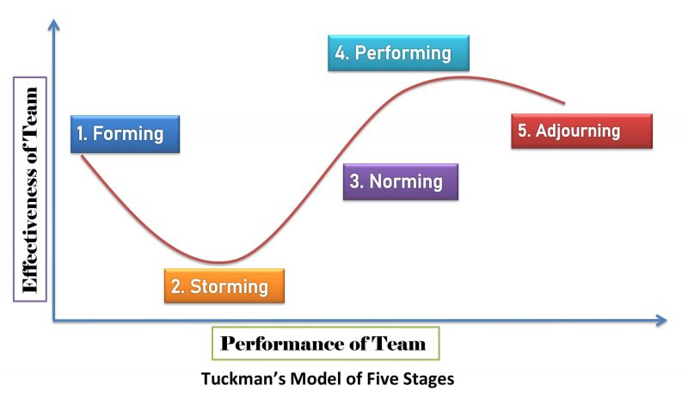
Figure: Tuckman model (Sheth, 2020)

What team roles are needed to create an effective team
Five roles for a successful team
Tom
The Tom's job is to provide the team's direction, vision, and motivation as well as teach teamwork techniques and establish ground rules for cooperation. All decisions are made by the Tom, including how information will be reported and how communication will take place. The ultimate objective of a Tom is to ensure that all of the team's duties and responsibilities are carried out successfully. Fixing, defining, and giving direction to the aim is thus the first step. (Bougie, 2019)
Director of Creative
The success of every team depends on having a source of creative energy. A creative thinker who can propose novel ideas and thoughts is necessary when people are working as a team. The team is kept continually striving for improvement to avoid stunted growth. A creative director helps a team to sustain the forward momentum needed for successful teamwork for all parties involved. If somewhat doesn't work for a team, the original director switch the emphasis to a dissimilar plan-(Kumar et al, 2021)
Facilitator
The decision-making process is aided by the facilitator, who in many companies lacks official power. Even when a Tom is serving as a facilitator, the Tom is still encouraging or requesting the team to perform those actions. A facilitator must be present to accurately and concisely record all team brainstorming and discussion of plans and ideas. One of the responsibilities of a facilitator is to support the team in achieving the goal by assisting in the team's understanding of the goals. A facilitator guides the team toward the objective in this way. Above all, become skilled at delegation. Tom should also efficiently manage discipline, interact with others, build Tom team, and inspire others. (Lau, 2020)

Coach
Following training, a team's coach offers one-on-one assistance. If a group member has acquired schooling with something, the Tom will provide assistance for them following the education. If a hassle arises during one-on-one training, educate is the first person the group turns to. From time to time these legal guidelines go across. A coach and team captain may be the same man or woman. The cornerstone for a group's powerful operation is a professional and nicely educated expert group, and it's far on this potential that fulfils his or her duties. (Bougie, 2019)
Coordinator
Powerful team Toms need to also attend crew meetings and do all duties given to them. Members participate in brainstorming classes, concept generating, and any other assist that is required for the duration of conferences or via a webinar platform. Additionally, the Tom is in charge of organising and planning any regular meetings that need to be conducted. The team Tom is also in charge of defining each team member's Tom and collective responsibilities. (Lau, 2020)
Tom team will be more successful when Tom plays to each Other's blessings than if tom paintings on my own. One of the many blessings of cooperation is having access to other employees' skill sets. Tom ought to excel in conceptual thinking, whilst some other co-worker is probably the group's cross-to expert on making plans, and nonetheless some other might be at their high-quality when making presentations. (Bocken, 2019)
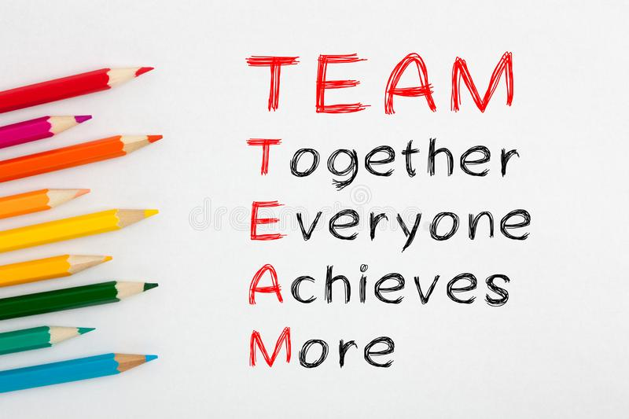
Figure: team (Meyer et al, 2022)

What are the benefits of teamwork?
The benefits of teamwork
Enhanced inventiveness
When people work together as a team, they come from a variety of backgrounds and have access to a range of experiences, which provides a particularly fertile environment for brainstorming and original issue solution. Employees can overcome obstacles and come up with innovative solutions to issues when they work together as a team. (Bocken, 2019)
Network of support
Employees should feel at ease relying on one another for support and direction since a strong team atmosphere is crucial to the success of any firm. By enlisting others' assistance, they are able to accomplish their objectives more quickly while maintaining their attention on the task at hand. (Meyer et al, 2022)
Resolution of disputes
The development of constructive conflict resolution techniques also promotes the value of collaboration in the workplace. Having a quarrel sometimes is not a need for teamwork. However, a strong team is able to disagree amicably by hearing each other out and cooperating to find a workable solution. (Meyer et al, 2022)
Recruiting talent
Teams entice top talent. Employees of the Millennial and Gen-Z generations are known to place a higher emphasis on cooperation than on rivalry, and they are drawn to businesses that foster a culture of teamwork. Teamwork is essential to many tasks, and without it, many businesses would struggle to function. It is safe to assume that it is significant as a result. Here are several advantages of emphasising the value of cooperation at work (Bland, 2019)

Better service-
The quality of the service offered to consumers is also affected by improved collaboration. People Often keep away from companies with disgruntled people and prefer to paintings with those whose staff contributors have a robust sense of teamwork and paintings ethic. (Pedersen et al, 2020)
Developing a career
Working together as a team is important, but it also affects Toms. Tom may learn about the skill sets of the other team members through working together, and Tom can also learn more from them to develop Tom own skill set. By forming partnerships, Tom have the chance to expand Tom professional network and open doors to more advantageous prospects. (Bland, 2019)
Work division:
Considered one of the biggest benefits of operating in a group is that there may be often an equitable division of labour; as a end result, anyone best has to cope with one a part of a mission rather than having to recollect all of its components separately. Running in a group appreciably reduces burden considering smaller duties are simpler and take much less time and effort to perform. (Amankwah-Amoah et al, 2021)
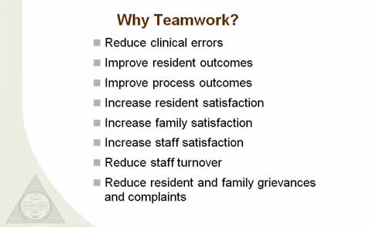
Figure: team (Meyer et al, 2022)

What are the barriers to effective teamwork identified in this scenario
The success of any firm depends on teamwork. There are many different definitions of teamwork, but the majority of them centre on a group of Toms cooperating skilfully and productively to achieve a shared objective-(Pedersen et al, 2020)
Unsuccessful management
Groups require Tom who can direct them, offer their attitude, and constantly promote cooperation if they may be to work collectively correctly. Consequently, groups who experience vulnerable management may additionally feel disengaged and uninspired which might also negatively affect how properly they can cooperate- Tom can also control those occasions by means of offering more possibilities for cooperation, helping crew contributors in growing their abilities, and figuring out methods to praise productive collaboration. (Rangarajan et al, 2021)
Goal confusion
Setting up commonplace objectives that the group can paintings towards collectively is a common starting point for success cooperation. If groups do not properly recognise or agree upon their work's desires, they may run into troubles. Groups might also create a described methodology for developing objectives, assessing them, and laying out workflow to correctly accomplish them that allows you to keep away from aim misunderstanding. Conversation chasms (Rangarajan et al, 2021)
Communication gaps
Experts who work in groups need to have tremendous communique competencies that enable them to connect with co-people, express their viewpoints, concentrate to others, and transmit expectancies. Team contributors may not apprehend expectations or their obligations because of verbal exchange breakdowns. To shut these gaps and have interaction greater successfully, groups might consciously endeavour to improve their conversation abilities. (Amankwah-Amoah et al, 2021)

Absence of faith
Specialists in a team regularly need to construct respectful relationships based totally on mutual consider and self-belief in one another's abilities with a view to cooperate toward a not unusual set of objectives. Without accept as true with, group participants won't feel secure imparting comments or expressing their points of view at some point of collaborative responsibilities. (Ritter et al, 2020)
Inequitable decision-making
In a crew placing, it's usual for one team member to tackle more responsibility than the others and manage the decision-making approaches. The reality that sure group members are more outgoing, have better advanced abilities, or have a tendency toward a self-sufficient work fashion normally contributes to this unequal atmosphere. (Setyowati et al, 2021)
Poor conflict resolution skills
By means of democratising workflow and guaranteeing that each one team participants can make a contribution equitably, groups might also conquer unequal selection-making approaches. However, if they sense that their ideas aren't valuable, crew participants who are extra introverted and feature a collaborative work fashion may additionally begin to make a contribution less. (Ritter et al, 2020)

Conclusion
Thus, create a timetable with agreed-upon dates, milestones, and responsibilities for the important tasks. Set up a code of conduct for the team to make certain that everyone is aware about what is anticipated of them. The appropriateness of each member's behaviour and contributions will be ensured by establishing clear standards early on. A loss of accept as true with might also lead to misunderstandings and conflicts, which might make it harder for a team to perform collectively. Thus, group-building sports and common possibilities for cooperation, specialists might also greater efficaciously create trustworthy connections. 5. Improper decision-making (Amankwah-Amoah et al, 2021)

References
Amankwah-Amoah, J., Khan, Z. and Wood, G., 2021. COVID-19 and business failures: The paradoxes of experience, scale, and scope for theory and practice. European Management Journal, 39(2), pp.179-184.
Bland, D.J. and Osterwalder, A., 2019. Testing business ideas: A field guide for rapid experimentation. John Wiley & Sons.
Bocken, N., Boons, F. and Baldassarre, B., 2019. Sustainable business model experimentation by understanding ecologies of business models. Journal of Cleaner Production, 208, pp.1498-1512.
Bougie, R. and Sekaran, U., 2019. Research methods for business: A skill building approach. John Wiley & Sons.
Fairlie, R., 2020. The impact of COVID‐19 on small business owners: Evidence from the first three months after widespread social‐distancing restrictions. Journal of economics & management strategy, 29(4), pp.727-740. FB
Gelderman, C.J., Schijns, J., Lambrechts, W. and Vijgen, S., 2021. Green marketing as an environmental practice: The impact on green satisfaction and green loyalty in a business‐to‐business context. Business Strategy and the Environment, 30(4), pp.2061-2076.
Hofacker, C., Golgeci, I., Pillai, K.G. and Gligor, D.M., 2020. Digital marketing and business-to-business relationships: a close look at the interface and a roadmap for the future. European Journal of Marketing, 54(6), pp.1161-1179.
Kumar, S., Sureka, R., Lim, W.M., Kumar Mangla, S. and Goyal, N., 2021. What do we know about business strategy and environmental research? Insights from Business Strategy and the Environment. Business Strategy and the Environment, 30(8), pp.3454-3469.
Lau, A., 2020. New technologies used in COVID-19 for business survival: Insights from the Hotel Sector in China. Information Technology & Tourism, 22(4), pp.497-504.
Meyer, B.H., Prescott, B. and Sheng, X.S., 2022. The impact of the COVID-19 pandemic on business expectations. International Journal of Forecasting, 38(2), pp.529-544.
Pedersen, C.L., Ritter, T. and Di Benedetto, C.A., 2020. Managing through a crisis: Managerial implications for business-to-business firms. Industrial Marketing Management, 88, p.314.
Rangarajan, D., Sharma, A., Lyngdoh, T. and Paesbrugghe, B., 2021. Business-to-business selling in the post-COVID-19 era: Developing an adaptive sales force. Business Horizons, 64(5), pp.647-658
Ritter, T. and Pedersen, C.L., 2020. Digitization capability and the digitalization of business models in business-to-business firms: Past, present, and future. Industrial Marketing Management, 86, pp.180-190.
Setyowati, W., Widayanti, R. and Supriyanti, D., 2021. Implementation Of E-Business Information System In Indonesia: Prospects And Challenges. International Journal of Cyber and IT Service Management, 1(2), pp.180-188.
Sheth, J., 2020. Business of business is more than business: Managing during the Covid crisis. Industrial Marketing Management, 88, pp.261-264.

