Timeline of computing
Name: Mohamed Moftah
Student number: 2326684
Assignment 1
Module code: ACDA4024
Contents page
Title page …………………………………………………………………………………………………………... 1
Introduction………………………………………………………………………………………………………. 2
The first computer made……………………………………………………………………………………... 3
The Alto, Radio shack….………………………………………………………………………………………. 4
Windows……………………………………………………………………………………………………………. 5
70’s computer innovations…………………………………………………………………………………… 6
Silicon chips………………………….…………………………………………………………………………… 7
Most powerful computer in 2024……….…………………………………………………………………… 8
Facts about Frontier……………………………………………………………………………………………. 9
Conclusion………………………………………………………………………………………………………. 10

Table of figures
FIGURES | TITLE | PAGE
FIGURE 1 | Babbage, Charles | 2
FIGURE 2 | Atanasoff-Berry | 3
FIGURE 3 | Alto | 4
FIGURE 4 | Computers, tablets and smartphones | 4
FIGURE 5 | Tandy radio shack | 5
FIGURE 6 | Windows XP | 6
FIGURE 7 | Windows 10 | 6
FIGURE 8 | Silicone chips | 8
FIGURE 9 | Silicone market | 8
FIGURE 10 | Frontier supercomputer | 9
FIGURE 11 | Top 10 supercomputers | 9
FIGURE 12 | Frontier | 10

Introduction
The timeline of computing spans millennia, from the ancient abacuses and slide rules to the sophisticated silicon chips of today. Beginning with the earliest counting tools in ancient civilizations, the 20th century witnessed the birth of electronic computers like the ENIAC and the development of key concepts such as the Von Neumann Architecture. The advent of microprocessors in the 1970s paved the way for personal computing, while the 1990s saw the explosion of the internet with the World Wide Web. In the 21st century, the rise of smartphones, cloud computing, and artificial intelligence has propelled computing into every aspect of modern life, promising new frontiers with quantum computing and the Internet of Things (IoT). This timeline encapsulates a journey from basic arithmetic to the interconnected, data-driven, and increasingly intelligent digital world we inhabit today.[1]
Inventor
Charles Babbage (born December 26, 1791, London, England—died October 18, 1871, London) was an English mathematician and inventor who is credited with having conceived the first automatic digital computer.
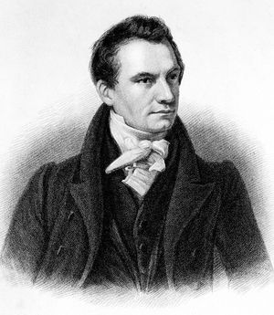
Figure 1 reference https://cdn.britannica.com/12/194612-050-6100BA16/Charles-Babbage.jpg
Babbage, Charles,
Charles Babbage.

In 1812, Babbage played a pivotal role in establishing the Analytical Society, aimed at importing mathematical advancements from the European continent into English mathematics. Four years later, in 1816, he attained fellowship in the Royal Society of London. Additionally, he played a key role in the establishment of the Royal Astronomical Society in 1820 and the Statistical Society in 1834.
During the mid-1830s, Babbage formulated plans for the Analytical Engine, heralded as the precursor to modern digital computers. This groundbreaking device was envisioned to execute any arithmetic operation based on instructions from punched cards, featuring a memory unit for storing numbers, sequential control, and other fundamental components of contemporary computing. Much like the Difference Engine, this project surpassed the complexity of anything previously constructed. The proposed memory unit was designed to accommodate 1,000 50-digit numbers, a capacity exceeding that of any computer constructed before 1960. It was intended to be steam-driven and operated by a single attendant.
In 1843, Babbage's colleague, mathematician Ada Lovelace, translated a French paper on the Analytical Engine and, through her annotations, illustrated how it could perform a series of calculations, marking the inception of the first computer program. However, the Analytical Engine remained unfinished. Babbage's design remained obscure until the discovery of his unpublished notebooks in 1937. In 1991, British scientists constructed the Difference Engine No. 2, accurate to 31 digits and adhering to Babbage's specifications. Subsequently, in 2000, the printer for the Difference Engine was also successfully constructed.
. [2]
Reference: Charles Babbage | Biography, Computers, Inventions, & Facts | Britannica
When was the first computer made?
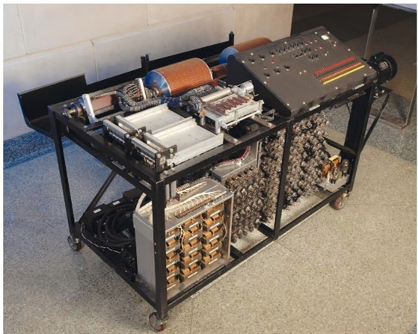
Figure 2 https://th.bing.com/th/id/R.43a39525963bb3290ed908978d5a351b?rik=jDDnon7sUk2GDg&riu=http%3a%2f%2fs3.amazonaws.com%2flibapps%2fcustomers%2f639%2fimages%2fabc.jpg&ehk=ByjNHIw3o8LkPVns6eryhrZ9yXTYsobfg%2bHeGiZW8lw%3d&risl=&pid=ImgRaw&r=0&sres=1&sresct=1
The first electronic digital computer was the Atanasoff-Berry Computer (ABC), which was developed by John Atanasoff and Clifford Berry at Iowa State College (now Iowa State University) in the United States. The ABC was designed to solve linear algebraic equations and was not a general-purpose computer like later models.
Work on the Atanasoff-Berry Computer began in 1937 and continued until 1942. However, it was not completed until 1942, due to interruptions caused by World War II. The ABC used binary representation for numbers and electronic switches for its operations. It was a significant milestone in the history of computing, demonstrating the feasibility of using electronics for digital computation. [3]
Although the Atanasoff-Berry Computer was not widely recognized at the time of its development, its contributions to computing history have been acknowledged, particularly in paving the way for later developments in electronic computing machines.
Types of computers used.
The alto:
The Alto made in 1973 is a groundbreaking computer with wide influence on the computer industry. It was based on a graphical user interface using windows, icons, and a mouse, and worked together with other Altos over a local area network. It could also share files and print out documents on an advanced Xerox laser printer. Applications were also highly innovative: a WYSISYG word processor known as “Bravo,” a paint program, a graphics editor, and email for example. Apple’s inspiration for the Lisa and Macintosh computers came from the Xerox Alto. [3]
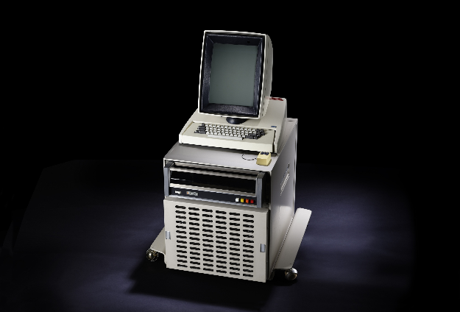
Figure 3 reference, SALES chart from earliest to latest computer - Search Images (bing.com)
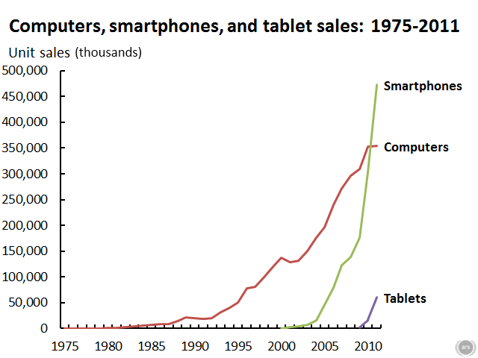
Figure 4 reference https://nat.museum-digital.de/data/owl/images/201410/20103258906.jpg

Tandy Radio Shack introduces its TRS-80:
Performing far better than the company projections of 3,000 units for the first year, in the first month after its release Tandy Radio Shack´s first desktop computer — the TRS-80 — sells 10,000 units. The TRS-80 was priced at $599.95, included a Z80 microprocessor, video display, 4 KB of memory, a built-in BASIC programming language interpreter, cassette storage, and easy-to-understand manuals that assumed no prior knowledge on the part of the user. The TRS-80 proved popular with schools, as well as for home use. The TRS-80 line of computers later included colour, portable, and handheld versions before being discontinued in the early 1990s. [3]
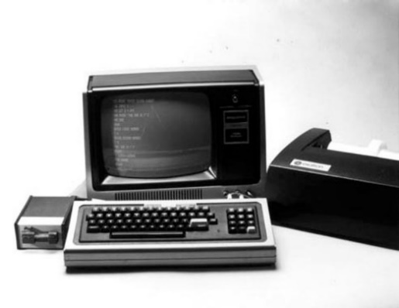
Figure 5 reference www.google.com.

Windows XP is an operating system made on August 24, 2001, lets you use several types of applications or software. For example, it allows you to use a word processing application to write a letter and a spreadsheet application to track your financial information.
Windows XP is a graphical user interface (GUI). It has pictures (graphical) that you use (user) to communicate (interface) with the computer. This type of system is popular because it is logical, fun, and easy to use.
This operating system has multi-tasking capabilities, meaning it can run several applications at the same time. Multi-tasking allows you to view this lesson on the Internet at the same time you practice using other applications with Windows XP. [4]

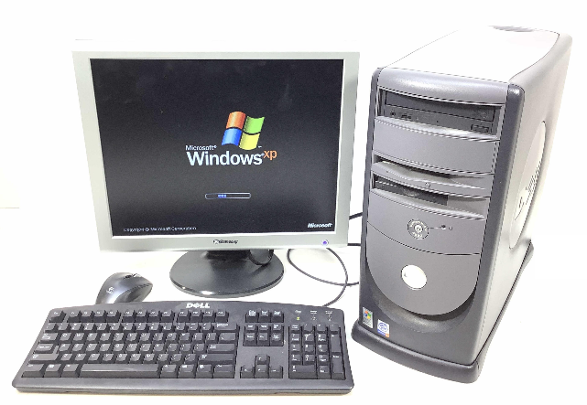
Figure 6 Reference https://image.invaluable.com/housePhotos/ejsauction/73/696573/H8897-L246019147_original.jpg
Windows 10 is a major release of Microsoft's Windows NT operating system. It is the direct successor to Windows 8.1, which was released nearly two years earlier. It was released to manufacturing on July 15, 2015, and later to retail on July 29, 2015. [5]

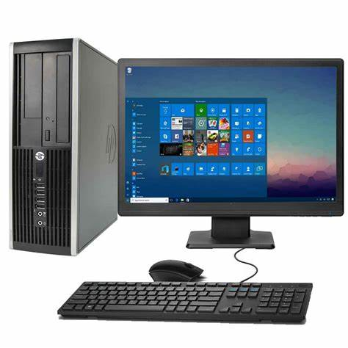
Figure 7 Reference https://th.bing.com/th/id/OIP.AgXGWysZ1SYdKgaKfnOcLgAAAA?rs=1&pid=ImgDetMain

Windows 11 introduces a sleek, centred Start menu, enhanced productivity features like Snap Layouts and Desktops, and a redesigned Microsoft Store. It boasts better gaming capabilities with Direct Storage and Auto HDR and supports Android apps via the Amazon Appstore. Its fresh design and improved functionality aim to elevate user experience.
70'S Computer Innovations
First RAM chip Intel 1970
4004 microprocessor Intel 1971.
8008 microprocessor Intel 1971.
8080 Microprocessor Intel 1974.
Altair 8800, the second personal computer 1974.
BASIC by Bill Gates and Paul Allen and formation of Microsoft, developed for Altair 1975.
Apple, I single-board computer 1976.
Z80 chip released by Zilog 1976.
Apple II 1977.
Tandy TRS80 1977.
Commodore PET 1978.
Arcade Video game 'Space Invaders' released 1979.
IBM start development work on personal computer 1979.
[6]

Silicon chips
The silicon chip was invented in 1961 by two American electrical engineers, Jack Kilby and Robert Noyce.
Their creation revolutionized and miniaturized technology and paved the way for the development of the modern computer.
Until the chip was invented, most electrical devices were constructed using bulky, power-hungry vacuum tube technology.
The development of transistors partially solved the problem, but these still had to be wired to circuit boards.
Kilby and Noyce hit on the solution simultaneously, combining separate components in an integrated circuit made of a semi-conductor material. [7]

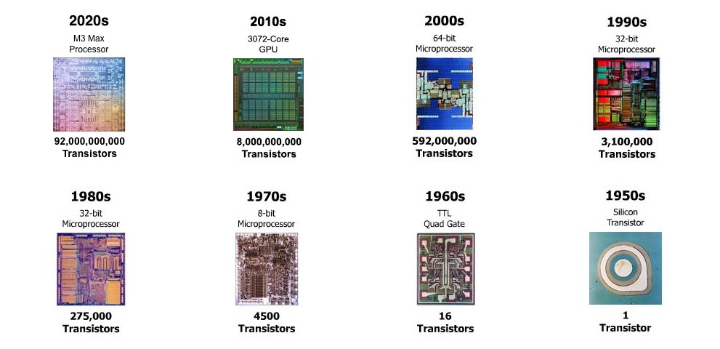
Figure 8 REFERENCE, silicon chips sale graph 1950s to 2020 - Search Images (bing.com)
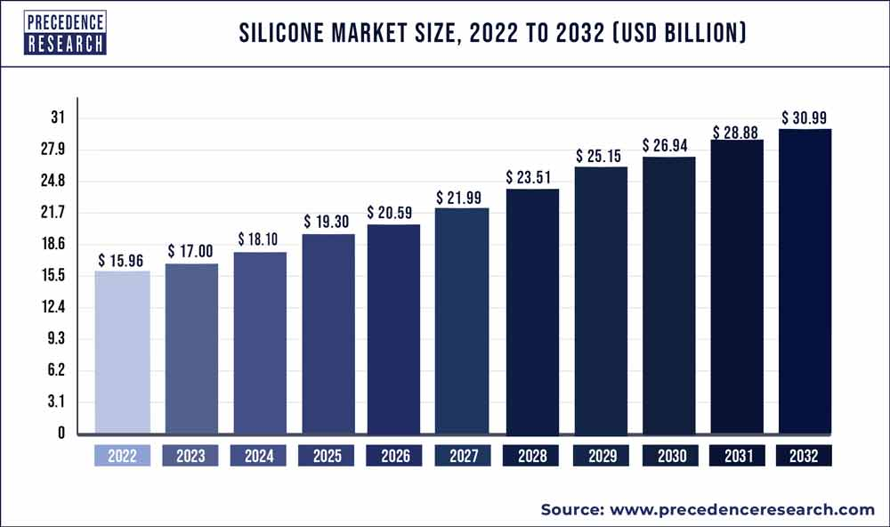
Figure 9 reference www.google.com
Most powerful computer today (2024)
The world’s latest fastest supercomputer, Frontier at Oak Ridge National Lab, in Tennessee, is so powerful that it operates faster than the next seven best supercomputers combined and more than twice as well as the No. 2 machine. Frontier is not only the first machine to break the exascale barrier, a threshold of a billion calculations per second, but is also ranked No. 1 as the world’s most energy-efficient supercomputer. Now the companies that helped build Frontier, Advanced Micro Devices (AMD) and Hewlett Packard Enterprise (HPE), reveal the electronic tricks that make the supercomputer tick.
Frontier consists of 74 HPE Cray EX supercomputing cabinets, each weighing more than 3,600 kilograms, which altogether hold more than 9,400 computing nodes. Each node contains one optimized third-generation AMD EPYC 64-core 2-gigahertz “Trento” processor for general tasks and four AMD instinct MI250x accelerators for highly parallel supercomputing and AI operations, as well as 4 terabytes of flash memory to help quickly feed the GPUs data. In total, Frontier contains 9,408 CPUs, 37,632 GPUs, and 8,730,112 cores, linked together by 145 kilometres of networking cables. The lab says its world-leading supercomputer consumes about 21 megawatts. [8]
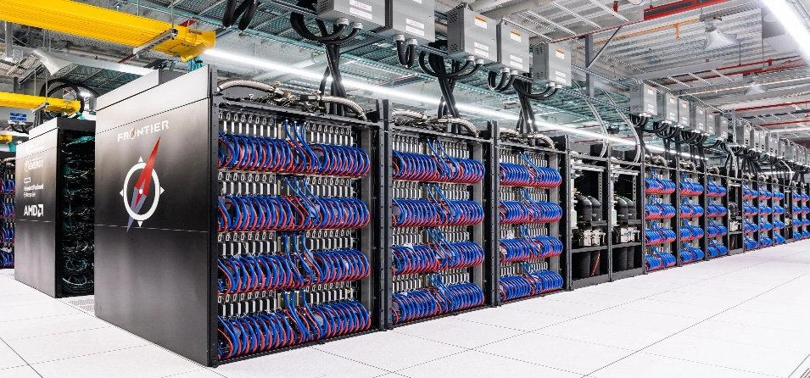
Figure 10 reference frontier supercomputer graph - Search Images (bing.com)
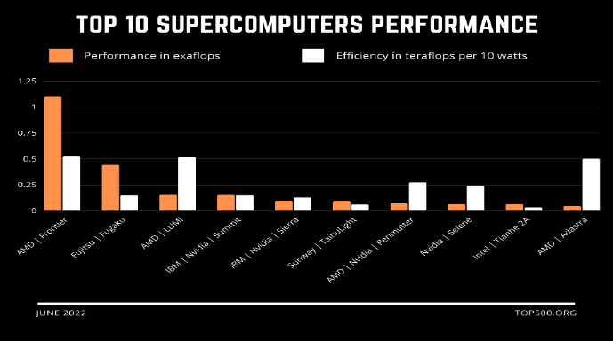
Figure 11
FACTS ABOUT FRONTIER
The incredible performance of the Frontier supercomputer is made possible by cutting-edge technology from HPE and AMD:
Comprising 74 HPE Cray EX supercomputer cabinets, Frontier is purpose-built to deliver next-generation supercomputing capabilities and scalability, available for early science access. Each cabinet houses one optimized EPYC™ processor and four AMD Instinct™ accelerators, totalling over 9,400 CPUs and 37,000 GPUs across the system. This configuration streamlines application programming for developers, thanks to the coherency facilitated by the EPYC processors and Instinct accelerators.
Powering Frontier's connectivity is HPE Slingshot, the sole high-performance Ethernet fabric designed specifically for next-gen HPC and AI solutions. It's tailored to handle larger, data-intensive workloads, ensuring smooth application execution and enhanced performance.
Frontier's I/O subsystem, scheduled to debut this year, is integral to supporting both the supercomputer and the OLCF. This system features an in-system storage layer and Orion, a Lustre-based file system recognized as the world’s largest and fastest single parallel file system, leveraging the Cray ClusterStor E1000 storage system. The in-system storage layer utilizes compute-node local storage devices linked via PCIe Gen4 connections, delivering peak read speeds exceeding 75 terabytes per second, peak write speeds surpassing 35 terabytes per second, and over 15 billion random-read input/output operations per second. The Orion file system provides approximately 700 petabytes of storage capacity and peak write speeds of 5 terabytes per second.
Frontier stands out as the world’s fastest open science supercomputer, boasting energy-efficient.
. [9]
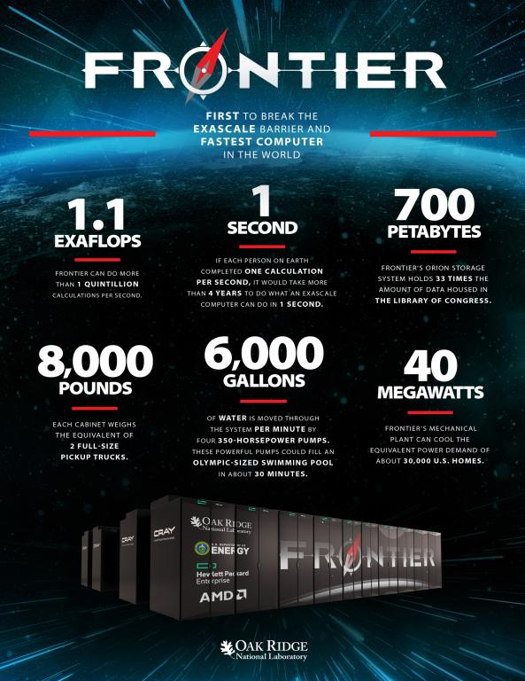
Figure 12 reference Frontier supercomputer debuts as world’s fastest, breaking exascale barrier | ORNL
Conclusion

Firstly, the timeline of computers showcases a remarkable journey of innovation and progress, spanning over several decades and we can witness transformative breakthroughs that have reshaped the fabric of human civilization. From the rudimentary mechanical calculators of the 17th century to the sophisticated supercomputers and quantum machines of today, each milestone marks a leap forward in our quest for computational excellence.
Secondly, we are reminded of the relentless march of progress and the boundless potential of human ingenuity. From humble beginnings to the brink of quantum supremacy, the journey of computers is a testament to our relentless pursuit of knowledge and our capacity to reshape the world through technology.
Thirdly, they have revolutionized communication, commerce, education, healthcare, entertainment, and countless other domains. However, with great power comes great responsibility. The potential of computers to drive positive change is immense. From addressing pressing global challenges like climate change and healthcare disparities to fostering innovation and creativity, computers hold the key to unlocking a brighter future for humanity. It is imperative that we harness their power responsibly, guided by principles of inclusivity, sustainability, and ethical stewardship. Only then can we fully realize the transformative potential of computers in building a more equitable and prosperous world.
Lastly, I think that computers are the only way forward for humanity, computers help us medically, economically, and domestically. We use them everywhere, weather it is a desktop, laptop, smartphone or tablet I cannot imagine a future without such innovative products.

References

[1] | AICHAT, Timeline introduction, 2024.
[2] | britannica, “Charles Babbage,” Encyclopaedia Britannica, p. 1, 2024.
[3] | c. h. museum, “history of computers,” 2024.
[4] | GCFGLOBAL, “WINDOWS XP,” GCFGLOBAL.
[5] | wikipedia, “windows 10,” windows 10.
[6] | “70s computer innovations”.
[7] | cnn, “silicone chips”.
[8] | IEEE, “most powerful computer today”.
[9] | G. T. B. E. M. I. Justin L Whitt, “oak ridge”.

