
University of Wales Trinity Saint David
School of Engineering
Measuring brake disc vibration with a laser Doppler vibrometer

JIAN SONG
2300254
Automotive
18/03/23
ACEB7013 Structural Integrity and Material Evaluat

Abstracts: This paper summarises and outlines the use of laser Doppler vibrometry for inspection and monitoring of brake discs based on non-contact measuring instruments, summarises and investigates principal element analysis based on laser Doppler vibrometry, illustrates the results of the experiments and the errors present in the experiments.

1.Apparatus
Sample: Automotive brake disc.
PolyTec PSV-400 Scanning Laser Doppler Vibrometer: a non-contact measurement tool used in this experiment to measure the resonant frequency modes and shapes of a brake disc.
A solenoid actuator: is used to apply an excitation to a brake disc to make it vibrate. Ultrasonic Flaw Detector: A device used to record the amplitude of ultrasonic reflections.

2.Introduction
In the modern automotive industry, the design and optimisation of braking systems has become particularly important as the requirements for vehicle performance, safety and passenger comfort continue to increase. Brake discs, as a key component of the braking system, are subjected to extremely high thermal energy and physical pressure generated during the braking process. These conditions not only challenge the material and structure of the disc, but can also cause vibration problems in the disc, which in turn affects braking efficiency and generates unwanted noise. Therefore, accurately measuring and analysing the vibration characteristics of brake discs, especially their resonance frequency modes and shapes, has become an important part of improving the performance of the braking system and passenger comfort. Vibration analysis plays a vital role in diagnosing and preventing brake disc related problems. Excessive or abnormal vibration is often indicative of potential failures or design flaws, which can lead to degraded braking performance and even a threat to occupant safety. Conventional vibration measurement methods typically rely on sensors in contact with the surface of an object, which not only may affect the natural state of the measurement object, but also may not be feasible or sufficiently accurate in some cases. The emergence of laser Doppler vibration measurement (LDV) provides a revolutionary solution for vibration analysis of critical automotive components such as brake discs.LDV technology utilises the laser Doppler effect to accurately capture the vibration state of a target object, including its resonant frequency and vibration modes, by means of non-contact measurements. Compared to traditional methods, this technique not only provides higher measurement accuracy and resolution, but also avoids physical interference with the test object, enabling researchers to make accurate measurements without affecting the normal working condition of the brake disc. The PolyTec scanning laser Doppler vibrometer (LDV), as an advanced application of this technique, has a unique scanning capability and a highly sensitive measurement system, making PolyTec Scanning Laser Doppler Vibrometer (LDV), an advanced application of this technology, with its unique scanning capability and highly sensitive measurement system, is the ideal tool for assessing the vibration characteristics of brake discs. The precise determination of the resonance frequency of the disc and the detailed analysis of the vibration modes can reveal the dynamic behaviour of the disc under extreme operating conditions, thus providing valuable information for the design and optimisation of the braking system. By taking advantage of the high performance features of the PolyTec LDV system, this experiment aims to investigate the resonance frequency pattern and shape of the brake disc in depth, which can provide a scientific basis for the engineering design and performance improvement of the brake disc.

3.Literature Review
Xiang Lin (Ling Xiang, 2012)used a laser Doppler vibrometer to measure the torsional vibration of a rotating shaft system. N.B. Roozen (N.B. Roozen, 2017)used a pump laser and a laser Doppler vibrometer for non-contact experimental evaluation of the apparent dynamic stiffness of a constrained-layer damped sandwich panel over a wide frequency range, which is also often used in automotive applications. Andrea Cavicchi (Andrea Cavicchi, 2021) investigated the dynamic behaviour of GDI injectors by simultaneously measuring the injector needle lift and final injection rate, measured by laser Doppler vibrometry, while the injectors were tested by an injection analyser based on the Zeuch method.

4.experimental purpose
The main objective of this experiment is to monitor and determine the resonant frequency pattern and shape of a brake disc under conditions of no external physical contact using a PolyTec scanning laser Doppler vibrometer (LDV). This experiment aims to achieve the following:
4.1 Determine the resonance frequencies of the brake disc under different excitation conditions.
4.2 Describe and analyse the vibration pattern and shape of the brake disc at the main resonance frequencies.
  - Possible vibration problems in the design of the brake disc and suggest optimisation.

5.Experimental principle
The core of the laser vibrometer is a high-precision laser interferometer and a signal processor. The laser in the high precision laser interferometer sends out the polarised light (set the frequency as F0) by the beam splitter into two ways, one way as the measurement light, one way as the reference light. The reference light has a certain frequency shift (F) through the acousto-optic modulator, and the measurement light is focused onto the surface of the measured object, which vibrates to cause the Doppler shift of the measurement light (f=2v/λ). The system collects the reflected light and converges with the reference light on the sensor so that the two beams of light interfere on the sensor surface, the frequency of the interference signal is F0+F+f, which carries the vibration information of the object to be measured, and the signal processor converts the frequency signal into the velocity and displacement signals of the vibration of the object. The frequency of the wave changes with the relative motion between the wave source, and the observer during propagation. When light strikes the surface of a moving object, for a light detector, the motion of the object makes the frequency of the light scattered from its surface change, and the value of this frequency change is related to the speed, direction, and wavelength of the object's motion, as well as the direction of the incident light. If the latter parameters are known, the speed of the moving object can be obtained by measuring the change in the frequency of the scattered light. Optical aberration interference, that is, by two beams of different frequencies of coherent light simultaneously projected onto the photodetector photosensitive surface interference occurs, and then through the square law effect of the photoelectric conversion between them to get the frequency difference, the frequency difference is the required Doppler shift, the rest of the frequency of the light wave frequency is close to the frequency of the wave or a higher frequency information due to out of the frequency response of the photodetector range and was filtered out.

6.Methodology
6.1 first of all the brake disc fixed in a vise, keep the brake disc stationary, and then a solenoid actuator with tape fixed in a vise, so that when it opens can be normal impact on the brake disc, is the brake disc to produce vibration, to ensure that the brake disc and the solenoid actuator are relatively static and fixed, so that every time the same force transferred to the brake disc, you can generate the The same frequency can be generated by the same force transmitted to the brake disc every time.
6.2 Place the scanning head in front of the brake disc, in the opposite direction to the solenoid actuator, at a distance of about 1 metre, and at the same time adjust the height of the scanning head so that the height of the laser emitter can be detected within the effective range of detection of the brake disc.
6.3 Open the PSV Acquisition software in the computer for set-up and perform analysis. once the acquisition app is running, select the acquisition menu and select settings. Then set the bandwidth to 20kHz and see how the brake disc vibrates below 20kHz.
6.4 Open 2D Alignment in Setup, first autofocus the laser and set the z-distance between the scanning head and the DUT to 1 m. Next, define an alignment point on the surface of the DUT and repeat this step at least 5 times.
6.5 Open Define Scan Points in Setup, select the scan points and connect them with a straight line as shown in the figure.
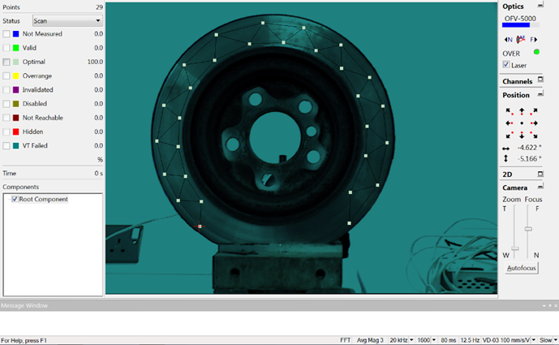
Figure 1 Scanning points
6.6 Open the scan in the Acquisition menu, after the scanning is finished, you can see from the figure that the scanning status of all the points is optimal, and it can be considered that the measurement of each point is valid.
6.7 Open the PSV analysis application to analyse the experimental data. Open frequency band, you can see the FFT will be converted to frequency domain response curve, select the frequency band of the peak in the curve. Then recalculate the frequency band, you can see the vibration modes of each band.

7.Raw measurement data and graphs
Figure () enables the selection of the frequency band in which the peaks appear in the curve:
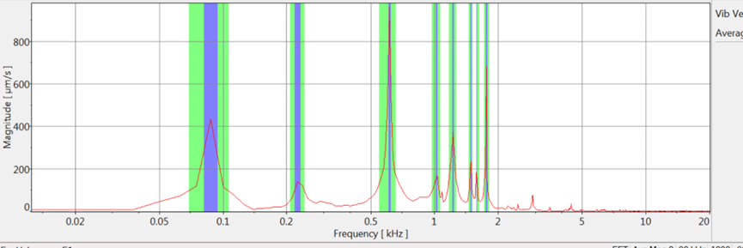
Figure 2 Frequency response graph
According to the diagram, 8 frequency bands are selected as shown：
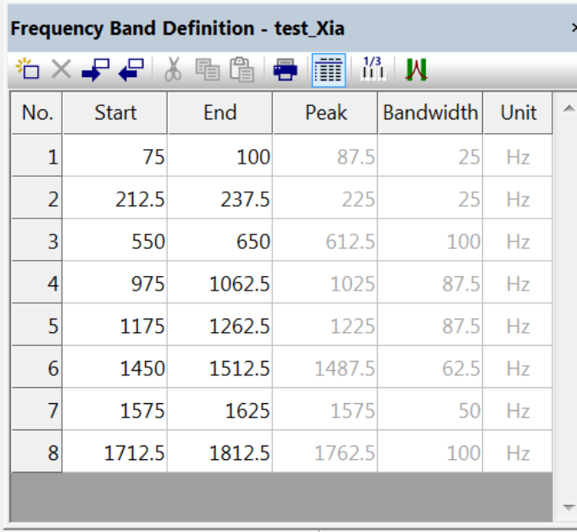
Figure 3 Selected frequency data
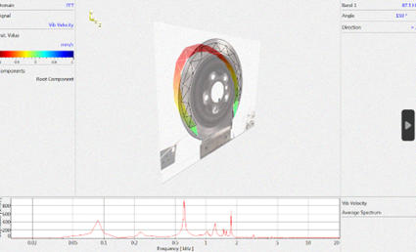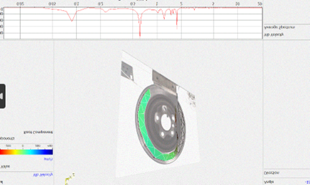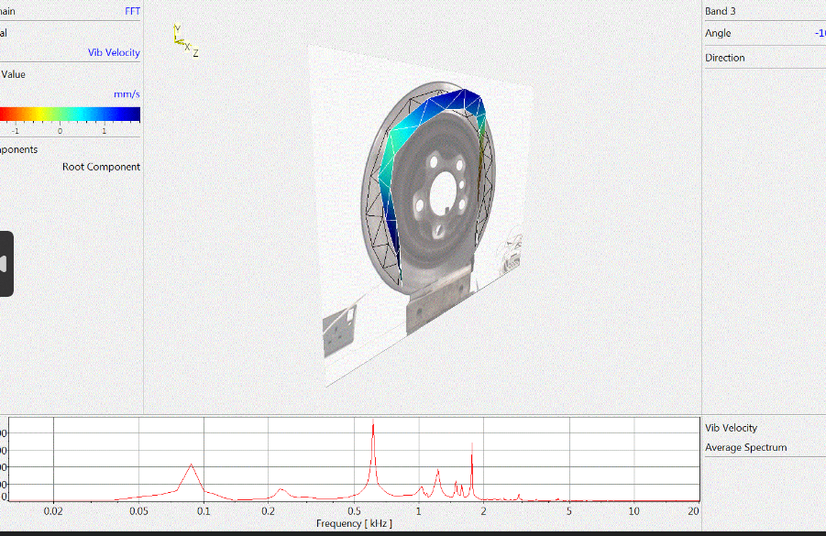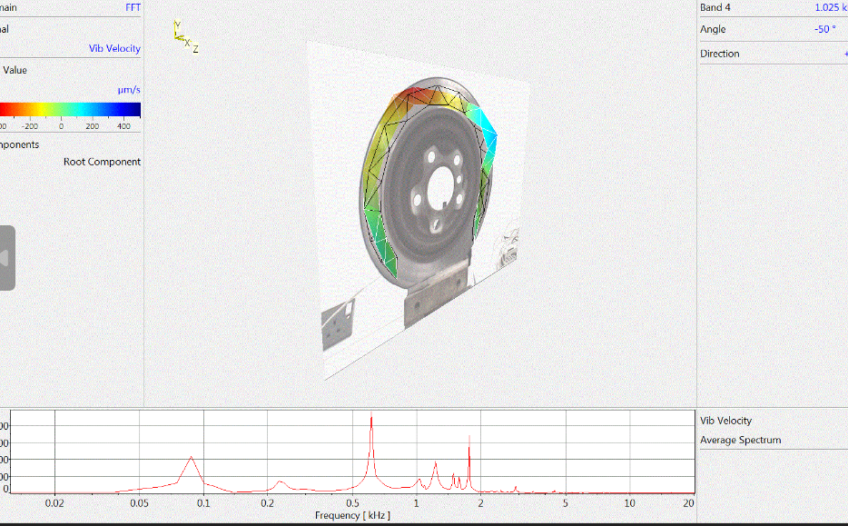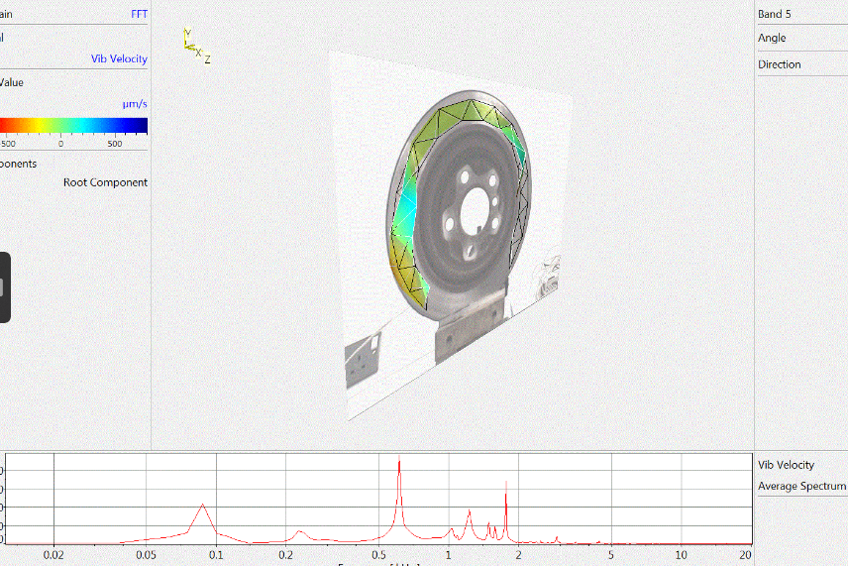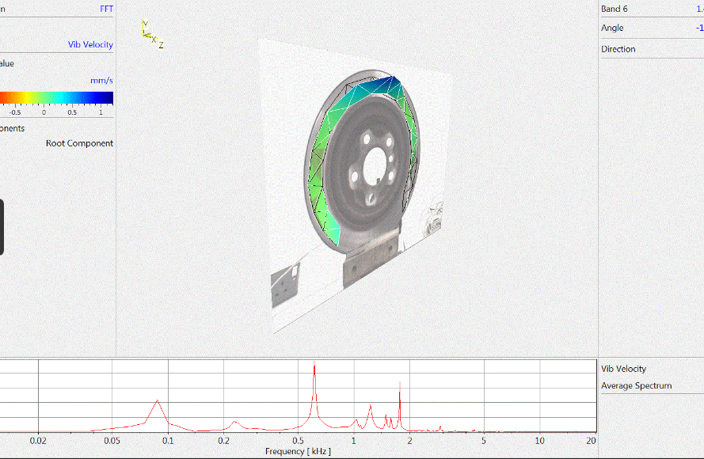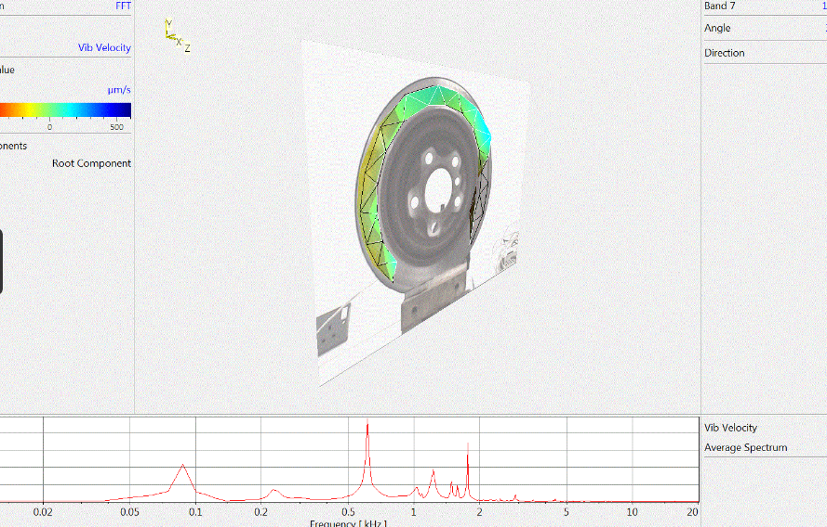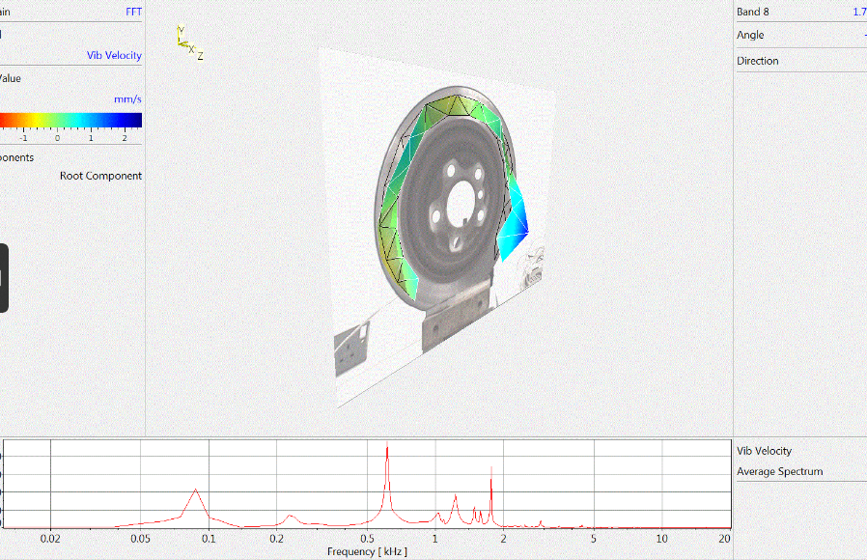
Figure 3 Vibration modes for each frequency band
8.Analysed
The number of nodes is related to the order of the modal vibration mode, here at the node is when the amplitude value is zero, at this point, the sample to be tested does not resonate with the neighbouring parts; however, this bounded place is not counted as a node, that is, the lower end of the braking disc is not counted as a node. Usually we need to judge the resonant frequency mode, so by counting the number of nodes, the larger the number of nodes, the higher it is. And on this basis, with the brake pads as the object of study, the brake pads in different working conditions show different different characteristics, that is, in different working conditions, produce different amplitude, amplitude, amplitude and other characteristics. bent mode, which indicates that in one direction, the whole disc has been moved or bent, such as a disc can be bent towards one side. According to the analysis of the above figure, as shown in figure (a), when f=87.5Hz, the resonant frequency mode does not appear node in reality, according to our judgement method, the current frequency does not have the point of zero amplitude, so it is the first-order frequency mode, and the type of judgement is bent mode, when f=1762.5Hz, there are three nodes that It is the third order frequency mode and the judgement is wave.

9.error estimation
1、 Surface Reflection Characteristics LDV relies on laser light reflected from the surface of an object to measure vibration. If the surface of the brake disc is too rough or uneven, it may affect the reflectivity of the laser, resulting in weaker signal strength or lower signal quality. Coatings or dirt on the surface of the brake disc may also affect the reflection characteristics of the laser, which in turn affects the measurement accuracy.
2. Environmental factors Vibrations in the experimental environment, such as those from surrounding mechanical equipment, may be captured by the LDV, thus interfering with the measurement of brake disc vibration. Temperature fluctuations and air currents can alter the propagation path of the laser, especially over long measurement distances, which can lead to uncertainty in the measurement results.
3.The laser beam must be accurately aligned to the measurement point on the brake disc. Inaccurate alignment may lead to deviations in the measurement results. If the laser beam is not focused correctly on the surface of the brake disc, this may result in a weak reflected signal and affect the accuracy of the data.
4. Signal processing errors Errors may be introduced by the digital processing of the signal (e.g. sampling rate and quantisation). A low sampling rate may lead to aliasing, while quantisation errors may affect the ability to capture details of the signal. Filter settings (e.g., cutoff frequency) used in data preprocessing and analysis must be appropriate or they may remove useful signals or retain noise.
5. Test Configuration and Repeatability Repeatability of experiments may be affected by differences in test configurations, such as the way the brake discs are held in place, and the position and angle of the laser beam. Small differences between different brake discs, including material properties and manufacturing tolerances, may also lead to differences between measurements.

10.Conclusions
So based on the above analysis, we can conclude that the laser Doppler vibrometer converts the vibration signals in the time domain to frequency domain signals, and at the same time identifies the resonance frequency of the vibration, and through the understanding of the vibration pattern, we can carry out the modal analysis of the brake disc. Through the analysis we can assess the structural health of the brake disc, the resonance frequency change is obviously abnormal, indicating that there is no obvious structural damage to the brake disc, and at the same time identifying the modes of vibration of the brake disc also helps to understand the vibration pattern at the resonance frequency, which is helpful for the subsequent design improvement.
References
Andrea Cavicchi, L. P., 2021. Simultaneous needle lift and injection rate measurement for GDI fuel injectors by laser Doppler vibrometry and Zeuch method,. Journal of Sound and Vibration, Volume 285, pp. 0016-2361.
Ling Xiang, S. Y. C. G., 2012. Torsional vibration measurements on rotating shaft system using laser doppler vibrometer. Optics and Lasers in Engineering, 50(11), pp. 1596-1601.
N.B. Roozen, L. L. Q. L. K. E. S. A., 2017. Non-contact experimental assessment of apparent dynamic stiffness of constrained-layer damping sandwich plates in a broad frequency range using a Nd:YAG pump laser and a laser Doppler vibrometer. Journal of Sound and Vibration, Volume 395, pp. 90-101.

