“ACCOUNTING FUNDAMENTALS”
Table of Contents
Introduction 3
Answer for 1 3
A. Preparation of “income statement and statement of finance for the business of Wales plc” 3
B. Significance between balancing position of the statement of finance 6
Answer for 2 8
A. Computation of “accounting ratios for the business of Sweet plc for 2021 and 2020” 8
B. Evaluate present basis “financial performances of Sweet plc on behalf of the financial statement” 10
Conclusions 12
References 13

Introduction
Fundamentally, the presence of accounting fundamentals indicates the primary approach of accounting preparation and presentation support that can be initiated in order to formulate some decision-making progress mainly. It can be recognised as the method through the initiative of which different accounting reports have been prepared including maintenance of transactions as well, and structure of managerial decision-making progress in proper order. Over individual business, the presence of three prime accounting fundamentals is noticed related to “Going Concern approach, accrual concept and consistency support” (Damayanti, 2019).
The presence of both initiatives is structured for balancing and comprehensive development identification which brings the ultimate support of feasibility and consistent appearances of business accounting. This report provides a detailed presentation of “financial accounting for Wales plc and also accounting analysis for Sweet plc” in relation to the current accounting period.

Answer for 1

A. Preparation of “income statement and statement of finance for the business of Wales plc”
According to primary accounting presence, the engagement of “accounting cycle” mainly indicates the presence of eight different processes that includes; “identification of transaction, a record of the transaction, preparation of general ledger, preparing unadjusted trial balance, adjustment entries, adjusted trial balance, creating financial statements, closing entries”. A proper presentation of such accounting is initiated for balancing and managing the accounting development on a proper basis that is initiated for managing the progress and formulated progress on a proper basis. Formulated presence of accounting is not only used to deliver the details of accounting transactions with balancing support, instead of that, it allows one to understand the basic accounting progress as well as difficulties so that managerial decisions including strategies can be effectively initiated (Demirkan et al., 2020).
The general concept of accounting mainly indicates the presence of accounting growth and accounting formulation that provides a systematic identification regarding financial positivity and accountability mainly. As per basic principles, the presence of the “Income statement” concept of business indicates the presence of accounting development as well as business profit identification engagement that brings the stability and progressive structure of operating growth on a proper basis. Positive support to such accounting engagement also brings stability and formulated growth support with the maintenance of which the general progressive structure of a business can also be initiated. Identification of general accounting engagement brings stability and operating development as well that can be managed for formulated growth including the standardised approach of business on a proper basis.
“In the books of Wales plc”
“Income statement”
“For the year ended 31st December 2021”
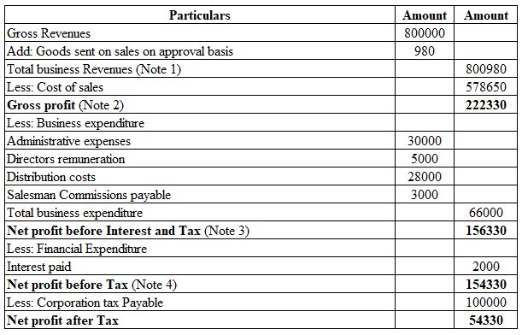
Note 1: According to basic accounting engagement, the presence of business revenue includes the presence of goods sent of sale on approval basis that is initiated for maintaining the accounting balance and progressive presence of revenue in proper order. It also indicates the general area of financial accountability mainly that brings the progressive determination regarding optimised financial accounting support on an effective basis.
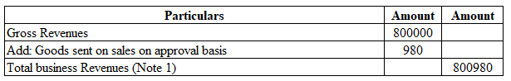
With respect to general accounting engagement the presentation of the “P&L appropriation account” is initiated for presenting detailed support of current accounting profitability that can be initiated in order to properly recognise the distributions level of profit among business and shareholders properly. The presence of this type of accounting identification is initiated to balance the standardised progress and accounting formulation approach about business feasibility structure, which indicates the progress including optimised growth of business on a proper basis (Monteiro and Cepêda, 2021). The identification support regarding this type of accounting is also initiated in order to balance the retained earning value and dividend approach on a proper basis that is influential for business stability and market capitalization growth purposes.
“In the books of Wales plc”
“Profit and Loss appropriation”
“For the year ended 31st December 2021”
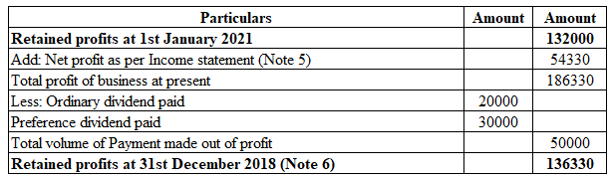
The identification support of “Statement of Finance” mainly indicates the detailed appearances of business “assets, liabilities and capital engagement” that is optimum for recognising the accounting development and formulated progress in an effective basis. With the initiative of this type of accounting presence, the managerial department can supportively identify the progressive area of development as well as some of the basic accounting formulation support in a proper manner (Zyznarska-Dworczak, 2019). Additionally, the presence of such accounting identification is also managed for development and progressive structural support regarding accounting feasibility also which is optimum for balancing and operating the development of business on an effective basis.

“In the books of Wales plc”
“Statement of Finance”
“For the year ended 31st December 2021”
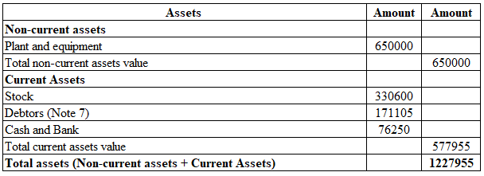
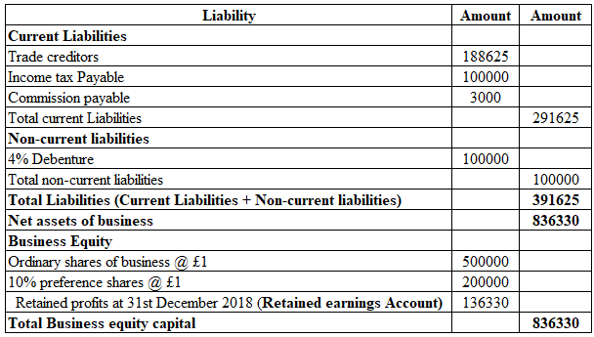
Notes: The adjustment of the goods sale on approval basis is adjusted along with the balance of debtor mainly so that a supportive presence of accounting outstanding balance can be initiated on an effective basis. The presence of such accounting presence also formulated the operating development that brings the ultimate support of financial feasibility growth of business on an effective basis.
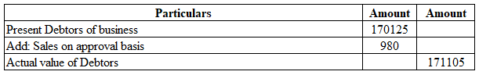

B. Significance between balancing position of the statement of finance
According to basic accounting engagement, the primary concept of business accounting indicates the presence of financial details on a proper basis that brings the operating growth on a proper basis. The concept of “accounting equation” concept is mainly initiated for presenting the detailed support of accounting development including accounting operating identification that is optimum for operating stability and marketing growth initiative support on a proper basis (Garbowski et al., 2019). The presence of this concept indicates the formula of “Assets = liabilities + Capital”, where the identification of the “double entry accounting concept” is supportively balanced. The presence of such accounting principles indicates that “for every business transaction, an entry is recorded in at least two accounts as a debit or credit” is initiated which provides the presence of accounting balance support on a proper basis. The presence of such an accounting principle is initiated for both the “accrual and actual accounting” aspects that provide a formulated development including accounting sustainability on a proper basis mainly.
For example; the Purchase of machinery through initiating a bank payment of 50,000; for this transaction, the journal will be;
“Machinery account” ……………………………… Debit 50,000
“To bank account”…………………………………. 50,000
(“To acquire machinery significant business cash balance has been contributed in the present accounting period”)
The presence of such accounting engagement indicates the characteristics of both debit and credit engagement that is initiated for maintaining the balancing support of “statement of financial position” in an effective basis. It also indicates the optimised balancing approach to the accounting feasibility structure as well, with the maintenance of which a progressive determination about the accounting sustainability approach can also be balanced. Proper identification of this type of accounting principles and accounting equation support is initiated to balance the progressive and formulated development which balances the operating compatibility and strategic identification support in the proper order (Akimova et al., 2018). In the same context, over the accrual accounting transaction this type of accounting balance support can also be initiated that provides the maintenance approach about accounting feasibility on a proper basis. Depending on the above example if instead of paying through cash, the management acquired the machinery from the creditor on a credit basis therefore instead of bank balance declining and increasing the position of creditors balance will be initiated. The presence of this approach indicates therefore the positivity and accountability support regarding operating Optimisation which is influential for performance initiatives and progressive determinations of the business in future.

Answer for 2

A. Computation of “accounting ratios for the business of Sweet plc for 2021 and 2020”
Importance of accounting presence in the form of a statement is initiated for presenting detailed support about the accounting performances that indicate feasibility and accounting compatibility on a proper basis. It also brings the general approach of optimised accounting development including financial progress on a proper basis that can be structured in order to balance the strategic initiative for business development in future (Akimova et al., 2018). The identification support related to accounting analysis on the contrary represents the area of development with a historical analysis that can be initiated in order to formulate the progressive structure and operating stability approach on a proper basis. In some cases, the presence of this type of identification also initiates the formulated development and optimised operating maintenance approach also which is balancing for future progress.
General conceptual engagement regarding “accounting ratios” is initiated for a detailed approach to accounting development including progressive structure mainly with the intuitive idea of which a formulated support about operating development can be effectively balanced. The identification of basic accounting analysis in the form of ratios is initiated for balancing and operating accountability initiatives that bring the standardised approach to business growth on a proper basis (Vegera et al., 2018). Depending on the present accounting engagement, a detailed financial analysis for the business of Sweet plc has been initiated for the two different accounting periods in order to recognise the operating and financial progress on an effective basis.
Return on Capital Employed
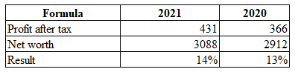
Return on Equity
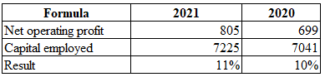
Earnings per share
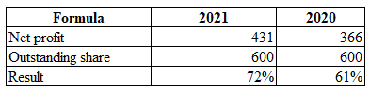
Net profit margin
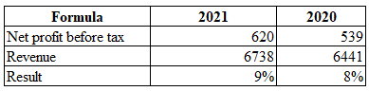
Asset turnover
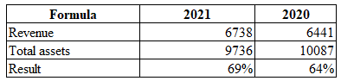
Stock holding days
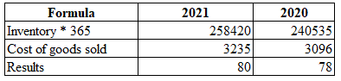
Debtor’s collection period
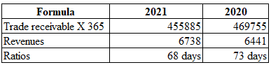
Current ratio
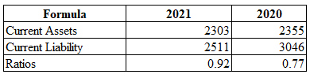
Gearing ratio
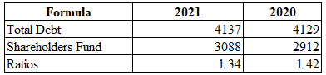
Interest cover
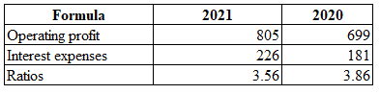

B. Evaluate present basis “financial performances of Sweet plc on behalf of the financial statement”
With the support of present accounting engagement, a significant and systematic presence of current accounting evaluation for the business of Sweet plc related to two different accounting periods has been initiated that indicates the operating and sustainable accounting identification in a proper basis. A primary analysis of present accounting identification has been evaluated;
“Return on Capital Employed”: Identification of this analysis mainly indicates the accounting progress including development initiatives that indicates the earning approach associated with capital processing. As per the present computation during the period of 2020 around 13%, while in 2021 around 14% growth is initiated, indicating the progressive formulation including operating development on a proper basis. The present supply chain development including marketing progress mainly formulates a progressive approach to the business for initiating optimised growth and a progressive approach on an effective basis (Osadcha et al., 2018).
Return on Equity: The presence of such accounting analysis is initiated for evaluating the earning capabilities of business in relation to equity capital that manages the progressive and formulated development on a proper basis. As per the current determination during the period of 2020 around 10%, while in 2021 around 11% growth is initiated, this is optimum for balancing and formulating the operating stability on a proper basis. In accordance with present marketing initiatives, the operating growth including present marketing management indicates sustainable performance progress that is influential for stability and performance initiative purposes.
Earnings per share: As per general accounting identification evaluating this measurement is initiated to recognise the earning capability of businesses on behalf of their basis. Depending on the current accounting progress around 61% during 2020 and 72% growth in 2021 is mainly initiated which indicates sustainable development including operating an optimised balancing approach on an effective basis. Current growth initiatives related to business revenue processing including the maintenance of the cost presence of this business provide a systematic volume of profitability initiative which is sustainable for managing the earning capability of the business on an effective basis (Uyar, 2019).
Net profit margin: Identification of this measurement is initiated to recognise the earning capability of business during the present accounting period with the formulation of which a progressive determination regarding business feasibility can be balanced. According to the present computation around 8% growth in 2020 is noticed while in 2021 it will enhance to 9% supportively. The presence of this development indicates progressive management including an optimised growth approach, which is sustainable in order to maintain the operating stability and progressive measurement of business formulations in future in proper order.
Asset turnover: Maintenance of this measurement is initiated for basic identification regarding the turnover approach of business in relation to asset structure that is initiated for managing the progressive measurement of business feasibility properly. According to current computation during the period of 2020, the volume of such growth was 64 % while in the present period it increased to 69%. The present marketing demand includes operating engagement of the business by initiating a systematic volume of revenue progress approach which is comprehensive for balancing the stable structure of the business in the preceding period (Ostaev et al., 2019).
Stock holding days: Identification of this measurement is initiated to recognise the overall volume of inventory performances of business on a proper basis that is initiated to balance the marketing demand on a proper basis. According to the present computation, significant progress is identified which indicates that the overall marketing demand is rapidly increasing in the present situation and by holding the inventory volume the business is intended to maintain the pricing structure on a proper basis. The presence of this type of initiative will provide a systematic volume of revenue development that can be balanced to standardise the progressive approach in proper order in future.
Debtors collection period: Primary identification regarding this measurement is initiated to evaluate the overall time period within which positive reimbursement support regarding the outstanding dues from accounting receivables can be recovered. According to the current computation, the declining position is noticed, indicating that the current compatibility of the business regarding credit formulation support is developed in order to maintain the standardised progress and operating stability on a proper basis (Brooks and Schopohl, 2020). It also indicates the optimised value creation support of business as well which is influential for managing the stability and operating accountability structure related to revenue progress in a future basis.
Current ratio: Identification of this measurement is initiated to recognise the liquidity structure for the working capital position of business during the present accounting year that is influential in order to maintain the stability and progress of the structure of business in proper order. It is also initiated to balance the optimised value process and is approved related to business short-term payment support which indicates Sustainable progress in the present scenario compared to the previous year's structure. However, the management needs to control the volume of the liquidity amount on a proper basis so that the standardised and ideal position related to the current ratio can be initiated in future.
Gearing ratio: Identification of this measurement is initiated to formulate the optimum position regarding the business capital structure that is influential in order to stability and progressive approach of business on a proper basis. Proper maintenance support regarding this type of computation is initiated for balancing the capital positions as well which is influential for stability in future. According to current computation mainly a declining position is noticed that indicates a progressive development related to business equity capital compared to the debt capital structure. However, depending on the present accounting compatibility the management of the business needs to proceed with a systematic volume of outsourcing financial controlling approach mainly so that the risk assessment level can be declined in relation to the Capital effect.

Conclusions
In conclusion, primary and basic accounting is required for financial compatibility including accounting development purpose that brings the ultimate support of financial positivity. A systematic presence of accounting brings supportive identification of accounting positivity and drawbacks that can be initiated for organisational development in proper order. As per the basic accounting engagement regarding both the business mainly indicates a progressive and formulated development that indicates the operating development including a sustainability approach on a proper basis. A systematic presence of such accounting also initiates development as well as operating compatibility support that is optimised for operating stability and other basic growth support.

References
Akimova, L., Osadcha, O. and Akimov, O., 2018. Improving accounting management via benchmarking technology. Фінансово-кредитна діяльність: проблеми теорії та практики, (1), pp.64-70.
Akimova, L.M., Levytska, S.O., Pavlov, K.V., Kupchak, V.R. and Karpa, M.I., 2019. The role of accounting in providing sustainable development and national safety of Ukraine. Financial and credit activity problems of theory and practice, 3(30), pp.54-61.
Brooks, C. and Schopohl, L., 2020. Green accounting and finance: Advancing research on environmental disclosure, value impacts and management control systems. British Accounting Review, Forthcoming.
Damayanti, C.R., 2019, August. Accounting and its challenges in the new era. In Annual International Conference of Business and Public Administration (AICoBPA 2018) (pp. 81-83). Atlantis Press.
Demirkan, S., Demirkan, I. and McKee, A., 2020. Blockchain technology in the future of business cyber security and accounting. Journal of Management Analytics, 7(2), pp.189-208.
Garbowski, M., Drobyazko, S., Matveeva, V., Kyiashko, O. and Dmytrovska, V., 2019. Financial accounting of E-business enterprises. Academy of Accounting and Financial Studies Journal, 23, pp.1-5.
Monteiro, A. and Cepêda, C., 2021. Accounting information systems: scientific production and trends in research. Systems, 9(3), p.67.
Osadcha, O.O., Akimova, A.O., Hbur, Z.V. and Кrylova, I.I., 2018. Implementation of accounting processes as an alternative method for organizing accounting. Financial and credit activity problems of theory and practice, 4(27), pp.193-200.
Ostaev, G.Y., Kondratyev, D.V., Kotlyachkov, O.V., Konina, E.A., Suetin, S.N. and Istomina, L.A., 2019. Improving the methods and approaches of analysis and management accounting in agriculture. Amazonia Investiga, 8(20), pp.135-143.
Uyar, M., 2019. The management accounting and the business strategy development at SMEs. Problems and perspectives in management, (17, Iss. 1), pp.1-10.
Vegera, S., Malei, A. and Trubovich, R., 2018. Accounting development of natural resources in organizations carrying out the disposal of municipal waste and biogas extraction in the context of the'green'economy. Entrepreneurship and Sustainability Issues, 6(1), pp.211-225.
Zyznarska-Dworczak, B., 2019. The impact of the accountability on accounting development as the essence of sustainability accounting. Problems of Management in the 21st Century, 14(1), p.73.

