High Performing Teams: My Role as a Line Manager

A series of 3 lunchtime lectures

Facilitation Guide

Face to Face Delivery

Course Overview
This course is suitable for all current line managers and any future potential line managers.
Please note that this course is a series of 3 lunch time sessions approximately. The initial session is approximately 1 hour long with 2 x 30 minute follow up sessions. Each session should take place within 2 weeks of the previous session. The attendees should be from a variety of departments and locations, there should be no more than 20 attendees per session.

Preparation Checklist

Checklist
Preparing:
1 | Book appropriate room  Requirements – appropriate table numbers, pens, projector with sound
2 | Send out email with session details to attendees for each of the 3 sessions with a copy of the background reading (i.e. report to HR director)
3 | Gather required resources  - Paper register  - Post it notes and pens  - Handouts (HRD Report, CIPD Factsheet [Session 2])
4 | Check facility is able to project slides on big screen and can include sound
A week before workshop
5 | Send out reminders, if anyone drops out, look for replacement
Just before you start the workshop
6 | As people arrive, get them to sign the register

Facilitation Notes – Session 1

Suggested Time | Slide 1 – Opening slide
 | 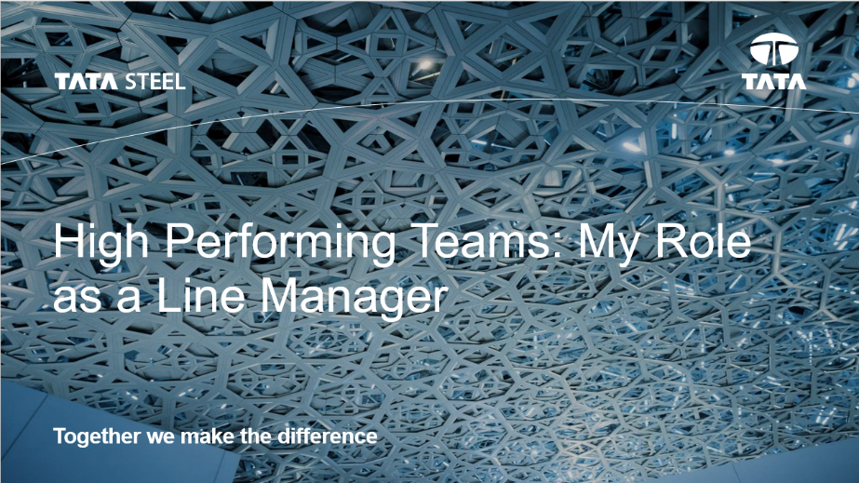
Welcome people on arrival, introduce yourself, get them comfortable in the room. Make sure everyone signs the register on arrival.
Get everyone to say a quick hello, say their name and where they work.

Suggested Time | Slide 2 – Icebreaker Activity
15 minutes | 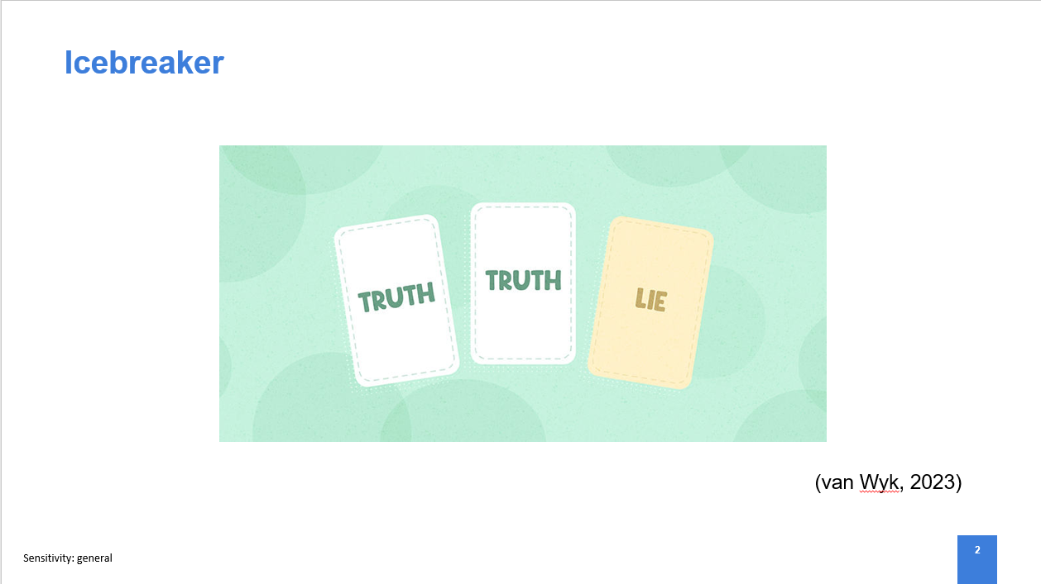
- Explain to the group that for each of the 3 sessions, the group will remain the same so this is a good opportunity to get to know one another
- Ask attendees to spend 5 minutes thinking of 2 truths about yourself and 1 lie, try to make these as obscure as possible but ask that the statements are kept appropriate.
- Spend 10 minutes going through the statements asking the rest of the group to vote for which statement they feel is the lie prior to the individual revealing.

Suggested Time | Slide 3 – Session 1 Objectives
2 minutes | 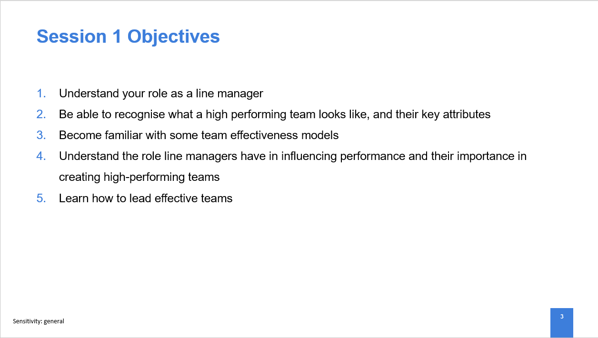
Read through each of the session objectives.
Suggested Time | Slide 4 – What is a line manager?
2 minutes | 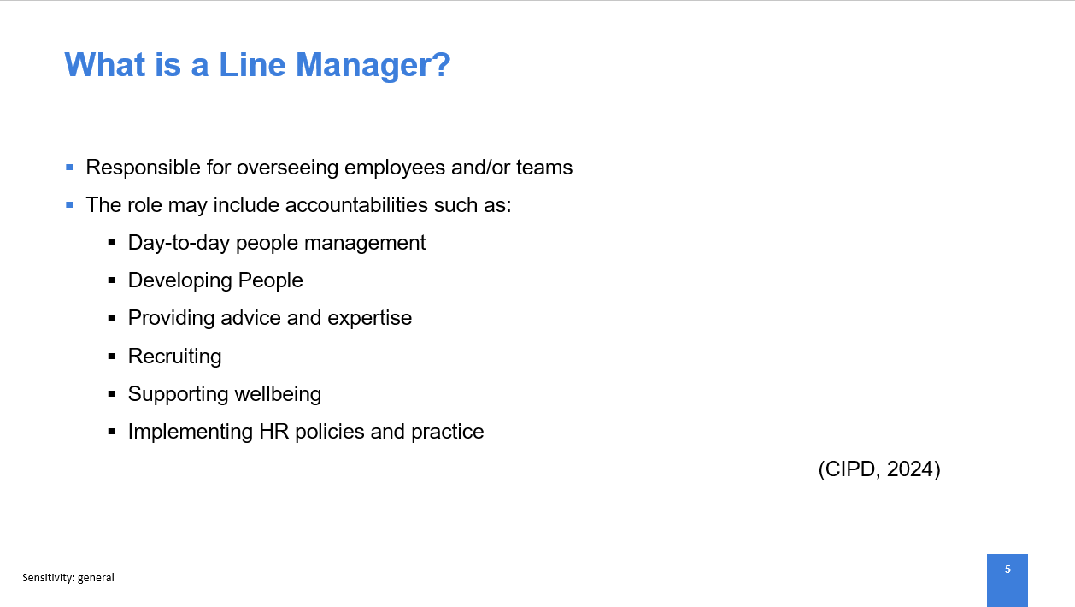
- As a line manager you are directly responsible for overseeing your team, their performance and development (Morris, 2021).
- As a line manager, people management should be one of your top priorities and you are responsible for acting as the bridge from the UK Management Team to your team members on a number of things including strategy, policy and goals (Salama, 2023).
- Discuss examples of line manager accountabilities as shown on the slide.

Suggested Time | Slide 5 – What is a High Performing Team?
2 minutes | 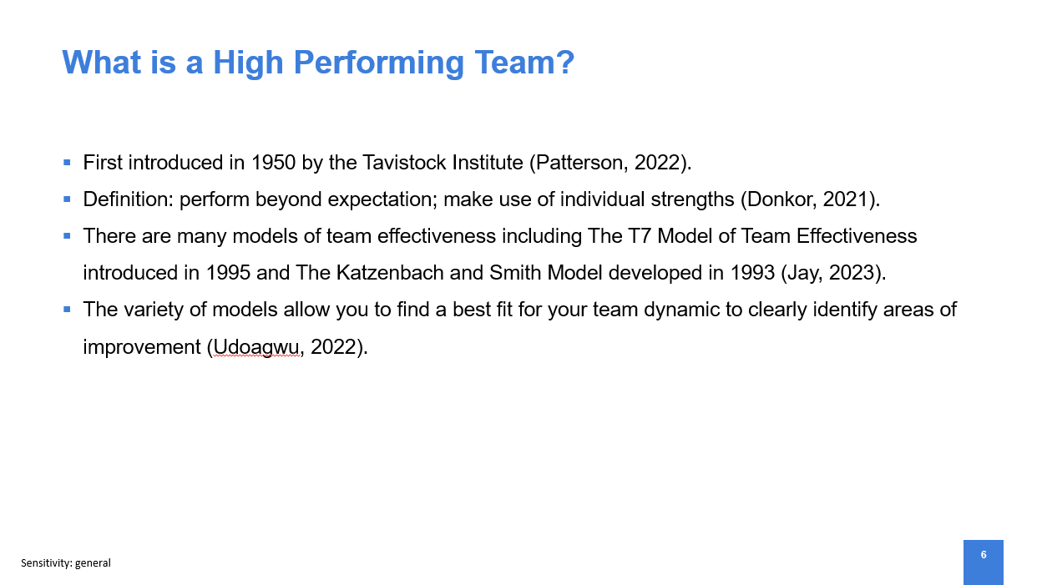
- The concept of high performing teams was first introduced in 1950 by the Tavistock Institute but wasn’t adapted by organisations until the 1980’s (Patterson, 2022).
- There is not one agreed definition but historically, high performing teams are considered to be those that perform beyond expectation and make use of the strengths of the each individual team member (Donkor, 2021).

Suggested Time | Slide 6 – Activity
15 minutes | 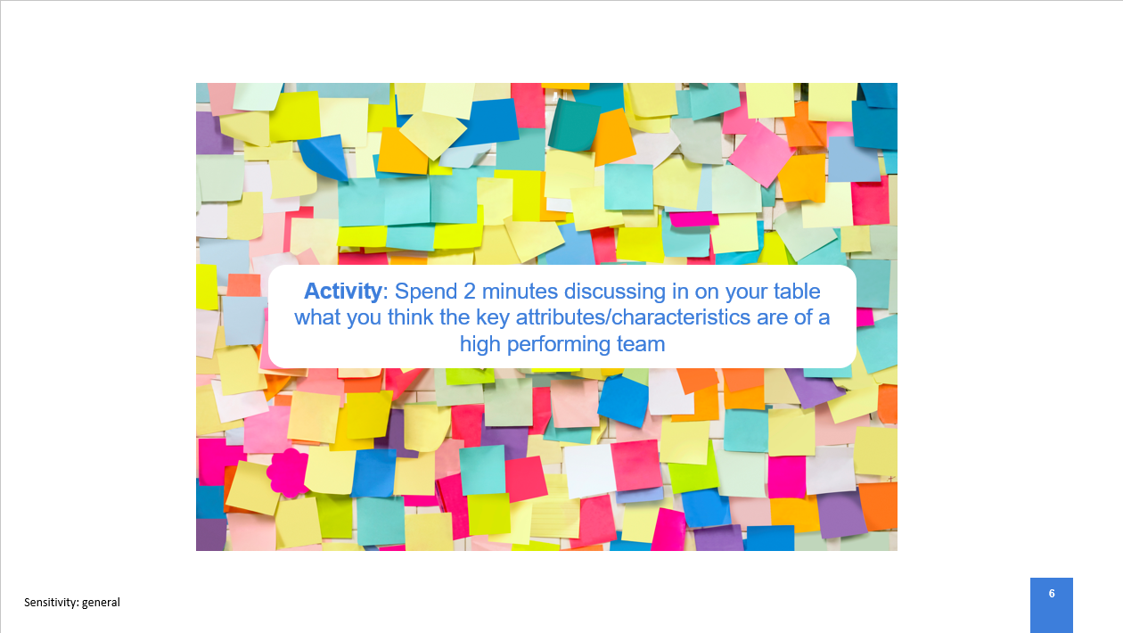
- Ask the group to spend 2 minutes discussing in their tables what they think the key attributes/characteristics are of a high performing team
- Ask that they write each attribute/characteristic on a separate sticky note
- Once completed gather all sticky notes and read through some of the reoccurring or unique attributes/characteristics

Suggested Time | Slide 7 – Attributes and Characteristics of High Performing Teams
2 minutes | 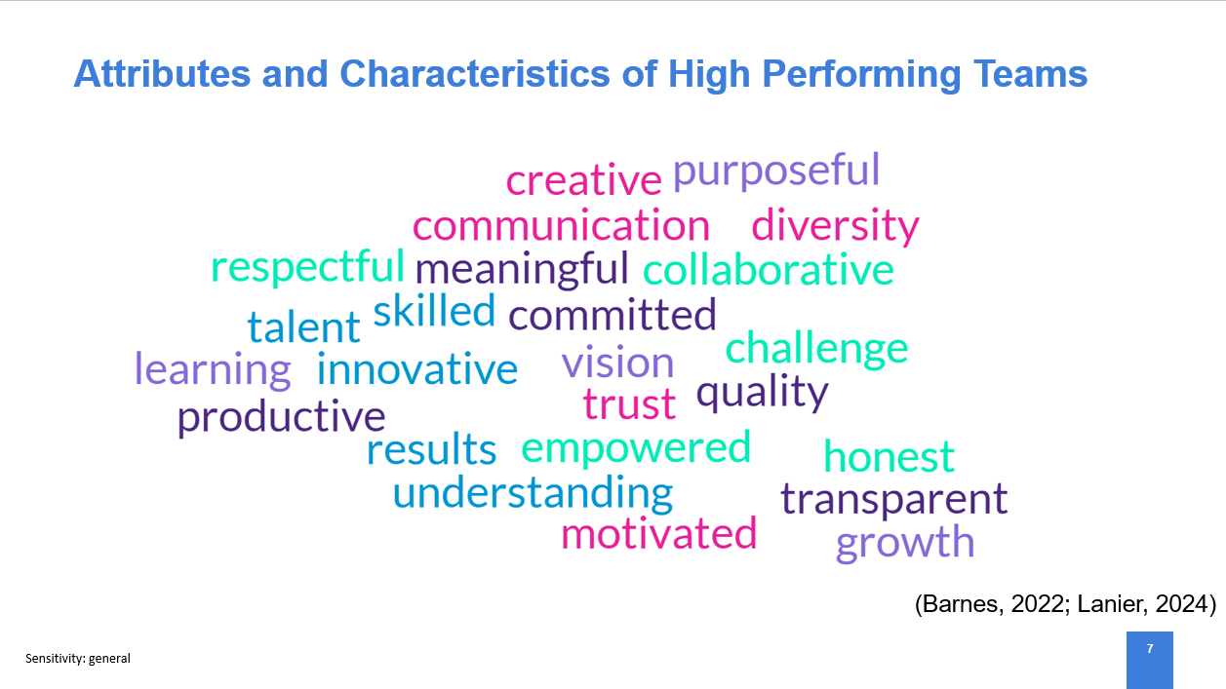
- Following on from the activity, review any attributes or characteristics that were not mentioned by the attendees.

Suggested Time | Slide 8 – Team Effectiveness Models
5 minutes | 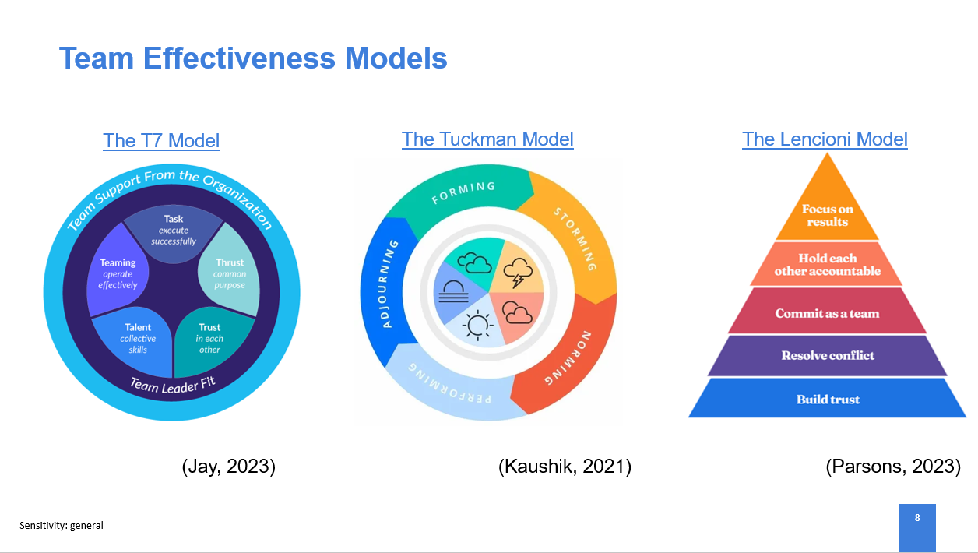
- Theorists have produced many team effectiveness models including the 1995 T7 Model of Team Effectiveness and The Katzenbach and Smith Model developed in 1993 (Jay, 2022).
- You may ask what the purpose is for using team effectiveness models, you can use the models to identify strengths, areas of concerns and specific challenges facing individuals or the team in order to develop and maximise performance and results (Personio, 2022).
- The models have differing areas of focus which make it easier to find a best fit for your own team dynamic and thus you can more clearly identify areas of improvement (Udoagwu, 2022).
- Talk through the components of each model show on screen and in what scenario they would be most effective:
- Use the T7 model in project teams (Freeman-Gray, 2024);
- Use Tuckman’s Model when trying to quickly improve the team dynamic (Chance, 2022);
- Use Leonici’s Model to address dysfunctions within teams and understand the root causes of these dyfunctions (Osmani, 2022).
- Encourage the attendees to do some self-learning on some team effectiveness models and have a go at using one of them to evaluate their team.

Suggested Time | Slide 9 – Line Managers role in influencing performance and creating high-performing teams
5 minutes | 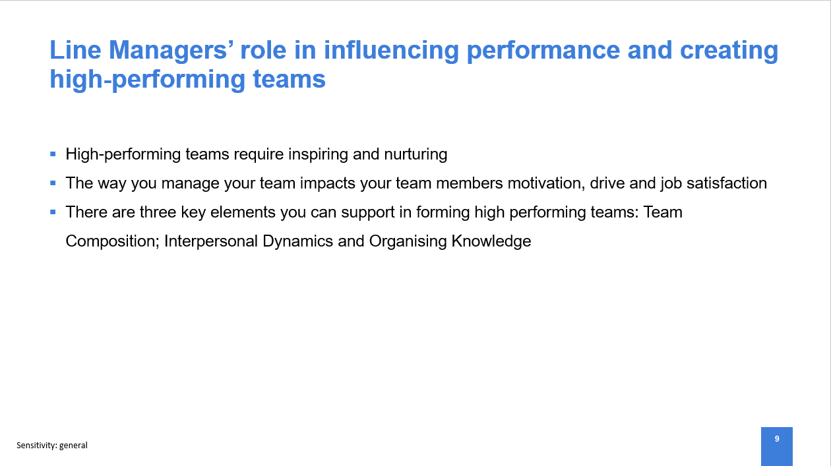
- High performing teams do not appear in an instant, they take time to develop and inspire, line managers are fundamental in nurturing these teams, enabling organisational policies and developing their teams (Laiken, 1994; CIPD, 2024).
- The way you manage your teams will be a big determining factor on your employees’ overall motivation and drive impacting the levels of organisational commitment and job satisfaction (Savaneviciene and Stankeviciute, 2012).
- As a line-manager you have the ability to support the formation of high performing teams by ensuring you have three key elements present:
- Team composition: a diverse team with complementary personalities
- Interpersonal dynamics: ensuring there is trust, psychological safety and social cohesion in the team
- Organising knowledge: encourage shared thinking and information-sharing
(CIPD, 2023a)
- While many recognise the main component of a high performing team to be the specialists or experts that make up the team, a strong leader is an essential ingredient (Burkus, 2023; Scarinzi, 2024). Line managers set the expectations and boundaries of employees in their roles and by fostering the right environment will create more engaged and motivated teams, working to their fullest potential; the foundations of a high-performing team (Scarinzi, 2024).

Suggested Time | Slide 10 – How to lead effective teams
5 minutes | 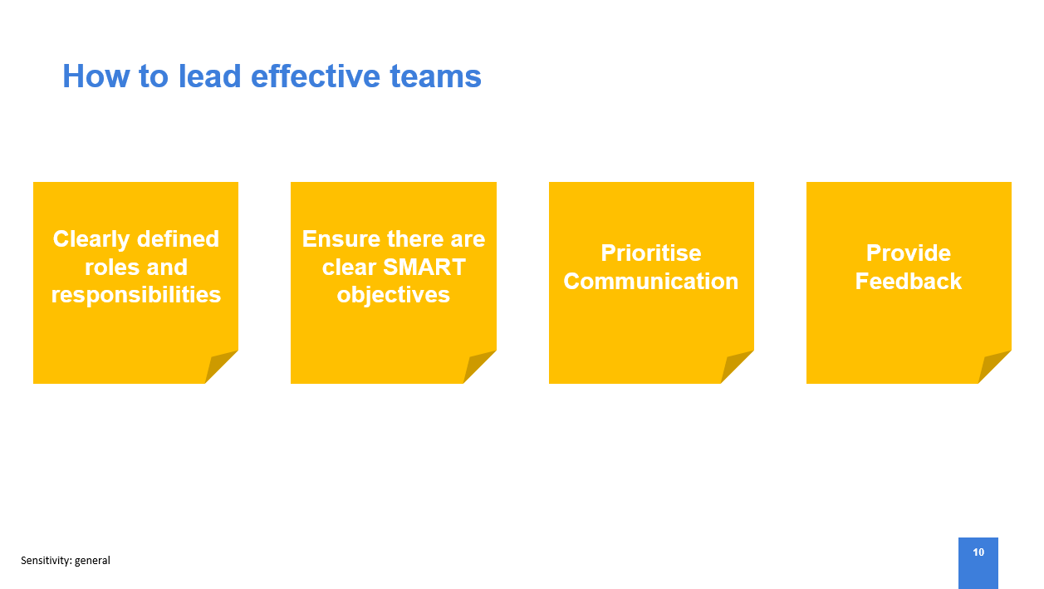
As a line manager there are many things you can do to effectively lead your teams:
- Clearly define individual roles and responsibilities – not only will this increase efficiency through preventing duplication of efforts and motivate employees through giving them ownership of tasks,it will also reduce potential conflict within the team if individual’s aren’t taking accountability for their performance (Wen, 2024).
- Ensure there are clear SMART objectives for individuals and the team as whole so they can understand their contribution to the organisation’s goals and success. This will also help track progress and areas where further support is required (Darby, 2024).
- Prioritise communication with your team – communication is a critical factor in leading effective teams. You should ensure that individuals have the platform and confidence to share ideas, make recommendations and give feedback to allow for continuous improvement and a motivating team environment (Hayes, 1997).
- Provide Feedback to allow areas for development to be identified,support the individual in working towards these improvements, constructive feedback must be specific in order for the individual to address the concerns (Wen, 2024). It is also necessary to provide positive feedback to individuals and the team to motivate and recognise achievements (Pilipenko, 2021).

Suggested Time | Slide 11 – Measuring team effectiveness
3 minutes | 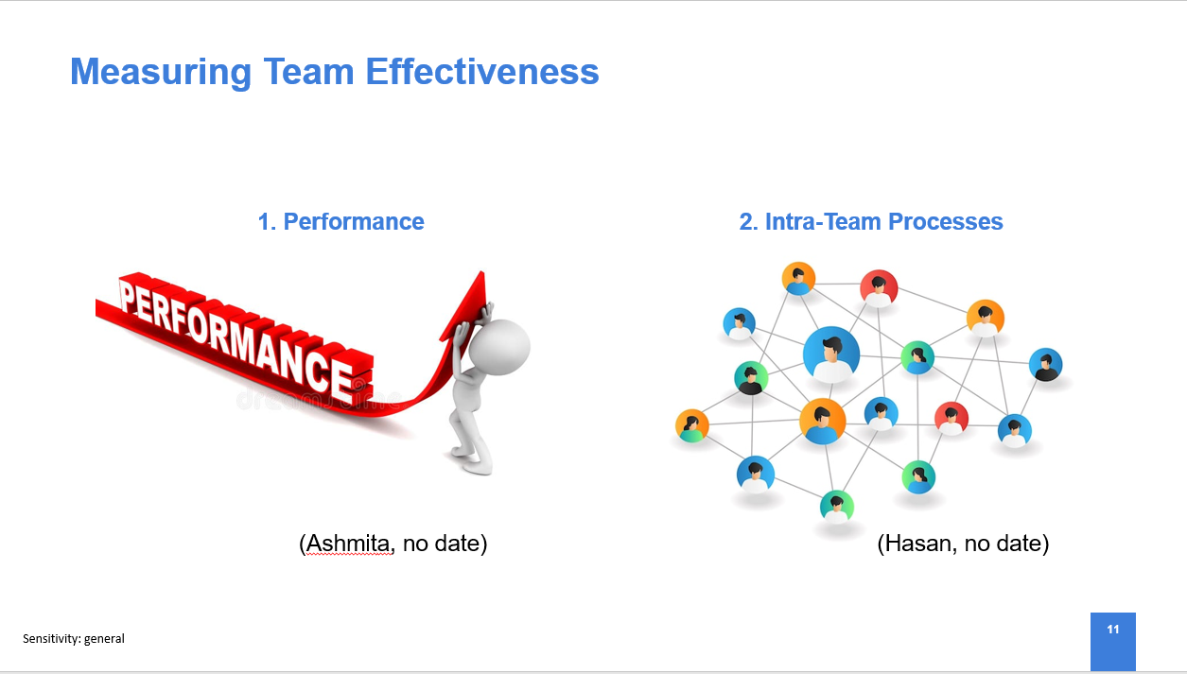
How do you know if a high performing team is performing effectively? There is not an accepted method for measuring team effectiveness however there are two criteria which you should review
- Performance – review completion against objectives and accomplishment of set goals alongside the task output of the team i.e. how many errors have been made or how much money has been saved for example.
- Intra-Team processes – it is important for you as a leader to observe exchanges and communication within the team and the level of support and sharing of information they offer one another.
(CIPD, 2023b)

Suggested Time | Slide 12 – Review of Session 1 Objectives
2 minutes | 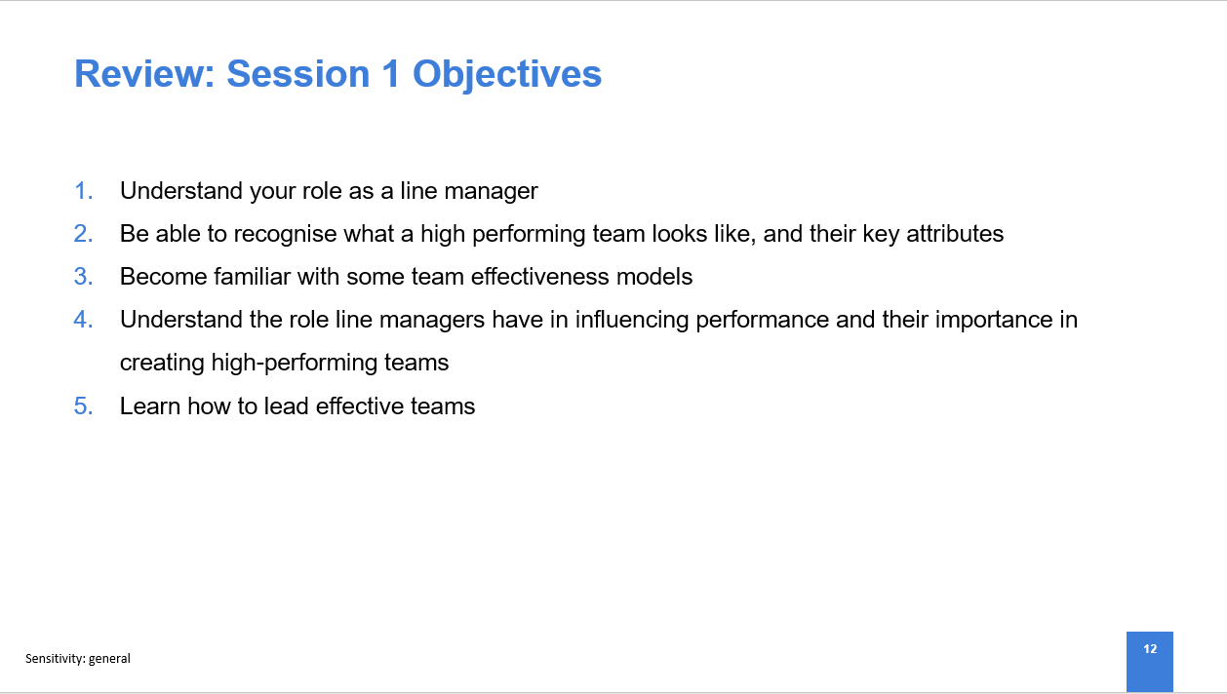
Review the session objectives and highlight some of the key learnings
i.e. in relation to objective 4, we have learnt about 3 team effectiveness models: The T7 Model; The Tuckman Model and The Lencioni Model and in what situation you would use each.

Suggested Time | Slide 13 – Questions
 | 
- Ask if any of the attendees have any questions related to the content covered in the session
- Encourage attendees to go away and reflect on their learnings and how they would use this in their roles as line managers
- Remind line managers that in order to complete the course they will need to attend 2 further sessions of which they will already have the invite for.

End of Session 1

Facilitation Notes – Session 2

Suggested Time | Slide 14 – Opening Slide
 | 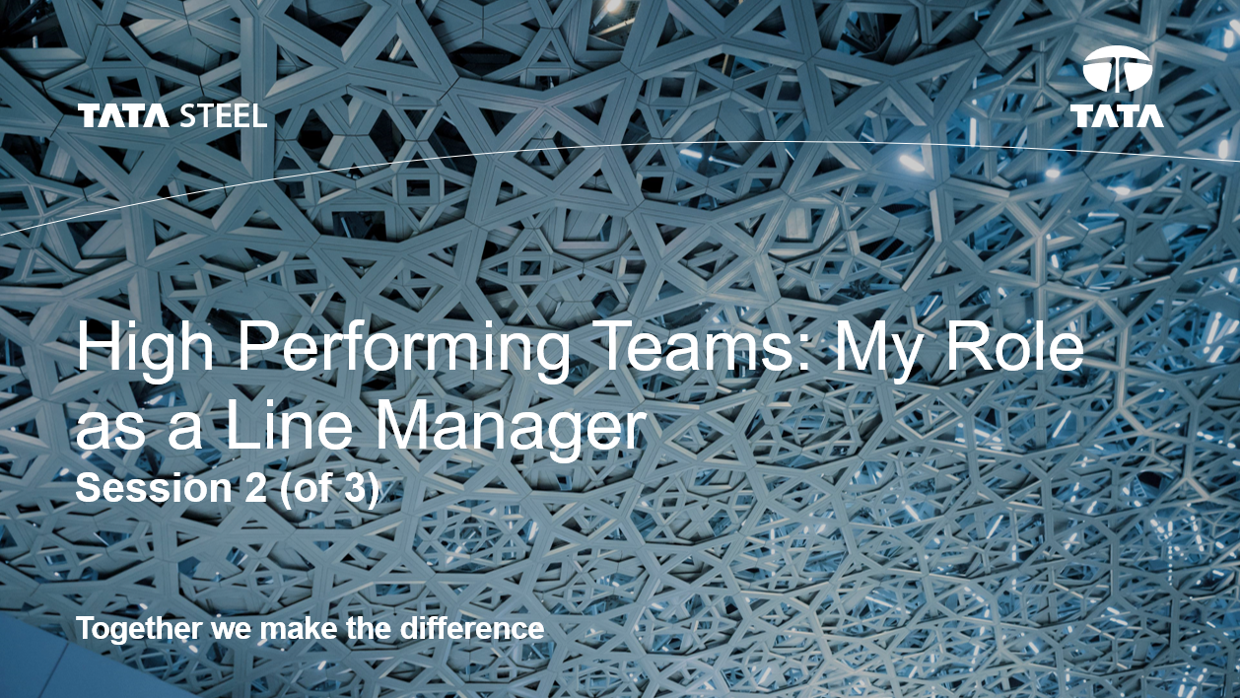
Welcome people on arrival, get them comfortable in the room. Make sure everyone signs the register on arrival.

Suggested Time | Slide 15 – Session 2 Objectives
2 minutes | 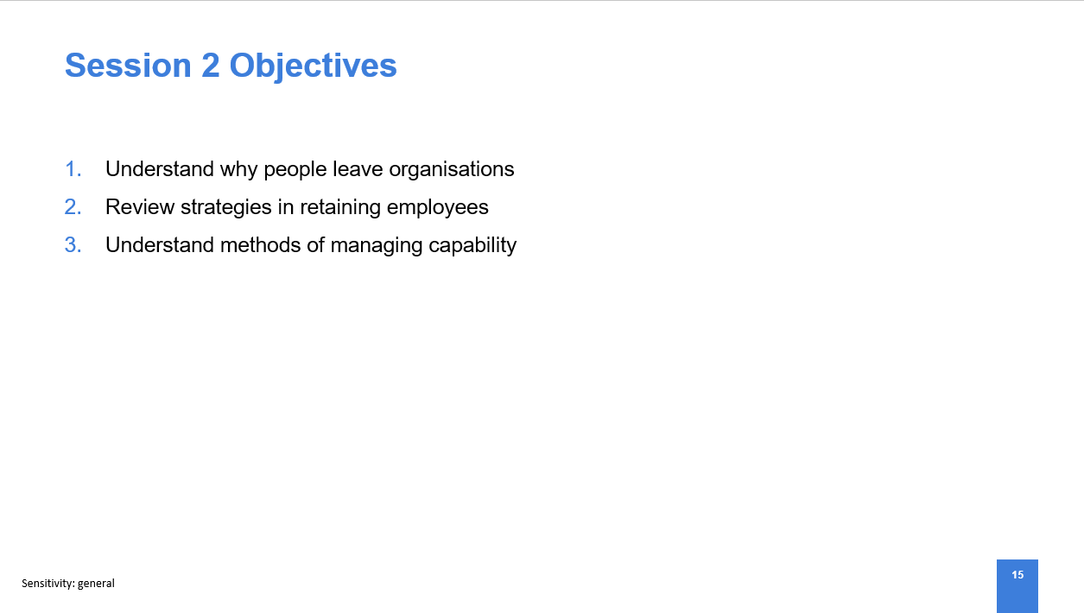
Read through each of the session objectives.

Suggested Time | Slide 16 – Why do people leave organisations?
5 minutes | 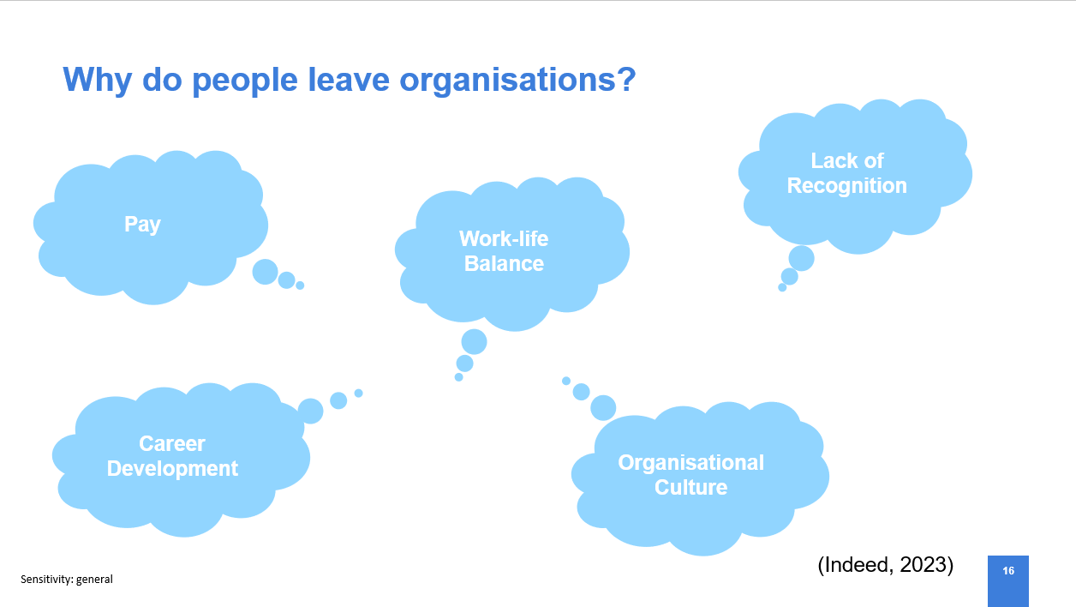
- The societal view of work has changed significantly with Millennials and Generation Z in the workplace as society has moved away from wanting a ‘job for life’ and now expects multiple career and organisational changes (Sinha, 2024).
- While this shift in dynamic has been apparent for some time, has been accelerated by the Covid-19 pandemic where the importance of wellbeing and work-life balance became a priority (Brace, 2022).
- Therefore, employee retention has become a top item on organisation’s agendas in order to prevent increased hiring costs and prevent loss of key skills and talent (Corrigan, 2023).
- So why do people leave organisations? – discuss some of the reasons on the slide, ask if the attendees have any additional contributions.

Suggested Time | Slide 17 – Strategies for Retaining Employees
10 minutes | 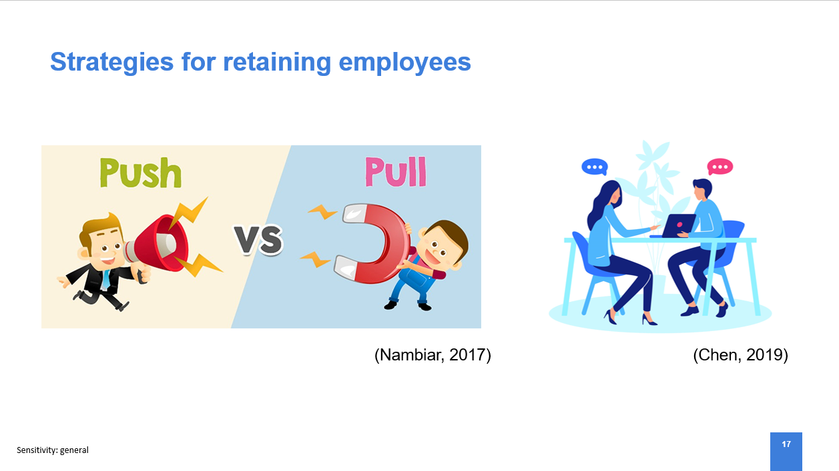
- When understanding why individuals are leaving the organisation it is important to recognise the push and pull factors that are at play. The ‘push’ factors are often within our control while the ‘pull’ factors are what is attracting the individual to a different organisation (Orr, 2021).
- Ask the attendees to shout out any push or pull factors that they know.
- There are many methods to retain individual employees such as project opportunities, increased pay, flexible hours however, to truly improve retention we need to act on changes with a wider impact.
- We discussed on the previous slide some of the reasons why people leave organisations, if we use career progression as an example, the push factors to leave the organisation would be a lack of career progression opportunities while the pull factor to move organisation would be career development opportunities or promotion. It is important to understand why people are leaving the organisation in order to improve retention.
- Understanding why people are leaving the organisation is the first step to making improvements in order to retain staff. One means of gathering this information is through exit interviews.
- Some believe that exit interviews are ineffective due to the individual being emotionally disconnected at the point of the interview meaning their account of their individual experience isn’t the whole truth (Gangnes, 2022).
- However, exit interviews allow you to get insights into culture, management styles, policies, the organisational mission and many other aspects directly from an employee (Aquarious Technology Pvt. Ltd., 2023).
- By analysing exit interview data and making visible changes based on this feedback, organisations can promote engagement and in turn enhance retention through showing their employees that their voice matters (Spain and Groysberg, 2016).
- We can also be more proactive and introduce employee voice forums such as focus groups, suggestion boxes. This allows us to gather individual’s concerns and suggestions to make improvements such as employee benefits, cultural changes etc. prior to them disengaging and leaving the organisation (Investors in People, 2019).

Suggested Time | Slide 18 – What is capability?
3 minutes | 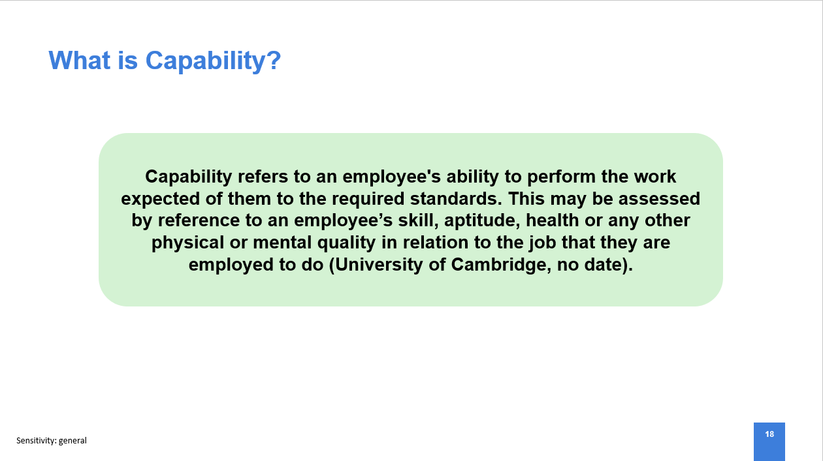
- Read the definition of ‘capability’ as shown on the slide
- A lack of capability is when an employee does not meet the required competency or carryout the required tasks to fulfil their role this could be due to a number of reasons such as ill health or performance issues (Loughborough University, 2021). Capability issues can have a negative impact on team morale and productivity, by effectively addressing capability concerns you demonstrate to the rest of the team your appreciation of their hard work and value (Czerwonka, 2024)
- In knowing how to manage the situation, it is vital to establish whether the poor performance is due to the fact that the employee ‘can’t’ or ‘won’t’ perform.

Suggested Time | Slide 19 – Managing Capability – Poor Performance
5 minutes | 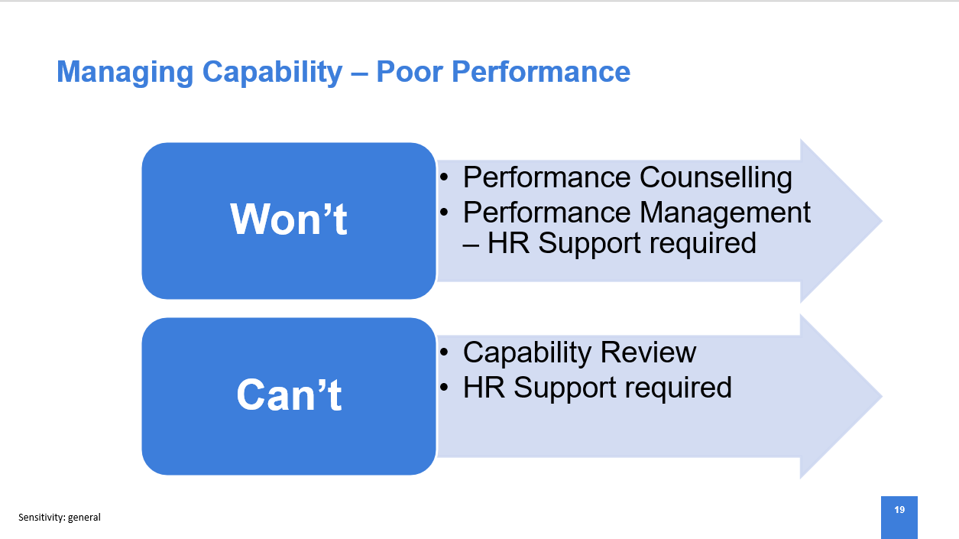
- If an employee ‘won’t’ perform to the requirements of their role then this will need to be addressed through the Managing Capability Poor Performance process.
- At Tata Steel UK we have guidance available to you via the Line Manager’s HR Hub to support you in identifying when performance concerns arise and how to respond.
- Where a genuine performance concern exists you would start by setting up an informal performance counselling meeting, this is an opportunity to support an individual and put support measures in place through an action plan.
- Where there are no improvements against the plan you would move to Formal Performance Management where HR will support you in managing the concern and advise appropriate outcome where required up to and including dismissal.
(Tata Steel UK, 2024)

Suggested Time | Slide 20 – Using Performance Reviews to drive good performance
5 minutes | 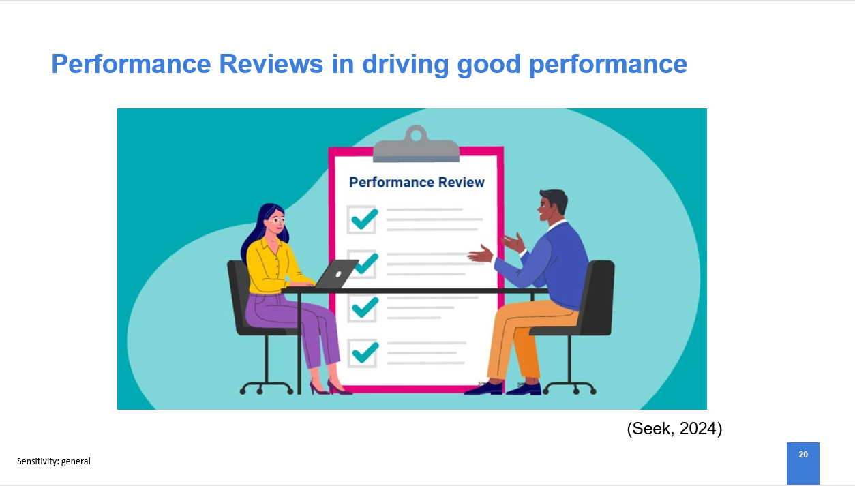
- Where there are no performance concerns there are other means of positively managing performance.
- One way of doing this is through meaningful performance reviews and objective setting, this gives employees a way of measuring their performance against goals which is key in encouraging employees and giving them motivation (Doerr, 2024).
- Further reading – please see the additional information on your table or review the online information: Performance Management | Factsheets | CIPD

Suggested Time | Slide 21 – Review Session 2 Objectives
5 minutes | 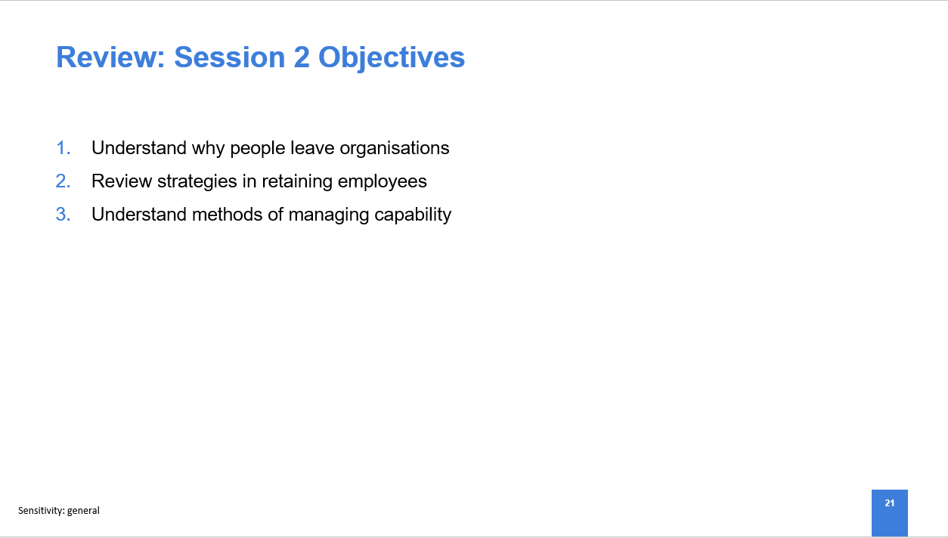
Review the session objectives and highlight some of the key learnings
i.e. in relation to objective 1, we have reviewed some of the push and pull factors that cause individuals to stay in / leave an organisation.

Suggested Time | Slide 22 – Questions
 | 
- Ask if any of the attendees have any questions related to the content covered in the session
- Encourage attendees to go away and reflect on their learnings and how they would use this in their roles as line managers
- Remind line managers that in order to complete the course they will need to attend 1 further session of which they will already have the invite for.
`

End of Session 2
Facilitation Notes – Session 3
Suggested Time | Slide 23 – Opening Slide
 | 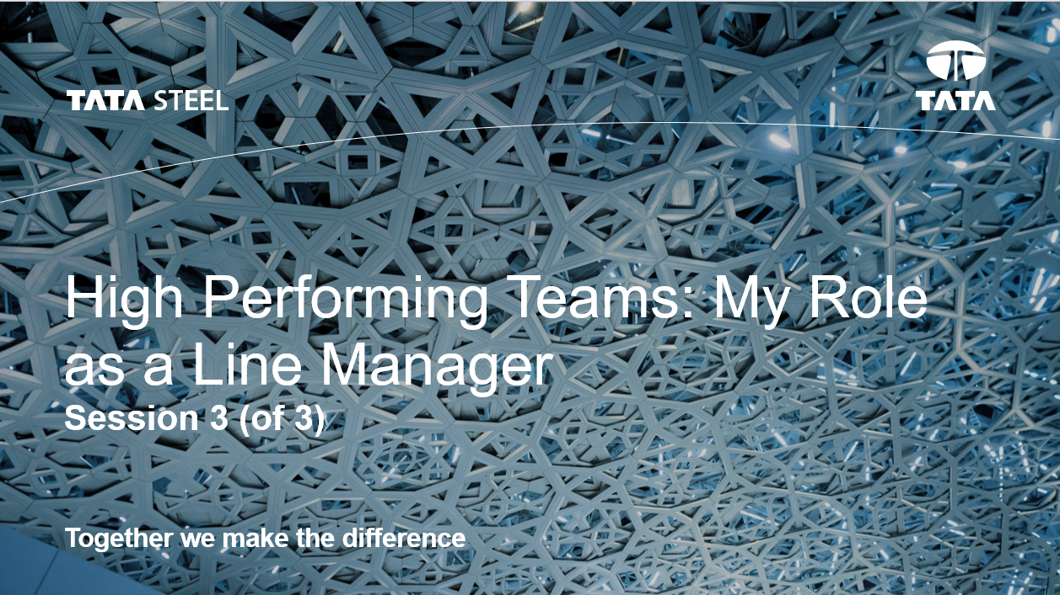
Welcome people on arrival, get them comfortable in the room. Make sure everyone signs the register on arrival..

Suggested Time | Slide 24 – Session 3 Objectives
2 minutes | 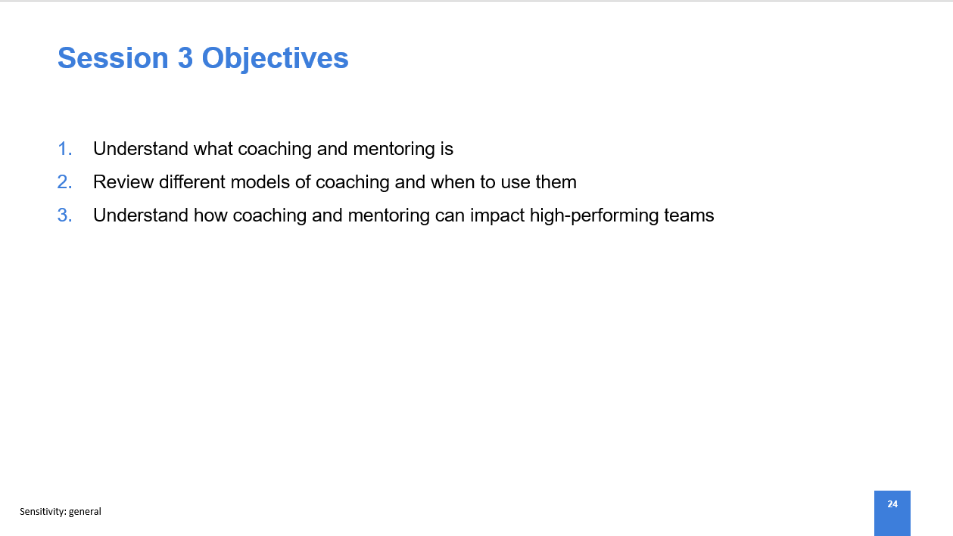
Read through each of the session objectives.

Suggested Time | Slide 25 – Activity
10 minutes | 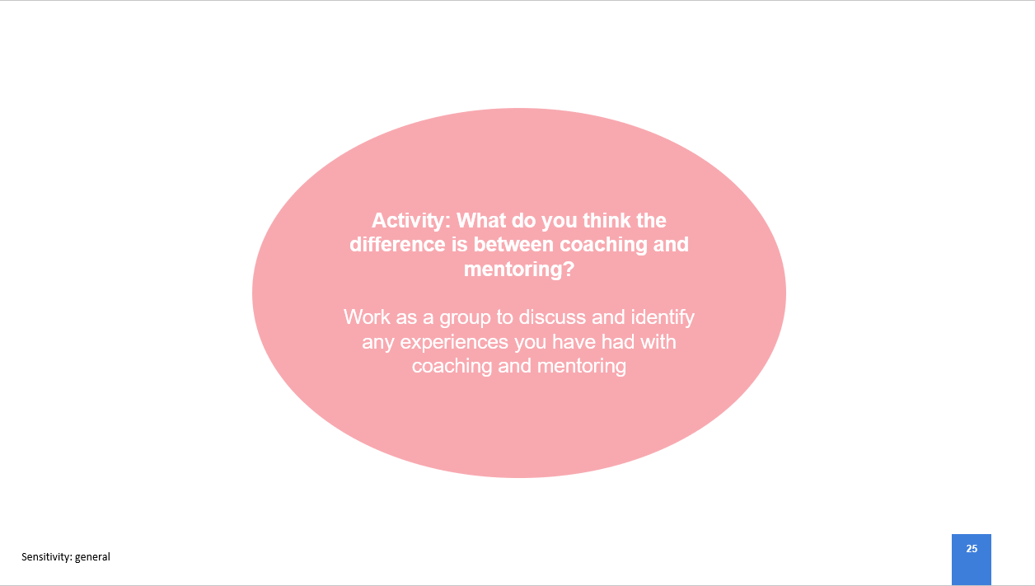
- Ask each table to work as a group to explain the difference between coaching and mentoring
- After the activity ask the group to feedback on any experiences they have had with coaching and mentoring

Suggested Time | Slide 26 – What is Coaching and Mentoring?
5 minutes | 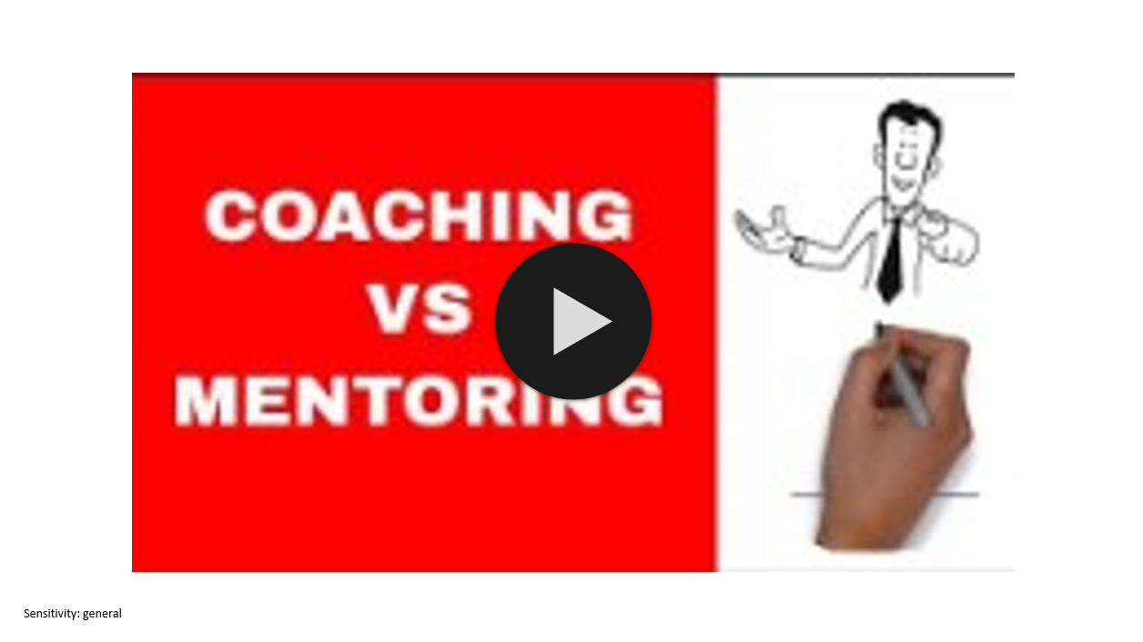
- Play the video explaining the difference between coaching and mentoring. Video link: Coaching vs Mentoring (youtube.com)
- In summary, coaching aims to improve performance at work with regards to specific skills or goals and this is usually carried out by a trained coach (CIPD, 2023c). Meanwhile, the CIPD (2023c) describe mentoring as a workplace relationship where colleagues share their experiences and provide guidance and support to one another, this can be from a senior to less senior individuals or in the reverse situation. Reverse mentoring is often used to drive Equity, Inclusion and Diversity where a younger employee would mentor a more senior employee (Pursell, 2023).
- Coaching and mentoring allows us to unlock employees’ abilities, increasing their potential and therefore productivity. A manager that applies coaching and mentoring techniques can create a psychological safe environment for employees to thrive (ILM, no date).

Suggested Time | Slide 27 – Models of Coaching
7 minutes | 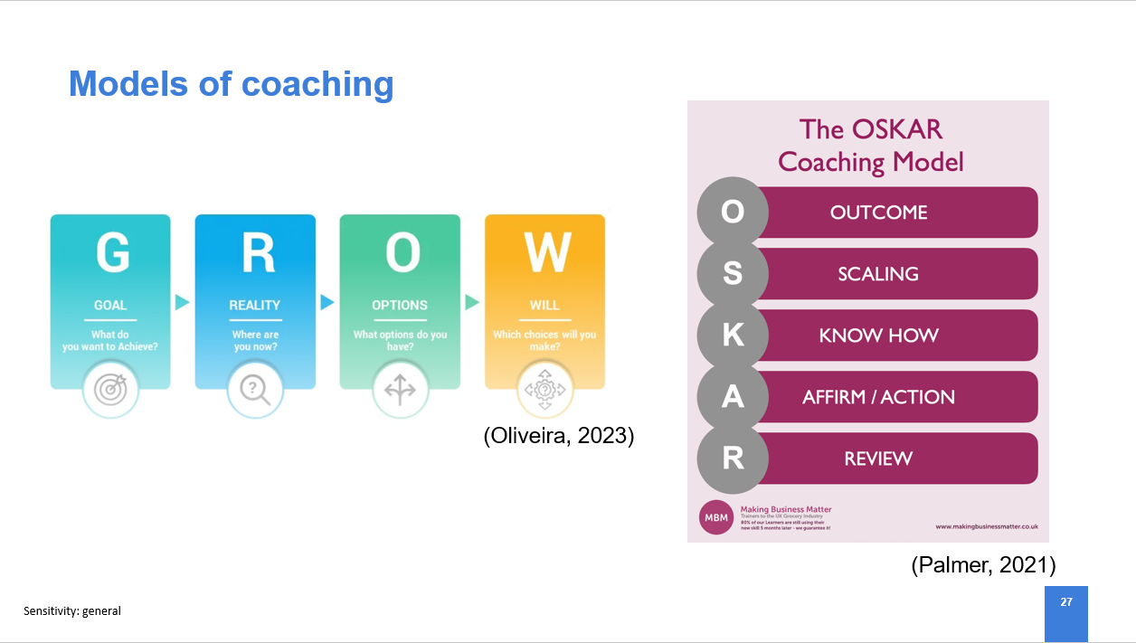
- Coaching models are useful in structuring coaching sessions and facilitating the conversation to ensure it remains focussed (Bergenroth, 2021).
- One popular coaching model is the GROW model developed by Sir John Whitmore in 1992 which sets out four stages: Goal, what do you want?; Reality, what is your current situation?, Options, what are your options?; and Will, what actions will you take? (Imperial College London, no date).
- Another widely used coaching model, developed in early 2000’s by Paul Jackson and Mark McKergow is the OSKAR model. There are a series of 5 steps similarly to the GROW model, these are as follows: outcome; scaling; know-how; affirm and action; and review (Cuofano, 2024).
- While the GROW model is useful in increasing performance and productivity through promoting awareness and self-confidence, the OSKAR model is beneficial as it drives personal reflection in order to create actionable solutions (Upskillist, 2023; Boutin, 2024).
- There are limitations to all models, the GROW model, if followed too rigidly can make coaching conversations too structured which can omit important consideration to external factors and self-awareness (Patary, 2023). Similarly, the OSKAR model leads the coach to focus on the ‘Affirm’ element which poses a risk in loosing sight of the desired outcome and a lack of actionable solutions (MindTools, no date).
- It is important to remember when using coaching models that they are to facilitate you and are not a prescriptive guide to the conversation. You can tailor models to different scenarios and there will be contexts where one model will be more beneficial than the other, for example, the GROW model is particularly useful in dealing with straightforward goals, where the OSKAR model is more helpful in complex situations (Linkedin, no date).

Suggested Time | Slide 28 – How coaching and mentoring impacts High-Performing Teams
5 minutes | 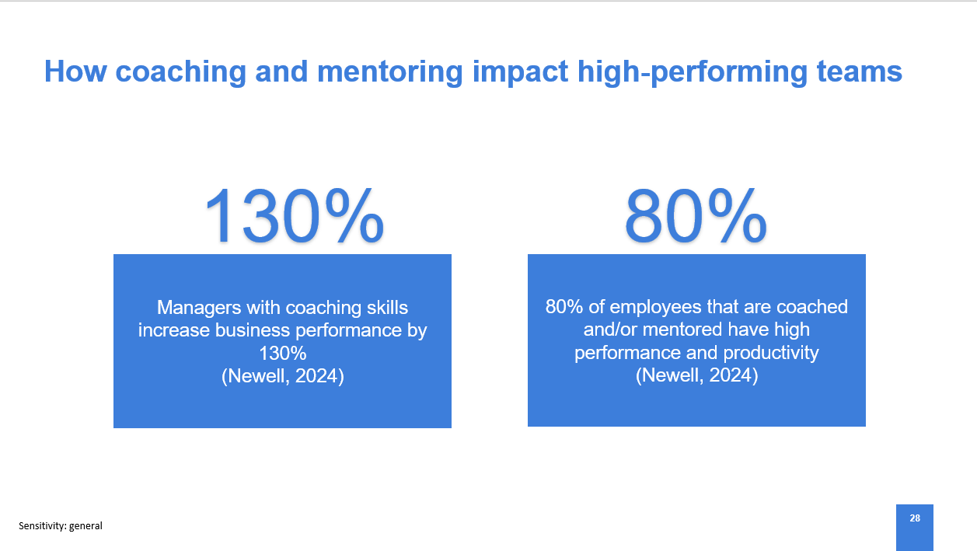
- Studies show that managers with coaching skills increased business performance by 130% and 80% of employees on coaching and mentoring programmes report high performance and productivity (Newell, 2024).
- Coaching and mentoring is effective in driving high-performing teams through either individual development or team development. A line manager may act as a coach to their team, utilising coaching models to identify and barriers or develop strategies to improve performance and output while aligning the team’s objectives to the organisational vision and mission (Lim, 2023). Thus creating a culture of growth where individuals and teams can thrive and develop resulting in a dynamic and diverse working environment (Jones, 2021).

Suggested Time | Slide 29 – Recap of course learnings
5 minutes | 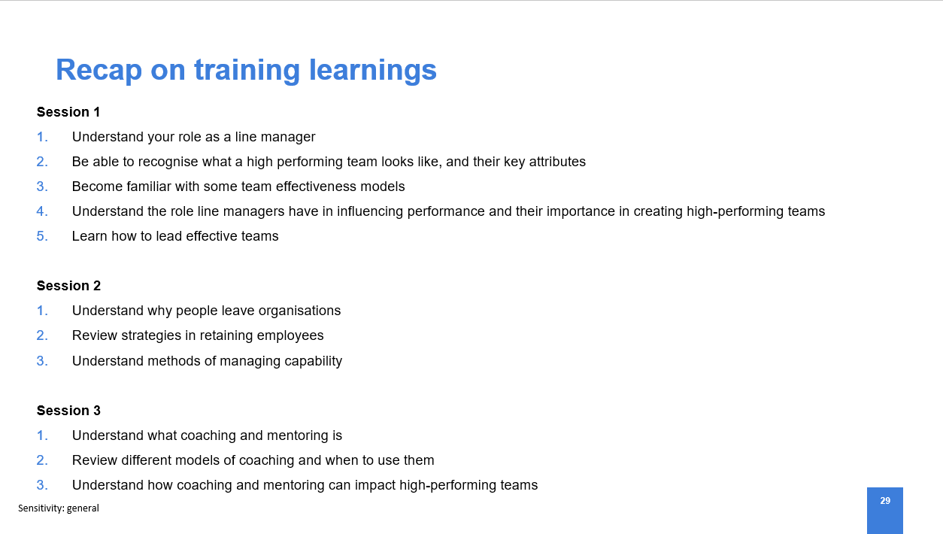
Review the session objectives and highlight some of the key learnings
i.e. we know what role a line manager plays in creating high performing teams, we understand there are different types of capability and that these need managing in different ways and we have reviewed coaching models and understood the situations these would be most impactful
Suggested Time | Slide 30 – Questions
 | 
- Ask if there are any questions related to the content covered the course
- Encourage attendees to go away and reflect on their learnings and how they would use this in their roles as line managers

Suggested Time | Slide 31 – Feedback
 | 
- Ask attendees to scan the QR code with their smartphones, to complete a training.
- Ask those without smartphones, to leave their works email to send a link to the form.
End of Session 3

Facilitator Checklist on completion of training

Facilitator To Do list |  | 
After the workshop
1. | Scan/take photo of the registers and send to traininghrssc@tatasteeleurope.com to update PeopleLink records
2. | Follow up with supporting information e.g. copies of handouts, link to the line managers HR for HR hub etc.
3. | Review the feedback and action anything that needs attention

References
Aquarious Technology Pvt. Ltd. (2023) The Importance of Exit Interviews: Improving Retention. Available at: https://www.linkedin.com/pulse/importance-exit-interviews-improving-retention-aquarious-technology/ (Accessed: 3 May 2024).
Bergenroth, S. (2021) 'Coaching models and their importance for effective executive & leadership coaching', Linkedin, 1 February. Available at: https://www.linkedin.com/pulse/coaching-models-importance-effective-executive-simon-bergenroth/ (Accessed: 3 May 2024).
Boutin, C. (2024) The 5 Components of the OSKAR Coaching Model (And How to Use Them). Available at: https://paperbell.com/blog/oskar-coaching-model/ (Accessed: 3 May 2024).
Brace, R. (2022) 'Work-Life Balance In A Post-Pandemic World', Forbes. Available at: https://www.forbes.com/sites/forbesbusinesscouncil/2022/08/02/work-life-balance-in-a-post-pandemic-world/ (Accessed: 3 May 2024).
Burkus, D. (2023) 'What Makes Some Teams High Performing?', Ascend, 30 August. Available at: https://hbr.org/2023/08/what-makes-some-teams-high-performing (Accessed: 2 May 2024).
Chance, J. (2022) 'Building a Team Culture: Moving Through the Tuckman Model of Team Development', Action Strategies By Design, 10 November. Available at: https://www.action-strategies.com/building-a-team-culture-part-2-moving-through-the-tuckman-model-of-team-development/#:~:text=The%20Tuckman%20Model%20of%20Team%20Development%20can%20be%20applied%20to,structure%20and%20meet%20performance%20goals. (Accessed: 2 May 2025).
CIPD (2023a) High-performing teams. London: CIPD. Available at: https://www.cipd.org/globalassets/media/knowledge/knowledge-hub/evidence-reviews/2023-pdfs/8388-high-performing-teams-practice-summary.pdf (Accessed: 2 May 2024).
CIPD (2023b) Scientific Summary: High-Performing Teams. London: CIPD. Available at: https://www.cipd.org/globalassets/media/knowledge/knowledge-hub/evidence-reviews/2023-pdfs/8388-high-performing-teams-scientific-summary-may23.pdf (Accessed: 3 May 2024).
CIPD (2023c) Coaching and mentoring. Available at: https://www.cipd.org/uk/knowledge/factsheets/coaching-mentoring-factsheet/#what-are-coaching-and-mentoring (Accessed: 3 May 2024).
CIPD (2024a) Line managers' role in supporting the people profession. Available at: https://www.cipd.org/uk/knowledge/factsheets/line-managers-factsheet/#evolving (Accessed: 20 April 2024).
CIPD (2024b) Performance management: an introduction. Available at: https://www.cipd.org/uk/knowledge/factsheets/performance-factsheet/#three (Accessed: 5 May 2024).
Corrigan, H. (2023) 'Importance Of Employee Retention Post-COVID', O2 Employment Services, 7 November. Available at: https://o2employmentservices.com/blog/importance-of-employee-retention-post-covid/ (Accessed: 3 May 2024).
Cuofano, G. (2024) What Is The OSKAR Coaching Model? The OSKAR Coaching Model In A Nutshell. Available at: https://fourweekmba.com/oskar-coaching-model/ (Accessed: 3 May 2024).
Czerwonka, E. (2024) How to Deal with Poor Performance On Your Team. Available at: https://buddypunch.com/blog/how-to-deal-with-poor-performance-on-your-team/#:~:text=Effectively%20managing%20the%20poor%20performance,positive%20attitude%20in%20the%20workplace. (Accessed: 3 May 2024).
Darby, J. (2024) 'How to Build High Performance Teams', Thomas, 12 April. Available at: https://www.thomas.co/resources/type/hr-blog/how-build-high-performance-teams (Accessed: 3 May 2024).
Doerr, J. (2024) 'Employee performance goals & examples: The ultimate guide', Leapsome, 12 March. Available at: https://www.leapsome.com/blog/performance-objectives-examples#:~:text=Performance%20objectives%20are%20designed%20to,to%20prosper%20in%20their%20careers. (Accessed: 3 May 2024).
Donkor, C. (2021) 'High-Performing Teams', Price Waterhouse Cooper, 21 April. Available at: https://www.pwc.ch/en/insights/disclose/27/high-performing-teams.html (Accessed: 20 April 2024).
Freeman-Gray, J. (2024) 'T7 Model for Teams', Mutomorro, 7 April. Available at: https://mutomorro.com/t7-model-for-teams/#:~:text=Use%20the%20T7%20Model%20to%20guide%20team%20development%20and%20training,for%20specific%20roles%20or%20projects. (Accessed: 2 May 2025).
Gangnes, J. (2022) Why Exit Interviews Aren’t Enough. Available at: https://thoughtexchange.com/blog/why-exit-interviews-arent-enough/ (Accessed: 3 May 2024).
Hayes, Nicky. (1997) Successful team management. London: International Thomson Business.
ILM (no date) Coaching & Mentoring for better performance. Available at: https://www.i-l-m.com/news-and-events/news-and-blog/coaching-and-mentoring-for-better-performance (Accessed: 3 May 2024).
Imperial College London (no date) The GROW model. Available at: https://www.imperial.ac.uk/personal-tutors-guide/developing-students/coaching/the-grow-model/ (Accessed: 3 May 2024).
Investors In People (2019) Employee voice: why is it important to sustainable success? Available at: https://www.investorsinpeople.com/knowledge/employee-voice/ (Accessed: 3 May 2024).
Jay, S. (2023) '11 Team Effectiveness Models to Build High-Performing Teams', Academy to Innovate HR, 2 October. Available at: https://www.aihr.com/blog/team-effectiveness-models/(Accessed: 20 April 2024).
Jones, A. (2021) 'How To Use Coaching & Mentoring to Develop High Performing Teams', Linkedin, 1 September. Available at: https://www.linkedin.com/pulse/how-use-coaching-mentoring-develop-high-performing-alan/ (Accessed: 4 May 2024).
Laiken, M. (1994) The Anatomy of High Performing Teams: A Leader’s Handbook. University of Toronto Press: JSTOR. Available at: https://www-jstor-org.ezproxy.uwtsd.ac.uk/stable/10.3138/j.ctt2ttgdq.3?seq=1
LeanVlog (no date) Coaching vs Mentoring. Available at: https://www.youtube.com/watch?v=3fFQiLOtDkc. (Accessed: 3 May 2024).
Lim, T. (2023) Coaching To Activate High-Performing Teams. Available at: https://www.forbes.com/sites/forbescoachescouncil/2023/05/15/coaching-to-activate-high-performing-teams/?sh=36c930422777 (Accessed: 4 May 2024).
Linkedin (no date) What are the differences between GROW and OSCAR coaching models? Available at: https://www.linkedin.com/advice/1/what-differences-between-grow-oscar-coaching-ybxde (Accessed: 3 May 2024).
Loughborough University (2021) Procedure for handling lack of capability. Available at: https://www.lboro.ac.uk/services/hr/topics/capability/#:~:text=Evidence%20of%20lack%20of%20capability,attendance%20due%20to%20ill%20health. (Accessed: 3 May 2024).
MindTools (no date) The OSKAR Coaching Framework. Available at: https://www.mindtools.com/agrk092/the-oskar-coaching-framework (Accessed: 3 May 2024).
Morris, A. (2021) 'What Makes Good Line Manager?', DavidsonMorris, 15 April. Available at: https://www.davidsonmorris.com/line-manager/ (Accessed: 01 May 2024).
Newell, D. (2024) Is your investment in coaching and mentoring fit for purpose?. Available at: https://www.peoplemanagement.co.uk/article/1871370/investment-coaching-mentoring-fit-purpose (Accessed: 4 May 2024).
Orr, M. (2021) 'Push and pull factors in the workplace that are crucial to employee retention', Rise People, 16 November. Available at: https://risepeople.com/blog/push-and-pull-factors-in-the-workplace/ (Accessed: 3 May 2024).
Osmani, A. (2022) 'Debugging teams with the Lencioni Model', addyosmani, 12 November. Available at: https://addyosmani.com/blog/debugging-teams-lencioni/. (Accessed: 2 May 2025).
Patterson, D. (2022) 'In-depth Look: High Performing Teams', Strategic Project Management: Theory and Practice for Human Resource Professionals. Available at: https://ecampusontario.pressbooks.pub/hrstrategicprojectmanagementtheory/
Personio (2022) Team Effectiveness Models: Types, Selection and Implementation. Available at: https://www.personio.com/hr-lexicon/team-models/ (Accessed: 2 May 2024).
Pilipenko, M. (2021) The Importance of Feedback. Available at: https://www.actitime.com/project-management/importance-of-feedback (Accessed: 3 May 2024).
Pursell, H. (2023) 'Reverse Mentoring: A Complete Guide to Getting it Right', Guider, 7 February. Available at: https://guider-ai.com/blog/reverse-mentoring-guide/#:~:text=Reverse%20mentoring%20is%20simply%20the,sides%20of%20a%20mentoring%20relationship. (Accessed: 3 May 2024).
Salama, F. (2023) 'Line Management Responsibilities', MakingBusinessMatter, 19 July. Available at: https://www.makingbusinessmatter.co.uk/line-management-responsibilities/ (Accessed: 01 May 2024).
Savaneviciene, A. and Stankeviciute, Z. (2012) 'HRM and Performance Linkage: The Role of Line Managers', Economics and Management: 2012, 17 (1), pp. 390-396. Available at: file:///C:/Users/B077138/Downloads/2294-Article%20Text-6762-1-10-20120828.pdf
Scarinzi, C. (2024) 'The Human Touch: An Essential Ingredient of High-Performing Teams', Linkedin, 9 April. Available at: https://www.linkedin.com/pulse/human-touch-essential-ingredient-high-performing-teams-chip-scarinzi-6djlc/(Accessed: 2 May 2024).
Sinha, R. (2024) 'Forget about a job for life. Today’s workers need to prepare for many jobs across multiple industries', The Conversation. Available at: https://theconversation.com/forget-about-a-job-for-life-todays-workers-need-to-prepare-for-many-jobs-across-multiple-industries-222753 (Accessed: 3 May 2024).
Spain, E. and Groysberg, B. (2016) 'Making Exit Interviews Count', Harvard Business Review, April 2016 issue, pp.88–95. Available at: https://hbr.org/2016/04/making-exit-interviews-count (Accessed: 3 May 2024).
Tata Steel UK (2024) Managing Capability: Poor Performance. Line Managers HR for HR Hub. Unpublished.
Udoagwu, K. (2022) '6 Different Team Effectiveness Models to Understand Your Team Better', wrike, 28 May. Available at: https://www.wrike.com/blog/6-different-team-effectiveness-models/ (Accessed: 20 April 2024).
Upskillist (2023) GROW Coaching Model. Available at: https://www.upskillist.pro/blog/the-benefits-of-the-grow-coaching-model/#:~:text=GROW%20coaching%20skills%20unlock%20potential,accomplish%20goals%20and%20overcome%20obstacles. (Accessed: 3 May 2024).
Wen, J. (2024) Leading a high-performing team: what you need to know. Available at: https://www.imd.org/reflections/high-performing-team/#item2 (Accessed: 3 May 2024).

