

Why the Business Needs to
Adopt Modern BI Trends,
Tools & Applications?

Gabriela Malinova
(2210801)
BA Business Management
Module: Data Handling & Business Intelligence
Module code: LCBB5000
Lecturer: Dr Xavier Matieni

Table of Contents
Introduction 2
Why BI Trends, Tools, and Applications are the Future for Business? 2
How BI Trends Can Help to Make Timely and Effective Decisions? 2
Conclusion 6
References 7

Introduction
Business Intelligence (BI) is becoming a key component for companies looking to use data for strategic advantage in the era of data-driven decision-making (Eboigbe, 2023). In order to help organisations gather, integrate, analyse, and display business information and support informed decision-making, business intelligence (BI) refers to a set of tools, applications, and procedures (Phillips-Wren, Daly and Burstein,2021). Understanding current business intelligence (BI) trends is essential for companies looking to preserve or grow their competitive advantage since BI plays an essential part in converting data into actionable knowledge (Mineli, Chambers and Dhiraj, 2013).

Why BI Trends, Tools, and Applications are the Future for Business?
Business intelligence (BI) trends, tools, and apps offer increased capabilities for data processing, visualization, and analysis. The above features reflect the changing environment of technology and the requirements required by businesses. These developments are additionally about managing data; rather, they are about cultivating a culture that is based on data, which enables organizations to swiftly adapt to changes in the market, foresee future trends, and make decisions based on accurate information (Chen, Chiang and Storey, 2012).

How BI Trends Can Help to Make Timely and Effective Decisions?
Business intelligence (BI) trends, tools, and apps offer increased capabilities for data processing, visualisation, and analysis (Marjamäki, 2017). These capabilities reflect the changing environment of technology and the requirements required by businesses. These developments are not only about managing data; rather, they are about cultivating a culture that is centred on data, which enables organisations to swiftly adapt to changes in the market, foresee future trends, and make decisions based on accurate information (Gupta and Soni, 2020).

- Data Discovery
A vital part of contemporary BI is data discovery, defined as the act of gathering and evaluating data to provide business insights. Decision-makers are empowered by this trend because it gives them access to information that was previously unavailable or too difficult to understand. To improve user experience and engagement, Spotify, for example, uses this tendency to analyse listening patterns and offer personalised playlists through its Discover Weekly feature. Although there are worries about privacy and the echo chamber effect, accurate targeting not only increases consumer happiness but also encourages the circulation of information (Velardo, 2019). According to Spotify Advertising Team (2020), between July 2015 and June 25, 2020, Spotify users watched more than 2.3 billion hours of their customized Discover Weekly playlist .

- Mobile BI
The capacity to access business intelligence (BI) data via smartphones and tablets is growing essential as the world's workforce grows more mobile. For sales teams operating in the field, mobile BI has proven invaluable. In order to increase the likelihood of closing agreements, SAP Roambi, for instance, rethinks the availability and presentation of sales data. This empowers salespeople to make data-driven choices during client meetings (Powlas, 2017).
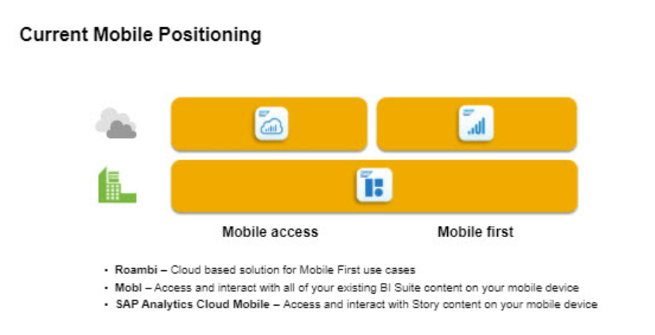
(Powlas, 2017)
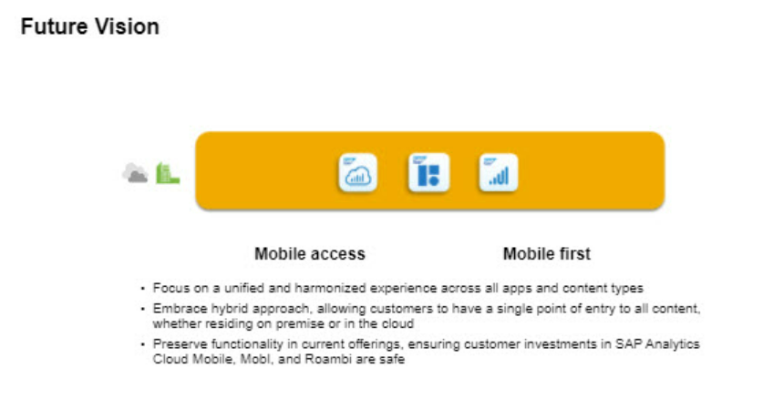
(Powlas, 2017)

- Natural Language Processing (NLP)
Through the use of natural language queries in BI solutions, such as those found in ThoughtSpot, natural language processing (NLP) enables users to access data analysis more easily. This ensures that decision-makers may immediately access the data they want without depending on specialised staff, lowering the entrance barrier for non-technical consumers. This instantaneous access has the potential to significantly minimise the time lag between inquiry and insight, which will impact how quickly the market reacts to developments (Pombo, 2023).

- Analytical Databases
The heavy lifting that is performed by business intelligence tools is supported by these, which are optimised for data processing and querying. Snowflake, for instance, provides a data warehouse that operates in the cloud and separates the tasks of storage and computation. This enables organisations to grow their operations and handle data in a more effective manner. Due to this efficiency, businesses are able to analyse massive datasets in a matter of seconds, which results in the generation of insights that lead to cost reductions, revenue growth, and operational improvements (Snowflake Data Cloud Glossary, n.d.).

- Artificial Intelligence (AI)
AI revolutionises business intelligence by means of predictive analytics and automation. The ability of Artificial Intelligence systems to recognise patterns and forecast future trends provides businesses with a level of foresight that could never be achieved by manual examination. For example, Netflix employs artificial intelligence to analyse watching trends, which enables predictive analytics to not only propose material to viewers but also to guide content development. This has a huge impact on viewer engagement and subscriber growth (Rashevskaya, 2024), (Netflix, 2023).

Benefits for Netflix | Benefits for Customers
Increased Engagement | Discovering the Netflix Big Show
Keyword Upscale | Personalised Experience
Content Promotion & Discovery
(Rashevskaya, 2024)

Conclusion
Organizations can utilize BI to unleash the power of data and use it as a strategic asset for well-informed decision-making Wu and Mircea (2021, pp.135, 136). Data discovery, mobile BI, NLP, analytical databases, and AI are examples of developments that highlight how dynamic business intelligence (BI) is and how crucial it is to future company plans. They provide businesses a major competitive edge through allowing them to make decisions that are more proactive, responsive, and adaptable. Keeping up with these developments is essential for businesses hoping to succeed in the data-driven economy as business intelligence (BI) keeps evolving (Eboigbe, 2023).

References
Chen, H., Chiang, R.H.L. and Storey, V.C. (2012). Business Intelligence and Analytics: From Big Data to Big Impact. MIS Quarterly, [online] 36(4), pp.1165–1188. doi:https://doi.org/10.2307/41703503.
Eboigbe, E.O., Farayola, O.A., Olatoye, F.O., Nnabugwu, O.C. and Daraojimba, C. (2023). BUSINESS INTELLIGENCE TRANSFORMATION THROUGH AI AND DATA ANALYTICS. Engineering Science & Technology Journal, [online] 4(5), pp.285–307. doi:https://doi.org/10.51594/estj.v4i5.616.
Gupta, R. and Soni, S. (2020). Developing Effective Big Data Strategies and Governance Frameworks: Principles, Tools, Challenges and Best Practices. International Journal of Responsible Artificial Intelligence, [online] 10(8), pp.10–19. Available at: https://neuralslate.com/index.php/Journal-of-Responsible-AI/article/view/62 [Accessed 4 Apr. 2024].
Marjamäki, P. (2017). Evolution and trends of business intelligence systems : a systematic mapping study. [online] laturi.oulu.fi. Available at: https://oulurepo.oulu.fi/handle/10024/8679.
Minelli, M., Chambers, M. and Dhiraj, A. (2013). Big Data, Big Analytics: Emerging Business Intelligence and Analytic Trends for Today’s Businesses. [online] Google Books. John Wiley & Sons. Available at: https://www.google.co.uk/books/edition/Big_Data_Big_Analytics/HYYaX9dsZsYC?hl=en&gbpv=1&dq=Given+its+role+in+transforming+data+into+actionable+intelligence [Accessed 1 Apr. 2024].
Netflix (2023). Netflix Research. [online] research.netflix.com. Available at: https://research.netflix.com/research-area/recommendations.
Phillips-Wren, G., Daly, M. and Burstein, F. (2021). Reconciling business intelligence, analytics and decision support systems: More data, deeper insight. Decision Support Systems, 146, p.113560. doi:https://doi.org/10.1016/j.dss.2021.113560.
Pombo, S. (2023). Natural Language Processing: Examples, Techniques, and More. [online] ThoughtSpot. Available at: https://www.thoughtspot.com/data-trends/ai/natural-language-processing.
Powlas, T. (2017). SAP Analytics Mobile Strategy and What’s New in Roambi #ASUG Webcast Recap. [online] SAP Community. Available at: https://community.sap.com/t5/technology-blogs-by-members/sap-analytics-mobile-strategy-and-what-s-new-in-roambi-asug-webcast-recap/ba-p/13346450 [Accessed 4 Apr. 2024].
Rashevskaya, A. (2024). Netflix and Learn: How Netflix Uses AI to Personalize Recommendations. [online] Litslink. Available at: https://litslink.com/blog/all-about-netflix-artificial-intelligence-the-truth-behind-personalized-content#:~:text=AI%20is%20changing%20the%20world [Accessed 4 Apr. 2024].
Snowflake Data Cloud Glossary (n.d.). What is a Data Warehouse? | Snowflake Data Warehousing Glossary. [online] Snowflake. Available at: https://www.snowflake.com/data-cloud-glossary/data-warehousing/.
Spotify Advertising Team (2020). Five Years of Discover Weekly | Spotify Advertising. [online] ads.spotify.com. Available at: https://ads.spotify.com/en-GB/news-and-insights/five-years-of-discovery-and-engagement-through-discover-weekly/.
Velardo, V. (2019). Spotify’s Discover Weekly explained — Breaking from your music bubble or, maybe not? [online] Medium. Available at: https://medium.com/the-sound-of-ai/spotifys-discover-weekly-explained-breaking-from-your-music-bubble-or-maybe-not-b506da144123.
Wu, R.M.X. and Mircea, M. (2021). E-Business: Higher Education and Intelligence Applications. [online] Google Books, BoD – Books on Demand, pp.135, 136. Available at: https://www.google.co.uk/books/edition/E_Business/774zEAAAQBAJ?hl=en&gbpv=1&dq=Through+BI [Accessed 4 Apr. 2024].

