

Module: Digital Skills And Research Methods
Module Code : BMSW4003
Student Name : Maritza Ramirez Rivera
Student Number : 2022095
Professor : Alfred Mensah
Year : 2020/2021

Table of Contents
Table of Contents 2
Research Title 3
Introduction 3
Rationale 3
Objectives 4
Methodology 4
Literature Review 4
Secondary Data Analysis 5
Conclusion/Recommendation 8
References 10

Research Title
Secondary Research on the Uses of Technology of Harley Street Healthcare Clinic

Introduction
Healthcare institutions play a very significant role in providing appropriate medical and health facilities to the general people of a country. Both public and private organisations in this sector are working together in order to ensure the best facilities and services for any kind of health issue (Ash, et. al., 2007). Harley Street Healthcare Clinic operating in London in order to profile general people of United Kingdom different kinds of services in order to keep them fit and fit all the time. The organisation is trying to provide best healthcare facilities with an affordable price in order to ensure maximum healthcare facilities to the people of all types in terms of financial capability in United Kingdom. In their process of treatment and other different kinds of services, the organisation has lots of different types of technologies to use in order to make its process of providing appropriate service to the patients of different kinds with efficiency and appropriate expected accuracy. In this report, secondary analysis has been done in order to understand the use of technology in this organisation and their importance along with their ethical reasoning for the uses of that equipment to make the readers understandable about the importance of different kinds of technologies in health and social care settings.

Rationale
To establish appropriate healthcare environment, there are several issues that the organisation needs to establish in its premises efficiently. Technology is one of them (Mettler, 2016). Technology in the present time is one of the major essential elements for healthcare institutions in order to provide appropriate services to the patients by testing them efficiently and also establish efficient communication system with all the related parties of any kind of treatment process with the aim of understanding the patients efficiently (Sidrov, 2006). Therefore, evaluation of the performance of all these technology is necessary for any business organisation to understand their effectiveness for providing appropriate service to the patients. For this reason, technology and uses of efficient and appropriate technology will be the key factor of success for any healthcare organisations across the world (Holden, et. al., 2011). So, it is rational to evaluate the effectiveness of all the technologies those Harley Street Healthcare Clinic is using. It will not only help the organisation to be more efficient but also make the organisation very much capable of solving different kinds of problems related with the treatment and check-up of the patients in a more efficient and meaningful manner.

Objectives
The objectives of this research will be:
- To understand how about the technologies are used in health care settings
- To find out the technologies used by Harley Street Healthcare Clinic
- To recommend some development areas or inclusion for Harley Street Healthcare Clinic in order to make the treatment and clinical process much more efficient

Methodology
This research will be a qualitative study of where different types of articles, journals, literatures will be evaluated to understand the current uses of technology in health and social care setting (Edmunds, 2009). It will be a comparative research as well in order to understand the uses of technology in Harley Street Healthcare Clinic in comparison with the industry. This research will be an inductive method to understand the reasons of use of technology of different types in healthcare industry and in Harley Street Healthcare Clinic in as well. This research will be established on realism philosophy to find out the actual status of the use of technology in Harley Street Healthcare Clinic. Therefore, by the help of this research it will be easier to understand how much efficient Harley Street Healthcare Clinic is in using different kinds of technologies in its premises in order to provide maximum efficient service to the patients.

Literature Review
Because of Covid-19, the use of technology in health and social care Institutions gets changed significantly. Some of the previous technological innovations have become very much popular now-a-days. The most common uses of technology in health and social care institution are:
Telemedicine facilities make it easier for the organisations and the patients to talk with each other and get connected from time to time with the opportunity of sharing all sorts of information efficiently (Hailes, 2012). Telemedicine facilities can be very much helpful for the patients and the doctors at the present time because there is a huge chance of infection of Covid-19 when there is a chance of physical contact of both the parties.
The scientific advancement in the recent time is changing the entire complexion of medication system (Brown, 2013). The Vaccine of Covid-19 has been discovered at a minimum time which shows the efficiency of modern technology in innovating new drugs and vaccine for the people of the world. In healthcare organisation, different kinds of information software have been used in order to record all the information of the customers efficiently (Eisenbergh, & Margulis, 2011). It will not on the help the organisation to provide appropriate service to the customers but also make the healthcare workers efficient and after provide appropriate service to the patient according to their health status (James, & Dasarathy, 2014).
The uses of Nanotechnology are increasing day by day. Different types of Institutions and now getting involved in implementing nanotechnology to provide different kinds of service to the patient. Imaging, diagnosis, sensing, and so many other different kinds of activities have been done by the help of Nanotechnology which are providing different kinds of supports to the institutions in health and social care to give with different kinds of complex diseases like cancer, tamer and so on (Winkler, et. al., 2018).
Uses of 5G enabled devices have also made it possible for healthcare organisations to use artificial intelligence in their process of providing treatment to their patients (Munro, 2014). Big Data and IoT are the most common uses of technology in health and social care settings to provide appropriate service to the customers (Bates, 2005). Different kinds of digital assistants like Alexa and Google at home are making it easier for the general people to interact with the health care people quite easily according to their demands (Mettler, 2016). It will not only help them to find the required person quickly but also help them to share their experiences or problem in a more meaningful and understandable manner.

Secondary Data Analysis
Harley Street Healthcare Clinic is providing numerous numbers of different kinds of services to the patients such as walk in clinic facilities, consultancy, essential check-up, different kinds of diagnostic test, sexual health, men and women health, vaccination, travelling health, athletic therapy, lifestyle consultancy, and different kinds of important services according to the requirements of the society in emergency.
To ensure all sorts of services efficiently Harley Street Healthcare is dealing with numerous numbers of different kinds of technological equipment and devices (Harley Street Healthcare Clinic, 2021). The organisation is trying to use Nanotechnology in different types of diagnostics in order to establish different kinds of imaging, sensing and other different kinds of complex services to ensure appropriate diagnostic for the probable patients of complex diseases such as cancer, tumour and so on.
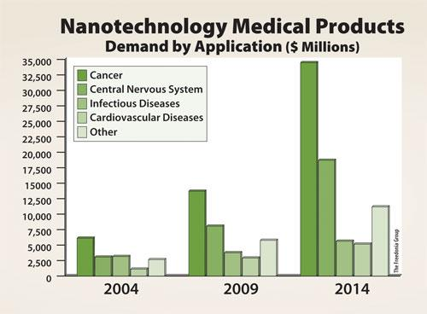
Figure 1: Uses of Nano Technology in Healthcare
As it can be easily understood from the above figure that the uses of Nanotechnology is increasing day by day in health and social care institution. Harley Street Healthcare is using artificial intelligence Technology for different kinds of tests in order to make it perfect such as MRI, Cite-scan, and so on (Harley Street Healthcare Clinic, 2021). The organisation in the recent time is also working with automated temperature monitoring system in order to protect all the parties related with the treatment of Covid-19.
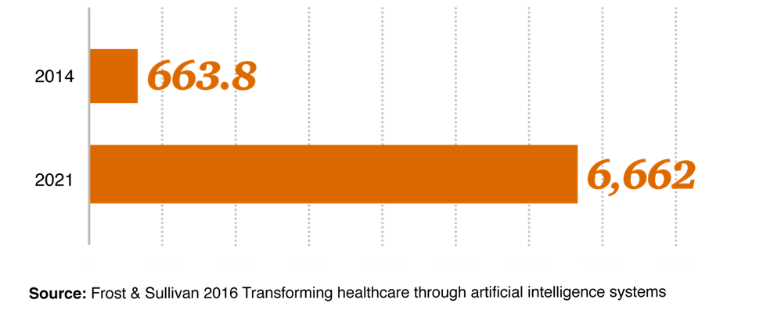
Figure 2: Artificial Intelligence Market
The uses of artificial intelligence is increasing significantly at this moment because of Covid-19 pandemic and the social distance issue. Artificial intelligence is now become one of the most important areas of research and development for Healthcare institutions. Harley Street Healthcare is using information technology of different kinds to record health information and to establish interactive session for the patients of different diseases in order to understand their status appropriately (Harley Street Healthcare Clinic, 2021). In this regard, the organisation is trying to maximize their capability to record information in online more and more.
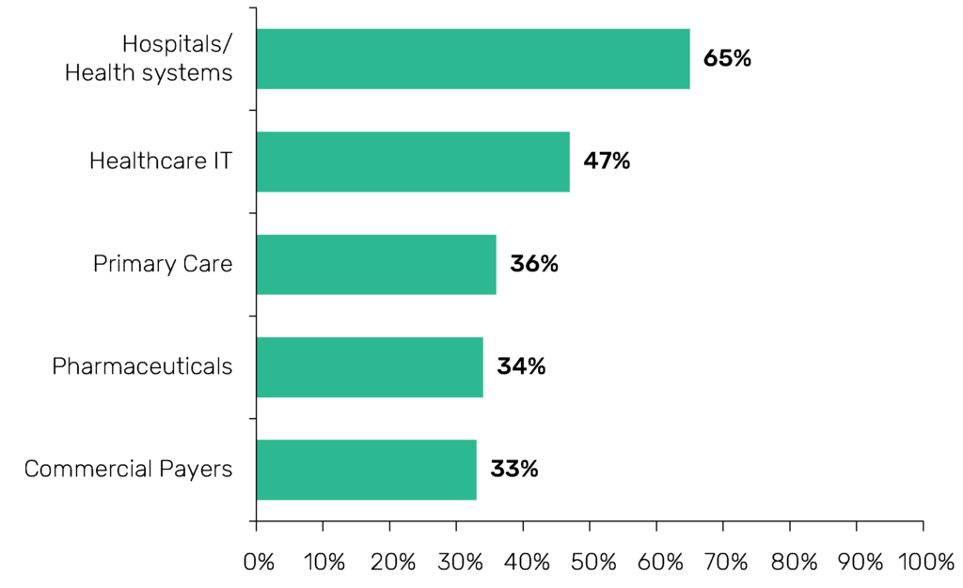
Figure 3: Uses of technology in different fields of Healthcare
According to some of the statistics, technological involvement is increasing day by day in health and social care Institutions across the world. To provide aesthetic treatments to the patients, Harley Street Healthcare is using fully computerized system controlled by human without touching the patients physically (Harley Street Healthcare Clinic, 2021). The organisation is also trying to make sure that they can provide efficient service to the patients about different kinds of health problems such as textual help issues, lifestyle issues and so on. In this regard, the organisation is trying to conduct interactive session with their patience by the help of online media such as Zoom, Google meet, and so on.
The organisation is also giving opportunity to their patients to consult with their expected consultant by the help of online messaging system where all the customers who will get the opportunity to receive services for 24/7.

Conclusion/Recommendation
Although the organisation is doing extremely well in COVID 19 situation in terms of providing appropriate service to their patients but there are some areas where the organisation needs to improve themselves which will make the organisation more efficient and effective in providing more quality treatment to their patients. For instance:
- In order to provide online treatment to the patients, the organisation should provide appropriate training to their employees and doctors, or other health workers (Harley Street Healthcare Clinic, 2021). It will make the organisation very much efficient in providing appropriate service to their patients.
- The organisation needs to be more careful about different kinds of information leaking which may cause serious trouble in the operation of the organisation. For this reason, the organisation has to be efficient enough to find out appropriate employees to protect all its information efficiently and according to the rules.
- The organisation needs to have a research and development activity in its business premises in order to find out more efficient and effective way of providing accurate and innervated service to the patients which will lead the organisation to be more comfortable for their patients in future (Harley Street Healthcare Clinic, 2021).
- The organisation should collect updated information about different kinds of technologically advanced equipment and devices which will make the organisation very much efficient and effective to be more accurate and precise in providing the best services to their patients.
- During this time of Covid-19, the organisation should get involved in different kinds of health precautionary activities and different kinds of online promotional campaign or online social awareness building activities in order to protect the general people of United Kingdom from this deadly virus (Harley Street Healthcare Clinic, 2021). It will not only help the organisation to become successful in reducing transmission of Covid-19 one person to another a little bit but also help the organisation to increase its brand value by working for the society in this time of global crisis.
All these things will definitely help the organisation to become more successful in providing more efficient and accurate service to their patients. In this regard, understanding the up-gradation of different cancer technologies understanding proper uses of technology will be the key factor for the organisation (Harley Street Healthcare Clinic, 2021). All the technology that the organisations are using are very important for providing appropriate service to the patients with different kinds of complex diseases. Therefore, it is ethically completely correct for the organisation to use different kinds of new technologies in its operational procedure in order to make sure that they are giving the right and best service to their patients (Harley Street Healthcare Clinic, 2021). Besides, according to the regulations of United Kingdom, it is necessary for any business organisation to ensure your best service to the patients without any kind of delay which the organisation is trying to ensure in order to make them one of the best in United Kingdom in this industry.

References
Ash J. S., Sittig D. F., Poon E. G., Guappone K., Campbell E., Dykstra R. H. (2007). "The extent and importance of unintended consequences related to computerized provider order entry". Journal of the American Medical Informatics Association. 14 (4): 415–423.
Bates D.W. (2005). "Physicians and ambulatory electronic health records". Health Affairs. 24 (5): 1180–1189.
Brown, Linda Renee (2013). "The secret life of a clinical documentation improvement specialist". Nursing. 43 (2)(Supplement 1): 10–12.
Edmunds M, Peddicord D, Detmer DE, Shortliffe E. (2009). Health IT Policy and Politics: A Primer on Moving Policy Into Action. Featured Session, American Medical Informatics Association Annual Symposium.
Eisenberg RL, Margulis AR (2011). A Patient's Guide to Medical Imaging. Oxford University Press. ISBN 978-0-19-972991-3.
Hailes, John (2012). "Truly Understanding Clinical Documentation Improvement for ICD-10" (PDF). U.S. Indian Health Service.
Harley Street Healthcare Clinic, (2021). https://www.harleystreet104.com/en/about/
Holden Richard J., Brown Roger L., Alper Samuel J., Scanlon Matthew C., Patel Neal R., Karsh Ben-Tzion (2011). "That's nice, but what does IT do? Evaluating the impact of bar coded medication administration by measuring changes in the process of care". International Journal of Industrial Ergonomics. 41 (4): 370–379.
James AP, Dasarathy BV (2014). "Medical Image Fusion: A survey of state of the art". Information Fusion. 19: 4–19. arXiv:1401.0166.
Mettler T (2016). "Anticipating mismatches of HIT investments: Developing a viability-fit model for e-health services". International Journal of Medical Informatics. 85 (1): 104–115.
Mettler T (2016). "Anticipating mismatches of HIT investments: Developing a viability-fit model for e-health services". International Journal of Medical Informatics. 85 (1): 104–115.
Munro, Dan (2014). "Setting Healthcare Interop On Fire". Forbes.
Sidrov J (2006). "It ain't necessarily so: The electronic health record and the unlikely prospect of reducing healthcare costs". Health Affairs. 25 (4): 1079–1085.
Winkler SA, Schmitt F, Landes H, de Bever J, Wade T, Alejski A, Rutt BK (2018). "Gradient and shim technologies for ultra high field MRI". NeuroImage. 168: 59–70.

