

Undergraduate assignment feedback form
(to be completed by marker)

Student Name: Elizabeth Bosworth

Module Code: HUSK6004  Module title: Roderic Bowen Centre: Archives and Research | Student number: 1500872
For completion by marker:
Comments:

Marker’s signature: |  | Date:
Provisional mark:
NB. All marks are provisional until confirmed by the final examination board.

Student Biography Research Project

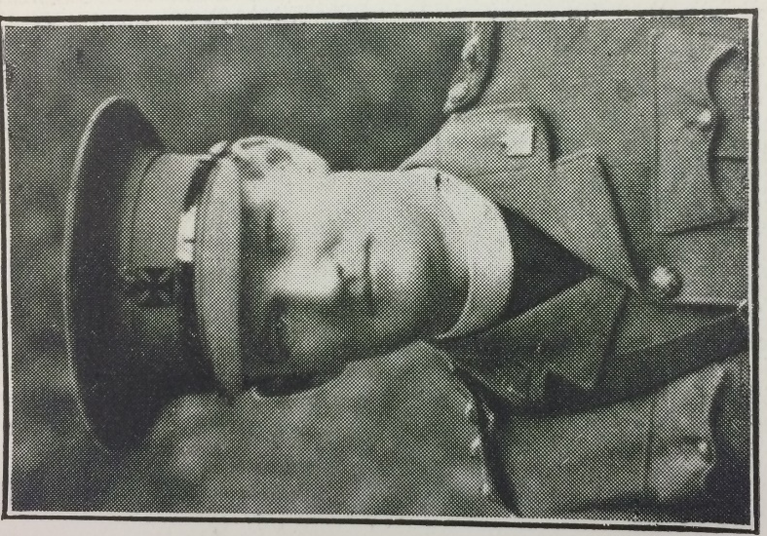
Figure 1. This image of William Edgar Jones is taken from volume 12 of the St. David’s College magazine. He is in uniform, so presumably it is from 1916 when he joined up to the Army Chaplain’s Department.

UA/SP/1/10

The student I was given to research for this project is named William Edgar Jones, who was later given the title of Reverend when he was ordained after leaving his studies at St. David’s College. He was born in 1888, and his birth was recorded in the Cardiganshire county register as being in the ‘first quarter’ of the year – meaning his date of birth was in either January, February or March. The exact date is not given on the record. He was born in Aberaeron (which was then spelled at Aberayron). His parents were Mr and Mrs Jones – recorded as Jonathon B. and Anne. Jonathon’s occupation is shown on the 1891 census as being a schoolmaster, but it is recorded on the 1911 census that Anne was widowed. Jonathon must have died between the 1901 and the 1911 census. As a result of his death, Anne took in a lodger named Daniel Evan Davies who paid rent in order to have a form of income. William had one brother and one sister, Joseph Sydney and Sarah Anne (the spelling of Sydney changes to ‘Sidney’ on other records and memorials). The school William attended was Ystrad Meurig Grammar School, which he left in 1908. The Jones family home is recorded as ‘Garth, Aberayron’. By chance, after finding such information out, on a bus ride from Lampeter via Aberaeron, I looked out of the window and saw a semi-detached house with the name ‘Y Garth’.
William lived in that house up until 1908; in September or October he moved into residence at St. David’s College. He is recorded as living at the college during each term for his three years’ studying. The 1911 census was taken in March, so William would still have been living at the college – right at the end of his degree.

In October 1908 William enrolled in the College to study a BA in History. The Examination Book also records him as taking exams in Welsh and in a Theological Certificate. He was awarded the Simonburn Exhibition in 1908 after taking an examination for it on October 7th, 1908 and was awarded the Butler Scholarship in 1909.

There is no mention in volume 12 of the college magazine of William partaking in any extra-curricular activities. He was also not a seasoned beer drinker – in his three years at the college, he is recorded as drinking a total of forty-five pints in the Beer Book.

William passed all of his exams, bar one, with second- or third-class results. He graduated on June 29th in 1911 with a BA in History and was awarded a 2nd class. He is also recorded in the St. David’s College Magazine as having graduated with a 2nd class Theological Certificate. He was ordained as the curate of Loughor in 1912, the curate of St. Jude in Sheffield during 1914 to 1916. His final curate position before he went to war was at St. Timothy in Sheffield from 1916 to 1917.

The West Wales War Memorial Project has an in-depth account of William’s wartime service, including his deployments and the battles he fought in. Originally, he joined as a chaplain to the forces, and was part of the Army Chaplain’s Department as of 1916. From this, he served in Salonika from the 15th of July 1917. As well as serving in Mesopotamia for an amount of time, he served in France for just under a year, as he was posted to the 9th Battalion of the Yorkshire Regiment in early 1918. Amongst the many named battles he fought in, William’s last battle was the Battle of the Selle. He was wounded there (details of his wounds are unknown) and was evacuated at a result. He sadly died of his wounds on the 24th October at the Casualty Clearing Station at Roisel. He is buried and memorialised nearby at the Roisel Communal Cemetery Extension in Somme, France. There is also a record of this from the Commonwealth War Graves Commission.

A site named History Points also explains how William’s brother, Joseph, died as a result of the war. After the 1911 census, Joseph got married to a Winifred Alice and moved into a house in Lewisham, London. He was enlisted into the Royal Army Medical Corps and served in Egypt, but fell ill due to poor hygiene conditions and died back in England in 1919. He is buried in Ladywell Cemetery in Lewisham.

According to the IWM website, the war memorial hall in Aberaeron features two plaques with the individual names of Aberaeron men who died in the two World Wars. Both brothers, William and Joseph are named as fallen.
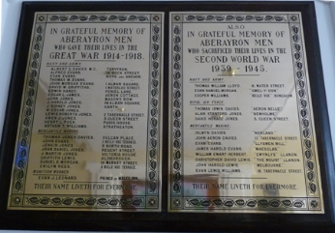
Figure 2. An image of the memorial taken from the West Wales War Memorial Project site.
The National Archives have a record of a medal card belonging to William. It is not accessible online (for free) so it is not clear what is written on there, or what number of medals he was awarded, if any.

Outside the Roderic Bowen Library and Archives there is a small exhibit on Lampeter graduates that died in the First World War. William is featured as just a name on a wooden carved memorial; there are profiles and images of other students, but William is not one of those chosen to feature.

Bibliography

Kew, The National Archives of the UK. Census Returns of England and Wales, 1891. Kew, Surrey, England: The National Archives of the UK (TNA): Public Record Office (PRO), 1891. Available: www.ancestry.co.uk.

Kew, The National Archives of the UK. RG14/33408/43.

Lampeter, Roderic Bowen Archive. UA/A/34/1.

Lampeter, Roderic Bowen Archive. UA/A/42.

Lampeter, Roderic Bowen Archive. UA/BUR/23.

Lampeter, Roderic Bowen Archive. UA/BUR/28/7.

Lampeter, Roderic Bowen Archive. UA/SD/3.

Lampeter, Roderic Bowen Archive. UA/SP/1/8.

Lampeter, Roderic Bowen Archive. UA/SP/1/10.

-
West Wales War Memorial Project, ‘Lampeter (St. David's College) War Memorial’, (2018) [online] Available: https://www.wwwmp.co.uk/ceredigion-war-memorials/lampeter-st-david-s-college-memorial/. (Accessed February 22 2018).
Commonwealth War Graves Commission, ‘JONES, The Rev. WILLIAM EDGAR’, (2018) [online] Available: https://www.cwgc.org/find-war-dead/casualty/299454/jones,-the-rev.-william-edgar/. (Accessed February 24 2018).

History Points, ‘Aberaeron War Memorial’, (2018) [online] Available: http://historypoints.org/index.php?mact=News,m73248,default,1&m73248number=3&m73248detailpage=&m73248pagenumber=2&m73248returnid=3791&page=3791. (Accessed February 27 2018).

Imperial War Museums, ‘Aberaeron Memorial Hall’, (2018) [online] Available: https://www.iwm.org.uk/memorials/item/memorial/17467. (Accessed February 27 2018).

West Wales War Memorial Project, ‘Aberaeron War Memorial’, (2018) [online] Available: https://www.wwwmp.co.uk/ceredigion-war-memorials/aberaeron-war-memorial/. (Accessed February 21 2018).

The National Archives, ‘Medal card of Jones, William Edgar Corps: Royal Army Chaplain's Department’, (n.d.) [online] Available: http://discovery.nationalarchives.gov.uk/details/r/D3170409. (Accessed February 26 2018).

RG14/33408/43.
The National Archives of the UK (TNA): Public Record Office (PRO), Census Returns of England and Wales, 1891 (Kew, England: 1891). Available: www.ancestry.co.uk.
UA/SP/1/10, St. David's College Magazine (bound vol), 1920-6.
UA/BUR/28/7, Residence Lists, 1904-1914.
UA/A/34/1, Examination Book, 1897-1916.
UA/BUR/23, Scholarship Account Book, 1894-1969.
UA/SD/3, Beer Account Book, 1888-1904.
UA/A/42, Graduates’ Register.
UA/SP/1/8, St. David's College Magazine (bound vol), 1908-12.
UA/SP/1/10, St. David's College Magazine (bound vol), 1920-6.
Ibid.
West Wales War Memorial Project, Lampeter (St. David's College) War Memorial, (2018) [online] Available: https://www.wwwmp.co.uk/ceredigion-war-memorials/lampeter-st-david-s-college-memorial/.
Commonwealth War Graves Commission, JONES, The Rev. WILLIAM EDGAR (2018) [online] Available: https://www.cwgc.org/find-war-dead/casualty/299454/jones,-the-rev.-william-edgar/.
History Points, Aberaeron War Memorial (2018) [online] Available: http://historypoints.org/index.php?mact=News,m73248,default,1&m73248number=3&m73248detailpage=&m73248pagenumber=2&m73248returnid=3791&page=3791.
Imperial War Museums, Aberaeron Memorial Hall (2018) [online] Available: https://www.iwm.org.uk/memorials/item/memorial/17467.
West Wales War Memorial Project, Aberaeron War Memorial (2018) [online] Available: https://www.wwwmp.co.uk/ceredigion-war-memorials/aberaeron-war-memorial/.
The National Archives, Medal card of Jones, William Edgar Corps: Royal Army Chaplain's Department (n.d.) [online] Available: http://discovery.nationalarchives.gov.uk/details/r/D3170409.

