

Problem Solving and Innovation (BMSW4014)

Title: An analysis of the factors impacting The Body Shop.
Student Name: Cristian Dinicuta
Student ID: 2323940
Date: 05/07/2024
Wordcount: 1.630

Contents
Introduction 3
Findings 3
PESTLE Analysis: Advantages and Limitations 3
PESTLE Analysis: The Body Shop 4
Stakeholder Analysis: Advantages and Limitations 9
Stakeholder Analysis: The Body Shop 9
Conclusion 12
Recommendations 13
Reference List 14

Introduction
The Body Shop is a popular British multinational beauty and personal care product manufacturer currently selling products in 66 different across the globe. The organisation operates with key business vision for offering customers with completely cruelty free and natural beauty product to support the purpose of animal welfare. Analysing the key factors influencing strategic decisions and operational conditions for the Body Shop is the key purpose of this study.

Findings

PESTLE Analysis: Advantages and Limitations
The PESTLE analysis could be defined as an analytical tool responsible for analysing the opportunities and threats within the macro business environment scenario for an industry or organisation (Adair, 2019). The key macro business environmental factors that are focused in the PESTLE include political, economic, technological, social, legal and environmental factors.
The biggest advantage of PESTLE analysis is its contribution in strategic planning and decision-making system within organisations through giving a broader overview of the market (Proctor, 2019). It is also one of the easiest business environment analysis tools that can be used for assessing major macro environmental trends. Moreover, PESTLE analysis could also foster more accurate prediction of future market conditions due to focus of analysis process on broader market scenario rather than industry specific assessment (Marmol, 2015).
PESTLE analysis can produce meaningful outcomes with insufficient data and analysis process is also limited to six key macro environmental factors only (Siddiqui, 2021). Hence, it is not an adequate analytical tool to assess all possible key market opportunities and threats. PESTLE analysis works on assumption of market opportunities and threats depending on available data but inaccurate interpretation of facts might lead to wrongful strategic selections in business as well (Çitilci & Akbalık, 2020).

PESTLE Analysis: The Body Shop
Political – After the domestic UK market, Europe is the second highest revenue generating market region for the Body Shop but change in free trade policies after BREXIT transition could deeply impact product export cost for the Body Shop from the British to the European market (Sharma et al., 2021). On the other hand, increase in corporate tax rate from 19% to 25% could also impact revenue generation for the Body Shop from the domestic UK market as well (Isbahi et al., 2024).
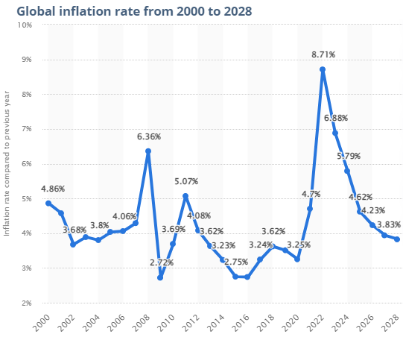
Source: Statista, 2024
Economical – Post-Covid average global inflation rate increased up to 8.71% by the end of 2022 and the UK faced massive 10.7% inflation during the same period causing significant living cost crisis for people (Isbahi et al., 2024). Research also claims that it will take time for inflation rate to stabilise till 2026-2027. Thus, current domestic and glob al market economic scenario and subsequent impacts on consumer spending power could impact demand condition for the Body Shop due to following premium pricing strategy for products (Gerstell et al., 2020).
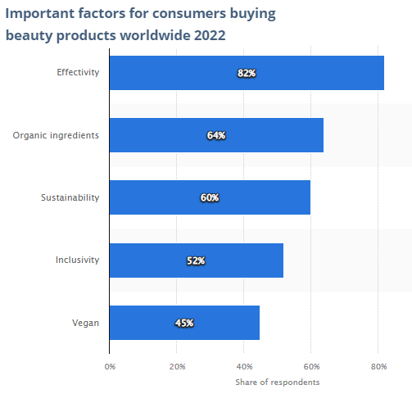
Source: Statista, 2024
Social – According a recent global social survey, organic and vegan ingredients respectively are the most important buying decision making factor for customers towards beauty and personal care products after effectiveness being the first priority factor (Azzahra & Fachira, 2022). Thus, changing social perception towards cruelty free and natural beauty and personal care products could positively impact demand condition for all-natural products of the Body Shop (Sharma et al., 2021).
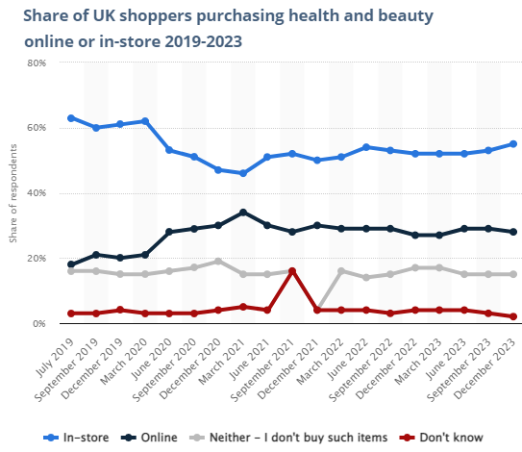
Source: Statista, 2024
Technological – As per reports, 22% of total global sales of beauty and personal care products is accounted by e-commerce based online sales channels (Isbahi et al., 2024). UK market scenario also shows that online purchase rate for beauty and personal care products has drastically increased between 2019 and 2023 while offline sales proportion has decreased simultaneously. Thus, changing technical scenario could have impacts on the marketing and sales strategies of the Body Shop through increasing the importance of online sales channels and reducing dependency on physical stores (Azzahra & Fachira, 2022).
Legal – The Assimilated Regulation (EC) No 1223/2009 has strong provisions for beauty and personal care product manufacturers for safer formulation of products to make them risk and impact free for the users (Gerstell et al., 2020). The Body Shop has product distribution network in 66 different countries across the globe. Thus, differences of consumer and product safety laws and policies could have impacts on the product innovation and production approaches of the organisation.
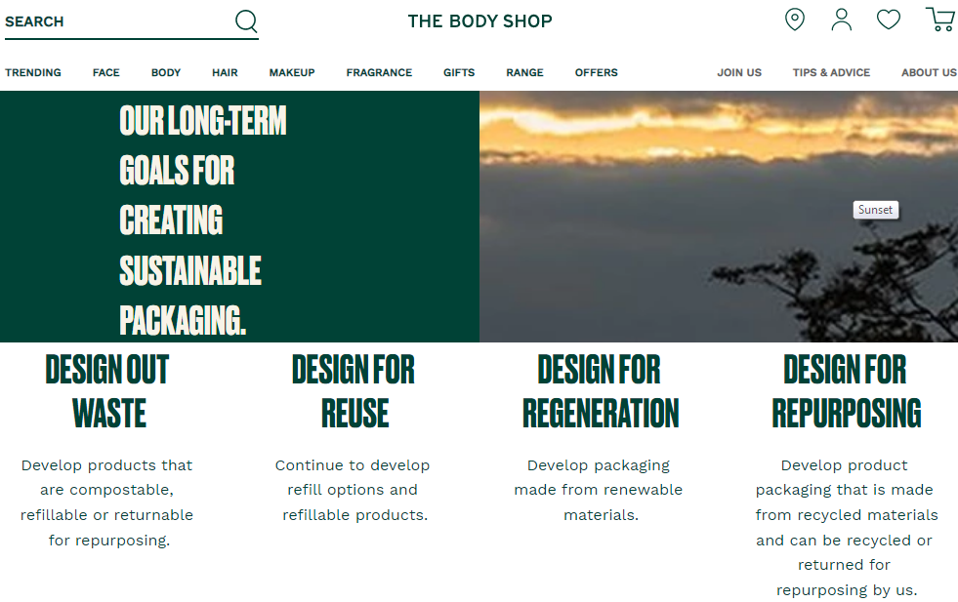
Source: The Body Shop, 2024
Environmental – It has also been analysed in the social environment that sustainability is also a key decision-making factor for nearly 60% customers in the global beauty and wellness product market (Sharma et al., 2021). Growing sustainability awareness among people and customers could also has deeper impacts on the CSR duty, packaging and operational strategies of the Body Shop as shown through the above figure.

Stakeholder Analysis: Advantages and Limitations
Stakeholder analysis could be referred to a collaborative process of research and analysis for identifying the key stakeholders to an organisational scenario or business project for evaluating their level of impact, key interest and subsequently plan their engagement strategy (Adair, 2019).
Stakeholder analysis could make an organisation more aware of the needs and interest of different stakeholder groups could plan their engagement strategies accordingly (Proctor, 2019). Stakeholder analysis could also help an organisation to identify key stakeholder categories and their level of impact on the business operations. Hence, it could guide organisations to plan strategies for engaging key stakeholders as per their importance level in business success and strategic decision-making progress (Stocker et al., 2020).
Human nature and personal priorities can largely vary from one person to another and subsequently stakeholder analysis process has limitations for making accurate assessment of stakeholder needs (Brunetti et al., 2020). Generalisation and stereotyping prediction of stakeholder needs could lead strategic decisions in business in wrong directions.

Stakeholder Analysis: The Body Shop
Identify – The most important stakeholder categories to be focused in the organisational context of the Body Shop include customers, employees, suppliers, subsidiary owner (Aurelius), franchise store owners, shareholders, legislative authorities, etc (Gregory et al., 2020).
Analyse – The impact and influence level of each of the key stakeholder segment for the Body Shop has been analysed through the below provided table.
Stakeholder | Contribution | Willingness to Engage | Influence | Necessity for Involvement
Customers | Low | Moderate | High | High
Employees | High | Low | High | High
Suppliers | Moderate | Moderate | High | High
Subsidiary owner | High | High | High | High
Franchise store owners | High | High | Moderate | Moderate
Shareholders | Low | High | High | Low
Legislative authorities | Low | Moderate | Moderate | Low

Mapping – The Power-Interest Grid could be the most effective theoretical framework for accurate mapping stakeholder priority within an organisational context with respect to level of stakeholder interest and power to influence business performance and decisions (Adair, 2019).
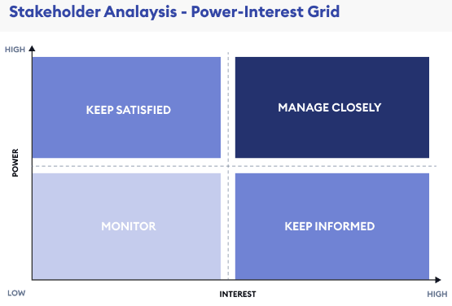
Source: (Brunetti et al., 2020)
Customers should the most important stakeholder category for the Body Shop in ‘keep satisfied’ category because retention of satisfactory experience and loyalty among buyers is the key to long-term success and sales performance consistency (Stocker et al., 2020). The new subsidiary owner or administrator, Aurelius should also be kept satisfied by leadership of the Body Shop to justify its growth potential and subsequent gain more investment for growth (Proctor, 2019).
Employees at the Body Shop must be closely managed to ensure performance consistency and their cooperation towards organisational success. Alongside employees, suppliers of the Body Shop should also be closely managed to ensure consistent supply of quality natural ingredients as per demand condition (Gregory et al., 2020). The Body Shop sources product material from more than 1000 farms and suppliers across the globe which also increases the need for closer management of international supply chain network (Brunetti et al., 2020).
Due to being a limited company by nature, the Body Shop must keep its shareholders informed about its financial performance and basic accounting data so that they could keep their trust and investment on the business (Sanny et al., 2020). Franchise owners associated with the Body Shop needs consistent monitoring so that change in offline productivity can be tracked amidst growing online sales potential. Moreover, legislative authorities in regional markets should also be monitored so that operations and products must be in line with necessary legal obligations (Mursandi et al., 2020).
Prioritisation – The recent UK market visions of the Body Shop leadership for store closure and 40% workforce downsizing could deeply impact staff motivation and loyalty and subsequently employee priority level must be revised with better job security (Gregory et al., 2020). Shareholder priority level at the Body Shop should also be increased as frequent changes of company ownership between L'Oreal, Natura & Co and Aurelius in recent years could increase their investment security concerns (Brunetti et al., 2020).

Conclusion
The above study made effective utilisation of different key analytical tools and frameworks like PESTLE and stakeholder analysis to assess impactful factors for the Body Shop. The organisation has strong growth potential with some contemporary challenges but suitable strategic approaches could ensure bigger success in the future.

Recommendations
Recent visions of the Body Shop for nearly 200 UK store closure and 40% workforce downsizing could have lasting impacts on employment relations and workforce engagement level (Isbahi et al., 2024). However, growing potential of online sales growth could be an opportunity for the Body Shop to provide employees with alternative deployment based on effective technical training programs and skill transformation (Mursandi et al., 2020).
In order to enhance customer engagement level and online sales growth, the Body Shop needs to enhance their online purchasing experience. For instance, AI and Machine Learning technology based personalised product recommendations and beauty tips for individual buyers could be a very suitable strategic recommendation n in this regard (Dwita et al., 2020).
In order to minimise the impacts of the global economic downturn on product demand conditions, the Body Shop needs to reposition its product and pricing strategies. The most sold products must be launched with smaller quantity containers or can be offered with loyalty discount rate to the buyers to keep affordable in the present market economy adversity.

Reference List
Adair, J.E. (2019) Decision making and problem solving : break through barriers and banish uncertainty at work. Fourth edition. London : KoganPage.
Azzahra, S., & Fachira, I. (2022). The Influence of Bring Back Our Bottle Program on The Body Shop Indonesia Brand Image, Brand Trust, Brand Love and Brand Loyalty. Asian Journal of Research in Business and Management, 4(3), 283-295.
Brunetti, F., Matt, D. T., Bonfanti, A., De Longhi, A., Pedrini, G., & Orzes, G. (2020). Digital transformation challenges: strategies emerging from a multi-stakeholder approach. The TQM Journal, 32(4), 697-724.
Çitilci, T., & Akbalık, M. (2020). The importance of PESTEL analysis for environmental scanning process. In Handbook of research on decision-making techniques in financial marketing (pp. 336-357). IGI Global.
Dwita, V., Leni, P., & Mulya, J. (2020, March). The Effect of Customer Relationship Management on Brand Loyalty: A Case Study on the Body Shop Indonesia’s Customers. In 4th Padang International Conference on Education, Economics, Business and Accounting (PICEEBA-2 2019) (pp. 944-954). Atlantis Press.
Gerstell, E., Marchessou, S., Schmidt, J., & Spagnuolo, E. (2020). How COVID-19 is changing the world of beauty. McKinsey & Company, 1-8.
Gregory, A. J., Atkins, J. P., Midgley, G., & Hodgson, A. M. (2020). Stakeholder identification and engagement in problem structuring interventions. European journal of operational research, 283(1), 321-340.
Isbahi, M. B., Pertiwi, T. K., & Purwanto, S. (2024). The Role of Green Brand Image Awareness and Environmental Awareness on Purchasing Decisions by Controlling the Behavior of Potential Consumers of the Body Shop Mojokerto. Indonesian Interdisciplinary Journal of Sharia Economics (IIJSE), 7(1), 442-461.
Marmol, T. del (2015) PESTLE analysis. Namur: Lemaitre Publishing.
Mursandi, D. A., Sudirman, H. A., & Militina, T. (2020). The impact of green marketing and corporate social responsibility on brand image, purchase intention, and purchase decision (Study on the body shop in Samarinda). International Journal of Economics, Business and Accounting Research (IJEBAR), 4(4).
Proctor, T. (2019) Creative problem solving for managers : developing skills for decision making and innovation. Fifth edition. New York : Routledge.
Sanny, L., Arina, A., Maulidya, R., & Pertiwi, R. (2020). Purchase intention on Indonesia male’s skin care by social media marketing effect towards brand image and brand trust. Management Science Letters, 10(10), 2139-2146.
Sharma, M., Trivedi, P., & Deka, J. (2021). A paradigm shift in consumer behaviour towards green cosmetics: An empirical study. International Journal of Green Economics, 15(1), 1-19.
Siddiqui, A. A. (2021). The use of Pestel analysis tool of quality management in the health care business and its advantages. Am J Biochem Biotechnol, 14, 507-12.
Stocker, F., de Arruda, M. P., de Mascena, K. M., & Boaventura, J. M. (2020). Stakeholder engagement in sustainability reporting: A classification model. Corporate Social Responsibility and Environmental Management, 27(5), 2071-2080.

