Extracts from Orhan Pamuk, Istanbul: Memories and the City, translated by Maureen Freely (London: Faber and Faber, 2005 [first published in Turkish 2003]), pp. 48, 54—55

[p. 48] The wooden mansions of my childhood and the smaller, more modest wooden houses in the city’s back streets were in a mesmerizing state of ruin. Poverty and neglect had ensured these houses were never painted, and the combination of age, dirt, and humidity slowly darkened the wood to give it that special colour, that unique texture, so prevalent in the back neighbourhoods that as a child I took the blackness to be original. Some houses had a brown undertone, and perhaps there were those in the poorest streets that had never known paint at all. But Western travellers in the eighteenth and mid-nineteenth centuries described the mansions the eighteenth and mid-nineteenth centuries described the mansions of the rich as brightly painted, finding in them and the other faces of opulence a powerful and abundant beauty … In summer, when these old wooden houses would dry out and turn a dark, chalky, tinderbox brown, you could imagine them catching (re at any moment; during the winter’s long cold spells, the snow and the rain endowed these same houses with the mildewy hint of rotting wood. So it was too with the old wooden dervish lodges, forbidden by the Republic to be used as places of worship, now mostly abandoned and of interest only to street urchins, ghosts, and antiques hunters. They would awaken in me the same degrees of fear, worry, and curiosity…
…. [p. 54] To see the city in black and white is to see it through the tarnish of history: the patina of what is old and faded and no longer matters to the rest of the world. Even the greatest Ottoman architecture has a humble simplicity that suggests an end-of-empire gloom, a pained submission to the diminishing European gaze and to an ancient poverty that must be endured like an incurable disease. It is resignation that nourishes Istanbul’s inward-looking soul.
To see the city in black and white, to see the haze that sits over it and breathe in the melancholy its inhabitants have embraced as their common fate, you need only to )y in from a rich western city and head straight to the crowded streets; if it’s winter, every man on the Galata Bridge will be wearing the same pale, drab, shadowy clothes. The İstanbullus of my era have shunned the vibrant reds, greens, and oranges of their rich, proud ancestors; to vibrant reds, greens, and oranges of their rich, proud ancestors; to foreign visitors, it looks as if they have [p. 55] done so deliberately, to make a moral point. They have not—but there is in their dense gloom a suggestion of modesty. This is how you dress in a black-and-white city, they seem to be saying; this is how you grieve for a city that has been in decline for a hundred and fifty years.
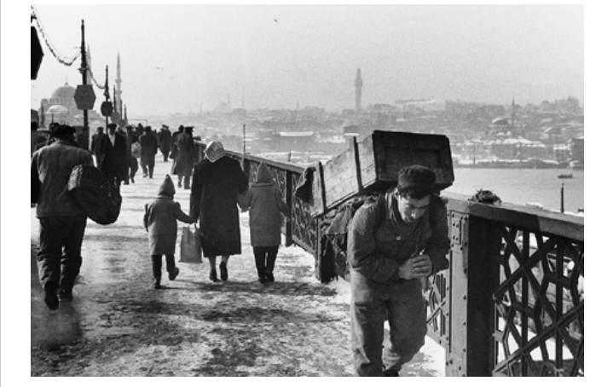
[Photograph by Ara Guler]

