Dimitrina Petrova Dissertation
Date: 05.09.2022

Submission date: 5 Sep 2022 – 23:59
Submission ID: 1905516
File name:
Word count:

DISSERTATION
By Dimitrina Petrova



Course: BA Business management

Dissertation on
Analyzing the adoption of Cryptocurrency from an economic perspective and its impact on developing countries.

Student’s name: Dimitrina Petrova
Student’s number: 1905516

Acknowledgments:
First and foremost, I would like to thank my supervisor, Dr. Gladius Kulothungan for their consistent guidance and support during the semester. Moreover, I would like to express my sincere gratitude to the rest of my lecturers over the years because without their support and collaborative effort I would not have had the opportunity to reach this level of my education. Furthermore, I would like to acknowledge all people for participating in my research. With their help, I managed to collect up-to-date information that increased the quality of my project significantly.

Abstract:
The proportion of electronic transactions in international payments is increasing all around the world. In the past decade, governments, politicians, and practitioners throughout the world have paid close attention to cryptocurrencies which are also known as electronic payment systems. (Nadeem, et al, 2021) Cryptocurrencies are expected to bring a massive revolution in the near future from an economic perspective. The reason for that is the innovative method of exchanging funds as there is no existing physical form of it. The transactions are faster and there is no need for cross-border usage, fees are less, high security, transparency, and privacy. In this project, I will emphasize the main economic factors that may affect the adoption of cryptocurrency by developing countries. The investigation that was conducted aims to provide a better understanding of the adoption factors and how different countries may strengthen their economic situation by implementing their own cryptocurrency. There will be answers to very important questions on how the nation will accept or deny such innovation. Will this modernization manage to gain people’s trust in cryptocurrency? Will this be enough in order to support the country’s economy? There are a few examples of how different developing countries achieved success by utilizing the option of electronic payments.
This study is based on ))))))))))))))) model and research frameworks that have been used to develop and test the proposed hypothesis. All data is collected via survey from -------- PARTICIPANTS. The findings of the research show that – need to add results of the conducted survey (still collecting responses)
Each chapter of the paper is clearly divided into separate sections. Each of the sections includes a detailed analysis of the study where more information alongside examples is presented. Chapter one is introducing the background and rationale of the study as well as the aims and objectives. Furthermore, chapter two includes a literature review where the main analysis takes place. All gained information is presented in this chapter with some facts on how cryptocurrencies affect the global economy and mainly within developing countries. There is a comparison between some countries in order to emphasize the visibility of the impact of digital assets.
Chapter three shows all facts and data collection from the interview and questionnaire. A details overview of the collected information is presented alongside graphs and tables. All factors have been considered as per the methodology point of view, timeframes were met, research methods were followed, and the result is carefully described within chapter four. Chapters five and six provide more analysis of the findings and there is a detailed discussion of the result. Based on the collected results, the final chapter includes recommendations as well as the conclusion of the investigation. The project was conducted during the summer of 2022 and some of the results may be affected by the current market situation. However, these results may be subject to change in the future.

Keywords: cryptocurrency, digital assets, electronic transactions, adoption, social trust, developing countries, global payments, economic perspective, blockchain technology.

Table of content:

Chapter One: Introduction……………………………..………………...………9
- Research background…………………………………………………….….9
- Rationale of the study……..………………………………………………..10
- Research question, Aims, and Objectives……………….…………..……..11
- Research structure………………………………………………...………..12
- Dissertation outline and chapter overview…………………………………13
Chapter Two: Literature review…………………………………………..……14
- Introduction of the chapter…………………………………………………14
- Critical analysis of cryptocurrency adoption by developing countries………………………………………………………...………….15
- Economic perspective of cryptocurrency…………………………………..24
- Impact of cryptocurrency adoption (positive or negative)……………..…..26
- Consequences…………………………..………………………..…………32
Chapter three: Methodology……………………………………..………..……33
- Introduction.………………………….…………………………….………33
- Research philosophy……………….……………….………...……………34
- Research approach……………….……………….……………….…..……34
- Research strategy………………….………………………………..………34
- Research techniques…………………………………………………..……35
- Type of investigation……………….………………………………………35
- Time horizons……………….…………………………………………...…37
- Data collection methods……………………………………………………37
- Data sampling……………….……………………………………………...37
- Questionnaire.……………….………………………………………..……38
- Primary research obstacles ……………………..……….…………………38
- Ethical consideration ……………….……………………...………………38
- Overview……………….…………………………………………..………39
Chapter Four: Analyzing data………………………………………………….40
- Introduction.……………….……………………………………….………40
- Inclusion and exclusion criteria………………………….…………………40
- Questionnaire analysis……………….…………………………………..…41
Chapter Five: Findings and Discussion
- Introduction……………….…………………
- Findings……………….…………………
- Discussion……………….…………………
Chapter Six: Recommendations and Conclusion
- Conclusion……………….…………………
- Recommendations……………….…………………
- Limitations……………….…………………
- Implications ……………….…………………
Reference list………………………………………………………………..…….
Appendix
- Questionnaire and Interview questions ……………….…………………
- Tables and graphs ……………….…………………
- Timetable……………….…………………
Topic: Analyzing the adoption of Cryptocurrency from an economic perspective and its impact on developing countries.

Chapter One: Introduction

- Research background
A modern form of private money, cryptocurrencies are based on high technological properties owning a global transparent transactions network that is fast and relatively safe. Furthermore, it provides them with decent forecasts for further growth. Nevertheless, virtual currencies are outstanding and unlikely to contest the dominant position of the central banks and sovereign currencies. As being an innovation for not many years, crypto currencies’ s anonymity and trans-border character posture a challenge to all financial regulators. (Dobrowski and Janikowski, 2018)
Virtual currencies are digital money that is generated via electronic payment systems without requiring government backup. In 2008 was invented the first cryptocurrency by an unknown programmer named Satoshi Nakamoto where users were able to transfer funds for digital equivalent value. These transfers are validated by decentralized systems and protocol, therefore no financial institutions such as banks are involved. Nowadays, the estimated size of the cryptocurrency space was developed over the past decade with a collective market capitalization of $1.75 trillion and above. (Hayes, 2022) Given such rapid growth and volatility, the attention of the public has been drawn by virtual currencies.
Society has been changing over the years and therefore the habits have changed, too. Since money is a developing concept and is strictly related to the community and environment new forms and demands have arisen. After the implementation of digital money, technology has become very crucial as progressive growth must be adopted worldwide. There are countries that still have inefficient financial sustainability that has the potential to be improved. With the introduction of cryptocurrencies, transactions have become more convenient, instant, and safe. Due to their digital nature and global distribution, these currencies clearly show the potential for challenging the long-standing financial systems within countries where the formal payment system is more advanced than others.

- Rationale of the study
The actual purpose of this project is to cover all aspects of virtual currencies’ nature and explore the investments as part of the economic situation of developing countries. The investigation has brought up to my attention that it is crucial for every country to consider the significance of cryptocurrency and how it can benefit the monetary system. The role of electronic assets is important, and it is imperative that everyone understands this innovative way of exchanging funds. The impact of adopting such currencies must be carefully analyzed alongside the conditions worldwide. Since cryptocurrencies are a modern way of investment, governments must be able to focus on developing their own virtual currency that can increase financial growth.

- Research question, Aims, and Objectives
The current aim of this study is about providing deep information concerning cryptocurrencies and their impact globally. Considering the factors of virtual currency investments will shed more light on an economic perspective and mainly it will line the benefit for the financial situation in developing countries. On other hand, the social trust in cryptocurrencies can also be investigated and analyzed by reviewing the results of the questionnaire below.
The objectives of the study are as per following:
- Understanding the significance of digital currencies
- Identifying the role of cryptocurrency investment on the economic state of developing countries
- Analyzing all factors that may affect the investments
- Providing recommendations that can improve the economic situation of the developing countries
The research questions are:
- What is the significance of digital currencies?
- What is the role of cryptocurrency investment on the economic state of developing countries?
- What are the factors that affect the investments?
- What strategies can be used to improve the economic situation of developing countries?

- Research structure
A detailed description of the research structure could be seen below:
Chapter One: Introduction
This chapter is the beginning of the project. It is essential to include the research background of the topic in order to give a context of the main idea as well as to provide the aim, objectives, and research questions of the study.
Chapter Two: Literature review
This chapter is highlighting all information that has been previously researched. All data will be investigated and analyzed accordingly.
Chapter Three: Methodology
The research onion that was introduced previously in the proposal will be developed. Also, the results gathered during the data collection will be described and examined in this chapter.
Chapter Four: Analyzing data
Detailed feedback will be provided in this chapter in relation to the questionnaire and the interview.
Chapter Five: Finding and Discussion
This chapter includes all results of the newly collected information.
Chapter Six: Recommendations and Conclusion
After performing the above investigation steps, the last chapter will conclude the final outcome by providing further recommendations to strengthen the main idea about cryptocurrencies acceptance.

- Dissertation outline and chapter overview
In general, the outline of this topic is to deliver thorough knowledge regarding cryptocurrencies and their utilization across the world. Considering the relevant questions and developing the main objectives stated in this chapter, the idea of virtual currency adoption may bring more opportunities for economical expansion and increase the financial level of every country. By analyzing the benefits of cryptocurrency implementation worldwide and comparing the countries with stronger financial systems to countries with weak financial systems, we can clearly understand how supportive it could be.
Reviewing the background of cryptocurrencies and their purpose, it is understandable that not every country would go ahead with such innovation when it comes to cryptocurrencies. There are a lot of factors to be reviewed and analyzed. Therefore, the next chapters will provide more evidence and explore the benefits of virtual currency adoption for developing countries.

Chapter Two: Literature Review

- Introduction of the chapter
In this chapter, the key examination will cover the role of cryptocurrencies in developing countries. Briefly, in this section, the theoretical background of the topic will be analyzed in depth as well as exploring the concept of different money forms and their influence over developing countries. A detailed inspection of all past literature is established by filling the gap with alternatives in order to avoid some restrictions imposed by financial institutions within these countries. Additionally, there is a need to observe all potential risks and limitations in relation to the adoption of cryptocurrencies. The relationship between digital currencies and evolving country’s economy plays an important role and more specifically with financial inclusion that may have a positive or negative effect.
There are a lot of existing challenges in terms of the developing country’s financial schemes. The trust for growth and every opportunity for innovation that may arise can predict and discover different alternatives for increasing socio-economic inclusion. Therefore, building an accelerating growth for electronic transactions will be advantageous because of the political and social context of the country. (Currie, 2009). For developing countries, it is beneficial to look at the experience of the mistakes that the West has made in terms of the system production, governance infrastructure, and financial services, or more specifically how to build a strong and relative blockchain technology.
Via these virtual currencies, the consumers are avoiding the physical use of banks. To exclude any further risks, developing countries may easily invest in the newest technology infrastructure achieving quick results which have taken a lot of time for other countries in the past decade. (Grinberg, 2011). By implementing cryptocurrencies, emerging countries will have their own leadership position over the adoptions and will create a new traditional system for online payments that will be triggered by the ability to remove the need for a trusted third party.

- Critical analysis of cryptocurrency adoption by developing countries
Cryptocurrency – definition, blockchain technology, developing countries, adoption and risk.
“What is needed is an electronic payment system based on cryptographic proof instead of trust, allowing any two willing parties to transact directly with each other without the need for a trusted third party.” (Nakamoto 2008).
Definition
The European central bank has classified cryptocurrencies as such, and they can be bought or sold against traditional money as well as being used for purchases. (Houben, 2018) Virtual currencies will replace the financial structures and will foster different monetary systems where anonymity, privacy, and autonomy will be leading. (Bashir, Strickland & Bohr 2016). Analyzing the past 10 years of cryptocurrencies’ lifetime, we can see that the long-term technology has been challenging the fiscal payments on fiat currencies.
There are three types of utilizing cryptocurrency. The first type of crypto purchase is for virtual goods such as online games. The second type is related to the real economy, and this is when purchasing cryptocurrency with real money. A conversion rate applies here which is in contribution to the real economy. And the third type is buying cryptocurrency with another cryptocurrency. There is also a bidirectional relationship with the real economy because there is a conversion rate when buying the virtual currency as well as when selling it. Of course, the value of the CC is exclusively driven by the market and therefore it involves a high risk of exchanging the currency at a lower price. Such virtual currencies are not regulated by any international or national authorities. (ECB, 2015)
Blockchain technology
To look more specifically at this, according to McLeay and Thomas’s article, systems that do not include the exchange of fiat currencies will need a specific payment system alongside a ledger to record the value. Furthermore, to avoid any ‘’double charges’’ for a single transaction there is a need for a system that can detect duplicated payments. Such a system is the blockchain, where non-cryptographic currency depends on a centralized balance sheet. The blockchain is an electronic ledger that makes sure all transfers are maintained securely and have been distributed efficiently by taking ownership. (Arjaliès 2020)

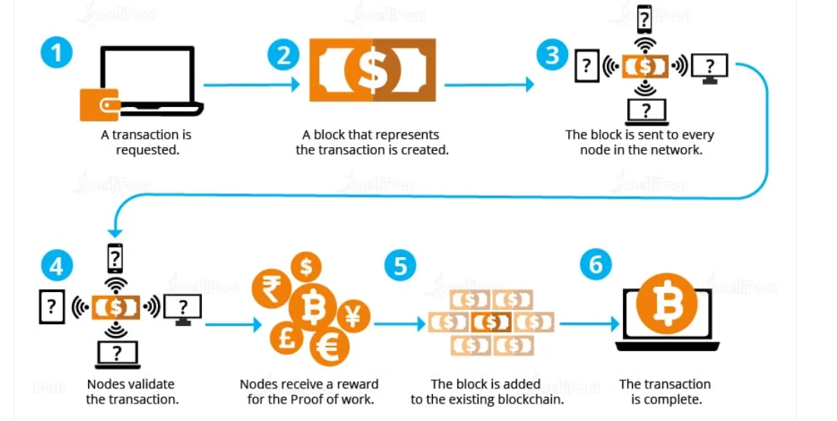
FIGURE 1: Transaction Process Through Blockchain

As per Figure 1, every transaction begins from a sole network node which is being sent to other network nodes. Each transaction must be verified before it is sent. For example, each block gets added only once the computational power of the network's nodes reaches consensus, which is done with the aid of the proof of work method. As a result, the transaction, along with previous transactions, generates a new block of data for the ledger. Each line in a transaction block has a unique identifier that is connected to the one before it. The preceding block's unique identification is utilized to compute the identifier for the next block, forming a mathematical connection between the blocks in the chain. The block is added to the current blockchain in this situation. Because all entries in the chain must be changed, editing or removing rows in the database is nearly impossible. Adding new rows to the data needs the node's consent, which is gained by the work verification procedure, which all nodes must use. As a result, as long as the software is running, blockchain will continue to be produced and maintained, unaffected by anyone withdrawing.
The cryptographic technology secures and transparently stores the details of every transaction on a public, distributed interlocked permanent, and transparent ledger. As a result, each participant will have a list of all transactions to confirm if future purchases are genuine or an effort to double spend. To deconstruct the blocks, the permission or "proof of work" would have to be completely re-executed for each block added after the altered one, which is computationally incredibly demanding. (Arjalies, 2020). All cryptocurrency transfers are being sent from and to electronic ‘’wallets’’ which on other hand are secured by encryption. Thus, it allows 100% anonymity of use as well as ownership. Therefore, this is one of the negative parts of these transfers because of the full anonymity creates an area for illegal trades. The good part is that not all virtual currencies are classified as fully anonymous. For instance, cryptocurrencies such as Bitcoin can hypothetically be tracked back to the owner’s wallet, however, the information still can remain anonymous for the basic purpose. Consequently, the value may be kept and exchanged in cryptocurrencies without revealing one's personal name to the public. (Dierksmeier & Seele 2018). Furthermore, the price of cryptocurrencies is determined by supply and demand, which may be favorable in countries where the currency is heavily influenced by inflation; nonetheless, it impacts the riskiness of the currency, which is vulnerable to considerable price changes.
There are currently over 1500 existing cryptocurrencies. However, there are about 10 currencies that lead the market by representing 80% of the total value in the cryptocurrency market. Although, cryptocurrencies such as Bitcoin or Ethereum only take around 55% of the market value. (Claeys, Demertzis & Efstathiou 2018) The overall market value of the 100 biggest cryptocurrencies is believed to have surpassed the equivalent of EUR 330 billion internationally by early 2018, while the total capitalization of cryptocurrencies peaked at an even greater USD 728 billion during the same time (Bratspies 2018).
Developing countries
The adoption of digital currency in developing countries will face a lot of challenges due to the complex economic and socio-cultural context that is deeply controlled by the formal financial scheme. In such countries, where the Human Development Index (HDI) and industrial base are low, there is a basic association between human wellbeing and income that is flawed. (UNDP Human Development Report Office 2015).
There are several factors that can measure the effectiveness of the development. Mostly, development rest on the resources made by savers and investors. Direct financial transactions between savers and borrowers would be available in a world without market obstacles and uncertainty. However, in the real world, where transactions have unpredictable outcomes and most agents are risk-averse, risk diversification and risk management services command a premium. On other hand the financial system may affect economic development positively as per a few factors (Afonso et al. 2002):
- Ability to manage financial resources.
- Savings deployment
- Decreasing information cost
- Decreasing investments cost projects
- Risk diversification
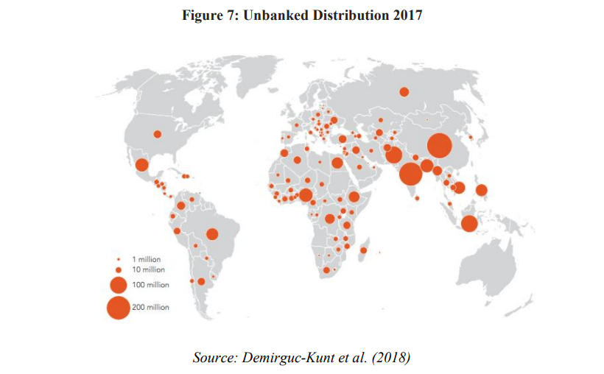
The main purpose of financial inclusion is to ensure individuals or businesses are able to access affordable products or services in order to meet their needs. However, some financial institutions are not able to offer people with opening bank accounts or provide an effective way of managing their finances. This of course causes a global market crisis because of the incapability to offer a proper financial service.

FIGURE 2:
Unbanked
Distribution
(Source: Demirguc-Kunt
et al. (2022))

In the figure above it is visible that the population within developing countries is unbanked. In 2022, the majority of African and Asian regions are unbanked which means that people do not possess a bank account which in percentage is 17% on the global aspect. According to Stopl (2022), formal financial accounts have only 26% of the population worldwide. In Jamaica, the percentage has increased up to 59%, however, this percentage includes the whole country, not specific cities or urban areas. The usage of financial bank accounts in most other developing countries does not exceed 30%.

Adoption
Dissimilarly to traditional forms of money, cryptocurrencies have the potential of becoming more pervasive due to their digital nature and global distribution. They are designed for swift transfers and frictionless which makes them the most preferable financial alternative for developing countries. An example is that according to the most recent statistic (Fig. 3), the bulk of cryptocurrency transactions take place in nations where the traditional payment infrastructure is well developed. According to data from the LocalBitcoin website, trade volume in evolving and boundary economies much outnumbers that in the developed world, and the digital currency is also less sensitive to price changes.
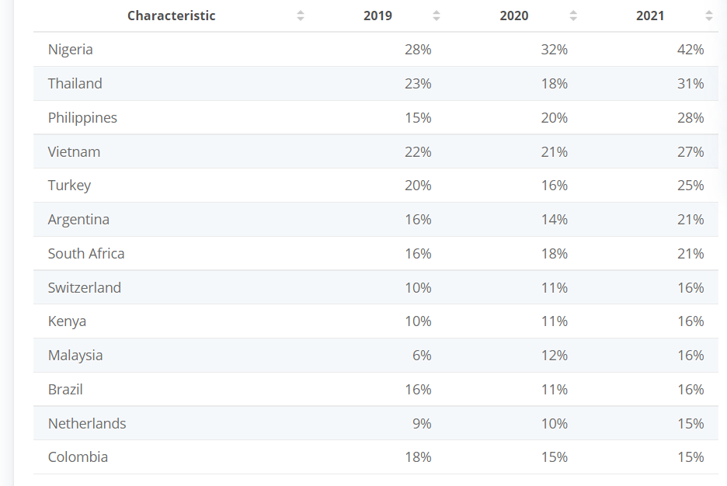
Figure 3, Source: Statista 2019-20220
Reflecting on the most recently collected data from the figure above, the top emerging countries that have adopted digital currencies are Nigeria, Thailand, Philippines, Vietnam, Turkey, Argentina, and South Africa which are above 20% globally. The survey shows that the percentage of people who own cryptocurrency has significantly increased over the years and the utilization and adoption of digital assets have become more popular.
As per the CEO of Wala, Tricia Martinez, in countries such as Africa cash is the king, however, if crypto is designed properly, the adoption will be aggressive. There is a nature of interest in virtual currencies between developed and developing countries because of the unique reflection of the profound difference between them. There are two main aspects in defining the potential of cryptocurrencies:
- These currencies can be seen as a new payments instrument where no relatively cross-border transaction costs are presentable. These are also an independent form of governments or monetary authorities.
- Digital currencies can also be seen as speculative trading instruments. There are a lot of opportunities in relation to cryptocurrency portfolios. These can be exchanged for fiat currencies, commodities such as gold, or stocks without prevaricating the economic uncertainty. (Baur et al, 2017)
The variety of cryptocurrencies could be an option for developing countries to be able to use as a speculative instrument. The standard financial system does not offer such a service and the adoption of cryptocurrencies will be beneficial. For instance, Africa’s population and businesses are not able to perform cross-border payments due to local restrictions. However, the utilization of digital currencies mainly for transfers will be much helpful for Africa to expand its economic scheme as it is a country with the fastest-growing population. (Baur et al, 2017)
As a matter of fact, the formal financial system within evolving countries plays the role of obligating the growth prospects. Furthermore, they represent alternatives for some innovations, too. It is not surprising that emerging countries should think about the best options to find alternative methods for increasing socio-economic inclusion by accelerating electronic payments. In order to develop a new payment system, it should be considered a political and a social process. (Currie 2009). It is advantageous for those countries to analyze the mistakes of The west when developing their own production system or monetary services by building a technological infrastructure such as blockchain technology. Online users are avoiding physical banks by using peer-to-peer digital money instead. (Greenberg, 2019). In fact, rather than evaluating all prior variants of technology when creating their infrastructure, these countries are able to skip to the most recent version, getting rapid results that would have taken decades in more industrialized countries, saving time and money. Emerging nations are gradually gaining the lead in cryptocurrency adoption as a financial alternative to the traditional payment system, owing to the potential of these digital currencies to eliminate the need for a trusted third party.

Risk
The utilization of cryptocurrencies involves a dozen of risk that rests on the real connection with the economy, the issued volume, and trading volume. (ECB, 2015) For example, if all developing countries depend on this economy, the danger of exposing and transaction electronic currencies will affect them. Particularly, the virtual currencies value depends on the investor’s demand as well as the market volume and if it drops then the value of the currency drops, too. Nevertheless, this currency value in emerging countries will not respond to the price variation because the more developed markets are driven by the more resistant currency rather than hypothetical reasons.
Cryptocurrencies are affecting developing countries such as Zimbabwe or Venezuela in a positive way due to the hyperinflation that eats every paycheck as soon as it is issued. Therefore, owning virtual currency plays a crucial role as an invisible peer-to-peer controlling spine that is safe by comparison. Moreover, banks refuse to help illiterate people that are unable to manage or understand the banking system. This leads us to think that unbanked people are low educational attainment. (Demirguc-Kunt et al. 2018)
Because of expanded financial inclusion, virtual currency adoption leads to speculative democratization. Moreover, monetary literacy has been demonstrated to underpin financial inclusion and boost the utilization of financial services. For the adoption of complicated financial innovations such as bitcoins, it is expected that a high degree of financial knowledge and inclusion will be necessary. (Klühs & Menkhoff 2018). Furthermore, according to Campbell (2006), families who recognize their own limitations may shun financial methods for which they feel unqualified, such as the adoption of cryptocurrencies. Cryptocurrencies emerged as a response to the rise in private value accumulation by financial intermediaries at the cost of ultimate savers. (Arjaliès et al. 2017).
On other hand by preventing financial intermediaries, virtual currency transactions are not very clear whether their appropriation value is distributed equally between the involved investment chain. In fact, everybody can own electronic currency, however, not everyone is capable of actually understanding and engaging with them. According to West (2015), the innovative financialized inclusion of the worldwide economy has the potential advantage of adopting cryptocurrency in order to boost further.

- Economic perspective of cryptocurrency
In order to help the population of virtual currencies across the developing countries there is a need of advanced technology and devices. This will help the nations to easily transfer fund over mobile phones globally. (Raymaekers 2015) Exanimating the traditional payment system the transactional cost is very high. Moreover, comparing electronic currencies and their cost-effective decentralized ledgers plays a crucial role in emerging countries’ economies. However, the lack of digital identity may affect access to such institutions. (Cheng, 2019) According to Waters (2016) the investment capital in most developing countries is limited because of the financial inclusion across the population. Traditional payment schemes cannot provide an adequate service and therefore the adoption of cryptocurrencies will reduce all economic barriers as we as reducing the monopolistic influence. (Honohan and Beck, 2017)
As a most important benefit for emerging countries is considered the improvement of financial inclusion. Nowadays, the innovation of technology is very popular, and everyone can have mobile device. This is another benefit that considers how educated a particular population is. The ability to operate a mobile device can also connect people with adopting and utilizing cryptocurrencies’ blockchain. (Darlington, 2014). Such investment opportunity can drive the entire world by providing availability to anyone to manage their own assets. For example, virtual currencies reflect on people beliefs by replacing the traditional financial system. (Raymaekers 2015). The cryptocurrency technology allows people to freely exchange funds in digital form globally and district the fiscal system by being cost-effective. (Cohen, 2017)
Logically, transacting electronic currencies offers an alternative because of the lower fees that occur. From an economic point of view, comparing virtual funds to the traditional financial system is more beneficial for developing countries. Decentralized ledgers have the potential to avoid any fee-related transactions, however, in practice, many crypto exchange platforms are charging small fees in order to maintain the security standard of the currencies. (Tachizawa & Wong 2014) On other hand, facilitated via blockchain low-cost transfers are an incentive for opening an account by preventing billion people from opening bank accounts. (Lichtfous, Yadav & Fratino 2019). Blockchains can help with identity solutions by providing a decentralized approach to identity management. Theoretically, users can have accounts based on their facial recognition where no passport or identity document is required.

- Impact of cryptocurrency adoption (positive or negative)
Cryptocurrency use is quickly becoming a fixture of daily life, particularly in countries with a history of financial instability or where access to traditional financial instruments such as bank accounts is difficult. For instance, in Brazil crypto investors are keeping their savings in an exchange-traded monthly investment basket that is very popular on the local bourse. In the US or Europe, the danger of trading crypto is warning users in relation to the regulators, however, these currencies are building deeper roots in emerging countries. (Klasa, 2021)
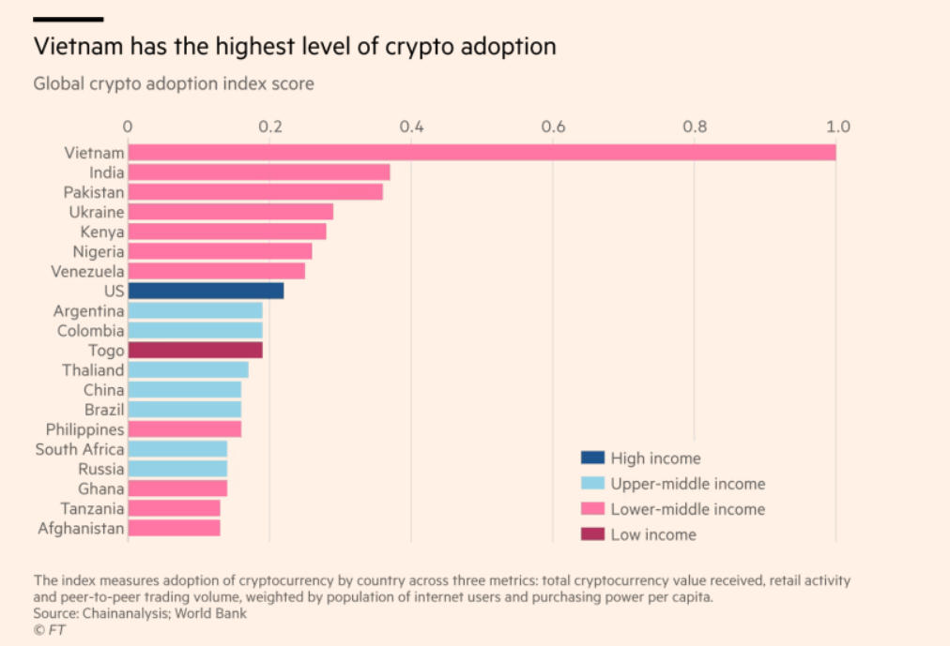
As per Weathley’s article in Financial Times, investors in Vietnam do trade or transact in cryptocurrencies, therefore the nation from South-East Asia is classified as the world’s highest rate of crypto adoption for 2021.

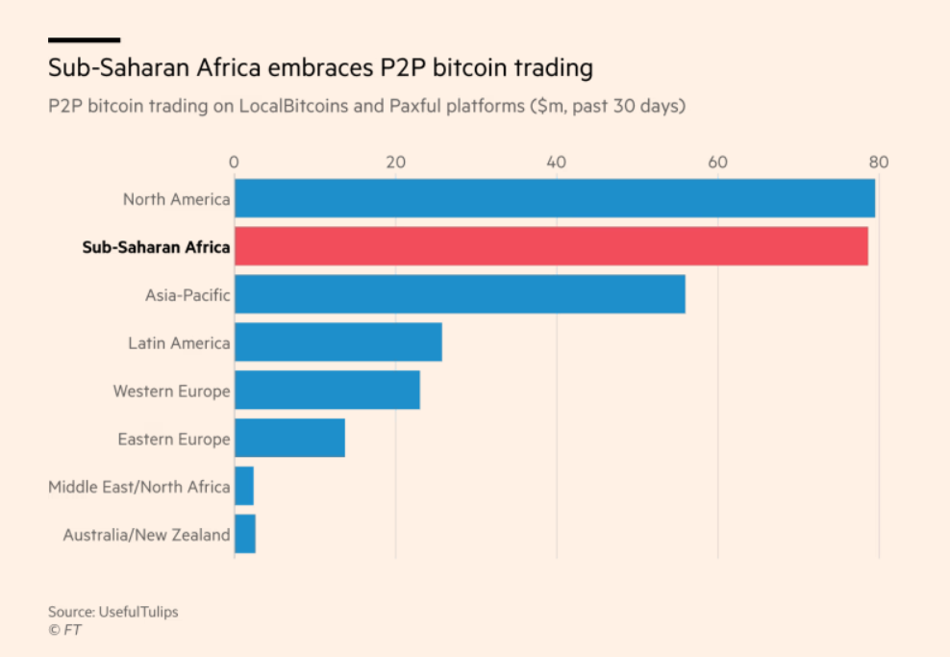
According to Kim Grauer, it is very powerful for emerging markets to adopt cryptocurrencies, as it is a massive footprint for many entrepreneurial opportunities. Vietnam is ranked by Chainalysis as the first top crypto adopter on a global basis. On other hand, following up on the crypto transactions, sub-Saharan Africa leads the trading platforms with the highest volume of crypto activity across the world. Even North America seems to stay behind comparing the transactions made over last year.

Another example is El Salvador, a small central American country with 6.4 million population which is about to become one of the first global tenders of cryptocurrency. A project was considered to accept cryptocurrencies as payment methods everywhere in the country, so people can use digital currencies as new payment instruments. Since the developing countries’ economy seems to be a fertile ground for electronic currencies, unpredictable regulatory uncertainty and financial inflation can become a thread of capital control. (Domjan, 2021)
Let’s take a look into Africa’s most occupied country Nigeria. Due to the numerous unemployment, capital control, and whims of the black market, the youthful nation is facing a lot of challenges and concerns. In fact, after the pandemic, the main export of petrol dropped, and this led the business towards bankruptcy. In such circumstances, it is important that the economy of the country can implement a flexible way of providing individuals or businesses with alternative payment instruments such as electronic payments.
Transactions range in scale from retail investors purchasing modest quantities of cryptocurrency for less than $100 to merchants clearing invoices to financial services organizations created on these platforms and employing hundreds of people. Moreover, importing goods between China and Nigeria using virtual currencies helps entrepreneurs to get into international trade. Because of the expense and complexity of legacy banking systems in countries such as Venezuela and Brazil, many individuals are more comfortable experimenting with and moving between different cryptocurrencies.
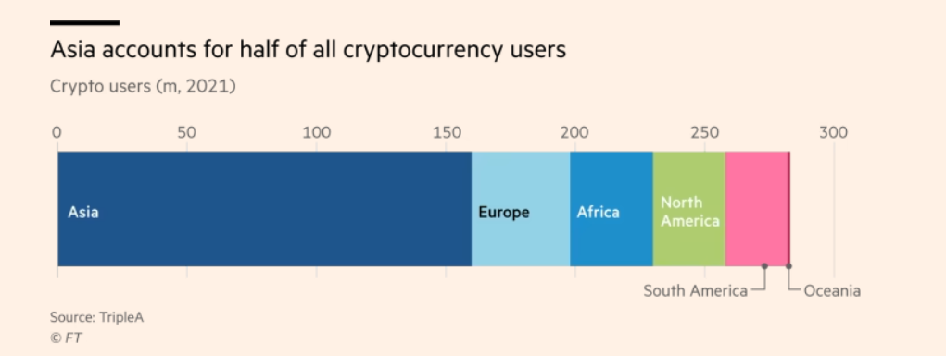

Coinbase and Binance are two of the biggest exchange platforms that provide service through the emerging countries. More than 80% of bitcoins by value moved to Latin America, Central and South Asia, and Africa pass through exchanges. Binance delivered over $14 billion in cryptocurrency to Eastern Europe in the fiscal year ending June 2020, accounting for 20% of all monies moved through the exchange internationally. It was also the preferred exchange in Latin America, moving more than $3 billion in cryptocurrency to the area within the same time period.
It also provides an alternative to conventional remittances, which are vital to many underdeveloped nations. Transferring money across borders using standard means like Western Union may be excessively costly. "Transferring money to the African country next door is a true nightmare, and sending money outside of Africa — to America, Europe, China, or elsewhere — is nearly impossible unless you are wealthy," Youssef adds. According to the World Bank, the cost of shipping $200 to Sub-Saharan Africa in the first quarter of 2020 averaged 9% of the transaction value, the highest of any world area, and can reach double digits in some regions. According to LocalBitcoins, these costs are normally about 2-5 percent on peer-to-peer crypto networks. According to statistics source BitInfoCharts, average transaction costs for bitcoin were less than $3 in August 2021, whereas Ethereum fees ranged between $8 and $44 over the same month.
However, some commentators argue that using bitcoins for remittances or other payments poses significant risks. According to Paola Subacchi, professor of international economics at the University of London's Queen Mary Global Policy Institute, lowering the cost of remittances would be a better option for migrant workers. "This is a poor solution to an issue that should be tackled with existing technology." "Cryptocurrencies and crypto businesses pitch themselves as financial inclusion devices, but those excluded from regular financial facilities are precisely those who can least afford to take any risks with their money," she says. Increased mainstream investment as with counterparts in wealthy economies, there is a lot of speculation about bitcoin in sections of the developing world, particularly in middle-income countries.
Nonetheless, crypto investing has made more inroads into the investment mainstream in several emerging economies than it has in mature markets. In the United States and the United Kingdom, for example, regulators have yet to approve the establishment of cryptocurrency ETFs, which enable investors to acquire exposure to the prospective gains and losses of bitcoin and other cryptocurrencies without personally holding any. Brazil is one of only a few nations this year to offer bitcoin ETFs. This year, Hashdex Asset Management established three regulated crypto ETFs on the So Paulo stock market, with over 160,000 investors.
Domjan and his co-authors highlight in Chain Reaction that institutions of trust, especially custodians of public records such as property registries and licensing agencies, are weaker in the developing world. And, they contend, if such flaws exist, it is simpler for DLT or blockchain-based systems to be "good enough" to provide an appealing alternative. "It seems reasonable to anticipate that such innovation... will have the greatest influence in developing nations," they write.
According to Domjan, such applications might liberate a large amount of "dead capital" to fuel investment and growth. Instability warnings While crypto enthusiasts are ecstatic with El Salvador's bitcoin currency experiment, most authorities are less enthusiastic.
Regulators in nations such as Zimbabwe have been harsh on crypto businesses, only to flip their attitudes. After prohibiting local banks from trading with cryptocurrencies in 2018, Zimbabwe's central bank has stated that it is preparing a regulatory framework for regulating them. In Nigeria, the central bank barred commercial banks from working with cryptocurrency businesses, which swiftly devised a workaround via third-party accounts.
Some observers, including the Central Bank of Nigeria, are concerned that unskilled investors may lose their little funds by betting on a highly speculative asset. "Small retail and unskilled investors also risk a significant chance of loss due to the current high volatility of investments," the bank stated as it moved to rein in the transaction. However, while most crypto services claim to want to comply with regulations, they feel that excessive bureaucracy will push individuals to seek their services. "If a central bank decides to put some direct sort of restriction on its people," Youssef argues, "you will witness a rush of those individuals flocking to [crypto platforms] searching for aid." "They all shift with the geopolitical world's flux, and we have to be prepared for that." Instead of cracking down on cryptocurrency, El Salvador's government has decided to embrace it. Whether the project succeeds or fails, Domjan believes it has altered the game. He describes El Salvador as "a true country." "It is not sanctioned, it is a member of the IMF, and it is a part of the world financial system." The aim is that it lends an air of credibility. We'll discover how a country can use a globally transferable digital money as a way of settlement."

- Consequences
Without broad access, the ensuing financial limitations severely limit the capacity of both families and small businesses to fund high-return projects, decreasing the efficiency of resource allocation and impeding participation in global commerce. Individuals and businesses who are not part of the official financial system are given a variety of options that are neither efficient nor equitable. As a result, the "unbanked" are stuck in a never-ending cycle of economic inequity, deprived of the essentials of financial empowerment. Furthermore, financial market frictions have been highlighted as crucial in perpetuating economic disparity or poverty. (Peachey & Roe 2004)

Chapter Three: Methodology

- Introduction
The research technics outline the approaches I used to investigate the collected data. This chapter is focused on analyzing the collected information from the questionnaire as well as developing the idea supported by facts in regard to cryptocurrency adoption in emerging countries. The chapter will be divided into small sections where a detailed explanation will be provided. The analysis of the research technique is conducted according to the figure below of the research onion:
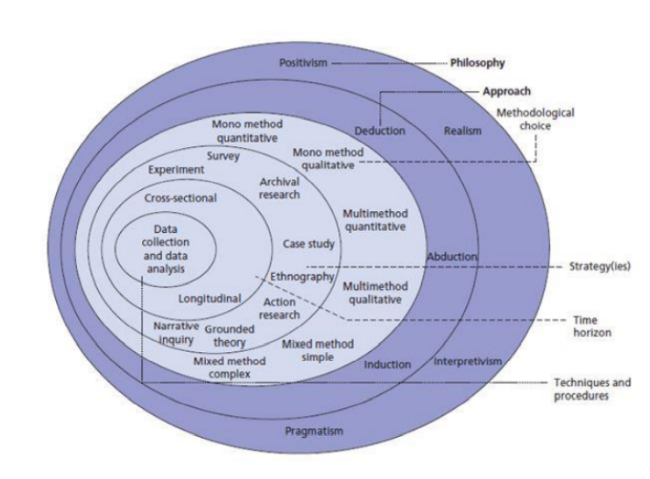

- Research philosophy
In this paper, the research philosophy is related to the ontology method because of the already existing data I have examined about cryptocurrency. To evaluate the research reliability and validity I did use the research paradigm – positivism as it is based on the objectives of the report by providing facts and observations based on the collected responses from the questionnaire.

- Research approach
The research approach that will help test my theory is deductive. All concepts have been clarified and developed into a detailed analysis where an up-to-date information is presented in an understandable way to the reader.

- Research strategy
In terms of the research strategy, I have decided to include the explanatory and descriptive approach in order to elaborate further on the collected data by providing facts and figures.
The participants of the survey were provided with the ability to access the form and see the actual results of all collected data for their reference. This section used descriptive technique in order to allow better subject description without it being affected by the validity of the sampling method. Giving an opportunity for multiple respondents will aid the survey by giving a better understanding on the subject.

- Research techniques
In this paper, quantitative research was implemented and utilized in order to give choice to all participants to answer honestly. The structure included a form of a questionnaire, providing more details on the scope. There were more than 100 participants involved and a copy of the questions was attached in the appendixes section of the report.
The quantitative method is based on numbers and statistics that help understand the averages and frequencies of the subject. By using this method, the interpretation of the collected information can happen during the experiment or by using sampling methods. (Gentles et al, 2016). The collected data was already reviewed and an analysis of it is provided in the next chapter. Also, the statistical results have been standardized and shared for visibility.

- Type of investigation
Primary research
Primary research was one of the tools I used in order to support this report. The collected information was conducted by creating a questionnaire where everyone is able to participate. The research is meant to gather first-response insight from people and their thought about cryptocurrencies. The primary research generally aims to provide information collected straight from the respondents and once it is investigated a conclusion will follow with the outcome.
Advantages: In the primary research, the issue is normally addressed in order to gather the information firsthand. It is more effective because the collected data comes straight from the original source, and it can be analyzed accordingly. The subject of the research gives an opportunity to understand the issue more specifically that researching general information. The analysis of data becomes essential because it needs to provide actual feedback on the researched problem.
Disadvantages: In this section, I would confess, that one of the main disadvantages of primary research is time-consuming. The ability to conduct professional research is not only related to the time, but it is related to a variety of sources, too. Conducting primary research involves a lot of resources as well as providing recommendations for resolving a particular problem is important. The lack of time or resources may lead to an inappropriate conclusion when analyzing the collected data.
Secondary research
Secondary research is another tool that helped me proceed with researching my subject. Based on already researched information, I managed to develop my paper by providing a lot of examples of how the adoption of virtual currencies will aid developing countries.
Advantages: Using secondary research delivers a lot of options where a particular subject has been developed. No time-consuming thread exits as all information is easily accessible and does not require any additional costs. There are many articles and sources that provide already existing evidence.
Disadvantages: When developing your own subject that brings more interest, some of the secondary research may not be fully focused on the same subject and therefore the researcher will be forced to seek more information in order to gain a better understanding. I have used multiple resources related to my subject and finally managed to create a good quality paper with interesting facts about cryptocurrency adoption.
- Time horizons
To collect all information, of course, I had the responsibility to manage my time. Each section was given a particular time frame to be completed. For instance, with primary research, I allowed myself more time in order to collect as many responses as possible. For the secondary research, the time needed was also significant because it is essential that all information is analyzed and delivered with all supported facts.
- Data collection methods
In order to collect reliable data, the utilization of primary and secondary sources was very helpful. With primary data, it is imperative to consider the objectives of the study before selecting the right tools when collecting information. By primary data, the collected information is not published, however by secondary data the collected information is already published. The study includes a survey with 11 questions via Google form. There is no time limit for completing the questions and all participants were able to give an honest opinion about cryptocurrencies and their impact on developing countries.

- Data sampling
Sampling is a method that allows a selection of people in a population to perform statistical inference by observing their characteristics. (Snyder, 2019) There are different sampling methods that can be used widely for market research as it helps collect actionable insights.
For this research, I concentrated on the probability sampling method where every member of the population will get a chance to be selected. This technique is most suitable for my quantitative research because the results I generated were represented by the whole population. Therefore, I choose a random simple sampling in order to give an equal chance for everyone to be selected. Participants were chosen on a random basis and had the opportunity to contribute to the questionnaire.

- Questionnaire
The questionnaire was published online, and everyone can participate. The collected responses are 108 and by looking into the statistics, most of the people are familiar with cryptocurrencies, however, not all of them own such. The questionnaire is attached in the appendix section for further reference. The time frame for collecting responses was 5 weeks and the form was available until the end of the survey.
- Primary research obstacles
Some issues have also occurred when completing the research. It has taken more time to create the questions. Also, the collection of responses consumed most of the time. The original time frame for the primary research was 3-4 weeks, however I had to extend it because the responses were not sufficient in order to conclude the report.
- Ethical consideration
Ethical consideration is connected to the principle of collecting data where no harm to society or individuals is created. (Zyphur and Pierides, 2017) Ethical consideration is one of the most important parts of the study. There is a set of principles that are used for collecting the needed information. It must be ensured that participants’ rights are protected by anonymity, the validity of the research must be enhanced, and to show good maintaining scientific integrity. The research was processed by providing participants with access to an online questionnaire form as well as they need to fill out a consent form stating they agree to be part of the research. Data Protection Act (1998) protocols was also followed in order to complete the research accordingly.

- Overview
According to the research onion, this report was created by following the main research techniques, approaches, strategy, design, and methodology. This chapter emphasizes the plan I followed in order to cover each section and explain the methods that took place. Overall, the chapter delivers an insight of the methodology I used and explains the research types. The sampling method was selected on random basis and the questionnaire was provided in online form. For collecting all responses, ethical considerations were examined by avoiding any further conflicts.

Chapter Four: Analyzing Data

- Introduction
The main part of the study is to analyze all collected information from the questionnaire. All responses are inspected and evaluated, therefore an overview of the positives or negatives from the participants was obtained and concluded in this section. The collected data is included in an Excel sheet formulating the result and creating a pie chart that will show the public outcome. The importance of this chapter is related to a valid data transformation and presenting all figures in a wat that the reader can understand.

- Inclusion and exclusion criteria
All collected information via secondary research was read and analyzed. There are multiple articles, journals, and books that were recently published. The selected subject was also examined according to the most recent economy conditions and the current market of cryptocurrency. The final outcome was based on the long-time research due to the more specific title I choose, however the result and the knowledge I received is more than satisfying.

- Questionnaire analysis

In this section, I will include all responses and the collected data followed by a detailed analysis of the result. There are also screenshots and tables created in order to visualize the participation of all people. Each screenshot was created by me using a Google form and will be followed by a table also created by me with the exact amount of all recipients. An overview of the results will be explained under each table.

Question 1 – What is your age?
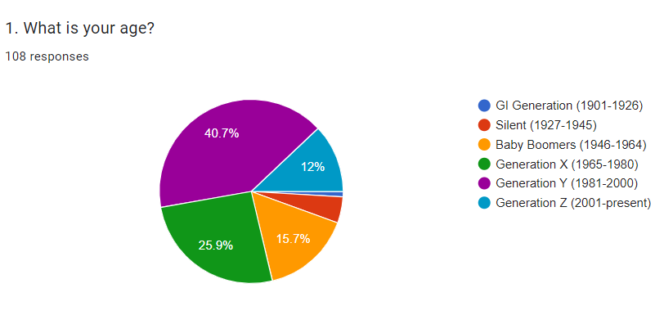

Question 1 – What is your age?
Answers: | Participants:
GI Generation (1901-1926) | 1
Silent (1927-1945) | 5
Baby Boomers (1946-1964) | 17
Generation X (1965-1980) | 28
Generation Y (1981-2000) | 44
Generation Z (2001-present) | 13

The majority of the respondents are aged Generation Y (1981-2000), which means that 40,7% of the participants are young people. Therefore, all people that participated are technology educated and were able to access the form via tech device. There is only one respondent of GI Generation (1901-1926) that were happy to review and fill out the questionnaire. 28 people classified as Generation X represent 25,9 % and 17 people of Baby Boomers (1946-1964) represent 15,7% of the total participants. The youngest generation seems not very interested in taking participation in surveys as they are only 12% in total. Silent generation (1927-1945) respondents are only 5 which overall takes 4,6% of the survey.

Question 2 – What is your income level?
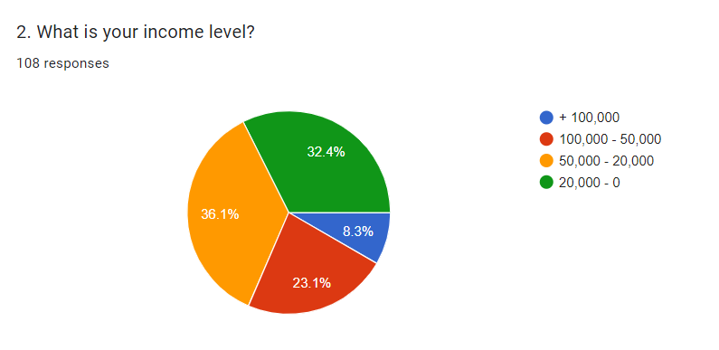

Question 2 – What is your income level? (£)
Answers: | Participants:
20,000 - 0 | 35
50,000 – 20,000 | 39
100,000 – 50,000 | 25
+ 100,000 | 9

This question was answered by 108 people and according to the responses the majority of them have quiet high-income level. 36,1% of the contributed people are taking between £20,000 and £50,000. Not very far behind are people with an annual income of £0-£20,000 which represents 32,4%. There are some wealthy people that take between £50,000-£100,000 yearly showing 23,1% of the total participants. However, there is a small percentage (8,3%) of people that fill out the survey with an income above £100,000 per annum.

Question 3 – Have you ever heard of Bitcoin, Ethereum or other cryptocurrencies?
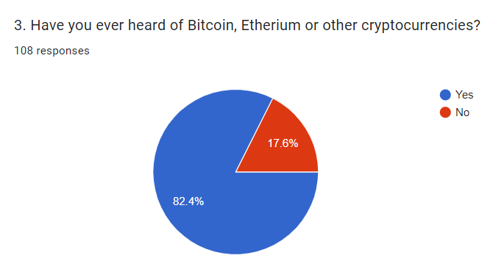

Question 3 – Have you ever heard of Bitcoin, Ethereum or other cryptocurrencies?
Answers: | Participants:
Yes | 89
No | 19

As per question 3, we understand that most of the participant are aware of what cryptocurrency is as well as what are the top gainers of them. As some of the most known cryptocurrencies, Bitcoin and Ethereum highlight that our participants are familiar with them and probably have own or still own some. 89 out of 108 people have heard of cryptocurrency which takes 82,4% in total of the whole survey. A small amount of people (19) have never heard of cryptocurrency at all.

Question 4 – Do you own any cryptocurrency?
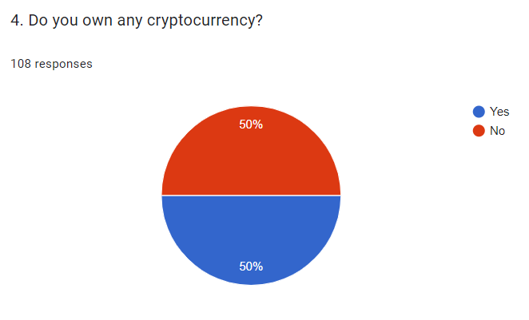

Question 4 – Do you own any cryptocurrency?
Answers: | Participants:
Yes | 54
No | 54

An interesting fact is that 50% of the participants currently own cryptocurrency. Consequently, this means that 54 out of 108 people of different ages are crypto owners. The income of the participants does also affect their choice of preferable crypto tokens and potential investments in the future.

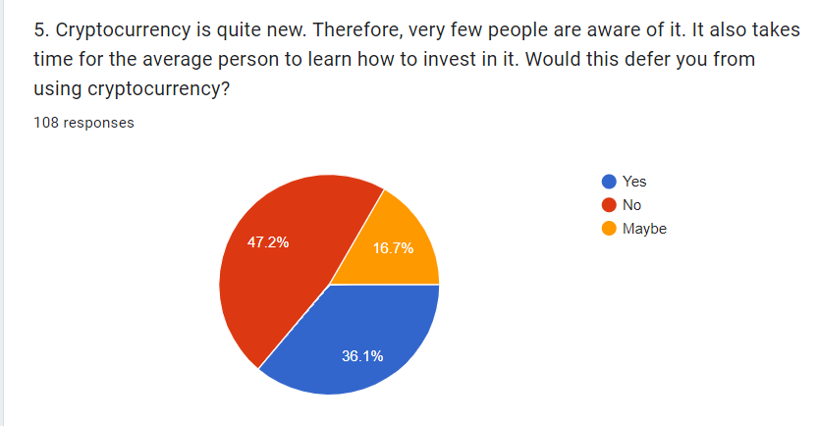
Question 5 - Cryptocurrency is quite new. Therefore, very few people are aware of it. It also takes time for the average person to learn how to invest in it. Would this defer you from using cryptocurrency?

Question 5 - Cryptocurrency is quite new. Therefore, very few people are aware of it. It also takes time for the average person to learn how to invest in it. Would this defer you from using cryptocurrency?
Answers: | Participants:
Yes | 39
No | 51
May be | 18

As a result of this question, we can clearly see that the majority confess that the innovation of cryptocurrency will not deter them from using it further. 47,2% of these people are ready to invest with no concerns about whether the crypto industry is new or not. These people tend to believe that the innovation of electronic payments will benefit them and the funds they invest in such platforms will increase its volume in future. The more people interested in virtual currency the better market sustainability is in a long-term goal. On other hand, 36,1% of the participants are stating that the innovation is not comfortable to them when it comes to their budget. Such people are choosing to stay on the safety side and wait until the market become more sustainable. There is 16,7% of the respondents that are not very sure whether the innovation of crypto market will affect their choice by joining crypto world or not. Such people are in doubt, and they will probably need more time to understand how the market and investments work.

Question 6 - Cryptocurrency has no tangible form. Does that diminish the value that you perceive about the currency?
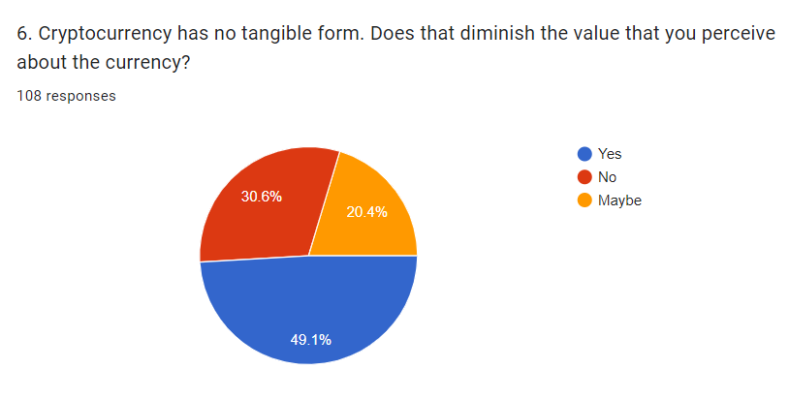

Question 6 - Cryptocurrency has no tangible form. Does that diminish the value that you perceive about the currency?
Answers: | Participants:
Yes | 53
No | 33
May be | 22

Question 6 tends to find out what people think about the crypto currencies and their intangible form. As per the responses above we can see that 53 out of 108 (49,1%) people do believe that due to the intangible form of electronic currencies the value of it seems difficult to perceive. The rest 30,6% of the respondents do not face an issue with this and 20,4% of them are also not sure if this would affect their choice of joining the market. Analyzing these figures, social trust in cryptocurrency is still an issue for people worldwide and this might be the main problem when adoption takes place.

Question 7 - Cryptocurrency is non-government regulated which offers users more freedom. Would this increase your interest in using cryptocurrency?
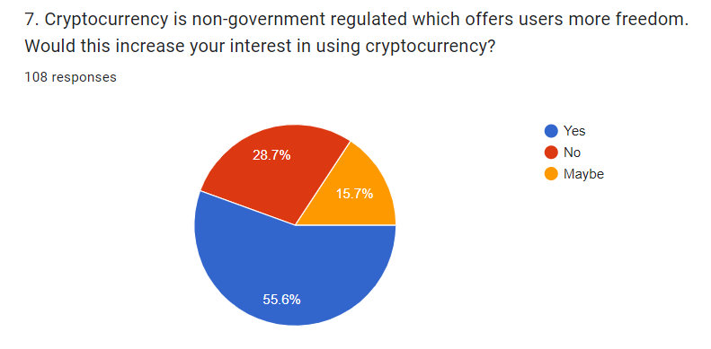

Question 7 - Cryptocurrency is non-government regulated which offers users more freedom. Would this increase your interest in using cryptocurrency?
Answers: | Participants:
Yes | 60
No | 31
May be | 17

In this section of the survey, participants were provided with more details on cryptocurrencies freedom. Potentially this question has made a lot of the respondents to re-think if owning crypto will benefit them from saving money when making transfers as per usual financial system. Clearly, the mainstream of them (55,6%) agree that virtual money will increase their interest due to being feeless. Another 31 people said no, and this makes me believe that 28,7% in total do not trust non-government regulated transfers. Gaining their trust is a difficult task and this needs to be address further. 15,7% of the respondents do not think that their interest will increase due to the freedom of crypto transfers globally.

Question 8 - Unlike other currencies, cryptocurrency requires much fewer fees to operate. Would this increase your interest in using cryptocurrency?
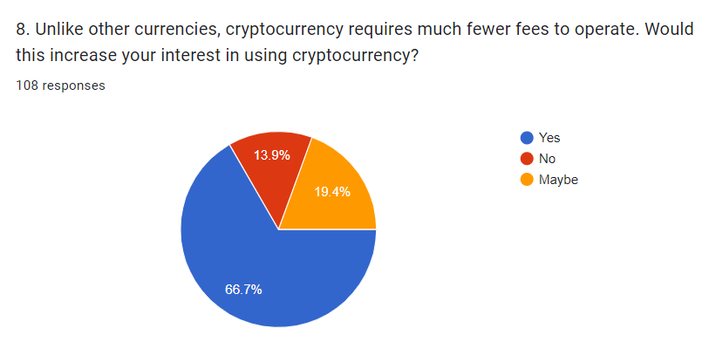

Question 8 - Unlike other currencies, cryptocurrency requires much fewer fees to operate. Would this increase your interest in using cryptocurrency?
Answers: | Participants:
Yes | 72
No | 15
May be | 21

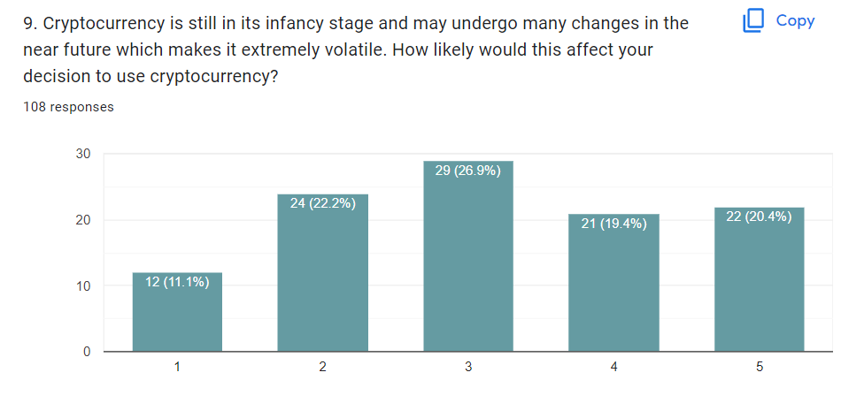
Question 9 - Cryptocurrency is still in its infancy stage and may undergo many changes in the near future which makes it extremely volatile. How likely would this affect your decision to use cryptocurrency?

Question 10 - If cryptocurrency is government regulated but remained intangible, would this increase your interest in cryptocurrency?
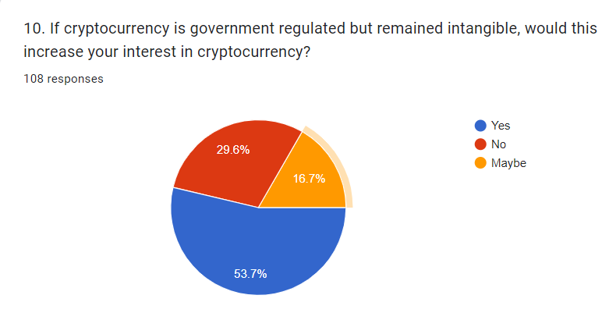

Question 10 - If cryptocurrency is government regulated but remained intangible, would this increase your interest in cryptocurrency?
Answers: | Participants:
Yes | 58
No | 32
May be | 18

Question 11 - If cryptocurrency providers created tangible coins (or notes) for cryptocurrency users with banks and ATMs readily available but remained non-government regulated, would this increase your interest in cryptocurrency?
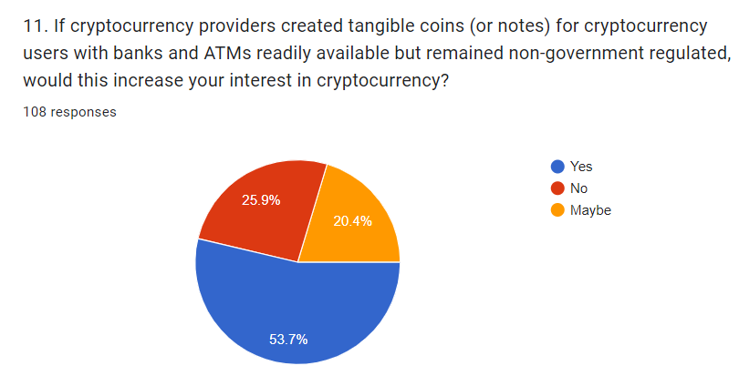

Question 10 - If cryptocurrency is government regulated but remained intangible, would this increase your interest in cryptocurrency?
Answers: | Participants:
Yes | 58
No | 28
May be | 22

Chapter Five: Findings and Discussion

- Introduction
- Findings
- Discussion

Chapter Six: Recommendations and Conclusion

- Recommendations
- Limitations
- Implications
- Conclusion

Reference List

Arjaliès, D. (2020), “ ‘At the Very Beginning, There’s This Dream.’ The Role of Utopia in the Workings of Local and Cryptocurrencies.”
Bratspies, R.M. (2018) "Cryptocurrencies and the Myth of the Trustless Transaction"
Claeys G., Demertzis M., Efstathiou K. (2018) “Cryptocurrencies and monetary policy”, Monetary Dialogue July 2018
Currie, J. (2009) Healthy, Wealthy, and Wise: Socioeconomic Status, Poor Health in Childhood, and Human Capital Development” Journal of Economic Literature, Volume 47, issue 1
Demirguc-Kunt, A. et al. (2018). The global findex database 2017: measuring financial inclusion and the fintech revolution. The World Bank
Dierksmeier, C. & Seele, P. (2018). “Cryptocurrencies and Business Ethics” Journal of Business Ethics
European Central Bank (2015), Virtual Currency Schemes – a further analysis
Grinberg, R. (2019) “Bitcoin: An Innovative Alternative of Digital Currency” Yale Law School
Martinez, T. (2019), Available at: ‘’Where thing went wrong for Africa – focused cryptocurrency Dala’’ https://www.howwemadeitinafrica.com/tricia-martinez-where-things-went-wrong-for-africa-focused-cryptocurrency-dala/63483/#:~:text=Tricia%20Martinez%20is%20the%20CEO,peer-to-peer%20transfers.

Appendix

- Questionnaire
- Tables and graphs
- Timetable

