Joshua Lewis 1805618
BA Business & Management
Digital Business BMSP6002

Report: Critically examine Airbnb as an example of the sharing economy

Lecturer: Dr Roisin Mullins

This report seeks to critically examine Airbnb as an example of the sharing economy. To accomplish this examination the report will be split into four key sections. Airbnb Landscape, which aims to capture current information regarding the nature of business including the current situation, financial position, and market challenges. The Business model canvas (BMC), This tool will be used to aid with the examination of the Airbnb business model. The Grand strategy matrix (GSR), another business tool used to analyse competitive position and market growth. Finally, Systems and tools. Examining how Airbnb make use of tools such as supply chain management (SCM), Enterprise resource management (ERM) and Customer relationship Management (CRM).
Airbnb is an online marketplace that connects people who wish to rent out their space with people seeking accommodation. Commonly used by travellers and tourists, Airbnb offers an alternative to traditional hotel accommodation. Airbnb hosts offer one of a kind stays and unique experiences that make it possible for guests to experience the world in a more authentic, connected way. (“About us”, 2021) Rentals opportunities on Airbnb consist of anything form one room in a host own home to a whole private island.
Airbnb was founded in 2008 by Brian Chesky, Nathan Blecharczyk and Joe Gebbia. As of September 30^{th,} 2020, Airbnb has over 5.6 million active listings in 100,000 cities over 220 countries and regions worldwide. (“About us”, 2021) Airbnb’s platform aims to connect peers, allowing hosts and guests to benefit from shared use of space.
The Sharing economy has been defined as “a platform that allows groups and individuals to make money from underused resources” (LI & Tabari, 2019) Schor (2014) states that sharing economy activities fall into four broad categories: recirculation of goods, increased utilization of durable assets, exchange of services, and sharing of productive assets. The sharing economy, commonly known as the peer-to-peer economy or collaborative consumption has become increasing popular over the last decade as consumers often prefer access over ownership. This take on the sharing economy perfectly describes Airbnb’s business. Airbnb offer a platform which allows peers to connect and share or rent under used assets.
Financial landscape
Wu, Lee & Reynard (2012) states that Airbnb have secured $120 million in venture funding and attributed the most of their growth to marketing and infrastructure. driving a 120% increase in branded searches and increasing the number of nights booked from 800,000 to 2 million. Additionally, Airbnb managed to grow its revenue from $850,000 in 2009 to nearly $45 million in 2012, translating to a 3-year compounded growth rate of 275%. Sales numbers rose similarly, from merely 365 bookings in 2008 to 15.8 million in 2012.
Eight years later in 2020, Airbnb went on to secure a $1 billion investment from silver lake and sixth street partners. (Franklin, 2020) Securing this investment Airbnb planned to invest the money into attracting more hosts and encouraging more homeowners to list properties for rent on the platform.
As of September 2020, Airbnb’s all time guest arrivals stand at over 800 million, (About us, 2020) A significant rise from 15.8 million seen in 2012. Hosts all time combined earning on through Airbnb stands at over $110 billion. (About us, 2021) and Airbnb’s revenue in 2020 reached $2.52 billion. (Lock, 2020) Airbnb’s financial landscape is unmatched by any of its competitors in the hotel/ accommodation rental industry.
Wu, Lee & Reynard (2012) identified the challenges Airbnb faces as establishing consumer trust and legality issues. As Airbnb operate in a sharing economy, they individuals to each other rather than connect individuals to businesses. Building trust with both hosts and guests is vital to enable growth of the business. While Airbnb has insurance policies in place to address issues of vandalism, theft, or violence, the true cost of these incidents lie with the potential damage to Airbnb’s reputation. Secondly, Airbnb operates in domestic and international markets. Operating in over 200 countries and territories means the company need to be well informed of differences in laws between each county. Airbnb must be cautious of its expansion to minimize the risks of lawsuits and increased pressure from the hotel industry.
Business Model Canvas (BMC)
The BMC developed by Alexander Osterwalder, is a strategic management tool used for developing or documenting business models. The BMC is an efficient tool to analyse business models because of its visualisation and structured format. The BMC provides valuable insight into infrastructure, customers, offering and finance through analysis of nine basic components of a business model. (Ching & Fauvel, 2013)
Spanz (2012) Describes the BMC as tool to develop, question and visualise business models in brainstorming. He identifies the tools positive features as simplicity, because of the visualisation and structed format it is presented in. Also, he mentions a ‘plug and play’ principle, where the BCM helps to bring participants to the same page, to talk about the same idea.
Kraaijenbrink (2012) criticised the BMC stating that it excluded strategic purpose, stating that the BMC suggests that financial success is the sole motivation behind entrepreneurs. Secondly, Kraaijenbrink states that the BMC is limited because it excluded a notion of competition, believing that competition is a crucial part of all business models, therefor use of this tool limits the analysis.
The Business Model Canvas
  Key  Partners  - Hosts  - Investors  - Insurance companies  - Professional photographer services |   Key  Activities  - Platform development  - Sales/marketing  - Managing behaviour and risks  - Maintain customer service | Value  Proposition  For Host:  - Simple & Secure  - Extra money  - Control  - Professional service  - Communication  For Guest:  - Save money  - Easy to browse and book  - Unique experience  - Safe |  |   Customer  Relationships  - Self-serve platform  - Personalised recommendations  - Customer service support |   Customer Segments  - Hosts  - Guests
 |   Key  Resources  - Airbnb platform & app  - Employees  - All properties listed on platform |  |  | Channels  - Airbnb website & app  - Platforms like content marketing, media coverage, digital ad campaigns  
  Cost  Structure  - Platform development  - Infrastructure cost  - Sales and marketing  - Salaries  - Development and Maintenance  - Insurance  - Legal & Administrative |  |  |   Revenue Streams  - Hosts fee 3%-5%  - Guests fee 0-20%

Upon analysing the BMC, it is easier to understand what the value propositions that Airbnb offer include. Airbnb creates opportunity for hosts to advertise their space and turn it into extra cash. With this opportunity hosts can earn up to 90% of the total rental value after Airbnb deducts their fees, usually around 3% - 14% (Airbnb, 2021) Additionally, Airbnb provides insurance for listings on its platform. Insurance provided via Airbnb commonly includes, cover for accidental bodily injury, damage to property and damage to common areas. (Airbnb, 2021).
The value proposition offered to guests includes cheaper accommodation rates. Guests can access the platform to connect with hosts to find better rates which are more specific to their needs. A study carried out by Priceonomics in 2013 found that it was 21% cheaper to rent out a whole apartment on Airbnb compared to renting a hotel room. Room for Room the study shows Airbnb was up to 49% cheaper in some cases. (Spencer, 2019)
Airbnb provide a platform allowing peers to connect online, a feature of Airbnb’s platform is the rating and review systems which are provided for both hosts and guests. From a host’s perspective, they can accept or reject booking after reading reviews of potential guests. Alternatively, guests can check reviews and pictures of accommodation prior to booking.
From evaluating the BMC it is visible that Airbnb operate a peer to peer business model. The purpose of the platform is to connect peers and provided a safe environment for a trade or rental to take place. Airbnb’s revenue streams and customer segments are created from two parties, hosts and guests. The majority of business operations are focused on creating value for both parties.
This aligns with the characteristics of a business operating in the sharing economy, as stated by Wu, LI & Reynard (2012) the peer-to-peer economy challenges existing traditional services in which a transaction is conducted between a company and a customer. consumers can now use a peer-to-peer marketplace where they can find more flexibility and often a better price.
Strategic Formulation Framework (SFF)
Strategy formulation framework is widely regarded as important strategy-formulation techniques which are combined into a three-stage decision making framework. Tools used throughout the framework can be applied business of all size and aid in the process of identifying, evaluating and selecting strategies. (Ozcay, 2017).
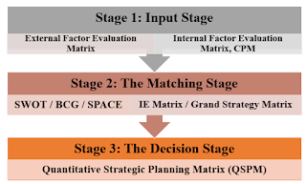

(ozcay, 2017)
As shown in the image above the SFF is split into three stages. Stage one is the input stage and aims to summarise the basic input information needed to formulate strategies by using three tools, external factor evaluation, competitive matrix profile and internal factor evaluation.
Stage two is the matching stage. This stage focuses on generating different strategies by aligning key internal and external factors. To accomplish this a variety of tools are used. For example, SWOT analysis, Strategic position, and action evaluation (space) matrix, internal external (IE) matrix and the Grand strategy matrix.
The final stage in named the decision stage which involves a single technique, the quantitative strategic planning matrix (QSPM). This matrix is used to evaluate the feasibility of different strategies identified in stage two.
The Grand strategy matrix (GSM) consists of a four-quadrant graph, similar to a SWOT matrix, that lists strategic options for companies in either strong or weak competitive positions in industries experiencing either rapid or slow growth (Ingram, 2018)
The benefits of using the GSM include its simplicity, which means it is easy to understand. It offers a comprehensive list of strategic options and it can create discussion and frame decisions.
Alternatively, some limitations of the GSM are, it only provides options rather than success criteria, it needs to be used alongside other tools to maximise the benefits and if the business has multiple products it may fall into multiple quadrants.

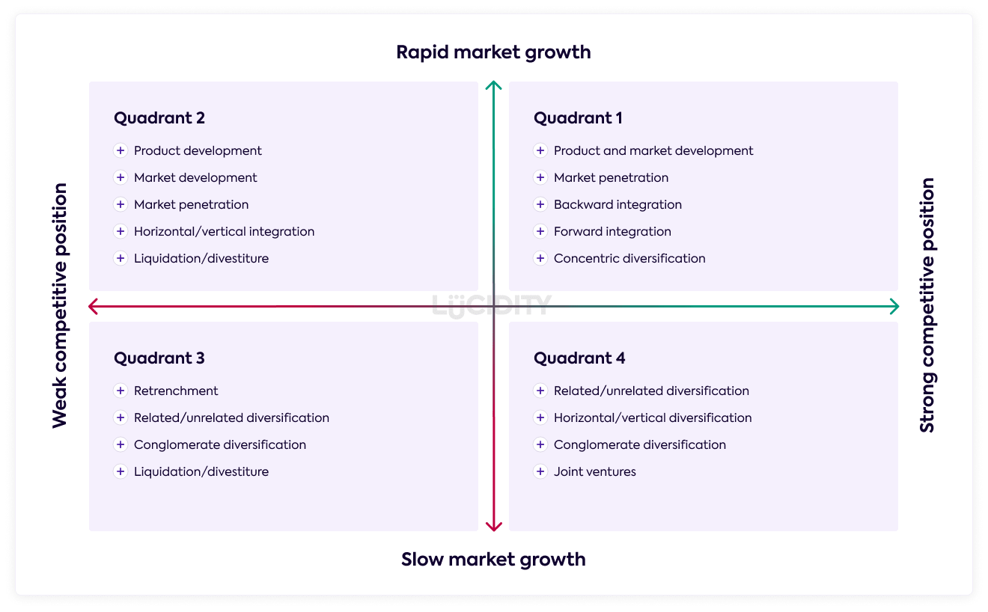

(Lucidity, 2018)

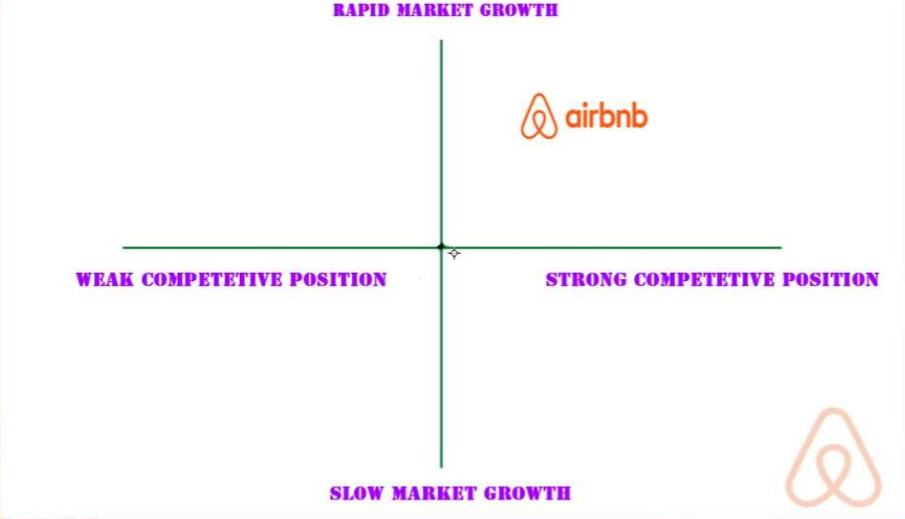

The diagram above shows where Airbnb sits on the GSM, the reasoning behind this positioning is down to Airbnb’s strong competitive position and the rapid market growth.
Airbnb’s has gained competitive advantage through strategic use of ICT and how it has brought the peer-to-peer business model into an industry that has traditionally been exclusive to business to consumer. (Northwestern business review, 2014)
Airbnb has several distinct advantages over its hotel competitors. Unlike hotels, Airbnb is not constrained by rising variable costs. Instead, Airbnb can offer an incredibly expansive list of rooms, in countries around the world, for little more than the price of the additional servers and engineers.
Another advantage of the expansiveness of Airbnb’s listings is the way in which the company can track the preferences of its users. behavioural information gives the company the opportunity to make inventive suggestions about the future travel plans of its clients in ways that brand hotels, which offer a homogenous experience independent of location, cannot.
Systems & Tools
Enterprise resource planning is defined as “suite of integrated corporate-wide software applications that drives manufacturing, financial, distribution, HR and other business functions in a real-time environment. Essentially, ERP systems integrate across functions to create a single, unified system rather than a group of separate, insular applications.” (Mullins, 2021) Airbnb uses amazon wed services (cloud) which in the home for all its systems. AWS is used to connect parties at different sides of market and to connect sellers with buyers. Airbnb co-founder Nathan Blecharczyk said Airbnb benefitted from the use of AWS by being able to ramp up more servers without having to contact anyone and without having minimum usage commitments. (“Customer stories”, 2021)
The use of ERP benefits Airbnb in several ways. Firstly, it allows the business to offer better customer service because the integrated software allows for better access to customer information leading to faster response times. Secondly, it gave Airbnb greater security over its data. All data is stored on one server instead of being stored over multiple serves, makes securing the data more manageable. Lastly, it allowed for enhanced business reporting, ERP gives instant access across multiple business functions, meaning business reporting can be done with real time information.
Customer relationship management is defined as “customer relationship management (CRM) as an approach to build and sustain long-term business with customers.” (Mullins, 2021) E-CRM is similar but refers to the use of digital technologies to maximise sales to existing customers and encourage customers to continue using the online services.
Airbnb rely on their CPM soft wear for almost every action they complete, when a customer uses Airbnb’s website to make an enquiry the information gets stored in the CRM system. After a booking is made through Airbnb the information needs to be captured, stored, and made available to the relevant parties and departments. Additionally, Airbnb use “CRM applications to send out, keep track and then measure the performance of their attractive email campaigns” (Binns, 2016) By doing this Airbnb are able to continuously improve and personalise the experience for the customer.
The benefits CPM bring to businesses is valuable for growth. The sharing of data can be distributed within the company to create new leads for sales teams. Maximising the use of all the data means the business can easily identify new business opportunities. Lastly, speed and efficiency. All data shared in real time between departments allows for a faster sale.
Drawing from the evidence within this report, it is evident that Airbnb are a prime example of a business operating in the sharing economy. From the Airbnb BMC it is easy to see the enormous amounts of work the business have done to focus on enhancing the peer-to-peer experience. Airbnb have achieved unprecedented success in the accommodation industry shown by the rise of booking on their platform in such a small amount of time. These figures have not been matched by any hotel operating a B2C economy. Airbnb’s success demonstrates a consumer shift from product ownership to product access.

References:
About us. (2021). Retrieved 6 March 2021, from https://news.airbnb.com/about-us/
About us. (2021). Retrieved 6 March 2021, from https://news.airbnb.com/about-us/
Airbnb. (2021). Host Protection Insurance. Retrieved 7 March 2021, from https://www.airbnb.co.uk/d/host-protection-insurance
Airbnb. (2021). What are Airbnb service fees?. Retrieved 7 March 2021, from https://www.airbnb.co.uk/help/article/1857/what-are-airbnb-service-fees
Binns, R. (2016). What CRM Does Airbnb Use?. Retrieved 7 March 2021, from https://www.expertmarket.com/crm/airbnb-crm
Ching, H., & Fauvel, C. (2013). CRITICISMS, VARIATIONS AND EXPERIENCES WITH BUSINESS MODEL CANVAS. European Journal Of Agriculture And Forestry Research, Vol. 1.. Retrieved from https://citeseerx.ist.psu.edu/viewdoc/download;jsessionid=B0EBFC81AEAB3E23F8A54B777EEBF5F6?doi=10.1.1.452.1207&rep=rep1&type=pdf
Customer stories. (2021). Retrieved 7 March 2021, from https://aws.amazon.com/solutions/case-studies/airbnb/
Franklin, J. (2020). Airbnb secures $1 billion investment from Silver Lake, Sixth Street. Retrieved 7 March 2021, from https://www.reuters.com/article/us-airbnb-funding-idCAKBN21O2V9
Ingram, D. (2018). Link Between the SWOT Matrix & the Grand Strategy Matrix. Retrieved 7 March 2021, from https://smallbusiness.chron.com/between-swot-matrix-grand-strategy-matrix-77953.html
Kraaijenbrink. (2012). Three shortcomings of the Business Model Canvas. Kraaijenbrink Training & Advies. Retrieved from http://kraaijenbrink.com/2012/07/shortcomings-of-the-business-model-canvas/
Li, L., Tabari, T. (2019) Impact of Airbnb on customers’ behavior in the UK hotel industry. Tourism Analysis, vol. 24. Sheffield business school. Retrieved from https://shura.shu.ac.uk/23916/7/Tabari_Impact_of_airbnb_%28VoR%29.pdf
Lock, s. (2020). Airbnb revenue worldwide 2017-2020. Retrieved 7 March 2021, from https://www.statista.com/statistics/1193134/airbnb-revenue-worldwide/#:~:text=The%20total%20revenue%20of%20Airbnb,travel%20disruption%20across%20the%20globe.
Lucidity. (2018). Introduction to the Grand Strategy Matrix. Retrieved 7 March 2021, from https://getlucidity.com/strategy-resources/introduction-to-the-grand-strategy-matrix/
Mullins, R. (2021). Platform – Multisided – P2P ecommerce. Presentation, UWTSD.
North western Business Review. (2014). Looking at AirBnB Through Michael Porter’s Competitive Advantage Framework. Retrieved 7 March 2021, from https://northwesternbusinessreview.org/looking-at-airbnb-through-michael-porters-competitive-advantage-framework-583dc8a50515
Ozcay, E. (2017). Strategic Management. Retrieved 7 March 2021, from https://ezgiozcay.blogspot.com/2017/12/strategy-formulation-framework_10.html
Ozcay, E. (2017). SFF framework [Image]. Retrieved from https://ezgiozcay.blogspot.com/2017/12/strategy-formulation-framework_10.html
Schor, J. (2014). Debating the sharing economy. Great transition Initiative. Retrieved from https://www.icscarsharing.it/wp-content/uploads/2019/02/2014-Schor-Debating-the-Sharing-Economy.pdf
Spanz, G. (2012). Startup best practice: Business Model Canvas. Ventureworks Blog. Retrieved from http://blog.ventureworks.ch/post/18727255435/startup-best-practice-business-modelcanvas
Spencer, E. (2019). Hotels Vs. Airbnb: How Much Can You Save?. Retrieved 7 March 2021, from https://www.moneyunder30.com/hotels-vs-airbnb
Wu, S., Lee, F., & Reynard, J. (2012). Airbnb (p. 2). UCLA. Retrieved from http://www.econ.ucla.edu/sboard/teaching/tech/Airbnb.pdf
Wu, S., Lee, F., & Reynard, J. (2012). Airbnb. UCLA. Retrieved from http://www.econ.ucla.edu/sboard/teaching/tech/Airbnb.pdf
Wu, S., Lee, F., & Reynard, J. (2012). Airbnb. UCLA. Retrieved from http://www.econ.ucla.edu/sboard/teaching/tech/Airbnb.pdf

