BMMB7026
MANAGING MARKETING CHANGE
Netflix Marketing Analysis
By: Mona Hussien
Student number: 2211516

Executive summary
This report focuses on Netflix's current challenges. Such as poor AI implementation. The report will discuss how Netflix's AI implementation has not been able to generate accurate predictions, leading to poor customer experience and a decrease in customer satisfaction. Additionally, the report will suggest solutions such as better AI algorithms and training to improve the accuracy of their predictions. The report will also examine the external environmental analysis of the company to show that a better innovation process can be gained through spending in the Research and Development department of the company. Internal business environment analysis has been conducted to show that high competition might be faced by the company due to the rise of new OTT platforms (Over-the-top media service (also known as streaming platform). The report analyses the challenges faced by Netflix in managing marketing change, including subscriber losses, stakeholder disengagement, and reputational issues. It evaluates Netflix's current strategies using models like SOSTAC, Lewin's Force Field Analysis, and Mendelow's Matrix. The report recommends embracing agile methodologies, design thinking, and an ambidextrous strategy to foster innovation, user-centricity, and adaptability. Effective change management and organizational commitment are emphasized for the successful implementation of the proposed approaches.

Table of Contents
Introduction 4
Task 1: Factors of driving marketing changes 4
Task 2: Analysis of the challenges 9
Task 3: Organizational approaches to change management 14
Conclusion 16
Reference List 18

Introduction

Streaming media giant Netflix connects with its customers through subscriptions, ad-free movies and HD quality content, which have accounted for the majority of paid-subscribers. As a result, the company has experienced significant growth in its financial performance. As compared to 2022, the company's net income in 2023 reached 5.4 billion US dollars, a significant increase from 2022 (Statista.com, 2024). Subscribers have been attracted to the company because it offers multiple foreign language contents and a competitive price range. Changes in market dynamics and external factors, however, make maintaining Netflix's competitive position in the entertainment sector challenging. The purpose of this report is to address the current issues of Netflix and to suggest a change process in order to bring significant changes to the company's marketing methods. Relevant models and tools on marketing methods of Netflix have supported its findings to provide a better experience to the customer under strategic guidance.

Task 1: Factors of driving marketing changes
Analysis of the impact of climate change and sustainability
Climate change is one of the core issues often faced by international organisations closely affecting customer perception about an organisation. The chosen issue has been impacting Netflix in the current context through the increased carbon emission from the cleaning up of film reels by the company (Cleanenergywire.org, 2024). Due to this issue, the company has faced loss in profit margin regarding the negative consumer perception. In 2022, net profit of Netflix was $4491.2 which was 5116.23% in 2021 (Statista.com, 2023). Impact of the climate change issues has resulted for Netflix in lowering its brand value and gross profit that justified its relevance.
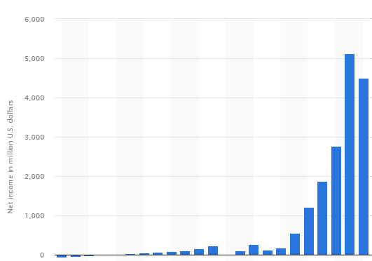
Figure 1: Comparatively lower profit margin of Netflix due to climate issues
(Source: Statista.com, 2023)
The current issue of increased carbon emission has made Netflix face controversy regarding its well-known sustainable policy. Figure 1 shows that the profit margin has decreased over the years in Netflix. The contradiction of the sustainability related regulations have impacted the company negatively. Keeping this in concern, Netflix has produced the movie “Don’t Look Up” based on promoting the importance of sustainability (Nytimes, 2024). It is expected that the company can generate a trustworthy customer base with the initiation.
ESG principle issues (Environmental, Social and Governance) :
Environmental issues of an organisation that has a huge carbine mission might be mitigated through effective ESG principles in order to save the Planet. Focusing on the People such as employees and suppliers to develop the Profit margin can also be possible through the ESG framework. Principle issues faced by Netflix regarding the environment include the aspect of “People” as employees in the company are not able to voice their opinions to managers. A poor subscriber base has also been faced by Netflix due to employee dissatisfaction issues (Economictimes.com, 2023). Productivity of the company might face disruption regarding this issue which can impact company reputation negatively.
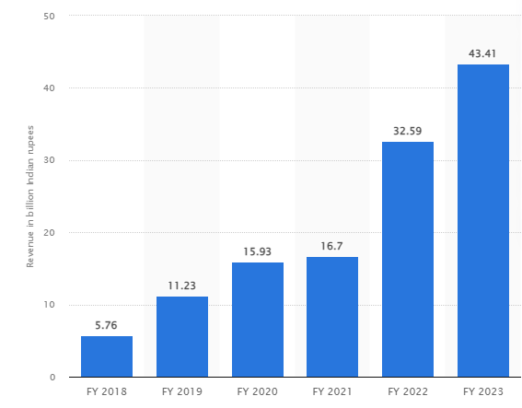
Figure 2: Revenue of Disney plus in 2023
(Source: Statista.com, 2024)
The factor of “Profit” has decreased Netflix due to its tough competition with Disney plus in the current scenario. It is seen that the revenue of Netflix is $33.7 billion in 2022 whereas the revenue of Disney plus is $32 billion that shows the close competition among the companies (Statista.com, 2023). In the current situation, Disney provides a tough competition to Netflix regarding its subscription based. The subscriber base of Disney in 2023 is over 121 million that is lower than Netflix (Statista.com, 2024). Figure 2 shows that the revenue of Disney is increasing over the years which might be a threat to Netflix in the coming years. Concerning this, it can be considered that Netflix needs to be focused on employee satisfaction through communicating with them to develop content’s productivity level. On the contrary, carbon emission due to film residue cleaning has been facing issues in Netflix that is impacting the “Planet” negatively (Cleanenergywire.org, 2024). Concerning this, Netflix is expected to deal with the issue of negative environmental impacts from managerial perspectives.
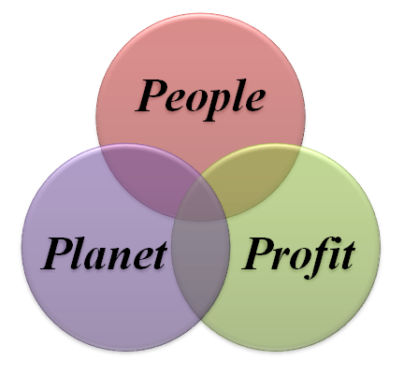
Figure 3: Key aspects of Triple Bottom Line theory
(Source: Self-created)
Technology development issues
Certain technological issues have become concerning the operational performance of Netflix in the long run. For instance, generative Artificial Intelligence (AI) implementation factors have been disrupting the technology development factor of Netflix excessively. Managers perspective about using generative AI in Netflix shows that “Uncertain copyright claims” can occur due to security concerns (Financialexpress, 2023). Security issues in the organisation have been facing issues due to poor AI implementation which is one of the most concerning factors for Netflix in the current business context.
Data analytics issues
Application of data analytics is useful in doing intense customer research and identification of the current market trends. In this context, Netflix has faced problems regarding algorithm pattern understanding and this has created certain video related issues in the company (Netflix.com, 2024). The data analytics process Netflix uses to develop its filming quality is experiencing problems, resulting in blurry images. As a result, Netflix may face long-term customer dissatisfaction.

Changing buying perceptions of consumers
Consumers in the current business context are closely connected to sustainable purchases. In Netflix, one of the most emerging issues regarding negative environmental impacts includes its huge carbon emission rate. Due to the higher subscription rate of Netflix, it is seen that almost 10 million views are generated every day.(Netflix.com,2024). streaming one video creates almost 100 grams of carbon dioxide release that is extremely harmful for the environment (Theguardian.com, 2023). As a result, it can be said that Netflix is directly involved in the enhancement of negative environmental impacts.
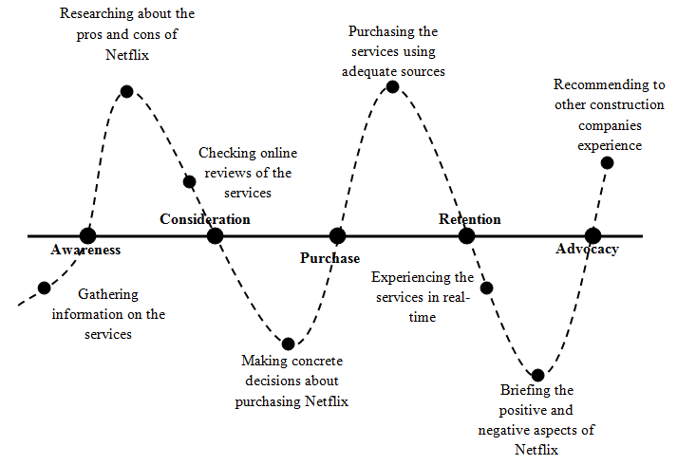
Figure 4: Customer Journey Map
(Source: Self-Created)
Web series such as “Stranger Things” have been creating issues in Netflix due to its huge views. Almost 1.13 billion viewers have watched “Stranger Things” on Netflix that has created almost 1.8 billion tonnes of carbon dioxide release (Theguardian.com, 2023). The current buying perception of consumers might affect the sustainable reputation of Netflix due to low environmental impacts. Cameron and Green (2019), have mentioned that organisations need to be focused on the implication of proper change management approaches to become customer oriented. Netflix in this regard, can try to be focused on doing intense market research and promote sustainable shows in the streaming platform to become environmentally friendly.
Issues with innovation and disruption
Innovation and disruption processes in an organisation helps in gaining better operational activities. In the view of Kim and Mauborgne (2017), innovation processes in an organisation often helps in developing employee capabilities, resulting in better profit margin. In the current business context, only 30% of employees feel motivated in doing regular work. Blue ocean leadership strategy might be helpful in the process of employee motivation and innovation in working due to its capability of focusing on employee management (Kim and Mauborgne , 2017). Innovation factors in Netflix have been facing issues due to the improper application of generative AI. Copyright and security related issues have been disrupting the innovation process of the company for a long time.
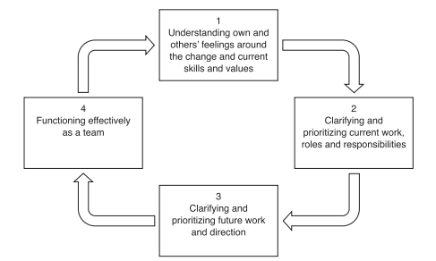
Figure 5: Impact of Blue ocean leadership
(Source: Kim and Mauborgne, 2017)
It is seen in Netflix that poor AI innovation processes have led Netflix to face the issue of customer related security. CAPTCHA generation in the company has been one of the core reasons for poor customer security through stealing customer credentials (Forbes.com, 2023). Concerning this, the company might face issues in retaining customers along with poor profit margin. As a result, Netflix might not be able to invest in Research and Development (R&D) that can negatively impact the innovation process. Apart from this, Phishing emails have also been disturbing the subscribers of Netflix that has resulted in negative reviews about the company (Forbes.com, 2023). Concerning this, it can be assumed that the company might need to develop its focus on better employee engagement and innovation process.

Task 2: Analysis of the challenges
Macro environment analysis PESTEL
Factors | Description | Impacts
Political | - Trading partners- China, Mexico, Canada, Germany, and Japan (Usitc.gov, 2021)  - Taxation changes: 39.6% tax rate (Whitehouse.gov, 2024) | Positive
Economic | - GDP- 2.73% (Statista.com, 2024)  - Unemployment index: 3.7% to 3.9% (Bls.gov, 2024) | Negative
Social | - Online streaming service purchasing rate- Spend of $46 a month (Forbes.com, 2024)  - Average income level index: $74,580 (Fred.stlouisfed.org, 2024) | Positive
Technological | - R&D expenditure- $886 Billion (Nsf.gov, 2024)  - Artificial Intelligence (AI) usage index: 64% (Statista.com, 2024) | Positive
Environmental | - Global Sustainability Index rank- 197th (Earth.org, 2021)  - Pollution level index: 25 (Aqi.in, 2024) | Negative
Legal | - OAS Model Registry Regulations (2009), Employment and labour regulations (State.gov, 2024)  - Consumer rights: “Federal Trade Commission Act (“FTC Act)” to protect rights of consumers (Iclg.com, 2024) | Positive
Table 1: PESTEL analysis for Netflix
(Source: Self-created)
Analysis
The external environment analysis shows that numerous trading partners have collaborated with the USA that has been helping the company to focus on a better internationalisation process. Apart from this, R&D expenditure of the country is almost $886 Billion (Nsf.gov, 2024). Concerning this, it is assumed that the company might gain opportunities in innovation strategies due to the huge support from the government in innovation. The analysis shows that the pollution level index of the USA is on the higher side, that is 25 (Aqi.in, 2024). In this regard, the company might face issues in the long run due to poor sustainability. On the contrary, legal factors can impact the company positively in the long run. For instance, the “Federal Trade Commission Act (“FTC Act)” is enabled in the USA to protect the rights of consumers (Iclg.com, 2024). Concerning this, it is expected that Netflix might be able to make user-friendly contents through abiding by the legal contexts.
Micro environment analysis
Factors | Description | Impact
Bargaining power of customers | - Netflix’s total paid subscribers worldwide is 269.6 million (Statista.com, 2024) | High
Bargaining power of suppliers | - Supplier number is increasing | Low
Competitive rivalry | - Amazon Prime Video, Disney+ and Hulu (Statista.com, 2024) | High
Threat of substitutes | - Unlimited ad-free movies, Free trials and others | High
Threat of new entrants | - New OTT platforms are rising | High
Table 2: Porter’s five forces
(Source: Self-created)
Analysis
The bargaining power of customers for Netflix is on the high side along with low bargaining power of suppliers. Due to the high competition with Disney+, Netflix has generated a comparatively low subscriber base that is 121 million for Disney+ (Statista.com, 2024). Competitive rivalry of Netflix might also face disruption due to the presence of Disney+. Further, the rise of new OTT platforms (Over-the-top media service, also known as streaming platform). might make Netflix face the issue of Threat of substitutes and Threat of new entrants in the long run.
Mendelow’s Matrix for Stakeholder Analysis
The “Mendelow stakeholder matrix” can be defined as a model that classifies stakeholder attitudes and expectations and their likely effect on organizational decisions. The Mendelow stakeholder matrix analyzes attitudes across two key variables: power and interest (Cieśla, 2023). In the “Netflix stakeholder mapping”, the table used to analyze stakeholders divides them into a power/interest matrix. According to the analysis, the internal stakeholders, with less power but high interest, are categorized as ‘keep informed’ while the board members, with high power and interest, are classified as ‘key players.’ The clients, with high power but low interest, are classified as ‘keep satisfied.’ Thus, the model offers a rational approach to stakeholder management.
Identification of the Stakeholders
Customers and employees are identified as core stakeholders for Netflix's business ventures, significantly influencing its development. The Netflix Company had a substantial number of full-time workers in 2023, impacting service quality and production rates. Additionally, Netflix boasted paid millions of subscribers worldwide, highlighting the importance of delivering quality services and addressing customer demands to foster satisfaction and brand awareness globally.
Ways to retain the Stakeholders
Appreciating the importance of stakeholder retention, firms aim at understanding the perceptions of the stakeholders and keeping the channels of communication open. This is because the parties are able to meet on a regular basis and exchange knowledge and ideas. It is for this reason that this approach allows companies to harness the knowledge of their stakeholders and make the best decisions. Some of the risks that Netflix encountered include the drastic decline of its share by a third in 2022 due to the loss of subscribers as reported by many sources. This situation has been worsened by the COVID-19 pandemic which has resulted in a reduction of subscribers. Such losses could have been averted through appropriate management of stakeholder relationships through empathy and proper communication with the stakeholders in order to ensure that they are in harmony with the strategic direction of the company.
SOSTAC Planning (Situation, Objectives, Strategy, Tactics and Action):
The “SOSTAC planning model” which is a step by step guide on how to develop and implement a marketing plan ensures that information from the control stage of the previous marketing plan is fed into the analysis of the situation for the next plan (Innanmaa, 2020). This model includes six elements which are based on Netflix like situations, objectives, strategy, tactics, action and control. Furthermore, both models serve useful purposes for understanding and applying data in the formation of a marketing strategy today. Marketing planning using the “SOSTAC model” begins with situation analysis before developing strategies and actions. This approach enables the taking of balanced actions and discourages the furious marketing strategies. According to certain information from reliable sources, Netflix is changing its approach to content delivery across different social media platforms; therefore, the concept of situation analysis as an element of marketing planning should be taken into consideration.
Lewin’s Force Field Analysis
“Lewin’s Force Field Analysis” is a well-established model used to analyze a situation and identify the forces that drive and resist change. The purpose of “Lewin’s Force Field Analysis” is to help individuals and organizations understand the dynamics of a situation or problem and determine the best approach to making changes (Ramos et al.,2021). The remote work and the quarantine measures also affected the share prices and stakeholders’ engagement since Netflix experienced a decrease in the number of subscribers during the pandemic. The limited resources and high competition, especially from other players in the market, affected the decisions on marketing as well as the strategies that could be used to increase subscriber numbers.
In 2022, Netflix was hit by a sharp decline in subscriptions, which resulted in the company losing subscribers. This decline together with stakeholder apathy led to the decline in the company’s sales and market share. From reliable resources, it has been estimated that the company was able to lose a third of its shares as a result of the drop in subscriber numbers which greatly affected the financial progress (Sánchez-Mompeán, 2021). In addition, there were issues that affected Netflix’s image such as the promotion of criticism within the organization and the inclusion of content that is transphobic.

Task 3: Organizational approaches to change management
Key Drivers of Marketing Change
In recent times, the organization under consideration has encountered several major drivers of marketing change. The first interesting factor that has contributed to impact the current changes in the consumption model is that digital technologies are advancing at a very high rate. The increase in the available social networks and online channels has brought about the need for more targeted and communicative marketing solutions (Dubbelink et al., 2021). The important role of sustainability and ethical business practices continue to be put into consideration putting the following as another driver of change. As individuals envisage themselves as responsible citizens, social and environmental questions have come to influence the strategy that the organization needs to adopt for its marketing plans.
Additionally, the organization has experienced increased competition from new entrants and changing consumer tastes and preferences. This has called for a change in its portfolio, price positioning, and brand image. There is also the issue of organization internationality which sometimes poses difficulties in marketing strategies, Locale adaptations and compliance with different cultures and legal requirements (Ekemezie and Digitemie, 2024).
These drivers can only be managed through effective change management strategies in order to keep the organization competitive enough to respond to market dynamics.
Current Approach to Change Management
The organization has opted to address the key drivers of change through multifaceted strategies that can help it manage change and adapt accordingly. Firstly, it uses the “7P’s Marketing Mix”, which includes the essential components of product, price, place, promotion, people, process, and physical evidence (Dally et al., 2021). This tool encompasses all aspects of the organization and is useful for a wide analysis of its marketing strategies; it can help to reveal which aspects need to be altered in response to the changing conditions in the market. In order to identify the internal and external factors that affect the performance of the organization, the organization employs the TOWS Analysis model (Threats, Opportunities, Weaknesses, Strengths) as proposed by Nuh et al. (2023). The strategy map is instrumental in defining strategies that should be deployed to build on the strengths and capitalize on the opportunities that are present within the marketing environment while at the same time working to contain the weaknesses and neutralizing the threats.
The organization employs the “Gartner’s Hype Cycle model” to determine the trends and possible impacts of technologies in the marketing domain. Moreover, the organization also embraces the customer centric loop where they get feedback from the customers and analyse it in order to make any changes that are deemed necessary to improve the experience of the customers. This is because the process is cyclical to ensure that any new trends or changes in customer needs and preferences are identified and incorporated to enable the organization to be sensitive to marketing change.
As for the change management theories and models that the organization has adopted, the organization has put in place “Lewin’s Change Management Model” which is divided into three stages; the current state, the change and new state and the new state which has to be frozen. This type of approach ensures that there is a clear and orderly way of transitioning during change, thus offering a good reference on how to handle change. This has been done in accordance with Lewin’s three-steps of ‘unfreezing’, ‘changing’ and ‘refreezing’. The first step, known as the unfreezing process is about identifying and implementing the need for change within the organizational culture. Refreezing entailed actions taken to ensure that the change becomes the new normal within the organization.
Critical Evaluation of Current Strategies
The current tactics followed in the organization to manage marketing change have both the advantages and the disadvantages. On the positive side, it is evident that TOWS Analysis and Gartner’s Hype Cycle as well as the Marketing 7Ps Mix exhibit the use of a well-rounded perspective in figuring out and responding to different facets of the marketing environment. The 7P’s Marketing Mix is useful as it provides a broad framework on marketing that can assist the organization in evaluating its strategies to determine that all the factors critical to it are in harmony with the current market conditions.
More importantly, TOWS Analysis is a systematised framework to key resources and their deficiencies, other opportunities in the environment and threats. It refers to formulations of effective strategies (Fitriani, 2022). Moreover, use of Gartner’s Hype Cycle also shows an innovative approach and a proactive measure to adapt to any coming revolutionized technological trends in marketing. However, it is still possible to find certain specific weaknesses of the current strategies of the given organization. There is also a concern that often too much emphasis is placed on existing theories and concepts that may not effectively capture the dynamics and risks of emergent markets. It may also limit the organization from changing direction with agility when markets become more dynamic, competitive and unpredictable as they are today.
Moreover, the customer-centric loop is another significant strategy; however, the device, software, application, method, system or mechanism is not appropriate if it is not learning and adapting to changes. However, if an organization lacks a strong culture that listens and adapts to customers, the customer-centric loop may be reduced not being a genuine tool of cultural change but turning into an administrative checklist (Rokkan, 2023). To improve upon these weaknesses, the organization should consider using different strategies than it presently does to be more flexible and adaptable, supporting trial and error, and embracing change. Besides, it has to focus on the creation of a strong change management framework to help employees understand change and manage it properly.
Recommended Response Strategies
Suggested Change Management Approaches
Embrace both exploitative and exploratory strategies, balancing the optimization of existing processes with the exploration of new opportunities and innovations. Embrace agile principles and methodologies, such as Scrum or Lean Startup, to foster a culture of continuous improvement, rapid experimentation, and iterative learning (Zorzetti et al., 2022). Furthermore, the organization has adopted the emergent view of change management, acknowledging that change is not always deliberate and linear.
Alignment with Identified Issues
They meet the specific needs of the organization, providing solutions for the weaknesses, for instance, using conventional knowledge and missing agility to adjust to the dynamic market conditions. The ambidextrous approach and the agile methodologies help the organization to manage the exploitation and exploration of the organizational resources to encourage flexibility and adaptation.
Evaluation of Proposed Methods
These methods promote the spirit of innovation, trying new ideas, and learning as the way of life. They help the employee owners to be agents of change and make positive change in the organization. Moreover, it helps to develop a user-oriented vision and fosters the organization’s capacity to adapt to changing customer requirements. Adopting these approaches may entail organizational change and cultural transformation, which may be arduous and resource-intensive. There may also be reluctance from key participants to the change since they are used to the previous way of doing things and this may call for proper change management and communication to the participants.

Conclusion
The organization is faced by challenges in the marketing change management due to technology advancement, sustainability challenges, and competition and consumer behavior fluctuations. Consequently, the organization can enhance its responsiveness, user orientation, and creativity by encouraging culture of change and continuous improvement. Key factors that may contribute to the success of the implementation of the strategies include, change management, communication plans, and organizational commitment to the strategies. This will go a long way in ensuring that the organization is in a position to be competitive and also sustainable in the dynamic marketing environment as shown below.

Reference List
Aqi.in, (2023). “United States Air Quality Index (AQI)”. Available at: https://www.aqi.in/dashboard/united-states. [Accessed on: 29th May, 2024]
Bls.gov, (2024). “THE EMPLOYMENT SITUATION — APRIL 2024”. Available at: https://www.bls.gov/news.release/pdf/empsit.pdf. [Accessed on: 29th May, 2024]
Cameron, E. and Green, M., (2019). Making sense of change management: A complete guide to the models, tools and techniques of organizational change. Kogan Page Publishers.
Cieśla, M., (2023). Determining the strategic position of car-sharing services in Poland based on the stakeholder analysis method. Journal of civil engineering and transport, 5(1).
Cleanenergywire.org, (2024). “Cleaning up film production”. Available at: https://www.cleanenergywire.org/news/net-zero-netflix-far-climate-neutral#:~:text=Cleaning%20up%20film%20production,in%20post%2Dpandemic%20film%20production. [Accessed on: 29th May, 2024]
Dally, D., Sinaga, O. and bin Mohd Saudi, M.H., (2021). The Impact Of 7p’s Of Marketing on The Performance of The Higher Education Institutions. Review of International Geographical Education Online, 11(3).
Dubbelink, S.I., Herrando, C. and Constantinides, E., (2021). Social media marketing as a branding strategy in extraordinary times: Lessons from the COVID-19 pandemic. Sustainability, 13(18), p.10310.
Economictimes.com, (2023). “Netflix subscriber Crisis Turning into Employee Crisis”. Available at: https://hr.economictimes.indiatimes.com/news/industry/netflix-subscriber-crisis-turning-into-employee-crisis/91608059 [Accessed on: 29th May, 2024]
Ekemezie, I.O. and Digitemie, W.N., (2024). Best practices in strategic project management across multinational corporations: a global perspective on success factors and challenges. International Journal of Management & Entrepreneurship Research, 6(3), pp.795-805.
Financialexpress, (2023). “Prepare in advance: 22 dry days in 2024 – A look at alcohol brand you should have in your mini-bar”. Available at: https://www.financialexpress.com/lifestyle/prepare-in-advance-republic-day-and-21-other-dry-days-in-2024-a-look-at-alcohol-brand-you-should-have-in-your-mini-bar/3374331. [Accessed on: 29th May, 2024]
Fitriani, E., (2022). TOWS analysis on recissbar to increase its competitiveness. Revista CEA, 8(16), pp.e1876-e1876.
Forbes.com, (2023). “New Netflix Threat: This Legit-Looking Scam Could Steal Your Credit Card Details”. Available at: https://www.forbes.com/sites/kateoflahertyuk/2020/07/29/new-netflix-threat-this-legit-looking-scam-could-steal-your-credit-card-details/?sh=6c35e76269d2. [Accessed on: 29th May, 2024]
Fred.stlouisfed.org, (2024). “Real Median Household Income in the United States (MEHOINUSA672N)”. Available at: https://fred.stlouisfed.org/series/MEHOINUSA672N. [Accessed on: 29th May, 2024]
Hidayat, A.T., Hariyati, R.T.S.H.S. and Muhaeriwati, T.M., (2020). Applicability of Lewin’s Change Management Model for Optimization Management Function in Nursing Delegation between Head Nurse and Team Leader: A Mini Project in Jakarta Military Hospital. International Journal of Nursing and Health Services (IJNHS), 3(4), pp.471-478.
Iclg.com, (2024). “Consumer Protection Laws and Regulations USA 2024”. Available at: https://iclg.com/practice-areas/consumer-protection-laws-and-regulations/usa#:~:text=The%20most%20generally%20applicable%20federal,practices%20in%20or%20affecting%20commerce%E2%80%9D. [Accessed on: 29th May, 2024]
Innanmaa, K., (2020). A strategic marketing plan.
Kim, W.C. and Mauborgne, R.A., (2017). Blue ocean leadership (Harvard business review classics). Harvard Business Review Press.
Netflix.com, (2024). “Video issues with Netflix”. Available at: https://help.netflix.com/en/node/47922. [Accessed on: 29th May, 2024]
Nuh, R., Phetkaew, C. and Zakaria, F., (2023). A SWOT–TOWS Analysis for Developing the Strategy of Cage-Based Aquaculture Business in Saiburi, Patani Province. Asia Social, (2023), p.16.
Nytimes, (2024). “Don’t Just Watch: Team Behind ‘Don’t Look Up’ Urges Climate Action”. Available at: https://www.nytimes.com/2022/01/11/climate/dont-look-up-climate.html. [Accessed on: 29th May, 2024]
Ramos, P.N., Enteria, M.L.B. and Norona, M.I., (2021), September. Readiness Model Development in the Adoption of Internet of Things (IoT) among Philippine Manufacturing SMEs Using Force Field Analysis Approach and Structural Equation Modelling. In Proceedings of the Second Asia Pacific International Conference on Industrial Engineering and Operations Management, Surakarta, Indonesia (pp. 14-16).
Rokkan, A.I., (2023). Market orientation (once again): Challenges and a suggested solution. AMS Review, 13(1), pp.71-91.
Sánchez-Mompeán, S., (2021). Netflix likes it dubbed: Taking on the challenge of dubbing into English. Language & Communication, 80, pp.180-190.
Shin, S. and Kang, J., (2022). Structural features and Diffusion Patterns of Gartner Hype Cycle for Artificial Intelligence using Social Network analysis. Journal of Intelligence and Information Systems, 28(1), pp.107-129.
Statista.com, (2023). “Artificial intelligence (AI) in the U.S. - statistics & facts”. Available at: https://www.statista.com/topics/7923/artificial-intelligence-ai-in-the-us/#topicOverview. [Accessed on: 29th May, 2024]
Statista.com, (2023). “Disney+ Hotstar revenue FY 2018-2023”. Available at: https://www.statista.com/statistics/1231769/india-hotstar-revenue/#:~:text=Disney%2B%20Hotstar%2C%20India's%20leading%20video,rupees%20due%20to%20high%20expenses. [Accessed on: 29th May, 2024]
Statista.com, (2023). “Netflix's net income from 2000 to 2023”. Available at: https://www.statista.com/statistics/272561/netflix-net-income. [Accessed on: 29th May, 2024]
Theguardian.com, (2023). “Streaming’s dirty secret: how viewing Netflix top 10 creates vast quantity of CO2”. Available at: https://www.theguardian.com/tv-and-radio/2021/oct/29/streamings-dirty-secret-how-viewing-netflix-top-10-creates-vast-quantity-of-co2. [Accessed on: 29th May, 2024]
Whitehouse.gov, (2024). “FACT SHEET: The President’s Budget Cuts Taxes for Working Families and Makes Big Corporations and the Wealthy Pay Their Fair Share”. Available at: https://www.whitehouse.gov/briefing-room/statements-releases/2024/03/11/fact-sheet-the-presidents-budget-cuts-taxes-for-working-families-and-makes-big-corporations-and-the-wealthy-pay-their-fair-share/#:~:text=The%20President's%20Budget%20restores%20the,Loopholes%20for%20the%20Very%20Wealthy. [Accessed on: 29th May, 2024]
Zorzetti, M., Signoretti, I., Salerno, L., Marczak, S. and Bastos, R., (2022). Improving agile software development using user-centered design and lean startup. Information and Software Technology, 141, p.106718.

