LCBB4004 MARKETING FUNDAMENTALS

The Effect of Globalisation on an Organisations’
Marketing Strategy- Assessment 2

Student ID:

Introduction
The essay is based on marketing fundamentals which include key marketing policies, marketing mix (7Ps), local & international marketing, internal & external stakeholders, global marketing environment & its impact on global marketing functions to any particular company, several marketing activities in the company & how these can satisfy the customers’ demand, etc. Local & international marketing refers to the marketing policy based on a situation such as UK’s marketing policies are not similar to other countries because these vary on politics, economic, environment, etc. Coca-Cola is selected for the essay as a scenario which is a carbonated soft drink company situated in Atlanta, USA.
Marketing & Global Marketing
According to Baker and Baker (2017), marketing, the sum of functions is to advertise & facilitate exchanges. People & groups gain what they demand & need through exchanging goofs & services with others by marketing. Such as method can happen only while there are minimum of two sides, evert of whom has something to propose. Furthermore, the exchange cannot happen unless the two sides are capable to contact regarding & to provide what they propose. Marketing isn’t a forcible method: all sides have to be independent to take or refuse what others are proposing. define
On the other hand, global marketing is stated as the method of regulating the marketing policies of a particular organisation to familiarise with the situations of other countries. Kotler et al (2020) said that if an organisation selects not to spread globally, this can face local competition from global organisations which are spreading their global existence. Of course, global marketing is more than selling a particular company’s goods & services internally. This is the entire procedure of making, planning, positioning, & advertising the goods into an international market.

Stakeholder
A stakeholder is a person, party or group who is connected with a particular organisation directly & indirectly both. This can affect the business and can be affected by the business. Kotabe and Helsen (2020) mentioned that in a company, a stakeholder is a member of “groups without help the company will cease to exist”. This has obtained wide receipt into corporate practice & theorising connecting to calculated administration, business governance, corporate objective and CSR. Any activities accepted through any group or company may affect those people who are connected with them into both the public & private sectors. Such as owners, employees, customers, associates, contractors, partners, & suppliers
Internal & External Stakeholders
Clarke (2018) stated that stakeholders can be internal & external to a business: internal stakeholders, also called primary stakeholders, come through a direct bonding and connect into financial transactions with the company. Coca-Cola’s internal stakeholders include investors, employees, employers, etc. External stakeholders, also called secondary stakeholders, do not come through direct relationship to a company, such as governments, public groups, creditors, financial institutions (Bank), customers, suppliers, etc.
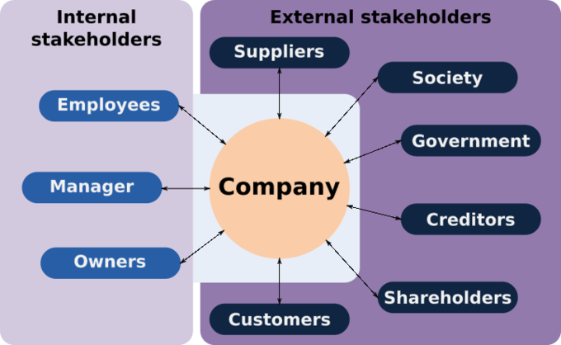
Figure 1: Stakeholders (Sources: de Chernatony and Harris 2018)
Investors are related to finance that they affect the business directly because, without capital, the business cannot run. Kotler et al (2020) described that again, while the governments initiate policies changes upon the economy, the decision influences the organisational functions. As Coca-Cola is a global company, it operates its business in about 200 countries & regions. Every region has a distributor who buys raw materials or products from the company according to organisational rules & regulations. Different counties have different suppliers, investors, government, employees, employers, etc.
Identifying the Stakeholders of Coca-Cola within a Global Marketing Environment
Some common stakeholders have existed in every company and Coca-Cola also has those stakeholders such as employees, owners, investors which are internal and government, customers which are external. The Coca-Cola Company (2021) mentioned that as the company is the number 1 soft drink company in the world, it cannot operate the whole business itself. For that, Coca-Cola has to make partnerships for different objectives in different regions. Bottling partners and chemical partners are two main stakeholders. The bottle can produce be produced differently but chemicals must be provided by the company to every country. The distributor is another who buys patents from Coca-Cola for operating business in his country. NGOs are another who can be suppliers, advertising media etc.
The impacts of those Stakeholders on Global Marketing Functions of Coca-Cola
There are various global marketing functions of Coca-Cola which are influenced or affected by its stakeholders. Major functions are below:
Market research: de Chernatony and Harris (2018) expressed that this is a systematised approach to collect data & information regarding target markets & consumers: realise about them, beginning with who they are. This is a significant element of business policy & a key issue in upholding competitiveness. Market research supports to recognise & analyse the demands of the market, the market size & the competition. Its methods incorporate both qualitative methods like an in-depth interview, focus group & descriptive anthropology and quantitative methods like consumer survey & research of secondary data. Many people & groups of Coca-Cola are connected with market research. Robson and Robson (2016) defined that these are a whole marketing department, different types of media which are hired by the company, some groups which conduct surveys. Sometimes, investors also affect the market research.
The customers provide both positive & negative reviews which are collected by survey groups of the company. Kirchoff, et al (2019) denoted that these reviews become positive if the company changes its products according to customers’ demands. On the other hand, many customers can be disinterested to hear the reviews of the products. The marketing department includes many employees who are paid by the company. They must advertise products & collect a market & customer’s demand. Even very marketing staffs have to be skilled, knowledgeable and experienced on marketing & market research. Cronin et al (2018) outlined that market research is a part of marketing research. Otherwise, Coca-Cola can face a vast loss in the market. Marketing media are also a group which promote the goods too.
Target customer: According to Hatch and Schultz (2016), a target market is a group of customers in an organisational serviceable available market where a company aims its marketing approaches & resources. It is a subsection of the whole market for a service or product. In this term, a customer is a key stakeholder who carries different types of characteristics such as age, location, income, status, education, etc. These are reflected most probable to purchase a corporate’s market offering and probable to be the most profitable sections for any organisation like Coca-Cola to service. Sautter and Leisen (2019) said that once the target market has been recognised, the marketing workforces of the company would generally modify the marketing mix with the demands & wants of the target in mind.
Customer researchers are another which involve obtaining bottomless insights into the distinctive customers’ encouragement, buying habits & media usage designs. Frow and Payne (2020) mentioned that a market analyst supports the segmentation process to reach the final phase. The owners of Coca-Cola provide customer-oriented direction to the production department, customer service department, etc. For example, the owners collect marketers’ judgement to provide the direction and after bearing out elementary analysis to recognise the above segments with the biggest potential for the company. De Boer (2018) described that some employees may choose more than one segment as the focus of their functions occasionally in where case, this will generally recognise an initial target & a secondary target.
Product development: This covers the whole procedure of bringing a product to market, renewing a present product or introducing a product in a new market. Maignan et al (2015) stated that this is also called new product management and is a sequence of phases that comprises the conceptualisation, idea, structure, design, improvement & marketing of afresh made or rebranded products. The purposes of this are to cultivate, uphold and enhance an organisational market share through satisfying a customer’s need. Both internal & external are connected with this and these are also called product development drivers. There are six phases of product development procedures. Three phases are internal & others are external.
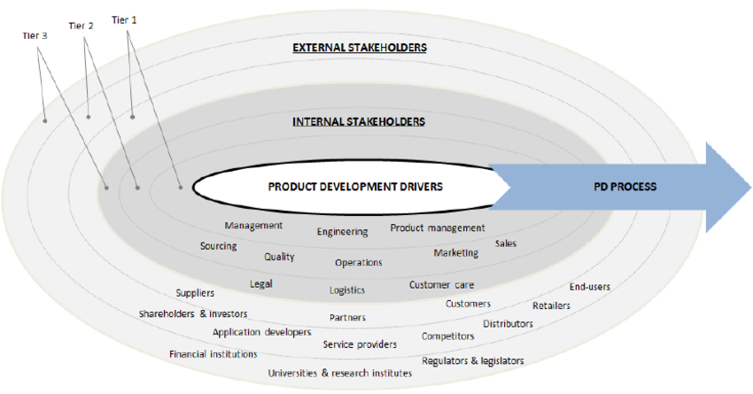
Figure 2: Product development Drivers (Sources: Blind et al 2019)

The most relevant external stakeholders depended on whole suggestions with product development drivers in Coca-Cola are suppliers, customers & partners. These are reflected significantly more pertinent than others. Kirchoff et al. (2019) mentioned that logically, the customers are associated with the function for their inputs. Another significant stakeholder is a supplier who provides new technologies. Partners are recognised for some major product development drivers comprising production policy, and new technologies. The second significant product development stakeholders are investors & shareholders who are recognised for four dominant product development drivers such as brand & image, profitability target, policy and revenue target.
Cronin et al (2018) outlined that the internet, standardisation body comprising bloggers & communities, and other media are also marked through some respondents. Again, the most pertinent internal stakeholders depended upon association with product development drivers. These are product management, administration & engineering. Product management is recognised for profitability target, the administration is found for making policies and engineering is classified for computer-aided design. Hatch and Schultz (2016) expressed that marketing, sourcing, sales, operations & quality can introduce the product in the market. It is concluded that internal stakeholders are linked more recurrently with the product development drivers than external stakeholders, which can designate that internal receive more supervisory consideration than external. There is no solid conclusion because the company’s market varies on B2C, B2B, business structure, design & the utilisation of technologies.
Promotional activities: According to Sautter and Leisen (2019), promotion is a fundamental component of the marketing mix. Promotional activity is any approach created through a company to contact potential consumers. There are two key objectives of promotional activities such as informing consumers about organisational stores, goods, pricing and persuading consumers to purchase the goods the company sells. Key promotional activities are personal selling, direct marketing, public relations, advertising, sales promotion. Frow and Payne (2020) stated that these activities are executed & accomplished by some stakeholders. Even to accomplish these, several stakeholders have to be connected. These are salespeople, the HR department, and the public relations departments. Besides the marketing department, these also want the promotion to be successful among others.
Salespeople are an outside group of marketing who are hired to join Coca-Cola’s worker advocacy program. De Boer (2018) said that they have each cause to be the company’s most effective workforce advocates & spread the organisational message, but they can benefit greatly from the workers’ advocacy program. They share quality content on social media, engage with pertinent posts and connect with pertinent researchers. According to LinkedIn,
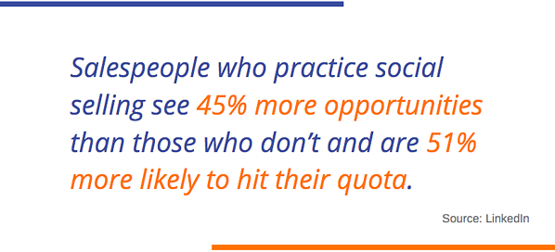
Maignan et al (2015) defined that HR is not dealing directly but the department appeals & initiates to reverberate not only with the purchasers of the goods but also investors, workers & corporate partners. It wants people in Coca-Cola to be proud of the product & for people to demand to perform at the organisation. Coca-Cola’s public relations team expects to keep the brand in a positive situation through advertising the brand & its workforces. For instance: Media relations inventiveness can greatly use worker advocacy to intensify the contents.

Sales and distribution: Blind et al (2019) explained that a sales channel is the way into which B2B sales organisation goes to market, either by direct or indirect paths, to sell its goods or solutions to end customers, such as Producers to Customers. On the other hand, a distribution channel is a chain of businesses or intermediaries by which a product passes till this reaches the last buyer or the last customer such as Producer-Wholesaler-Retailer-Customer.
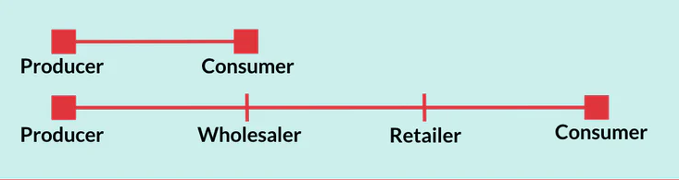
Figure 3: Sales & Distribution Channels (Sources: Robson and Robson 2016)
A sales channel (B2C) is the path a product accepted from the producer to customers. This is direct business but Coca-Cola cannot use this process because the company is too bigger in the market. For example, Brick-and-mortar stores, e-commerce sites, etc. Indirect sales channel refers to distributor channels (B2B) such as retailers, wholesalers, online media (Amazon), etc. Coca-Cola’s sales department cannot meet with final customers. Hatch and Schultz (2016) mentioned that the marketing channel is the communication tool & tactic utilised in the company’s marketing policy to advertise the products. This is the way utilised to grow concerned & induce consumers to ultimately buy the company’s goods. B2C sales channels of Coca-Cola include retail stores, Point of sales, e-commerce, etc. B2B sales channels social media, professional event, etc.

Discussing Various Marketing Functions within Coca-Cola
Marketing is a study regarding what consumers demand to purchase & then help them do so. Wind (2019) stated that this is both a science & art and very significant to the success of a particular company. It is the procedure that includes all the actions involved from the conception of the procedure, which is called the functions of marketings, such as distribution policy into marketing involves how an organisation is continuing to supply its goods to a consumer.
The promotion contains authorised organisational advertising that is viewed into the correct areas through the correct people. Product development is another which helps an organisation to bring a product from being a conception through to reaching the market. De Felice and Petrillo (2017) expressed that pricing policy is fixed based on market conditions & customers’ demands. Branding helps the company to be simply identifiable in the market. The action of causing the repetitive relation & evolution to complete the normal objectives of two or more people.
How Marketing functions satisfy customer needs
Product development: This plays a significant role in product selling. Coca-Cola whose products are better & pleasingly planned sells more than the products of others whose design occurs to be weak & unappealing. Kotler et al (2020) outlined that in this way, this can be mentioned that the control of a superior design affords the company a competitive advantage. This is imperative to recollect that this is not enough to make a design into the respect of a product, but this is more imperative to improve this uninterruptedly. The marketing department of Coca-Cola pays attention to the present products.
If the customers provide a negative review on the products after consuming or the products do not fulfil their needs, the company drops the products from the market and try to introduce new goods consistent with customers’ needs. According to Herrmann et al (2018), as a result, the customers will be engaged with the company & its products. Based on customer analysis, the company improves the goods that suit the demands of the customers the design of the goods is a significant issue for several goods too. For example: when a customer buys a soft drink, he/she must think the product quality is consistent with his/her health.
Pricing: Besides product development, the customers also think about the price of products. They do not buy unless the goods are reasonable at pricing. Coca-Cola accomplishes market research because market research can inform how the company fix the price of a product. Tansuhaj et al (2018) describe that efficient pricing is as much art as this is science, & the brand needs to search for that perfect place that balance how consumers value the company’s products with the cost of production & delivery and bookkeeping for the present price of competing goods. The observed value of the brand affects the company’s pricing policy.
Marketing research helps to light on the brands’ goodwill & supports the company better realise how much its target audience values the brand. According to Glassman and McAfee (2017), this is on top of the whole competitor research & company research crucial a reasonable inquiring piece ware for the products. The price of the products is impacted through costs, profit rates, competitors’ product price, the strategy of the Govt, etc. The price must be set in a way that this should not appear to be too higher & this must gain sufficient profit for the company at the same time. Even the organizational success or failure is also depended on the price of a product.
Distribution: The policy can differ based on what goods the company is proposing, as there are dissimilar distribution channels into marketing. Chan et al (2019) mentioned that distribution policy into marketing demands to be reflected while improving any idea. Coca-Cola makes sure the right distribution channels for its goods. This would depend on various issues like the attentiveness of the market, projection life of the goods, organizational capital necessities, etc. Inventory management is connected with the distribution. The customers cannot get the available products at any time they want unless the company maintains inventory management.
The distribution function is momentous relating to costs, profits, & budgeting sales. The benefits & demerits of direct versus indirect sales have to be accepted into account to determine these things. Moriarty and Kosnik (2020) said that since this is mostly worried about the distribution of the products, details of the types, sizes, & locations of distributors or dealers have to be regulated before the products are placed into the market. Because of that, the customers can know information about the products and get products of any size in the right location. Contracts & agreements with dealers are involved in distribution functions. Coca-Cola’s distribution department helps & direct resellers to perform easily.
Promotion: The customers want to know about the products and brands and through promotion, they can know. Organizational promotion increases customers engagement and fulfil customer needs. Kordupleski et al (2016) denoted that while people chart out their marketing objectives, promotion is generally at the top of the list. Promotional policies frequently overlay with other organizational units & concern-building functions like advertisement & public relations. Promotion can comprise all from email marketing & content marketing to influential marketing & social media. Especially, Coca-Cola encourages the customers to purchase its products through executing promotion functions.
De Felice and Petrillo (2017) stated that various methods of promotion such as advertisement, personal selling, publicity, etc. affect the sales which are executed by the marketers of Coca-Cola. The company provides various coupons & discounts which affect the customers’ brain chemistry and make them more contented. Giving infrequent discounts can create a consumer attracted, consequential into a more pleased consumer who can spend more in future & can become a loyal customer. Kotler et al (2020) outlined that again, personalized promotion is very efficient at enhancing consumer satisfaction. This is very easy not to perform with technologies to follow consumers’ choices. Through giving personalized promotions depending upon past activities, a customer feels vital.
Relationship development: According to Herrmann et al (2018), this is stated as a marketing function that focuses on enhancing the engagement organizational stakeholders especially customers have with the brand through supplying personalised messages & connecting with consumers across whichever channels they choose. Coca-Cola utilizes these functions to improve the relationship with consumers & improve laser-focused product awareness through utilising consumer data & review. This varies mainly from the traditional transactional marketing effort that focuses on enhancing individual sales numbers. Tansuhaj et al (2018) explained that the company prioritises relationships with customers, strives to make potential consumer connections, that can be emotional, to their product to advertise consumer loyalty & enhance consumer lifetime value. Excellent consumer service always and receiving to realise customers to forestall their demands help to build a strong relationship.
Branding: A brand is a term, name, design or symbol which is anticipated to recognize the products of a seller & to distinguish them from those of competition. Glassman and McAfee (2017) stated that this recognises the goods for a purchaser & provides the seller with a chance to gain goodwill & repeated support. The marketers of Coca-Cola build up a clear image of the company around the brand. The customers can easily recognise branded products in the outlets. This proposes security to the customers as this recognises the company behind the goods. Branding develops the company of guaranteed control over the market. An excellent market for the goods is created by this.
The objective of branding is to show that the goods of Coca-Cola are different from that of the competitors’ products and as a result, this has its uniqueness. Chan et al (2019) defined that branding makes trust in customers’ minds and trust is an essential precursor to any organizational long-time success. Brand need to realise the customers and try & activate association because this is trusted consumers perform assign to personality features. Being reliable in marketing, advertisement & the idea behind the brand supports making emotional ties which therefore bring trust & loyalty to the consumers. Brand identity can guide the customers’ buying decisions which is helpful for the company.

Conclusion:
At last, it is said that the report helps to know global marketing which includes different internal & external stakeholders who can influence the business, the effect of those stakeholders on marketing functions and different marketing functions which fulfil customers’ needs & demands. Every company should know & analyse these to operate their business in the market. Market research is the top of whole functions of marketing which can provide proper information to do for the business anything. After that product promotion can help the company to go ahead and survive in the market with competitors. For that, effective promotion is a very significant issue.

References:
Baker, M.J. and Baker, M.J. eds., 2017. The marketing book (Vol. 195). Oxford: Butterworth-Heinemann.
Blind, K., Gauch, S. and Hawkins, R., 2019. How stakeholders view the impacts of international ICT standards. Telecommunications Policy, 34(3), pp.162-174.
Chan, L.K., Kao, H.P. and Wu, M.L., 2019. Rating the importance of customer needs in quality function deployment by fuzzy and entropy methods. International journal of production research, 37(11), pp.2499-2518.
Clarke, T., 2018. The stakeholder corporation: A business philosophy for the information age. Long range planning, 31(2), pp.182-194.
Cronin, J.J., Smith, J.S., Gleim, M.R., Ramirez, E. and Martinez, J.D., 2018. Green marketing strategies: an examination of stakeholders and the opportunities they present. Journal of the Academy of Marketing Science, 39(1), pp.158-174.
De Boer, J., 2018. Sustainability labelling schemes: the logic of their claims and their functions for stakeholders. Business Strategy and the Environment, 12(4), pp.254-264.
de Chernatony, L. and Harris, F., 2018. Developing corporate brands through considering internal and external stakeholders. Corporate Reputation Review, 3(3), pp.268-274.
De Felice, F. and Petrillo, A., 2017. A multiple-choice decision analysis: An integrated QFD–AHP model for the assessment of customer needs. International Journal of Engineering, Science and Technology, 2(9).
Frow, P. and Payne, A., 2020. A stakeholder perspective of the value proposition concept. European journal of marketing.
Glassman, M. and McAfee, B., 2017. Integrating the personnel and marketing functions: The challenge of the 1990s. Business Horizons, 35(3), pp.52-59.
Hatch, M.J. and Schultz, M., 2016. Toward a theory of brand co-creation with implications for brand governance. Journal of Brand Management, 17(8), pp.590-604.
Herrmann, A., Huber, F. and Braunstein, C., 2018. Market-driven product and service design: Bridging the gap between customer needs, quality management, and customer satisfaction. International Journal of production economics, 66(1), pp.77-96.
Kirchoff, J.F., Koch, C. and Nichols, B.S., 2019. Stakeholder perceptions of green marketing: the effect of demand and supply integration. International Journal of Physical Distribution & Logistics Management.
Kordupleski, R.E., Rust, R.T. and Zahorik, A.J., 2016. Why improving quality doesn't improve quality (or whatever happened to the market). California Management Review, 35(3), pp.82-95.
Kotabe, M.M. and Helsen, K., 2020. Global marketing management. John Wiley & Sons.
Kotler, P., Armstrong, G., Saunders, J., Wong, V., Miquel, S., Bigné, E. and Cámara, D., 2020. Introducción al marketing. Pearson Prentice Hall.
Maignan, I., Ferrell, O.C. and Ferrell, L., 2015. A stakeholder model for implementing social responsibility in marketing. European journal of marketing.
Moriarty, R.T. and Kosnik, T.J., 2020. High-tech marketing: concepts, continuity, and change. MIT Sloan Management Review, 30(4), p.7.
Robson, J. and Robson, I., 2016. From shareholders to stakeholders: critical issues for tourism marketers. Tourism Management, 17(7), pp.533-540.
Sautter, E.T. and Leisen, B., 2019. Managing stakeholders, a tourism planning model. Annals of tourism research, 26(2), pp.312-328.
Tansuhaj, P., Randall, D. and McCullough, J., 2018. A services marketing management model: integrating internal and external marketing functions. Journal of Services Marketing.
The Coca-Cola Company. 2021. The Coca-Cola Company: Refresh the World. Make a Difference. [online] Available at: <https://www.coca-colacompany.com/> [Accessed 24 November 2021].
Wind, Y., 2019. Marketing and the other business functions. Wharton School, University of Pennsylvania, Marketing Department.

