

ASSIGNMENT 2020
Academic and Employability
Skills

The importance of skills for people development

Lecturer Submitted by
Joanna Walsh Mihail Daniel GUSA - 1916898

CONTENTS

Page No

- INTRODUCTION…………………………………………………………………..……....3

- SKILLS (definition and classification)……….……………………………………………4

  - Communication Skills
  - Problems-solving

- SELF REFLECTION…………………...…………………………………………………..5

  - PERSONAL SWOT ANALYSIS……………………………………………………..…..6

- THE SIGNIFICANCE OF TIME MANAGEMENT WITH PPDP……..........................8

- CONCLUSION……………………………………………………………………………..9

- REFERENCE LIST………………………………………………………………………..9

- INTRODUCTION

In this assignment, I would like to cover the learning outcome of the Module Academic and Employability Skills by highlighting the importance of skills in both personal and professional development.
I will also analyse some of my strengths and weaknesses, opportunities and threats in order to improve myself. In addition, I will refer to the Personal/Professional Development Plan by setting up the short, mid-term and long-term goals.
I will focus on Time management skill, and the role played in building the PPDP in order to achieve my personal and professional goals.
I will also refer to Kolb’s Learning Cycle to highlight the importance of reflective working in closing the gap between where I am and where I want to be.

- SKILLS (definitions, classification)

A skill is an ability earned through a combination of experiences, habits and sustained effort in order to enhance performance.
According to Cottrell (2019), a skill is the ability to perform well a learned activity. It is a learned ability rather than the outcome of chance or luck.
Morgan (2017), considers that learning skills are vital for people development. It requires a lot of time, depending on how quick is the learning process. It also involves a lot of factors such us practising the skill, opportunities, support, effort and motivation.
There are different types of skills which can be classified as follows:
- Academic Skills-are those skills which help and support students in the learning process, such as time management, communication, critical thinking, self-reflection.
For example, students can improve their problem-solving skills by working in groups and use brainstorming, ask questions, use creativity to find a solution for a challenging situation.
- Employability Skills-are essentials for people to perform in their workplaces. Employers require people who can add value to the organisation, confident individuals who can work independently and with others. Such skills are self-management, ability to research business and management issues, proactive personality.
- Hard Skills-are abilities which can be measurable and teachable, such as accounting, administrative, application of IT.
- Soft Skills-is characterised as personality traits and attitudes, such as work ethic, emotional intelligence, adaptability.
For example, the capacity of people to adapt to challenging situations. The outbreak of the Covid-19 which requests us to adapt by switching to online learning.
However, some academic and employability skills are overlapping; university makes sure that helps the students to be prepared for the workplace at the end of the courses.
The process of developing skills is a conscious one; people choose to develop their skills by taking actions, but most of the academic skills will be developed unconsciously.

  - Communication skills

Communication is a process who help people to transmit a message in order to create mutual understanding.
Communication requires a sender, a receiver, the message and the essential thing, the feedback-a respond to a sender based on the receivers’ interpretation of the message.
Communication can be verbal, nonverbal and written.
Verbal communication consists of words to send a message.
Non-verbal communication is the process of transmitting messages through body language, such as eye contact, facial expressions, body positioning.
Written communication is a form of business communication which includes letters, electronic messages, texts, blogs.
Effective communication is vital for every human being. For organisations, communication plays a crucial role and helps to create a good working relationship.
Active listening, assertiveness, using positive body language are just some of the vital communication skills which help to develop positive relationships.

  - Problems-solving

Problems-solving raises two variables: ‘Who owns the problem?’ and ‘Who solves the problem?’. Defining the problem is the first step to solve it.
Issues cannot be separated from people. Solving a problem involves people who can brainstorm to find ideas which can lead to solutions. Solving problems in the team, rather than individually, can be productive. Each person of the team can contribute with ideas, can have different perspectives, and can increase motivation. Combining and building on each others idea can be benefic in problems-solving.
The proper way of solving problems is to adopt, adapt and improve and can be efficient if one can challenge oneself sufficiently.

- SELF REFLECTION

Self-reflection is the ability to stand back and analyse the past actions. Experiences cannot be learned without reflection.
Reflection is essential for improving the things which we did not do them well and for learning from experiences.
Jasper (2006), considers that the process of reflection involves three essentials stages: experience, reflection and action; the final step, taking action is the most significant of reflective practice.
I found it very challenging when I took the time to create my SWOT analysis; It was not easy to stand back and look critically into myself.
To reveal weaknesses, errors, even success requires to be capable of self-criticism and to be honest with yourself.
What I find interesting whenever I reflect on things is the willingness and motivation to organise myself better, to prioritise the things which can help me to achieve my goals, and the need to be specific and comprehensive in my time planning.
Before writing the SWOT analysis, I was aware of my strengths and weaknesses. Still, I realised the importance of looking at them with patience and take actions to improve and develop skills which can help me to succeed in my professional life.
The SWOT analysis had enabled me to understand how good I am at certain skills and what I need to improve.
The key to do things well is to make a plan and set up a strategy and time frame of accomplishing your goals.
Another essential factor is to be aware of mistakes and to practice till obtaining the best results and the best version of ourselves. However, practice needs to be sustained by appropriate feedback.

  - PERSONAL SWOT ANALYSIS
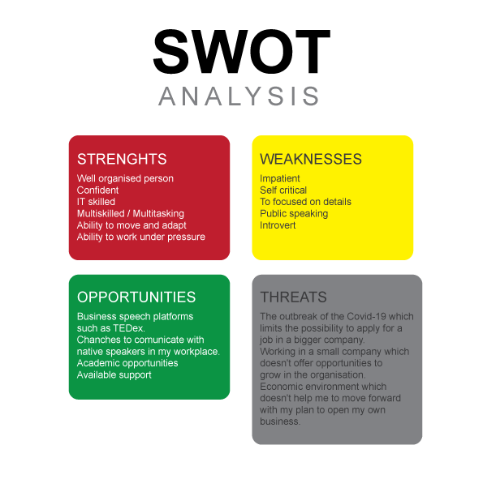

- THE SIGNIFICANCE OF TIME MANAGEMENT WITH PPDP

We cannot control or create time for our interests, but we are in control of our priorities. Time management is about making time for things which we value and how we organise ourselves in order to be productive. We all have the same number of hours in a week; what we need to do to use the time efficiently is to put the most important things first.
To be productive with our time, we need to be systematic in working out how to manage the time to achieve priorities.
To prioritise what is most important, I create my PPDP to avoid distractions and keep monitoring what I need to do to stay on target and stick with my plan.
I have applied time management techniques to save and manage time, so I can find out what works well with my strategy and resources available.
I have decided to refer to Kolb’s Learning Cycle to highlight the importance to build upon a concrete experience to achieve active experimentation.
Kolb (2015), describes the concept of learning from experience as a dynamic process of learning build on a learning cycle conducted by action-reflection and experience-abstraction. The outcome is the knowledge obtained through the transformation of experience, as a result of the combination of taking in information and transforming experience.
So that the first step of Kolb’s learning cycle, Concrete Experience, I identified my development need, and I decided to carry out the Profesional Development Plan.
The second stage, Reflective Observation, had helped me to reflect on what I need to plan for my PDP:
- My Goals
- Short-Term Time Frame: what can I do to run my own business
- Mid-Term Time Frame: apply my knowledge and start my new online e-commerce business in the next six months
- Long-Term Time Frame: to learn more about managing people and business environment to extend e-commerce
- Skills and knowledge to be learned
- Short-Term Time Frame: Business Management; Business environment in the UK
- Mid-Term Time Frame: Manage a small team; learn more about the printing process and suppliers
- Long-Term Time Frame: how to recognise an opportunity and take advantage of it
- Next steps
- Short-Term Time Frame: attend as many classes as I can to learn more, have a better understanding and more knowledge and skills
- Mid-Term Time Frame: start a small online e-commerce shop to practice and learn
- Long-Term Time Frame: learning from my mistakes and try to avoid them in the future
- Resources
- Short-Term Time Frame: skills, time and knowledge
- Mid-Term Time Frame: space, heat press, plotter, printer, materials
- Long-Term Time Frame: new equipment, employees to support my business and more space if the business grows
- Time schedule
- Short-Term Time Frame: 2 months
- Mid-Term Time Frame: 3-4 months
- Long-Term Time Frame: 2-3 years
- When will I start
- Short-Term Time Frame: June 2020
- Mid-Term Time Frame: July 2020
- Long-term Time Frame: end of the year 2020

The third stage of Kolb’s Learning Cycle, Active experimentation, had helped me to analyse the reasons why I was late in making important decisions.
The idea of starting my own business is quite old; But apart from that, there have been financial factors which kept me on hold. I was also worried that I do not have the knowledge and experience necessary to manage a business. I was focused on finding a minimal viable product and getting customers in a foreign country. All these aspects require time and effort, planning, organising and thinking every single step to obtain something achievable.
The last stage of Kolb’s Learning Cycle, Abstract Conceptualisation, offers the possibility to go back to or reflections and think about the changes we need to make in the previous situation and try to implement those changes.
So, what I would do differently now, and what I could learn from waiting to move further with my idea of e-commerce is that there is no proper time to start to put in practice your plans. As long as you have created the project, it is essential to find ways to begin with your ideas so that you can observe what is going well, if it is successful, or which action you need to take in order to run the business.
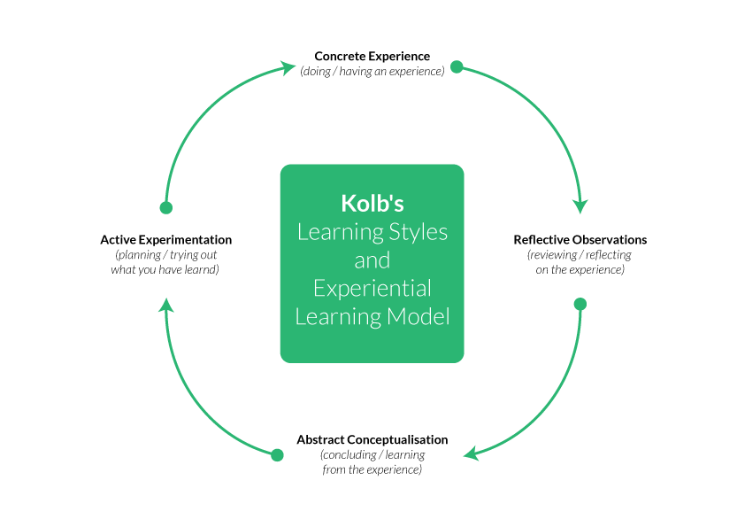

- CONCLUSION

Skills are required for academic success and for employability. Setting SMART goals can lead to the development of personal and professional skills.
The skills developed during the education process are essential for the professional life of each person. They are related to those needed for the future career.
University tries to enable students to develop appropriate skills. The process which allows people to be successful in their professional life also involves effort, engagement and active participation.
The balance between personal and professional life is to learn how we can grow and develop, which technology and knowledge are required based on our interests.
To be successful in our growth, we have to identify what we need to develop, and how the process can be conducted. On the other hand, we need to be aware of our strengths and weaknesses, to take advantages of every opportunity and to find a way to deal with the threats.
Creating a plan with objectives and setting a deadline can help to keep track of the process of achieving goals.
The process of development consists of a mixture of hard-working, motivation, focus and perseverance.

- REFERENCE LIST

- Cottrell, S. (2019), The study skills handbook, Red Globe Press Publication, 5th edition, UK.
- Morgan, P. (2017), The Bussiness Student’s Guide to Study and Employability, SAGE Publication Ltd, 1st edition, UK.
- Jasper, M. (2006), Reflection, Decision-making and Professional Development, Blackwell Publication, UK.
- Kolb, D.A. (2015), Experiential learning. Experience as the source of learning and development, Pearson Education Publication, 2nd edition, USA.

