Qualification: CIPD Diploma in Applied Human Resources

Module Name: Contributing to the Management of Change

Assessment 5AMOC - I1A1008

Word Count:
LO 1: 809
LO 2: 891
LO 3: 876
Total: 2,576

Student Name: Sharon Richards
Student Number: 2014447
CIPD Membership Number: 57493181

By signing below, I confirm that the work/evidence presented is my own, unaided work. I understand the regulations pertaining to candidate malpractice and the action that may be taken as a result.

Signed: S Richards
Date: 01/12/2021
Contents Page

Evidence Matrix 3
Personal Statement for Learning Objective 1 6
Reference List for Learning Objective 1 8
Evidence for Learning Objective 1 9
Personal Statement for Learning Objective 2 14
Reference List for Learning Objective 2 16
Evidence for Learning Objective 2 17
Personal Statement for Learning Objective 3 26
Reference List for Learning Objective 3 28
Evidence for Learning Objective 3 29

Candidate name: Sharon Richards |  |  |  |  | CIPD Membership/registration No.:  57493181
Qualification title: CIPD Level 5 Diploma in Applied Human Resources |  |  |  |  | Unique Learner No. (ULN): 2014447
Unit code | Unit title |  | Assessment criteria no. | Evidence description | Evidence reference number |  | Assessor  initials | I/V initials if sampled
5AMOC | Contributing to the Management of Change |  | 1.1 | Email from Line Manager confirming receipt of draft SBAR and extract from body of SBAR | 1.1
5AMOC | Contributing to the Management of Change |  | 1.1 | Email confirmation of decision to Procurement | 1.2
5AMOC | Contributing to the Management of Change |  | 1.2 / 3.3 | Stakeholder Map | 1.3
5AMOC | Contributing to the Management of Change |  | 1.2 | Email communication to Executive Directors | 1.4
5AMOC | Contributing to the Management of Change |  | 1.2 | Response to concerns raised by Executive Director | 1.5
5AMOC | Contributing to the Management of Change |  | 1.4 / 2.4 | Change Plan | 1.6
5AMOC | Contributing to the Management of Change |  | 1.4 | Change Management Gantt Chart | 1.7
5AMOC | Contributing to the Management of Change |  | 2.1 | Copies of emails chasing communication of termination of contract | 2.1
5AMOC | Contributing to the Management of Change |  | 2.1 | Copy of email chasing issue of contract termination notice | 2.2
5AMOC | Contributing to the Management of Change |  | 2.1 / 2.5 | Extract of minutes and actions from implementation ‘kick off’ meeting | 2.3
5AMOC | Contributing to the Management of Change |  | 2.1 | Submission of signed contract | 2.4
5AMOC | Contributing to the Management of Change |  | 2.1 | Email from exiting provider following exit strategy meeting | 2.5
5AMOC | Contributing to the Management of Change |  | 2.1 | Calendar invite for Finance-to-Finance call to agree payment arrangements | 2.6
5AMOC | Contributing to the Management of Change |  | 2.1 | Email seeking confirmation of rate breach approvers | 2.7
5AMOC | Contributing to the Management of Change |  | 2.2 | Email to Assistant Directors seeking agreement to communication | 2.8
5AMOC | Contributing to the Management of Change |  | 2.2 | Extract of communication to services | 2.9
5AMOC | Contributing to the Management of Change |  | 2.2 | Follow up communication emails | 2.10
5AMOC | Contributing to the Management of Change |  | 2.2 | Extract from communication to services showing training sessions | 2.11
5AMOC | Contributing to the Management of Change |  | 2.2 | Invitation to Therapy Managers meeting | 2.12
5AMOC | Contributing to the Management of Change |  | 2.3 | Presentation slide showing benefits of Client Relationship Manager model | 2.13
5AMOC | Contributing to the Management of Change |  | 2.3 | Agreement to extend timesheet approval deadline | 2.14
5AMOC | Contributing to the Management of Change |  | 2.3 | Email to notify timesheet approvers of outstanding timesheets | 2.15
5AMOC | Contributing to the Management of Change |  | 2.3 / 3.1 | Feedback from senior managers post-change | 2.16
5AMOC | Contributing to the Management of Change |  | 2.5 | Medacs Project Plan | 2.17
5AMOC | Contributing to the Management of Change |  | 2.5 | Extract of training attendance record | 2.18
5AMOC | Contributing to the Management of Change |  | 3.1 | Commission savings summary | 3.1
5AMOC | Contributing to the Management of Change |  | 3.2 | Email from service lead seeking advice on booking an agency worker | 3.2
5AMOC | Contributing to the Management of Change |  | 3.3 | Extract from WfIS Programme Group | 3.3
5AMOC | Contributing to the Management of Change |  | 3.4 | Email from line manager confirming my contribution to the change management process | 3.4
5AMOC | Contributing to the Management of Change |  | 3.5 | Email from new service provider confirming support and contribution to the change management process | 3.5
Candidate declaration:
- I confirm that the work/evidence presented for assessment is my own unaided work.
- I have read the assessment regulations and understand that if I am found to have ‘copied’ from published work without acknowledgement, or from other candidate’s work, this may be regarded as plagiarism which is an offence against the assessment regulations and leads to failure in the relevant unit and formal disciplinary action.
- I agree to this work being subjected to scrutiny by textual analysis software if required.
- I understand that my work may be used for future academic/quality assurance purposes in accordance with the provisions of the Data Protection Act 1998.
- I understand that the work/evidence submitted for assessment may not be returned to me and that I have retained a copy for my records.
- I understand that until such time as the assessment grade has been ratified through internal and external quality assurance processes it is not final.
Signature: |  | S Richards |  |  |  | Date: | 01/12/21

Learning Objective 1 - Planning for the implementation of change

  - Establishing the need, objectives and potential benefits in relation to a specific change requirement

Introduction
Over recent years, the Health Board has been forced to rely heavily on agency workers to cover substantive clinical and medical vacancies (Welsh Conservatives, 2021). In 2017, the Health Board entered into a contract with ‘Provider L’ for the provision of Allied Health Professional (AHP) and Healthcare Science (HCS) workers via an Agency Direct Employment (ADE) model (NHS Professionals, 2021).

The contract ran for a period of two years and extended a further period of one year in 2019 and 2020. Procurement advised that the Health Board had exhausted all opportunities to extend the contract period beyond 31st October 2021.

Options appraisal
Contact was made via email to Procurement in April 2021 seeking guidance on the options for the provision of this service post November 2021 to allow sufficient time to consider options and any potential change management processes required. Discussions between Procurement, myself and my line manager, the Assistant Director of Workforce: Resourcing and Utilisation, commenced in June 2021.

In August 2021, I drafted an SBAR (IHI, n.d.) (Evidence 1.1) setting out an option appraisal (Gov.uk, 2017) for the provision of this service from 1st November 2021. The SBAR was further refined by my line manager whilst I was on annual leave and presented to the Director of Workforce for consideration.

Benefits
The advantages and disadvantages of each option were analysed in terms of cost, customer satisfaction and relations, time constraints and alignment with the national agenda.

The key advantages of the preferred option were:

- A timely and compliant procurement process via a Change Control Notice process.
- Alignment with the Welsh Government’s aspiration for one supplier across Wales.
- Will bring all staff groups under one provider.
- Financial savings, through a reduction in the managed service charge and commission fees.
- Opportunity cost savings because of introducing a Client Relationship Manager (CRM).
- Reduced workload for service managers as the CRM will manage the entire booking, negotiation and compliance process.

Decision
The Director of Workforce verbally confirmed her approval to include these additional staff groups within our current contract with Medacs to the Assistant Director of Workforce: Resourcing and Utilisation on 7th September 2021. No further action was required in terms of the decision-making process as the provider was on an All-Wales Procurement Framework (Welsh Government, 2021). I communicated this decision to Procurement on the same day (Evidence 1.2).

  - Analysing who will be affected by the changes and their potential information and support needs

As stated by the SHRM (n.d.), key to success of organisational change is the development of a communication plan to inform engagement with stakeholders.

A clear learning point highlighted during this change management process was the need to identify and analyse our stakeholder requirements at the outset.

Whilst I did produce a basic Stakeholder Map (SHRM, 2019) (Evidence 1.3), I had not produced a Communication Plan (SHRM, 2017) and have therefore produced this retrospectively.

Prior to initiation, communication was limited to the Director of Therapies and Director of Operations as the current provider had not been notified of the termination of contract at this point. This email communication was drafted by myself and sent by my Line Manager, the Assistant Director of Workforce (Evidence 1.4).

Some concerns were raised by the Director of Therapies around the new model to which I was able to contribute some valid points in response (Evidence 1.5).

Developing the Communication Plan (Evidence xx) an at early stage of the process could have pre-empted some areas of concern raised by stakeholders:
- The viability of alternative solutions.
- The continued supply of incumbent agency staff.
- The impact of a new model in terms of service workload.

Whilst there was no disruption to supply and the new model reduces administration for services, earlier communication would have avoided some initial anxiety and frustration expressed during implementation.

1.3 Identifying the resources required for the change process and how these will be made available

As the lead for Workforce Efficiency, operationalisation of the change management process for the Health Board naturally fitted within my area of responsibility. A change manager, project manager and project support were identified to lead the change process on behalf of the provider.

Recognising that the implementation of a new supplier and new system might create additional work for services that are already stretched, much of the preparatory work was undertaken ‘behind the scenes’ linking in with the existing provider and our Finance department to extract the staff information required to set up the new system.

1.4 Devise a plan, including objectives, actions and timescales for implementing the required change.

To manage the change, I produced both a Change Plan (AIPM, 2020) (Evidence 1.6) and a Gantt Chart (Gantt.com, n.d.) to track the required activities and plan for next steps (Evidence 1.7).

Reference list

AIPM (2020) How to Create a Change Management Plan. Available at How to Create a Change Management Plan – AIPM. (Accessed: 3rd November 2021)

Gantt.com (n.d.) What is a Gantt Chart? Available at What is a Gantt Chart? Gantt Chart Software, Information, and History. (Accessed: 3rd November 2021)

Gov.uk (2017) Stage 5: options appraisal. Available at Stage 5: options appraisal - GOV.UK (www.gov.uk). (Accessed: 29th October 2021)

IHI Institute of Health Improvement (n.d.) SBAR Tool: Situation-Background-Assessment-Recommendation. Available at SBAR Tool: Situation-Background-Assessment-Recommendation | IHI - Institute for Healthcare Improvement. (Accessed: 28th October 2021)

NHS Professionals (2021) Direct Engagement. Available at Direct Engagement (nhsprofessionals.nhs.uk). (Accessed: 29th October 2021)

SHRM (2017) Communications Plan Template. Available at https://moodle.uwtsd.ac.uk/mod/resource/view.php?id=195983. (Accessed: 2nd November 2021)

SHRM (2019) Stakeholder Mapping Worksheet. Available at https://moodle.uwtsd.ac.uk/mod/resource/view.php?id=212781. (Accessed: 2nd November 2021)

SHRM (n.d.) Managing Organizational Change. Available at Managing Organizational Change (shrm.org). (Accessed: 2nd November 2021)

Welsh Conservatives (2021) Wales’ health boards spend £1.3bn to fill staff shortages. Available at Wales’ health boards spend £1.3bn to fill staff shortages | The Welsh Conservative Party (conservatives.wales). (Accessed: 29th October 2021)

Welsh Government (2021) Welsh Government Procurement. Available at Welsh Government procurement | GOV.WALES. (Accessed: 22nd November 2021)

Evidence for Learning Objective 1

Evidence 1.1 – email from Line Manager confirming receipt of draft SBAR and extract from body of SBAR

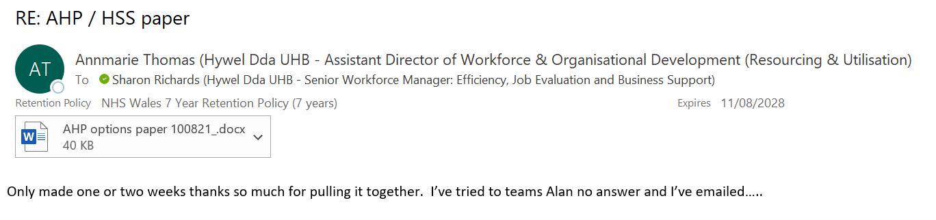
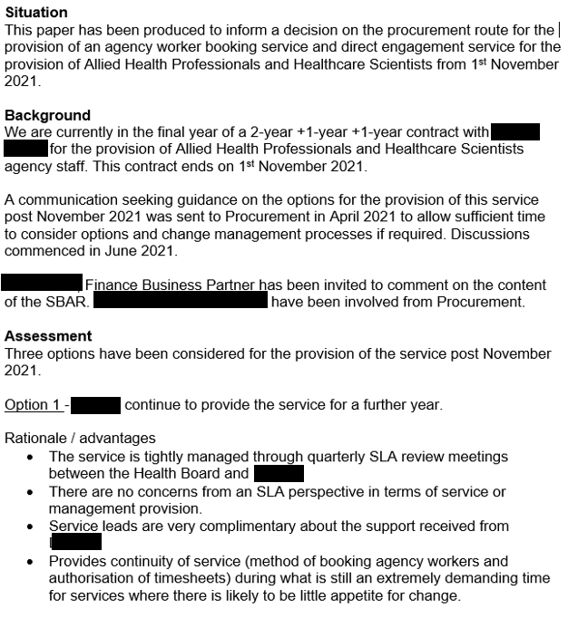

Evidence 1.2 – email confirmation of decision to Procurement

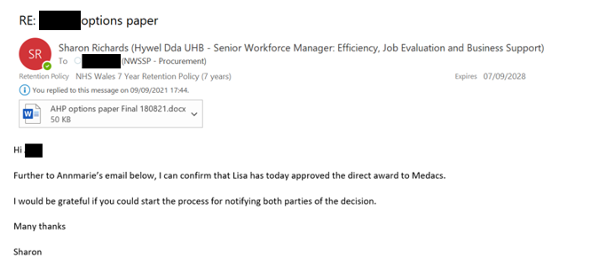

Evidence 1.3 – Stakeholder Map
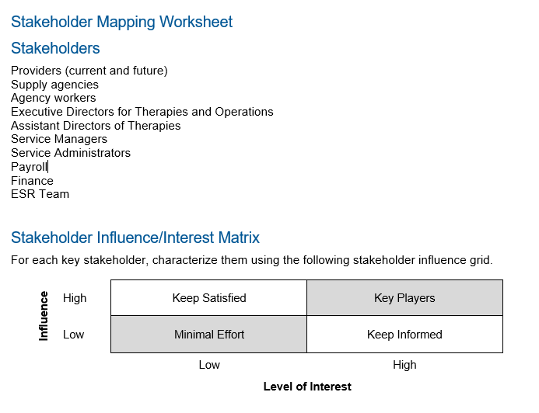

Evidence 1.4 – email communication to Executive Directors

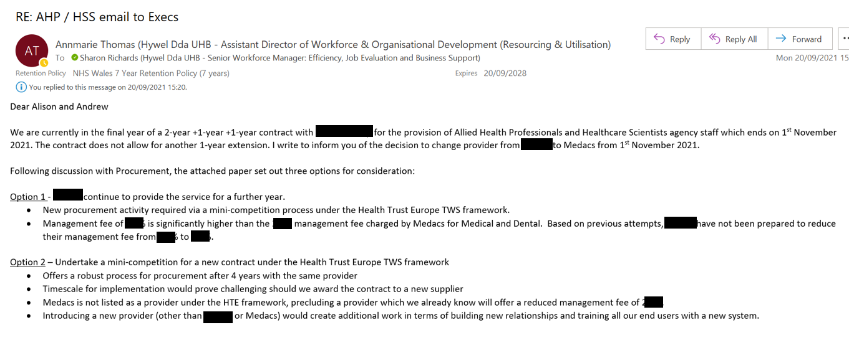
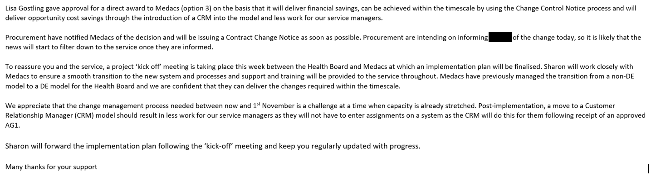

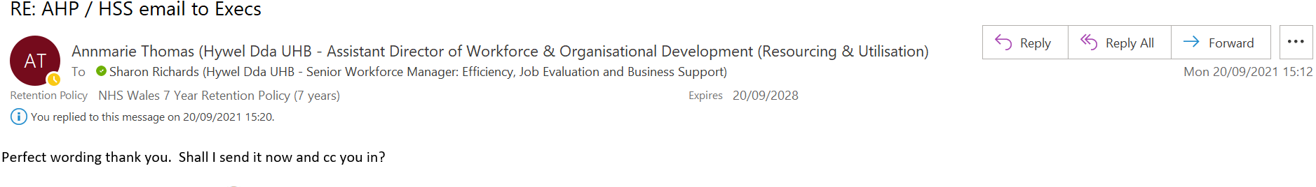

Evidence 1.5 – response to concerns raised by Executive Director

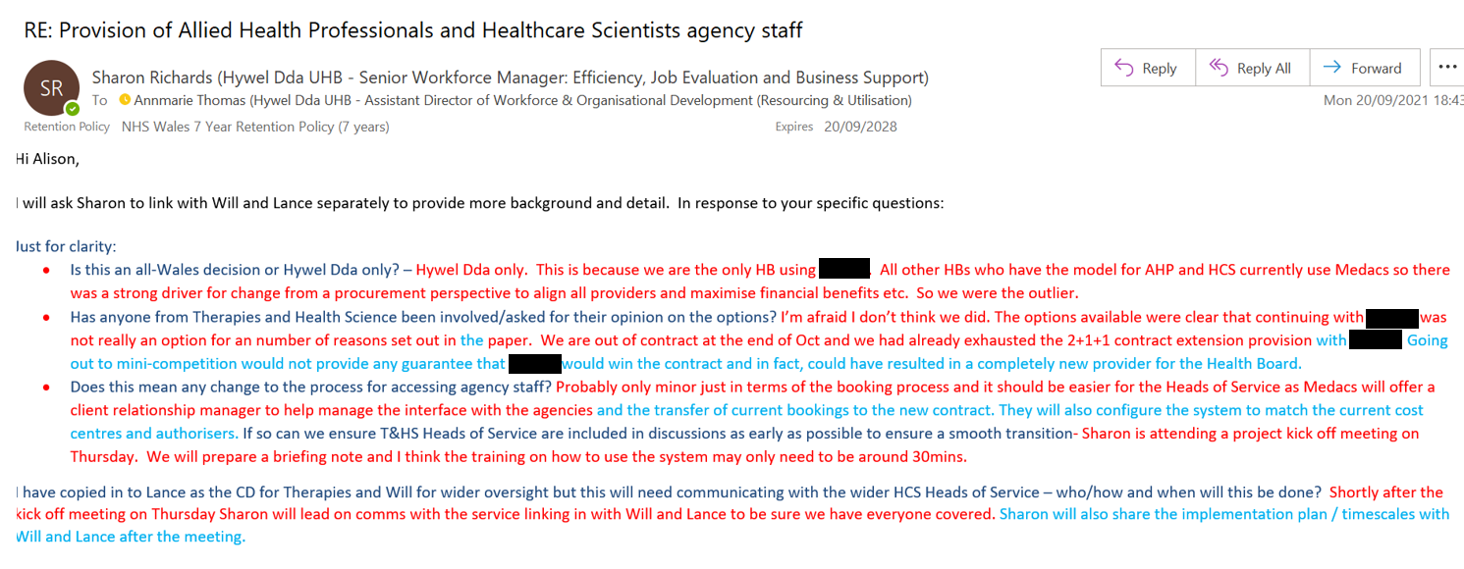

Evidence 1.6 – Change Plan

Allied Health Professional / Healthcare Scientist contract
Change Management Plan
Created by | Sharon Richards  Senior Workforce Manager: Workforce Efficiency, Job Evaluation and Business Support
Date | 12th August 2021
Vision and Objectives
To ensure the smooth transfer of the direct engagement model for the supply of Allied Health Professional and Healthcare Scientist agency staff from the current provider ‘Provider L’ to the new provider Medacs Healthcare from 1st November 2021.

Objectives are to:
- Communicate intended changes to stakeholders.
- Agree agency worker contracts.
- Migrate all financial cost codes and internal authorisers from old to new system.
- Maintain the same agency supply.
- Provide training, user guides and other information to services.

Activities to achieve objectives
Attached Gantt chart breaks down the actions required to implement the change, alongside the named leads, timescales and progress.

Business case
See attached SBAR

Stakeholders
See attached Stakeholder analysis.

Scope of change
This contract change relates to Allied Health Professionals and Healthcare Scientist temporary staffing across the Health Board. The provision of temporary staffing for the Nursing and Midwifery and Medical and Dental staff groups are covered by alternative arrangements.

Team
The Assistant Director of Workforce: Resourcing and Utilisation will provide sponsorship and strategic oversight of the contract change. Implementation will be project managed by the Senior Workforce Manager: Workforce Efficiency, Job Evaluation and Business Support on behalf of the Health Board and the Head of Workforce Solutions on behalf of the provider, Medacs.

Stakeholder map
See attached Stakeholder map.

Support to be offered
Information and training sessions for service staff will be provided by the Senior Workforce Manager for the Health Board and the Head of Workforce Solutions for Medacs during the last 2 weeks of October 2021. A user guide to the electronic platform and training videos will be provided following the training sessions.

The Client Relationship Manager for Medacs will provide full ongoing and daily support to services from ‘go live’ on 1st November 2021.

Timescales and milestones
See attached Gantt chart.

Resources required
- No financial cost
- Change in electronic system but no financial cost to the Health Board
- Project Management resource – Health Board and Medacs
- Training materials provided (electronically) – no financial cost to the Health Board
- Time investment from service staff to attend training sessions (max 1 hour)

Monitoring activities
- Regular implementation meetings between Health Board and Medacs
- Regular review of Gantt Chart to ensure the change remains on schedule
- Ongoing dialogue and feedback from service leads
- Regular 1:1 update to Line Manager
- Attendance at training sessions

An evaluation of the impact of the change will be undertaken within 3 months of implementation.

Success Measures
- No loss of service provision
- Clinical and admin time saved as a result of Client Relationship Manager model
- Rate and commission savings
- Positive feedback from services

Evidence 1.7 – Change Management Gantt Chart

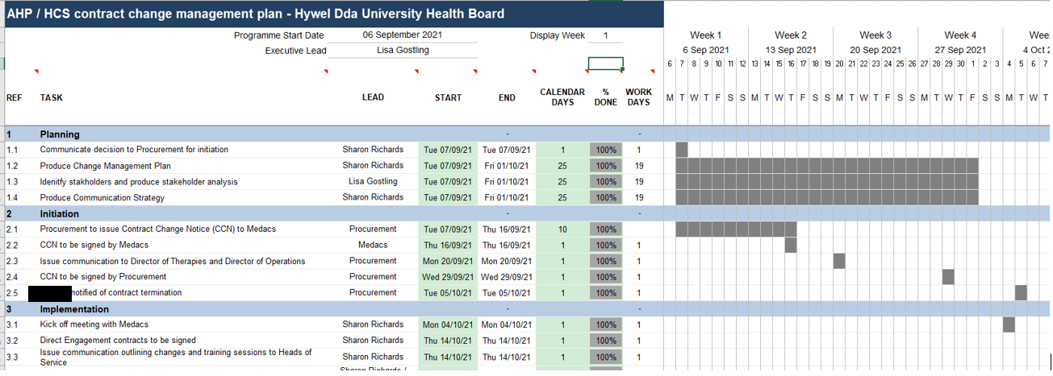
Learning Objective 2 – Implementing Change

2.1 Following the agreed plan to implement change processes.

The change process was managed through a Gantt Chart that set out the key activities and a system for tracking progress; this was critical for ensuring that, given the challenging timescales we were working to, that there was no loss of supply at the point of transfer. Medacs provided their own Gantt chart for tracking their actions required to allow the migration of agency workers from the existing supplier to themselves.

Ideally, planning for the change would have commenced much sooner than it did; however, there were some delays that were out of our control with delays in signing the Contract Change Notice (Gov.uk, 2006) and in issuing notice of termination to the current provider (Evidence 2.1 and 2.2)

The Implementation ‘kick off’ meeting was held on 4th October 2021 (Evidence 2.3)

One of the most time critical actions was to agree the employment contract between the agency worker and Health Board (Acas, n.d.). This was a complex task which involved a review of the existing medical contract and amending this to reflect the requirements for the AHP / HCS staff groups. The contract was signed and returned on 15th October 2021, one day later than planned (Evidence 2.4)

Other key actions completed included agreeing:
- Agreeing contract exit arrangements with the current supplier (Evidence 2.5)
- Agreeing payment arrangements with our Finance Department (Evidence 2.6)
- Agreeing rate breach approvers with our service leads (Evidence 2.7)

2.2 Providing information and support to stakeholders in line with their identified requirements.

As mentioned in 1.2 above, procurement delays meant that the planned changes were not communicated to services until two weeks before ‘go live’. Prior to communicating directly with services, I sought approval from the relevant Assistant Directors on the content of the communication (Evidence 2.8) and the agreed version was circulated on 13th October 2021 (Evidence 2.9). This communication was followed up with reminders on 25th October and 1st November (Evidence 2.10).

During the two weeks prior to ‘go live’ a number of information and training sessions were provided in partnership with Medacs. Service leads and service timesheet approvers were asked to commit to a one-hour information and training session Five sessions were run to maximise attendance and additional sessions offered to services if required (Evidence 2.11). In addition, along with Medacs I attended a Head of Service meeting with the Therapies team to deliver the same session (Evidence 2.12)

These sessions were supplemented with user guides, training videos and FAQs and the Client Relationship Manager for Medacs was available to provide full ongoing and daily support to services pre and post ‘go live’.

2.3 Applying techniques for maintaining positive working relationships throughout the change processes.

I was acutely aware of the pressure on services to adopt a new process in such a short space of time and was keen to maintain positive relationships during and post transition. I took the opportunity at the training sessions to provide some background to the change and to apologise for the short timescales involved. Both Medacs and I were also proactive in sharing the benefits of the new process to service staff, with a particular focus on the Client Relationship Manager role which would positively impact on service workload (Evidence 2.13).

A key risk for the Health Board was the failure to approve timesheets prior to the shutdown of the previous system, potentially leading to non-payment which could ultimately deter agency staff from working for the Health Board, creating service gaps. One such timesheet was identified which subsequently led to the identification of several other unapproved timesheets sitting on the system. I undertook an urgent exercise to request an extension to the timesheet approval deadline (Evidence 2.14) and to notify timesheet approvers of the need to approve by the deadline (Evidence 2.15).

I do not feel that the change has negatively impacted on my relationship or reputation with services or indeed with our new providers, Medacs. Feedback from senior managers has been positive, with no negative feedback reported to them (Evidence 2.16)

2.4 Monitoring the effectiveness of the implementation, agreeing and making justified adaptations where required.

As previously mentioned, the timescale for implementing the change was severely impacted resulting in a very short window to implement the change. However, all the change objectives set out in the Change Management plan (Evidence 1.6) were delivered successfully and on time. These were:
- Communicate intended changes to stakeholders.
- Agree agency worker contracts.
- Migrate all financial cost codes and internal authorisers from old to new system.
- Maintain the same agency supply.
- Provide training, user guides and other information to services.

Monitoring activities included:
- Regular implementation meetings between Health Board and Medacs.
- Regular review of Gantt Chart to ensure the change remains on schedule.
- Ongoing dialogue and feedback from service leads.
- Regular 1:1 updates to Line Manager.
- Attendance at training sessions.

2.5 Maintaining records of the change process in line with organisational requirements.

The change management process was managed via the following:
- a master Project Plan maintained by Medacs that set out all the actions required to transfer agency staff from the existing to the new contract (Evidence 2.17)
- a Gantt chart setting out the actions for us as a Health Board, including communication
- Regular progress catch up meetings between myself and Medacs (Evidence 2.3)
- Records of staff who attended training (Evidence 2.18)

Reference List

Acas (n.d.) Employment contracts: Agency workers. Available at Working through an agency: Agency workers - Acas. (Accessed: 15th November 2021)

Gov.uk (2006) Contract change notices. Available at Contract change notices - GOV.UK (www.gov.uk). (Accessed: 15th November 2021)
Evidence for Learning Objective 2

Evidence 2.1 – Copies of emails chasing communication of termination of contract

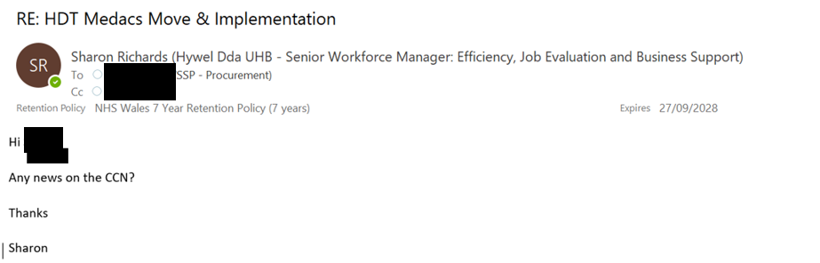
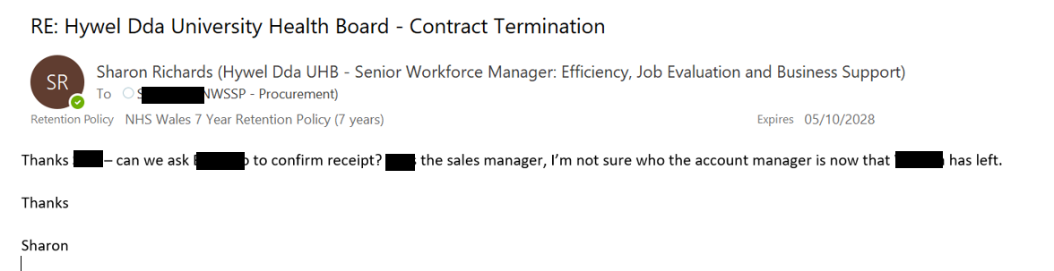

Evidence 2.2 – Copy of email chasing issue of contract termination notice

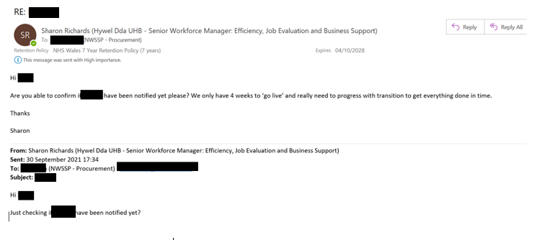

Evidence 2.3 – Extract of minutes and actions from implementation ‘kick off’ meeting
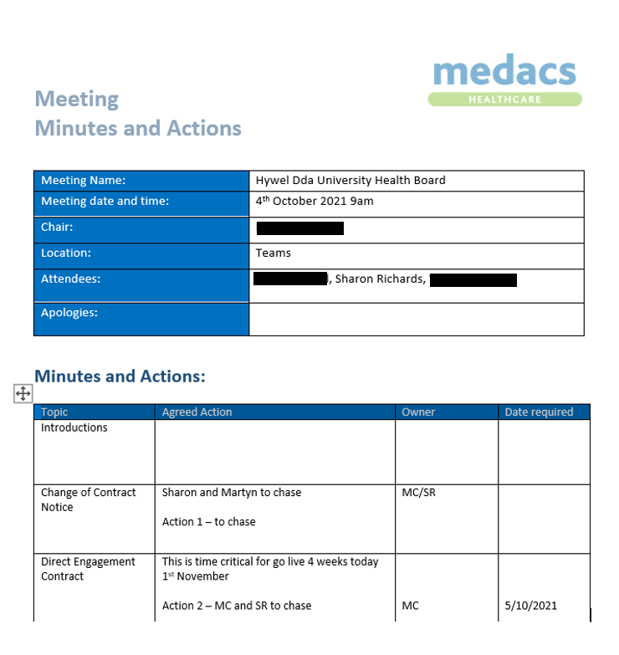

Evidence 2.4 – submission of signed contract

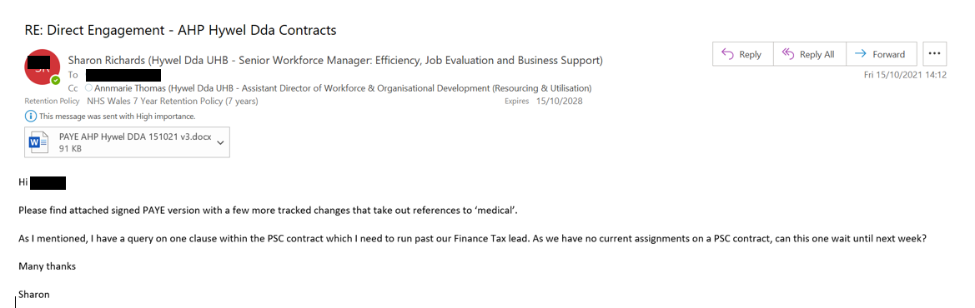

Evidence 2.5 – email from exiting provider following exit strategy meeting

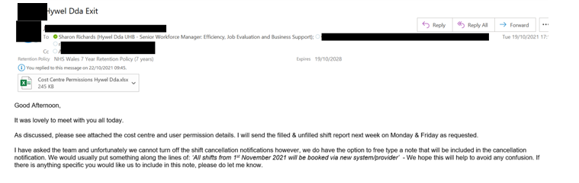

Evidence 2.6 – calendar invite for Finance-to-Finance call to agree payment arrangements
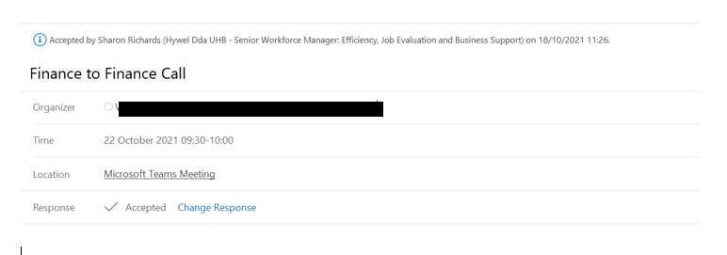
Evidence 2.7 – email seeking confirmation of rate breach approvers

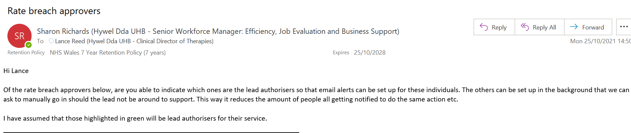

Evidence 2.8 – email to Assistant Directors seeking agreement to communication

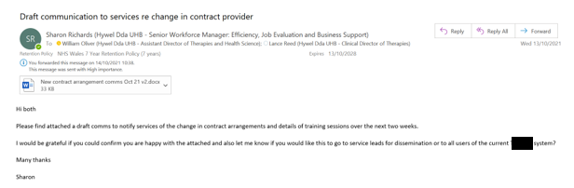

Evidence 2.9 – Extract of communication to services

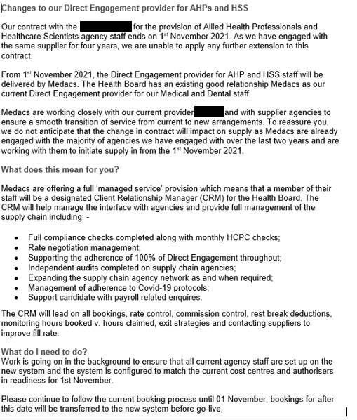

Evidence 2.10 – follow up communication emails

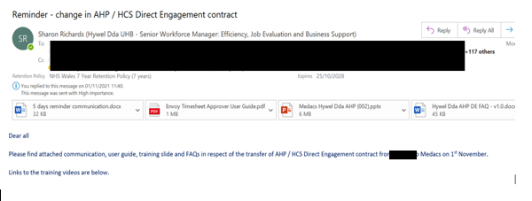

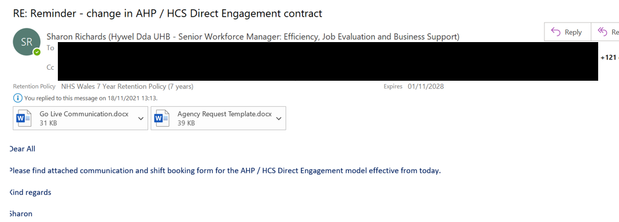

Evidence 2.11 – extract from communication to services showing training sessions

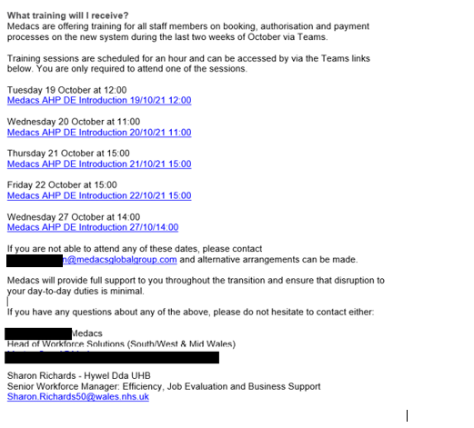
Evidence 2.12 – invitation to Therapy Managers meeting

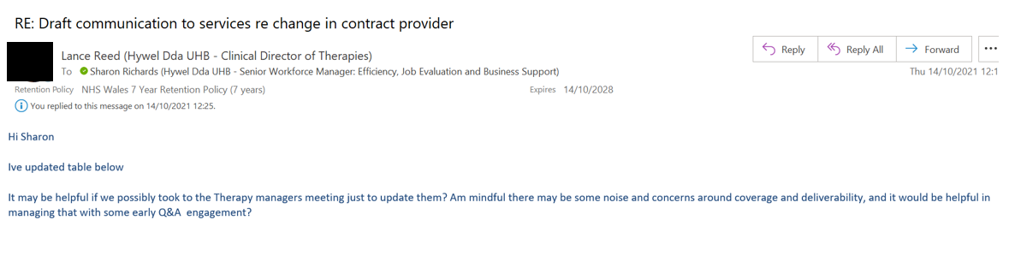
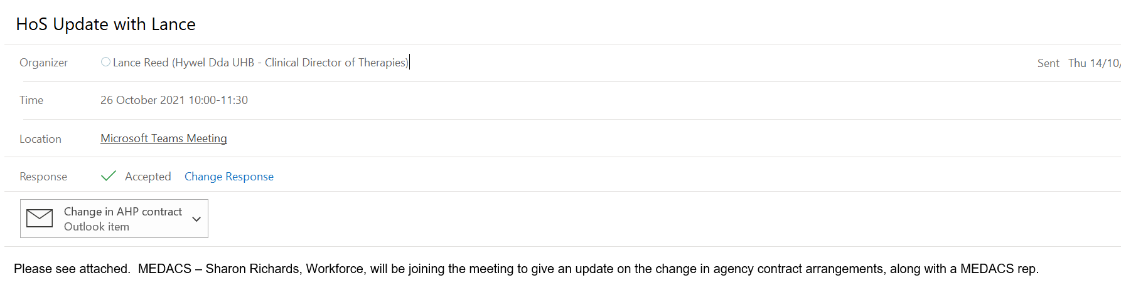

Evidence 2.13 – presentation slide showing benefits of Client Relationship Manager model

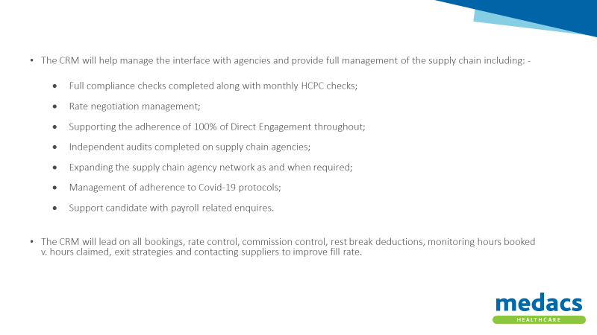
Evidence 2.14 – agreement to extend timesheet approval deadline

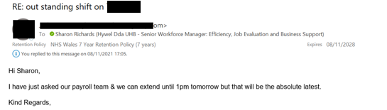

Evidence 2.15 – email to notify timesheet approvers of outstanding timesheets

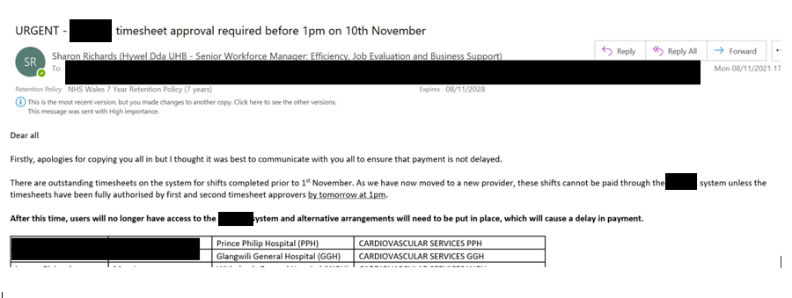

Evidence 2.16 – feedback from senior managers post-change

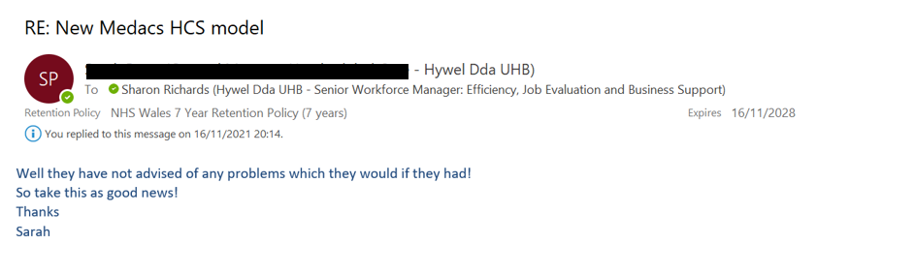
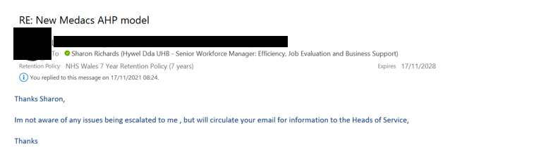
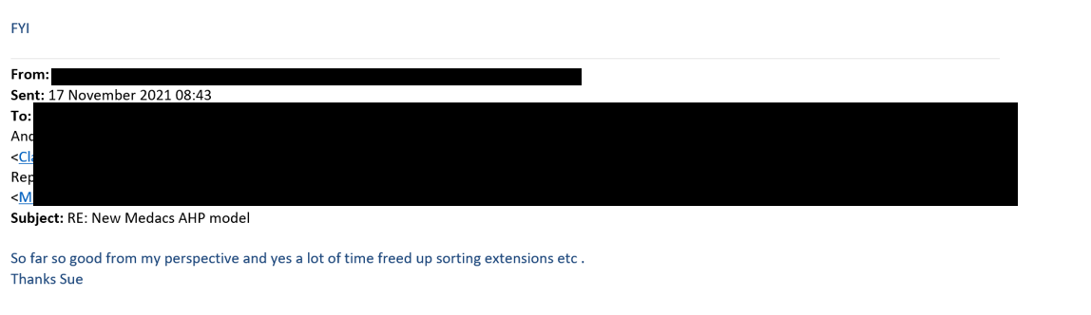

Evidence 2.17 – Medacs Project Plan

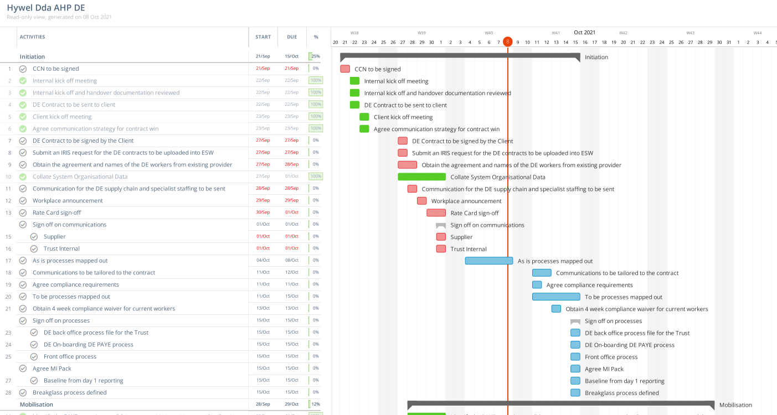

Evidence 2.18 – Extract of training attendance record

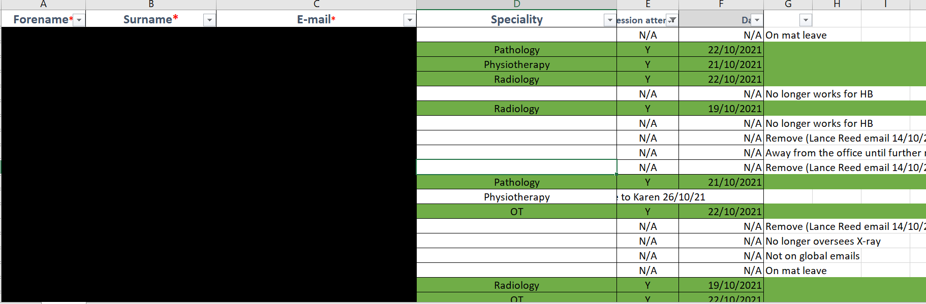
Learning Objective 3 - Assessing the impact of the change process

3.1 The effectiveness of the change process in meeting the required objectives

As well as the successful delivery of the change objectives highlighted in 2.4 above, the effectiveness of the change process will be dependent on several success measures. These are that:
- There was no loss of service provision.
- Clinical and admin time were saved as a result of the Client Relationship Manager model.
- Savings were realised in respect of both rate and commission charges.
- Feedback from services was positive.
Whilst it is too early to confidently report that all the success measures have been met, I am able to confirm that there was no loss of service provision during the change process.

As part of the transfer of agency workers from the previous supplier to Medacs, Medacs were successful in negotiating commission reductions for 12 assignments, giving a total reduction of over £2,000 in the first three weeks of November 2021 (Evidence 3.1).

Some brief feedback from services has been received giving an indication that the change will bring benefits (Evidence 2.16). However, I do plan to undertake an evaluation of the impact of the change early in 2022. This will include seeking feedback from services via an online questionnaire, feedback from Medacs as part of regular Service Level Agreement (Keystone Law, 2012) meetings and an analysis of variable pay spend (NHS England, 2021).

3.2 Further work required to embed changes and/or further developments required.

The new arrangements are continuing to embed across services who have recently used agency staff. However, there are some services who have not historically used agency staff and will not necessarily understand that a central process is in place (Evidence 3.2). Thought needs to be given to how this is communicated across all services to ensure that services explore opportunities to cover shifts via alternative arrangements, such as filling shifts internally or using bank workers, prior to seeking agency workers. Conversely, if services are not aware of the process, there is a risk that they could engage directly with agencies who are not on a framework where there are no agreed rates and commissions and no recorded due diligence checks on the supplier. This is something that will be considered with Medacs and our Finance team in due course.

Looking towards the medium-term, as well as opportunities for commission rate savings, adopting a ‘reduce and replace’ strategy (Medacs, n.d.) for each booking will enable the Health Board to control costs and realise savings for existing bookings. Exit strategies for all agency workers will be developed and monitored regularly as part of the SLA management, prioritising long-term, high-cost agency workers seeking to reduce cost via the offer an NHS contract or where this is not an option, negotiating lower rates, or replacing with a lower cost worker.

3.3 Communicate the key outcomes and the impact of change to stakeholders.

Within three months of implementation, I intend to conduct a benefits realisation (APM, 2019) of the change process. Whilst this will include a focus on financial benefits, it will also consider the impact of the change on the people affected by the change – our stakeholders (Evidence 1.3). Impact will be measured via:
- Questionnaires seeking feedback on the effectiveness of the change process.
- Questionnaires seeking feedback on the impact of the change in terms of efficiency, budgets, relationship management, agency worker satisfaction and patient care.
- Regular meetings with Medacs to monitor SLA compliance.
- Attendance at Service Lead meetings to discuss operational issues.
- The tracking of ad hoc queries received from stakeholders.

A benefits realisation report encompassing the above and including lessons learned will be produced and presented to the Health Board’s Workforce and Information Systems (WfIS) Programme Group (Evidence 3.3).

3.4 Evaluate the effectiveness of own performance in contributing to the management of change.

As part of my own professional development, I tend to reflect on how I performed in a particular task, in a meeting or on a bigger project. Self-assessing your own performance is important to be able to identify areas of potential improvement (Uzialko, 2021).

Reflecting on this change management process, I feel that I demonstrated:
- Collaborative working with both our managed service provider and our services which I feel consolidated a positive relationship with both.
- An ability to problem-solve, rarely, if at all needing to refer to my line manager for a decision.
- An ability to work under pressure – the change process was successfully implemented in less than four weeks.

However, through this process I have identified some areas of self-development:
- Earlier planning – whilst there was an extremely short timescale for implementation, in hindsight, there were some activities that I could have focused on at an earlier point in the process, for example the development of a communications plan.
- Seeking to understand – I realise that I tend to defer tasks or actions if I don’t fully understand an issue. In future change projects, I need to be more proactive in seeking to understand by asking questions and seeking advice from the subject experts.

My line manager, Annmarie Thomas, Assistant Director of Workforce, has provided confirmation that I led the implementation of the change process without issue (Evidence 3.4).

I have also received feedback from the new provider on my contribution to the change process from their perspective (Evidence 3.5).

Reference List

APM (2019) Benefits management – an opportunity not just a process. Available at Benefits management – an opportunity not just a process | APM. (Accessed: 23rd November 2021)

Keystone Law (2012) Service Level Agreements. Available at Service Level Agreements (keystonelaw.com) Service Level Agreements (keystonelaw.com). Service Level Agreements (keystonelaw.com) (Accessed: 22nd November 2021)

Medacs (n.d.) Staff Bank. Available at Staff Bank | Medacs Healthcare. (Accessed: 22nd November 2021)

NHS England (2021) The 2021/22 aligned payment and incentive approach. Available at Consultation on the 2021/22 national tariff (england.nhs.uk). (Accessed: 22nd November 2021)

Uzialko, A (2021) ‘Self-Assessment: 5 Tips for Writing Your Performance Evaluation’ in Business News Daily. Available at How to Write a Performance Evaluation Self-Assessment - businessnewsdaily.com. (Accessed: 23rd November 2021)

Evidence for Learning Objective 3

Evidence 3.1 – commission savings summary
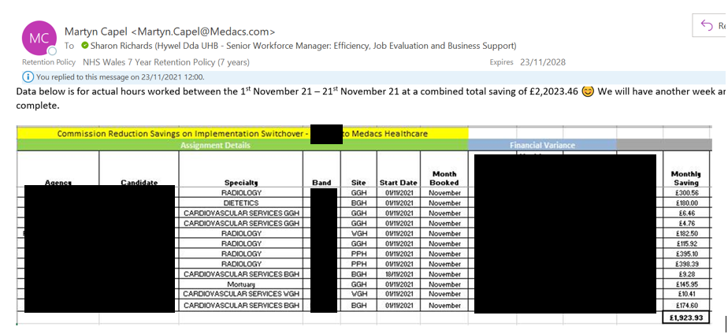

Evidence 3.2 – Email from service lead seeking advice on booking an agency worker

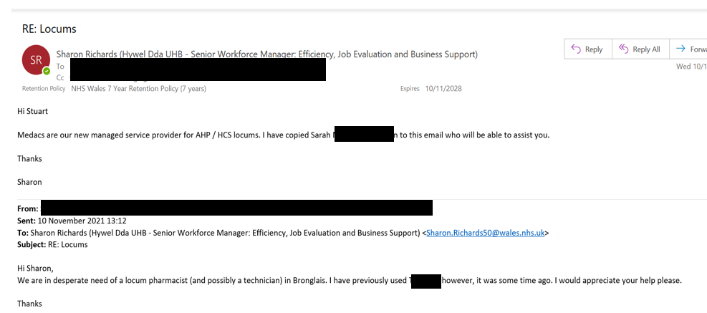

Evidence 3.3 – Extract from WfIS Programme Group
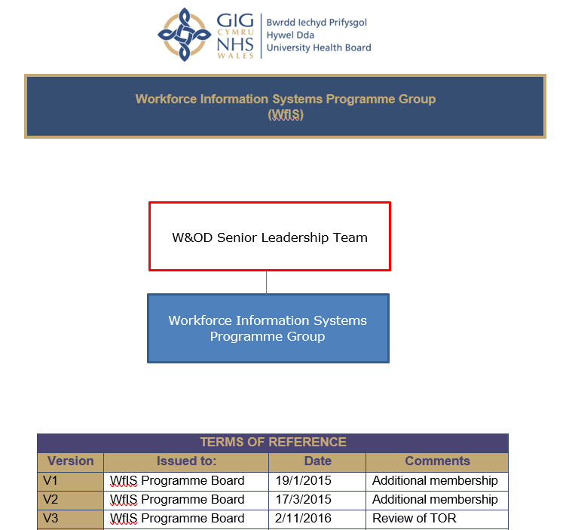

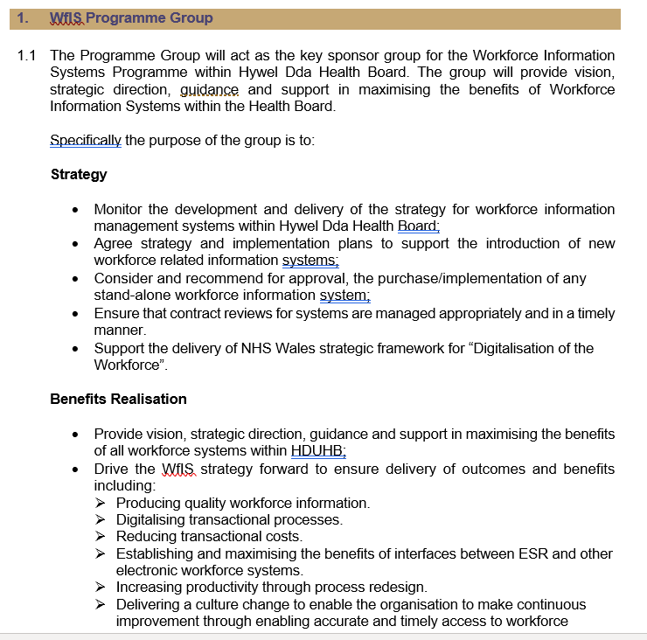

Evidence 3.4 – Email from line manager confirming my contribution to the change management process
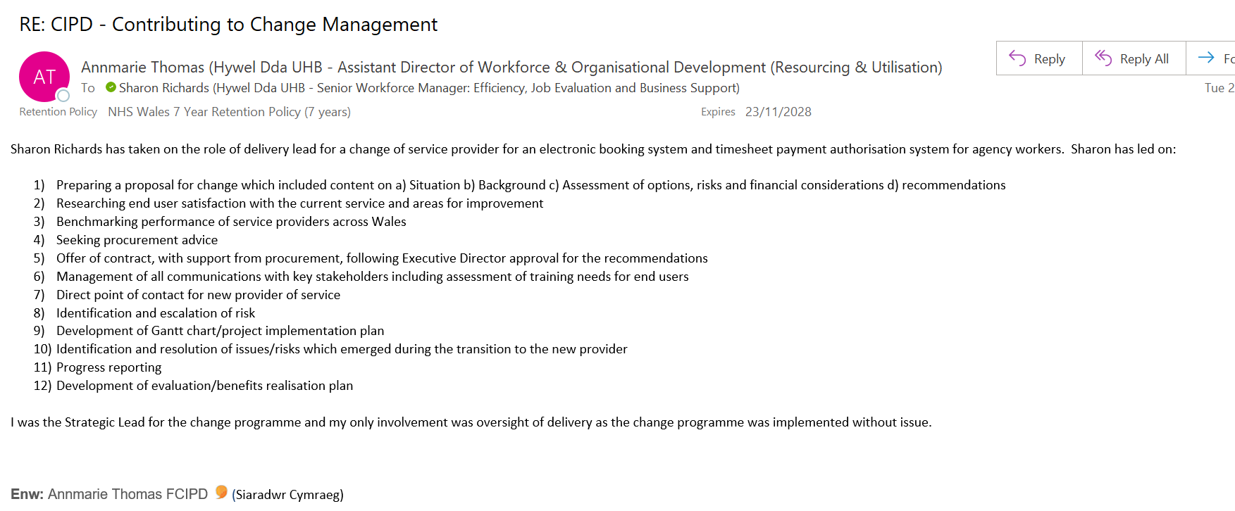

Evidence 3.5 - email from new service provider confirming support and contribution to the change management process



