13/12/2025
UNIVERSITY OF WALES TRINITY SAINT DAVID
LONDON CAMPUS
Cybersecurity Resilience Strategy Report
Computing Assignment

Couse Name: Network and Cybersecurity Essentials
Course Code: ACCA4024
Student Name: Hamdan Khan Sadozai
Student ID: 2426725
Lecturer Name: Dr Amit Naik


Table of Contents
Introduction 1
1. Identification of Modern Threats 1
2. New Security Policies 3
3. Technical Mitigation Measures 3
4. Proactive Monitoring and Incident Response 5
5. Continuous Training and Awareness 5
Appendices 6
Appendix A: Zero Trust Architecture Diagram 6
Appendix B: Incident Response Flow Chart (SIEM/SOAR) 7
Appendix C Presentation Slides (10-Minute Outline 9
Conclusion 9
References 9

Introduction
This report outlines a strategic plan for VTAM (Vigilant Trust & Asset Management) to address the need for a new cybersecurity framework due to the fact that VTAM's previous network based approach is not able to defend against the rapidly evolving threats present in today’s society. VTAM has grown rapidly, leading to major changes in how we handle data. Employees now regularly work from home and use their own devices. Because of this growth and the new hybrid work model, our old security walls (edge-based methods) are no longer effective.

1. Identification of Modern Threats
The initial step for tightening up our defences is to conduct thorough research, so that we can better understand the threats currently targeting financial services and place them into a "zero trust" framework, in which we operate on the assumption that the threat actors are already inside the network [5].
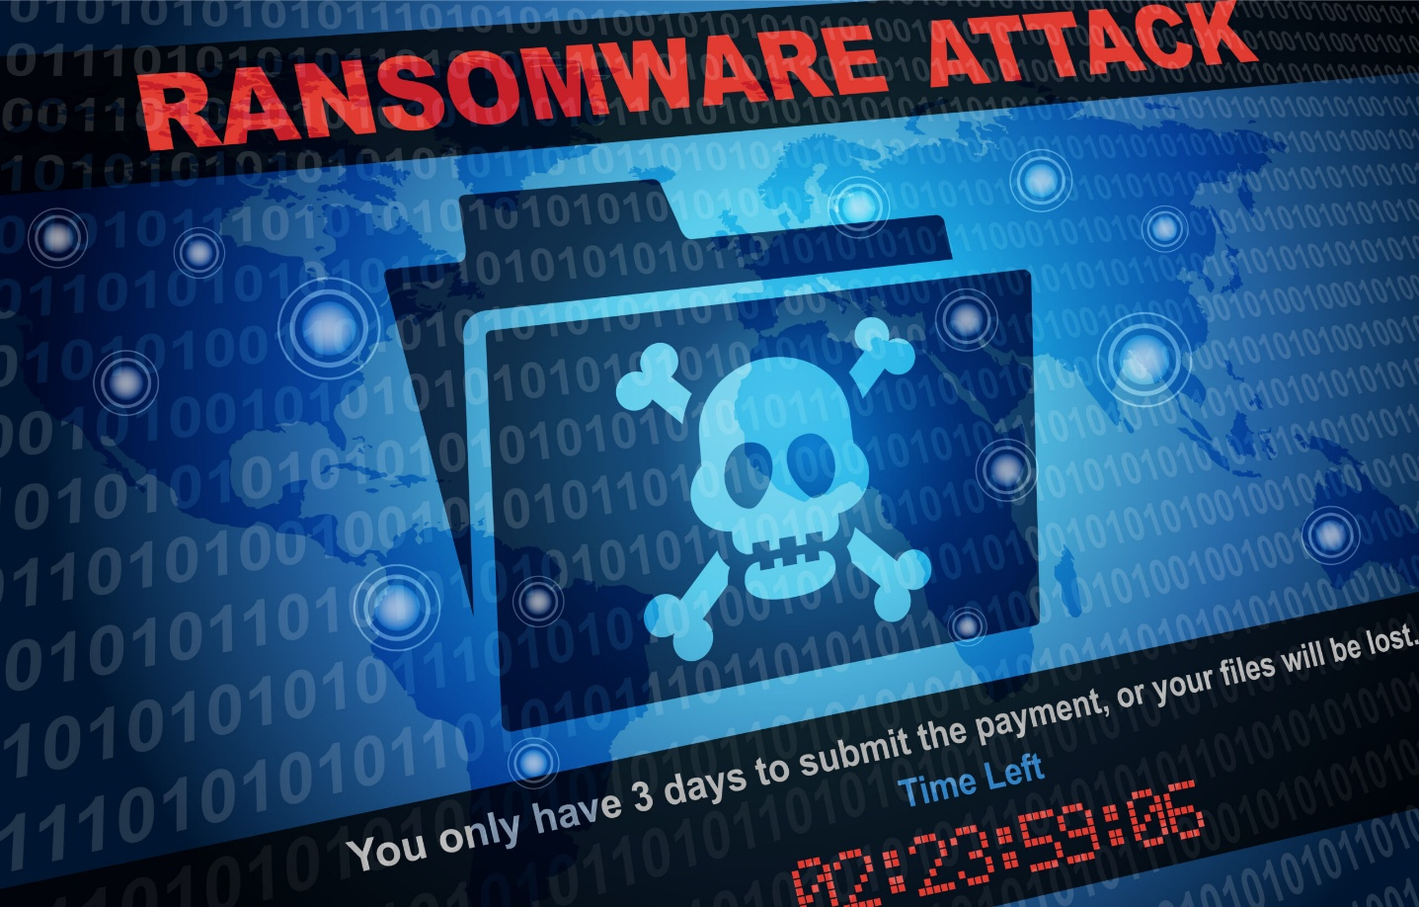
The most financially damaging threat facing VTAM is Ransomware as a Service (RaaS), which frequently begins with successful social engineering or the use of stolen credentials [1]. RaaS groups have increased the risk by introducing double extortion tactics. They first steal data, threatening to expose it (a risk to client Confidentiality), and then they encrypt the organization's systems (a risk to business Availability). While external breaches are a problem, the ability of attackers to use social engineering tactics still remains the most successful way to breach a system [1].

In addition to these direct attacks, the complexities of our IT infrastructure create other critical risk factors. Attackers can gain an entry point into our network through a supply chain compromise, by successfully targeting a trusted third party vendor which means we cannot blindly rely on vendors without continuous verification [5]. Furthermore, the use of public cloud services and our hybrid workforce presents risks, as simple human errors such as mistakenly configuring cloud storage can result in catastrophic data leaks, violating the data confidentiality principle [1]. Therefore, utilizing a Zero Trust Architecture (ZTA) is the necessary solution, as it addresses all these borderless threats by providing security at every point of access, no matter the owner of the asset or where it is located [5].

2. New Security Policies
To effectively achieve a Zero Trust security posture, we must transition from managing network borders to managing access to data and services. The Continuous Verification Policy is one of the most critical aspects of the ZT approach. It requires explicit authentication and authorization of all access requests to a resource, regardless of where the user is located or whether they have previously authenticated [5].
The Policy Engine verifies user access based on real time information regarding their identity, the status of the user's device, and their behavior. This process assigns them a trust score for granting or denying access. The Least Privilege Access Policy is implemented alongside this, allowing only the minimum rights necessary for each task performed by users and systems. This principle is crucial in protecting the users and systems from lateral movement as well as limiting the damage if an account or device has been compromised [5].
The Data Classification Policy serves as the basis for protecting VTAM's assets. It therefore fulfills the ISO 27001 compliance requirement for protecting the Confidentiality, Integrity, and Availability (CIA) triad [2]. This policy requires that all VTAM data be classified in detail by level of sensitivity. It also requires that additional security controls, such as advanced data encryption during transport and when in a dormant state, be adhered to. The classification connects policies that protect assets and data, ensuring ZT resources are secured according to their classification [5]. Lastly, the Endpoint Posture Policy outlines that all connecting devices (PCs, cellular devices, tablets) will continuously validate their level of security. This means they must have recent security updates, operate with approved endpoint protection, and otherwise conform to acceptable configuration prior to granting access. The Endpoint Posture Policy is a dynamic security measure that affects user access decisions in real time [5].

3. Technical Mitigation Measures
Technical mitigation strategies are necessary components of the overall security program to prevent accessed by malicious actors and are primarily partnered with the Protect Function of NIST Cybersecurity Framework (CSF) to provide a more secure environment [4].

An approach simply to patch everything after identifying the threat is not effective and impractical due to the backlog of thousands of vulnerabilities faced by many organizations. For this reason, VTAM must adopt a strategic process that focuses on prioritizing vulnerabilities based on real world risk and addressing vulnerabilities using a technical mitigation [3]. VTAM will directly monitor and fix vulnerabilities that are known to have been exploited by attackers, using data supported by CISA. This is the most efficient way to focus limited resources on fixing flaws that are most likely to be used in attacks, such as Ransomware as a Service intrusion, which will improve VTAM's overall defensive posture [1].
Organizations must use a Third Party Provider to deliver Multi Factor Authentication (MFA) to all employees at every Access Point. These points include Virtual Private Networks (VPN), Cloud Applications, and Internal Systems. This control supports the organization's continued efforts in enforcing the Continuous Verification Policy [5].
To further support the enforcement of a Least Privilege Policy, and prevent Ransomware as a Service (RaaS) from quickly spreading laterally, an organization's network must be segmented into small, secure segments by using a technology called Micro Segmentation . In the case of VTAM, Micro Segmentation will logically segment their internal network into small, secure zones. By default, access to communicate or share data with another zone will be denied unless explicitly granted by a Policy Enforcement Point following Zero Trust Verification [5].
To reduce the risk of Cloud Misconfiguration, and Ransomware as a Service (RaaS) Extortion, an organisation must take two complementary approaches. First, organisations should use a Cloud Security Posture Management (CSPM) Tool. The CSPM Tool should continuously scan all Cloud Services for misconfiguration errors, informing Administrators about any violations to Policies, and also reducing the possibility of accidentally exposing data that is sensitive, whilst providing an organisation insight into vulnerabilities [5]. Second, an organisation should use Immutable Backups, which is required under the NIST Cybersecurity Framework (CSF) Recover function. Immutable Backups will store all critical Client and Operational Data in a format that is immutable and non erasable, and therefore cannot be deleted or encrypted by a Ransomware attack, and therefore also provides VTAM with a mechanism to restore its Operations to Full Functionality, without the need to pay a Ransom [4].

4. Proactive Monitoring and Incident Response
As part of its Cybersecurity Program, VTAM must implement a proactive approach to Incident Response. This approach should use a wide range of detailed logs, not just basic Event Logs, to successfully capture, analyze, and fix security issues.

A Security Information and Event Management (SIEM) system is required as the central nervous system for security [4]. The central function of a SIEM is to enable an organization to collect, aggregate, and analyze security logs and telemetry from all of the organization's technical security controls (MFA, EDR, CSPM, and micro segments). A SIEM acts as a trusted intermediary that allows organizations to correlate security events for disparate systems. This enables detection of atypical or anomalous actions that indicate security policy violations or intrusions, which is part of the Detect function of an organization’s security program [4].
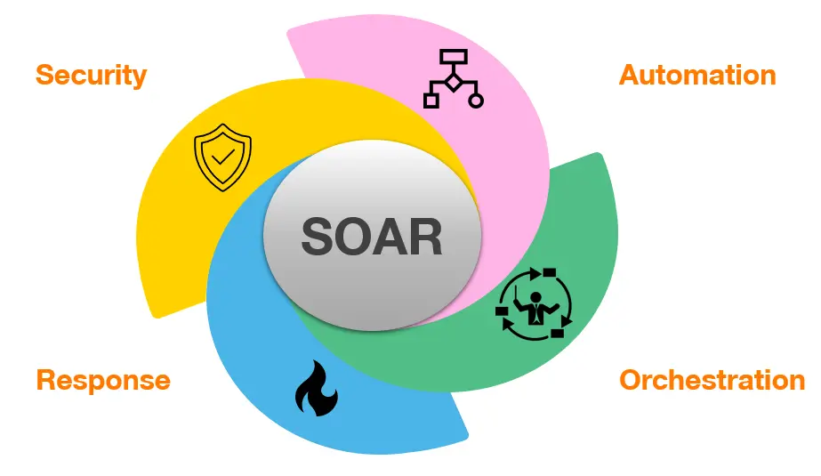
The response to an incident must be immediate because RaaS threats spread quickly. As such, a Security Orchestration, Automation, and Response (SOAR) platform should be integrated directly into the organization's SIEM. In the case of a confirmed high severity incident, such as the detection of known malicious code on an endpoint, the SOAR system will automatically execute an established playbook. This playbook contains a series of procedures that help contain the incident. For instance, if an organization's SOAR system detects malware on an endpoint, it will immediately isolate the endpoint and revoke all access tokens for that user, typically within seconds [4]. Automating the containment process reduces the scope of the initial breach and is a component of the Respond function of the organization's security program. The SOP for this process should mirror the traditional security lifecycle workflow of Detect (SIEM), Contain (SOAR), Investigate, Eradicate, and Recover (from an Immutable Backup) [4]. This repeatable process will be illustrated in an accompanying Incident Response Flow Chart.

5. Continuous Training and Awareness
Because the human element is the final line of defense against social engineering (see [1]), there must be ongoing training. This training should satisfy the requirement for continuous training and competence that is provided for in the Protect Function of the NIST Cybersecurity Framework (CSF), as well as the competence and training requirements of ISO/IEC 27001:2013 [2].

The increasing use of social engineering to launch Ransomware as a Service (RaaS) attacks, along with the rise of vishing, means that our basic email filters are no longer enough. Because attackers primarily target employee login details, the training program must be more thorough than simple annual courses. It should include using randomized simulated phishing campaigns to test employees' vigilance in their email inboxes regularly. Furthermore, the program should also feature vishing and smishing simulations (voice and text) so employees are prepared to handle fraudulent attempts that use artificial intelligence to impersonate others. This prepares staff to recognize deepfake voice technology and other deceptive tactics [1].
Each role within a company will receive role specific training, such as training on additional verification protocols for employees who have financial authority. The training will help to instill a culture of awareness, where employees are encouraged to report potential breaches of security without fear of persecution [4]. This is vital to maximising the value of the Detect Function for the entire organisation.

Appendices

Appendix A: Zero Trust Architecture Diagram
The Zero Trust Architecture depends on the Policy Engine to make all decisions about granting access. This decision is based on checking the user, their device, and the specific resource they are asking for. This diagram illustrates the core parts of the ZTA model. It confirms that no one is trusted automatically, and access is only given after the Policy Engine confirms verification [5].
(ZTA Diagram)
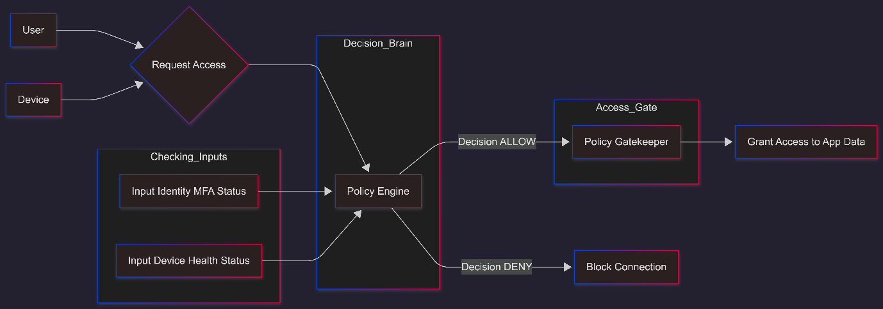

Appendix B: Incident Response Flow Chart (SIEM/SOAR)
This flow chart outlines VTAM's streamlined process for rapidly handling a security incident, which shows the importance of automation and immediate containment. It follows the NIST CSF functions of Detect, Respond, and Recover [4].
(SIEM/SOAR Incident Response Flow Chart)
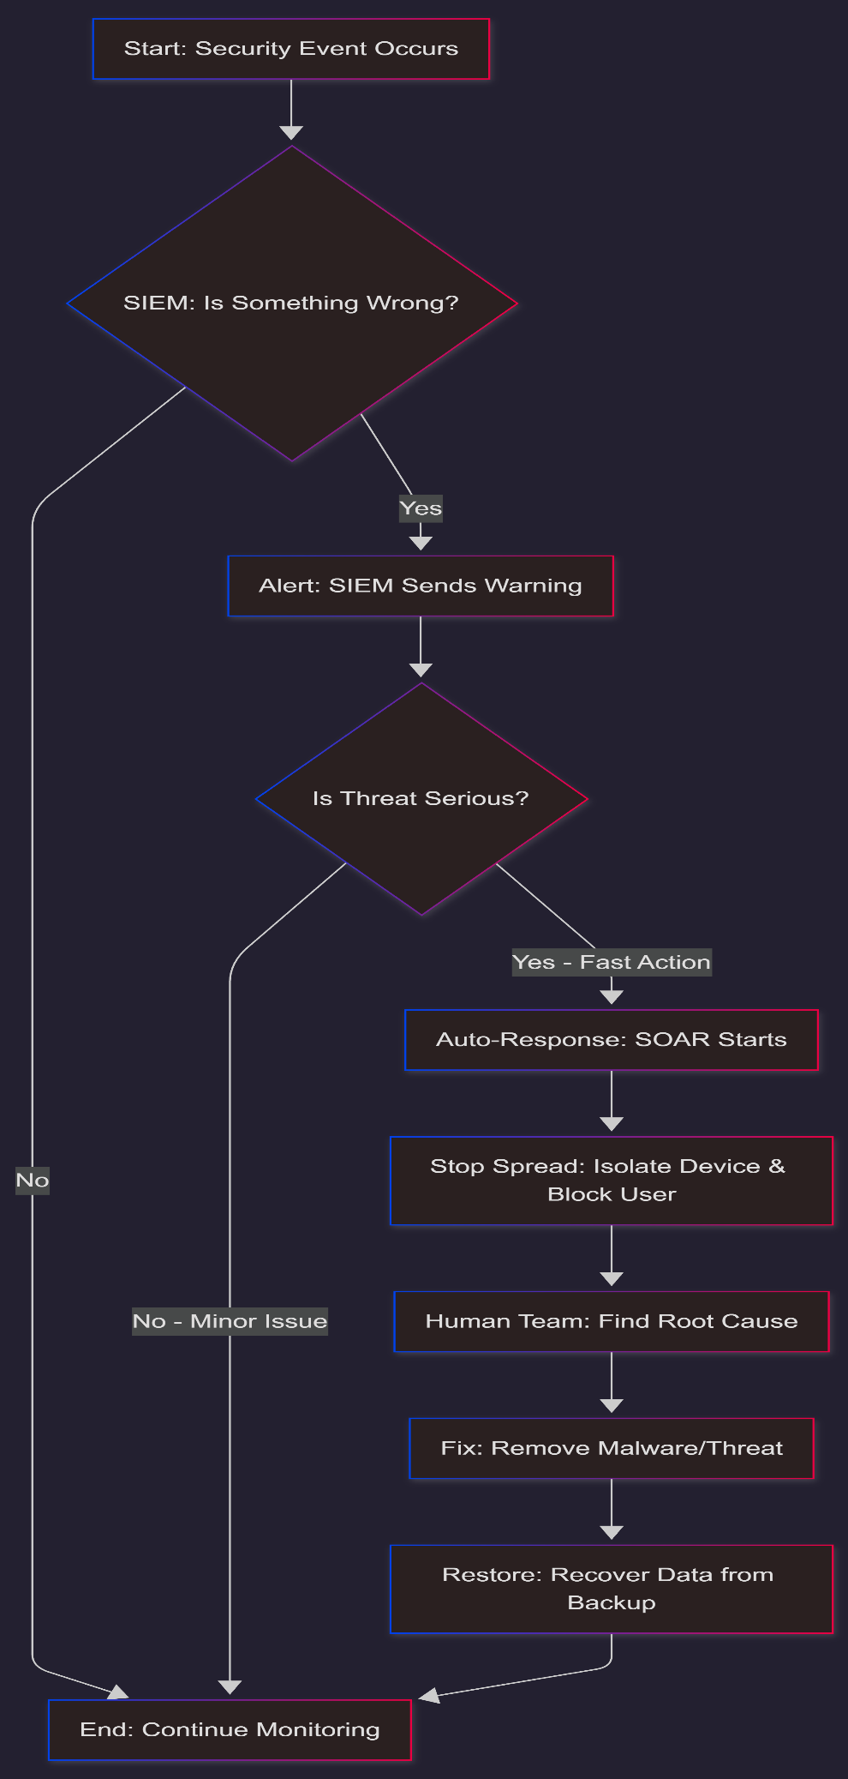

Appendix C Presentation Slides (10-Minute Outline
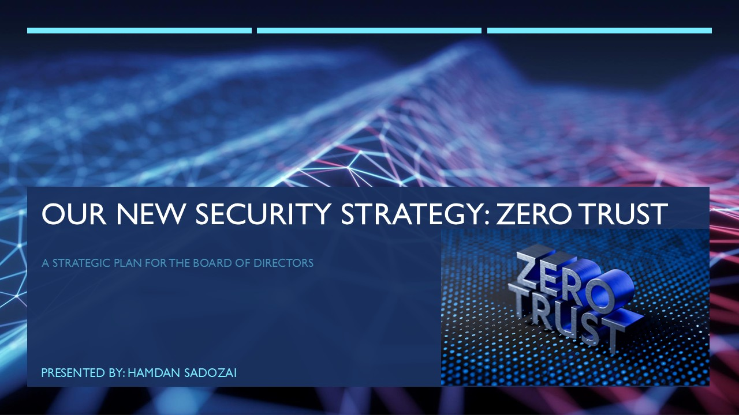
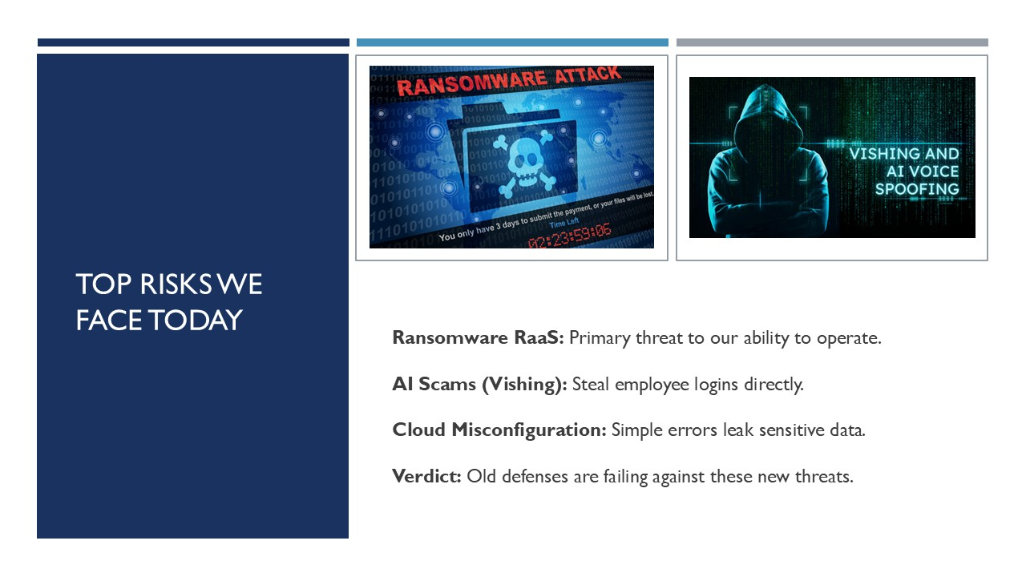
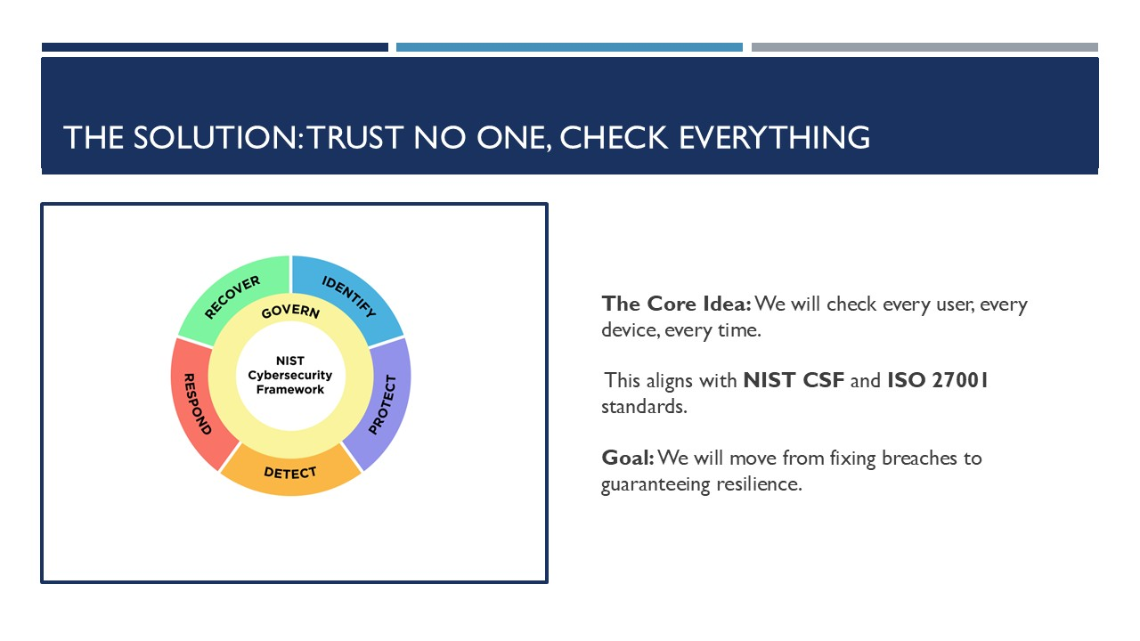
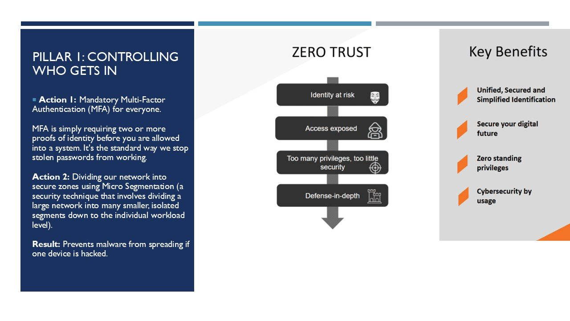
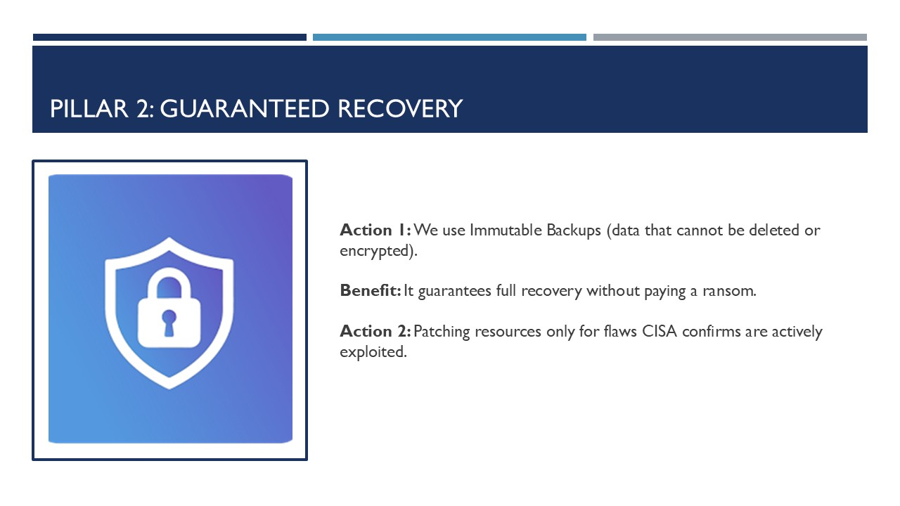
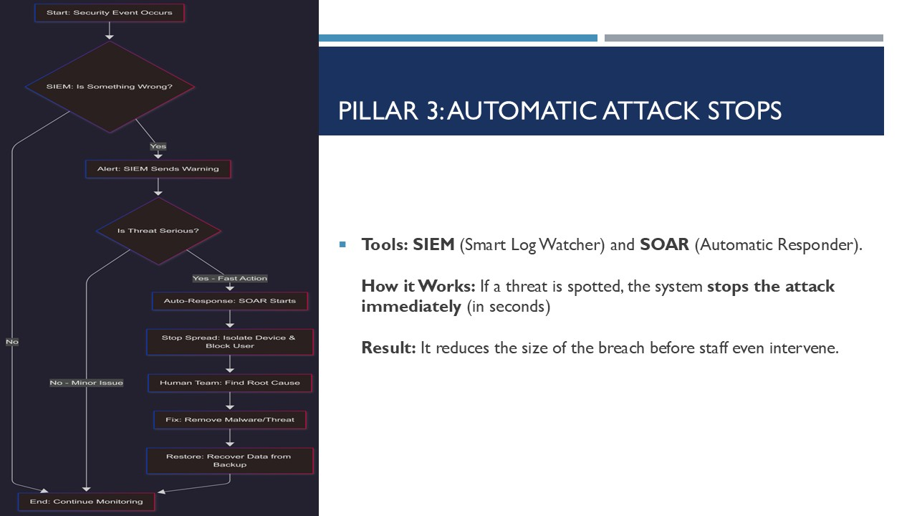
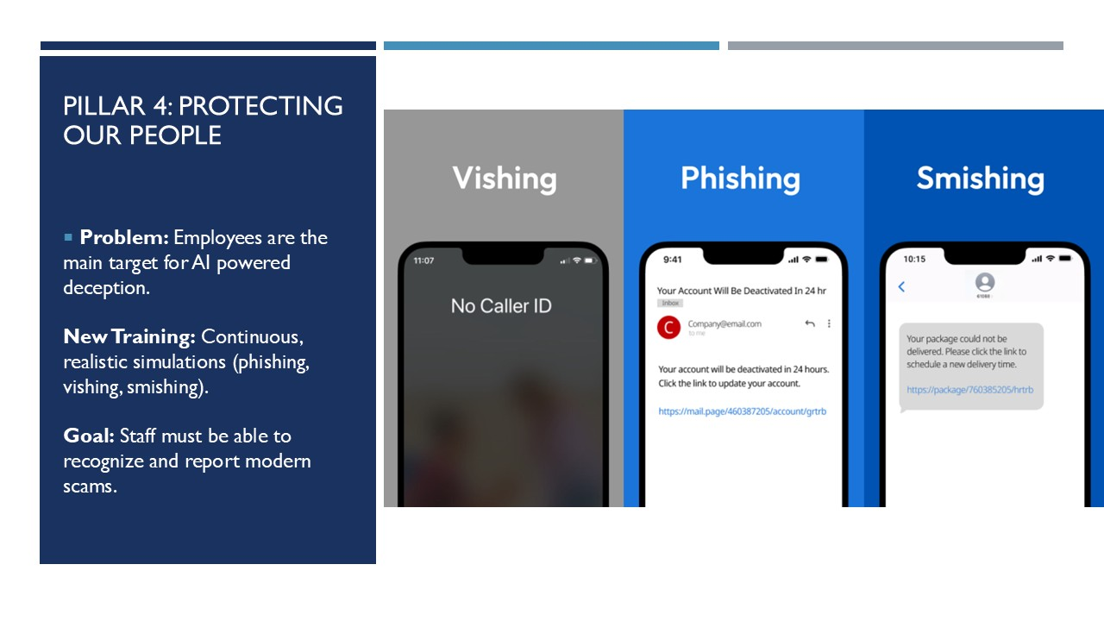
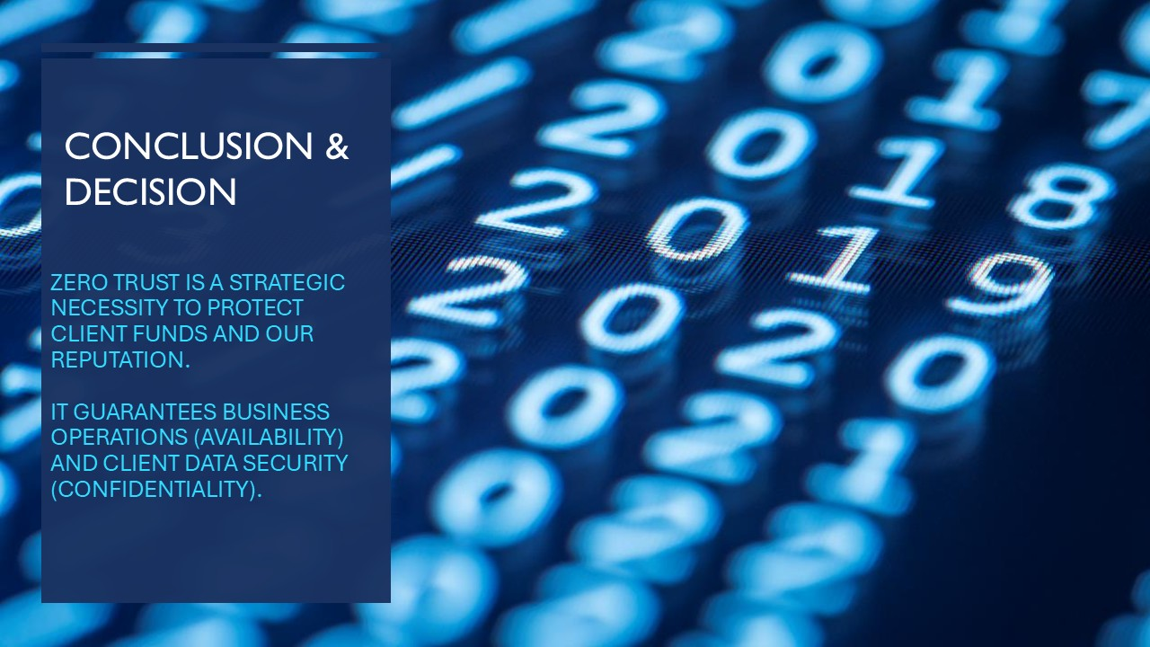

Appendix D: Cisco Packet Tracer Completion Certificate
The certificate has been included here as I attempted to submit it through the certificate submission link to the Moodle portal as requested but I encountered an error with the link provided.
Here is the link to the pdf file of my certificate along with a screenshot.
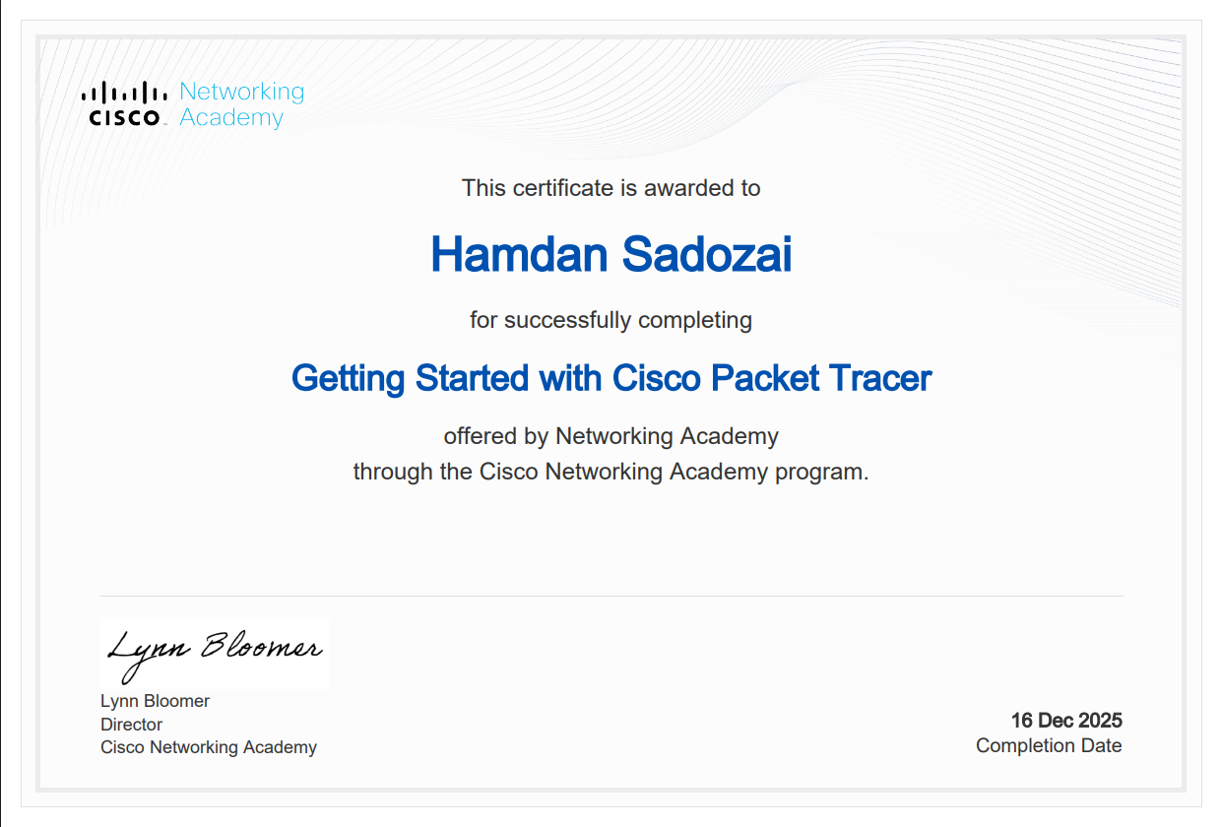

Conclusion
Ultimately, VTAM must make use of a comprehensive security model utilizing Zero Trust Architecture in order to secure its most valuable assets from dangers. We will use ISO 27001 governing rules as our policy sources and the NIST CSF Security Lifecycle as our procedural basis [2, 4]. This approach will further establish protection that is both sustainable and measurable.
We will achieve risk reduction through accurately targeting and justifying the key actions. These include mandating Multi Factor Authentication (MFA), implementing appropriately characterized immutable backups, and using strategic prioritization to apply necessary patching [3]. This entire effort will be measured using a metric based system to guide continuous improvement and strategic planning [3].
Therefore, VTAM must develop this framework to reduce the business risk demonstrated by cyber incidents, deliver assurances of Confidentiality and Availability to its customers, and continue to earn their confidence in today’s borderless environment. Implementation of this Framework is essential.

References
[1] A. Bello and A. Maurushat, "Synthesis of evidence on existing and emerging social engineering ransomware attack vectors," in Cybersecurity Issues, Challenges, and Solutions in the Business World, IGI Global Scientific Publishing, 2023, pp. 234–254.
[2] A. Calder, Information Security based on ISO 27001/ISO 27002, Van Haren, 2020.
[3] J. Edwards, A comprehensive guide to the NIST cybersecurity framework 2.0: Strategies, implementation, and best practice, John Wiley & Sons, 2024.
[4] V. Stafford, "Zero trust architecture," vol. 800, no. 207, pp.800–207, 2020,
[5] O. O. Val, T. M. Kolade, M. O. Gbadebo, O. Selesi-Aina, O. O. Olateju and O. O. Olaniyi, "Strengthening cybersecurity measures for the defense of critical infrastructure in the United States," vol. 17, no. 11, pp.25–45, 2024,

